/****** SSMS 中 SelectTopNRows 命令的指令碼 ******/

HostnameAddOS

SELECT TOP 5000 [DeviceNumber]

,[ComputerName]

,[OsFamilyName]

,[CurrentOperatingSystem]

,[OsServicePack]

,[OsArchitectureBits]

,[CpuArchitectureBits]

FROM [ServerScan_20161021].[AllDevices_Assessment].[HardwareInventoryCore]

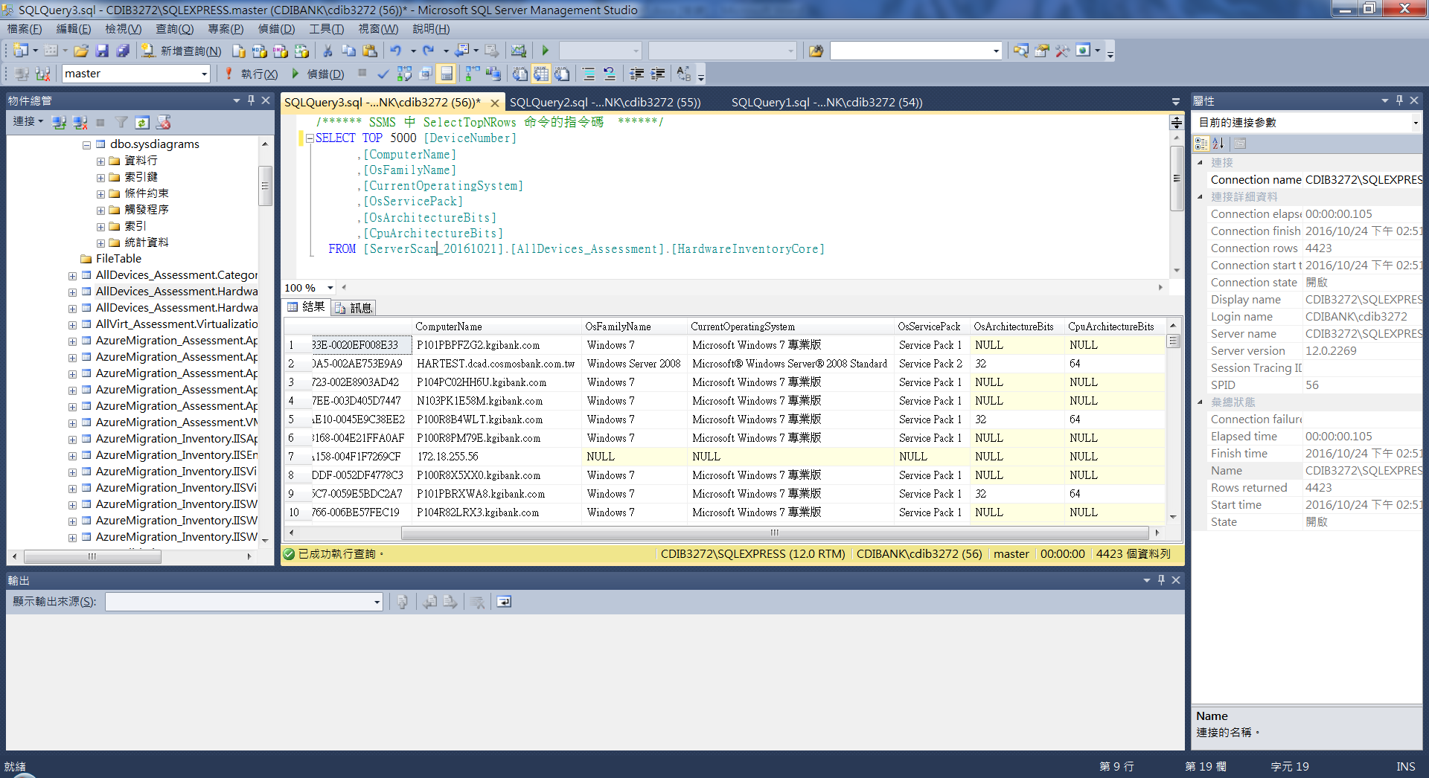

/****** SSMS 中 SelectTopNRows 命令的指令碼 ******/

CpuRamSN

SELECT TOP 1000 [DeviceNumber]

,[WMIStatus]

,[ComputerModel]

,[ActiveNetworkAdapter]

,[IPAddress]

,[Domain/Workgroup]

,[NumberOfLogicalProcessors]

,[Cpu]

,[SystemMemory]

,[BIOsSerialNumber]

,[BIOsManufacturer]

,[MachineType]

FROM [ServerScan_20161021].[AllDevices_Assessment].[HardwareInventoryEx]

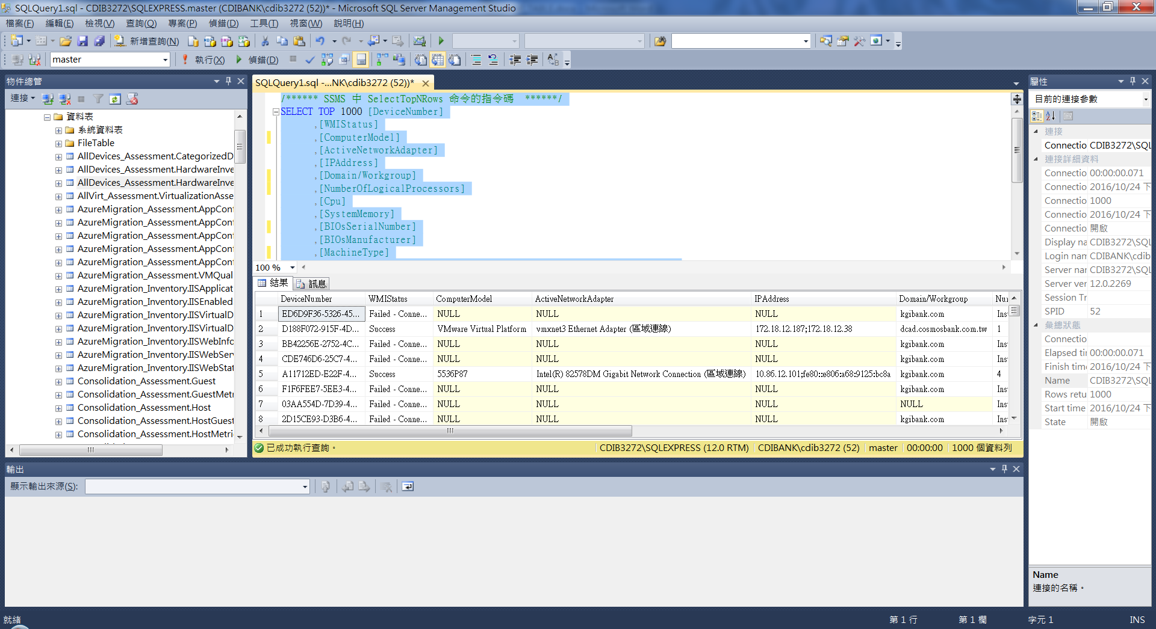

/****** SSMS 中 SelectTopNRows 命令的指令碼 ******/

SELECT TOP 1000 [DeviceNumber]

,[ServerName]

,[DbName]

,[Fileid]

,[Name]

,[Filename]

,[Filegroup]

,[Size]

,[Maxsize]

,[Growth]

,[Usage]

,[CreateDatetime]

FROM [ServerScan_20161021].[SqlServer_Inventory].[DataBaseFileGroup]

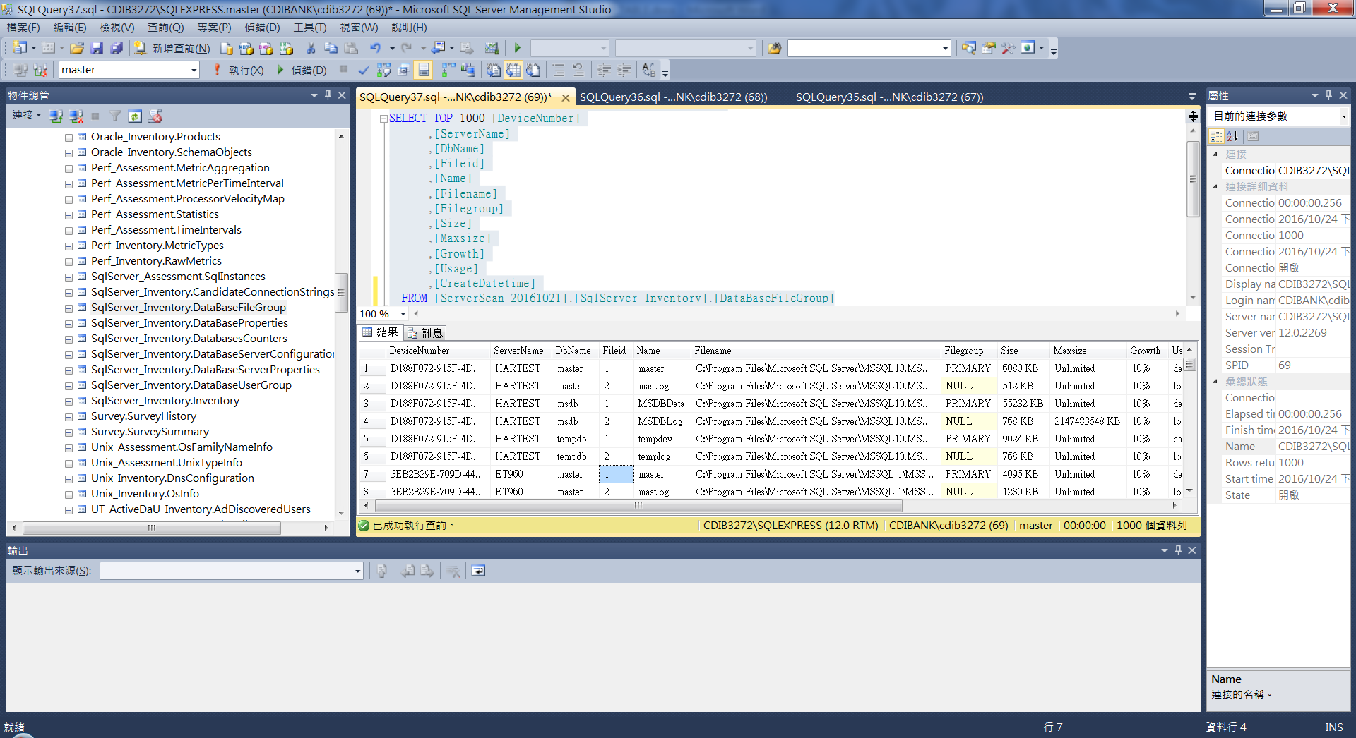

/****** SSMS 中 SelectTopNRows 命令的指令碼 ******/

SELECT TOP 1000 [DeviceNumber]

,[ServerName]

,[DbName]

,[UserName]

,[RoleName]

,[LoginName]

,[DefDbname]

,[DefSchemaName]

,[UserId]

,[Sid]

,[CreateCollectorId]

FROM [ServerScan_20161021].[SqlServer_Inventory].[DataBaseUserGroup]

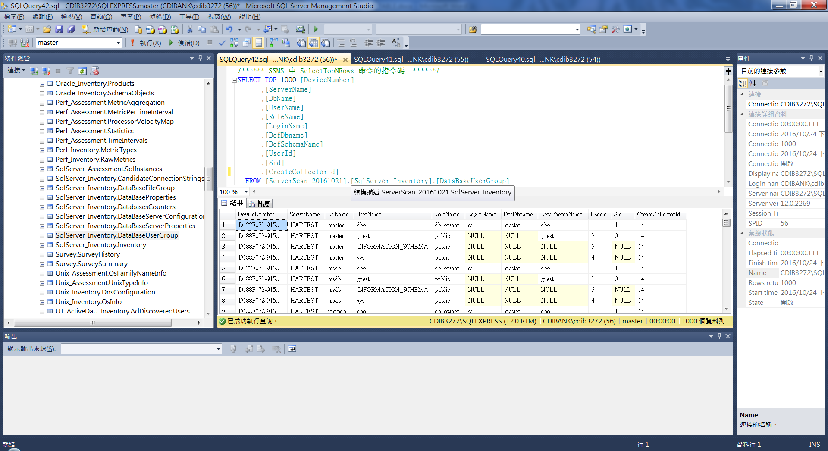

/****** SSMS 中 SelectTopNRows 命令的指令碼 ******/

SELECT TOP 1000 [DeviceNumber]

,[Name]

,[Vendor]

,[Version]

,[SystemComponent]

,[IdentifyingNumber]

,[InstallDate]

FROM [ServerScan_20161021].[Win_Assessment].[WindowsInstalledSoftwareFull]

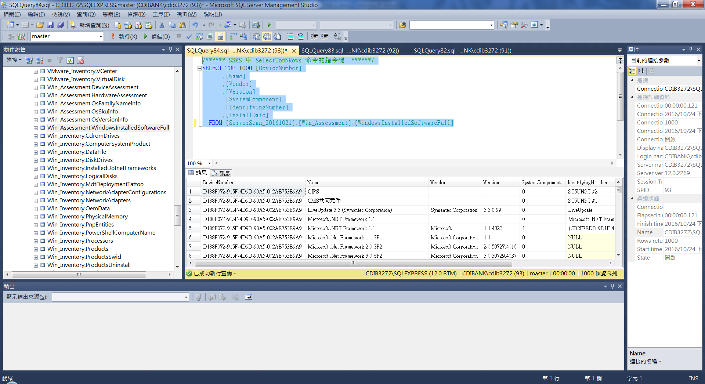

/****** SSMS 中 SelectTopNRows 命令的指令碼 ******/

SELECT TOP 1000 [DeviceNumber]

,[IdentifyingNumber]

,[Name]

,[Vendor]

,[Version]

FROM [ServerScan_20161021].[Win_Inventory].[ComputerSystemProduct]

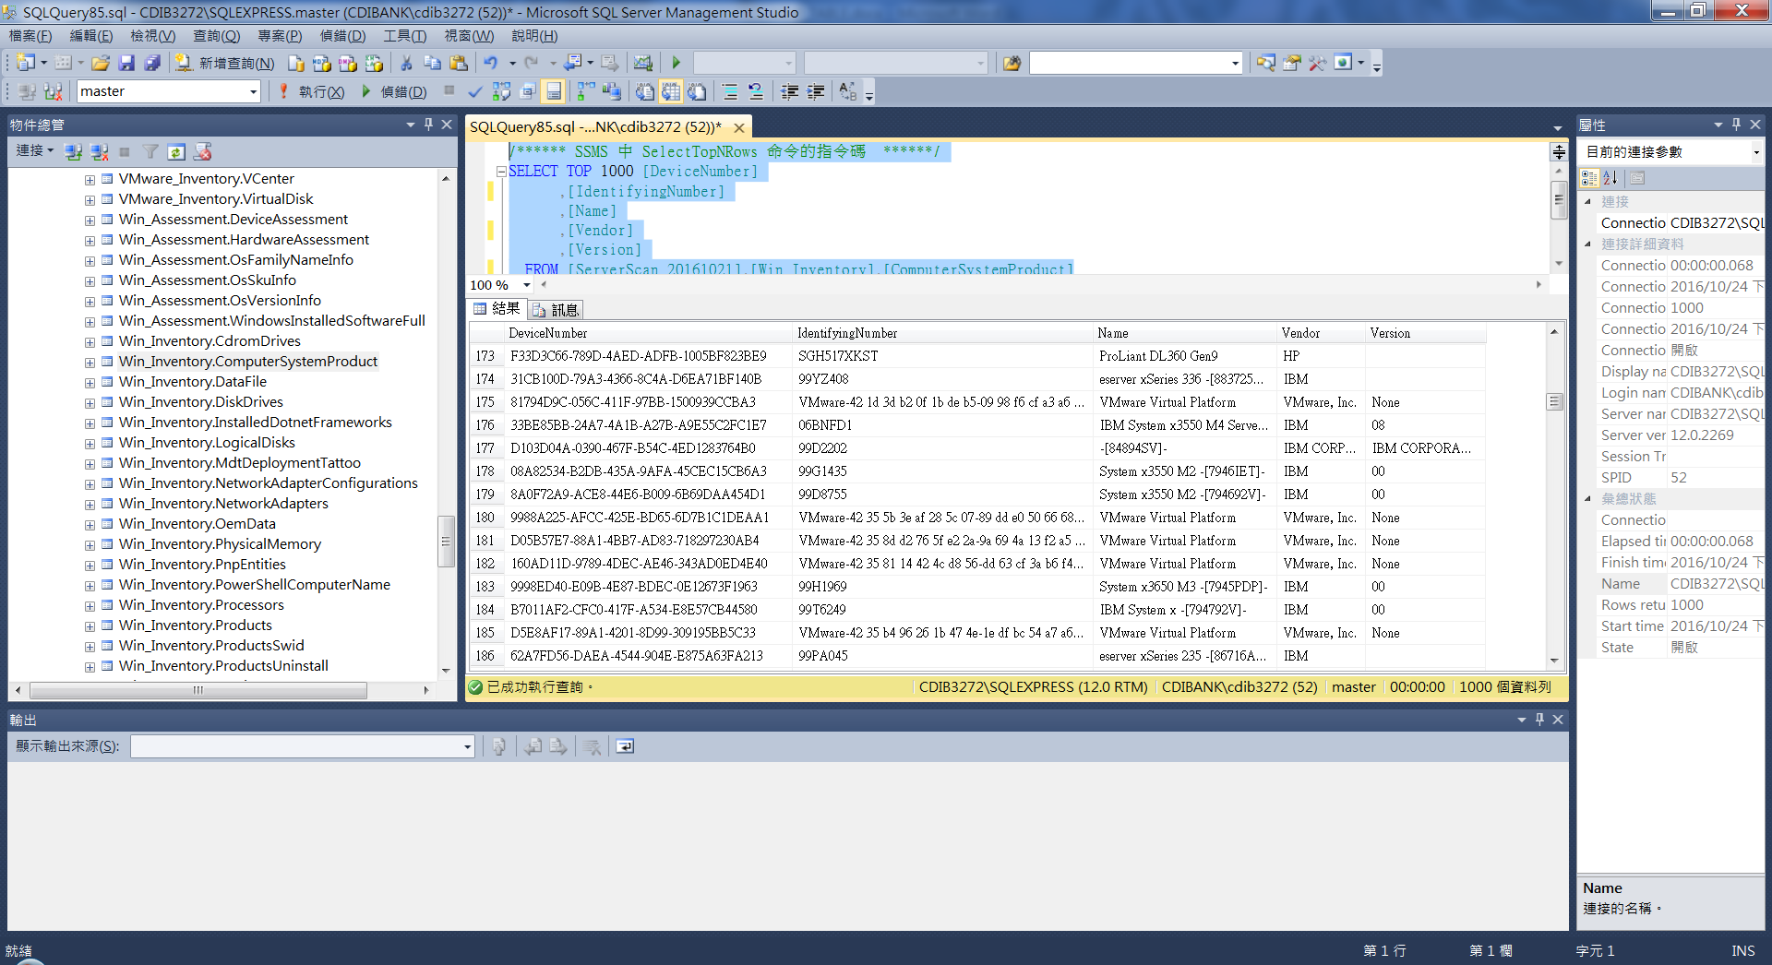

/****** SSMS 中 SelectTopNRows 命令的指令碼 ******/

SELECT TOP 1000 [DeviceNumber]

,[Caption]

,[Description]

,[DeviceId]

,[DriveType]

,[FreeSpace]

,[Name]

,[Size]

,[VolumeName]

,[VolumeSerialNumber]

FROM [ServerScan_20161021].[Win_Inventory].[LogicalDisks]

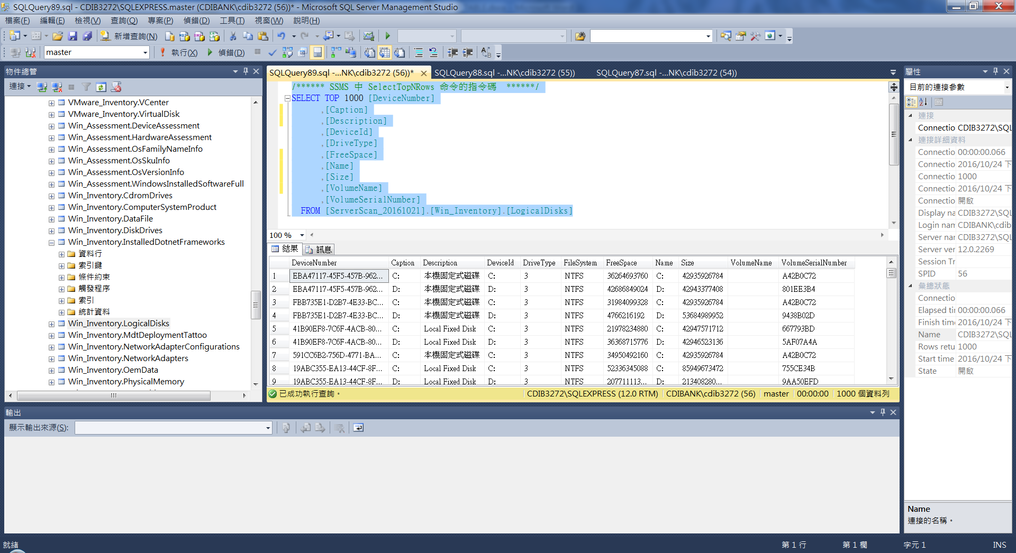

/****** SSMS 中 SelectTopNRows 命令的指令碼 ******/

SELECT TOP 1000 [DeviceNumber]

,[Caption]

,[Description]

,[DnsDomain]

,[DnsServerSearchOrder]

,[IpAddress]

,[IpEnabled]

,[MacAddress]

,[WmiDnsHostName]

FROM [ServerScan_20161021].[Win_Inventory].[NetworkAdapterConfigurations]

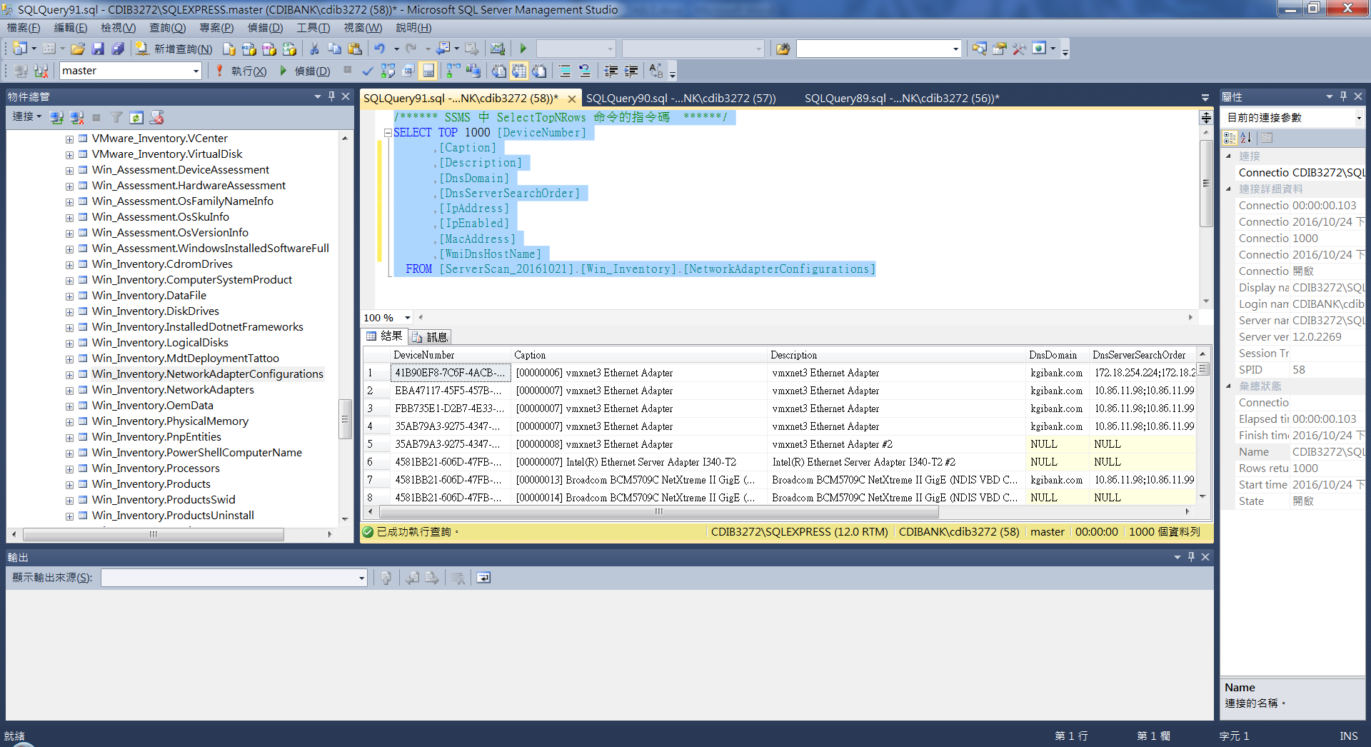

/****** SSMS 中 SelectTopNRows 命令的指令碼 ******/

SELECT TOP 1000 [DeviceNumber]

,[Caption]

,[Description]

,[DisplayName]

,[Name]

,[StartMode]

,[StartName]

,[State]

,[Status]

FROM [ServerScan_20161021].[Win_Inventory].[Services]

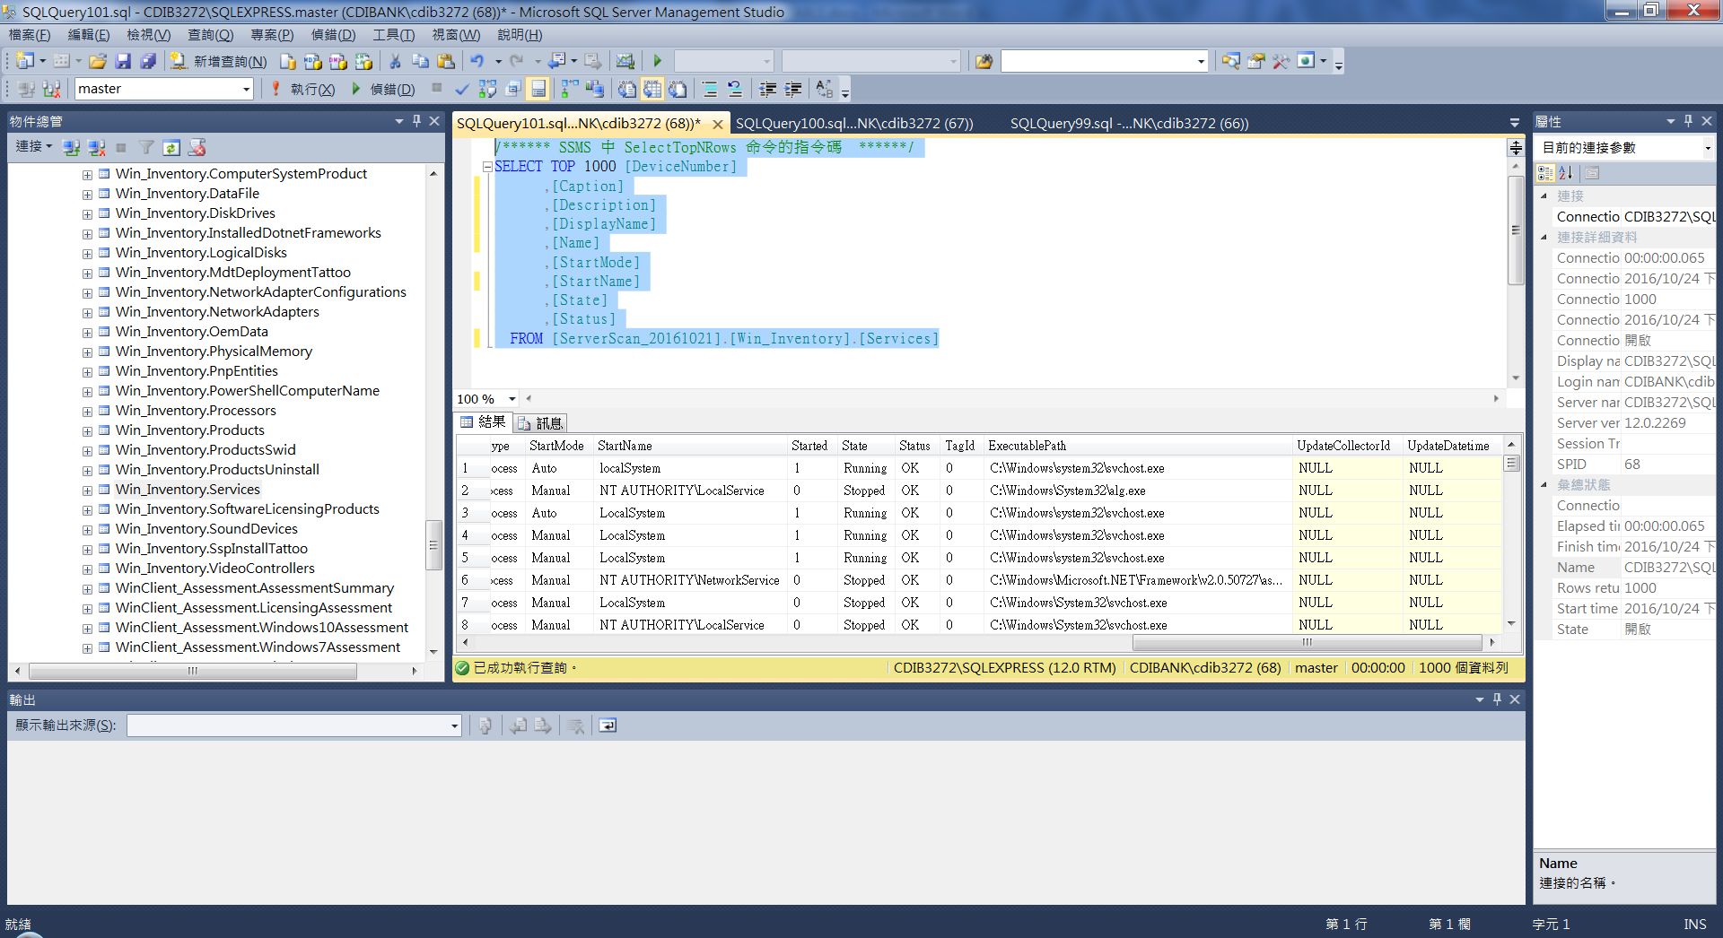

/****** SSMS 中 SelectTopNRows 命令的指令碼 ******/

SELECT TOP 9999 [DeviceNumber]

,[ComputerSystemName]

,[TotalPhysicalMemory]

FROM [ServerScan_20161021].[WinServer_Assessment].[ServerAssessment]

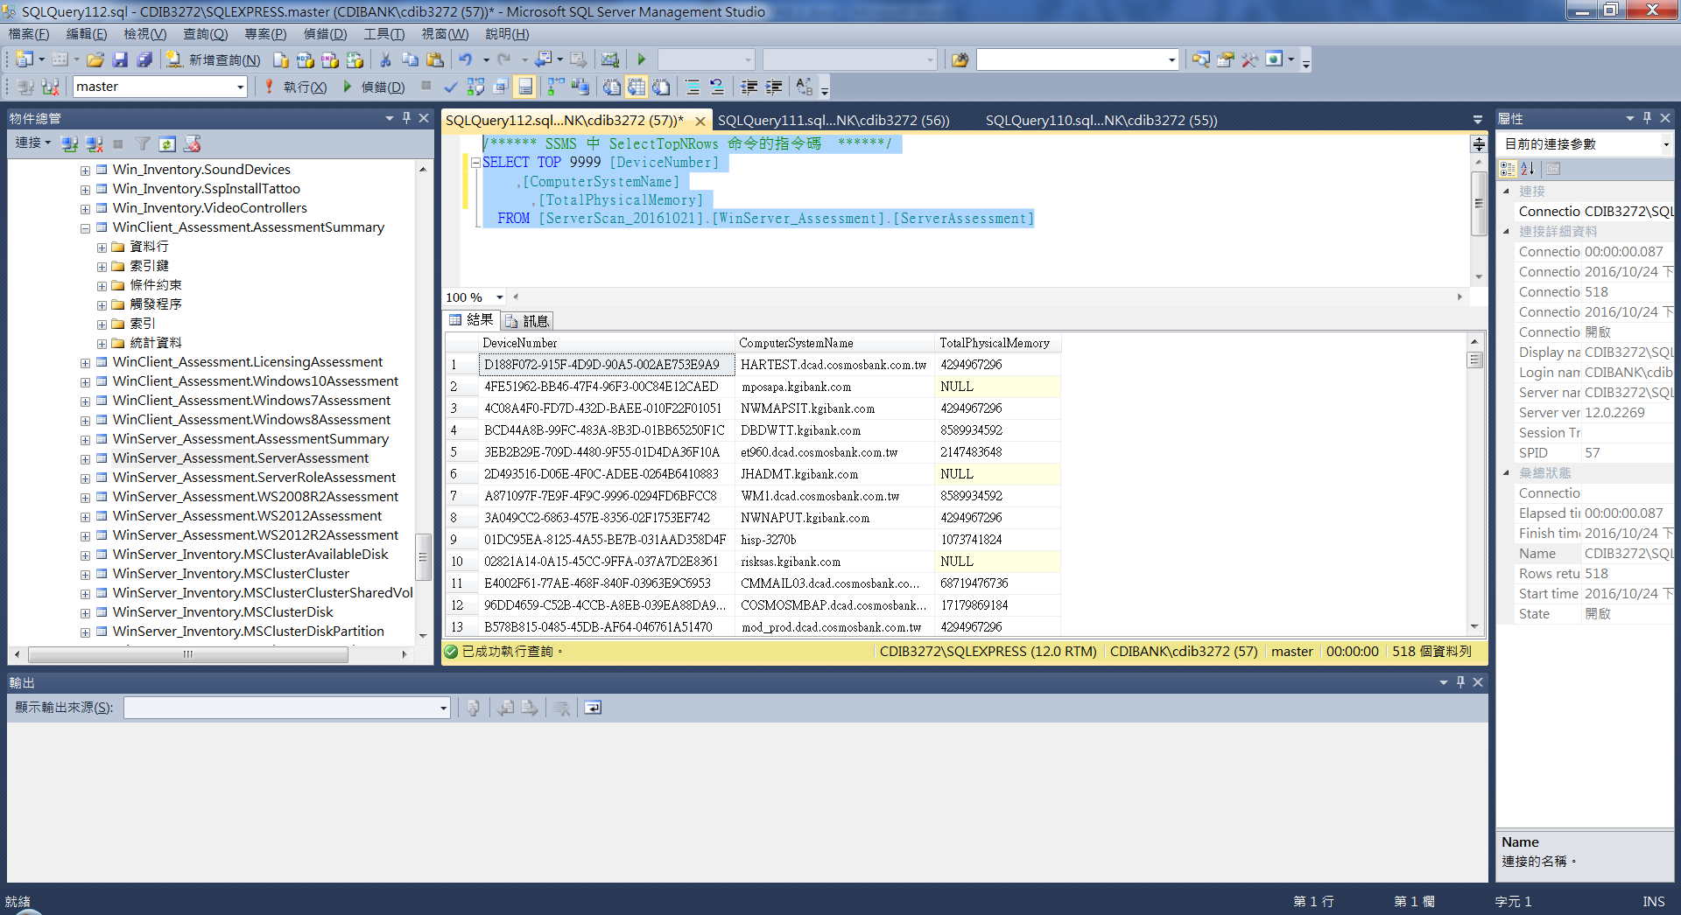

/****** SSMS 中 SelectTopNRows 命令的指令碼 ******/

SELECT TOP 1000 [DeviceNumber]

,[Name]

,[ClusSvcRegroupOpeningTimeout]

,[ClusSvcRegroupPruningTimeout]

,[ClusSvcRegroupStageTimeout]

,[ClusSvcRegroupTickInMilliseconds]

,[ClusterLogSize]

,[CrossSubnetDelay]

,[CrossSubnetThreshold]

,[EnableSharedVolumes]

,[QuorumPath]

,[QuorumType]

,[SharedVolumesRoot]

FROM [ServerScan_20161021].[WinServer_Inventory].[MSClusterCluster]

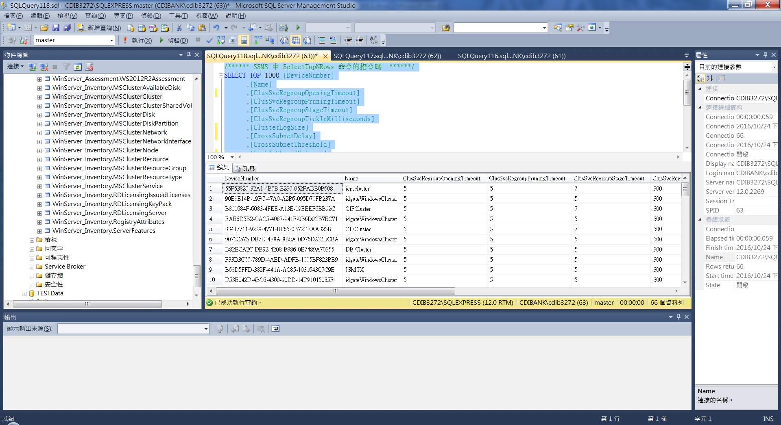

/****** SSMS 中 SelectTopNRows 命令的指令碼 ******/

SELECT TOP 1000 [DeviceNumber]

,[Name]

,[Address]

,[IPv4Addresses]

FROM [ServerScan_20161021].[WinServer_Inventory].[MSClusterNetwork]

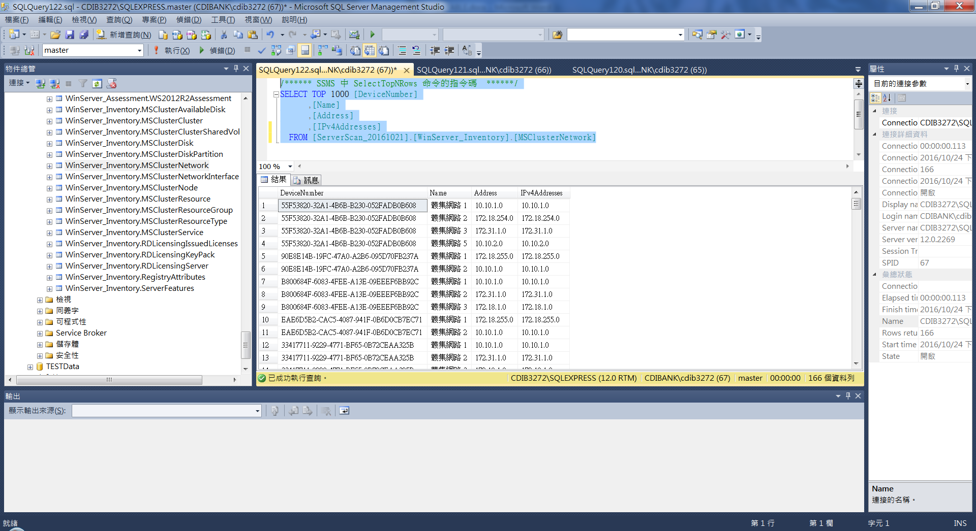

/****** SSMS 中 SelectTopNRows 命令的指令碼 ******/

SELECT TOP 1000 [DeviceNumber]

,[DeviceID]

,[Name]

,[SystemName]

,[Node]

,[Adapter]

,[AdapterId]

,[Address]

,[IPv4Addresses]

,[Network]

FROM [ServerScan_20161021].[WinServer_Inventory].[MSClusterNetworkInterface]

