RTL/Bidi Test Samples
4-Column: Name | Input | Visual | Points
Name | Input (Unicode) | Visual Rendition | Points
Test 1: Mixed Direction | السعر الكلي 123 ريال - the price is 123 riyals | 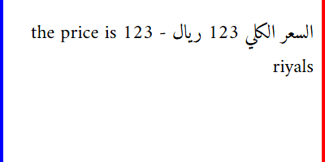 | [*] Mixed LTR/RTL  [*] Numbers grouped (123 not 321)  [*] Arabic RTL, English LTR  [*] Aligns to RIGHT
Test 2: Pure RTL Paragraph | هذا نص عربي بسيط لاختبار اتجاه النص من اليمين إلى اليسار | 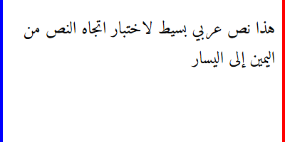 | [*] Pure RTL  [*] Right-to-left flow  [*] RIGHT margin  [*] Wraps from right
Test 3: Diacritics (Harakat) | كِتَاب (book) مَدْرَسَة (school) | 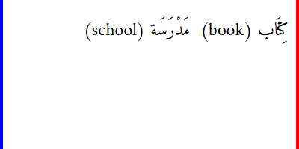 | [*] Diacritics (harakat)  [*] Marks ABOVE letters  [*] Arrow key skips  [*] Never between letter+mark
Test 4: Multiple RTL Scripts | Hello مرحبا שלום | 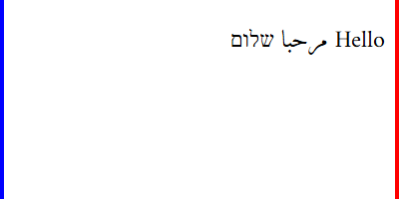 | [*] English + Arabic + Hebrew  [*] English LTR, RTL text  [*] No CJK (font limit)  [*] Mixed direction
Test 5: Numbers in Arabic | الشركة: Acme Corp العنوان: 123 Main Street | 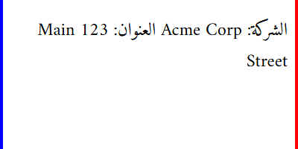 | [*] Numbers grouped (123)  [*] Company readable  [*] RTL flow  [*] Proper ordering
Test 6: Kashida Variants | احمد vs أحمد | 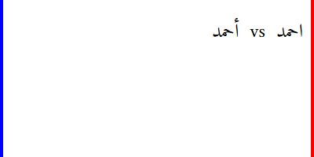 | [*] Kashida variant  [*] Find & Replace  [*] Finds both forms  [*] Proofing tools
Test 7: Caret & Selection | السعر 123 ريال | 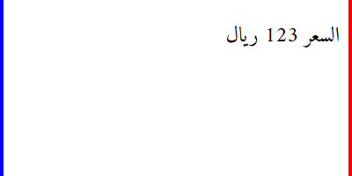 | [*] Caret direction  [*] Selection spans  [*] Home/End visual  [*] Arrow keys RTL
Test 8: RTL List | • البند الأول  • البند الثاني | 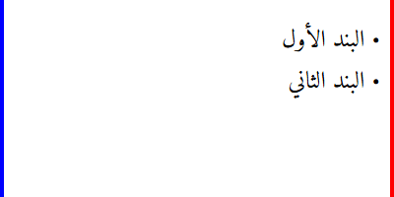 | [*] RTL lists  [*] Bullets RIGHT  [*] Text RTL  [*] Indent from right

