DC
1) On the DC device, a compromised account performed a remote network logon to the host on 2022-03-08 at 05:40:39 (UTC). What is the remote IP address associated with this logon event?

Answer: 192.168.56.103
First, based on the question, I used the WHERE clause on the “TimeCreated” column with the timestamp 2022-03-08 05:40:39 to search for related results.
Second, I applied for the Event ID 4624 filter. Event ID 4624 is the Windows "An account was successfully logged on" event. It records every successful logon, including the source IP address.
In the end, there are a total of 7 records, but all of them show the same remote host IP address.
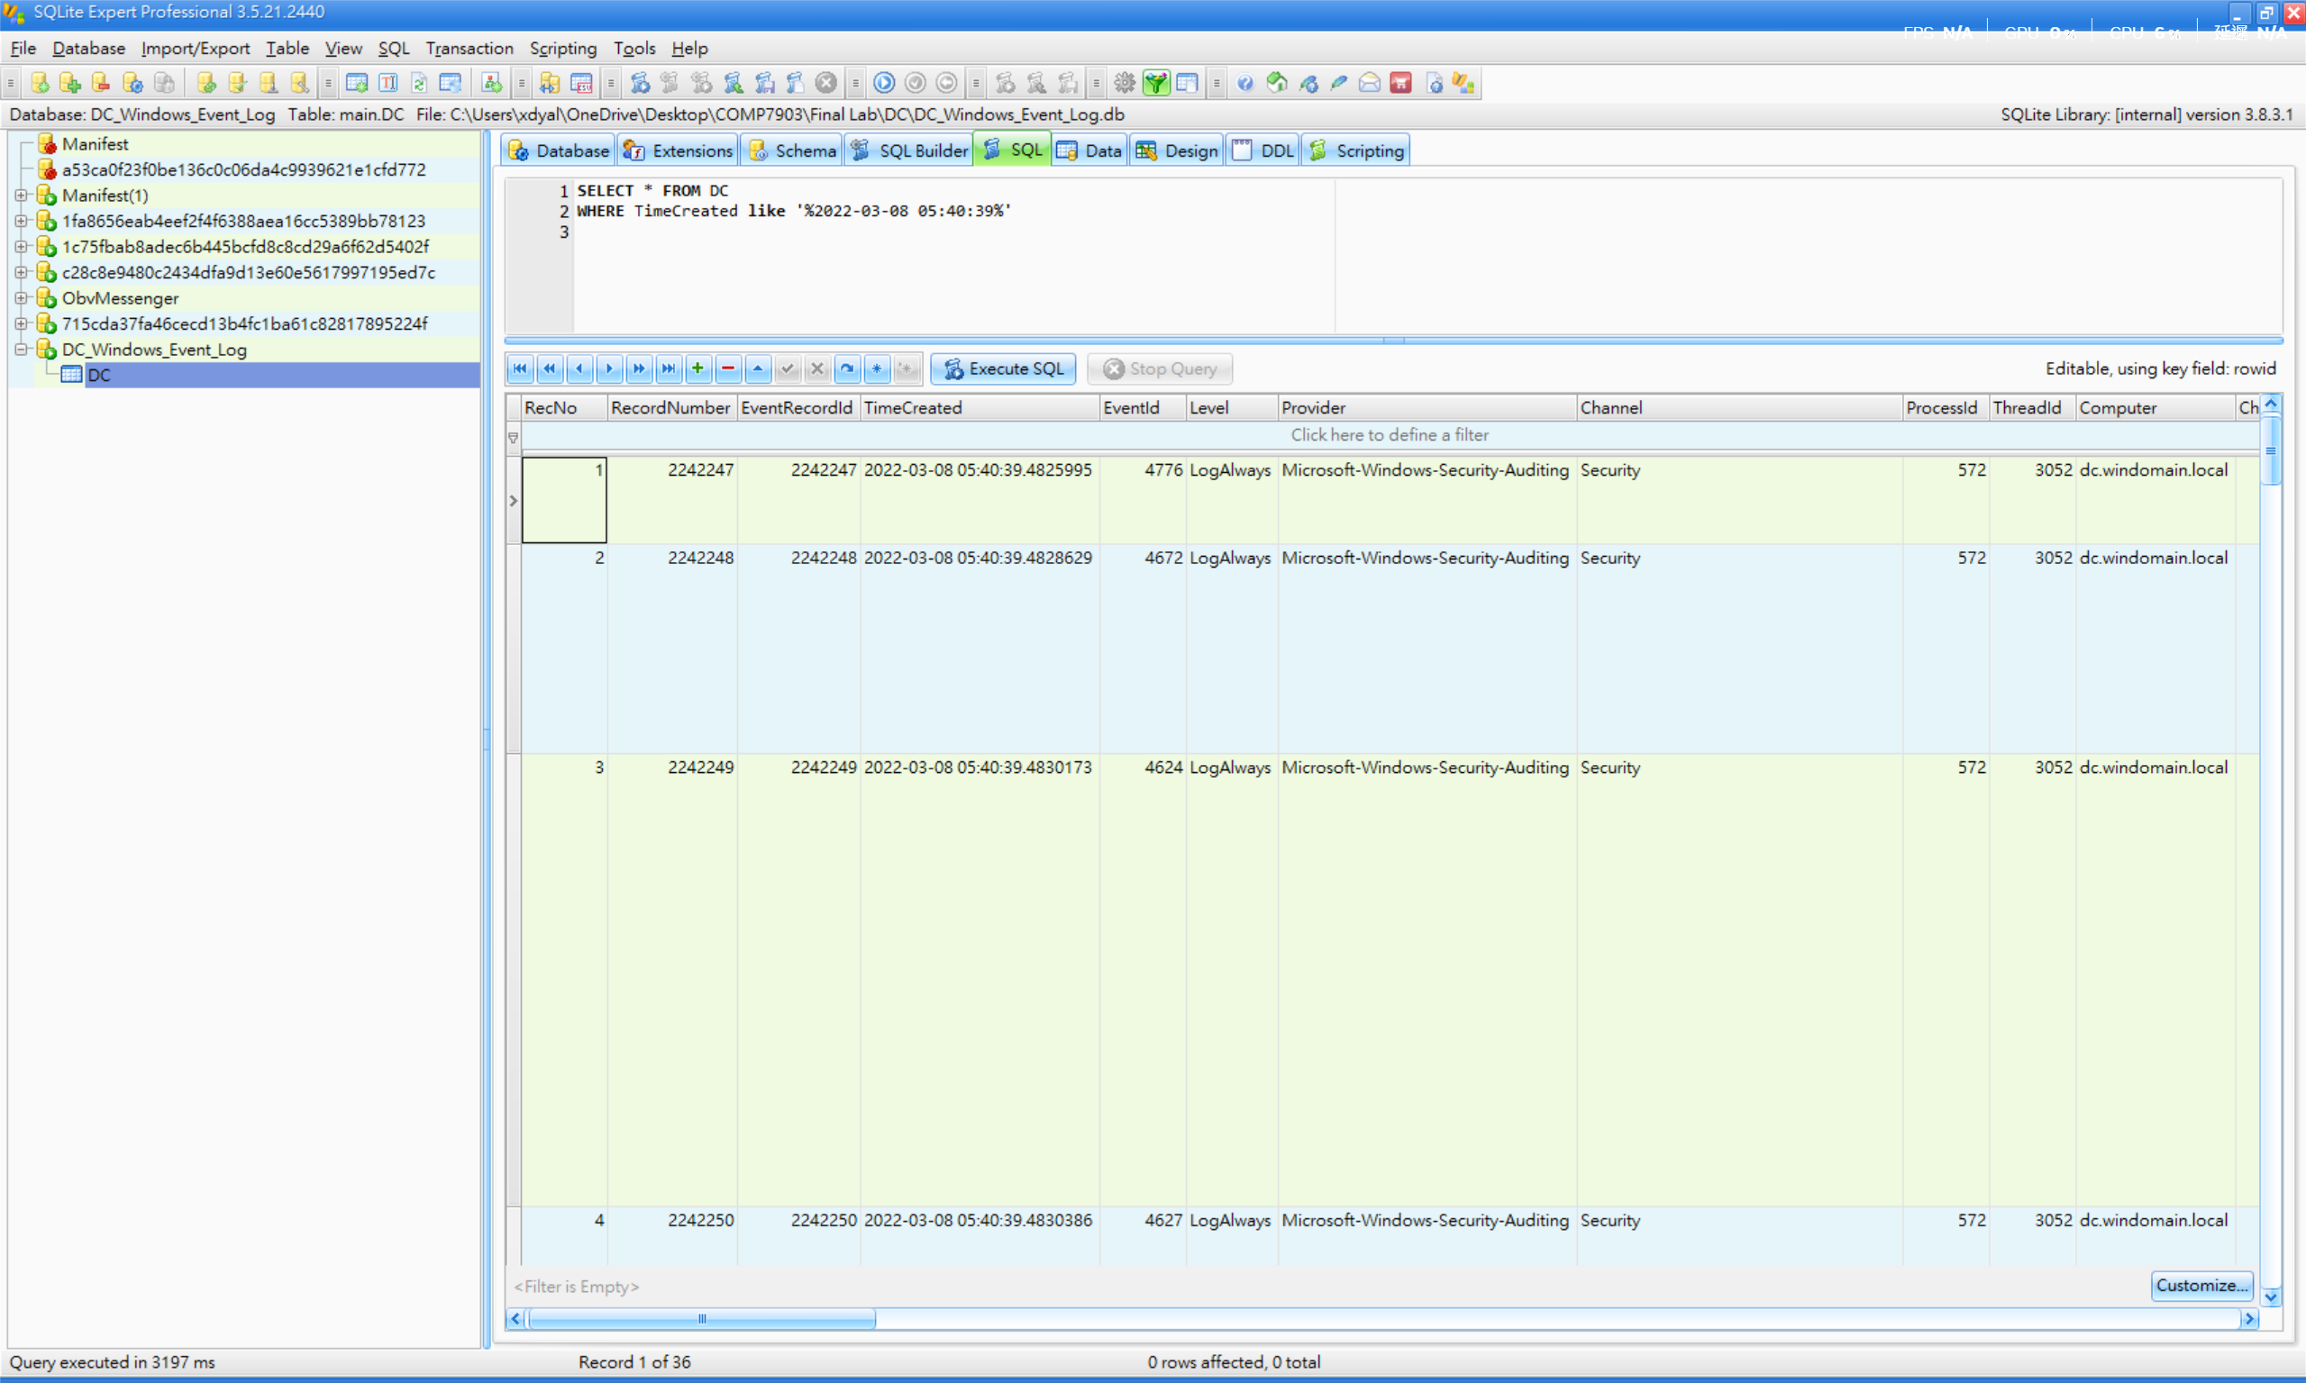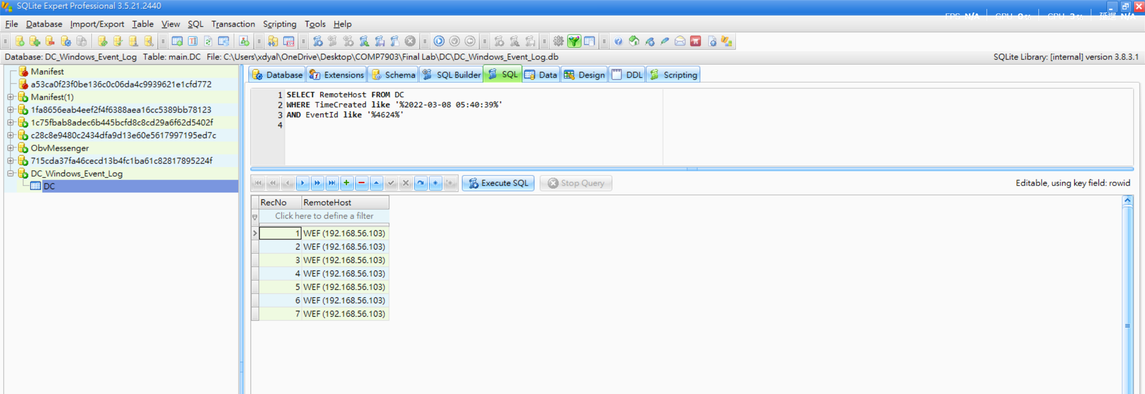
2) On the DC device, Windows Event Log EID 7045 indicates that a suspicious service was installed on the system on 2022-03-08 at 05:41:00 (UTC). Which User Security Identifier (SID) is associated with this service installation event?

Answer: S-1-5-21-2910388070-2332933552-733495091-1113
First, based on the question, I used the WHERE clause on the “TimeCreated” column with the timestamp 2022-03-08 05:41:00 to search for related results.
Second, I applied for the Event ID “7045” filter. Event ID 7045 is logged in to the System channel whenever a new service is installed on a Windows machine. It is a key indicator of persistence or lateral movement.
Therefore, we can find the result in the userId column.
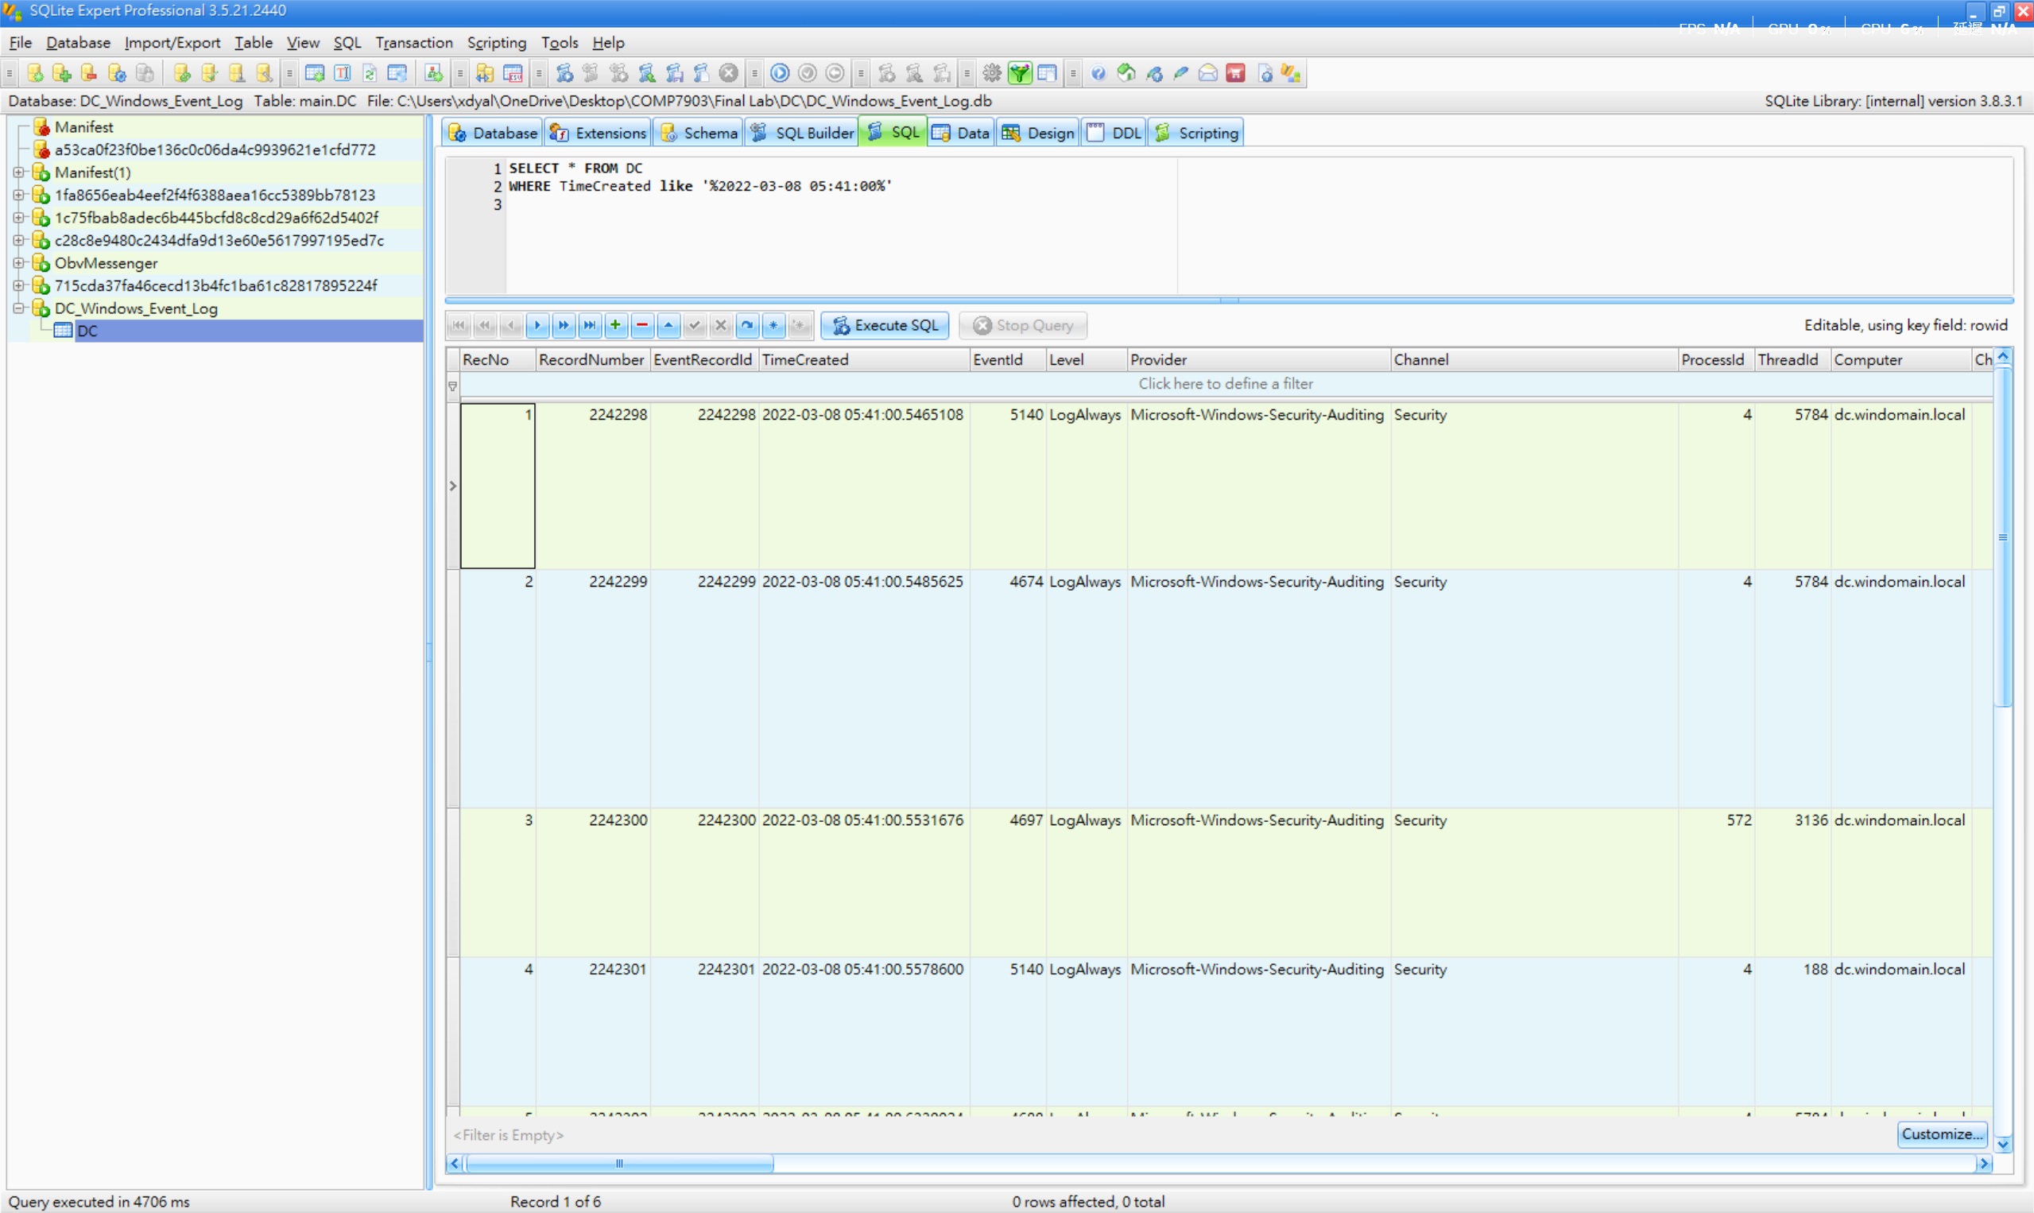
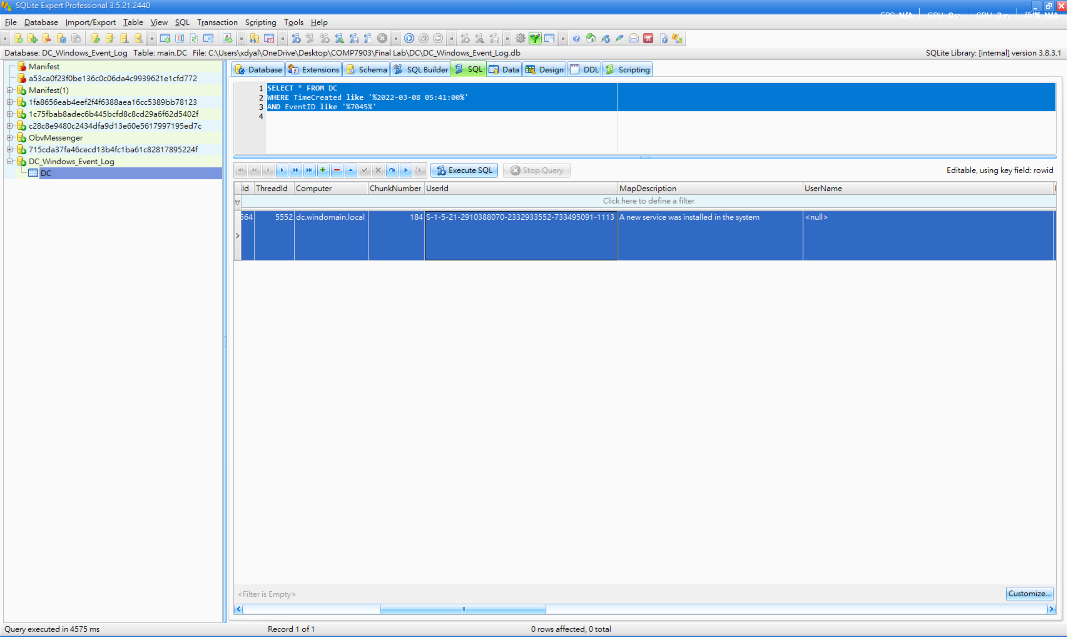

3) On the DC device, a suspicious process initiated a network connection to a Cobalt Strike Command and Control (C2) IP address on 2022-03-25. What is the specific C2 IP address?

Answer: 3.93.196.132
First, based on the question, I used the WHERE clause on the “TimeCreated” column with the date 2022-03-25 to search for related results.
Second, I applied the “Sysmon” channel filter and the Process ID “2752” filter in PayloadData1. This is because Sysmon is a Windows tool that logs detailed process and network activity. Event ID 3 in Sysmon specifically records network connections, including which process initiated the connection and the destination IP address. Moreover, process ID 2752 corresponds to the WMI Service (winmgmt), which is commonly used by applications and scripts to query system information.
In the end, most of the values in the PayloadData6 column show the IP address 3.93.196.132.
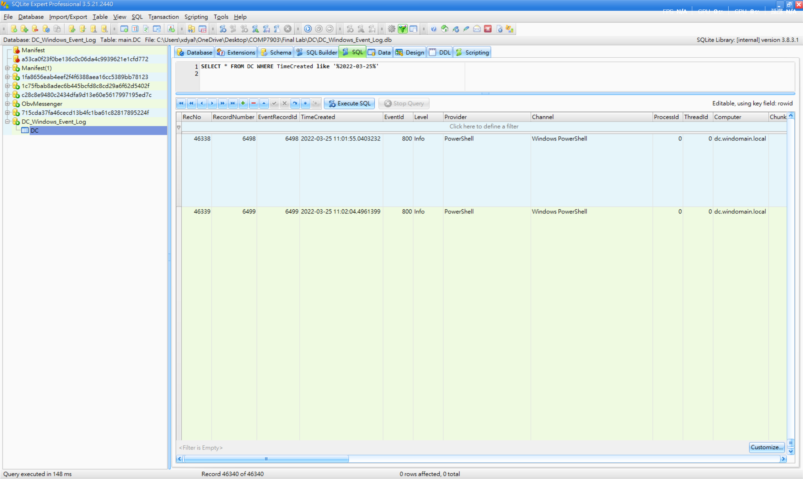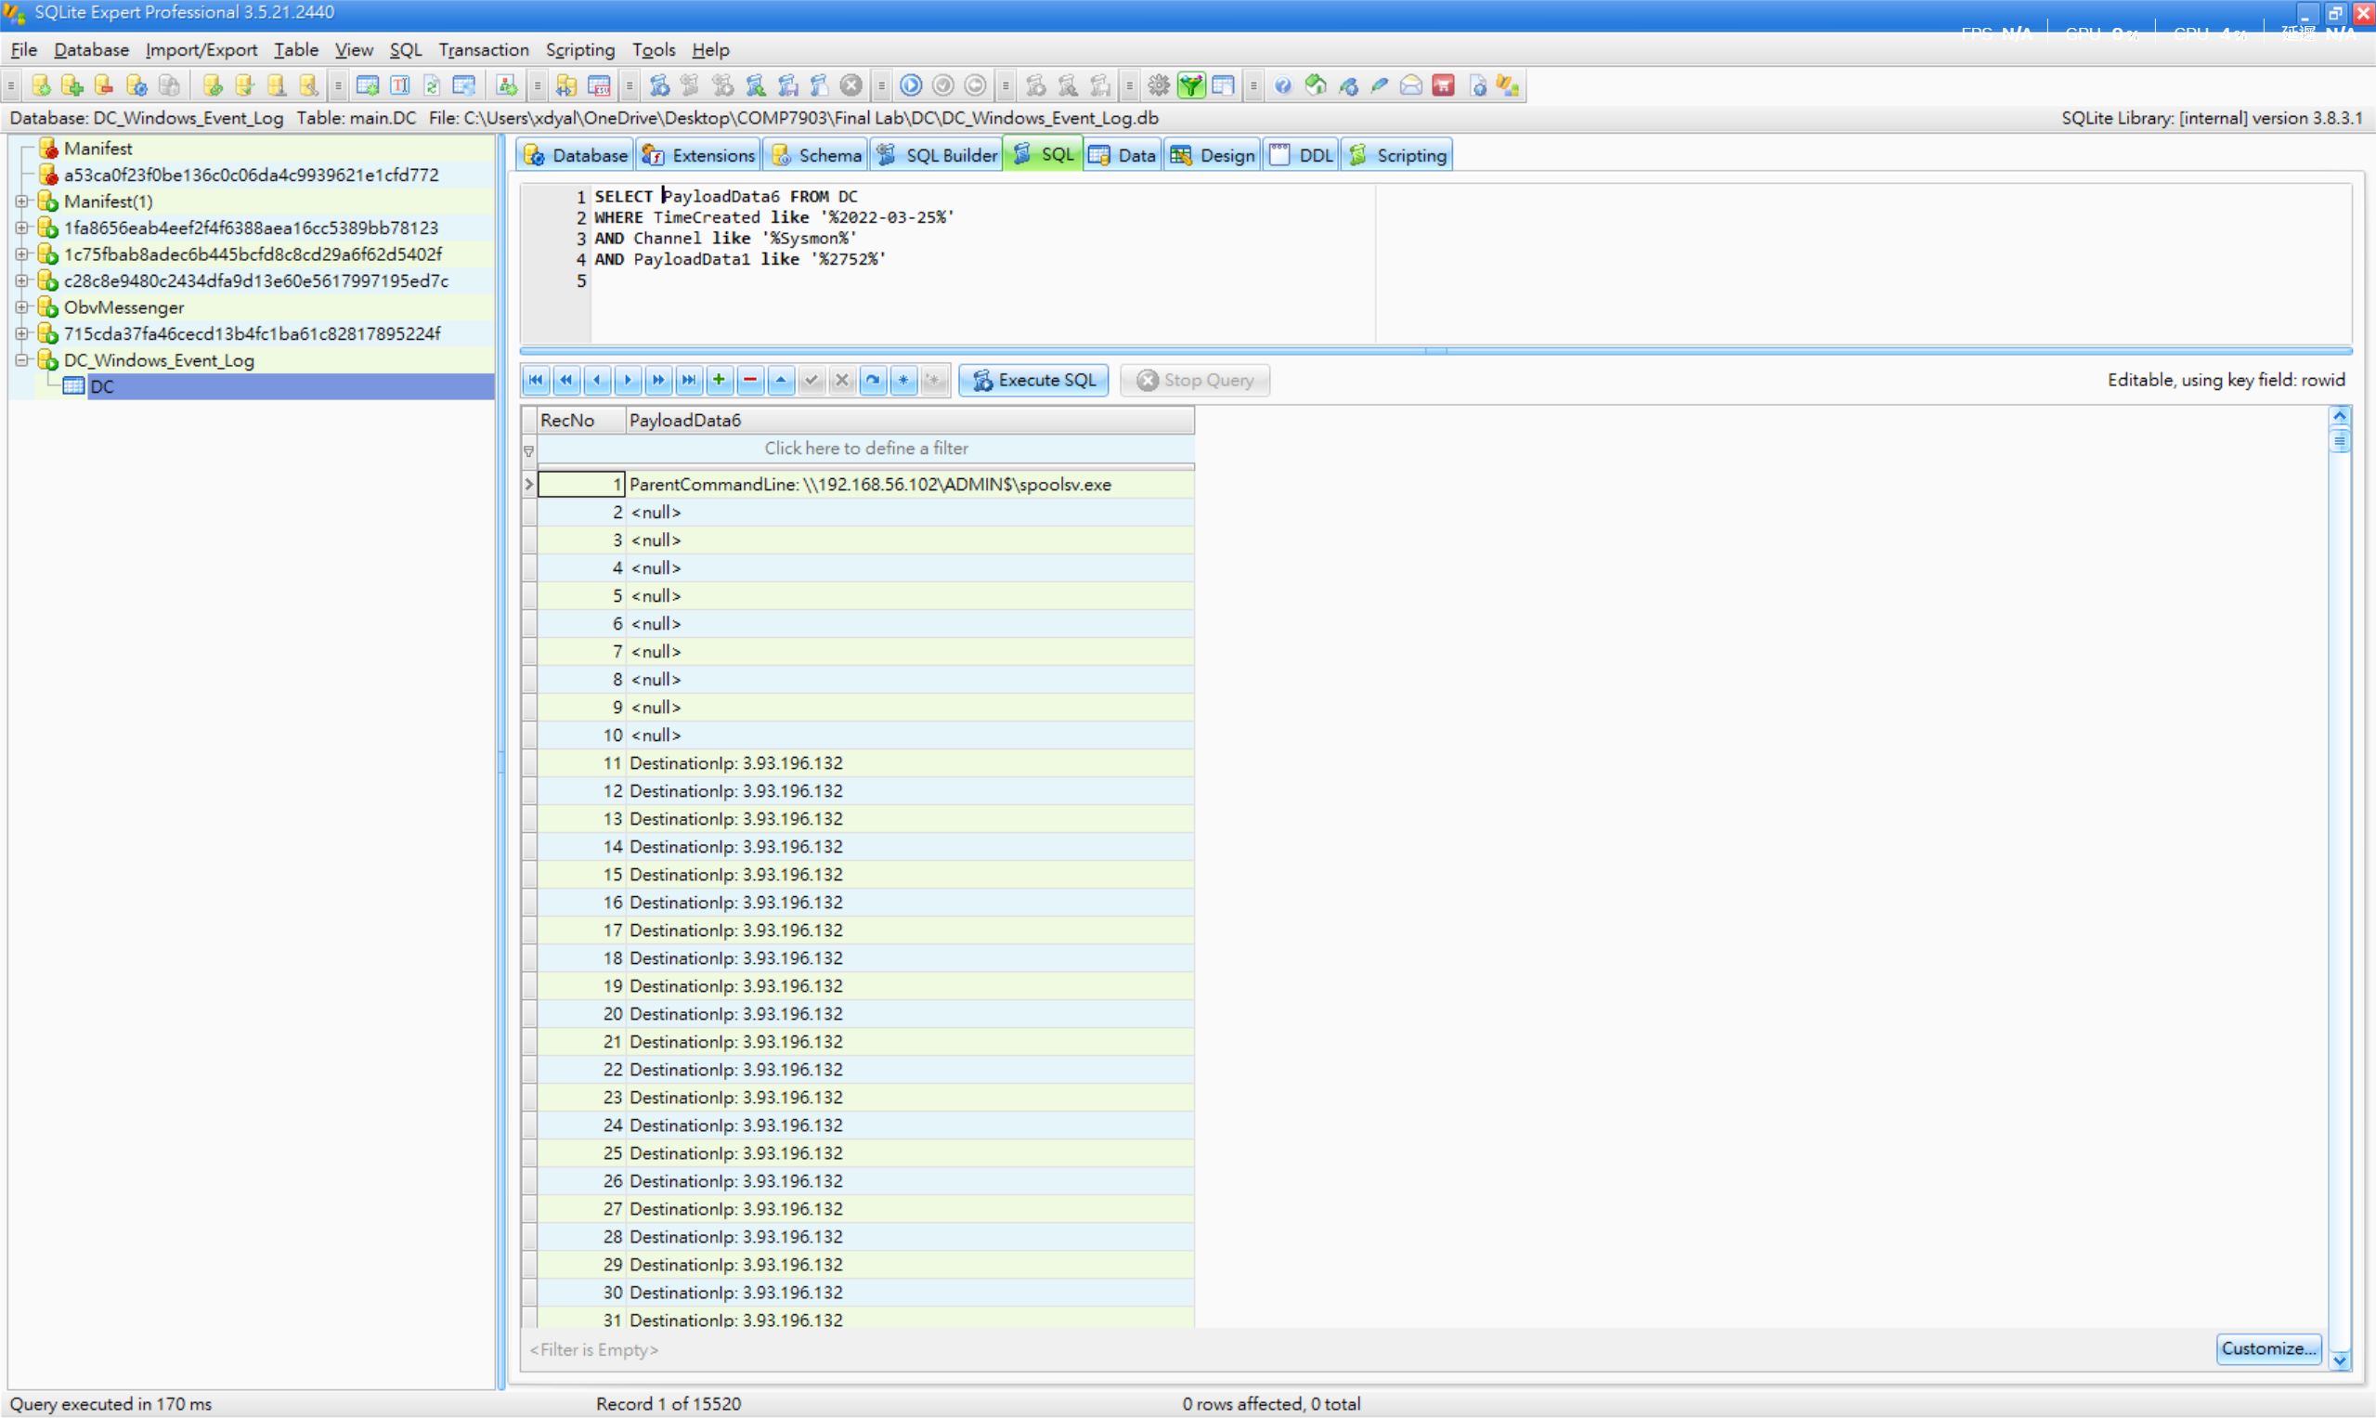
4) On the DC device, an obfuscated PowerShell command was executed on 2022-03-25 at 07:49:31 (UTC). Decode this command and identify the specific named pipe used within the payload. What is the name of the pipe?
(Hint: You can use tools like CyberChef to deobfuscate the command).

Answer: srvsvc-1-5-5-01334
First, based on the question, I used the WHERE clause on the “TimeCreated” column with the timestamp 2022-03-25 07:49:31 to search for related results.
Second, we can find the executable information: “powershell -nop -w hidden -encodedcommand JABzAD0ATgBlAHcALQBPAGIAagBl……”
After executing this PowerShell command, Windows rejected it because it contained malicious content.
Third, I used CyberChef to decode the content. A total of three decode layers were applied:
Decode Layer 1:
- Input: The Base64 string from the PowerShell command
- Recipe: From Base64 → Decode text (UTF-16LE)
- Result: This reveals a PowerShell script that creates a MemoryStream from another Base64 string, then GZip-decompresses it.
Decode Layer 2:
- Input: The Base64 string from Layer 1 result
- Recipe: From Base64 → Gunzip
- Result: This reveals a Cobalt Strike stager script containing shellcode encoded in yet another Base64 string, XOR’d with key 35.
Decode Layer 3:
- Input: The shellcode Base64 string from Layer 2 result
- Recipe: From Base64 → XOR (key: 35, decimal)
- Result: In the output, by looking for readable ASCII strings, we can find: \\.\pipe\srvsvc-1-5-5-01334 (** It is the final answer)
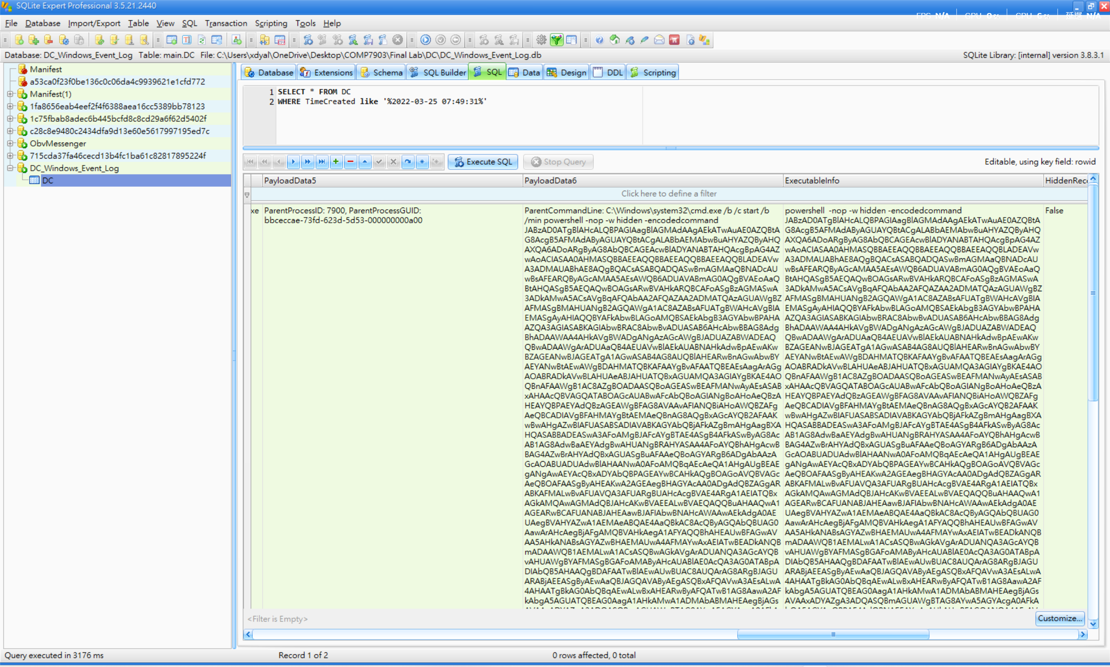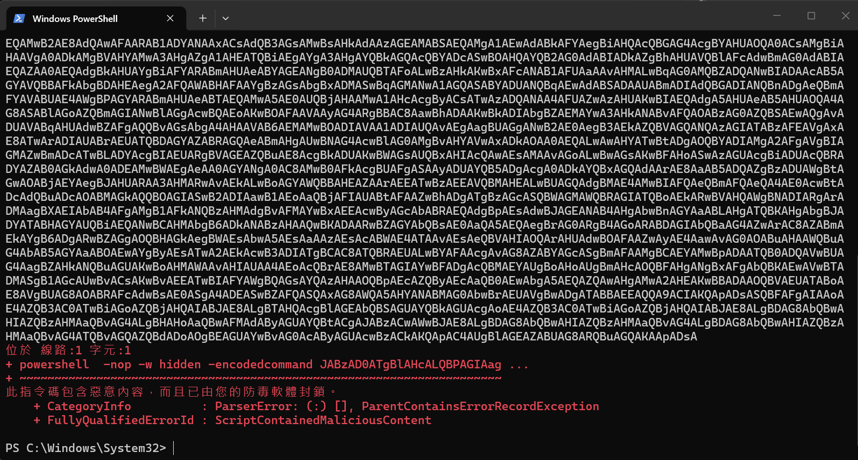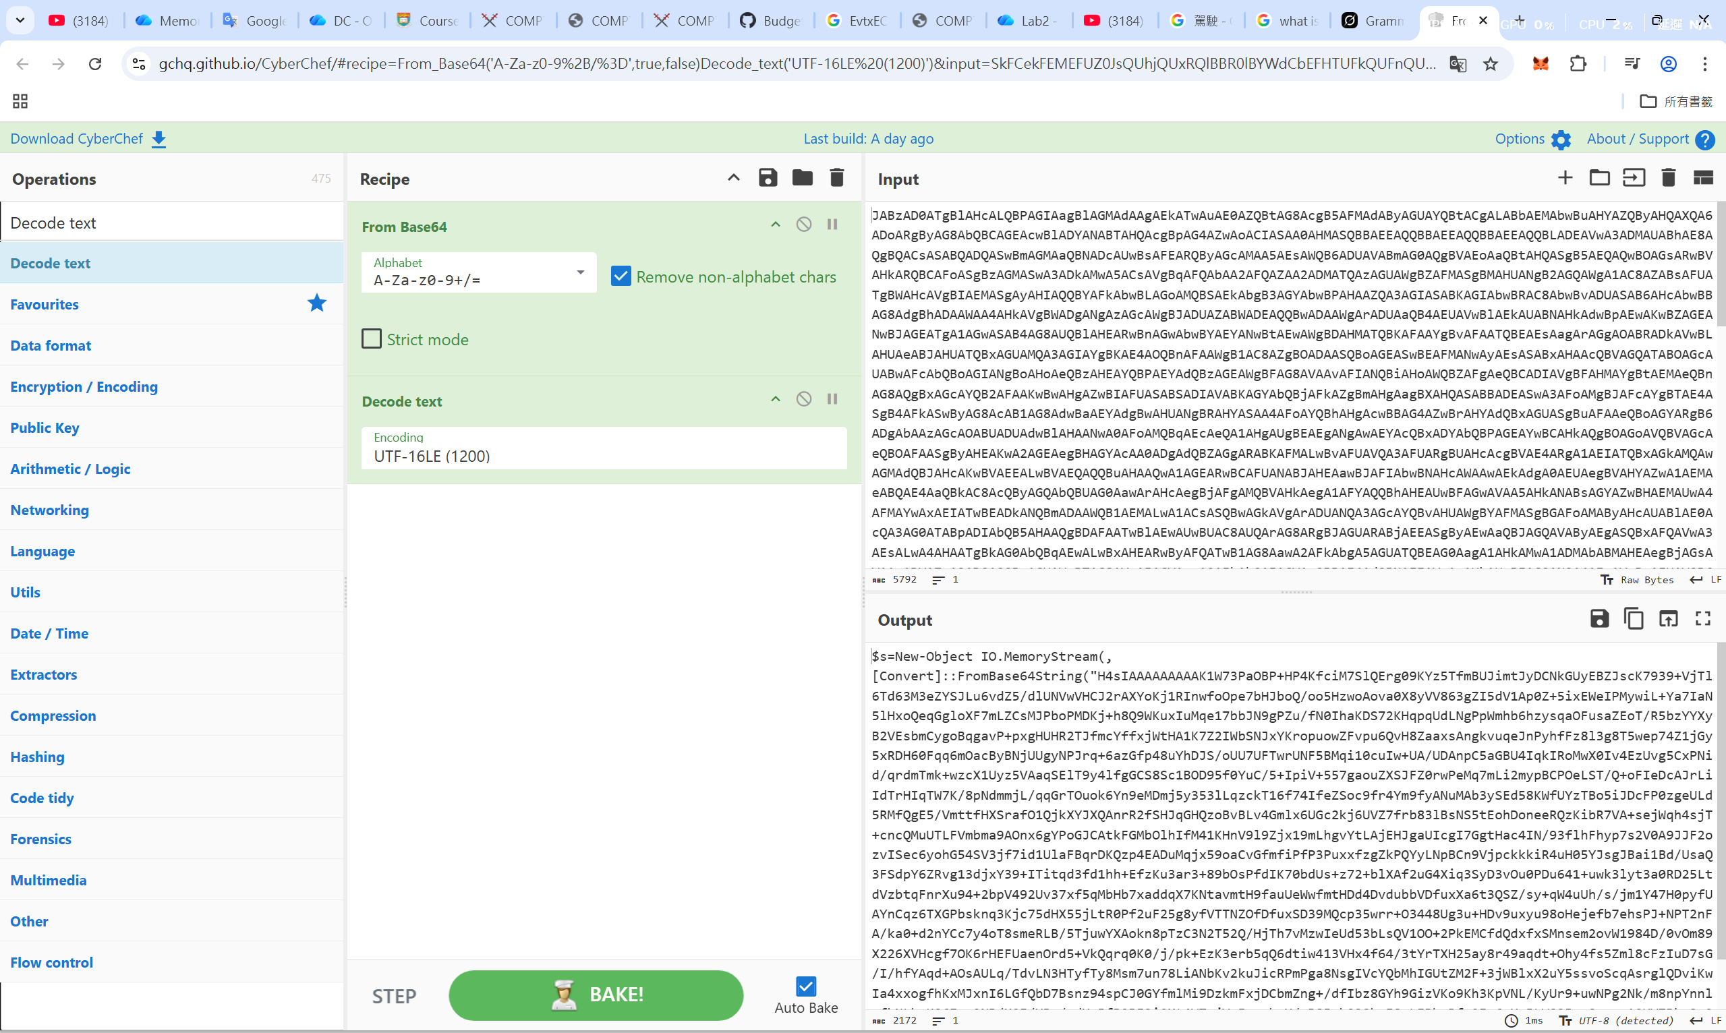
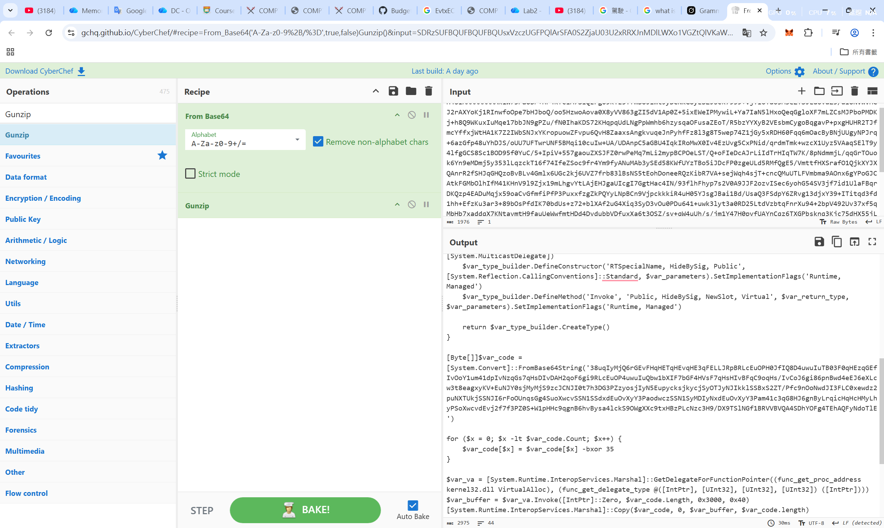
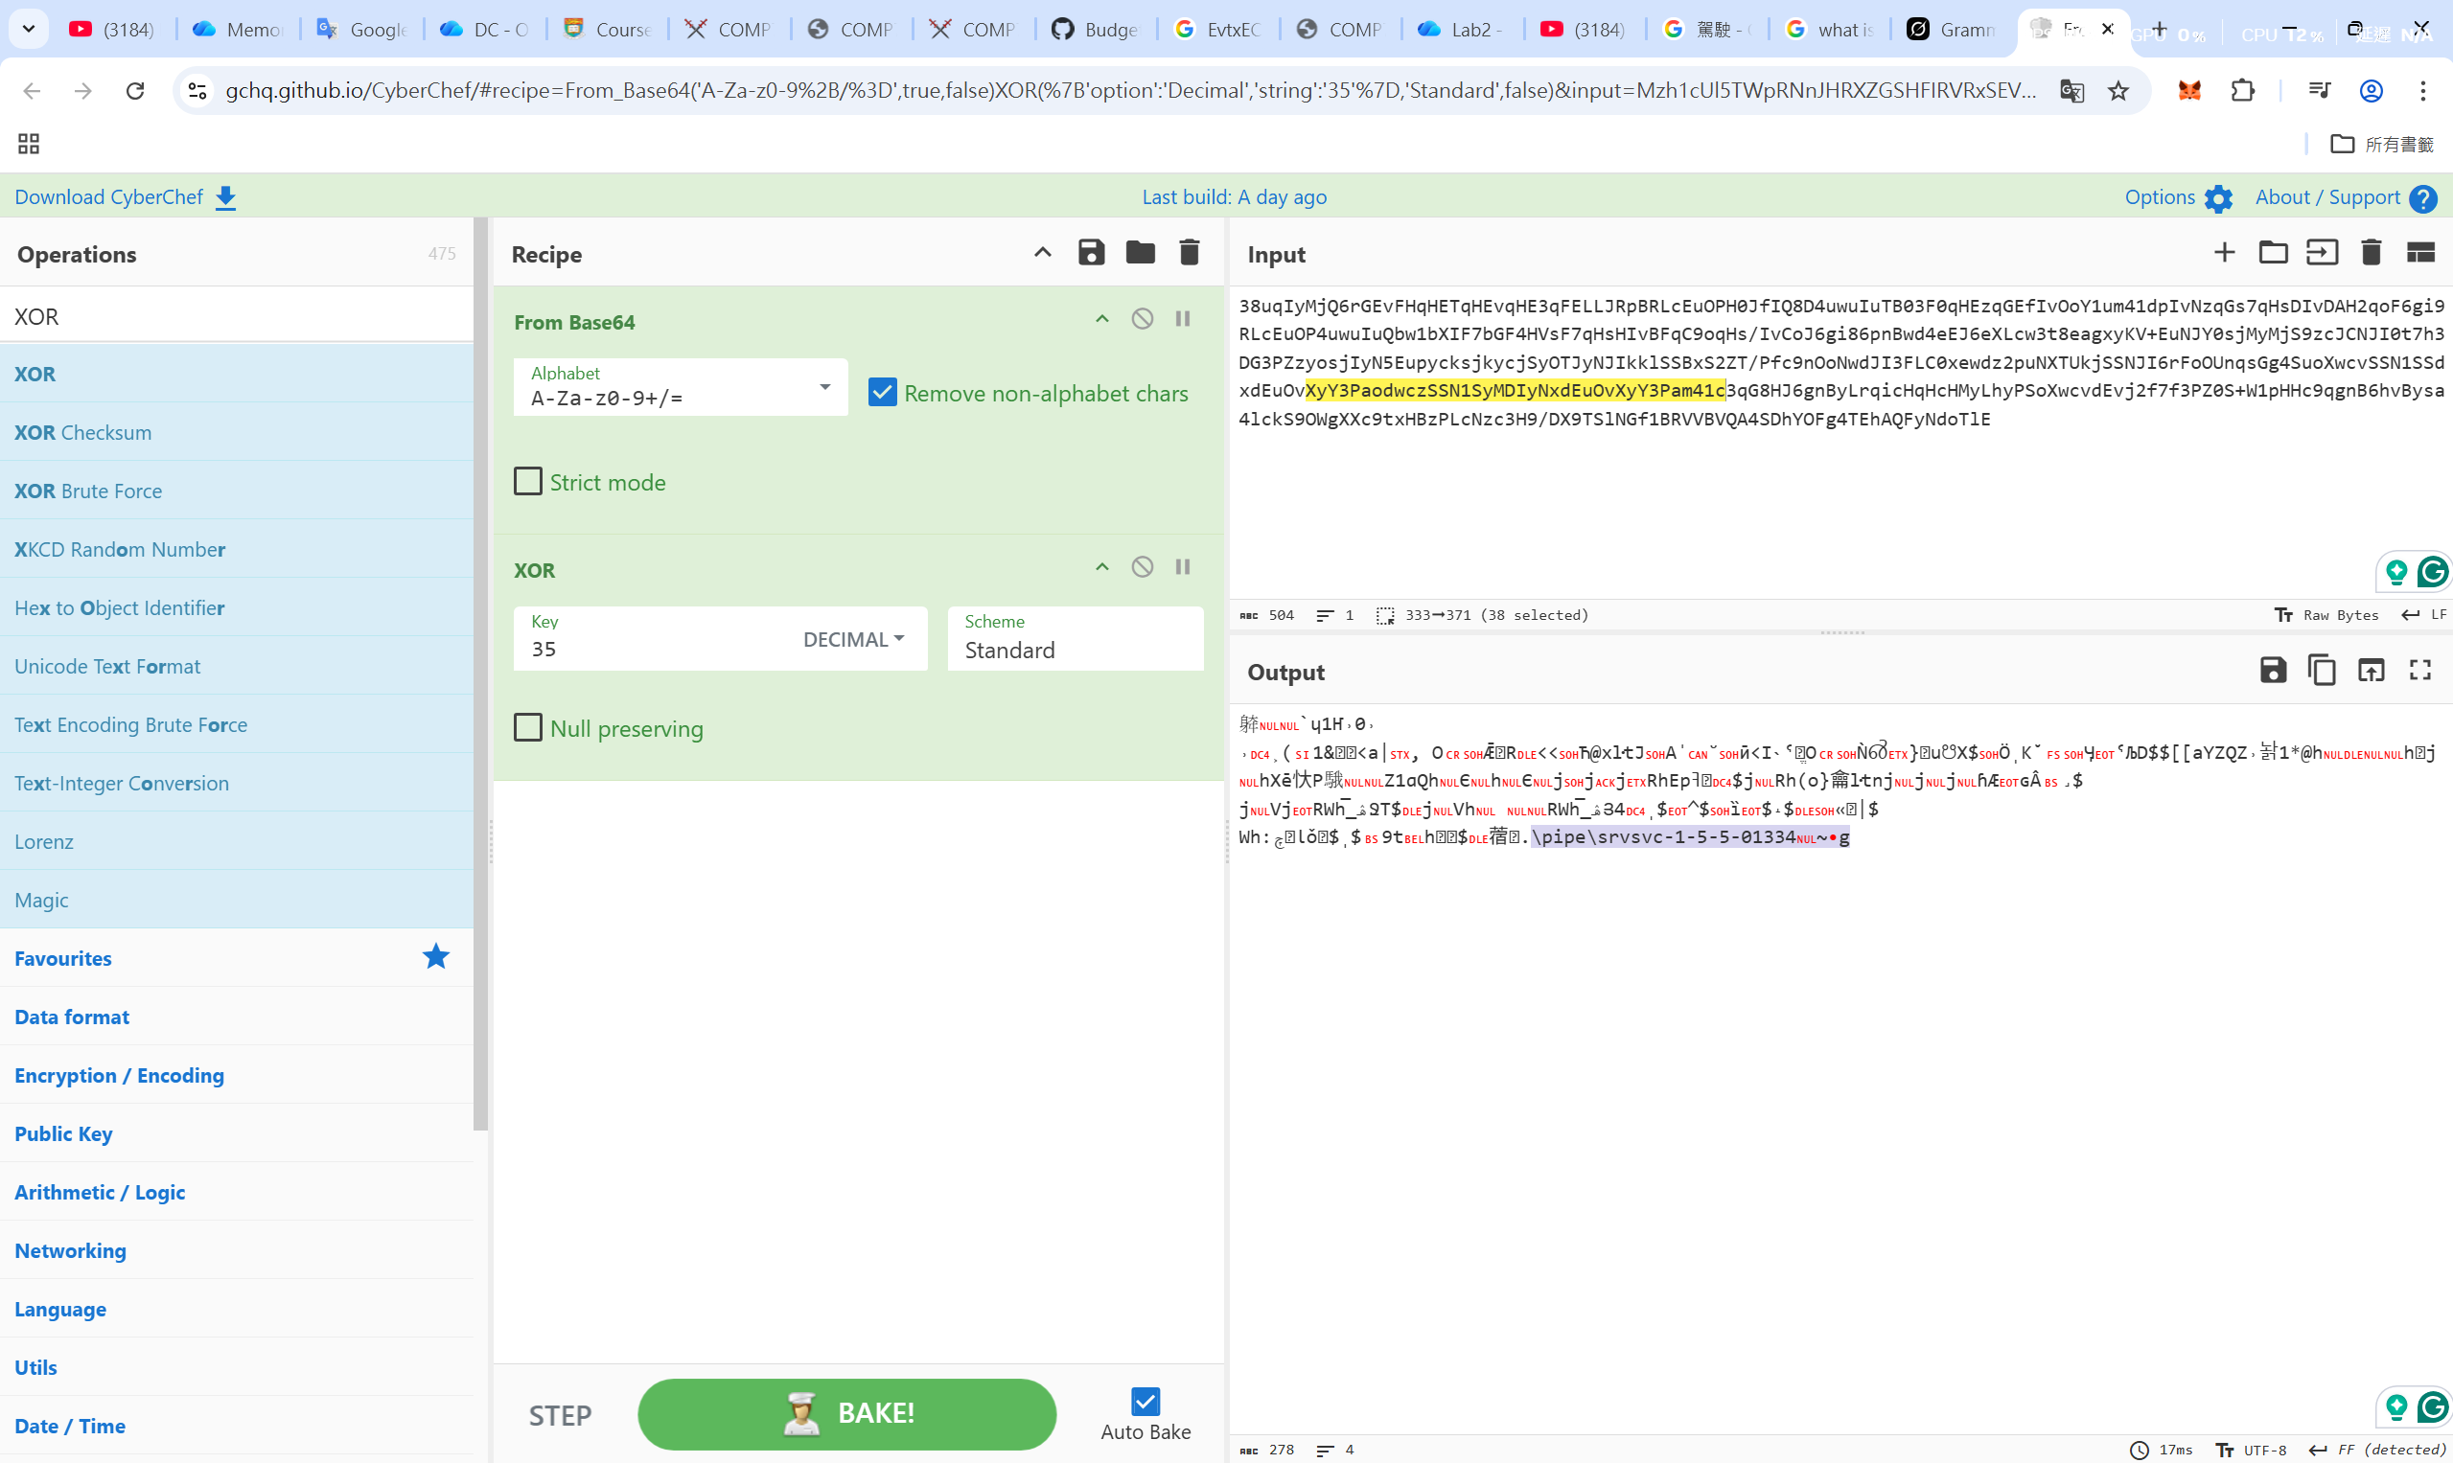
WEF
1) On the WEF device, what is the remote IP address associated with the multiple failed login attempts for the account dulci.bernice on March 8, 2022?

Answer: 192.168.56.104
First, based on the question, I used the WHERE clause on the “TimeCreated” column with the timestamp 2022-03-08 and “PayloadData1” column with “dulci.bernice” to search for related results.
Second, I applied for the Event ID “4625” filter. It is because the key point is “failed login" in the question. In Windows Security logs, EID 4625 relates to the failed logon attempts
In the end, all of the RemoteHost result is 192.168.56.104.
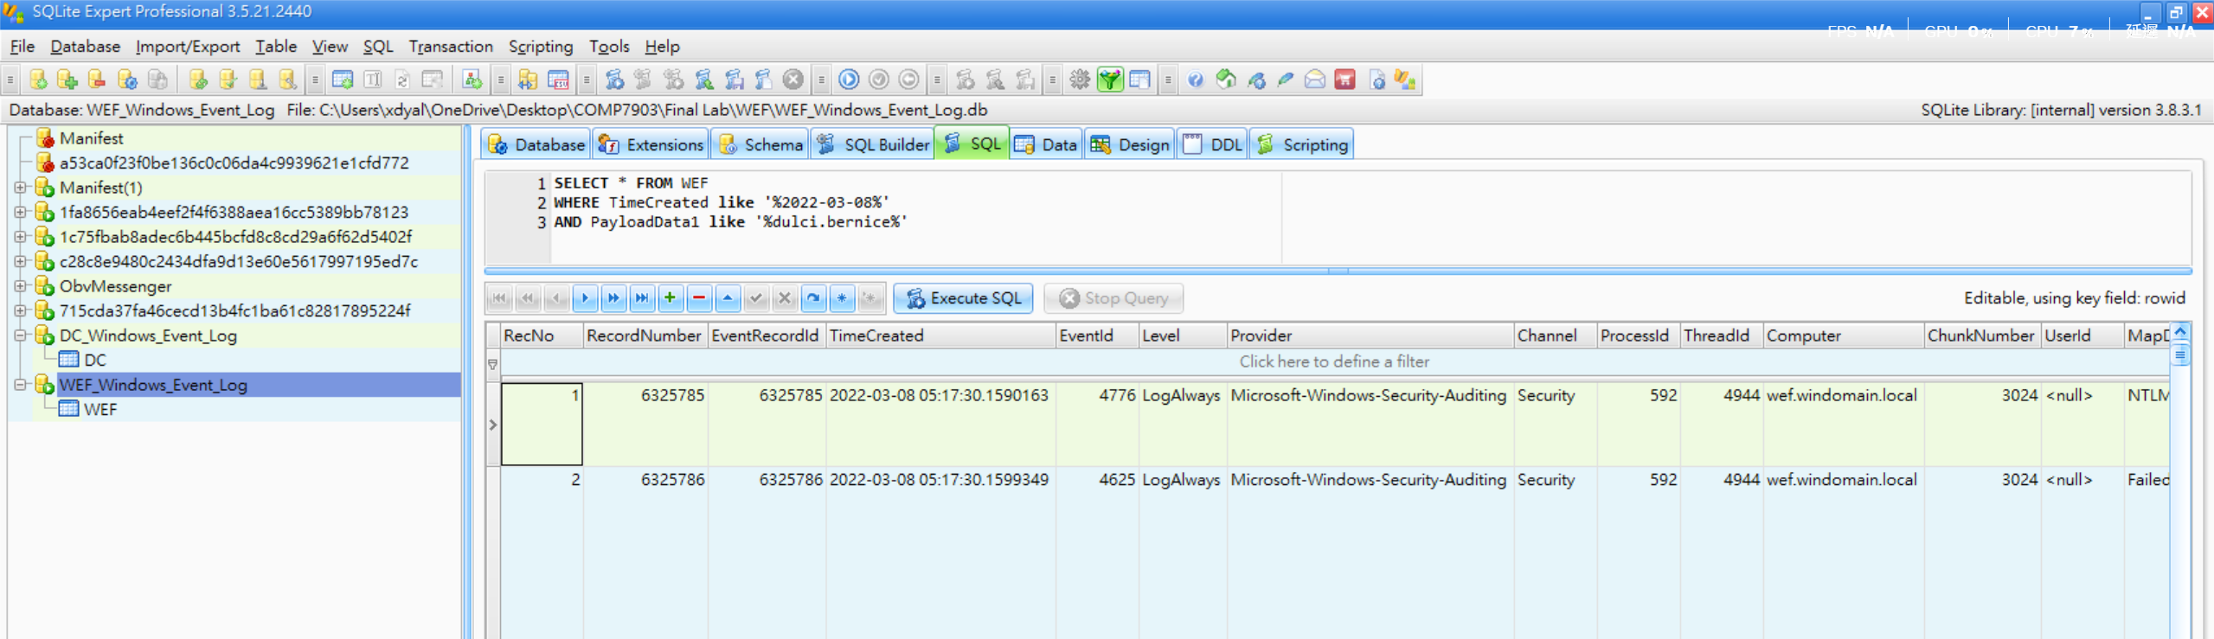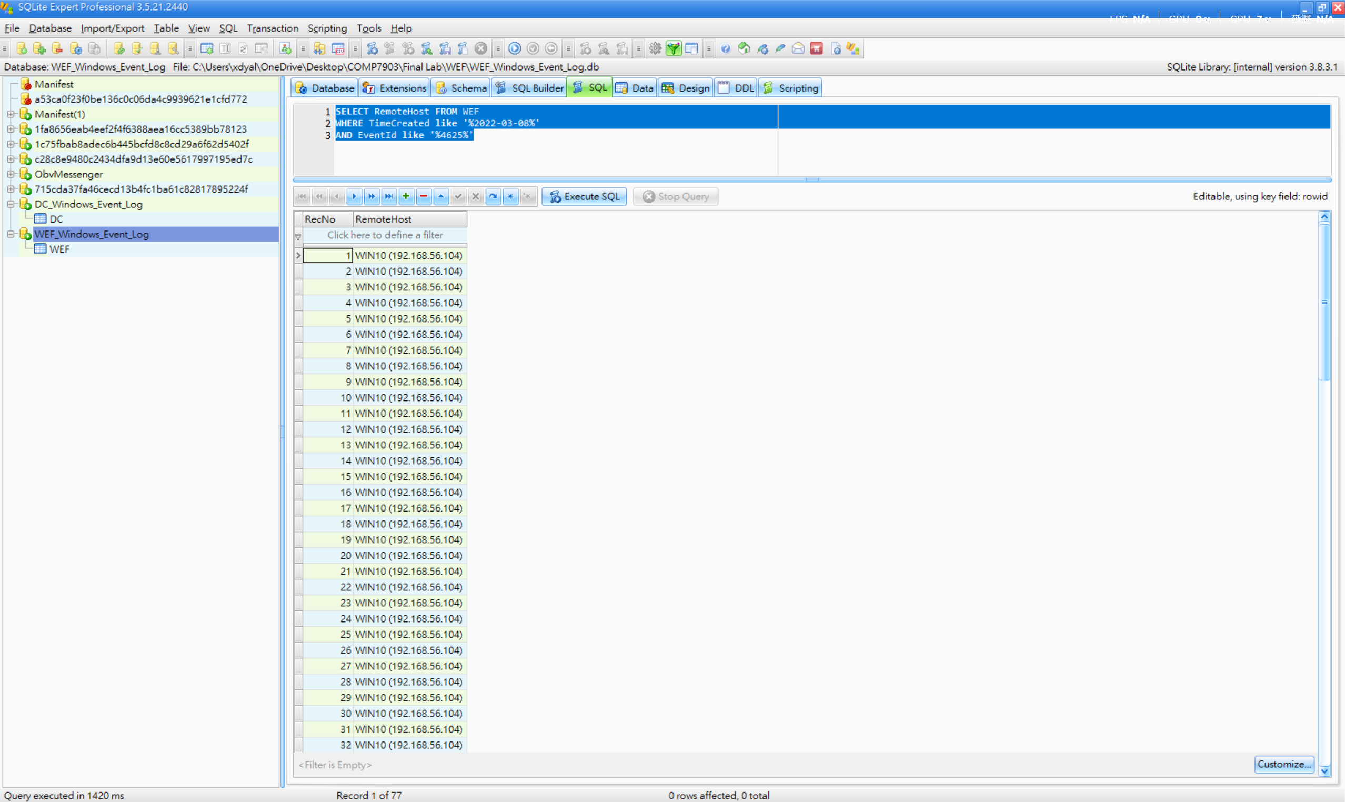
2) By analyzing the memory dump of the WEF device, identify the Cobalt Strike beacon that is actively communicating with the Command and Control (C2) IP address. What is the Process ID (PID) of this malicious process?

Answer: 5408
In this question, we analyze the memory dump “WEF\Memory\data.lime” using Volatility 3. I ran both the windows.netscan and windows.psscan plugins to search for related evidence:
- vol.exe -f "WEF\Memory\data.lime" windows.netscan
- vol.exe -f "WEF\Memory\data.lime" windows.psscan
According to the scanning results, there are two suspicious processes:
PID | PPID | ImageFileName | CreateTime
5408 | 7292 | rundll32.exe | 2022-03-08 05:21:57
5008 | 892 | rundll32.exe | 2022-02-28 03:03:43

The key point is the rundll32.exe process, as rundll32.exe is Cobalt Strike’s default process injection target. The following red flags of 5408 PID are observed:
- Creation time: 2022-03-08 05:21:57 — occurred right within the attack window.
- PPID 7292: This parent process is not present in the psscan results. The parent has already exited and cleaned up, which is typical of Cobalt Strike’s spawn-and-inject technique.
- Session 0: The process is running as a service, not as an interactive user session.

As a result, 5408 is the Process ID (PID) answer.
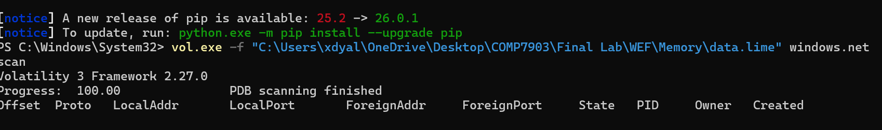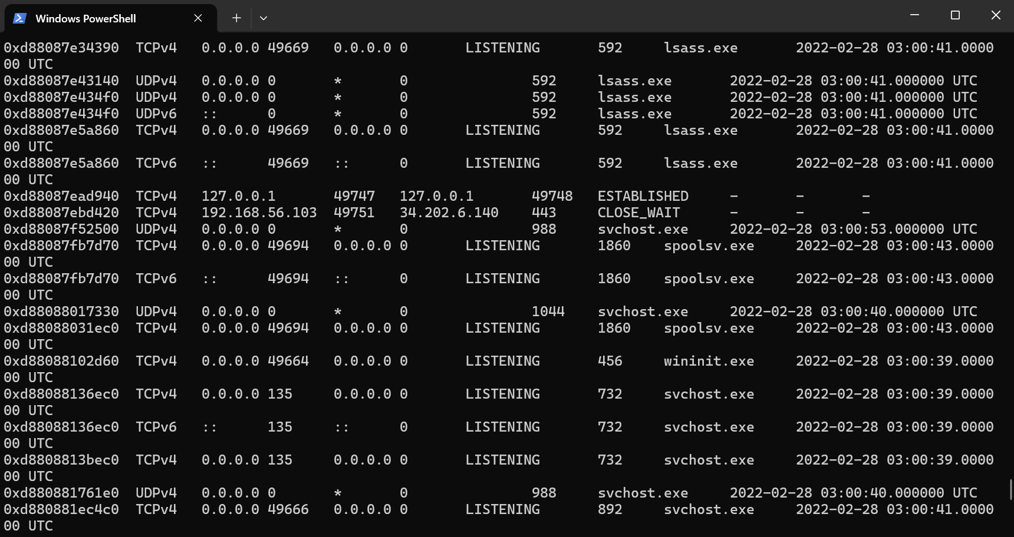
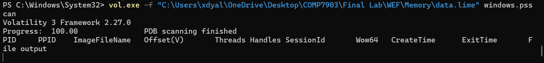
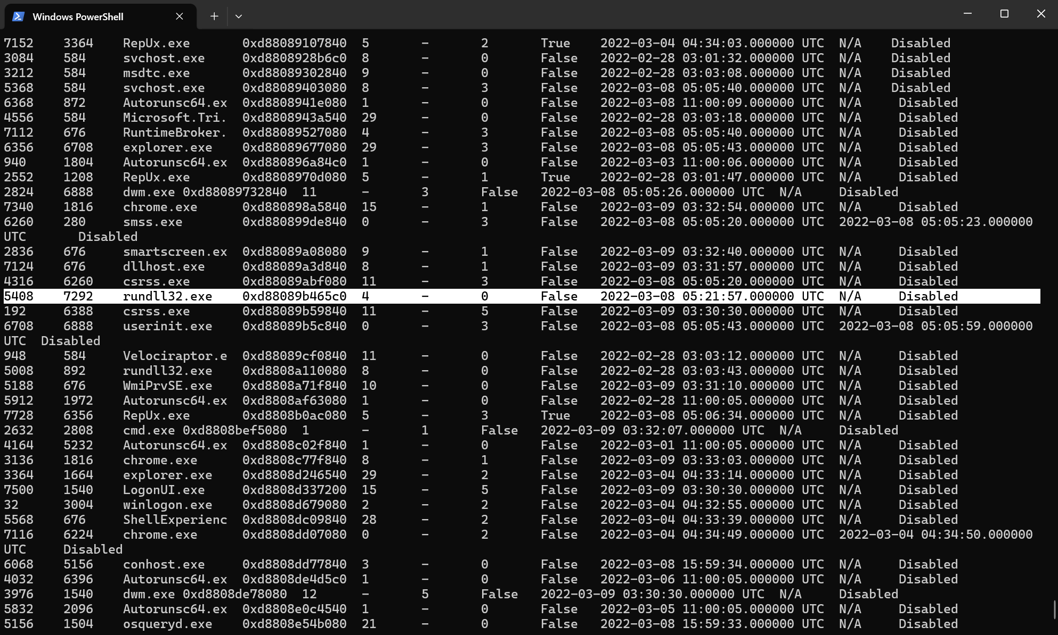

3) Using the 1768.py tool, analyze the WEF memory dump to extract the configuration of the identified Cobalt Strike beacon. Based on the tool's output, what is the specific Cobalt Strike payload type?

Answer: windows-beacon_http-reverse_http
According to the question requirements, I downloaded the 1768.py script to my local computer.
I then used this script to analyze the memory dump file “WEF\Memory\data.lime”.
As a result, the answer is windows-beacon_http-reverse_http.
This is a Windows HTTP beacon that calls back to the Command and Control (C2) server over HTTP (port 80). This matches the C2 connections to 3.93.196.132:80 that we previously identified in the netscan and domain controller analysis.
Additionally, the SpawnTo parameter confirms the use of rundll32.exe, which matches the suspicious PID 5408 found in the previous question. The C2 URI path /load also aligns with the beacon’s typically GET callback pattern.

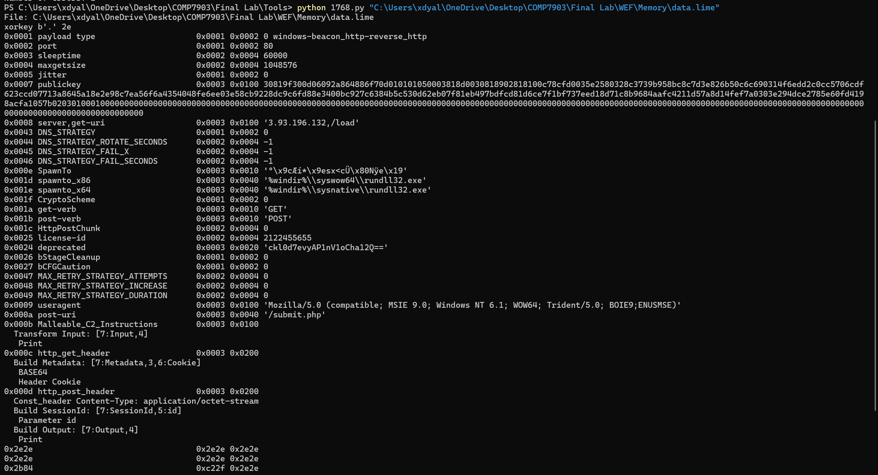

4) On the WEF device at 2022-03-08 05:25:01, the Cobalt Strike beacon (C:\windows\system32\rundll32.exe) attempted to read the memory of lsass.exe, likely to extract cached credentials. Shortly after, at 05:25:38, a successful Logon event (Event ID 4624, Logon Type 9) occurred using NT AUTHORITY\SYSTEM credentials, indicating a probable Pass-the-Hash attack.
By examining this specific Event ID 4624 log, what is the LogonProcessName associated with this event?

Answer: seclogo

How to Use the Hint: Event Log Explorer + EID 4624 Filter
The hint gives you a GUI-based approach using Event Log Explorer on the raw .evtx file.

Step 1: Open the Raw EVTX File
Open Event Log Explorer (or Windows Event Viewer) and load:

Step 2: Filter by Event ID 4624
In Event Log Explorer:
- Click Filter (or press Ctrl+F)
- Set Event ID = 4624
- Apply the filter
This narrows thousands of Security events down to only successful logon events.

Step 3: Navigate to the Record at 2022-03-08 05:25:38 (UTC)
Scroll or search to find the event at 2022-03-08 05:25:38 UTC.
You'll see one event matching all criteria:
Field | Value
Time | 2022-03-08 05:25:38.8868385
Event ID | 4624
Target User | NT AUTHORITY\SYSTEM
LogonType | 9 (NewCredentials)
LogonProcessName | seclogo
AuthenticationPackageName | Negotiate
TargetOutboundUserName | jonell.kirk
TargetOutboundDomainName | WINDOMAIN

Step 4: Read the Answer from the Detail Tab
In Event Log Explorer's detail pane, the XML will show:

Comparison: Hint Approach vs Our Approach
Aspect | Hint (Event Log Explorer) | Our Approach (CSV)
Tool | GUI - Event Log Explorer | PowerShell/Python + pre-parsed CSV
Source file | Security.evtx (raw) | WEF_Windows_Event_Log.csv (parsed)
Filter | GUI filter: EID 4624 | Where-Object { $_.EventId -eq '4624' -and $_.TimeCreated -like '*05:25:3*' }
Find record | Scroll to 05:25:38 | Timestamp string match
Read answer | XML detail pane → LogonProcessName | PayloadData5 column or JSON Payload field
Result | seclogo | seclogo
Both approaches reach the same answer. The CSV approach is faster for scripted analysis; the Event Log Explorer approach gives you the full XML view which is useful when you don't know which fields to look for.

