Bangladesh University of Business and Technology
BUBT
Committed to Academic Excellence
PROJECT REPORT
Simon's Sequence: A Memory Tile Game Built with 2D Computer Graphics Algorithms and Digital Image Processing Techniques
Course: CSE 452 — Graphics and Image Processing

Name | ID | Intake
Md. Redwan Molla | 20235203038 | 44-02
Supriya Bosu | 20235203072 | 44-02

Submitted To:
Shaila Shaznin
Lecturer, Department of CSE (BUBT)

Submission Date: 17th August 2026

Abstract
Simon's Sequence is a desktop memory tile game, implemented in Python with Pygame, that was built specifically to demonstrate the 2D computer graphics and digital image processing techniques covered in the CSE 452 course syllabus. Rather than relying on Pygame's built-in drawing primitives, every visual element in the game — tile borders, glow highlights, HUD panels, gradients, and victory patterns — is rendered by hand-written implementations of the DDA line algorithm, Bresenham's line and circle algorithms, the midpoint circle algorithm, a scanline polygon fill routine, and a stack-based flood fill. Tile animation (flashing, pulsing, and press feedback) is driven by composing 2D affine transformations expressed as 3×3 homogeneous matrices using NumPy, and both line clipping (Cohen–Sutherland) and polygon clipping (Sutherland–Hodgman) are used to keep decorative and glow effects confined to the play field and to individual tile boundaries. On top of the graphics engine, the project layers a digital image processing subsystem: hand-written correlation and convolution routines support five spatial filters — mean/blur, median, sharpen, Sobel edge detection, and emboss — which are applied both live during gameplay (each tile color triggers a specific filter on a correct hit) and to a post-game screenshot, which can be compared against its filtered versions side by side using Matplotlib. The final deliverable is a fully playable game with several bonus features, including a live algorithm visualizer, a frame-by-frame replay system, procedurally generated audio, and persistent high-score tracking, that makes the connection between course theory and working code explicit throughout the codebase.

Table of Contents
1. Introduction 4
1.1 Background 4
1.2 Problem Statement 4
1.3 Objectives 4
1.4 Scope 5
2. Background and Related Concepts 6
3. System Design and Methodology 7
3.1 Technology Stack 7
3.2 Module Overview 7
3.3 Core Gameplay Loop 8
3.4 Rasterization Algorithms 8
3.5 2D Geometric Transformations 9
3.6 Clipping 10
3.7 Digital Image Processing Pipeline 10
3.8 Extended Concept: Image-Processing Effect Tiles 11
4. Implementation 12
5. Bonus and Extra Features 14
6. Results and Discussion 16
7. Conclusion 18
8. Future Work 18
References 19

1. Introduction

1.1 Background
Computer graphics and digital image processing are, by nature, mathematical subjects — line and circle rasterization, coordinate transformations, clipping, and spatial filtering are usually taught through static diagrams, pseudocode, and small isolated exercises. This project set out to consolidate those individual topics into a single interactive application, so that each algorithm from the CSE 452 syllabus has a visible, playable role rather than being demonstrated in isolation.
The chosen vehicle is a classic “Simon”-style memory game: the game flashes a growing sequence of colored tiles and the player must reproduce it by clicking the tiles in the same order. The gameplay itself is simple by design, which leaves the visual and algorithmic layer — how the tiles are drawn, animated, clipped, and filtered — as the true subject of the project.

1.2 Problem Statement
Most student implementations of graphics algorithms stop at drawing a single line or circle on a blank canvas. This project instead asks: can an entire, visually polished, real-time application be built where every pixel on screen is traceable back to a specific algorithm taught in the course, with no reliance on the graphics library's own drawing functions (e.g., pygame.draw.*)? A secondary problem is to connect the image-processing half of the syllabus (correlation, convolution, spatial filters) to the same interactive experience, rather than treating it as a separate, offline exercise.

1.3 Objectives
- Implement fundamental 2D line and circle drawing algorithms (DDA, Bresenham's line, Bresenham's circle, midpoint circle) from first principles, without using built-in graphics drawing functions.
- Apply 2D geometric transformations (translation, rotation, scaling) — expressed as homogeneous matrices and composed with NumPy — to animate game objects such as the memory tiles and their highlight/flash effects.
- Implement line clipping (Cohen–Sutherland) and polygon clipping (Sutherland–Hodgman) to constrain drawing and highlight effects within the boundaries of each tile and the overall play field.
- Implement correlation, convolution, and spatial filters (mean, median, sharpen, edge detection, emboss) and apply them live during gameplay as well as to in-game screenshots.
- Design and develop a complete, playable, and visually polished memory game that clearly demonstrates the practical use of every major topic covered in the course.

1.4 Scope
The scope of the project covers the full rendering pipeline of a 2D tile-based memory game — board rendering, tile animation, HUD, menus, and post-round analysis — built entirely on hand-written rasterization and filtering code. It excludes 3D rendering as a core requirement, though an optional OpenGL-based rendering mode was additionally implemented (via the moderngl library) as an exploratory extension beyond the original proposal, and is described in Section 4.4.

2. Background and Related Concepts
The “Simon” memory game format — originating from the 1978 electronic game of the same name — is a well-established pattern in introductory game-development exercises because its core logic (sequence generation, playback, and input matching) is simple enough to implement quickly, leaving room to focus effort elsewhere. In this project, that “elsewhere” is the rendering and image-processing layer.
The graphics algorithms used are all standard topics in 2D computer graphics: the Digital Differential Analyzer (DDA) and Bresenham's line algorithm are the two classical incremental approaches to rasterizing a straight line, differing mainly in that Bresenham's method uses only integer arithmetic. Bresenham's circle algorithm and the midpoint circle algorithm are their circular counterparts, both exploiting eight-way symmetry to minimize the number of points that must be explicitly computed. Scanline polygon filling is the standard technique for filling arbitrary polygons row by row using edge intersections, and flood fill is a seed-based region-filling technique commonly implemented with a stack or queue to avoid recursion limits. On the transformation side, 2D affine transformations (translation, scaling, rotation) are conventionally expressed using 3×3 homogeneous coordinate matrices so that translation can be combined with linear transformations through simple matrix multiplication. Cohen–Sutherland and Sutherland–Hodgman are the two classical clipping algorithms for lines and polygons respectively, both taught alongside these rasterization topics.
On the image-processing side, correlation and convolution are the two foundational sliding-window operations underlying all spatial filtering; convolution differs from correlation only in that the kernel is rotated 180 degrees before the sliding-window multiply-and-sum. Mean/blur, median, sharpening, Sobel edge detection, and embossing are common spatial filters typically introduced as applications of this correlation/convolution machinery, and are the five filters implemented in this project.

3. System Design and Methodology

3.1 Technology Stack
Tool / Library | Purpose
Python 3 | Core programming language for the entire project
Pygame | Window creation, the main event loop, input handling, tile rendering surface, and sound playback — used strictly for the window and surface; no pygame.draw.* function is used anywhere
NumPy | Matrix-based implementation of translation, rotation and scaling; pixel-array operations for the spatial filters
Matplotlib | Displaying the original screenshot against its filtered (blur, sharpen, edge-detection, emboss) versions side by side
moderngl (bonus) | Optional hardware-accelerated OpenGL rendering path (opengl_demo.py, renderer/) explored as an extension beyond the original proposal
Custom modules | Hand-written implementations of DDA, Bresenham line/circle, midpoint circle, scanline/flood fill, clipping, correlation and convolution — no built-in drawing or filter functions are used

3.2 Module Overview
The codebase is organized into focused modules, each responsible for one layer of the system, mirroring the structure of the course syllabus:
File | Responsibility
main.py | Entry point; launches the game
game.py | Game states, board logic, scoring, HUD, menus, pause screen, high-score persistence, cached backgrounds/panels, victory pattern, and replay wiring (≈ 1000 lines — the central controller)
game_objects.py | Tile class: drawing, animation, clipping, and glow behaviour for a single tile
graphics_algorithms.py | DDA line, Bresenham line/circle, midpoint circle, scanline polygon fill, gradient fill, flood fill, and rounded-rectangle point generation
transformations.py | 2D homogeneous transformation matrices (translation, scaling, rotation) and their composition
clipping.py | Cohen–Sutherland line clipping and Sutherland–Hodgman polygon clipping
image_filters.py | Correlation, convolution, and the five spatial filters
audio.py | Procedurally generated tones for tile flashes and correct/incorrect feedback
visualizer.py | Live Algorithm Visualizer bonus mode
replay.py | Replay recorder and player (bonus feature)
renderer/, opengl_demo.py | Optional moderngl-based hardware-accelerated rendering path (bonus extension)

3.3 Core Gameplay Loop
The game presents the player with a grid of colored tiles (4 or 6, depending on the selected board size). Each round proceeds as follows:
- Draw the game board (tile grid, borders, score panel).
- Generate a new random tile and append it to the current sequence.
- Animate the sequence playback by scaling/highlighting each tile in order, with polygon clipping constraining the glow effect to each tile's own boundary.
- Track player clicks and compare them against the expected sequence.
- On a correct click, apply a scale/rotation “press” animation to the tile, trigger that tile's live image filter, and update the score.
- On an incorrect click, end the round, display the Game Over screen, and prepare the post-round screenshot for filter comparison.
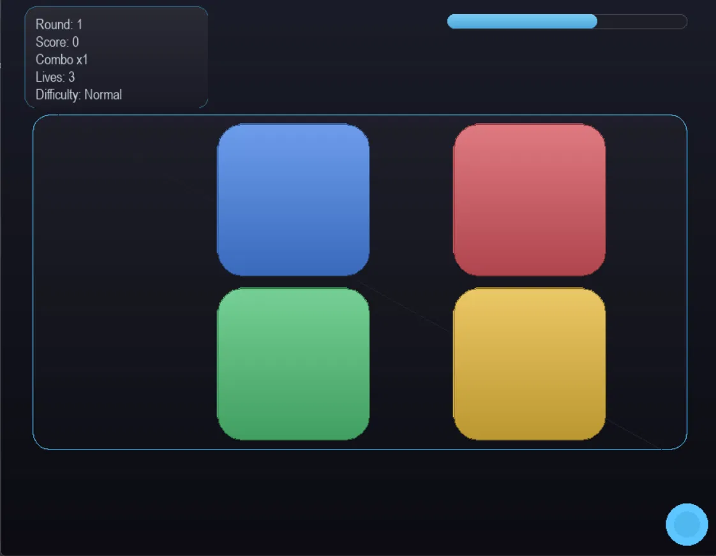
Figure 3.1: In-game view of the 4-tile board, showing the rounded gradient-filled tiles, the HUD panel (round, score, combo, lives), the countdown timer bar, and the Cohen–Sutherland-clipped decorative diagonal.

3.4 Rasterization Algorithms
All rasterization in graphics_algorithms.py plots pixels one at a time with surface.set_at(), so that every line, circle, and fill on screen is traceable to one of the following hand-written routines:

DDA Line Algorithm
dda_line() steps from the start point to the end point in equal increments along whichever axis has the larger displacement, rounding each intermediate coordinate to the nearest pixel. It is used to render the decorative field diagonal and the visualizer grid.

Bresenham's Line Algorithm
bresenham_line() uses the classical integer-only decision-variable formulation (error term adjusted by 2·dy and 2·dx per step) to avoid floating-point division entirely. It is used for tile borders and every polygon outline drawn in the game, via draw_polygon_outline().

Bresenham's and Midpoint Circle Algorithms
Both bresenham_circle() and midpoint_circle() generate one octant of the circle using their respective integer decision parameters and mirror it into the remaining seven using 8-way symmetry (_circle_points()). The midpoint circle routine specifically renders the HUD accent dot and the procedurally generated victory patterns.

Scanline Polygon Fill and Gradient Fill
fill_polygon() implements the standard scanline algorithm: for each row that crosses the polygon, it computes the x-intersections of that row with every edge, sorts them, and fills each intersection pair as one contiguous span. fill_polygon_gradient() reuses the identical intersection math but linearly interpolates the fill colour between a top and bottom colour per row, producing the glossy tile and panel gradients used throughout the interface. For performance, each row's span is written with a single pygame.PixelArray slice assignment rather than one Python call per pixel — the scanline mathematics itself is unchanged.

Flood Fill
flood_fill() is an iterative, stack-based 4-connected flood fill (avoiding recursion-depth issues) that fills a connected region matching a seed colour, optionally stopping at a specified boundary colour. It is used to colour the interior of the procedurally generated victory shapes.

Rounded-Rectangle Point Generation
rounded_rect_points() builds the corner points of a rounded rectangle as four small corner arcs, sampled with cosine/sine in the same way the circle-point generation works, and joins them into a single convex polygon that is then rendered with the same fill_polygon()/draw_polygon_outline() routines used everywhere else.

3.5 2D Geometric Transformations
transformations.py expresses translation, scaling, and rotation as 3×3 homogeneous matrices built and multiplied with NumPy:
def translation_matrix(tx, ty):
return np.array([[1, 0, tx], [0, 1, ty], [0, 0, 1]], dtype=float)
def scaling_matrix(sx, sy):
return np.array([[sx, 0, 0], [0, sy, 0], [0, 0, 1]], dtype=float)
def rotation_matrix(theta_degrees):
t = math.radians(theta_degrees)
c, s = math.cos(t), math.sin(t)
return np.array([[c, -s, 0], [s, c, 0], [0, 0, 1]], dtype=float)
These are composed with combine(), which right-multiplies a sequence of matrices, and applied to a list of points with apply_transform(), which converts each (x, y) point to homogeneous coordinates, multiplies by the combined matrix, and normalizes by the homogeneous coordinate. transform_about_center() uses this machinery to scale and rotate a shape about its own centre by composing translate-to-origin → rotate → scale → translate-back — exactly the sequence used for the tile “press” feedback animation and the flashing/pulsing highlight effect, so that tiles are genuinely transformed via matrix composition rather than simply redrawn at new coordinates.

3.6 Clipping
clipping.py implements both classical clipping algorithms taught in the course:
- Cohen–Sutherland line clipping (cohen_sutherland_clip()) assigns each line endpoint a 4-bit outcode describing its position relative to a rectangular clip window, then iteratively clips the segment against whichever boundary an out-of-range endpoint has crossed. It is used to clip the decorative field diagonal to the play area.
- Sutherland–Hodgman polygon clipping (sutherland_hodgman_clip()) clips a subject polygon against each edge of a convex clip polygon in turn, keeping only the portion of the subject that lies on the inside of every edge. It is used to constrain each tile's glow highlight to that tile's own rectangular boundary, so a bright flash never bleeds past the edge of the tile it belongs to.

3.7 Digital Image Processing Pipeline
image_filters.py implements the correlation/convolution machinery and five spatial filters directly on NumPy pixel arrays, with no calls to cv2 or scipy.signal:
def correlate2d(channel, kernel):
kh, kw = kernel.shape
pad_h, pad_w = kh // 2, kw // 2
padded = _pad(channel.astype(float), pad_h, pad_w)
windows = np.lib.stride_tricks.sliding_window_view(padded, (kh, kw))
out = np.sum(windows * kernel, axis=(2, 3))
return out
def convolve2d(channel, kernel):
flipped = kernel[::-1, ::-1]
return correlate2d(channel, flipped)
correlate2d() implements the textbook sliding-window multiply-and-sum formula by hand; np.lib.stride_tricks.sliding_window_view() is used only to gather the windows efficiently so the per-pixel arithmetic runs fast enough for live, per-frame use — the correlation computation itself remains explicit. convolve2d() is then simply correlation with a 180-degree-rotated kernel, matching the formal distinction between the two operations. Built on top of these two primitives are the five filters used in the game:
Filter | Mechanism
Mean / blur | Convolution with a uniform k×k averaging kernel
Median | Sliding-window median (order-statistic filter, not a kernel convolution)
Sharpen | Convolution with a 3×3 sharpening kernel that emphasizes the centre pixel
Sobel edge detection | Grayscale conversion, then convolution with the Gx and Gy Sobel kernels; gradient magnitude √(Gx²+Gy²) is taken as the edge response
Emboss | Convolution with an asymmetric emboss kernel that produces a raised, 3D-like relief effect

3.8 Extended Concept: Image-Processing Effect Tiles
To connect the image-processing half of the syllabus to live gameplay rather than confining it to a single post-game step, each tile colour is linked to a specific spatial filter that is applied to the screen the moment that tile is correctly clicked as part of the sequence:
- Blue tile — applies the mean/blur filter to the screen on a correct hit.
- Red tile — applies the sharpening filter on a correct hit.
- Green tile — applies the Sobel edge-detection filter on a correct hit.
- Yellow tile — applies the emboss filter on a correct hit.
This turns every correct click into a live demonstration of the correlate2d()/convolve2d() functions rather than an offline exercise, and is handled in game.py by _apply_live_filter().

4. Implementation

4.1 Rendering Pipeline
Game.py is the central controller: it owns the Pygame window, the main loop (run()), event handling (_handle_event(), _handle_menu_click(), _handle_tile_click()), and all drawing (_draw(), _draw_board(), _draw_hud(), _draw_menu(), _draw_victory_pattern(), _draw_replay_overlay(), _draw_pause_overlay(), _draw_game_over_overlay()). Static elements such as the background gradient and glass panels are pre-rendered once and cached (_build_background(), _build_static_panels(), _build_glass_panel()) rather than redrawn every frame, which keeps the hand-written scanline fill routines fast enough for real-time play even though every pixel is still produced by the algorithms described in Section 3.
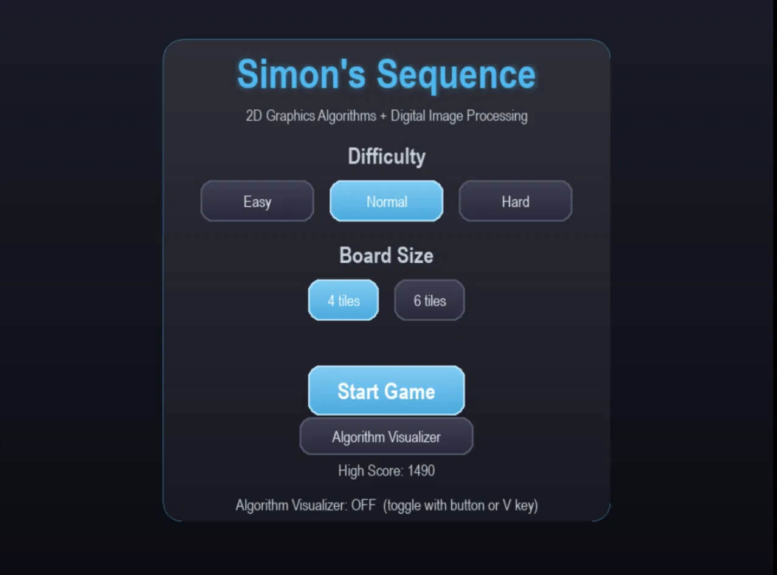
Figure 4.1: The main menu, built entirely from the hand-written rounded_rect_points()/fill_polygon_gradient() glass-panel routines, with difficulty, board-size, and high-score controls.

4.2 Tile Object
game_objects.py defines the Tile class, which owns each tile's position, colour, and current animation state, and is responsible for drawing itself (using fill_polygon_gradient() and draw_polygon_outline()), animating its scale/rotation via transform_about_center(), and clipping its own glow highlight with sutherland_hodgman_clip().

4.3 Post-Round Image Processing
When a round ends, _prepare_post_round_analysis() captures a screenshot of the final game screen. Pressing M on the Game Over screen calls show_post_round_matplotlib(), which runs the screenshot through the mean, median, sharpen, and Sobel edge-detection filters from image_filters.py and displays the original alongside each filtered version in a single Matplotlib figure for direct visual comparison.

4.4 Optional OpenGL Rendering Path (Bonus Extension)
Beyond the scope of the original proposal, the project additionally includes an optional hardware-accelerated rendering path (opengl_demo.py and the renderer/ package) built with moderngl, comprising a GL context wrapper, a simple camera, mesh handling, a picking system for tile selection, and GLSL vertex/fragment shaders (renderer/shaders/tile.vert, tile.frag). This path is exploratory and separate from the primary CPU-rasterized rendering pipeline that fulfils the course requirements; the default and primary rendering path remains the hand-written Pygame/NumPy pipeline described in Section 3.

5. Bonus and Extra Features

5.1 Live Algorithm Visualizer (V)
Implemented in visualizer.py and toggled with the V key, this is a floating panel that continuously animates the DDA, Bresenham's line, and midpoint circle algorithms one step at a time, printing each algorithm's decision variable (err for the line algorithms, p for the circle algorithm) at every step and cycling automatically between algorithms — turning the algorithms themselves into an on-screen teaching aid.
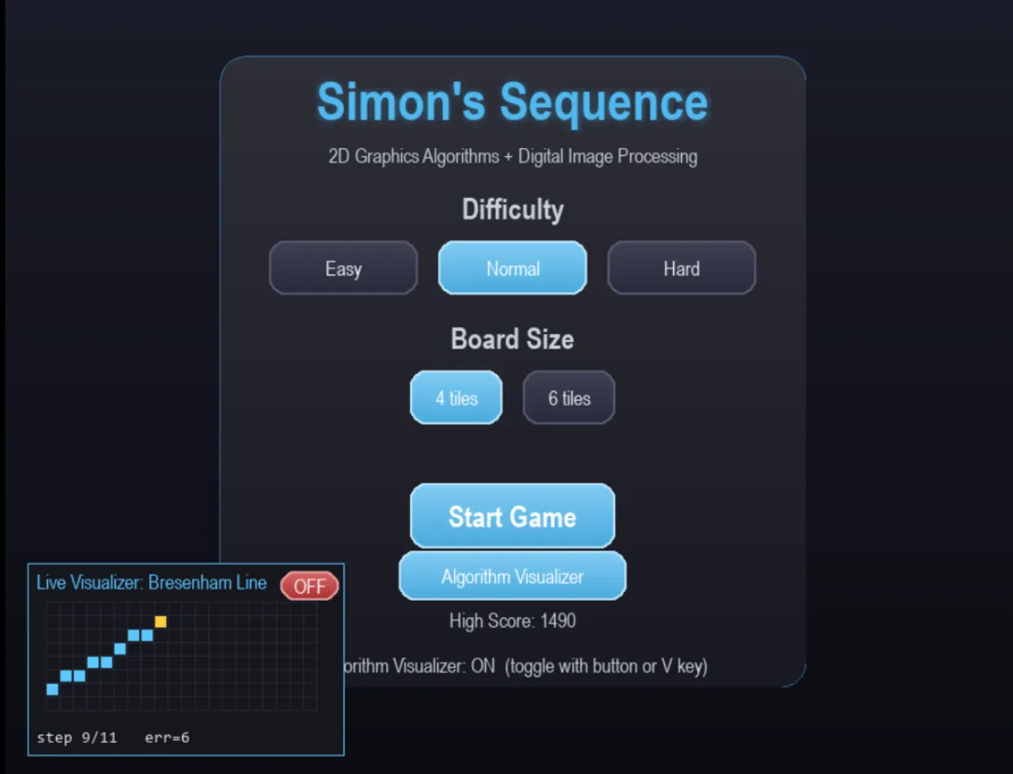
Figure 5.1: The Live Algorithm Visualizer panel mid-animation of Bresenham's line algorithm, showing the plotted pixel grid, the current step count, and the live decision variable err.

5.2 Flood Fill Victory Pattern
Every fifth successful round, _generate_victory_pattern() in game.py draws a random decorative shape (star, flower, or diamond) using the manual line and circle algorithms, then fills its interior using the hand-written stack-based flood_fill(), briefly displaying it in a glass panel.

5.3 Replay System with Frame-by-Frame Filter Playback
replay.py timestamps every flash, click, and round transition during play. When the game ends, pressing R on the Game Over screen replays the entire session automatically — including every tile's live filter effect — without further input from the player.
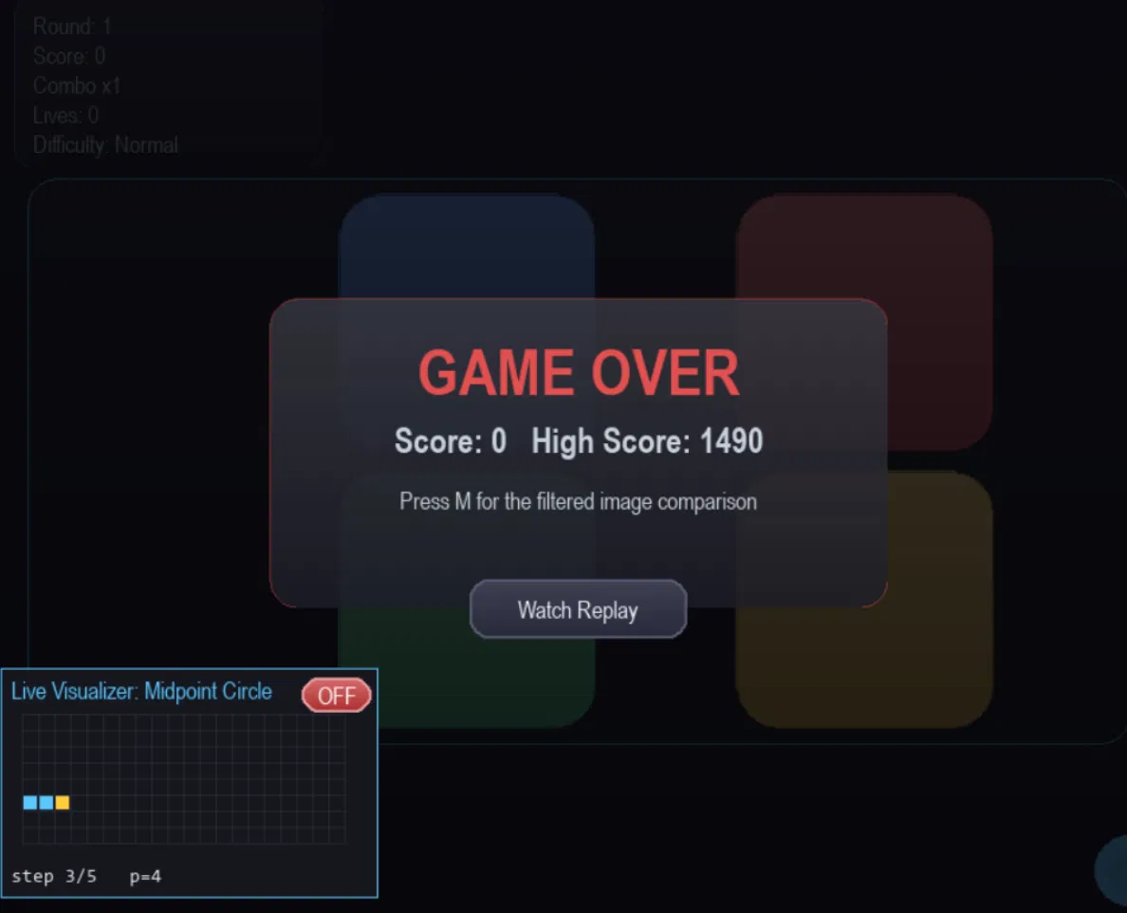
Figure 5.2: The Game Over overlay, offering the “Watch Replay” option, with the Live Algorithm Visualizer simultaneously cycling through the Midpoint Circle algorithm in the background.

5.4 Additional Gameplay Features
- Multiple difficulty levels (Easy / Normal / Hard) and a choice of 4-tile or 6-tile board size.
- Countdown timer bar and a lives system.
- Persistent high-score tracking, stored in highscore.json.
- Procedurally generated audio: a distinct tone per tile plus correct/incorrect feedback stingers (audio.py).
- Combo multiplier for consecutive correct sequences.
- Pause menu (P key).

5.5 Visual Style (“Glass and Glow” Redesign)
The interface uses a cached vertical-gradient background (built once rather than per frame), rounded gradient-filled tiles with a soft additive glow halo, and rounded, translucent “glass” panels for the HUD, pause menu, and overlays. Every one of these effects is still produced by the hand-written fill_polygon(), fill_polygon_gradient(), draw_polygon_outline(), and rounded_rect_points() functions — no pygame.draw.* call is used anywhere in the project; pygame.PixelArray is used only to write each computed horizontal scanline span in one slice rather than one Python call per pixel, purely for speed.

6. Results and Discussion

6.1 Mapping Course Topics to Implementation
The following table summarizes where each topic from the CSE 452 syllabus is demonstrated in the finished application, confirming that every objective set out in Section 1.3 was met:
Course Topic | Location | In-Game Role
DDA line algorithm | graphics_algorithms.py: dda_line | Field diagonal, visualizer grid
Bresenham line algorithm | graphics_algorithms.py: bresenham_line | Tile borders, all polygon outlines
Bresenham circle algorithm | graphics_algorithms.py: bresenham_circle | Available circle primitive
Midpoint circle algorithm | graphics_algorithms.py: midpoint_circle | HUD accent dot, victory pattern
Scanline polygon fill | graphics_algorithms.py: fill_polygon | Fills tiles, glow highlights, victory shapes
Gradient scanline fill | graphics_algorithms.py: fill_polygon_gradient | Glossy tile/panel gradients
Flood fill | graphics_algorithms.py: flood_fill | Victory pattern interior fill
2D transformations (homogeneous coords) | transformations.py | Tile press scale + rotation
Line clipping (Cohen–Sutherland) | clipping.py: cohen_sutherland_clip | Clips the decorative diagonal to the play field
Polygon clipping (Sutherland–Hodgman) | clipping.py: sutherland_hodgman_clip | Clips each tile's glow to its own boundary
Correlation | image_filters.py: correlate2d | Core sliding-window multiply-and-sum
Convolution | image_filters.py: convolve2d | Correlation with a 180°-rotated kernel
Mean, median, sharpen, Sobel, emboss filters | image_filters.py | Per-tile live filters and post-game comparison

6.2 Controls
Input | Action
Mouse click | Click tiles in the flashed order
P | Pause / resume
Esc | Quit
V | Toggle the Live Algorithm Visualizer
M (on Game Over) | Open the Matplotlib filter comparison
R (on Game Over) | Watch the automated replay

6.3 Discussion
Building the entire rendering pipeline from first principles, with no reliance on pygame.draw.*, confirms in practice what is usually only shown in theory — that the scanline fill and incremental line/circle algorithms are genuinely fast enough for real-time, per-frame use once obvious optimizations (caching static surfaces, writing whole scanline spans through a single PixelArray slice rather than one Python call per pixel) are applied. Linking each tile colour to a distinct spatial filter, rather than confining filtering to a single post-game step, also demonstrates that correlation and convolution are cheap enough with NumPy's sliding_window_view to run live without perceptibly affecting the game's responsiveness. Overall, the project shows that a complete pipeline — rasterization, transformation, clipping, and spatial filtering — taught across a semester as separate topics, can be unified into one coherent, interactive application in which every visual element is directly attributable to a specific, hand-implemented algorithm.

7. Conclusion
This project set out to build a complete, playable Memory Tile Sequence game in which every visual element and animation is produced by algorithms implemented directly from the CSE 452 syllabus, and every image-processing concept taught in the course is demonstrated through in-game or post-game visual effects. That goal was met: the DDA and Bresenham line algorithms, Bresenham's and the midpoint circle algorithms, scanline and flood fill, homogeneous-matrix transformations, Cohen–Sutherland and Sutherland–Hodgman clipping, and correlation/convolution-based spatial filtering are all implemented from first principles and are each traceable to a specific, documented role in the finished game. By implementing these drawing algorithms, transformations, clipping techniques, and spatial filters from scratch rather than relying on built-in library functions, the project reinforced theoretical understanding of each topic while producing a tangible, interactive, and demonstrable end product that goes beyond the original proposal with several additional bonus features — a live algorithm visualizer, a flood-fill victory pattern, a frame-by-frame replay system, and an exploratory OpenGL rendering path.

8. Future Work
As proposed, the most natural extension of this project is a progressive level system: introducing new challenges, additional visual elements (such as new tile shapes or board layouts requiring different clipping regions), and new gameplay mechanics at each stage, so that later levels could, for example, introduce additional spatial filters or more complex polygon clipping scenarios as the difficulty increases.

References
[1] Foley, J. D., van Dam, A., Feiner, S. K., & Hughes, J. F. (1995). Computer Graphics: Principles and Practice (2nd ed.). Addison-Wesley.
[2] Hearn, D., & Baker, M. P. (2010). Computer Graphics with OpenGL (3rd ed.). Prentice Hall.
[3] Gonzalez, R. C., & Woods, R. E. (2018). Digital Image Processing (4th ed.). Pearson.
[4] Bresenham, J. E. (1965). Algorithm for computer control of a digital plotter. IBM Systems Journal, 4(1), 25–30.
[5] Sutherland, I. E., & Hodgman, G. W. (1974). Reentrant polygon clipping. Communications of the ACM, 17(1), 32–42.
[6] Pygame documentation. https://www.pygame.org/docs/
[7] NumPy documentation. https://numpy.org/doc/
[8] Matplotlib documentation. https://matplotlib.org/stable/
[9] Project source code repository: Simon's Sequence (CSE 452 course project).

