**ДЗ №1 по SQL**

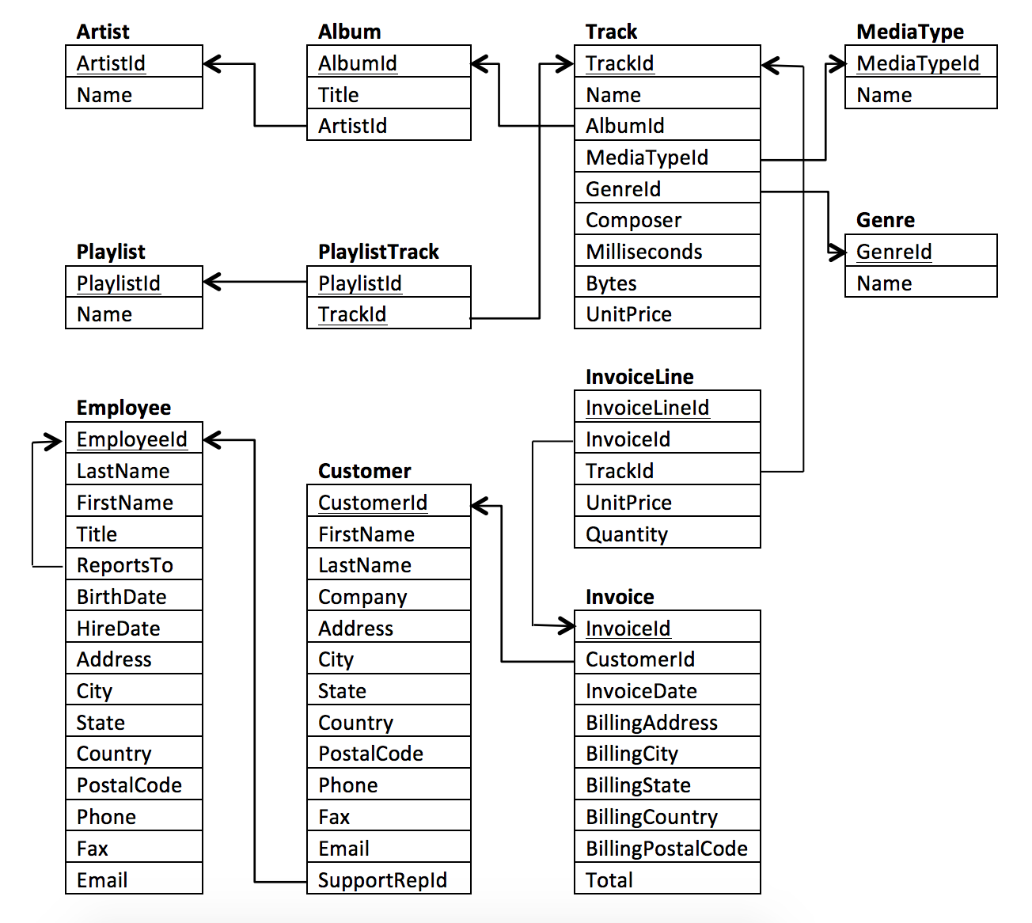

**Part 1**

1.Use the Invoice table to determine the countries that have the lowest invoices. Provide a table of BillingCountry and Invoices ordered by the number of invoices for each country. The country with the most invoices should appear last

2. We would not like to throw a promotional Music Festival in the city we made the least money. Write a query that returns the 5 city that has the lowest sum of invoice totals. Return both the city name and the sum of all invoice totals.

3. The customer who has spent the least money will be declared the worst customer. Build a query that returns the person who has spent the least money. I found the solution by linking the following three: Invoice, InvoiceLine, and Customer tables to retrieve this information, but you can probably do it with fewer!

4.The team at Chinook would like to identify all the customers who listen to Rock music. Write a query to return the email, first name, last name, and Genre of all Rock Music listeners. Return your list ordered alphabetically by email address starting with 'S'.

5.Write a query that determines the customer that has spent the most on music for each country. Write a query that returns the country along with the top customer and how much they spent. For countries where the top amount spent is shared, provide all customers who spent this amount.

**Part 2**

1. How many tracks appeared 5 times, 4 times, 3 times....?
2. Which album generated the most revenue?
3. Which countries have the highest sales revenue? What percent of total revenue does each country make up
4. How many customers did each employee support, what is the average revenue for each sale, and what is their total sale?
5. Do longer or shorter length albums tend to generate more revenue?
6. Is the number of times a track appear in any playlist a good indicator of sales?
   1. Note: Calculate the sum of revenue based on appearance
7. How much revenue is generated each year, and what is its percent change from the previous year?