**SRS - Train Tracking and Arrival Time Prediction App**

**1. Scope:**

- The scope of this project is to develop a mobile and web application that enables users to track trains in real-time and provides accurate arrival time predictions for selected train stations.

**2. General Description:**

a. Target Audience:

- Commuters and travelers who rely on train transportation.

- Train station personnel and management.

- Rail enthusiasts and hobbyists.

**b. Objectives:**

- Provide real-time tracking of trains on a map interface.

- Predict arrival times for selected train stations.

- Improve the overall experience and convenience of train travel.

- Enhance train station management and operations.

**c. Constraints:**

- Availability of real-time train data from relevant train operators.

- Data accuracy and reliability.

- Compliance with privacy and data protection regulations.

- Accessibility considerations for users with disabilities.

**3. Functional Requirements:**

- User Registration and Authentication:

- Users can create accounts and log in securely.

**- Train Tracking:**

- Users can search for and track specific trains by train number or name.

- The application displays the real-time location of the train on a map.

- Users can set up notifications for train updates.

**- Arrival Time Prediction:**

- Users can select a train station and view predicted arrival times for upcoming trains.

- Arrival time predictions are based on historical data and real-time information.

**- Favorites and Reminders:**

- Users can mark favorite trains and stations for quick access.

- Set reminders for train departures and arrivals.

**- Feedback and Reporting:**

- Users can provide feedback on train services and report issues.

- Administrators can review and respond to user feedback.

**- Admin Panel:**

- Administrators can manage train data, station information, and user accounts.

- Generate reports on train performance and delays.

**4. Non-Functional Requirements:**

**- Performance:**

- The application should load quickly and provide real-time updates.

- Response times should be within milliseconds.

**- Security:**

- User data, including personal information, should be securely stored and encrypted.

- Protection against data breaches and unauthorized access.

**- Scalability:**

- The system should be scalable to accommodate a growing number of users and train stations.

- Handle a large volume of concurrent users.

**- Reliability:**

- The application should be available 24/7 with minimal downtime.

- Implement redundancy and failover mechanisms.

**- Usability:**

- The user interface should be intuitive and accessible to all users.

- Support multiple languages and accessibility features.

**- Compatibility:**

- The application should work on various devices and web browsers.

- Mobile app versions should be available for both iOS and Android.

**5. Use Case Models (UML Diagrams):**

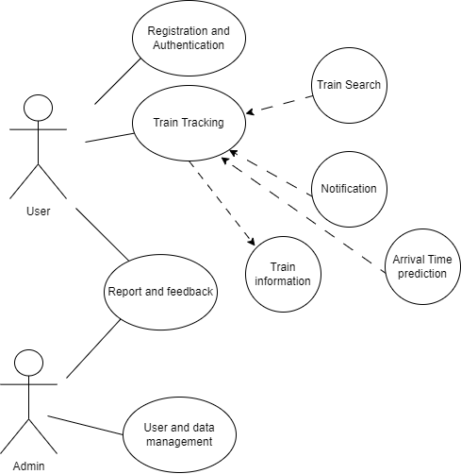

**6. Appendices:**

**a. Definitions, Acronyms, Abbreviations:**

**b. References:**