**SRS document for Fitness App with Workout Diet & Motivation**

1. **Scope**

The purpose of this document is to outline the requirements for a Fitness App that will provide its users with workout routines, diet plans, and motivational content in order to achieve their fitness goals.

1. **General Description**
   1. Target Audience:

Individuals aged 18-60 who are interested in fitness and well-being.

* 1. Objectives:
     1. To provide personalized workout routines.
     2. To offer diet plans tailored to individual needs.
     3. To deliver daily motivational content.
  2. Constraints:
     1. Limited to iOS and Android platforms.
     2. Requires internet connectivity for some features.

1. **Functional Requirements**
2. User Authentication
3. Profile Creation
4. Workout Plan Generation
5. Diet Plan Suggestions
6. Daily Motivational Quotes
7. **Non-Functional Requirements**
   1. Performance: App should load within 3 seconds.
   2. Usability: User-friendly interface.
   3. Security: Secure user data with encryption.
8. **Use Case Models**

UML Diagrams:

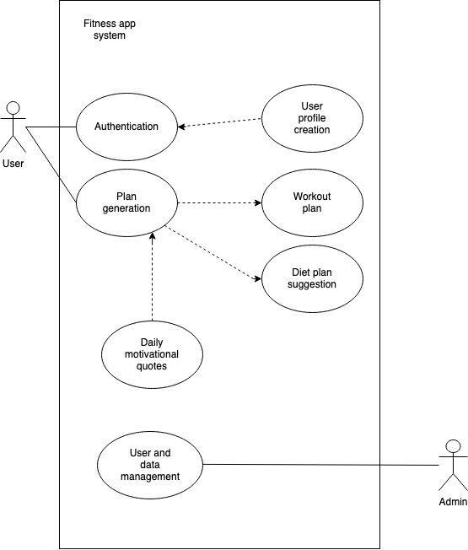

1. **Appendices**
   1. Definitions, Acronyms, Abbreviations:

- UML: Unified Modeling Language

* 1. References: