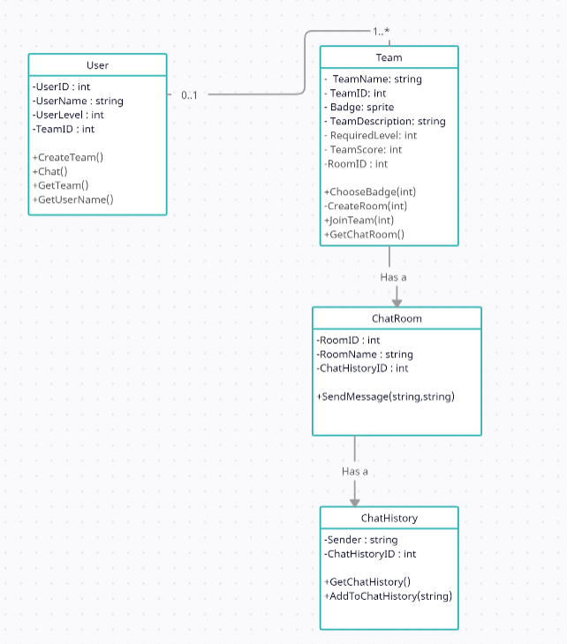

Primary Keys

PrimaryKey(User) = User.UserID
PrimaryKey(Team) = Team.TeamID
PrimaryKey(ChatRoom) = ChatRoom.RoomID
PrimaryKey(ChatHistory) = ChatHistory.ChatHistoryID

Foreign Keys

User.TeamID → Team.TeamID
Team.RoomID → ChatRoom.RoomID
ChatRoom.ChatHistoryID → ChatHistory.ChatHistoryID

