Step 1: Import Basic Libraries
✅ Basic libraries imported successfully!

Step 2: Load Train and Test Data
Mounted at /content/drive
----- Train Dataset -----
 | 2 | Stuning even for the non-gamer | This sound track was beautiful! It paints the senery in your mind so well I would recomend it even to people who hate vid. game music! I have played the game Chrono Cross but out of all of the games I have ever played it has the best music! It backs away from crude keyboarding and takes a fresher step with grate guitars and soulful orchestras. It would impress anyone who cares to listen! ^_^
0 | 2 | The best soundtrack ever to anything. | I'm reading a lot of reviews saying that this is the best 'game soundtrack' and I figured that I'd write a review to disagree a bit. This in my opinino is Yasunori Mitsuda's ultimate masterpiece. The music is timeless and I'm been listening to it for years now and its beauty simply refuses to fa...
1 | 2 | Amazing! | This soundtrack is my favorite music of all time, hands down. The intense sadness of "Prisoners of Fate" (which means all the more if you've played the game) and the hope in "A Distant Promise" and "Girl who Stole the Star" have been an important inspiration to me personally throughout my teen y...
2 | 2 | Excellent Soundtrack | I truly like this soundtrack and I enjoy video game music. I have played this game and most of the music on here I enjoy and it's truly relaxing and peaceful.On disk one. my favorites are Scars Of Time, Between Life and Death, Forest Of Illusion, Fortress of Ancient Dragons, Lost Fragment, and D...
3 | 2 | Remember, Pull Your Jaw Off The Floor After Hearing it | If you've played the game, you know how divine the music is! Every single song tells a story of the game, it's that good! The greatest songs are without a doubt, Chrono Cross: Time's Scar, Magical Dreamers: The Wind, The Stars, and the Sea and Radical Dreamers: Unstolen Jewel. (Translation varie...
4 | 2 | an absolute masterpiece | I am quite sure any of you actually taking the time to read this have played the game at least once, and heard at least a few of the tracks here. And whether you were aware of it or not, Mitsuda's music contributed greatly to the mood of every single minute of the whole game.Composed of 3 CDs an...
---------------------------------------------------------
----- Test Dataset -----
 | 2 | Great CD | My lovely Pat has one of the GREAT voices of her generation. I have listened to this CD for YEARS and I still LOVE IT. When I'm in a good mood it makes me feel better. A bad mood just evaporates like sugar in the rain. This CD just oozes LIFE. Vocals are jusat STUUNNING and lyrics just kill. One of life's hidden gems. This is a desert isle CD in my book. Why she never made it big is just beyond me. Everytime I play this, no matter black, white, young, old, male, female EVERYBODY says one thing "Who was that singing ?"
0 | 2 | One of the best game music soundtracks - for a game I didn't really play | Despite the fact that I have only played a small portion of the game, the music I heard (plus the connection to Chrono Trigger which was great as well) led me to purchase the soundtrack, and it remains one of my favorite albums. There is an incredible mix of fun, epic, and emotional songs. Those...
1 | 1 | Batteries died within a year ... | I bought this charger in Jul 2003 and it worked OK for a while. The design is nice and convenient. However, after about a year, the batteries would not hold a charge. Might as well just get alkaline disposables, or look elsewhere for a charger that comes with batteries that have better staying p...
2 | 2 | works fine, but Maha Energy is better | Check out Maha Energy's website. Their Powerex MH-C204F charger works in 100 minutes for rapid charge, with option for slower charge (better for batteries). And they have 2200 mAh batteries.
3 | 2 | Great for the non-audiophile | Reviewed quite a bit of the combo players and was hesitant due to unfavorable reviews and size of machines. I am weaning off my VHS collection, but don't want to replace them with DVD's. This unit is well built, easy to setup and resolution and special effects (no progressive scan for HDTV owner...
4 | 1 | DVD Player crapped out after one year | I also began having the incorrect disc problems that I've read about on here. The VCR still works, but hte DVD side is useless. I understand that DVD players sometimes just quit on you, but after not even one year? To me that's a sign on bad quality. I'm giving up JVC after this as well. I'm sti...

Train shape: (3599999, 3)
Test shape: (399999, 3)
Train columns: ['2', 'Stuning even for the non-gamer', 'This sound track was beautiful! It paints the senery in your mind so well I would recomend it even to people who hate vid. game music! I have played the game Chrono Cross but out of all of the games I have ever played it has the best music! It backs away from crude keyboarding and takes a fresher step with grate guitars and soulful orchestras. It would impress anyone who cares to listen! ^_^']
Test columns: ['2', 'Great CD', 'My lovely Pat has one of the GREAT voices of her generation. I have listened to this CD for YEARS and I still LOVE IT. When I\'m in a good mood it makes me feel better. A bad mood just evaporates like sugar in the rain. This CD just oozes LIFE. Vocals are jusat STUUNNING and lyrics just kill. One of life\'s hidden gems. This is a desert isle CD in my book. Why she never made it big is just beyond me. Everytime I play this, no matter black, white, young, old, male, female EVERYBODY says one thing "Who was that singing ?"']

<class 'pandas.core.frame.DataFrame'>
RangeIndex: 3599999 entries, 0 to 3599998
Data columns (total 3 columns):
# Column Dtype
--- ------ -----
0 2 int64
1 Stuning even for the non-gamer object
2 This sound track was beautiful! It paints the senery in your mind so well I would recomend it even to people who hate vid. game music! I have played the game Chrono Cross but out of all of the games I have ever played it has the best music! It backs away from crude keyboarding and takes a fresher step with grate guitars and soulful orchestras. It would impress anyone who cares to listen! ^_^ object
dtypes: int64(1), object(2)
memory usage: 82.4+ MB

Dataset Structure
score | summary | text
0 | 2 | The best soundtrack ever to anything. | I'm reading a lot of reviews saying that this is the best 'game soundtrack' and I figured that I'd write a review to disagree a bit. This in my opinino is Yasunori Mitsuda's ultimate masterpiece. The music is timeless and I'm been listening to it for years now and its beauty simply refuses to fa...
1 | 2 | Amazing! | This soundtrack is my favorite music of all time, hands down. The intense sadness of "Prisoners of Fate" (which means all the more if you've played the game) and the hope in "A Distant Promise" and "Girl who Stole the Star" have been an important inspiration to me personally throughout my teen y...
2 | 2 | Excellent Soundtrack | I truly like this soundtrack and I enjoy video game music. I have played this game and most of the music on here I enjoy and it's truly relaxing and peaceful.On disk one. my favorites are Scars Of Time, Between Life and Death, Forest Of Illusion, Fortress of Ancient Dragons, Lost Fragment, and D...
3 | 2 | Remember, Pull Your Jaw Off The Floor After Hearing it | If you've played the game, you know how divine the music is! Every single song tells a story of the game, it's that good! The greatest songs are without a doubt, Chrono Cross: Time's Scar, Magical Dreamers: The Wind, The Stars, and the Sea and Radical Dreamers: Unstolen Jewel. (Translation varie...
4 | 2 | an absolute masterpiece | I am quite sure any of you actually taking the time to read this have played the game at least once, and heard at least a few of the tracks here. And whether you were aware of it or not, Mitsuda's music contributed greatly to the mood of every single minute of the whole game.Composed of 3 CDs an...

Missing values per column:
score 0
summary 207
text 0
dtype: int64

 | score | summary | text
191931 | 2 | Well Worth the $$ | Very durable, comfortable & very reasonably priced. A lot of cool colors, too. Love it & will continue purchasing when needed.
47982 | 1 | It's not this woman's thing | I asked a black friend (I am white) if this was a "black" thing or a "woman" thing b/c I was intriqued, hearing ravings of male-bashing in the press. She also loved it and said it was a "woman" thing. It was about black women with miserable lives as far as I'm concerned and it was very unenjoyab...
55461 | 1 | The Best Anime Film! | This movie was ok, but it definitely wasn't a good anime film. Everything in this movie suffered, from the character development to the story line. I did not find myself hooked into the the story line or any of its characters. Anyone who wants to see a good sci-fi anime knows that you have to lo...
46833 | 2 | SOLIDARNOSC LIVE GDANSK 2005 | Dear All. I've bought the Solidarnosc Live DVD a couple weeks ago. Truly this is the best JMJ live performance so far...It's more than just 15/$25 worth of music disc. I strongly recommend it to everyone! (The only thing I regret is that I didn't go to Poland last year to see it live!)
16647 | 2 | Changing Pad | I received the changing pad in mail yesterday. I bought it based on the positive reviews. I only give it a 4 out of 5 b/c I have not used the pad yet. It looks like it will be a good changing pad but I will just have to wait and see.

Step 3: Map Score to Sentiment
Train sentiment distribution:
sentiment
negative 1800000
positive 1799999
Name: count, dtype: int64

Test sentiment distribution:
sentiment
negative 200000
positive 199999
Name: count, dtype: int64

Step 4: Clean & Preprocess Text

4.1 Remove stopwords
Original review:
I'm reading a lot of reviews saying that this is the best 'game soundtrack' and I figured that I'd write a review to disagree a bit. This in my opinino is Yasunori Mitsuda's ultimate masterpiece. The music is timeless and I'm been listening to it for years now and its beauty simply refuses to fade.The price tag on this is pretty staggering I must say, but if you are going to buy any cd for this much money, this is the only one that I feel would be worth every penny.

Cleaned review:
im reading a lot of reviews saying that this is the best game soundtrack and i figured that id write a review to disagree a bit this in my opinino is yasunori mitsudas ultimate masterpiece the music is timeless and im been listening to it for years now and its beauty simply refuses to fadethe price tag on this is pretty staggering i must say but if you are going to buy any cd for this much money this is the only one that i feel would be worth every penny

[nltk_data] Downloading package stopwords to /root/nltk_data...
[nltk_data] Unzipping corpora/stopwords.zip.
Original clean_text:
im reading lot reviews saying best game soundtrack figured id write review disagree bit opinino yasunori mitsudas ultimate masterpiece music timeless im listening years beauty simply refuses fadethe price tag pretty staggering must say going buy cd much money one feel would worth every penny

After removing stopwords:
im reading lot reviews saying best game soundtrack figured id write review disagree bit opinino yasunori mitsudas ultimate masterpiece music timeless im listening years beauty simply refuses fadethe price tag pretty staggering must say going buy cd much money one feel would worth every penny

Step 5: EDA on Cleaned Text

5.1 Class Distribution
/tmp/ipython-input-2632664995.py:13: FutureWarning:

Passing `palette` without assigning `hue` is deprecated and will be removed in v0.14.0. Assign the `x` variable to `hue` and set `legend=False` for the same effect.

sns.barplot(
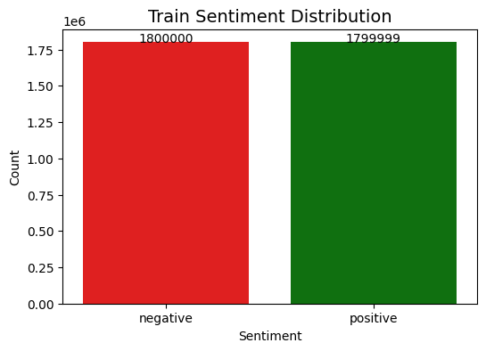

Dataset is balanced, so no class weighting or oversampling is needed
Sample negative review:

buy instrument child year playing keys bend instrument become unplayable cheaply made read discriptions instrument website notice much talk pretty case glitters gold shiny junk flashy caseno band directors recommend instruments repair shops refuse work youd replace keys fix ityou get pay beginner clarinet getting wind costing total buy another one breaks

Sample positive review:

gulda musical rebel exploring pieces result different performances example gulda uses slow tempos never recorded beforeexcept peices pf mind played much slower piano used toalso gulda manages true counterpoint voice separation perfectsome people would say gulda ffff especially fugue expositions way makes sense meif need single example greatness gulda listen pf c minor wtc iiif afford buy gould gulda tureck listen pf compare themgulda put much musical knowledge broadness horizons inner vision pieces may take one listening session grasp monumental performance bethis desert island cd

Observation:
Reviews are lowercase, punctuation removed, no URLs/newlines.
Text ready for tokenization.

5.2 Review Length Analysis
Compare part 1
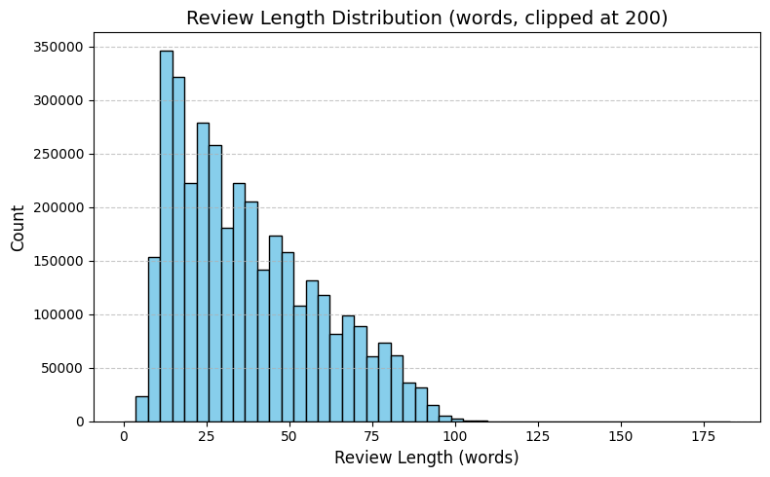
Most reviews are moderate length.

5.3 Most Frequent Words
Requirement already satisfied: wordcloud in /usr/local/lib/python3.12/dist-packages (1.9.4)
Requirement already satisfied: numpy>=1.6.1 in /usr/local/lib/python3.12/dist-packages (from wordcloud) (2.0.2)
Requirement already satisfied: pillow in /usr/local/lib/python3.12/dist-packages (from wordcloud) (11.3.0)
Requirement already satisfied: matplotlib in /usr/local/lib/python3.12/dist-packages (from wordcloud) (3.10.0)
Requirement already satisfied: contourpy>=1.0.1 in /usr/local/lib/python3.12/dist-packages (from matplotlib->wordcloud) (1.3.3)
Requirement already satisfied: cycler>=0.10 in /usr/local/lib/python3.12/dist-packages (from matplotlib->wordcloud) (0.12.1)
Requirement already satisfied: fonttools>=4.22.0 in /usr/local/lib/python3.12/dist-packages (from matplotlib->wordcloud) (4.61.0)
Requirement already satisfied: kiwisolver>=1.3.1 in /usr/local/lib/python3.12/dist-packages (from matplotlib->wordcloud) (1.4.9)
Requirement already satisfied: packaging>=20.0 in /usr/local/lib/python3.12/dist-packages (from matplotlib->wordcloud) (25.0)
Requirement already satisfied: pyparsing>=2.3.1 in /usr/local/lib/python3.12/dist-packages (from matplotlib->wordcloud) (3.2.5)
Requirement already satisfied: python-dateutil>=2.7 in /usr/local/lib/python3.12/dist-packages (from matplotlib->wordcloud) (2.9.0.post0)
Requirement already satisfied: six>=1.5 in /usr/local/lib/python3.12/dist-packages (from python-dateutil>=2.7->matplotlib->wordcloud) (1.17.0)
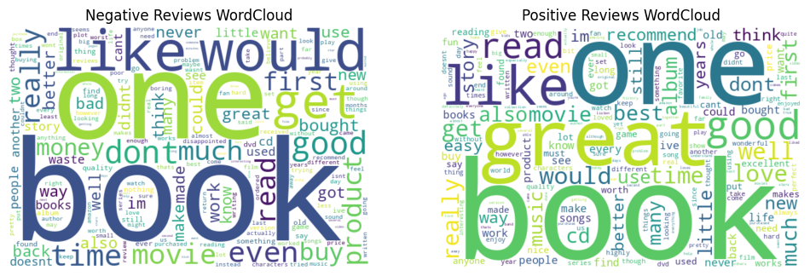
Top 10 negative words: [('book', 864215), ('one', 646764), ('like', 514071), ('would', 505897), ('get', 373106), ('good', 365287), ('dont', 352863), ('time', 323979), ('even', 306109), ('movie', 286931)]
Top 10 positive words: [('book', 892748), ('one', 607028), ('great', 580954), ('like', 460049), ('good', 453904), ('read', 349243), ('would', 314378), ('love', 302804), ('well', 298973), ('really', 280562)]

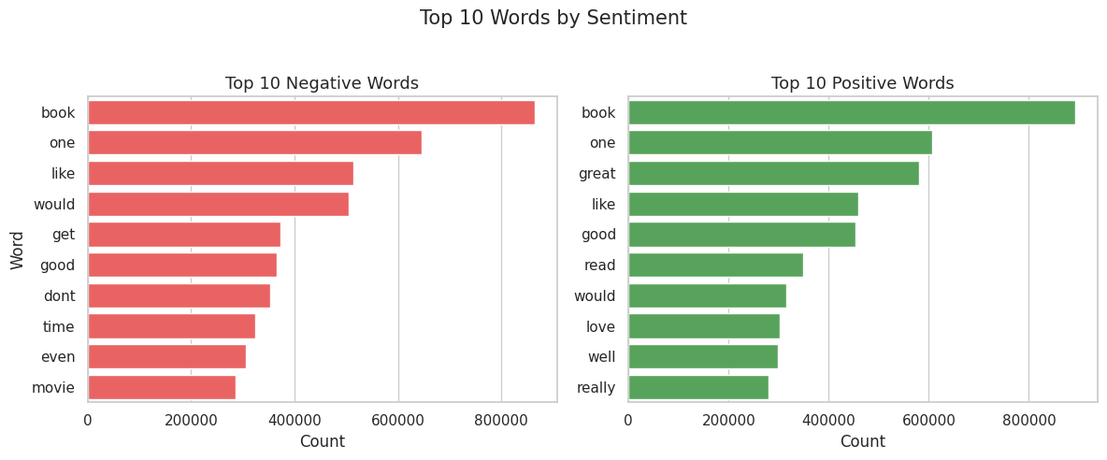
Observation (Before Custom Stopwords)
Words like one, would, get, like, book are still very frequent in both positive and negative reviews.
Meaningful sentiment words (good, great, love, dont) are present but not the most dominant.
Neutral/frequent words may dilute the signal for sentiment classification.
To make the features more informative, we should remove these frequent neutral words using a custom stopwords list.
\ Top 10 negative words (custom stopwords removed): [('dont', 352863), ('really', 265202), ('much', 261877), ('product', 246628), ('first', 246281), ('buy', 240019), ('money', 221904), ('bought', 216934), ('better', 215031), ('could', 212122)]
Top 10 positive words (custom stopwords removed): [('great', 580954), ('love', 302804), ('well', 298973), ('really', 280562), ('best', 232962), ('first', 227166), ('much', 215267), ('cd', 210925), ('album', 203852), ('dont', 195413)]

Advanced EDA Tasks
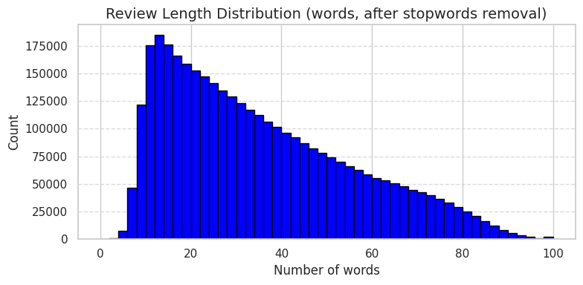
Reviews are slightly shorter after removing stopwords.

Step 6: Feature Engineering & Vectorization

6.1 TF/ IDF

score | summary | text | sentiment | clean_text | clean_text_final
0 | 2 | One of the best game music soundtracks - for a game I didn't really play | Despite the fact that I have only played a small portion of the game, the music I heard (plus the connection to Chrono Trigger which was great as well) led me to purchase the soundtrack, and it remains one of my favorite albums. There is an incredible mix of fun, epic, and emotional songs. Those... | positive | despite fact played small portion game music heard plus connection chrono trigger great well led purchase soundtrack remains one favorite albums incredible mix fun epic emotional songs sad beautiful tracks especially like theres many kinds songs video game soundtracks must admit one songs lifea ... | despite fact played small portion game music heard plus connection chrono trigger great well led purchase soundtrack remains favorite albums incredible mix fun epic emotional songs sad beautiful tracks especially theres many kinds songs video game soundtracks must admit songs lifea distant promi...
1 | 1 | Batteries died within a year ... | I bought this charger in Jul 2003 and it worked OK for a while. The design is nice and convenient. However, after about a year, the batteries would not hold a charge. Might as well just get alkaline disposables, or look elsewhere for a charger that comes with batteries that have better staying p... | negative | bought charger jul worked ok design nice convenient however year batteries would hold charge might well get alkaline disposables look elsewhere charger comes batteries better staying power | bought charger jul worked ok design nice convenient however year batteries hold charge might well alkaline disposables look elsewhere charger comes batteries better staying power
2 | 2 | works fine, but Maha Energy is better | Check out Maha Energy's website. Their Powerex MH-C204F charger works in 100 minutes for rapid charge, with option for slower charge (better for batteries). And they have 2200 mAh batteries. | positive | check maha energys website powerex mhcf charger works minutes rapid charge option slower charge better batteries mah batteries | check maha energys website powerex mhcf charger works minutes rapid charge option slower charge better batteries mah batteries
3 | 2 | Great for the non-audiophile | Reviewed quite a bit of the combo players and was hesitant due to unfavorable reviews and size of machines. I am weaning off my VHS collection, but don't want to replace them with DVD's. This unit is well built, easy to setup and resolution and special effects (no progressive scan for HDTV owner... | positive | reviewed quite bit combo players hesitant due unfavorable reviews size machines weaning vhs collection dont want replace dvds unit well built easy setup resolution special effects progressive scan hdtv owners suitable many people looking versatile productcons universal remote | reviewed quite bit combo players hesitant due unfavorable reviews size machines weaning vhs collection dont want replace dvds unit well built easy setup resolution special effects progressive scan hdtv owners suitable many people looking versatile productcons universal remote
4 | 1 | DVD Player crapped out after one year | I also began having the incorrect disc problems that I've read about on here. The VCR still works, but hte DVD side is useless. I understand that DVD players sometimes just quit on you, but after not even one year? To me that's a sign on bad quality. I'm giving up JVC after this as well. I'm sti... | negative | also began incorrect disc problems ive read vcr still works hte dvd side useless understand dvd players sometimes quit even one year thats sign bad quality im giving jvc well im sticking sony giving another brand shot | began incorrect disc problems ive vcr still works hte dvd side useless understand dvd players sometimes quit year thats sign bad quality im giving jvc well im sticking sony giving another brand shot

X_train_sub shape: (100000, 20000)
X_test_sub shape: (100000, 20000)

Observation: Why We Use Subset
Full dataset is huge (~4 million reviews × 20,000 features).
Training on full data takes very long time and uses high memory.
Subset of 100,000 reviews allows quick testing.
Helps to compare models efficiently before scaling to full dataset.

Step 7: Baseline Models

Train Multiple ML Models
Requirement already satisfied: xgboost in /usr/local/lib/python3.12/dist-packages (3.1.2)
Requirement already satisfied: numpy in /usr/local/lib/python3.12/dist-packages (from xgboost) (2.0.2)
Requirement already satisfied: nvidia-nccl-cu12 in /usr/local/lib/python3.12/dist-packages (from xgboost) (2.28.9)
Requirement already satisfied: scipy in /usr/local/lib/python3.12/dist-packages (from xgboost) (1.16.3)
Training Logistic Regression ...
Training Naive Bayes ...
Training SVM ...
Training Random Forest ...
Training XGBoost ...

All Model Metrics & Time Comparison on Subset:
Accuracy Precision Recall F1-Score Train Time (s) \
Logistic Regression 0.85808 0.856233 0.859940 0.858083 0.677653
SVM 0.85046 0.849411 0.851182 0.850295 2.291180
Random Forest 0.82690 0.837935 0.809653 0.823551 434.906166
XGBoost 0.81986 0.809703 0.835247 0.822277 108.748548
Naive Bayes 0.81901 0.823517 0.811056 0.817239 0.039749

Prediction Time (s)
Logistic Regression 0.009597
SVM 0.009539
Random Forest 8.179942
XGBoost 1.052153
Naive Bayes 0.037351

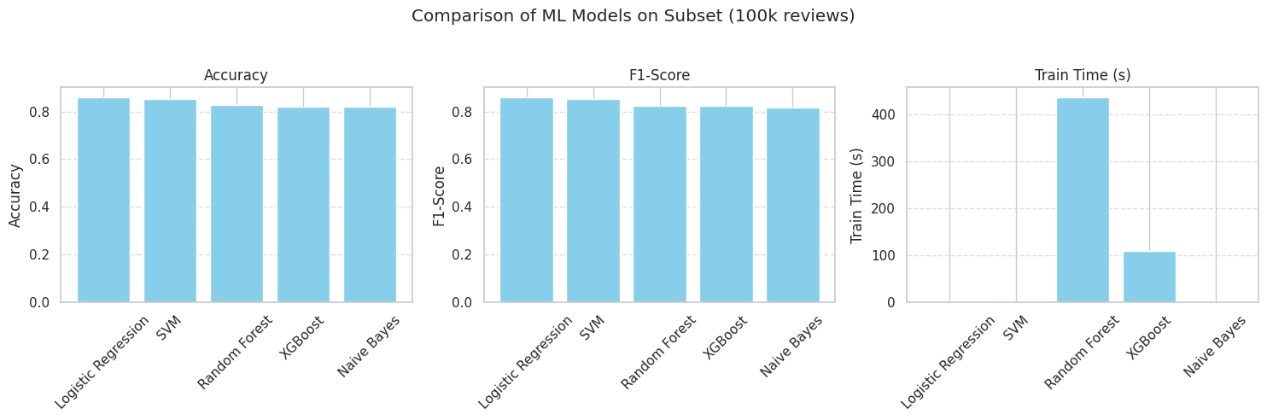

✅ Model and TF-IDF vectorizer saved successfully!

Model Performance Overview:
 | Accuracy | Precision | Recall | F1-Score | Train Time (s) | Prediction Time (s)
Logistic Regression | 0.858080 | 0.856233 | 0.859940 | 0.858083 | 0.677653 | 0.009597
SVM | 0.850460 | 0.849411 | 0.851182 | 0.850295 | 2.291180 | 0.009539
Random Forest | 0.826900 | 0.837935 | 0.809653 | 0.823551 | 434.906166 | 8.179942
XGBoost | 0.819860 | 0.809703 | 0.835247 | 0.822277 | 108.748548 | 1.052153
Naive Bayes | 0.819010 | 0.823517 | 0.811056 | 0.817239 | 0.039749 | 0.037351

✅ Model and vectorizer loaded successfully!

 | review | label
32 | Cheap material, looks nothing like the image. | 0
7 | Five stars! Would definitely buy again. | 1
11 | Totally worth it, great value for money. | 1
16 | Very nice product, looks amazing. | 1
24 | Customer support was not helpful at all. | 0
1 | Amazing quality and super fast delivery. | 1

📊 Model Performance on Unseen Dataset:
Accuracy: 0.93
Precision: 0.87
Recall: 1.00
F1-Score: 0.93

📋 Classification Report:
precision recall f1-score support

Negative 1.00 0.85 0.92 20
Positive 0.87 1.00 0.93 20

accuracy 0.93 40
macro avg 0.93 0.93 0.92 40
weighted avg 0.93 0.93 0.92 40

🔍 Example Predictions:
Review: I love this product, it works great!
Predicted Sentiment: Positive | Actual: Positive

Review: Amazing quality and super fast delivery.
Predicted Sentiment: Positive | Actual: Positive

Review: Highly recommend, I’m very satisfied.
Predicted Sentiment: Positive | Actual: Positive

Review: Best purchase ever! Worth every penny.
Predicted Sentiment: Positive | Actual: Positive

Review: Excellent service and friendly staff.
Predicted Sentiment: Positive | Actual: Positive

Step 8: Comparisons
SVM (Classical ML)
SVM Accuracy: 0.8535

Classification Report:
precision recall f1-score support

0 0.85 0.85 0.85 50107
1 0.85 0.85 0.85 49893

accuracy 0.85 100000
macro avg 0.85 0.85 0.85 100000
weighted avg 0.85 0.85 0.85 100000

Confusion Matrix:
[[42754 7353]
[ 7297 42596]]

CNN for Text (Deep Learning)
/usr/local/lib/python3.12/dist-packages/keras/src/layers/core/embedding.py:97: UserWarning: Argument `input_length` is deprecated. Just remove it.
warnings.warn(
Model: "sequential"
┏━━━━━━━━━━━━━━━━━━━━━━━━━━━━━━━━━┳━━━━━━━━━━━━━━━━━━━━━━━━┳━━━━━━━━━━━━━━━┓
┃ Layer (type) ┃ Output Shape ┃ Param # ┃
┡━━━━━━━━━━━━━━━━━━━━━━━━━━━━━━━━━╇━━━━━━━━━━━━━━━━━━━━━━━━╇━━━━━━━━━━━━━━━┩
│ embedding (Embedding) │ ? │ 0 (unbuilt) │
├─────────────────────────────────┼────────────────────────┼───────────────┤
│ conv1d (Conv1D) │ ? │ 0 (unbuilt) │
├─────────────────────────────────┼────────────────────────┼───────────────┤
│ global_max_pooling1d │ ? │ 0 │
│ (GlobalMaxPooling1D) │ │ │
├─────────────────────────────────┼────────────────────────┼───────────────┤
│ dense (Dense) │ ? │ 0 (unbuilt) │
├─────────────────────────────────┼────────────────────────┼───────────────┤
│ dropout (Dropout) │ ? │ 0 │
├─────────────────────────────────┼────────────────────────┼───────────────┤
│ dense_1 (Dense) │ ? │ 0 (unbuilt) │
└─────────────────────────────────┴────────────────────────┴───────────────┘
Total params: 0 (0.00 B)
Trainable params: 0 (0.00 B)
Non-trainable params: 0 (0.00 B)
Epoch 1/10
2500/2500 ━━━━━━━━━━━━━━━━━━━━ 185s 73ms/step - accuracy: 0.7791 - loss: 0.4544 - val_accuracy: 0.8559 - val_loss: 0.3346
Epoch 2/10
2500/2500 ━━━━━━━━━━━━━━━━━━━━ 199s 72ms/step - accuracy: 0.9017 - loss: 0.2491 - val_accuracy: 0.8522 - val_loss: 0.3504
Epoch 3/10
2500/2500 ━━━━━━━━━━━━━━━━━━━━ 180s 72ms/step - accuracy: 0.9601 - loss: 0.1113 - val_accuracy: 0.8419 - val_loss: 0.4738
Epoch 4/10
2500/2500 ━━━━━━━━━━━━━━━━━━━━ 197s 70ms/step - accuracy: 0.9844 - loss: 0.0461 - val_accuracy: 0.8393 - val_loss: 0.6519
Epoch 5/10
2500/2500 ━━━━━━━━━━━━━━━━━━━━ 179s 71ms/step - accuracy: 0.9900 - loss: 0.0300 - val_accuracy: 0.8363 - val_loss: 0.8530
Epoch 6/10
2500/2500 ━━━━━━━━━━━━━━━━━━━━ 181s 73ms/step - accuracy: 0.9926 - loss: 0.0207 - val_accuracy: 0.8409 - val_loss: 0.8225
Epoch 7/10
2500/2500 ━━━━━━━━━━━━━━━━━━━━ 178s 71ms/step - accuracy: 0.9932 - loss: 0.0199 - val_accuracy: 0.8320 - val_loss: 0.8557
Epoch 8/10
2500/2500 ━━━━━━━━━━━━━━━━━━━━ 179s 71ms/step - accuracy: 0.9954 - loss: 0.0135 - val_accuracy: 0.8356 - val_loss: 1.0749
Epoch 9/10
2500/2500 ━━━━━━━━━━━━━━━━━━━━ 188s 75ms/step - accuracy: 0.9954 - loss: 0.0132 - val_accuracy: 0.8343 - val_loss: 0.9569
Epoch 10/10
2500/2500 ━━━━━━━━━━━━━━━━━━━━ 198s 73ms/step - accuracy: 0.9965 - loss: 0.0104 - val_accuracy: 0.8357 - val_loss: 1.1652
3125/3125 ━━━━━━━━━━━━━━━━━━━━ 46s 15ms/step
CNN Accuracy on Test Set: 0.83707

Classification Report on Test Set:
precision recall f1-score support

0 0.84 0.84 0.84 50107
1 0.84 0.83 0.84 49893

accuracy 0.84 100000
macro avg 0.84 0.84 0.84 100000
weighted avg 0.84 0.84 0.84 100000

Confusion Matrix on Test Set:
[[42136 7971]
[ 8322 41571]]
