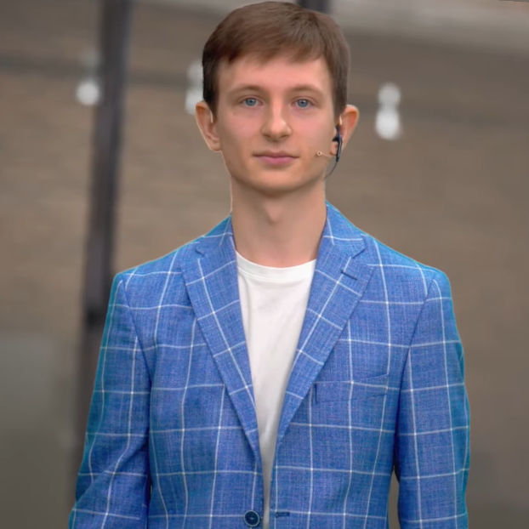

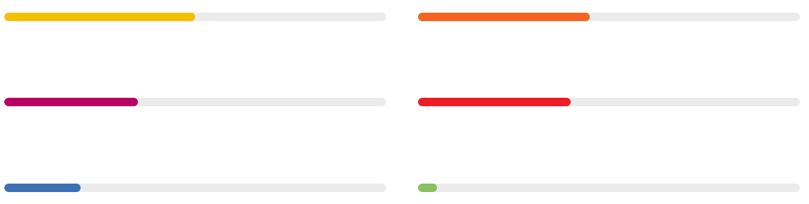

**HTML 50% CSS 45%**

**JavaScript 35% Git 40%**

**React 20% TypeScript 5%**

**SKILLS**

* Project management
* Conducting training
* Knowledge of CAD and CAE programs
* Organization business trips
* Creation of video content
* HTML, CSS and JavaScript Algorithms

**LANGUAGES**

* Russian: Native speaker
* English: B2
* Spanish: A1

**ABOUT ME**

PhD of Engineering Science, graduated from magistracy with honors. Have qualification of the teacher-researcher. Conducted numerous training sessions for clients. I am fluent in calculation and design CAD/CAE programs. I have extensive experience in business trips. Author of more than 20 scientific papers in science journals. Create high-quality promotional or educational videos. I Have SQL Skills for Programmers and Developers. Familiar with HTML and CSS that my web CV is based on. I like programming. Built a smart home system based on the Home Assistant code in Python. I will learn a new language with pleasure. I recently started learning Frontend, went through the basics of HTML, CSS, JavaScript, at the moment I'm learning React, and with it TypeScript.

**EXPERIENCE**

**Lead Systems Engineer CAD/CAE**ITOOLS Ltd Moscow [www.i-tools.info](http://www.i-tools.info)  
07/2019 — present Technical specialist in SOLIDWORKS Simulation, Flow Simulation, Electronic Cooling, HVAC, Motion, Sustainability and similar products on the 3DEXPERIENCE platform.

**Structural Engineer (Engineer of Strength)**Nadezhnost PLUS Ltd Moscow [www.nadezhnost.com](http://www.nadezhnost.com)  
STRENG s.r.o. Praha [www.streng.cz](https://www.streng.cz/index.php/en/)  
05/2017 — 06/2019  
Examination and repair of heavy engineering equipment.

**Structural Engineer (Engineer of Strength)**Rocket and Space Corporation “Energia” Korolev, Moscow [www.energia.ru](http://www.energia.ru)  
07/2016 — 06/2017  
Participated in the project by Roscosmos to develop a new-generation, partially reusable crewed spacecraft. Design in SOLIDWORKS, PTC Creo Pro ENGINEER.

**Structural Engineer (Engineer of Strength)**JSC «Scientific and research institute of parachute design and production»  
JSC «NII parachutostroyeniya» Moscow [www.niiparachute.ru](http://www.niiparachute.ru/)  
12/2015 — 06/2016  
Performance of strength calculations for parachute systems. Writing programs for numerical analysis of deploy and opening of the parachute by Runge-Kutta

method in Matlab and Fortran..

**EDUCATION**

**Postgraduate studies, PhD**, Educational programs «Dynamics and Strength of Machines, Instruments and Equipment», Dept. of Robotics, Mechatronics, Dynamics and Machine Strength, Institute of Power Machinery and Mechanics, National Research University «Moscow Power Engineering Institute», 2021.

**Master**, Dept. of Robotics, Mechatronics, Dynamics and Machine Strength, National Research University «MPEI», 2017, Graduation with honors

**Bachelor**, Dept. of Dynamics and Strength of Machine, MPEI, 2015

**COURSES**

**Responsive Web Design**  
freeCodeCamp  
may 2022

**JavaScript**  
learn.javascript, freeCodeCamp

august 2022

**Git**Learn Git Branching  
december 2022

**Beginner React Developer**  
KTS.STUDIO  
february 2023

**Evgenii Zuev**

**Frontend developer**

**PORTFOLIO**

My portfolio: <http://evgeny.byethost17.com>

Moscow  
[+7 (915) 359-79-50](tel:+79153597950)   
[ZuevEuA@gmail.com](mailto:ZuevEuA@gmail.com)

[Facebook.com/aligatorru](https://www.facebook.com/aligatorru)  
[Telegram: @Eugeny_Zuev](https://t.me/Eugeny_Zuev)  
[linkedin.com/in/EvgenyZuev](http://www.linkedin.com/in/EvgenyZuev)