

SCHOOL OF INFORMATION TECHNOLOGY
General Luna Road, Baguio City Philippines 2600

Telefax No.: (074) 442-3071 Website: www.ubaguio.edu E-mail Address: sit@e.ubaguio.edu

HUMAN-COMPUTER INTERACTION 1

2ndSemester SY 2025-2026

Name: Aligay,Rexeir A.___________________________ Date: 01-23-26_____
Course and Year: Computer Science – First Year Section: IDA6_______
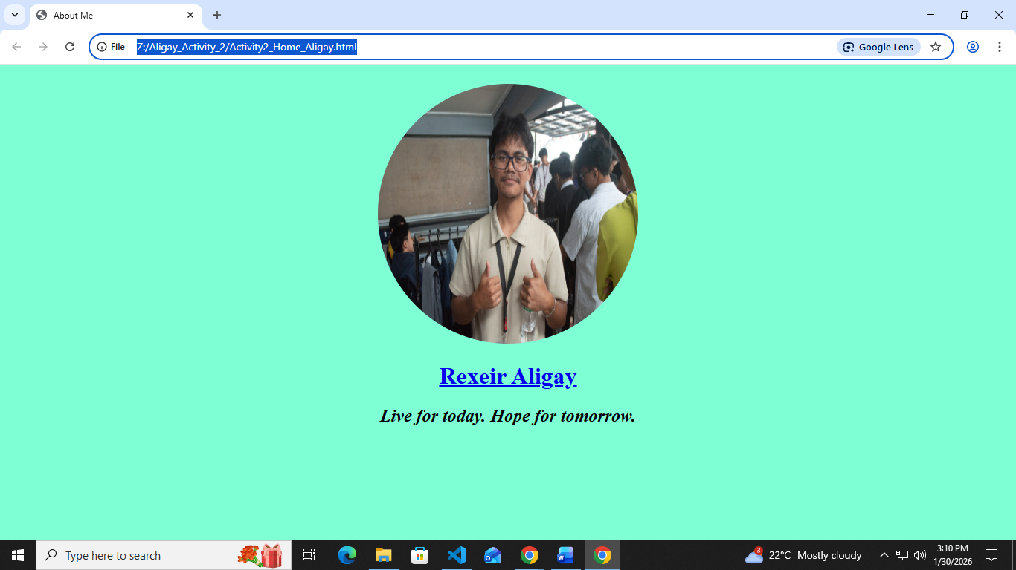
Activity2_Home_Aligay.html
<!DOCTYPE html>
<html>
<head>
<meta chartset="UTF-8">
<center>
<title>About Me</title>
<body style="background-color: aquamarine;">
<div>
<br>
<img src="MyImage.jpg" height="350" width="350"
style="border-radius: 50%;" class="MyImage"><br>
<a href="AllAboutMe.html"><h1>Rexeir Aligay</h1></a>
<p>
<h2><em>Live for today. Hope for tomorrow.</em></h2>
</p>
</div>
</body>
</center>
</head>
</html>

REFLECTION:
- What was the most challenging part of using the basic HTML tags like headings and paragraphs?
- The most challenging part for me is remembering each tags and attributes because I often forgot how to use them just like the anchor tag which connects files or link.
- How do you think a simple, well-structured webpage can improve the way personal information is presented online?
- With simple structured webpage, it will be easy to understood by its users or viewers and it won’t be hard to follow what was the page is all about or how does the page function.

