**PLANNING THE TECHNICAL FOUNDATION**

**HACAKTON-03 | DAY 02**

1. TECHNICAL REQUIRMENTS :-

* **Frontend Requirements:-**
  + - User-friendly interface for browsing furniture products (chairs and sofas, etc.).
    - Responsive design for both mobile and desktop users.
    - Essential pages:

***Home, Product Listing (with categories like Chairs, Sofas, etc.), Product Details, Cart, Checkout, and Order Confirmation.***

* + - High-quality images and 360-degree views for furniture products.
* **Backend:-**

Use Sanity CMS to manage product data (e.g., chair and sofa details), customer details, and order records.

Design schemas in Sanity to align with the business goals from Day 1.

Example schema fields for furniture products: name, price, description, material, color, dimensions, stock, image.

* **API’s:-**

Integrate APIs for shipment tracking, payment gateways, and other backend services.

Ensure APIs provide the necessary data for frontend functionality, such as real-time stock updates for furniture items.

1. **SYSTEM ARCHITECTURE :-**

* **Architecture Diagram:-**

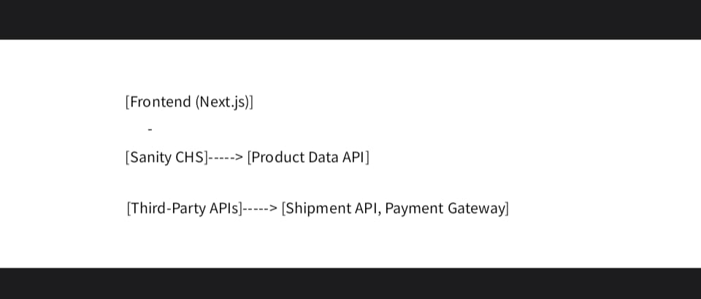

* **Key Workflows :-**

CREATED BY: ALI HAMZA

**-** User Registration:

User signs up, data is stored in Sanity, and a confirmation is sent.

**-** Product Browsing:

User views furniture categories (chairs, sofas), Sanity API fetches data, and products are displayed on the frontend.

**-** Order Placement:

User adds furniture items to the cart, proceeds to checkout, and order details are saved in Sanity.

**-** Shipment Tracking:

Order status updates are fetched via a third-party API and displayed to the user.

1. **PLAN API REQUIRMENT :-**

* **Endpoint: /Product -**
* **METHOD:- GET.**
* **DISCRIPTION:- Fetch all available furniture products (chairs and sofas) from Sanity.**
* **RESPONSE:-**
* **{**
* **"id": 1,**
* **"name": "Modern Leather Sofa",**
* **"price": 500,**
* **"material": "Leather",**
* **"color": "Black",**
* **"dimensions": "80x30x35 inches",**
* **"stock": 10,**
* **"image": "sofa_image_url"**
* **},**
* **Endpoint: /Order –**
* **METHOD:- POST.**
* **DISCRIPTION:-** **Create a new order in Sanity.**
* **PAYLOAD:-**
* **{**
* **"product i.d":18k0c,**
* **"items": "4",**
* **"total price": 5500,**
* **“date”: 16/01/2025**
* **},**
  + - * **RESPONSE:-**
      * {
      * "order Id": 1234,
      * "status": "Success"
      * "message": thanks for shopping,
      * }

CREATED BY: ALI HAMZA

* **Endpoint: /Payment –**
  + - **METHOD:- POST.**
    - **DISCRIPTION:-** **Payment processing method**
    - **PAYLOAD:-**

**{**

**"user Id": 1234,**

**"items": [ { "product Id": 1, "quantity": 2 } ],**

**"total Price": “1000,"**

**“payment Status": "Paid",**

**“payment method": "jazz cash",**

**"transaction date": "16/01/2025"**

**}**

* **RESPONSE:-**
  + - * {
      * "status": completed,
      * "message": **Your payment has been successfully done!"**
      * **"transaction Id": "txn_456789"**
      * }
* **Endpoint /Shipment :–**
  + - **METHOD:- GET.**
    - **DISCRIPTION:-** **Track order status via a third-party API.**
    - **RESPONSE:-**
    - {
    - "shipment Id": 456,
    - "order Id": 123,
    - "status": "In Transit",
    - "expected-Delivery-Date": "2023-10-25"
    - }

CREATED BY: ALI HAMZA

USER WORK FLOW



product

Log-in

Register

nnRigin

STOP

Order

cms

nnn

confirmation

cms

nnn

user

"Order confirmation means the user receives a messagee that their order has been done!”

Tracking/API

shipment

API

payment

Check out

Add to cart

cms

nnn

API

Third party

cms

nnn

CMS

cms

nnn

Sanity

cms

nnn

Frontend

nnn

Next.js

nnn