Requirements Analysis Document

1. Introduction
The purpose of this document is to define the requirements for the ML-ViSSim: Interactive 3D Cost Function Educational Simulation project. This system will function as an educational tool designed for university-level students of Machine Learning (ML).
The primary reason for its development is to address a significant gap in current ML pedagogy: the difficulty of visualizing and intuitively understanding the behavior of optimization algorithms. Traditional methods, such as static 2D plots (e.g., from matplotlib) or textbook diagrams, fail to capture the dynamic, step-by-step nature of how a model "learns."
The objective of this project is to create an interactive 3D/2D simulation environment. This system will allow users to select an ML model, configure its parameters, and visually observe, in real-time, how an optimization algorithm (like Gradient Descent) navigates the cost function surface.
The project's success criteria are:
- Intuitive Understanding: A student using the tool must gain a clearer intuitive understanding of the relationship between learning rates, cost, and model variables than they would from static materials.
- Interactivity: The user must be able to control the simulation (start, pause, step) and manipulate the 3D visualization (rotate, zoom).
- Fidelity: The visual simulation must accurately represent the mathematical calculations performed by the underlying Python model.

2. Current System
The "current system" for students learning ML optimization is not a single, cohesive product. Instead, it is a fragmented and disconnected process that relies on a collection of non-interactive tools and manual coding tasks. This process typically involves:
- Manually writing scripts (e.g., in Python) to load data, define a model, and run an optimization.
- Using static plotting libraries (such as matplotlib) to generate 2D graphs of the cost function after the model has finished training.
- Consulting passive educational materials like textbook diagrams or pre-rendered video animations.
This fragmented approach creates significant barriers to intuitive learning. The primary problems and limitations of this "current system" directly correlate to the opportunities our proposed system will address:
- Lack of a Unified, Interactive Workflow: There is no single environment that guides a student through the logical Data > Model > Algorithm > Visualization workflow. The student must manually connect these steps using code, which distracts from the learning objective.
- Impossibility of Dynamic Comparison: The current system makes it prohibitively difficult to conduct side-by-side, iterative comparisons. To compare two algorithms (e.g., Brute Force vs. Gradient Descent), a student would need to write, execute, and meticulously log data from two separate, complex scripts, and then write a third script to attempt to visualize the comparison. This is an advanced engineering task, not an educational one.
- Focus on Results, Not Process (No Step-by-Step Insight): Static tools only show the final result. The process of learning—the "journey" the algorithm takes at each iteration—is completely hidden. It is impossible to pause, inspect the current values of model variables, and build an intuition for why the cost is changing.
- Opaque and Ineffective Visualization: Static 2D graphs are a poor substitute for interactive visualization. Furthermore, static 3D plots are often unusable as they cannot be rotated or inspected from different angles, which is crucial for understanding the complex topology of a cost function surface.
Educational Impact: This current system forces students to spend more time fighting with their tools (e.g., debugging plotting code) than engaging with the concepts. It creates a "black box" effect where the internal mechanics of optimization remain abstract and obscure.
The proposed system will replace this fragmented, static, and opaque process by providing a single, unified, and fully interactive simulation environment. It is designed to move the focus from "coding the plot" to "understanding the concept."

3. Proposed System
This section documents the requirements elicitation and the analysis model of the new system.

3.1 Functional Requirements
The functional requirements section describes the high-level functionality of the system. The system's functionality is organized around a mandatory user workflow.
FR-Workflow 1: Data Source Selection
- FR-1.1: The system shall require the user to select a data source as the first step of the workflow.
- FR-1.2: The system shall provide two distinct options for data sourcing:
  - Uploading a user-owned dataset file.
  - Utilizing the built-in synthetic data generator.
- FR-1.3: If data generation is selected, the system shall allow the user to specify a range of parameters to define the characteristics of the generated dataset.
- FR-1.4: The system shall require user confirmation of the active dataset (either uploaded or generated) before allowing the workflow to proceed.
FR-Workflow 2: Model Type Selection
- FR-2.1: After a data source is confirmed, the system shall require the user to select a Machine Learning model type.
- FR-2.2: The system shall support a range of pre-defined model types appropriate for supervised learning tasks.
FR-Workflow 3: Algorithm Selection
- FR-3.1: After selecting a model, the system shall require the user to select an optimization or training algorithm from a provided list.
- FR-3.2: The system shall dynamically filter the list of available algorithms to show only those that are compatible with the previously selected model type.
- FR-3.3: The algorithm selection list shall include both standard, efficient algorithms and non-standard or comparative algorithms, provided for educational purposes.
FR-Workflow 4: Hyperparameter Configuration
- FR-4.1: After selecting an algorithm, the system shall present a panel for configuring all relevant hyperparameters for that algorithm.
- FR-4.2: The system shall provide sensible default values for all hyperparameters to allow for quick setup.
FR-Workflow 5: Visualization Selection
- FR-5.1: Before starting the simulation, the system shall require the user to select the primary visualization type for displaying the cost function.
- FR-5.2: The system shall offer multiple visualization types (e.g., 2D, 3D) appropriate for the dimensionality of the selected data and model variables.
FR-Simulation: Core Functionality
- FR-6.1 (Simulation Control): The user shall be able to Start, Pause, Step-Through (one iteration at a time), and Reset the simulation via dedicated UI controls.
- FR-6.2 (Real-time Data): The system shall display the following values in real-time during the simulation: Current Iteration Number, Current Cost (Loss), and Current Model Variable values.
- FR-6.3 (Visual Feedback): The system shall render the selected cost function graph and plot the optimization path as an animated trace on this graph.
- FR-6.4 (Graph Manipulation): The user shall be able to interactively manipulate the visualization's camera and view (including rotation, panning, and zooming).
FR-Comparison: Comparison Panel
- FR-7.1: The system shall provide a "Comparison Panel" feature.
- FR-7.2: This panel shall allow the user to select and run two or more algorithm configurations simultaneously for the same selected data and model.
- FR-7.3: The panel shall display the performance of each algorithm side-by-side on a per-iteration basis, using comparative graphs and metrics.

3.2 Nonfunctional Requirements
This section describes user-level requirements that are not directly related to functionality.
Performance
- NFR-01 (Responsiveness): The visualization must update in near real-time with the backend calculations. The perceived lag between a calculation step and its visual representation must be minimal to ensure a smooth animation.
- NFR-02 (Manipulation): 3D/2D graph manipulation (rotation, zoom, pan) must remain smooth and responsive, even while a simulation is actively running.
- NFR-03 (Comparison Performance): Running a comparison simulation with multiple algorithms simultaneously must not cause the application to freeze or become unresponsive.
Usability
- NFR-04 (Learnability): A new user with a basic understanding of ML concepts must be able to follow the intended workflow (data selection, model selection, etc.) and run a complete simulation within minutes without consulting documentation.
- NFR-05 (Clarity): The user interface must be intuitive and enforce the logical workflow. Options that are not yet available in the workflow sequence (e.g., algorithm selection before model selection) must be clearly disabled or hidden.
- NFR-06 (Defaults): The system shall provide sensible default values for all configurable parameters so the user can run a simulation with minimal setup.
Implementation
- NFR-07 (Backend): All machine learning models and optimization algorithms must be implemented in Python.
- NFR-08 (Frontend): The interactive 3D/2D visualization and user interface must be implemented in Unity.
- NFR-09 (Bridge): A stable, high-speed communication protocol must be established to pass data between the Python backend and the Unity frontend in real-time.
Modifiability & Supportability
- NFR-10 (Modularity): The system architecture must be modular. Adding a new ML Model type or a new Algorithm in the future must not require a complete redesign of the core application.
Reliability
- NFR-11 (Error Handling): The system must gracefully handle invalid user inputs or unstable simulation parameters. A simulation that results in non-numerical values must not crash the application but should instead display a warning and pause the simulation.

3.3.1 Scenarios
Scenarios are short "stories" that describe how an Actor (the User) interacts with the system to achieve a specific goal.
Scenario 1: Basic Simulation Workflow (Successful Path)
- Scenario Name: Understanding Single Algorithm Behavior
- Actor: User
- Goal: To observe the optimization process of a cost function in 3D for a specific model and algorithm configuration.
- Flow:
  - The User starts the application.
  - The system prompts the User to select a data source (UC-01).
  - The User, not having a dataset, selects the "Generate Synthetic Data" option.
  - The User specifies data characteristics (e.g., number of points, noise) and generates the data. The system confirms the data is ready.
  - The system prompts the User to select a model (UC-02). The User selects a model type from the list.
  - The system lists the algorithms compatible with the chosen model. The User selects a standard optimization algorithm.
  - The User leaves the relevant hyperparameters (e.g., learning rate, iteration count) at their default values.
  - The User selects "3D Surface Plot" as the visualization type.
  - The User clicks the "Start" button.
  - The User watches the animated optimization path (trace) appear on the 3D graph while simultaneously reading the real-time cost and variable values.
  - To get a better view, the User clicks the "Pause" button and uses the mouse to rotate the 3D graph (UC-04), inspecting the cost surface topology.
- Result: The User gains an intuitive understanding of how the selected algorithm behaves on the cost function surface with default settings.
Scenario 2: Comparative Analysis Workflow
- Scenario Name: Comparing Algorithm Efficiencies
- Actor: User
- Goal: To compare the performance (e.g., speed of cost reduction) of two different optimization algorithms on the same data and model.
- Flow:
  - The User starts the application and uploads their own dataset (UC-01). The system confirms the data is valid.
  - The User navigates to the "Comparison Panel" (UC-03).
  - The User selects the base model type to be used for the comparison.
  - Panel 1 (Contender 1): The User selects a standard, efficient optimization algorithm and sets its hyperparameters.
  - Panel 2 (Contender 2): The User selects a non-standard or comparative (e.g., brute-force) algorithm for the same model.
  - The User clicks the "Start Comparison" button.
  - The system runs both simulations simultaneously.
  - The User observes the performance curves of both algorithms on the "Cost vs. Iteration" graph.
- Result: The User clearly sees that the standard algorithm reduces the cost rapidly, while the comparative algorithm is much slower, providing a concrete understanding of their efficiency differences.

3.3.2 Use Case Model (Detailed)
This model provides a granular breakdown of the User's interactions and the system's functional components.
1. Actor
- Actor: User
  - Description: The primary operator of the system (e.g., student, researcher) who interacts with all functions.
2. Use Cases
The Use Cases are grouped by their function in the workflow.
Group 1: Data Management
- UC-01: Provide Data
  - Summary: (Abstract goal) The goal of having a valid dataset ready for the system. This is specialized by the following two Use Cases.
- UC-01a: Upload Dataset
  - Summary: The User selects and uploads a local dataset file. The system validates it.
  - Relationship: UC-01a is a specialization (Generalization) of UC-01.
- UC-01b: Generate Synthetic Dataset
  - Summary: The User specifies parameters, and the system generates a new dataset.
  - Relationship: UC-01b is a specialization (Generalization) of UC-01.
Group 2: Core Simulation Workflow
- UC-02: Configure Single Simulation
  - Summary: The primary goal of setting up all parameters for a single simulation run. This Use Case is composite and requires other Use Cases to be completed.
  - Relationships:
    - <<includes>> UC-03: Select Model
    - <<includes>> UC-04: Select Algorithm
    - <<includes>> UC-05: Set Hyperparameters
    - <<includes>> UC-06: Select Visualization
  - Precondition: UC-01 (Provide Data) must be complete.
- UC-03: Select Model
  - Summary: (Sub-Use Case) The User selects a model type from a list.
- UC-04: Select Algorithm
  - Summary: (Sub-Use Case) The User selects an algorithm from a list filtered by the chosen model.
- UC-05: Set Hyperparameters
  - Summary: (Sub-Use Case) The User inputs values for the selected algorithm's parameters.
- UC-06: Select Visualization
  - Summary: (Sub-Use Case) The User selects the 2D/3D graph type.
- UC-07: Run Single Simulation
  - Summary: The User controls the execution (Start, Pause, Step, Reset) of the configured simulation.
  - Precondition: UC-02 (Configure Single Simulation) must be complete.
Group 3: Comparative Analysis Workflow
- UC-08: Configure Comparison
  - Summary: The User sets up a side-by-side analysis of two or more algorithm configurations.
  - Relationships:
    - <<includes>> UC-03: Select Model (Once, for the base model)
    - <<includes>> UC-04: Select Algorithm (Multiple times, [2..*])
    - <<includes>> UC-05: Set Hyperparameters (Multiple times, [2..*])
    - <<includes>> UC-06: Select Visualization
  - Precondition: UC-01 (Provide Data) must be complete.
- UC-09: Run Comparison
  - Summary: The User controls the execution of the configured comparison.
  - Precondition: UC-08 (Configure Comparison) must be complete.
Group 4: Visualization Interaction (Optional)
- UC-10: Rotate Visualization
  - Summary: The User clicks and drags to rotate the 3D graph.
  - Relationship: <<extends>> UC-07: Run Single Simulation and UC-09: Run Comparison. (This is optional and can only happen during those Use Cases).
- UC-11: Zoom Visualization
  - Summary: The User uses the scroll wheel to zoom in or out.
  - Relationship: <<extends>> UC-07: Run Single Simulation and UC-09: Run Comparison.
- UC-12: Pan Visualization
  - Summary: The User holds a key and drags to pan the 2D/3D view.
  - Relationship: <<extends>> UC-07: Run Single Simulation and UC-09: Run Comparison.
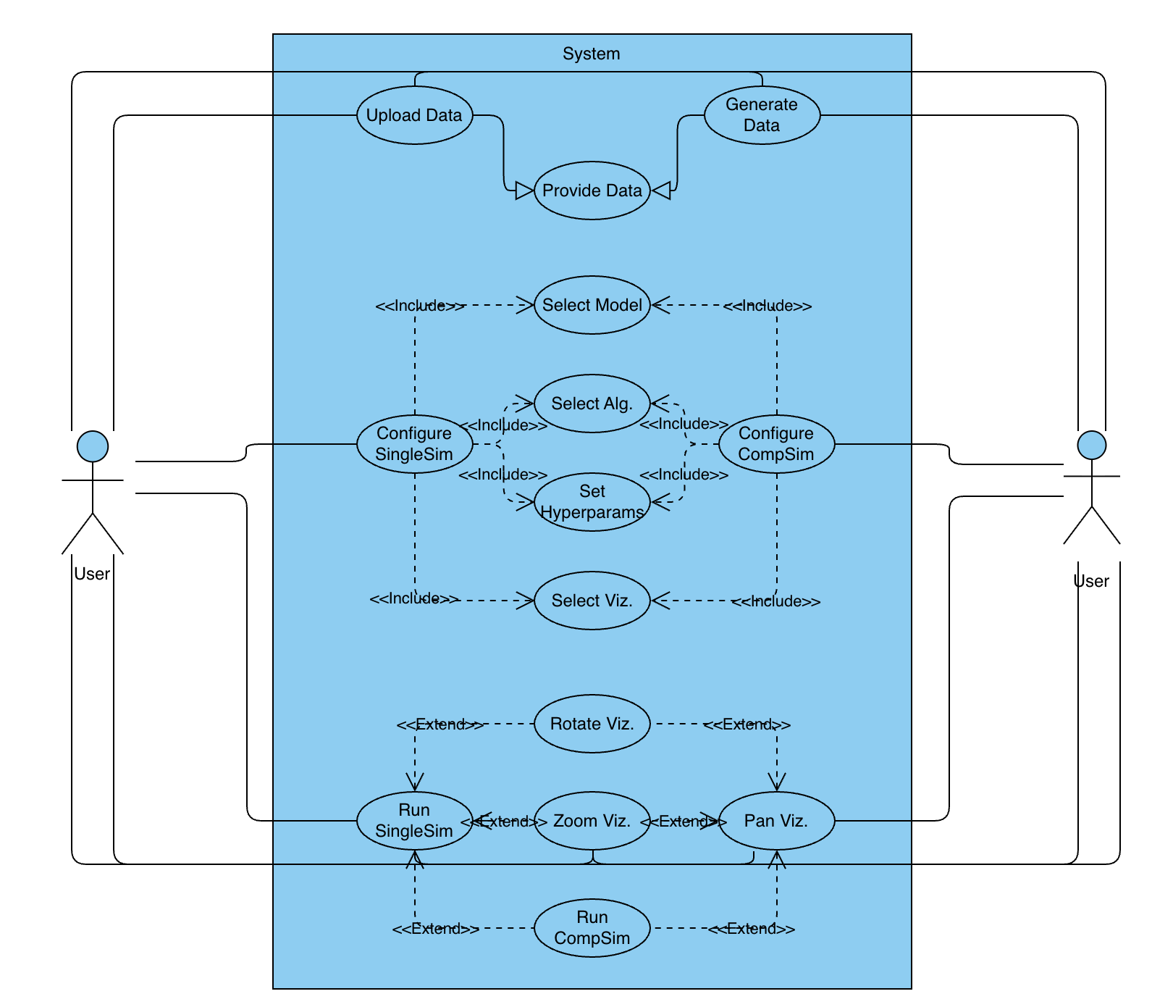

.3.5 User Interface Mock-ups
This section describes the layout of the system's main screens and the navigational paths, based on the provided low-fidelity mock-ups.
The system's UI is based on a three-panel design: a Configuration Panel on the left, a main Visualization Viewport in the center, and a Data Log at the bottom. The following mock-ups describe the user's workflow.
1. Initial State and Data-First Workflow
This mock-up shows the application's initial state ("page_1") and the data-first workflow.
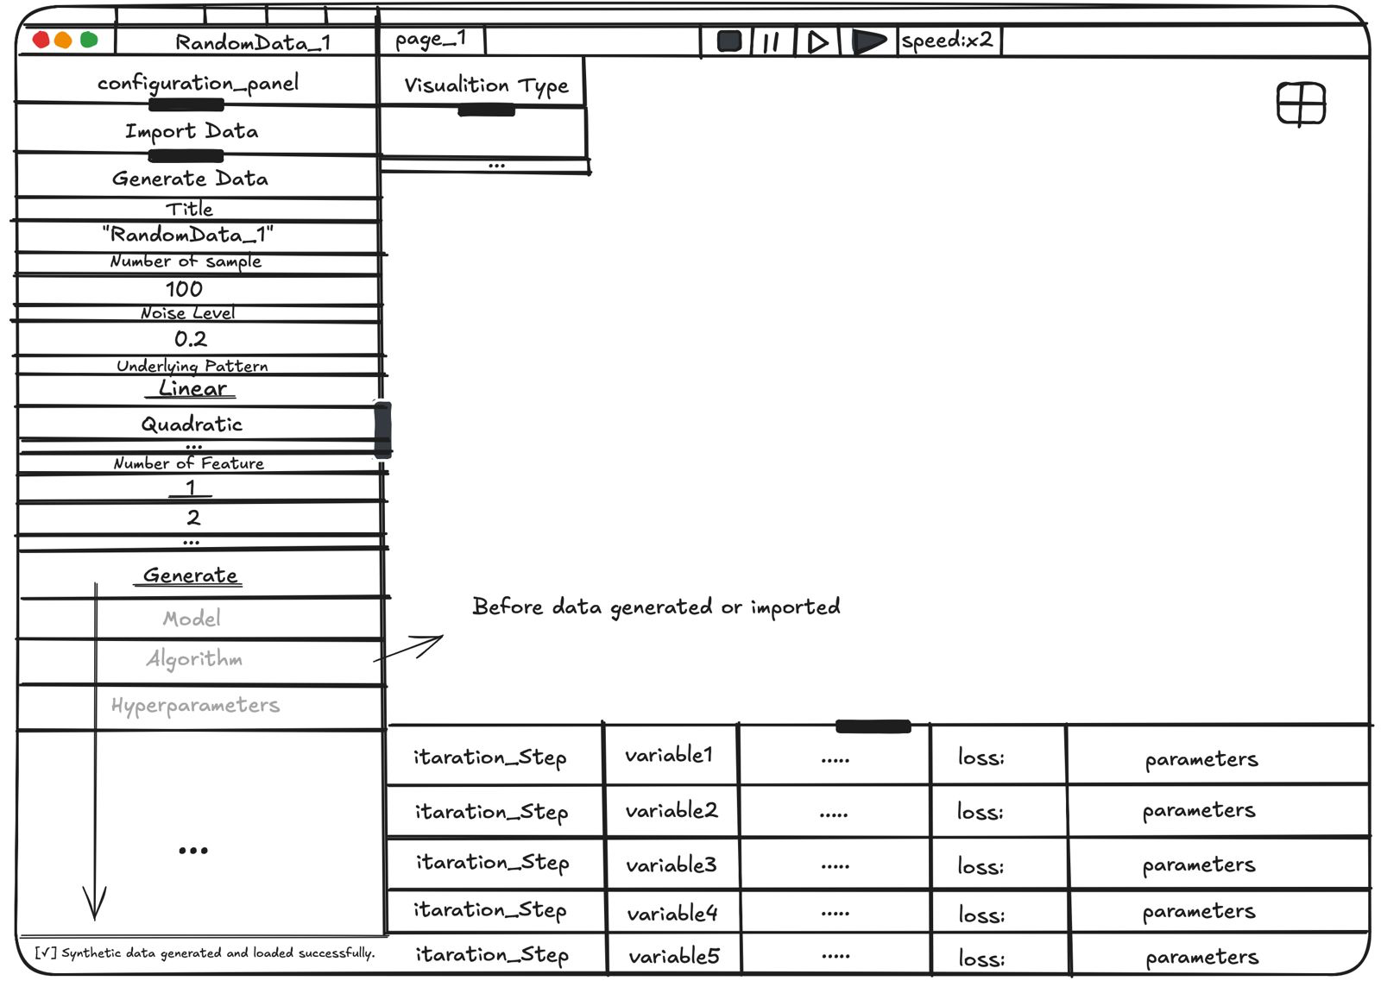
- Logical Workflow: The Configuration Panel (left) correctly places the Import Data and Generate Data sections at the top.
- Disabled State: The Model, Algorithm, and Hyperparameters sections are shown as disabled (grayed out). The annotation "Before data generated or imported" explicitly states that data must be provided before configuration can begin, satisfying requirement NFR-05 (Clarity).
- Data Generation: The Generate Data section is expanded, showing all necessary parameters for synthetic data creation (Title, Number of Sample, Noise Level, Underlying Pattern, Number of Feature).
- Feedback: Upon clicking the Generate button, a "toast" notification ([✓] Synthetic data generated...) appears in the notification line (bottom left) to confirm success.
2. Main Simulation View (Single Simulation)
This mock-up shows the primary simulation view after the user has loaded data (exp_data) and configured a single simulation.
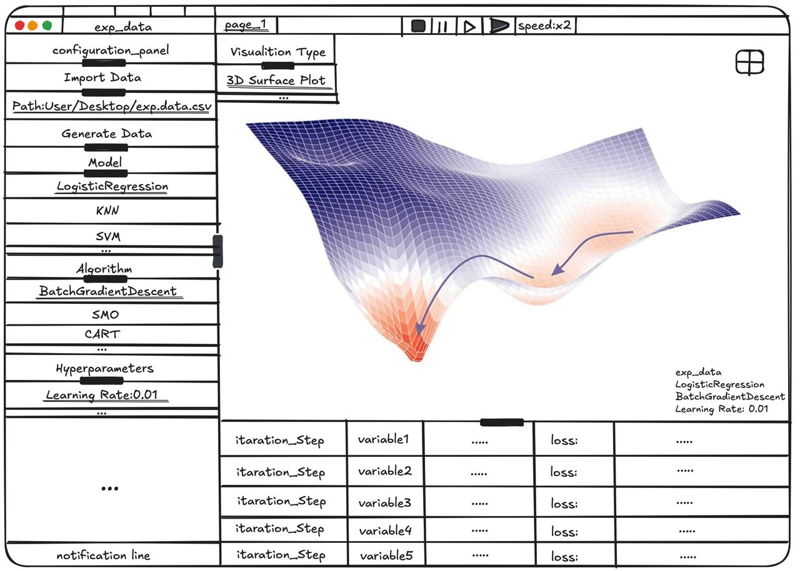
- Active State: The Configuration Panel (left) now shows the selected Model (LogisticRegression) and Algorithm (BatchGradientDescent). These sections are now enabled.
- Visualization & Control: The Visualization Viewport (center) displays the selected 3D Surface Plot for "page_1". The simulation controls (Play, Pause, Step, Speed) are visible at the top.
- Data Log: The Data Log (bottom) populates with real-time data (itaration_Step, variable1, loss, etc.) as the simulation runs.
- Status Bar: A permanent status bar (bottom right) displays the active configuration for "page_1" (exp_data, LogisticRegression, etc.), providing constant context.
3. Comparative Analysis View (Multiple Pages)
This mock-up shows the Comparative Analysis view (UC-08), which the user accesses by adding a new page (e.g., "page_2").
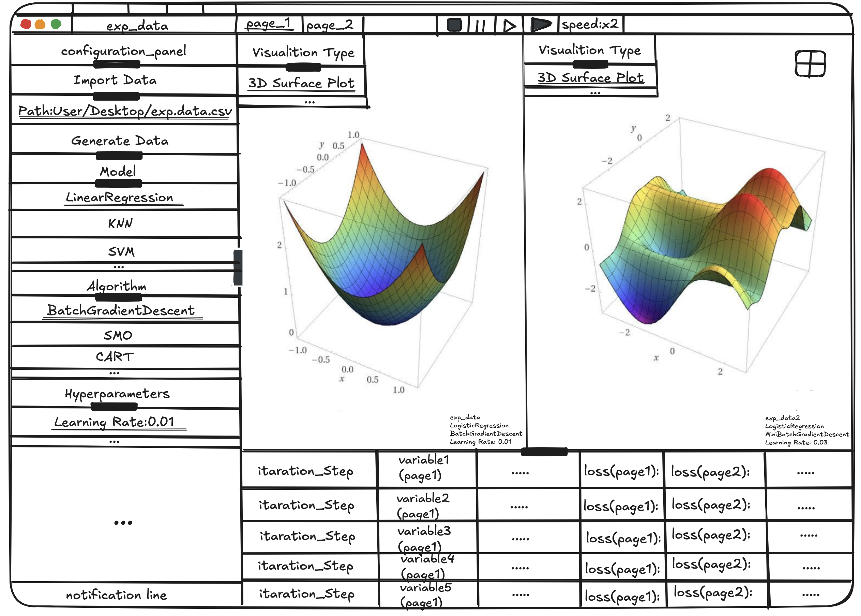
- Tabbed Interface: The top bar now shows two active tabs: page_1 and page_2.
- Split-Screen Viewport: The Visualization Viewport is split, allowing the user to view the 3D graphs from both simulations side-by-side in real-time.
- Combined Data Log: The Data Log (bottom) dynamically changes its structure to support comparison. It now displays columns for loss(page1) and loss(page2) in the same table, allowing for direct, iterative comparison.
- Independent Status Bars: Two separate status bars are displayed (bottom right) to provide context for each of the two active simulations.

4. Glossary
This section defines important application domain concepts and technical terms used throughout the document to ensure consistency.
- Algorithm (Optimization Algorithm): A specific method or process (e.g., Gradient Descent, Brute Force) used to iteratively adjust the model's variables to minimize the Cost Function.
- Cost Function (or Loss Function): A mathematical function that measures the "error" or "cost" of a model. It quantifies how poorly the model is performing. The primary goal of the simulation is to visualize the surface of this function and the algorithm's path to its minimum value.
- Data Log: The UI panel (at the bottom of the screen) that displays a tabular, step-by-step log of simulation metrics, such as iteration number, loss, and variable values.
- Hyperparameter: A configuration setting for an optimization algorithm (e.g., Learning Rate) that is set by the user before the simulation begins and is not learned during the process.
- Iteration (or Step): A single calculation or update cycle performed by the optimization algorithm. The simulation allows the user to run, pause, or step through these iterations.
- Model (ML Model): A mathematical representation of a real-world process (e.g., Linear Regression). The simulation seeks to find the best variables for this model.
- Synthetic Data: Artificially generated data used to test or visualize the simulation. This is distinct from user-imported data.
- Variable (or Model Parameter / Weight): The internal values that the model adjusts during training to minimize cost (e.g., the slope and intercept in a linear regression model).
- Visualization Viewport: The main, central panel of the UI responsible for rendering the 2D or 3D visualizations of the cost function or model.

