Project Title: ML-ViSSim: Interactive 3D Cost Function Educational Simulation
System Design Document

1. Introduction
The purpose of the Introduction section is to provide a brief overview of the software architecture and the design goals. This document outlines the high-level system architecture for the ML-ViSSim project, defining its core components, their responsibilities, and their interactions.
This design is a direct response to the needs defined in the Requirements Analysis Document (RAD).

1.1 Purpose of the System
The purpose of the ML-ViSSim system is to provide an interactive 3D/2D educational simulation environment. It is designed for students of Machine Learning to intuitively visualize and compare the behavior of optimization algorithms and hyperparameter tuning. The system must process complex ML calculations and render them in a real-time, interactive 3D viewport.

1.2 Design goals
To achieve the system's purpose, the following design goals (listed by priority) have been established:
- 1. Modularity (High Priority): The core simulation logic (ML model calculations) must be completely decoupled from the presentation logic (UI and 3D visualization). This allows the calculation engine (Python) and the visualization engine (Unity) to be developed, tested, and modified independently.
- 2. Performance (High Priority): The system must handle two distinct performance loads:
  - Calculation Performance: The ML backend must execute complex iterations efficiently.
  - Rendering Performance: The 3D visualization (graphs, paths) must be smooth, responsive, and manipulatable in real-time.
- 3. Extensibility (Medium Priority): The architecture must allow for new ML Models, Algorithms, and Visualizations to be added in the future with minimal changes to the core system components (e.g., adding a new Python algorithm script without needing to rebuild the Unity application).
- 4. Portability (Medium Priority): The final application should be a standalone desktop application capable of running on major operating systems (Windows, macOS, Linux).

2. Current Software Architecture
As documented in the RAD, there is no existing, unified "Current Software Architecture" for this problem.
The current "system" is a fragmented and manual process, composed of disconnected tools:
- Writing and executing Python scripts for ML model training.
- Using static, non-interactive plotting libraries (e.g., matplotlib) to generate 2D graphs after the process has finished.
- Manually comparing results from different scripts.
This project's proposed architecture is not replacing an existing architecture; it is creating a new, integrated system to solve the inefficiencies of the current fragmented process.

3. Proposed Software Architecture
This section documents the system design model for the new system. It is divided into five subsections that define the high-level architecture.

3.1 Subsystem decomposition
The architecture is decomposed into two primary, decoupled subsystems, following a Client-Server architectural pattern. This pattern is chosen to meet our high-priority design goal of Modularity, separating calculation logic from presentation logic.
A third, non-executable subsystem (Communication-Bridge) is defined to manage the interface between them.
- 1. Unity-Frontend (Client Subsystem)
  - Responsibilities: This subsystem is responsible for all user interaction, UI rendering, and 3D visualization. It handles:
    - Rendering the UI panels (Configuration, Data Log) as defined in the mock-ups.
    - Accepting all user input (button clicks, slider changes, data imports).
    - Rendering the 3D/2D visualization viewports.
    - Dynamically generating and updating 3D/2D graph meshes based on data from the backend.
    - Managing the overall application state (e.g., "page_1" vs. "page_2" comparison view).
- 2. Python-Backend (Server Subsystem)
  - Responsibilities: This subsystem is a headless (no UI) service responsible for all mathematical computation and simulation logic. It handles:
    - Generating synthetic data based on user parameters.
    - Parsing and loading user-imported data.
    - Executing all ML model logic and optimization algorithm iterations.
    - Calculating cost function values.
    - Returning simulation data (iteration results, graph data) to the Unity-Frontend.
- 3. Communication-Bridge (Interface)
  - Responsibilities: This is not a separate executable but the defined API contract (interface) that allows the two subsystems to communicate.
  - Pattern: The Unity-Frontend (client) will make requests (e.g., via HTTP/REST or WebSockets) to the Python-Backend (server), which will respond with data (e.g., JSON).
A UML Component or Package Diagram would be used here to visually represent these three subsystems and their dependencies.
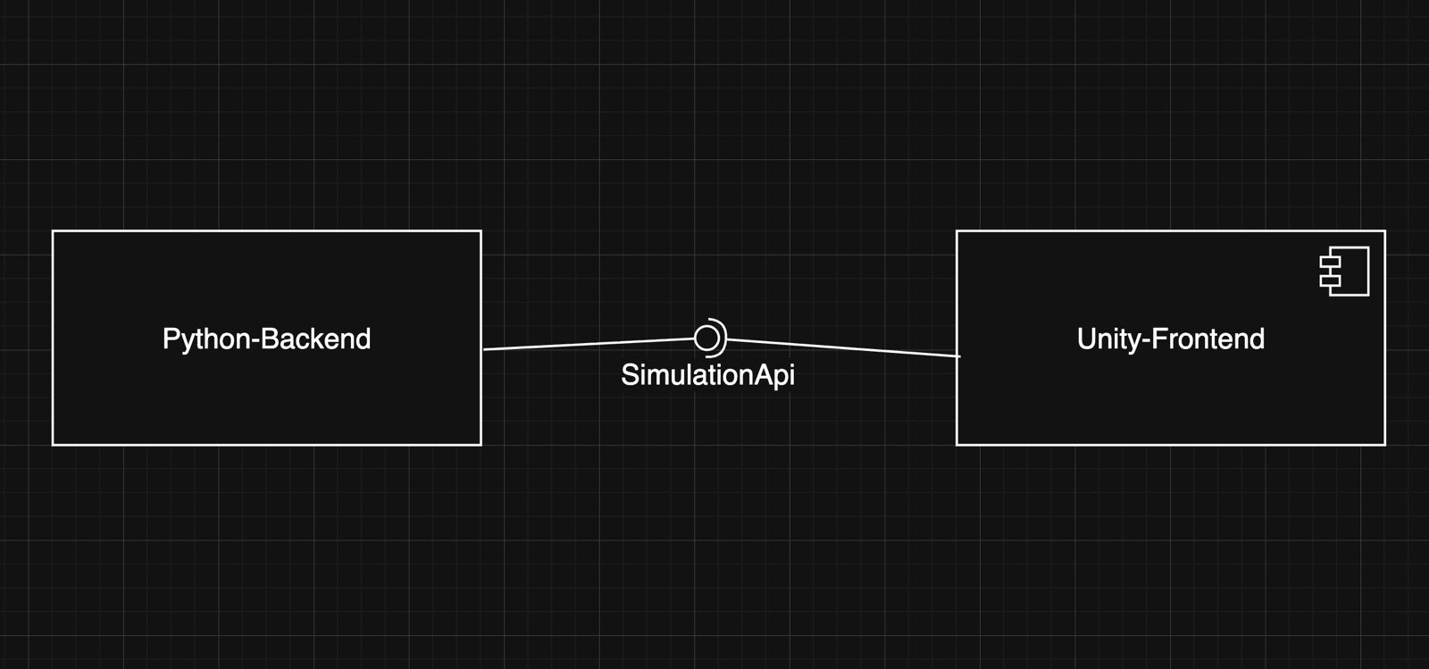

3.2 Hardware/software mapping
The system is designed as a standalone desktop application running entirely on the user's local machine.
- Host Node: User Desktop (PC/Mac/Linux)
  - Artifact 1: ML-ViSSim Application (.exe, .app, etc.)
    - This is the Unity-Frontend subsystem, compiled as a native executable. The user launches this artifact.
  - Artifact 2: Python Service (.py process)
    - This is the Python-Backend subsystem.
    - This service will be bundled with the Unity application and launched as a background (child) process by the Unity application at startup.
  - Communication Path: The Unity-Frontend application will communicate with the Python-Backend service via the localhost network (e.g., http://127.0.0.1:5000).
A UML Deployment Diagram would be used here to show the User Desktop node, the two artifacts (Unity App, Python Service) running on it, and the localhost communication path
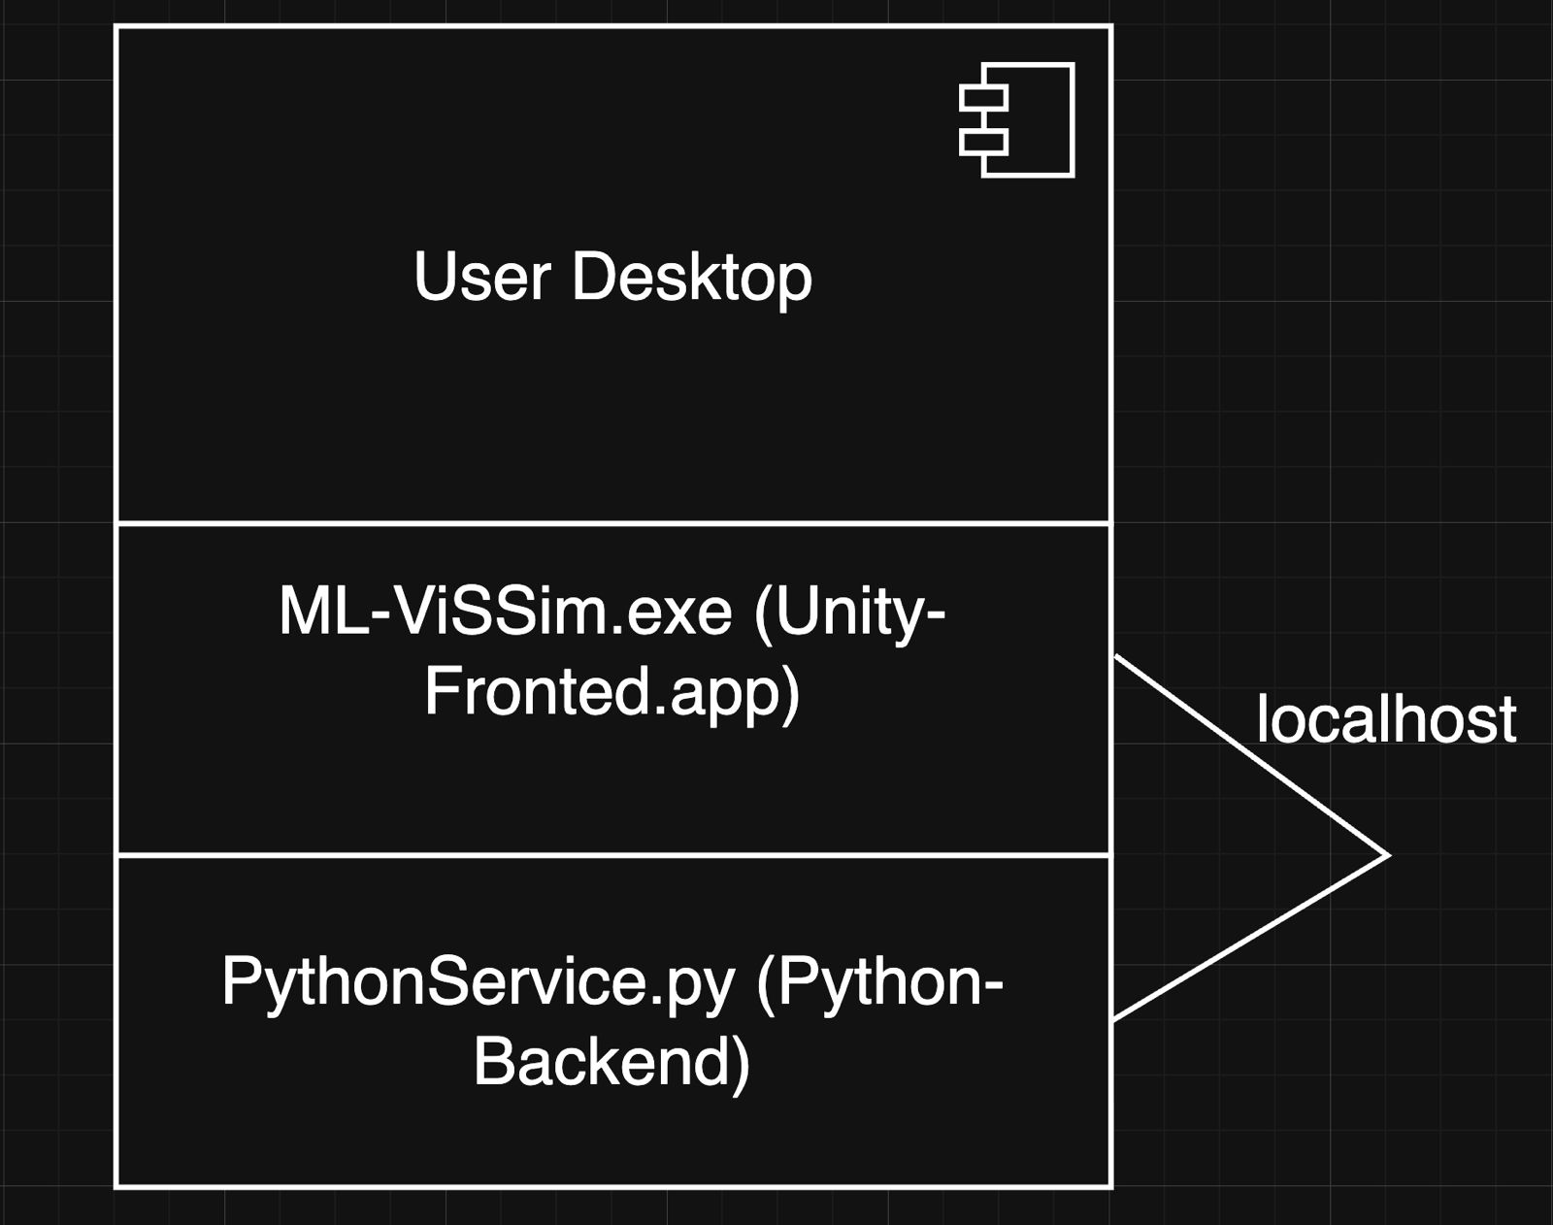.

3.3 Persistent data management
This system does not require a dedicated database or complex persistent data management infrastructure.
- Data Storage: Data is managed in two ways, as defined in the RAD:
  - User-Provided Files: The system loads data from user-provided files (e.g., .csv). Persistence is the user's responsibility.
  - In-Memory Data: Synthetically generated data is created and held in memory (RAM) for the duration of the user's session and is not saved unless the user explicitly exports it (a feature not currently in scope).
- Session State: The simulation configuration (e.g., "page_1" settings) is also held in-memory and is non-persistent.

3.4 Access control and security
This system is a local, single-user desktop application.
- Access Control: There is no user authentication, login, or role-based access control. The RAD defines only one User actor.
- Security: Security is limited to the host Operating System's file permissions. The application will require standard read-access to the file system to allow the user to select and Import Data files. The Python-Backend service will only be bound to localhost and will not be exposed to the external network.

3.5 Boundary conditions
This section describes the system's behavior at startup, shutdown, and in error states.
- Start-up Condition:
  - User launches the ML-ViSSim Application (Unity executable).
  - The Unity app immediately launches the Python-Backend service as a child process.
  - The Unity app displays a "Loading..." screen while it pings the localhost service.
  - Once the Python service responds with a "ready" signal, the main UI (as defined in the mock-ups) is loaded and enabled.
- Shutdown Condition:
  - User closes the ML-ViSSim Application window.
  - The Unity app sends a "shutdown" signal to the Python-Backend child process.
  - Both processes terminate.
- Error Condition (Boundary Use Case): Python Service Fails
  - Actor: User
  - Trigger: The Python-Backend service fails to start (e.g., a port is busy, Python is not found) or crashes during operation.
  - Response: The Unity-Frontend (which is monitoring the service) will detect the connection loss. It will display a non-recoverable error message (e.g., "Simulation Service connection lost. Please restart the application.") and disable all simulation controls.
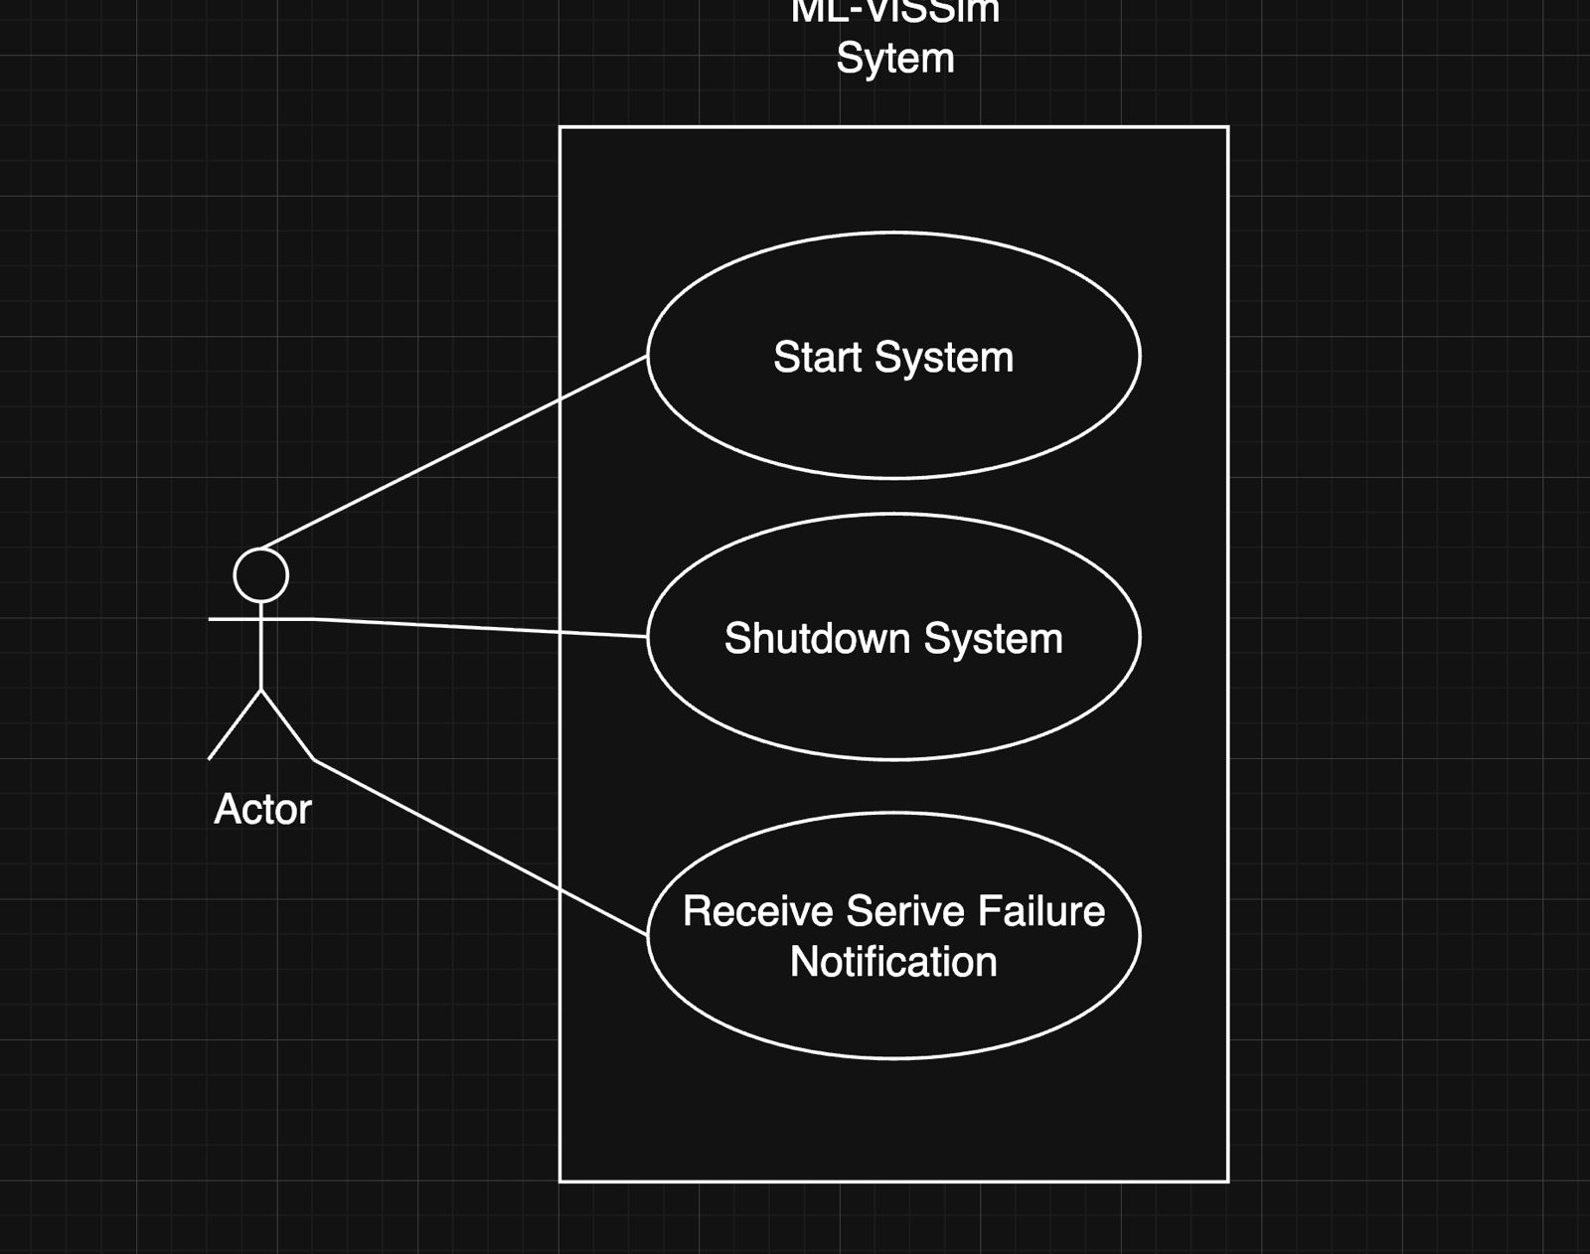

4. Subsystem Services
This section describes the services provided by each subsystem , defining the boundaries between them. In our Client-Server architecture, the Python-Backend acts as the service provider, and the Unity-Frontend acts as the service consumer.
A UML component diagram would be used here to visually represent the Python-Backend component. This component would expose a single "lollipop" interface (e.g., ISimulationService). The Unity-Frontend component would be shown consuming this interface, illustrating the dependency.
The ISimulationService provided by the Python-Backend includes the following core services, which are called by the Unity-Frontend:
- Service: GenerateSyntheticData(parameters)
  - Description: This service is called by Unity when the user clicks the "Generate" button. It takes the data generation parameters (e.g., number of samples, features, noise) defined in the UI. The backend generates the data, loads it into its memory, and returns a unique data_id to Unity.
- Service: LoadUserData(file_content)
  - Description: This service is called by Unity when the user clicks "Import Data". Unity reads the file from the user's disk and sends its content (e.g., CSV as a text string) to the backend. The backend parses and loads this data into memory, returning a data_id.
- Service: GetCostSurfaceData(data_id, model_type, parameters)
  - Description: This is a one-time, heavy calculation call used to draw the 3D/2D graphs. Unity requests the "terrain" of the cost function. The backend runs a "brute-force" or "grid search" calculation, sampling the model's cost over a 2D grid of variable values (e.g., calculating 'Cost' for 100 different 'b0' values and 100 different 'b1' values). It returns a large array of (x, y, z) coordinates that Unity uses to construct the 3D mesh.
- Service: RunSimulation(data_id, model_type, algorithm, hyperparameters)
  - Description: This service is called when the user presses the "Play" button for a full simulation. The backend runs the entire simulation (e.g., all 1000 iterations of Gradient Descent). It returns a complete log of the entire run, such as an array of (iteration_step, loss, variables) results, which Unity can then play back at the user-defined speed.
- Service: CalculateNextStep(data_id, model_type, algorithm, hyperparameters, current_state)
  - Description: This service is called when the user presses the "Step" button. It takes the current state of the simulation (e.g., current variables, current iteration number) and calculates only the next single iteration. It returns the single result for that new step.
- Service: RunHyperparameterSearch(data_id, model_type, search_parameters)
  - Description: This service is used for non-Gradient-Descent models like KNN or Random Forest. It runs a hyperparameter search on the backend (e.g., testing K from 1 to 20) and returns an array of results (e.g., (k_value, error_rate)) for Unity to plot as a 2D graph.
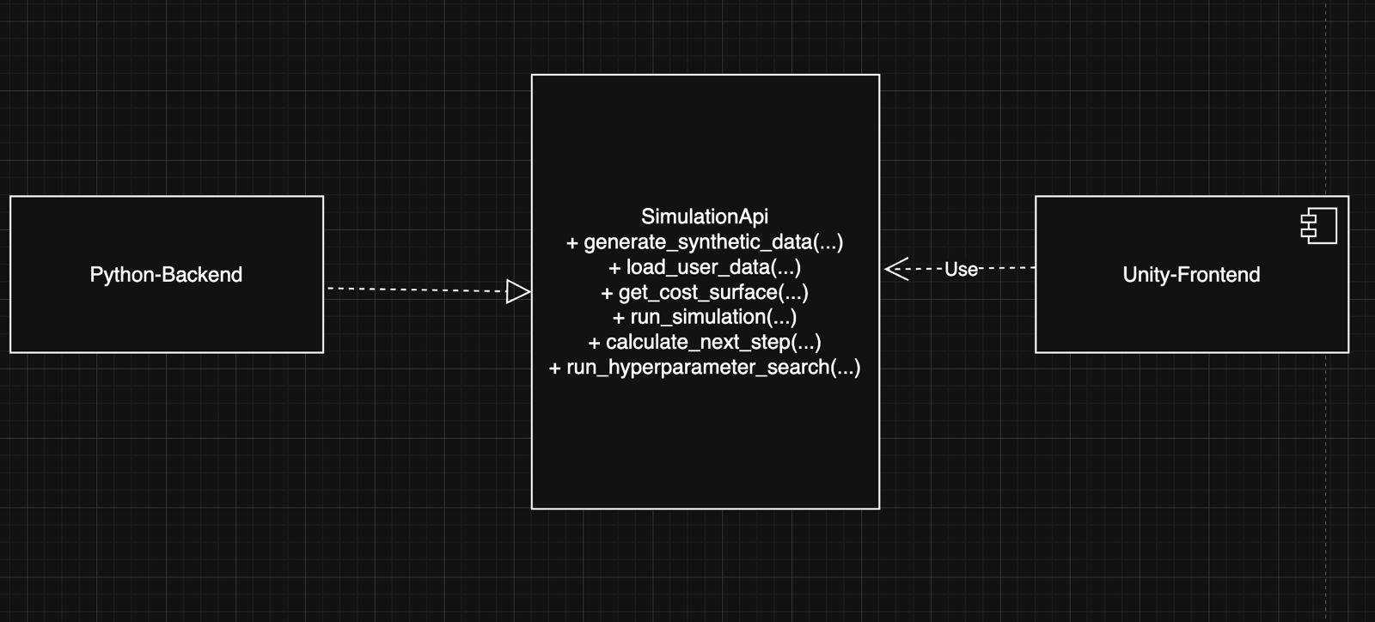

5. Glossary
This section describes definitions, acronyms, and abbreviations used in this report.
- API (Application Programming Interface): The set of rules and protocols (services) that allow the Unity-Frontend and Python-Backend to communicate.
- Client: The subsystem that requests services. In this architecture, the Unity-Frontend.
- Server: The subsystem that provides services. In this architecture, the Python-Backend.
- Service: A specific function or capability exposed by a subsystem (e.g., CalculateNextStep).
- Subsystem: A major, high-level architectural component of the project (e.g., Unity-Frontend).

