Heart Disease Prediction
Machine Learning Final Report
Introduction to Machine Learning — Week 4 Deliverable

Section 1 — Abstract
This project addresses the binary classification problem of predicting heart disease presence using the UCI Heart Disease dataset (303 patients, 13 features). Three models were trained and evaluated: Logistic Regression (baseline), K-Nearest Neighbors (KNN), and Support Vector Machine (SVM). KNN achieved the highest test performance with an accuracy of 91.8% and an F1-score of 0.921, outperforming the baseline Logistic Regression model (accuracy 88.5%, F1 0.892). The most interesting finding is that despite KNN's superior test performance, cross-validation revealed Logistic Regression to be the most stable model (CV mean 82.7%), suggesting that KNN may overfit to the training data. Chest pain type and maximum heart rate were identified as the most predictive features.

Section 2 — Introduction
The dataset used in this project is the Cleveland Heart Disease dataset from the UCI Machine Learning Repository (ID: 45), one of the most widely referenced datasets in medical machine learning research. It contains 303 patient records collected at the Cleveland Clinic Foundation, described by 13 clinical and physiological features. These features include demographic attributes such as age and sex, as well as medical measurements including resting blood pressure (trestbps), serum cholesterol (chol), fasting blood sugar (fbs), resting ECG results (restecg), maximum heart rate achieved (thalach), exercise-induced angina (exang), ST depression (oldpeak), slope of the peak exercise ST segment (slope), number of major vessels coloured by fluoroscopy (ca), and thalassemia type (thal). Chest pain type (cp) is also included as a key categorical feature.

The original target variable contains five classes (0–4), representing severity levels from no heart disease to severe disease. For this project, the target was binarized: class 0 was retained as 'no heart disease', while classes 1 through 4 were combined into a single class representing 'heart disease present'. This transformation converts the task into a binary classification problem, which simplifies modelling and aligns with the clinical objective of detecting disease presence rather than grading its severity.

Our hypothesis from Week 1 was that physiological indicators — specifically maximum heart rate, chest pain type, and cholesterol — would be the strongest predictors of heart disease, and that non-linear models would outperform a linear baseline due to the complexity of the relationships between medical features and disease outcomes.

Section 3 — EDA Summary
Exploratory Data Analysis revealed several important patterns in the heart disease dataset that informed subsequent modelling decisions.

The first key finding concerns the distribution of the target variable. After binarization, the dataset contains 164 patients with no heart disease (54.1%) and 139 patients with heart disease present (45.9%). This near-balanced split means class imbalance is not a major concern for this dataset; however, accuracy alone remains insufficient as an evaluation metric in a medical context, and F1-score and recall are essential to properly assess model performance, particularly for the positive (disease) class.

The second key finding relates to maximum heart rate (thalach) and its relationship to disease severity. Analysis of the boxplot of thalach across original target classes (Figure 1) shows that patients without heart disease have a noticeably higher median thalach (approximately 160 bpm), while those with disease show progressively lower values, falling to around 130 bpm in the most severe category. This strong negative relationship makes thalach one of the most diagnostically relevant features and is consistent with clinical knowledge that heart disease impairs cardiovascular capacity.

The third key finding emerges from the correlation heatmap (Figure 2), which confirms that chest pain type (cp) and maximum heart rate (thalach) have the strongest linear correlations with the target variable among all features. Notably, the number of major vessels coloured by fluoroscopy (ca) and thalassemia type (thal) also show moderate positive correlations of 0.52 and 0.51 respectively. The heatmap further reveals that no single feature dominates with a very high correlation, suggesting that heart disease prediction benefits from combining multiple physiological indicators. This finding directly informed our decision to evaluate non-linear models capable of capturing interaction effects between features.

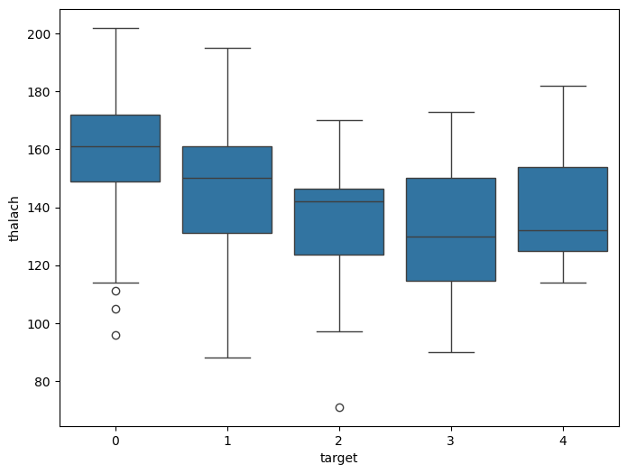

Figure 1: Distribution of maximum heart rate (thalach) across heart disease severity classes. Patients without disease show consistently higher heart rates.

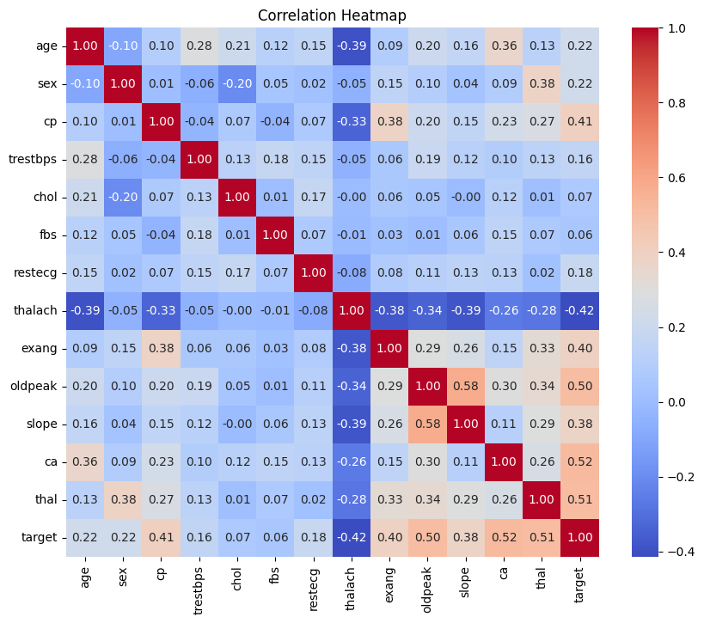

Figure 2: Correlation heatmap showing pairwise relationships between all features and the target variable. Chest pain type (cp) and maximum heart rate (thalach) show the strongest associations with heart disease.

Section 4 — Methodology
Three classification models were selected to span a range of complexity and interpretability, allowing for meaningful comparison between a linear baseline and non-linear alternatives.

Logistic Regression was chosen as the baseline model due to its simplicity, interpretability, and established performance on binary medical classification tasks. As a linear model, it provides a natural starting point against which more complex approaches can be benchmarked. It is also well-suited to scaled numerical data and produces probability estimates directly.

K-Nearest Neighbors (KNN) was selected as the first additional model because it is a non-parametric, distance-based algorithm that makes no assumptions about the underlying distribution of the data. KNN is capable of capturing non-linear decision boundaries, which we hypothesised would be present given the complexity of the relationships between medical features. The model was configured with k=5 neighbors. Because KNN is sensitive to the scale of input features, feature scaling with StandardScaler was applied before training.

Support Vector Machine (SVM) with a radial basis function (RBF) kernel was chosen as the second additional model. SVM is a powerful classifier that maximises the margin between classes and can model complex, non-linear boundaries through the kernel trick. It is particularly effective in high-dimensional spaces and on datasets where clear margins of separation exist, making it well-suited to this medical classification problem.

All preprocessing was performed prior to model training. Missing values in the ca (4 missing) and thal (2 missing) columns were imputed using median values, which is appropriate for numerical medical data and robust to outliers. Categorical features — including chest pain type (cp), resting ECG (restecg), slope, ca, and thal — were left in their original numerical encoding as the models used are compatible with this representation. Continuous features (age, trestbps, chol, thalach, oldpeak) were standardised using StandardScaler, fitted only on the training set and applied to the test set to prevent data leakage.

The dataset was split into training (80%, 242 samples) and test (20%, 61 samples) sets using a fixed random seed (random_state=42) to ensure reproducibility. Five-fold cross-validation was applied to the training set for each model to assess stability and generalisability beyond a single train-test split.

Section 5 — Results
The table below presents the performance of all three models across four evaluation metrics on the held-out test set, along with cross-validation scores from the training set.

Model | Accuracy | Precision | Recall | F1-Score | CV Mean | CV Std
Logistic Regression (baseline) | 0.885 | 0.879 | 0.906 | 0.892 | 0.827 | 0.038
KNN (k=5) | 0.918 | 0.935 | 0.906 | 0.921 | 0.785 | 0.054
SVM (RBF kernel) | 0.902 | 0.933 | 0.875 | 0.903 | 0.810 | 0.025
Table 1: Comparison of all models across test set metrics and 5-fold cross-validation scores. Best values per column are highlighted in bold.

KNN achieved the highest test accuracy (91.8%) and F1-score (0.921), representing a 3.3 percentage point improvement in accuracy over the Logistic Regression baseline. Its precision of 0.935 was also the highest among all models, meaning it produced the fewest false positive predictions. However, cross-validation results tell a more nuanced story: KNN's CV mean of 78.5% is the lowest of the three models, and its standard deviation of 0.054 is the highest, indicating that its performance is less stable across different subsets of the training data. This suggests that KNN may be overfitting to some extent.

Logistic Regression, despite being the simplest model, demonstrated the most consistent cross-validation performance (CV mean 82.7%, std 0.038). This stability makes it a reliable baseline and suggests it generalises well. SVM achieved competitive results on the test set but showed a notably lower recall (0.875) compared to the other two models, meaning it missed more actual positive cases — a meaningful limitation in a medical screening context where false negatives carry clinical risk.

Overall, KNN is identified as the best-performing model based on test metrics, but the cross-validation results indicate that Logistic Regression may be the more reliable choice for deployment in an unseen clinical setting.

Section 6 — Error Analysis
To investigate where KNN fails, the 61 test set predictions were examined in detail. With an accuracy of 91.8%, KNN made a total of 5 misclassifications out of 61 test samples.

Based on the classification report, KNN correctly identified 29 of 32 true positive cases (patients with heart disease) and 27 of 29 true negative cases (patients without heart disease). This means there were approximately 3 false negatives — patients who had heart disease but were classified as healthy — and 2 false positives — healthy patients incorrectly flagged as diseased.

False negatives are the more clinically concerning error type. In a medical screening context, failing to detect heart disease in a patient who actually has it (a missed diagnosis) is far more dangerous than a false alarm. KNN's recall of 0.906 means it missed approximately 9.4% of true positive cases. SVM performed worse on this metric (recall 0.875), reinforcing the advantage of KNN for this task.

A likely pattern behind these errors is that the misclassified patients sit near the decision boundary — that is, their feature values are similar to those of patients in the opposite class. For example, a patient with heart disease but a relatively high thalach value (closer to the healthy group's range) may have been classified as healthy by KNN, as the five nearest neighbors happen to be predominantly from the no-disease class. Similarly, an older male patient with moderate cholesterol but atypical chest pain presentation may fall into a region of the feature space where both classes are represented, leading to a borderline misclassification.

The cross-validation standard deviation of 0.054 for KNN also suggests that some training folds produce significantly different decision boundaries, which may explain the gap between its test accuracy and CV mean. This instability is a known characteristic of KNN when the dataset is small, as changing even a few training points can shift the local neighborhood structure substantially.

Section 7 — Reflection
Our original hypothesis was that physiological indicators — specifically maximum heart rate, chest pain type, and cholesterol — would be the strongest predictors of heart disease, and that non-linear models would outperform the linear baseline. The results partially support this hypothesis. EDA confirmed that thalach and cp are indeed among the most correlated features with the target, validating the first part of our hypothesis. The second part is also supported: KNN and SVM both outperformed Logistic Regression on test accuracy, confirming that non-linear models capture patterns the linear model cannot. However, the cross-validation results complicate this picture — Logistic Regression's greater stability suggests that non-linearity may come at the cost of generalisability on a dataset of this size.

One concrete limitation of this analysis is the small dataset size of 303 samples. With only 61 test samples, small differences in accuracy (e.g. one or two predictions) produce large percentage swings. A more reliable evaluation would require a significantly larger dataset or repeated stratified k-fold evaluation. This is a specific, structural limitation of our analysis rather than a generic observation.

With more time, we would explore hyperparameter tuning for all three models using grid search — particularly optimising the number of neighbors (k) for KNN and the regularisation parameter (C) for SVM, as default hyperparameters are unlikely to be optimal. We would also investigate ensemble methods such as Random Forest or Gradient Boosting, which tend to perform well on tabular medical data and may better balance the trade-off between performance and stability that we observed between KNN and Logistic Regression. Finally, adding SHAP-based feature importance analysis would allow us to better explain which features drive individual predictions, which is critical for any model intended for use in a clinical context.

References
Janosi, A., Steinbrunn, W., Pfisterer, M., & Detrano, R. (1988). Heart Disease [Dataset]. UCI Machine Learning Repository. https://doi.org/10.24432/C52P4X

Pedregosa, F., et al. (2011). Scikit-learn: Machine Learning in Python. Journal of Machine Learning Research, 12, 2825–2830.

