Json.php
where file is located:
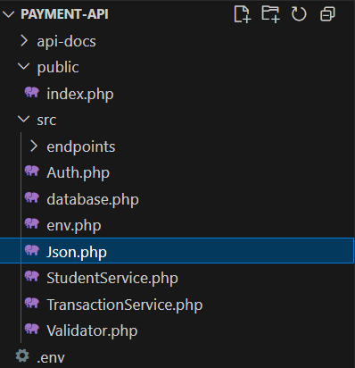

The purpose of this file is to return a message, whether successful or an error, in JSON format.

enable strict types; without it, PHP is loose with types, with it, PHP becomes strict
declare(strict_types=1);

We use a the same namespace used previously, so this class is part of the same group of files. We use it by use App\Json
namespace App;

we create a final class because we don’t want it to be extended or changed. We named it Json it has two functions: ok for success messages and error for error messages
final class Json{

We create a function called ok it has two attributes:
int $code: it has the HTTP status code, such as 200, 201, etc.
array $data: is the response payload
public static function ok(int $code, array $data){
for the client to read the data correctly we set HTTP header

