database.php

where file is located:
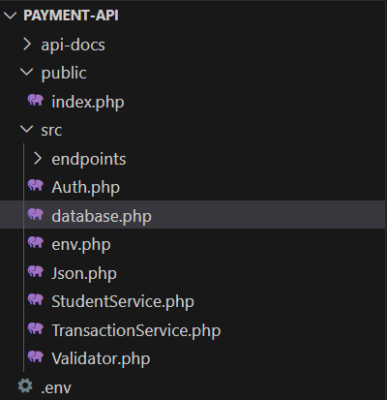

The purpose of this file is to connect to the database and hold a connection for the whole request.

We create a new namespace called App, so we can organize the code use this database connection easily in other files.
namespace App;

we use PDO and PDOException:
PDO: PHP Data Object, It’s a built-in class in PHP that lets you connect to different databases (MySQL, MariaDB, SQLite, PostgreSQL, etc.) in the same way.
We use PDO to:
- Opeb the connection
- Run SQL queries
- Prepare and execute statements safely (to prevent SQL injection)
PDOException:
- by importing it, we can catch the error inside a try and catch block
- When something goes wrong (like a bad password, wrong host, or server down), PDO throws a PDOException.
use PDO, PDOException;

we make a final class because we don’t want it to be extended or changed. We name it database and declare a private static variable $pdo, and we set it to null
final class database{
private static ?PDO $pdo=null;

we crate a static function called pdo(). Inside the method, we check if $pdo is already created and if yes, we return it to reuse the same connection

We read the data from the environment .env file by using getenv() in env.php we used putenv() to write key and value into the current PHP process environment, so now we can read it anywhere using getenv()
(as described in env.php.docx, page 4)
public static function pdo(){
//Reuse if already created
if(self::$pdo) return self::$pdo;

//Read from environment (loaded by env.php)
$host = getenv('DB_HOST') ?: '127.0.0.1';
$db = getenv('DB_NAME') ?: 'payment-systemdb';
$user = getenv('DB_USER')?: 'root';
$pass = getenv('DB_PASS')?: '';
$charset = getenv('DB_CHARSET') ?: 'utf8mb4';

We create a variable call $dsn, which stands for Data Source Name.
It’s a sting that tell PDO how and where to connect to the database, it includes the driver name, host, database name, and charset.
Think of it as a GPS route before starting to drive.
it prepares the connection details but doesn’t connect yet.
$dsn = "mysql:host=$host;dbname=$db;charset=$charset";

We make an associative array to save PDO options
1) PDO::ATTR_ERRMODE => PDO::ERRMODE_EXCEPTION
• Controls how PDO reports errors.
• Setting this to ERRMODE_EXCEPTION tells PDO to throw a PHP Exception whenever something goes wrong (e.g., bad SQL).
• This makes debugging safer and easier, because you can catch exceptions in a try/catch block.
2) PDO::ATTR_DEFAULT_FETCH_MODE => PDO::FETCH_ASSOC
• Controls the format of rows returned from queries.
• FETCH_ASSOC returns results as associative arrays (column names as keys).
• Without this, PDO defaults to FETCH_BOTH, which returns both numeric and associative keys—messy and redundant.
Example with FETCH_ASSOC:
$stmt = $pdo->query("SELECT id, name FROM users");
$row = $stmt->fetch();
// $row = ["id" => 1, "name" => "Ali"]
Without FETCH_ASSOC (default FETCH_BOTH):
$row = [0 => 1, "id" => 1, 1 => "Ali", "name" => "Ali"];

3) PDO::ATTR_EMULATE_PREPARES => false
• Controls how PDO handles prepared statements.
• Setting this to false tells PDO to use the database’s native prepared statements instead of emulating them in PHP.
• Native prepares are safer against SQL injection and allow the database to optimize queries.
Native prepares: PHP sends the query with ? directly to MySQL, and the database itself prepares and runs it. This is safer because the data and SQL are separated by MySQL, not by PHP. It also lets MySQL optimize and cache that query.
Why this matters:
– Safer: prevents edge-case SQL injection.
– Faster: lets MySQL/MariaDB cache and optimize statements.
– More predictable: works as expected with complex queries.
$opt=[
PDO::ATTR_ERRMODE => PDO::ERRMODE_EXCEPTION,
PDO::ATTR_DEFAULT_FETCH_MODE => PDO::FETCH_ASSOC,
PDO::ATTR_EMULATE_PREPARES =>false,
];

We start to create the database connection we wrap it in a try and catch block. Inside the try we use the variable $pdo and create a new PDO object,passing $dsn, $user, $pass, $opt
($user: database username, $pass: database password)
If the connection is successful, we return $pdo
try{
self::$pdo = new PDO($dsn, $user, $pass, $opt);
return self::$pdo;}
if anything fails, we catch the error by PDOException $e and return an error in JSON format using Json::error()
(it was described and explained in Json.php.docx)
catch(PDOException $e){
Json::error(500, 'DB connection failed', ['details' => $e->getMessage()]);

