StudentService.php
where file is located:
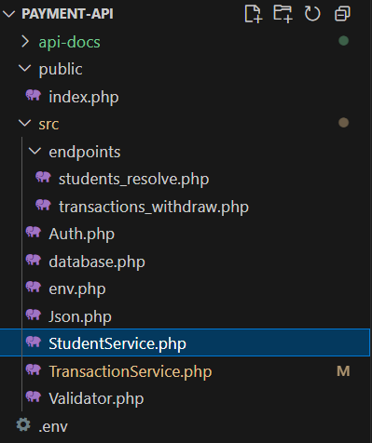

The purpose of this file is to resolve a user by their Link_ID.
The Link_ID is the same ID the user logs in with.
This resolver is essential for the withdrawal flow: it lets the system find the user’s account/card data so the user can click “Pay” instead of typing card details.
It returns account id, card id, balance, and link ID.
This method is not secure for production — it’s implemented here for educational purposes to help understand the API flow.
enable strict types; without it, PHP is loose with types, with it, PHP becomes strict
declare(strict_types=1);

We use a the same namespace used previously, so this class is part of the same group of files. We use it by use App\StudentService.
namespace App;

we use PDO: PHP Data Object, It’s a built-in class in PHP that lets you connect to different databases (MySQL, MariaDB, SQLite, PostgreSQL, etc.) in the same way.
We use PDO to:
- Opeb the connection
- Run SQL queries
- Prepare and execute statements safely (to prevent SQL injection)
use PDO;

we create a final class because we don’t want it to be extended or changed. The class will have one static function that is responsible for fetching the user data from the database.
final class StudentService{

we call the static function getByLinkid it has one parameter of type string called $linkId.
In the function, we write a SQL query to run and fetch the user data and return an associative array.
public static function getByLinkid(string $linkId){

we use a class that we created in database.php (for more info, see database.docx). we create a variable $pdo and store the static method pdo() from that class.
This allows us to use pdo() for all database operations instead of writing database::pdo() each time.
$pdo= database::pdo();
We create a variable called $start to store the SQL prepare statement inside it.
We use the prepare() function to write SQL queries safely.
In this query, we make a JOIN between two tables — accounts and card.
We use aliases (a and c) to make the query easier to read.
We join the card table (c) on the condition that both tables share the same Account_ID.
We select the specific columns we need:
- Account_ID from the accounts table
- Link_ID from the accounts table
- Card_ID and Balance from the card table
We then filter the results to match the Link_ID of the user who logged in,
and order the results by Card_ID in ascending order (ASC).
$start=$pdo->prepare
( 'SELECT
a.`Account_ID` AS account_id,
a.`Link_ID` AS link_id,
c.`Card_ID` AS card_id,
c.`Balance` AS balance
FROM `accounts` AS a
JOIN `card` AS c ON c.`Account_ID` = a.`Account_ID`
WHERE a.`Link_ID` = :link
ORDER BY c.`Card_ID` ASC
LIMIT 1'
);

:link is a named placeholder.
It represents the value we want to safely pass into the query without directly inserting it into the SQL string.
and the value we pass in execute() replaces it safely, to run the prepared statement and pass associative array where the key is the placeholder name (:link) and the value is the variable we want to use ($linkId).
Its like “Replace :link in the query with the value stored in $linkId.”
$start->execute([':link'=>$linkId]);

we create a variable called $row and store the fetched result using the fetch() function.
In fetch parameters, we set the mode to FETCH_ASSOC, which returns the result as an associative array and controls the format of rows returned from queries.
$row=$start->fetch(PDO::FETCH_ASSOC);

We check if nothing has been fetched we return nothing.
We do this by using if statement and the not operator(!).
if(!$row){
return null;
}

If everything is fine and the record exists, we return the join table we made in associative array format.
return[
'account_id' => (int)$row['account_id'],
'card_id' => (int)$row['card_id'],
'balance' => (float)$row['balance'],
'link_id' => (string)$row['link_id']
];

We explicitly cast each value to its correct data type for consistency and safety:
- account_id → integer
- card_id → integer
- balance → float
- link_id → string

