TransactionService.php
where file is located:
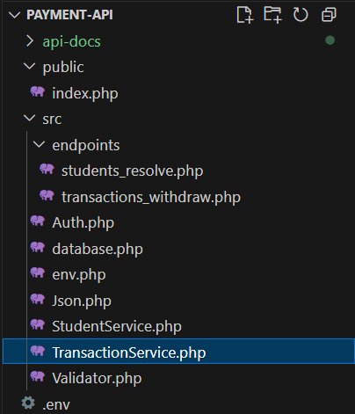

The purpose of this file is to handle business logic for handling transactions.
Also handling withdrawals subtracts money from the card and inserts a row in the transaction table, and ensures consistency using SQL transactions.
Also, to prevent double charges with the indempotency_key

enable strict types; without it, PHP is loose with types, with it, PHP becomes strict
declare(strict_types=1);

We use a the same namespace used previously, so this class is part of the same group of files. We use it by use App\TransactionService.
namespace App;
use an Exception for a try and catch block to handel any database or runtime error safely.
use Exception;
we create a final class because we don’t want it to be extended or changedcalled TransactionService that has once static function that is responsible for the withdraw(), which is responsible for the entire withdrawal process and returns the result info.
final class TransactionService{
public static function withdraw(
The function has four parameters:
- Int $cardId: it’s the number of the card in the database.
- String $product: it’s the product name that has been bought.
- String $idemkey: it’s the key that prevents any duplicates.
- Float $Amount_taken: is the amount is taken or added to the user balance.
public static function withdraw(int $cardId,string $product, string $idemkey, float $Amount_taken)

we use a class that we created in database.php (for more info, see database.docx). we create a variable $pdo and store the static method pdo() from that class.
This allows us to use pdo() for all database operations instead of writing database::pdo() each time.
$pdo= database::pdo();

We open a try block and use beginTransaction(); to start a database atomic transaction.
This means all the database operations that follow will be treated as one single unit of work.
What it does is start a transaction and doesn’t finalize changes until we explicitly commit it later using commit().
It ensures that either everything succeeds, or nothing changes in the database if an error occurs.
$pdo->beginTransaction();
We check if the idempotency key was used before.
we create a variable called $check and store the SQL prepare statement inside it.
We use the prepare() function to write SQL queries safely.
$check=$pdo->prepare('SELECT * FROM `transaction` WHERE `Idempotency_Key` = ? LIMIT 1');

We store this query in the variable $check, and use the execute() function to run it.
in the parameters of execute(), we pass the value we want to search for here it’s $idemkey.
The ? inside the SQL query acts as a placeholder, and the value we pass in execute() replaces it safely.
$check->execute([$idemkey]);

We check using an if statement. Inside the condition, we create a variable called $existing and store the fetched result using the fetch() function.
If the query finds a transaction with the same idempotency key, $existing will contain that row.
if($existing=$check->fetch()){

if we enter the if statement, that means this idempotency key was already used.
We stop the current database atomic transaction by calling commit(), since we don’t need to make any new changes.
And return an associative array, we set indepotent to true because it has the same idempotency key and transaction to the $existing variable and a note to the message that we want to show.
$pdo->commit();
return[
'idempotent' => true,
'transaction' => $existing,
'note' => 'Same Idempotency_Key used; returning previous result.'
];
}
We insert a new row in the transaction table.
Any triggers defined in the database will automatically execute when this insert happens.(for example: updating balance or setting the status).
we create a variable called $insert and store the SQL prepared statement inside it using prepare().
We store this query in the variable $insert, and use the execute() function to run it.
in the parameters of execute(), we pass the value we want to insert for Here, we want card ID, product, amount taken, and idempotency key.
$insert=$pdo->prepare(' INSERT INTO `transaction`
(`Card_ID`, `Product`, `Amount_taken`, `type`, `Idempotency_Key`)
VALUES (?, ?, ?, "withdraw", ?)');
$insert->execute([$cardId, $product,$Amount_taken, $idemkey]);

Now we want to return the transaction back to the user, it contains the same rows and columns in the database.
First, we create a new variable called $autoID and we cast the value to an integer.
We use the PDO function lastInsertId(), which returns the ID of the last inserted row in the database.
$autoID=(int)$pdo->lastInsertId();
Next, we create a variable called $get and store the SQL prepared statement inside it using prepare().
We store this query in the variable $get, and use the execute() function to run it.
in the parameters of execute(), we pass the value we want to search for here, we want the id of the last inserted row(autoID).
We store the ID of the last inserted row in $autoID.
Then we fetch the result and store it in $row as an associative array by using a function called fetch().
and we stop the current database atomic transaction by calling commit().
$get=$pdo->prepare('SELECT * FROM `transaction` WHERE `ID`= ?');
$get->execute([$autoID]);
$row=$get->fetch();
$pdo->commit();
And now we want to return the transaction to the user.

By using ferch(), we have an associative array so we can use $row[] to get the values we want to return to the user.
return[
'status' =>$row['status'],
'card_id' =>(int)$row['Card_ID'],
'type' =>$row['type'],
'Amount_taken' =>(float)$row['Amount_taken'],
'Balance_After' =>(float)$row['Balance_After'],
'Product' =>$row['Product'],
'Transaction_ID' =>$row['Transaction_ID'],
'Idempotency_key' =>$row['Idempotency_Key']
];
We end the try block.
And we make a catch block in case we run into errors.
If any error happens in the withdrawal process, PHP jumps to the catch block.
catch(Exception $e){
we use if statement to check is their an active database connection by using PDO function inTransaction()
If there is, we use the PDO rollback() function so no parial data is saved.
That prevents broken or half-finished records from entering the database.
We then return an error message in JSON format using Json::error().
We send a 500 (Internal Server Error) status code and include an associative array with extra details.
The details are fetched using the getMessage() function from the Exception object $e.(it was described and explained in Json.php.docx).

we return an empty array as the function’s return value.
if($pdo->inTransaction()){
$pdo->rollBack();
Json::error(500,'Transaction failed', ['details' => $e->getMessage()]);
return [];
}
return[];
}

