index.php
where file is located:
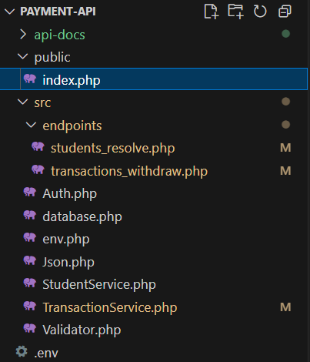

The purpose of this file is to read the HTTP method and path, and it serves as the entry point.
It includes the path and query string.
When building API we care about the path /v1/name of the path to know which “endpoint” to run.
/v1/…: current first stable version of the API
enable strict types; without it, PHP is loose with types, with it, PHP becomes strict.
declare(strict_types=1);

when the frontend and backend API are on different domains.
The browser blocks requests for security reasons unless the API explicitly allows them.
PHP automatically stores all request headers inside $_SERVER.
We create a variable called $origin to store the website domain that made the request, and if the header doesn’t exist, we use * as a default, which means allow everyone.
$origin = $_SERVER['HTTP_ORIGIN'] ?? '*';

We allow requests coming from this origin.
header('Access-Control-Allow-Origin: ' . $origin);

we tell the browser and proxies that the response can vary depending on the Origin header.
It’s a best practice to avoid caching mistakes when multiple websites call the same API.
header('Vary: Origin');

We don’t allow cookies or authorization headers(like session tokens) to be sent
We set Access-Control-Allow-Credentials to false, meaning “don’t send credentials, this API is stateless.”
header('Access-Control-Allow-Credentials: false');

we tell the browsers which HTTP methods are allowed.
We accept GET and POST mainly, but we list other flexible.
header('Access-Control-Allow-Methods: GET, POST, PUT, PATCH, DELETE, OPTIONS');
we tell the browsers which custom headers are allowed in the requests, we use:
- X-API-Key: authentication header.
- Content-Type: needed for sending JSON.
header('Access-Control-Allow-Headers: X-API-Key, Content-Type');

When a browser (not Postman or curl) wants to send a special kind of request —
for example a POST with JSON or a custom header like X-API-Key —
the browser doesn’t send it immediately.
Instead, it first sends a small check request using the method OPTIONS.
That is called a CORS preflight request.
If the API replies, “Yes, you’re allowed,”
then the browser sends the real POST request afterward.
We check what HTTP method the client used USING IF STATEMENT, $_SERVER[‘REQUEST_METHOD’] IS ‘OPTIONS’.
So the condition is true, we return a HTTP response code 204 (No Content), and exist.

if ($_SERVER['REQUEST_METHOD'] === 'OPTIONS') {
http_response_code(204);
exit;
}

We load all the helpers and bootstrap we need
require_once __DIR__ . '/../src/env.php'; //loads .env variables and sets JSON Content-Type header
require_once __DIR__ . '/../src/Json.php'; //helpers to return JSON consistently
require_once __DIR__ . '/../src/Auth.php'; //API key enforcement
require_once __DIR__ . '/../src/database.php'; //PDO connection factory
require_once __DIR__ . '/../src/Validator.php'; //input validation helpers
require_once __DIR__ . '/../src/TransactionService.php'; //business logic (transactions, student lookup, etc.)
require_once __DIR__ . '/../src/StudentService.php';
We use the namespace that we created to access the functions within it.
use App\Json;

We create a variable called $method and save the HTTP request method in it by using $_SERVER[‘REQUEST_METHOD’]
This value tells us what kind of request the client made — for example, GET, POST, PUT, DELETE, or OPTIONS.
$method = $_SERVER['REQUEST_METHOD'];

We create a variable called $path and use the function parse_url() to split a URL into pieces(path, host, query, etc),
In the parameter, we pass $_SERVER['REQUEST_URI'], which gives everything after the domain, including both the path and query string.
And we pass the component PHP_URL_PATH is a special constant built into PHP, It tells parse_url() which specific part of the URL you want to extract.
Without it we will get
[
"path" => "/v1/students/resolve",
"query" => "link_id=001"
]
With PHP_URL_PATH
/v1/students/resolve
And we store the result in $path so it is easy for reuse.
$path = parse_url($_SERVER['REQUEST_URI'], PHP_URL_PATH);

We check if $method is GET and the path is ping.
If both conditions are true, we return Json::ok (described in json.php.docx, page 3) with status code 200 and message “'ok'=> true,'service' => 'payment-api'”.
if($method=='GET' && $path=='/v1/ping'){
Json::ok(200,['ok'=> true,'service' => 'payment-api']);
}

We check if $method is POST and the path is transactions/withdraw.
If both conditions are true, we include the file transactions_withdraw.php using require.
This file contains the full withdrawal process logic.
After including it, we call exit to stop the script so no further code runs.
(transactions_withdraw.php was described in transactions_withdraw.docx)
if($method == 'POST' && $path =='/v1/transactions/withdraw'){
require __DIR__ . '/../src/endpoints/transactions_withdraw.php';
exit;
}

We check if $method is POST and the path is student/resolve.
If both conditions are true, we include the file student_resolve.php using require.
This file contains the full withdrawal process logic.
After including it, we call exit to stop the script so no further code runs.

(student_resolve.php was described in student_resolve.docx)
if($method =='GET' && $path=='/v1/students/resolve'){
require __DIR__ . '/../src/endpoints/students_resolve.php';
exit;
}
If nothing matched we return 404 status code and the method and path using Json::error (described in json.php.docx, page 4) with status code 404 and message “not found $method $path”.
Json::error(404,"Not found: $method $path");

