Transactions_withdraw.php
where file is located:
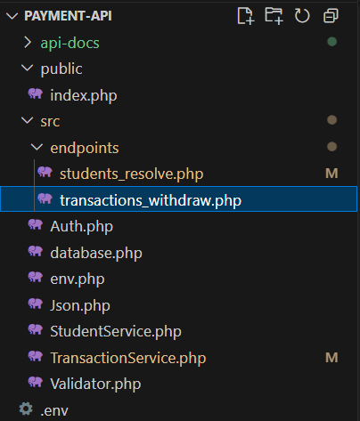

The purpose of this file is to connect to the handles withdrawal transactions.
- Validates input JSON (required fields, amount > 0).
- Delegates to TransactionService::withdraw(), which:
• Starts a DB transaction
• Checks if idempotency key already exists
• If so, returns the previous transaction instead of creating a new one
• Otherwise, inserts a new row in `transactions`
• DB triggers calculate Balance_After, update the card balance, and set status
- Returns a JSON response with the right HTTP status code.

enable strict types; without it, PHP is loose with types, with it, PHP becomes strict.
declare(strict_types=1);

We use the namespace that we created to access the functions within it.
use App\Validator;
We use the namespace that we created to access the functions within it.
use App\Json;
We use the namespace that we created to access the functions within it.
use App\TransactionService;

we check if the body is not JSON valid, by using the static function we created in Validator.php (it was described fully in Validator.php.docx, page 3).
$body=Validator::jsonBody();

We get all HTTP request headers safely.
we use the function function_exists(‘getallheaders’ ) to check if the function exists in the current environment.
if it exists, we call it to read all request headers and store them in $headers.
If it doesn’t exist, we adding an empty array to $headers to avoid any errors.
It’s part of making API robust and portable, meaning it can run anywhere — even in a CLI test, Docker container, or hosting that doesn’t fully support getallheaders(.
$headers = function_exists('getallheaders') ? getallheaders() : [];

we check multiple possible spellings or capitalizations for the header name.
If one exists, we save the value in a variable called $headersKey.
If none exist, $headerKey becomes null.
$headerKey =
$headers['Idempotency-Key'] ??
$headers['idempotency-key'] ??
$headers['IDEMPOTENCY-KEY'] ?? null;
We check if the JSON field ‘idempotency_key’ is empty and if the variable $headerKey has a value.
If both conditions are true, we save the value of $headerKey into the JSON field ‘idempotency_key’.
if (empty($data['idempotency_key']) && $headerKey) {
$data['idempotency_key'] = $headerKey;
}

We send the required fields to a static function we create in Validator.php called required() (it was described fully in Validator.php.docx, page 4).
We ensure all required fields are present in the request.
If any are missing required() will stop and return HTTP 422 status code.
Validator::required($body,['card_id', 'Amount_taken','product','idempotency_key']);

We ensure the amount in the field is a positive number by using the static function we create in Validator.php called positiveAmount() (it was described fully in Validator.php.docx, page 5).
Validator::positiveAmount($body['Amount_taken']);

We ensure that idempotency key exists and also enforce a maximum length of 64 characters by using the static function we created in Validator.php called idempotencykey()(it was described fully in Validator.php.docx, page 5).
Validator::idempotencyKey($body['idempotency_key']);

We cast each field into the correct PHP type for safety.
$cardId= (int)$body['card_id'];
$amount= (float) $body['Amount_taken'];
$product= (string) $body['product'];
$idemkey= (string) $body['idempotency_key'];

We call the static function called withdraw() we created in TransactionService.php.
We pass in the parameters the field we cast, and store the result in a variable called $result.
$result = TransactionService::withdraw($cardId, $product, $idemkey,$amount);

We return the HTTP status code to return based on the result.
The status value comes from the database trigger, which determines whether the withdrawal was successful or not.
When the status is success, we return 201(new successful withdrawal.) and return the result, and we store it in a variable called $result.
if(($result['status'] ?? null) == 'success'){
Json::ok(201,$result);
}

if the idempotency key is duplicated, we return HTTP status code 200(duplicate request (same idempotency key)) ok with the previous transaction details.
We check if the ‘idempotent’ is true, if withdraw static function in TransactionService recognized a repeated key
if(($result['idempotent'] ?? false)==true){
Json::ok(200,$result);
}

Any other situation, such as insufficient funds, failed triggers or any other processing issue
We return HTTP status code 409 conflict, it mean ‘we understood the request, but couldn’t complete it’.
Json::ok(409,$result);

(All JSON stuff is described in Json.php.docx)

