Auth.php
where file is located:
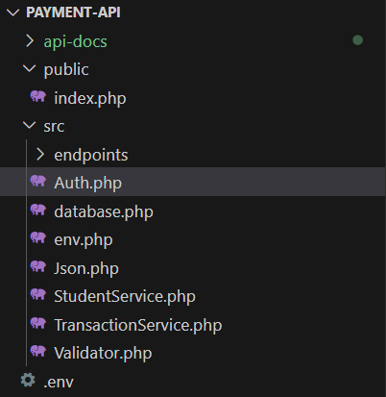

The purpose of this file is to authorize the API key by comparing the key sent by the client with the one stored in the environment if they don’t match, it returns a 401 error message in JSON format

enable strict types; without it, PHP is loose with types, with it, PHP becomes strict
declare(strict_types=1);

We use a the same namespace used previously, so this class is part of the same group of files. We use it by use App\Auth.
namespace App;

we create we create a final class because we don’t want it to be extended or changed. We named it Auth; it has one function called requireApiKey() that is responsible for the entire authorization process, which returns nothing.
final class Auth{
public static function requireApiKey(){

we save the key sent by the client in a variable called $provided, so we can compare it later with the one stored in the environment.
If there is no key sent by the client, we put an empty string to we prevent the API from crashing.
PHP turns HTTP headers into $_SERVER['HTTP_<NAME>']
So header "X-API-Key: abc" becomes $_SERVER['HTTP_X_API_KEY'] = "abc"
$provided=$_SERVER['HTTP_X_API_KEY'] ?? '';

We load the key that’s stored in the environment (we load from .env by env.php) and save it into a variable called $expected by using getenv().
(as described in env.php.docx, page 4)
If there is no key stored in the environment, we put an empty string to we prevent the API from crashing.
$expected=getenv('API_KEY')?: '';

We compare two strings to see if they don't match, we return a 401 error in JSON format.
We first check if $expected is empty, or if the keys don’t match.
To compare them safely, we use hash_equals() function. it compares strings in a constant-time way, which is safer against timing attacks than a normal === comparison.
When we compare we use in the if statement !hash_equals so if they are not the same we use \app\json::error function that we created in json.php file
(as described in json.php.docx, page 4)
$expected=getenv('API_KEY')?: '';
if($expected =='' || !hash_equals($expected,$provided)){
\App\Json::error(401,'Unauthorized: invalid API key');
}
}
}

