Validator.php
where file is located:
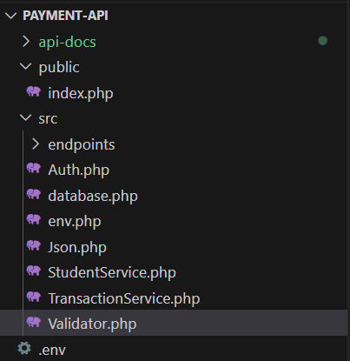

The purpose of this file is to validate input from HTTP requests.
it makes sure Json is parsed correctly, that required fields exist, the values are correct.
It also prevents malicious or incorrect input from reaching the database.
JSON is parsed” means the program takes the JSON text (like a long string) and turns it into data the code can understand and use, such as an array or an object.

enable strict types; without it, PHP is loose with types, with it, PHP becomes strict.
declare(strict_types=1);

We use the same namespace used previously, so this class is part of the same group of files. We use it by use App\Validator.
namespace App;

we create we create a final class because we don’t want it to be extended or changed. We name it Validator it has four functions that is responsible for the validation process, depending on the case.
final class Validator{
we create a static function to reads the raw request body such as (“php://input” stream), and tries to decode JSON into PHP array.
If the request is not valid JSON returns error 400.
public static function jsonBody(){

we save the raw string body into a variable called $raw using a function called file_get_contents('php://input') is a special stream in PHP that contains the raw data sent by the client in the HTTP request.
It fetches that content and saves it inside $raw.
('php://input' means “get the request body,”)
$raw=file_get_contents('php://input');

We decode the JSON into an array using a function called json_decode().
we add the $raw variable, and set the second parameter to true so it becomes an associative array instead of an object, and save the result into a variable called $data.
$data=json_decode($raw,true);

We check if $data has a valid result by using the not operator and the is_array() function that checks whether it's an array or not.
If $data is not an array, that means the JSON decoding failed, we call Json::error (described in json.php.docx, page 4) with status code 400 and message “invalid JSON body”.
If it is an array, that means the JSON was valid, so we return $data for further use.
if(!is_array($data)){
Json::error(400,'Invalid JSON body');
}
return $data;
}

We create a static function called required with two parameters, an array that contains the input data called $data, and an array of required field names called $called Keys, both of type array. The function checks if the keys, such as “card_id, amount,” exist.
public static function required(array $data, array $keys){
we loop over the array $Keys, and inside the loop, we check if any key is a missing key by using the function array_key_exists() and assign this function two parameters key we but the loop variable $k and the array we put the array $data, we use not (!) operator with the array_key_exists() to check if one of the keys dose not exist.
If any key is missing we call Json::error (described in json.php.docx, page 4) with status code 422 and message “missing: $k”.
foreach($keys as $k){
if(!array_key_exists($k,$data)){
Json::error(422,"Missing: $k");
}
}
}

To check if the amount is not less than or equal to 0, and to check if the number is numeric.
We create a static function called positiveAmount() and in the parameter we add a variable called $balance, which represents the amount.
public static function positiveAmount($balance): void{

We check if the variable is numeric by using the is_numeric() function and passing the parameter $balance.
This function checks if the value given is numeric or not. Or check if the $balance is less than or equal to 0.
If any of the conditions are met, we call Json::error (described in json.php.docx, page 4) with status code 422 and message “amount must be greater than 0”.
if(!is_numeric($balance) || $balance <=0 ){
Json::error(422,'amount must be grater then 0');
}
}
We create a static function called idempotencykey() and in the parameter we add a optional variable called $idempotency_key of type string
public static function idempotencykey(?string $idempotency_Key){
we check if $idempotency_key exists or not.
If it does not exist call Json::error (described in json.php.docx, page 4) with status code 422 and message “idempotency_key is required”.
if(!$idempotency_Key){
Json::error(422,'idempotency_key is required');
}
We also we also check if the $idempotency_key length greater than 64 and if it is If not we call Json::error (described in json.php.docx, page 4) with status code 422 and message “idempotency_key is too long”.
To calculate the length We use function called strlen()
if(strlen($idempotency_Key)>64){
Json::error(422,'idempotency_key too long');} } }

