env.php
where file is located:
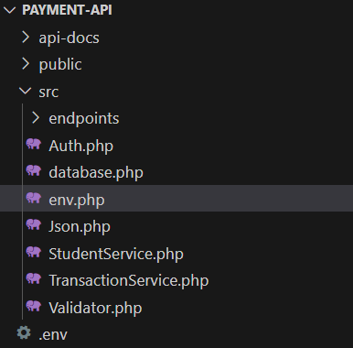

The purpose of this file is to load variables from .env into env.php and return responses in JSON.
-------------------------------------------------------------

enable strict types; without it, PHP is loose with types, with it, PHP becomes strict
declare(strict_types=1);

We load the path .env file into a variable $env so we can access the data we need.
$env= __DIR__.'/../.env';

Check if file exists if it exists loop over the .env file and read .env into array and ignore new lines or skip empty lines by using the function file
if(file_exists($env)){
foreach(file($env, FILE_IGNORE_NEW_LINES | FILE_SKIP_EMPTY_LINES) as $line){

trim the whitespace: trim remove unnecessary spaces from the beginning and end.

Its important because when reading from file some lines might have:
- Extra spaces at the start or end
- Tab characters
- Invisible whitespace
$line=trim($line);

We skip if the line is empty and if there are comments, by checking if the line is empty and the string starts with #
if($line=='' || str_starts_with($line, '#')){
continue;}

we check if the lines start with export KEY=VALUE in case thire is like linux shell file, we use strncasecmp(sting1,sting2,limt).
if(strncasecmp($line, 'export',7)==0){
$line=trim(substr($line,7));}
Substr takes the string and cuts it starting from 7 position, Since "export" is 6 letters long, plus usually 1 space ("export " = 7 characters), this removes the word export and its trailing space.

We split the line into key name and its value we use explode, we separate by =, the string is $line, and the limit is 2 to make sure it only splits once, and save it into a $pair
$pair=explode('=',$line,2);

We check if the line doesn’t contain ‘=’, we ignore it safely by using continue
if(count($pair)!==2){
continue;}

We clean the space around the Key and its value by using array_map with the callback trim and the array we apply it to is $pair.
We save the result into [$key, $value]
[$key, $value]= array_map('trim',$pair);

we use putenv() to write key and value into the current PHP process environment, so later we can read it anywhere via getenv().
putenv("$key=$value");

We set the default response header for the API. This tells the browser or client that we are sending JSON.

The charset=utf-8 makes sure all characters (like Arabic, emojis, symbols) are handled correctly.
header('Content-type: application/json; charset=utf-8');

