students_resolve.php
where file is located:
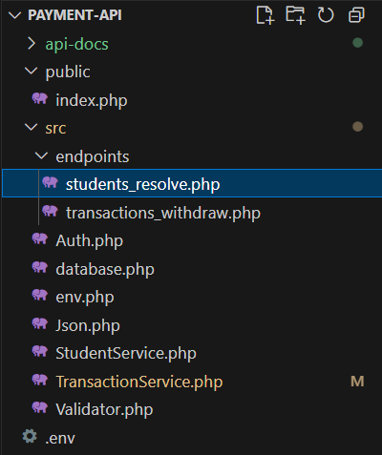

The purpose of this file is to connect to fetch a student account & card information by their numeric Link_ID.
enable strict types; without it, PHP is loose with types, with it, PHP becomes strict.
declare(strict_types=1);

We use the namespace that we created to access the functions within it.
use App\Json;

We use the namespace that we created to access the functions within it.
use App\StudentService;

we read the raw value as a string to preserve leading zeros and trim it, and save it in a variable called $linkIdRaw.
We use the PHP superglobal $_get[] to retrieve the value we want, in this case, link_id, from the URL parameters of the HTTP request. That looks like
(https://yourapi.com/student?link_id=12345)
If the value does not exist, we assign null to it by using null coalescing operator (??)
$linkIdRaw= $_GET['link_id']?? null;

We check if the value we received is a string by using the function is_string(), and we pass $linkIdRaw as the parameter.
If it’s a string, we use the function called trim(), to remove any extra spaces at the beginning or end.
if it is not string, we assign an empty string to $linkId.
This makes sure that $linkId always contains a clean, safe value before use it.
$linkId= is_string($linkIdRaw) ? trim($linkIdRaw) : '';

We check if $linkId is empty.
If it is, we return an error in JSON format using Json::error() with 400 status code and a message ‘Missing or invalid query parameter: link_id’, and we exit to stop the script completely
(it was described and explained in Json.php.docx)
if($linkId ==''){
Json::error(400, 'Missing or invalid query parameter: link_id');
exit;
}

We use a static function called getBylinkid() that we created in the StudentService class (as described in StudentService.docx).
we pass in the parameter $linkId to this function and store the fetched result in a variable called $result.
The function will return null if no row is found.
$result= StudentService::getByLinkid($linkId);

We check if the account does not exist or exists but with no card.
We do this by checking if $result is null or if the value of $result[‘card_id’] is empty using a function called empty().
If either condition is ture, it means theres no valid card or account found for the given link_id.
In that case, we return an error in JSON format using Json::error() with 404 status code and a message ‘not found for this link_id or no card for this account.’, and we exit to stop the script completely.
if ($result === null || empty($result['card_id'])) {
// If account exists but no card, you can choose to 404, or auto-create a card.
Json::error(404, 'not found for this link_id or no card for this account');
exit;
}

If the request is succussful, we return a response in JSON format using Json::ok().
We send an HTTP 200(ok) status code and an associative array containing the user account information. (it was described and explained in Json.php.docx).
Json::ok(200,[
'account_id' => $result['account_id'],
'card_id' => $result['card_id'],
'balance' => $result['balance'],
'link_id' => $result['link_id'],
]);

