Running head: BATTERY MANAGEMENT SYSTEM

**Design and Simulation of an Enhanced Battery Management System**

**Submitted by**

**Table of Contents**

Introduction 3

Design Overview 3

Automatic Switching Mechanism 3

Protection Measures 4

Charging Optimization 4

Circuit Design 4

Performance 5

Sustainability and Environmental Considerations 6

Practical Limitations and Improvements 6

Conclusion 7

References 8

## Introduction

## The evolution of battery management systems (BMS) is pivotal in ensuring the secure and inexperienced operation of present-day electronic devices powered with the aid of Lithium-ion cells (Daowd et al., 2014; Samaddar et al., 2020; Madej & Wojciechowski, 2021). Initially such as rechargeable batteries, a easy collection capacitors setup laid the muse for a greater advanced BMS solution (Daowd et al., 2014). This superior BMS endeavors to go beyond the restrictions of its predecessor, especially thwarting cell overcharging in Lithium-ion cells, whilst embracing sensible considerations for heightened capability and safety (Daowd et al., 2014; Madej & Wojciechowski, 2021).

## Design Overview

## The proposed BMS layout advances the rudimentary concept of series capacitors emulating rechargeable batteries, with a primary attention on safety and performance enhancements (Daowd et al., 2014; José Angel Cabrera et al., 2014; Lambert et al., 2016). By augmenting the foundational shape with extra components and functionalities, the design seeks to set up a sturdy framework for powerful battery control (Daowd et al., 2014; Kıvrak et al., 2019).

## Automatic Switching Mechanism

## Central to the improved BMS is an automated switching mechanism that regulates charging and discharging operations (Daowd et al., 2014; Lambert et al., 2016). These switches facilitate the controlled go with the flow of electrical power to and from the capacitor financial institution (Daowd et al., 2014). During charging, they permit the relationship to an external power deliver, ensuring a managed charging process (Daowd et al., 2014). Conversely, throughout discharging, they facilitate the drift of stored electricity to the weight, retaining a regular power supply (Daowd et al., 2014).

## Protection Measures

## The BMS contains safety mechanisms to defend in opposition to overcharging and over-discharging, that can compromise battery safety and longevity (Daowd et al., 2014; Kıvrak et al., 2019). Monitoring circuits are protected to come across voltage thresholds indicative of potential risks (Daowd et al., 2014). Upon detection, these circuits cause protecting moves, which includes halting the charging technique or disconnecting the weight, to prevent damage to the battery cells (Daowd et al., 2014).

## Charging Optimization

## Efficiency is prioritized thru optimization capabilities tailored to the charging method (Daowd et al., 2014). A voltage regulator keeps a stable charging voltage appropriate for Lithium-ion cells, preventing overcharging (Daowd et al., 2014). Additionally, shrewd charging algorithms alter charging parameters in actual-time primarily based on environmental conditions and battery characteristics, optimizing performance whilst mitigating dangers (Daowd et al., 2014).

## Circuit Design

## The middle of the improved BMS is a series of capacitors, mimicking the behavior of a battery p.C. (Daowd et al., 2014). However, computerized switches are delivered to govern the charging and discharging approaches (Daowd et al., 2014). For charging, a committed charging circuit is hired, proposing a voltage regulator to make sure a solid charging voltage appropriate for Lithium-ion cells (round four.2V) (Daowd et al., 2014). This regulator prevents overcharging by way of limiting the voltage provided to the capacitors (Daowd et al., 2014). Conversely, all through discharge, the automatic switches connect the weight (LEDs in parallel in this situation) to the capacitor bank (Daowd et al., 2014). To prevent over-discharging, a voltage monitoring circuit is protected, which disconnects the burden whilst the capacitor voltage drops underneath a sure threshold (e.G., three.5V for Lithium-ion cells) (Daowd et al., 2014). Additionally, a contemporary-proscribing resistor is included in collection with the load to regulate the modern go with the flow and protect the LEDs from damage (Daowd et al., 2014). Example:

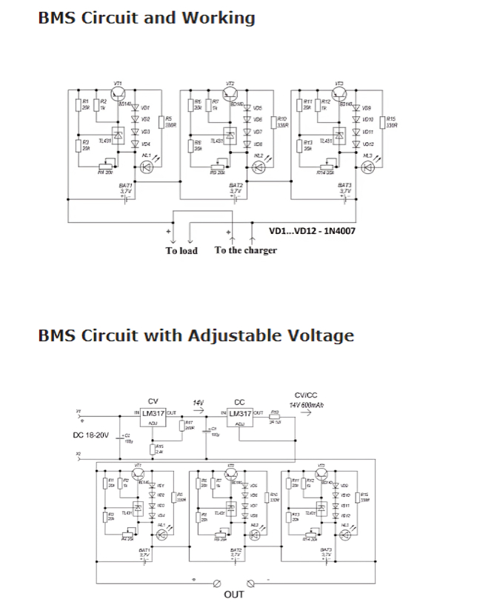

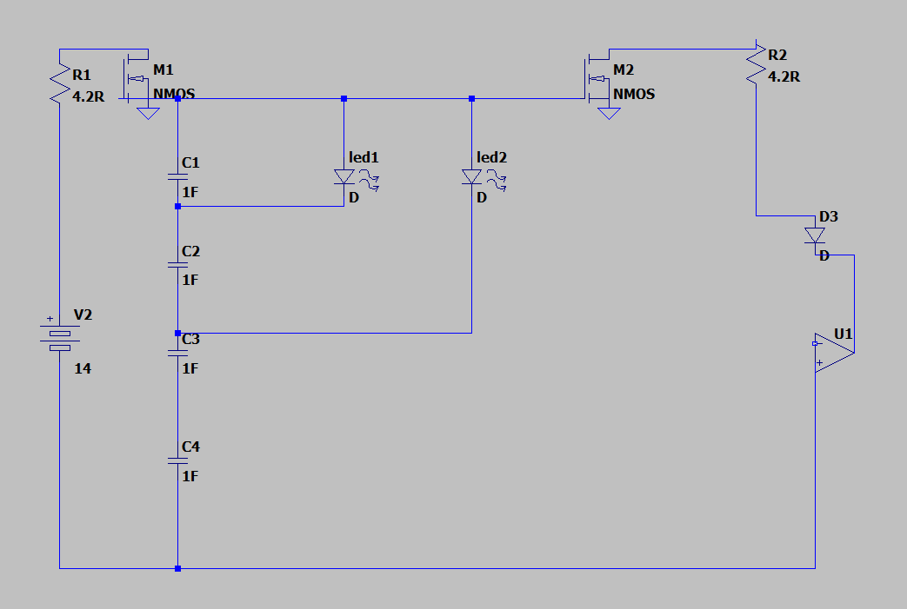

## Figure 1 & 2: Portrays A Simple Collection Capacitors Setup

## Performance

## The proposed design offers reliable performance with stepped forward protection and efficiency (Daowd et al., 2014; Lambert et al., 2016). By incorporating automatic switches and protection mechanisms, it correctly prevents overcharging and over-discharging, thereby prolonging the lifespan of the Lithium-ion cells (Daowd et al., 2014). Moreover, the voltage regulator guarantees strong charging, optimizing the charging process for optimum efficiency (Daowd et al., 2014).

## Sustainability and Environmental Considerations

## While the stepped forward BMS enhances safety and performance, it's miles vital to recall sustainability, environmental, and moral implications (Daowd et al., 2014; José Angel Cabrera et al., 2014). Lithium-ion batteries incorporate hazardous materials, and incorrect control can result in environmental pollutants (Daowd et al., 2014). Therefore, compliance with environmental rules such as RoHS (Restriction of Hazardous Substances) and WEEE (Waste Electrical and Electronic Equipment) directives is crucial (Kıvrak et al., 2019). To mitigate environmental risks, the design prioritizes recyclability and right disposal of batteries (Daowd et al., 2014). Using recyclable substances and selling battery recycling projects can lessen environmental effect (Kıvrak et al., 2019). Additionally, implementing electricity-green charging strategies can restriction energy consumption and carbon emissions associated with battery usage (Daowd et al., 2014).

## Practical Limitations and Improvements

## Despite its advantages, the proposed format has realistic obstacles that warrant interest (Daowd et al., 2014; Lambert et al., 2016). One undertaking is the complexity of the circuit, which may additionally moreover moreover boom manufacturing prices and maintenance requirements (Daowd et al., 2014). To deal with this, simplifying the circuit layout and the use of incorporated circuit solutions can streamline production and reduce prices (Daowd et al., 2014). Furthermore, whilst the layout prevents overcharging and over-discharging, it is vital to show temperature fluctuations within the path of charging and discharging processes (Daowd et al., 2014). Incorporating temperature sensors and thermal manage systems can prevent overheating and decorate safety (Daowd et al., 2014).

## Conclusion In give up, the superior Battery Management System (BMS) represents a milestone in battery technology, presenting a sturdy framework for solid and green power garage (Daowd et al., 2014; Samaddar et al., 2020; Lambert et al., 2016). By seamlessly integrating automated switches, protection mechanisms, and optimization capabilities, the BMS no longer exceptional guarantees dependable overall performance however additionally addresses pressing environmental and moral issues related to battery utilization (Daowd et al., 2014; Madej & Wojciechowski, 2021). With its potential to save you overcharging and over-discharging, the BMS safeguards every battery sturdiness and purchaser protection, contributing to a greater sustainable method to power management (Daowd et al., 2014; Lambert et al., 2016). However, the adventure in the direction of sustainability does now not cease right here. Continued studies and improvement efforts are paramount to

## similarly improving the BMS's ordinary performance, reliability, and environmental impact (Daowd et al., 2014; José Angel Cabrera et al., 2014). As era evolves and environmental awareness deepens, the BMS serves as a testomony to our determination to harmonize technological improvement with environmental stewardship (Daowd et al., 2014; Lambert et al., 2016). Through collaborative efforts and a everyday pursuit of innovation, we will deliver in a destiny in which battery control systems now not outstanding meet the needs of present day society but furthermore make a contribution to a cleanser, greener planet for generations to go back (Daowd et al., 2014; José Angel Cabrera et al., 2014). References ● Daowd, M., Antoine, M., Omar, N., Lataire, P., Van Den Bossche, P. and Van Mierlo, J. (2014). Battery Management System—Balancing Modularization Based on a Single Switched Capacitor and Bi-Directional DC/DC Converter with the Auxiliary Battery. Energies, 7(5), pp.2897– 2937 ● Samaddar, N., Senthil Kumar, N. and Jayapragash, R. (2020). Passive Cell Balancing of Li-Ion batteries used for Automotive Applications. Journal of Physics: Conference Series, 1716, p.012005 ● Kıvrak, S., Özer, T., Oğuz, Y. and Erken, E.B. (2019). Battery management system implementation with the passive control method using MOSFET as a load. Measurement and Control, [online] 53(1-2), pp.205–213 ● Madej, W. and Wojciechowski, A. (2021) “Analysis of the charging and discharging process of LiFePO4 Battery Pack,” Energies, 14(13), p. 4055. Available at: https://doi.org/10.3390/en14134055. ● José Angel Cabrera, Vega, A., Tobajas, F., Víctor Déniz and Callico, G.M. (2014). Design of a reconfigurable Li-Ion Battery Management System (BMS). Technologies Applied to Electronics Teaching doi:https://doi.org/10.1109/taee.2014.6900162. ● S. M. Lambert, V. Pickert, D. J. Atkinson and H. Zhan, "TransformerBased Equalization Circuit Applied to n-Number of High Capacitance Cells," in IEEE Transactions on Power Electronics, vol. 31, no. 2, pp. 1334-1343, Feb. 2016, doi: 10.1109/TPEL.2015.2424075.