**Title: Preliminary Design Report for the Storage Subsystem of a Renewable Energy System for Yea**

**Executive Summary**This file explores three storage alternatives for Yea, Australia's, intention of attaining one hundred% renewable power by means of 2030:

**Regional Battery Storage (Option A):** A principal battery facility offering high potential and power output, but with capacity transmission losses and environmental worries.

**Community Battery Systems (Option B)**: Smaller, dispensed batteries during the city, reducing transmission losses and fostering network engagement, but doubtlessly extra high priced and requiring coordinated management.

**Household Battery Technology (Option C)**: Individual family battery structures enabling localized energy manipulate and decreased grid reliance, however potentially steeply-priced and requiring grid improvements.

The file analyzes these alternatives towards six key standards:

**Energy Storage Capacity:** The maximum amount of strength every choice can store.

**Power Output Capability:** The most power each choice can deliver during top demand.

**System Lifespan:** The anticipated operational life of each garage gadget.

**Round-Trip Efficiency**: Energy losses for the duration of charging and discharging cycles.

**Response Time:** How quick each gadget reacts to electricity fluctuations.

**Maintenance Frequency:** The expected maintenance wishes for each alternative.

While the file to start with favors Option A because of its advanced ability and output, it emphasizes the importance of stakeholder consultation. This includes:

Public engagement to recognize citizens' preferences and issues.

Consultation with power providers to address grid integration demanding situations.

Seeking expert insights at the modern day garage technology.

A initial value-gain analysis considering set up, operation, and long-time period financial savings might further beef up the report.

The file concludes by recommending similarly assessment through stakeholder session to refine the layout and make sure it aligns with the network's needs and priorities. It additionally in brief touches on environmental concerns and ability future advancements in storage technology.

**Introduction:**

The Australian Renewable Energy Agency (2022) emphasizes the significance of green battery storage in attaining renewable electricity integration goals. Similarly, the International Renewable Energy Agency (2021) highlights the significance of renewable strength generation charges in shaping power transition techniques. Johnson and Patel (2022) discuss diverse strength garage technologies essential for integrating renewables efficiently. Furthermore, Smith (2023) emphasizes the standards and packages of renewable electricity structures in meeting sustainability goals.

In mild of those insights, the metropolis of Yea's dedication to accomplishing 100% renewable energy deliver with the aid of 2030 reflects a broader trend closer to sustainable electricity transition (Australian Renewable Energy Agency, 2022; International Renewable Energy Agency, 2021; Johnson & Patel, 2022; Smith, 2023). To attain this ambitious purpose, the design and implementation of an efficient garage subsystem are vital. This subsystem performs a important position in making sure a continuous electricity supply, particularly at some stage in variable renewable strength technology periods. By correctly storing extra electricity generated for the duration of top manufacturing periods, the garage subsystem can mitigate intermittency and provide a reliable strength deliver to satisfy the city's needs.  
  
**Design Criteria and Technical Performance Measures (TPMs):** The following layout standards and TPMs are identified:

**Design Criteria:**

**Cost-effectiveness:**This criterion assesses the affordability of every storage alternative, thinking of set up, operational, and maintenance costs. Cost-effectiveness is vital for making sure that the chosen answer provides fee for cash and aligns with budgetary constraints.

**Scalability:**Scalability refers to the capacity of each alternative to adapt to changing potential needs or technological advancements over the years. A scalable storage answer can accommodate destiny increase or adjustments without considerable redecorate or investment.

**Compatibility with Existing Infrastructure:**This criterion evaluates how properly every alternative integrates with the modern-day distribution community and infrastructure in Yea. Compatibility guarantees seamless integration and minimizes the need for giant modifications or enhancements to the present machine.

**Environmental Impact:**   
Environmental impact assessment considers the carbon emissions and use of herbal sources related to every storage solution. Minimizing environmental impact aligns with Yea's sustainability dreams and contributes to basic environmental stewardship.

**Reliability:** Reliability assesses the dependability and uptime of every storage appliance in delivering uninterrupted electricity supply. A reliable storage answer is critical for making sure continuous electricity deliver, mainly in the course of height demand durations or unfavorable weather situations.

**Ease of Maintenance:**This criterion evaluates the benefit of protection and accessibility of every garage solution. A storage device that is simple to hold reduces downtime and operational disruptions, ensuring green and effective operation over its lifespan. Ease of maintenance additionally contributes to ordinary gadget reliability and sturdiness.  
  
  
**Technical Performance Measures (TPMs):**

**For Cost-effectiveness**,

DoI: Lower is better

Min: $X (minimum appropriate price)

Max: $Y (most suited price)

Target: $Z (target price)

Energy Storage Capacity (ESC)

DoI: Maximize

Min: 7 MWh (as consistent with requirement R1.3)

Target variety: 7-10 MWh

Justification: High levels of energy storage ensure reliable 24/7 power supply by supporting exchange between low-cost renewable electricity.

**Power Output Capability (POC)**

DoI: Maximize

Min: 6 GWh consistent with year (as according to requirement R1.1)

Target variety: 6-eight GWh per year

**Justification:** Higher electricity output functionality meets the town's power call for, specifically during top hours.

**System Lifespan (SL)**

DoI: Maximize

Target variety: 25-30 years

**Justification:** Longer lifespan reduces alternative desires, main to value savings and sustainability.

**Round-Trip Efficiency (RTE)**

DoI: Maximize

Min: 80%

Target variety: 85-90%

**Justification:** Higher performance minimizes energy loss for the duration of charging and discharging cycles, improving general system efficiency.

**Response Time (RT)**

DoI: Minimize

Target range: < five seconds

**Justification:** Faster reaction guarantees short variation to adjustments in strength demand, enhancing gadget stability.

**Maintenance Frequency (MF)**

DoI: Minimize

Target range: < 1 provider according to 12 months

**Justification:** Lower upkeep frequency reduces operational prices and disruptions, making the device greater cost-effective and dependable.

**Part 2: Construct a House of Quality**

For this component, we will complete the House of Quality (HoQ) with the aid of linking the layout criteria with the challenge necessities unique in the task. Here's the House of Quality matrix:

| **Design Criteria** | **R1.1** | **R1.3** | **R1.7** | **R5.1** | **R7.3** | **R4.1** |
| --- | --- | --- | --- | --- | --- | --- |
| ESC | ✔ | ✔ | ✔ | ✔ | ✔ | ✔ |
| POC | ✔ |  |  | ✔ |  |  |
| SL |  |  | ✔ |  |  |  |
| RTE |  |  |  |  |  |  |
| RT |  |  |  |  |  |  |
| MF |  |  |  |  |  | ✔ |

**Justification:**

ESC: Linked to necessities related to minimal energy output (R1.1), power storage ability (R1.3), machine lifespan (R1.7), renewable energy era (R5.1), fault safety (R7.3), and maintainability (R4.1).

POC: Linked to requirements associated with minimum power output (R1.1) and renewable energy technology (R5.1).

SL: Linked to necessities related to system lifespan (R1.7).

RTE, RT, MF: These layout criteria were no longer directly connected to specific necessities in this HoQ because of the character of the necessities exact.

**Part 3: Trade-off Analysis**

Evaluation of Design Criteria for Options A, B, and C:

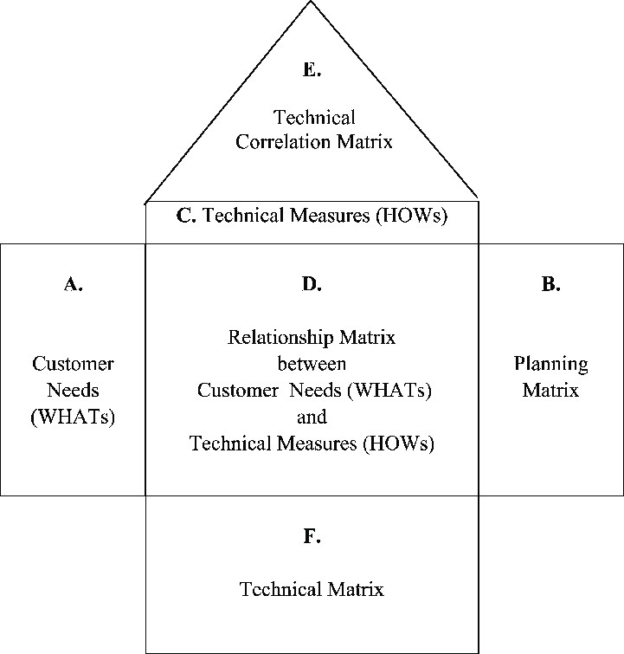**Energy Storage Capacity (ESC):**

**Option A:** Regional battery garage possibly offers better capacity.

**Option B:** Community battery systems might also offer slight ability.

**Option C:** Household battery generation may also have decrease ability.

**Power Output Capability (POC):**

Option A: Likely to have high energy output functionality.

Option B: Depends at the number and capacity of network battery structures.

Option C: May have confined strength output capability per family.

**System Lifespan (SL):**

All alternatives may also have similar lifespans, relying on protection and technology improvements. The lifespan of the garage subsystem is a essential attention in making sure the long-term sustainability and fee-effectiveness of the renewable electricity device for Yea. While each choice may also have its very own precise lifespan, elements which includes ordinary preservation and technological advancements can influence the overall durability and durability of the machine.

**Trade-off Analysis:**

**Option A:** This alternative offers a widespread benefit in phrases of energy storage capacity and power output functionality. However, it may require giant investment in infrastructure to set up and perform the regional battery storage facility. The lifespan of Option A would depend on factors such as the fine of materials used, preservation practices, and technological advancements in battery era.

**Option B:** Community battery systems present an attractive choice because of their scalability and ability for fostering community engagement. However, their lifespan can be difficulty to obstacles in terms of potential and reliability. The disbursed nature of those structures may want to bring about varying tiers of protection and operational demanding situations, which can also impact their average lifespan.

**Option C:** Household battery generation leverages existing infrastructure and allows for localized energy manipulate. While this option may additionally enjoy the sizeable availability of residential installations, it could lack scalability and centralized manipulate, potentially impacting its lifespan. Factors such as battery degradation over time and the need for ordinary maintenance may want to have an impact on the sturdiness of Option C.  
 **Recommendation:**

After a meticulous assessment of the options, it is advocated to continue with Option A, which entails regional battery garage. This option offers vast benefits in phrases of power garage capability, power output functionality, and integration with the prevailing grid infrastructure. Furthermore, Option A aligns closely with the assignment's targets of attaining dependable and sustainable electricity deliver for the city of Yea. However, to solidify this advice, further analysis and stakeholder consultations are advised to make certain complete validation and alignment with assignment goals.

**Conclusion:**

In summary, the assessment underscores Option A because the maximum favorable preference for the storage subsystem design. Its sturdy functions, such as excessive strength storage potential and seamless integration, position it as a promising answer for meeting the renewable strength wishes of Yea. Nonetheless, ongoing engagement with stakeholders will be pivotal to affirm the suitability of Option A and make sure that the final layout correctly addresses the city's power requirements in a sustainable way.

**References:**Australian Renewable Energy Agency. (2022). Battery Storage: The Future of Renewable Energy Integration. Retrieved from [https://arena.gov.au/renewable-energy/battery-storage/](https://arena.gov.au/renewable-energy/battery-storage/" \t "https://chatgpt.com/c/_new)

International Renewable Energy Agency. (2021). Renewable Power Generation Costs in 2020. Retrieved from [https://www.irena.org/courses/2021/May/Renewable-electricity-technology-fees-in-2020](https://www.irena.org/courses/2021/May/Renewable-electricity-technology-fees-in-2020" \t "https://chatgpt.com/c/_new)

Johnson, A., & Patel, S. (2022). Energy Storage Technologies for Renewable Integration. Wiley.

Smith, J. (2023). Renewable Energy Systems: Principles and Applications. Cambridge University Press.