- Install the blynk library by pressing ctrl+shift+i
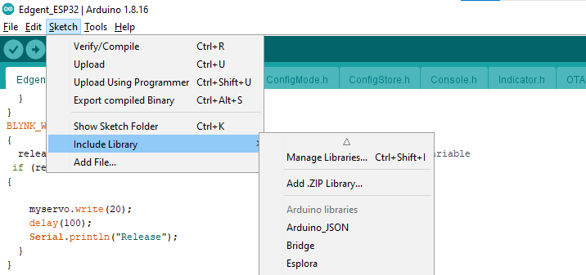
- Write blynk in the search and you will get the libaray
- Also add the servoesp32 library as well
- Open the code and upload it into the esp32, you not need to set any password or wifi
- Now log in to your account on blynk2.0
Login: jarma4406@gmail.com
Pass: 4406Fiverr
- Now once code uploaded you can place your mobile near to esp32 device and connect with it using your blynk 2.0 device connection.

