1. Linear regression

RMSE: 7.144958034041374

R\*\*2 score is: 0.5274663723837891

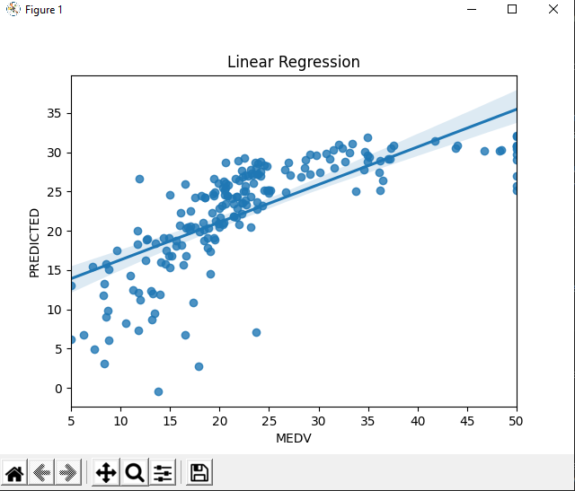

2.Polynomial regression

R\*\*2 score is: 0.6293327675165307

RMSE: 4.546309596896669

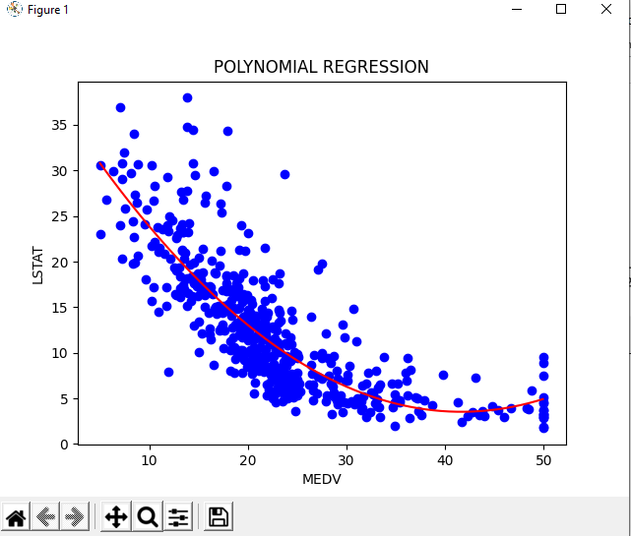

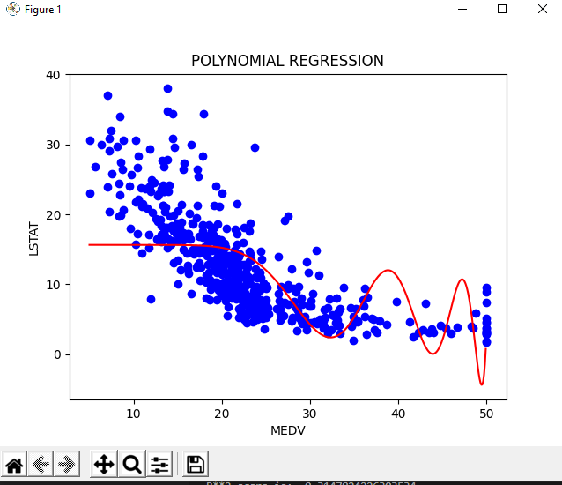

degree 20 graph

3.Multiple Regression

RMSE: 5.734152219295354

R\*\*2 score is: 0.6204936643522176

Adjusted R\*\*2 score is: 0.6147724633123013

