SOFTWARE ENGINEERING Charging Station in Berlin Project

# Question 7: Analyze both geovisualizations: Where do you see demand for additional electric charging stations?

* The most crowded areas have around 30.000 residents.
* The most charging stations are 95 and 82 stations.
* These charging stations are located in a crowded area and it is kind of in the middle of the crowded area.

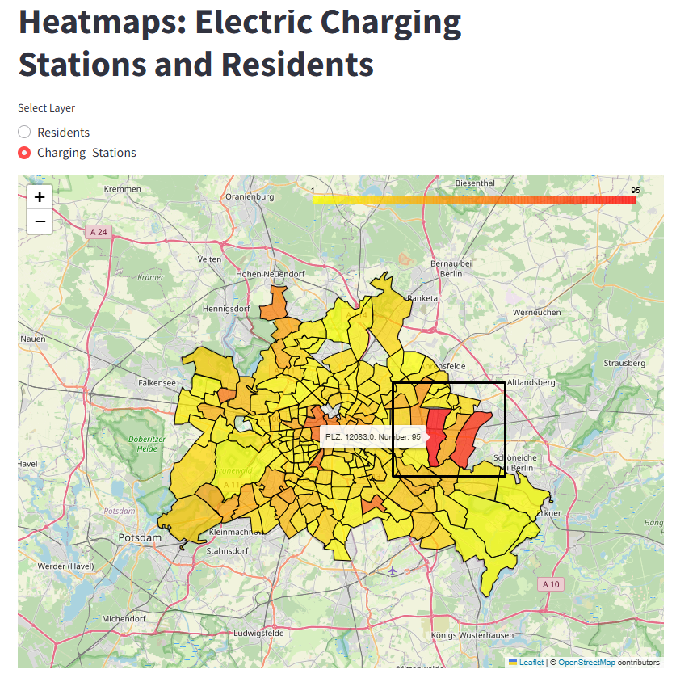

## **Comparison**:

|  |  |
| --- | --- |
| Residents Density | Number of the Stations (Density) |
|  |  |
| Density tends to be on the right side of the Berlin | Charging Stations also tend to be built on the right side. |
| There is a density on the top of the map as well. | However, charging stations are very less there. |
| Left side of the map has a middle or smaller population number according to the map | There are charging stations on the left side as well but its number is less than the right side. And this is understandable because of the residents number. |
| There is also a density at the bottom. | We could demand more charging stations for this area but these residents can use their neighbours’ stations. Because there are more stations nearby. |

**Conclusion**: More charging stations might be built in the top area of Berlin. A place where neighbours can have benefits from it as well. It could be there where whether no charging stations yet or there are less numbers of stations;

