CIFAR-10 Multi-class Image Classification from Scratch

Introduction
The CIFAR-10 dataset contains 60,000 images across 10 different classes (those include various animals and vehicles) and is used by for CNN-base image classification problems. Our problem involved developing two models for classifying a subset of 5 classes. The first one was the baseline, lightweight MLP that had to use between three and four hidden layers and a deeper more challenging model that required at least 10 layers and had to use at least two regularization techniques. The dataset was manually extracted to ensure that all batches and labels were correctly decoded and organised into NumPy arrays suitable for preprocessing and training.

Methodology
Both models required pixel normalizing creating one-hot encoded labelling since it is required when computing cross entropy losses. It is also standard practice to standardize features before being run through a model, so this was done using a standard scaler.
The next step was the actual initialization of the MLP classifier with all the necessary hyperparameters followed by MLP training which included the following steps in an orderly manner, weight initialization using He, data entrance at input layer, forward passing, output layer error calculation and finally backpropagation and parameter updating until termination via a stopping criteria, which in my case was an early stoppage which inspected decreasing validation loss with a patience value of 20. The deep model included extra bits like augmenting input data and normalizing batches before entering activation functions. After training the model was tested on the remaining 5000 images. To test the models a predict function forward propagated the 3072 input neurons through the fully trained neural network and return the value of the final activation.
For result interpretation and visualisation, graphs for the training and validation loss and accuracy versus epoch amount were. Adding a confusion matrix with class-wise performance accuracies also proved to be handy and helped in improving my model’s performance as it assisted in the decision for the classes to add to and remove from my models.
The most significant component of both models was the hyperparameter tuning which is used to determine the optimal hyperparameters. Although the process was time consuming especially when using CPUs, it almost always ensures that the final configuration was the most successful. The tuning reached its peak with the following layer architecture for the baseline model, [2048, 1024, 512, 256], with the deep model it decided on the following, regularization configuration Batch Normalization + Data Augmentation + Dropout(0.1) and the layer architecture found in the SCC323CW_DeepModel.py was decided based on research for most commonly used architectures for CIFAR-10 image classification. Input layer included weight initialization and data augmentation which is enabled based on a set probability for the input images. Hidden layers in the deep model had a dense layer followed by batch normalization before going through the ReLU activation function and finally a dropout layer if enabled.

Results

Figure 1: Training and validation loss and accuracy values with standard gradient descent Figure 2: Training and validation loss and accuracy values with Adam Optimizer
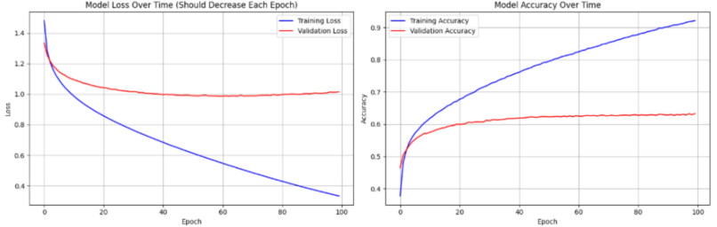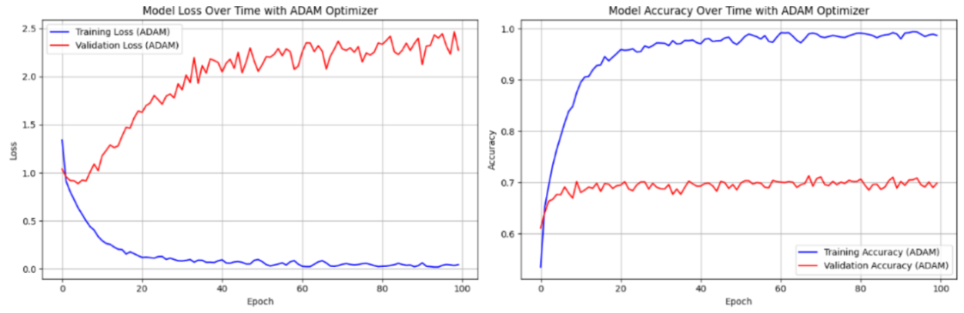
For my baseline model there were three breakthroughs. The first came after trying several different class configurations instead of the random 5 I initially chose. When classifying airplane, automobile, ship, truck and dog I discovered it yielded to the highest accuracy and it performed with a test accuracy of 62.31%, ~15% higher than the lowest performing combination of classes. Another one came after tweaking my learning rate which was initially 0.1. After some testing the model performed optimally with a rate of 0.001. The final breakthrough came after I performed extensive research about the practical way for updating parameters for image classification and stumbled upon the Adam optimizer. As the Adam optimizer is not within SCC323’s curriculum. Here’s how it works, it uses two momentum estimate values that control the learning rate for weight updates; these track the gradients allowing the optimizer to adjust step sizes adaptively. After applying bias correction, the updated weights and biases move in a direction that accelerates learning, leading to quicker convergence. This raised my test accuracy to 69.72% which was the highest test accuracy obtained.
Figure 3: Training and validation loss and accuracy using Adam optimizer with 100 epochs Figure 4: Training and validation loss and accuracy using Adam Optimizer with 160 epochs
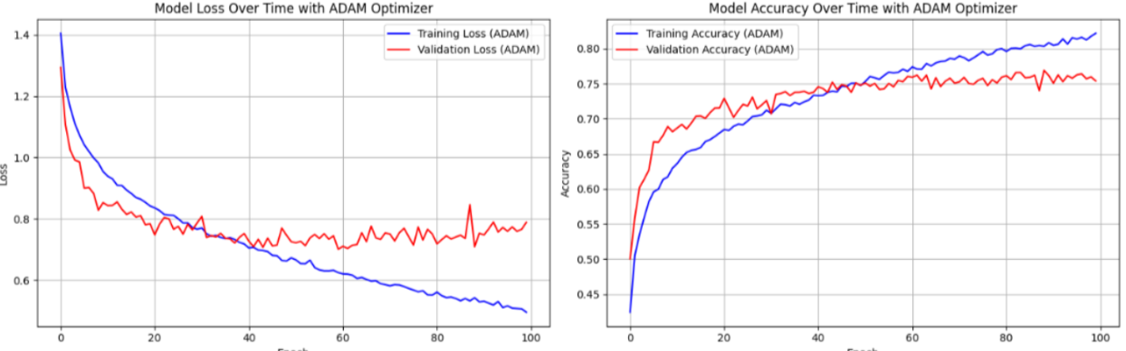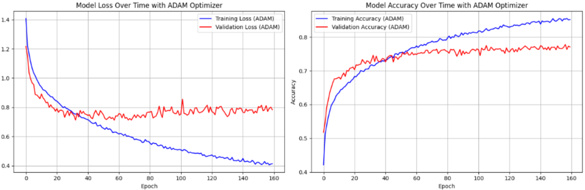
Figure 5: Final Confusion Matrix + class-wise performance (160-epochs)
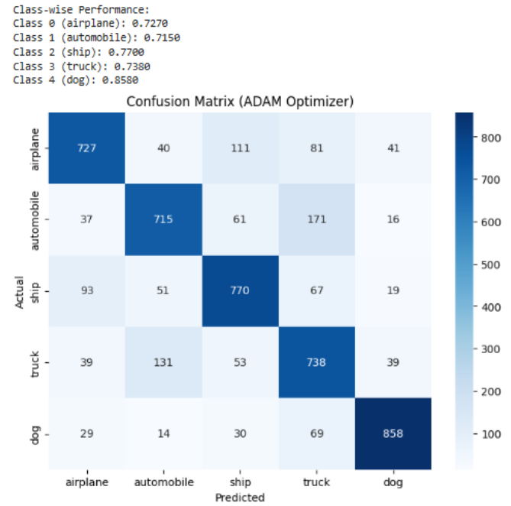

The deeper model had two breakthroughs. Upon reducing the dropout rate from 0.25 to 0.1 my validation accuracy values have all increased by a staggering 55%. Increasing the number of epochs also led to a jump in my test accuracy from 75% after completing 100 epochs to 77.17% post 160 epochs.

Discussion
Initially my learning rate was 0.1 as I was referring to week 3’s XOR lab problem where this learning rate was used. However, I learned that since this problem had only one hidden layer it worked properly with 0.1 as it as it converged quickly without causing unstable updates, additionally it had binary outputs unlike the image classification task with 4 hidden layers, far more parameters and much noisier gradients, which is why it performed well with a learning rate of 0.001.
The Adam optimizer combined with the optimal regularization technique combination (BN + Data Augmentation + Dropout(0.1) has led to the highest performance statistics due to the batch normalization stabilising activations, augmentation allowing the model to learn lower-level features which significantly reduced overfitting and a small dropout rate preserved leaning capacity without dropping too much information which may have been the reason for the 0.25% dropout’s poor performance.
The training curves reflected these effects as the MLP showed faster initial convergence due to no augmentation, but also larger gaps between training and validation losses, indicating overfitting. While the deeper model converges slower but overall generalised better. My results initially were low and stuck at around 20% occurred when reducing layer sizes by powers of 2 between each layer for the deep network. This may have occurred because of the network losing too much representational capacity too quickly, preventing it from capturing complex spatial patterns and leading to significant underfitting.

Conclusion
Overall, I believe both my models demonstrated a sufficient classification ability. Moreover, the overfitting which occurred in the MLP due to its lack of regularization, I believe was the optimal three to four-layer MLP as it might have been capped at ~75%, which means that my obtained 69.72% test accuracy is a reasonable outcome. As my deeper model had more layers, I opted for using Kaggle’s GPUs for hyperparameter tuning, but even with those strong processing units I couldn’t test all layer configurations, dropout rates and weight decay penalty values I initially planned out for testing. I would like to finally mention that the commented out hyperparameter tuning sections in both models are reproducible but take hours for configuring on a CPU and marginally less time on Kaggle’s GPU T4 x2 and generally my model performed slightly better when testing on GPUs which is pretty odd since I made sure that everything was kept the same including the random seed.

