

***Lebanese University – Faculty of Science***

***Master 1 Project Report***

**Computer science**

**Development of a Cosmetics E-commerce Website**

**Chaza Dally 112906**

**Ali Assi 112892**

**Jana Al Mawla 112893**

26 June , 2024

**Table of Contents**

Abstract ……………………………………………………………………………………… 6

General introduction ………………………………………………………………………… 7

Literature review …………………………………………………………………………….. 8

Proposed solution methodology - software realization ……………………………………… 9

Results ………………………………………………………………………………………. 11

Reference …………………………………………………………………………………… 14

**List of Figures**

**Tools and frameworks ……………………………………………………………………… 8**

**Database design ……………………………………………………………………………... 9**

**Result of the project ………………………………………………………………………. 11**

**List of Tables**

**Sale percentage in multiple years ………………………………………………………… 7**

**Abstract**

This project entails the creation of an e-commerce website specifically designed for the cosmetics market, leveraging PHP, CSS, JavaScript, and HTML for a dynamic and interactive user experience. The client interface provides features for browsing products, viewing detailed information, adding items to a shopping cart, and completing purchases securely. Additionally, customers can write product recommendations and reviews, and have the option to cancel orders within a specified time frame. The administrative interface includes functionalities for adding and removing products, updating item information such as prices, processing and accepting orders from clients, managing inventory, tracking sales, and handling customer reviews, aimed at enhancing operational efficiency. The website is designed to be responsive, ensuring accessibility on various devices. Comprehensive testing was conducted to ensure reliability and performance. This project demonstrates the effective use of web development technologies to build a user-centric and efficient online retail platform for cosmetics.

Finally , special thanks to **Dr. Walid Fahes** for their invaluable guidance and support throughout this project.

**General Introduction**

In recent years, the cosmetics industry has witnessed a significant shift towards digital platforms, driven by the increasing consumer preference for online shopping. This transformation underscores the need for robust e-commerce solutions that cater specifically to the unique demands of cosmetics retail. This project aims to address this need by developing a comprehensive e-commerce website tailored for the cosmetics sector.

Year Sale percentage %

1990 47%

2000 50%

2010 64%

2023 86%

The primary goal of this project is to create a feature-rich and user-friendly online platform that enhances the shopping experience for customers while optimizing operational efficiency for store administrators. Leveraging technologies such as PHP, CSS, JavaScript, and HTML, the website will offer a range of functionalities designed to streamline both front-end and back-end operations.

On the client side, users will have access to a visually engaging interface where they can browse a diverse catalog of cosmetics products, view detailed descriptions and images, add items to their shopping carts, and securely complete transactions. Additionally, customers will be able to provide product recommendations and reviews, contributing to an interactive shopping environment.

For administrators, the website will provide comprehensive tools to manage inventory, add or update product information including prices, process customer orders, monitor sales performance, and respond to customer feedback. This administrative interface is crucial for maintaining efficient operations and ensuring a seamless shopping experience.

Testing will ensure reliability and security, encompassing unit testing, integration testing, and user acceptance testing.

In conclusion, this project demonstrates the effective use of web technologies to build an efficient online retail platform for cosmetics, catering to evolving customer expectations and operational needs in the digital marketplace.

**Chapter 1: Literature Review**

Modern web development relies on essential tools and frameworks to enhance functionality and user experience. **Bootstrap** facilitates responsive design and rapid prototyping, ensuring consistency across devices. **Asynchronous JavaScript** techniques like AJAX enable seamless data retrieval and interactive user interfaces. JavaScript libraries such as **SweetAlert** and **Toastify** enhance UX with customizable alerts and notifications. **Third-party integration** like Google maps API and NLP model API . **MySQL** serves as a robust database management system, supporting scalable applications with efficient data handling and security measures. Together, these tools and frameworks empower developers to create dynamic and user-centric web applications that meet modern demands.



1.  b) c)



d) e)

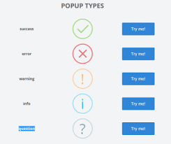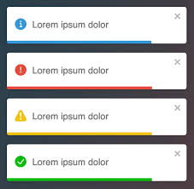

f)

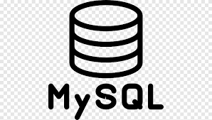

**Chapter 2: Proposed Solution Methodology - Software Realization**

The software realization phase aims to develop a comprehensive e-commerce platform tailored specifically for the cosmetics industry, employing a systematic approach to ensure functionality, scalability, and user satisfaction. Beginning with a rigorous requirements gathering process, stakeholders' needs will be analyzed and documented to establish clear objectives and specifications. This phase will involve creating detailed user stories, defining use cases, and prioritizing features to guide development.

In the design phase, an architecture will be designed that supports scalability and performance, utilizing a layered approach to separate concerns between presentation, business logic, and data access layers. The system will be designed to handle large volumes of data efficiently, with a MySQL database schema optimized for managing product catalogs, customer information, orders, and administrative data. Emphasis will be placed on data normalization, indexing strategies, and security measures to ensure data integrity and protection.

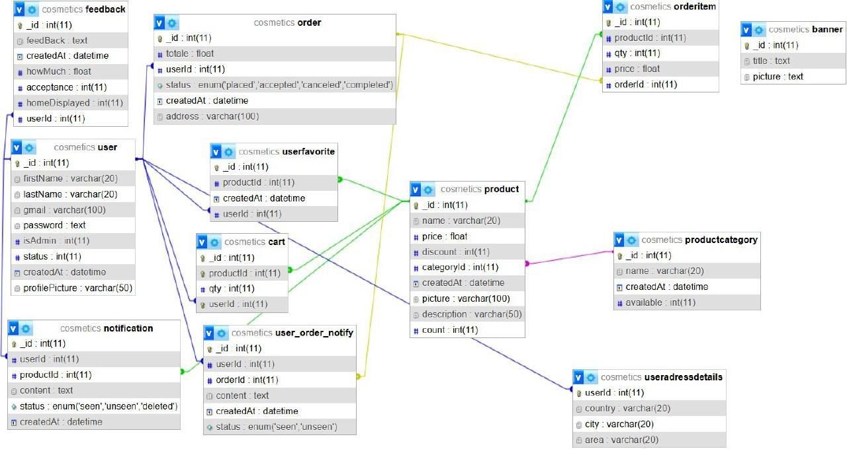

User interface (UI) design will prioritize responsive and intuitive interfaces using HTML, CSS, and JavaScript frameworks such as Bootstrap. This approach will ensure compatibility across different devices and screen sizes, enhancing user experience. JavaScript libraries like SweetAlert and Toastify will be integrated to provide interactive elements such as notifications and alerts, improving usability and user engagement.

Backend development will utilize PHP for server-side scripting, facilitating dynamic content generation and seamless integration with the MySQL database. Asynchronous JavaScript techniques (AJAX) will be implemented to enable real-time data updates and improve application responsiveness. Thorough integration testing will validate the integration of frontend and backend components, ensuring smooth functionality and performance under various scenarios.

Following development, user acceptance testing (UAT) will be conducted to validate that the platform meets stakeholder expectations and functional requirements. Deployment strategies will focus on optimizing performance and security, with considerations for scalability and load balancing. Ongoing maintenance and support post-deployment will address any issues promptly, optimize performance based on user feedback, and implement updates or enhancements to keep the platform current and competitive in the market.

**Chapter 3: Results**

The culmination of this project is the successful development and deployment of an advanced e-commerce platform designed specifically for the cosmetics industry. The platform incorporates responsive design principles, robust backend functionalities, and secure transaction mechanisms to provide a seamless shopping experience for customers. Key features include intuitive user interfaces, efficient order management systems, and real-time inventory tracking. Additionally, a Singleton pattern is implemented for database management, ensuring a single instance of the database connection object is created and reused throughout the application, enhancing efficiency and resource management. The platform also includes PHP files that mimic Java-like classes with attributes, controllers with functions such as delete banner and update, and routes that utilize these controllers to perform various operations. Post-deployment, ongoing maintenance ensures continuous optimization and adaptation to market demands, reinforcing its role as a competitive solution in the cosmetics retail sector.

1. As a user :

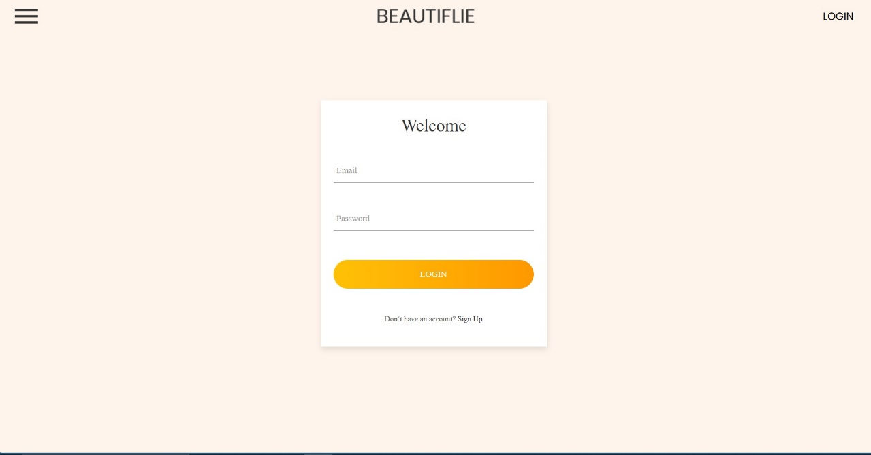

b)

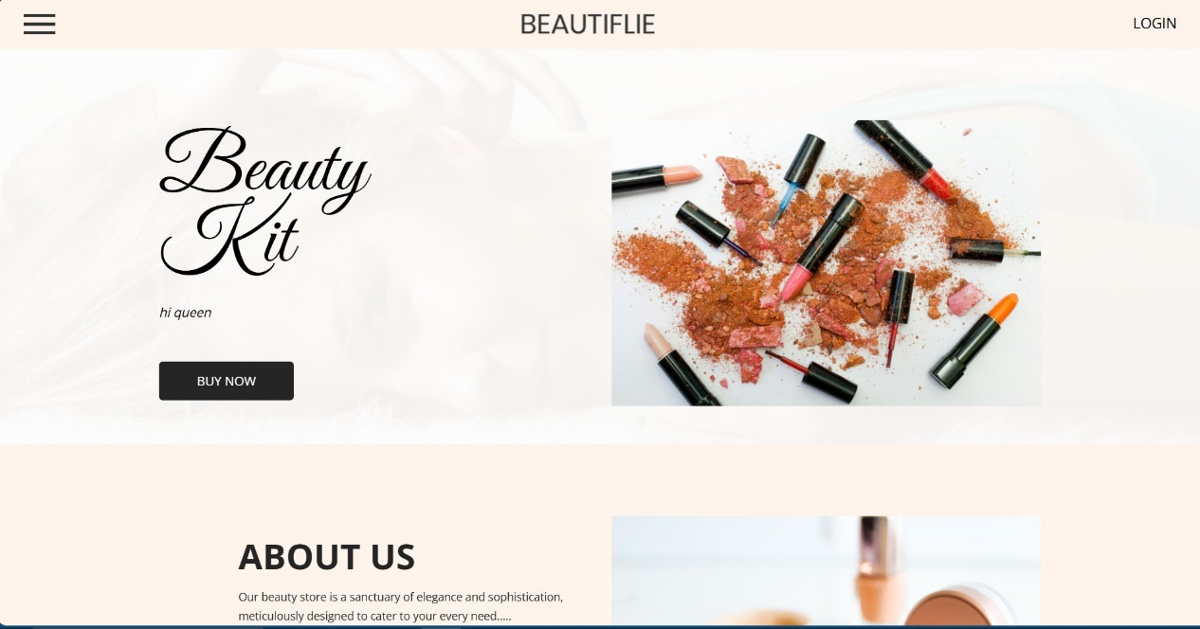

c)

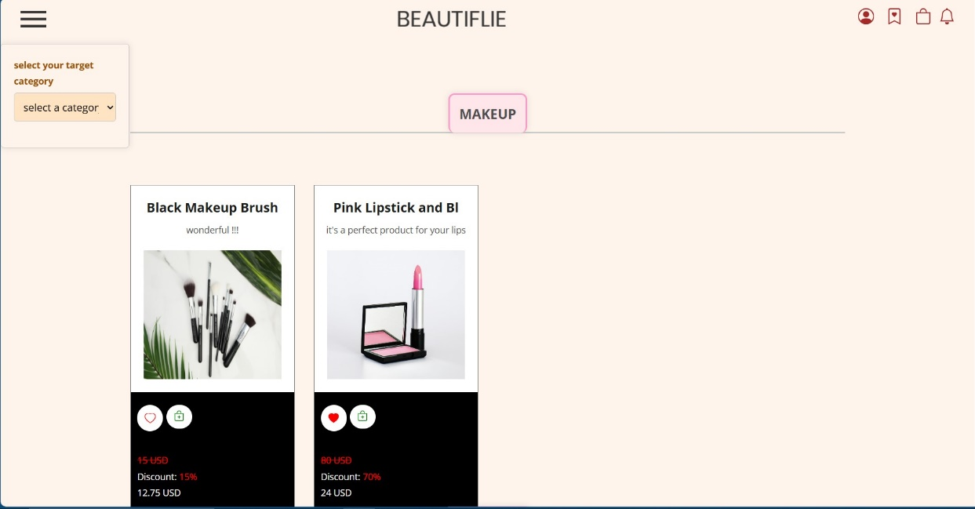

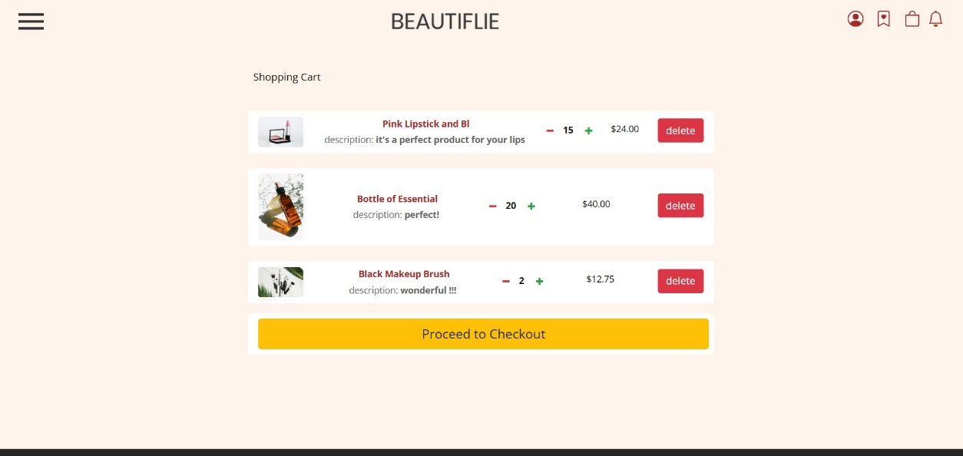 d)

e)

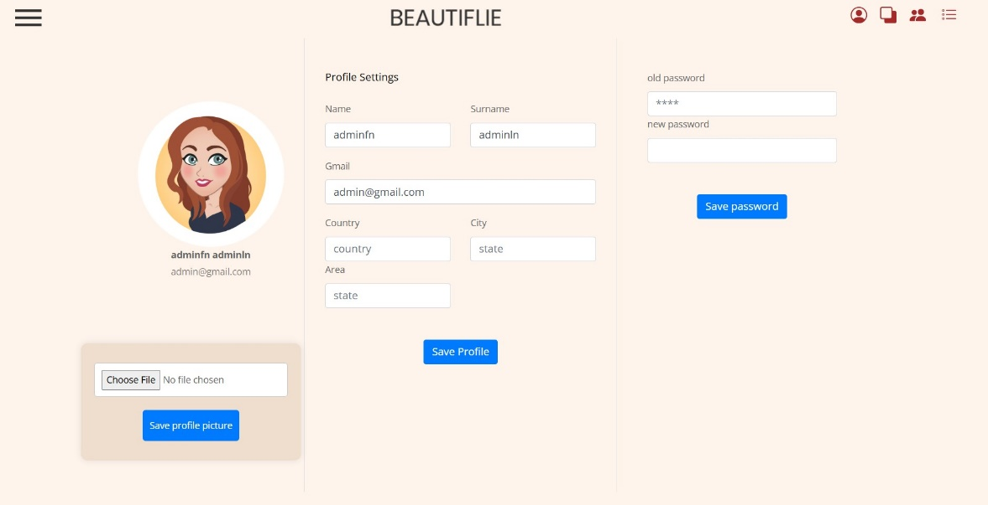

1. As an admin :

a)

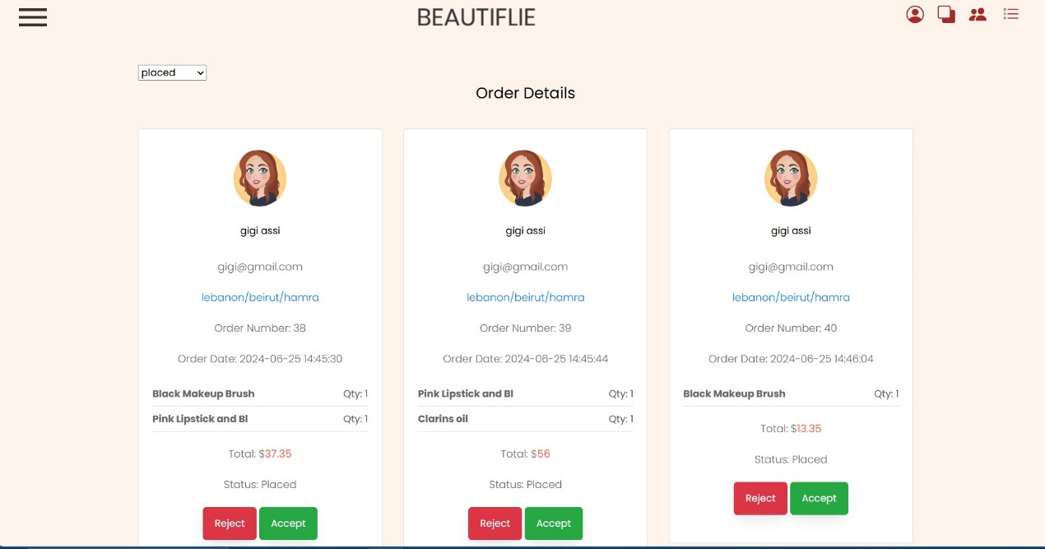

**Chapter 4:Conclusion and Perspective**

b)

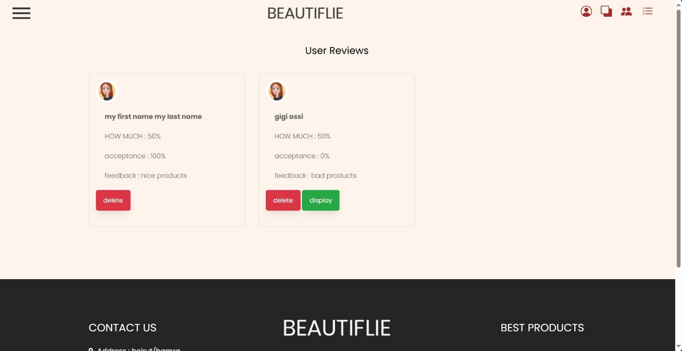

**References**

* Bootstrap. (2023). *Bootstrap Documentation*. Retrieved from <https://getbootstrap.com/docs/5.0/getting-started/introduction/>
* MySQL. (2023). *MySQL Documentation*. Retrieved from <https://dev.mysql.com/doc/>
* SweetAlert. (2023). *SweetAlert Documentation*. Retrieved from <https://sweetalert.js.org/docs/>
* Toastify. (2023). *Toastify Documentation*. Retrieved from <https://fkhadra.github.io/react-toastify/>