BSCS FINAL PROJECT
Agile Software Design Specification

DesignEye: AI-Powered Predictive UX/UI Heatmaps



Product Owner

Dr. Ghulam Mustafa

Presented by:
Group ID: S26CS003

L1S23BSCS0014 Ali Malik
L1S23BSCS0142 Muhammad Hussain
L1S23BSCS0002 Bisma Zahid

Faculty of Information Technology & Computer Science

University of Central Punjab

Agile Software Design Specification

SDS Phase II

Version: Version 1.0

Product Owner

Dr. Ghulam Mustafa

Scrum Master

Ali Malik

Group S26CS003

Team
Member Name | Roles
Ali Malik | Scrum Master; AI Model Development (U-Net/SalGAN) & Dataset Preprocessing
Muhammad Hussain | Backend API (FastAPI) & Database Integration
Bisma Zahid | Frontend Dashboard (React.js) & UI Visualization

Table of Contents
Abstract 1
1. System Architecture 2
1.1 High-Level Architecture 2
1.2 Architecture Diagram 3
1.3 Component Overview 4
2. Mapping Design to User Stories 5
3. Detailed System Design 6
3.1 Module Decomposition 6
3.2 Data Flow Description 7
3.2.1 Context Level DFD 8
3.2.2 DFD Level 01 9
3.2.3 DFD Level 02 10
4. UML Diagrams 11
4.1 Use Case Diagram 11
4.2 Class Diagram 12
4.3 Sequence Diagram 13
5. Database Design (ERD) 14
5.1 ER Diagram 14
5.2 Schema Tables 15
6. API Design 19
7. UI/UX Design (Prototypes) 20
7.1 Wireframes(Low Fidelity Prototypes): 20
7.2 2. Navigation Flow: 32
7.3 Screens(High Fidelity Prototypes): 33
7.3.1 Frontend Pages: 33
7.3.2 Authentication Pages: 34
7.3.3 Backend Pages: 38
8. Sprint-wise Design Evolution 45
9. Test Design 48
10. Design Quality Attributes 49
11. Deployment Considerations 50
12. Future Enhancements 51
13. Revised Project Plan 52
14. References 53

Revision History & Sprint Log
Version | Sprint | Date | Changes | Owner
1.0 | Sprint 1 | May 2026 | Initial architecture and auth design | DesignEye Team
1.1 | Sprint 2 | June 2026 | Upload pipeline, preprocessing, Cloudinary integration | Ali Malik
1.2 | Sprint 3 | July 2026 | AI inference engine, heatmap overlay, Clarity Score | Muhammad Hussain
1.3 | Sprint 4 | July 2026 | A/B comparison, dashboard, deployment | Bisma Zahid
1.4 | Sprint 5 | Aug 2026 | A/B comparison, project dashboard, deployment | DesignEye Team

Previous Phases Feedback

Idea Defence Feedback (Screenshot)
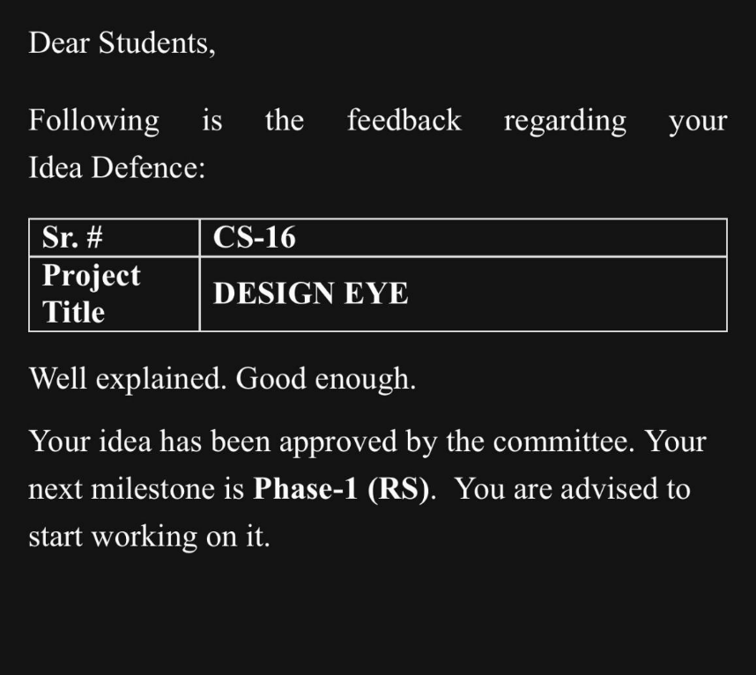

The committee approved the DesignEye concept and highlighted the importance of differentiating from existing post-launch tools like Hotjar. Feedback was incorporated by emphasizing pre-development static mockup analysis as the core differentiator. Phase 1 SRS was accepted with minor revisions to Use Case descriptions, which have been addressed in this Phase 2 document.

Abstract
DesignEye is a web-based SaaS platform that leverages deep learning to predict human visual attention on static UI designs, democratizing access to eye-tracking data without expensive laboratory hardware. Building on the Phase 1 requirements baseline, Phase 2 translates the Software Requirements Specification (SRS) into a comprehensive Software Design Specification (SDS). The system follows a three-tier Client-Server architecture: a React.js frontend, a FastAPI asynchronous backend, and a U-Net/SalGAN deep learning inference engine backed by MongoDB. Key design artifacts presented in this document include the high-level architecture diagram, module decomposition, UML class and sequence diagrams, entity-relationship diagram, schema tables, REST API contracts, UI/UX wireframes, sprint-wise design evolution, test case scenarios, and deployment strategy. Together, these artifacts provide a complete blueprint for implementing the core features identified in Phase 1: predictive heatmap generation, Clarity Score computation, Focus Order visualization, A/B design comparison, and a persistent project dashboard - all delivered within a 5-sprint Scrum lifecycle targeting sub-30-second analysis turnaround for UI/UX designers, product managers, and e-commerce teams.

System Architecture

High-Level Architecture
DesignEye follows a Three-Tier Client-Server architecture style. The system is divided into three clearly separated layers:
- Presentation Layer (React.js): Browser-based SPA providing the designer dashboard for mockup upload, heatmap visualization, and A/B comparison.
- Business Logic Layer (FastAPI + Celery): Handles API routing, JWT authentication, file validation, preprocessing orchestration, and asynchronous AI inference task management.
- Data Layer (MongoDB Atlas + Cloudinary): Document store for user profiles and results metadata, and object storage for mockup assets and heatmap outputs.

This architecture style was chosen because it enforces separation of concerns, allows the AI inference engine to be independently retrained or replaced without modifying the API layer, and supports horizontal scaling of FastAPI worker instances under concurrent designer uploads. The stateless backend with Celery task queue prevents GPU-intensive inference from blocking API response threads.

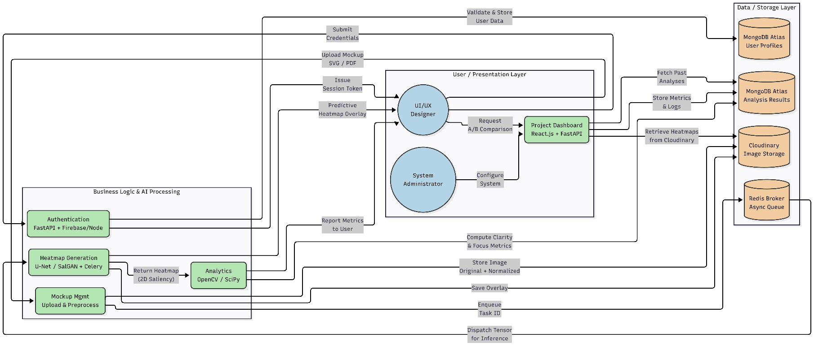
Architecture Diagram

Component Overview
Component | Responsibility
React.js Frontend | Browser-based interface for all user interactions: mockup upload, heatmap overlay rendering, Clarity Score display, Focus Order visualization, and A/B comparison.
FastAPI Backend | Single entry point; handles REST API routing, Firebase/Node JWT validation, file validation, and orchestrates preprocessing and inference task queuing.
Firebase/Node Auth
File Upload & Preprocessing Module | Validates uploaded SVG/PDF files, normalizes images to 224x224 RGB tensors using Pillow, and stores originals in Cloudinary with unique asset IDs.
Celery + Redis Task Queue | Manages the asynchronous inference task queue, preventing FastAPI blocking during GPU-intensive model inference.
AI Inference Engine (U-Net/SalGAN) | Receives normalized image tensors, runs forward pass through the pre-trained saliency model, and returns a 2D heatmap array with INT8 quantization for speed.
Analytics Module | Computes Clarity Score (0-100) using Sobel edge density and saliency entropy, and extracts numbered Focus Order nodes via non-maximum suppression.
MongoDB Atlas | Stores user profiles, project metadata, analysis history, Clarity Scores, focus nodes, and inference task records.
Cloudinary | Stores uploaded mockup files and generated heatmap overlays with tenant-prefix isolation per user.

Mapping Design to User Stories
The following table maps each user story from Phase 1 to the corresponding system component and design artifact addressed in this Phase 2 SDS document.

Sample Table
Story ID | Component | Description
US-01 | Firebase/Node Auth + FastAPI /auth/register | User registration - email/password sign-up with Fire base/Node Authentication.
US-02 | Firebase/Node Auth + FastAPI /auth/login | User login - Firebase/Node JWT issued; stored in browser session.
US-03 | Firebase/Node Auth + Email Service | Password reset - Firebase/Node sends reset link to registered email.
US-04 | React.js Upload Component + FastAPI /upload | Mockup upload interface - drag-and-drop SVG/PDF file submission.
US-05 | FastAPI Validation Middleware + Cloudinary | File validation and preprocessing - format check, normalization, storage.
US-06 | AI Inference Engine (U-Net/SalGAN) + Celery Queue | AI model inference - saliency map generation from normalized mockup tensor.
US-07 | React.js Canvas Overlay Component | Heatmap overlay rendering - JET colormap heatmap overlaid on original mockup.
US-08 | FastAPI Analytics Module | Clarity Score computation - 0-100 score based on edge density and saliency entropy.
US-09 | React.js Canvas + FastAPI Saliency Peaks | Focus Order visualization - numbered nodes on predicted attention sequence.
US-10 | React.js Split-Screen Component + FastAPI /compare | A/B comparison - side-by-side heatmaps with delta score.
US-11 | React.js Dashboard + FastAPI /projects | Project dashboard - paginated analysis history with rerun capability.

Detailed System Design

Module Decomposition
The DesignEye system is decomposed into six primary modules, each responsible for a distinct functional domain:

Authentication Module
- Sub-components: RegisterService, LoginService, TokenVerifyMiddleware, PasswordResetService.
- Responsibility: Handles user registration and login via Firebase/Node Authentication. Every incoming API request passes through TokenVerifyMiddleware, which validates the Firebase/Node JWT token before allowing access to protected endpoints.
- Technology: Firebase/Node Admin SDK (Python), FastAPI dependency injection.

File Upload & Preprocessing Module
- Sub-components: FileUploadController, FormatValidator, ImageNormalizer, CloudinaryStorageService.
- Responsibility: Accepts SVG/PDF mockup uploads, validates file type and size, normalizes the image to the model-expected tensor format (224x224 RGB), and stores the file in Cloudinary with a unique asset_id.
- Technology: Python Pillow, FastAPI UploadFile, Cloudinary.

AI Inference Engine
- Sub-components: ModelLoader, InferenceWorker (Celery Task), HeatmapPostprocessor.
- Responsibility: Loads the pre-trained U-Net/SalGAN model on startup. InferenceWorker receives the normalized image tensor from the Celery queue, runs the forward pass, and returns a 2D saliency map (float32 array). HeatmapPostprocessor normalizes the saliency map to [0,1] and converts it to a colormap overlay (JET colormap).
- Technology: PyTorch, torchvision, Celery, Redis broker.
Analytics Module
- Sub-components: ClarityScoreCalculator, FocusOrderExtractor.
- Responsibility: ClarityScoreCalculator computes a 0-100 score based on edge density (via Sobel operator) and saliency dispersion (entropy of the saliency distribution). FocusOrderExtractor applies non-maximum suppression to identify the top-N saliency peaks and returns their coordinates as numbered focus nodes.
- Technology: NumPy, SciPy, OpenCV.
A/B Comparison Module
- Sub-components: CompareController, DeltaScoreEngine.
- Responsibility: Accepts two asset_ids, retrieves their stored heatmaps and Clarity Scores, computes the delta score (Design A Clarity Score minus Design B Clarity Score), and returns both heatmaps and the delta for split-screen rendering.
- Technology: FastAPI, MongoDB aggregation queries.

Project Dashboard Module
- Sub-components: ProjectRepository, HistoryPaginator, RerunService.
- Responsibility: Manages persistent project records in MongoDB. HistoryPaginator retrieves paginated analysis history per user. RerunService retrieves the stored Cloudinary asset and re-enqueues inference without requiring a fresh upload.
- Technology: MongoDB (Motor async driver), FastAPI.

Data Flow Description
Step | Stage | Data Movement
1 | Authentication | User submits email/password → Firebase/Node Auth verifies credentials → JWT token issued → token stored in browser session.
2 | Mockup Upload | User uploads SVG/PDF file → FastAPI TokenVerifyMiddleware validates JWT → FormatValidator checks file type and size → ImageNormalizer converts to 224x224 RGB tensor → CloudinaryStorageService stores original file → asset_id and task_id returned to frontend (202 Accepted).
3 | Inference Queue | FastAPI enqueues Celery task with normalized tensor and asset_id → Celery worker picks up task → U-Net/SalGAN forward pass executes on GPU → 2D saliency map returned.
4 | Analytics Computation | HeatmapPostprocessor applies JET colormap → ClarityScoreCalculator computes 0-100 score → FocusOrderExtractor identifies numbered focus nodes → Results stored in MongoDB under project record.
5 | Frontend Polling | React frontend polls GET /status/{task_id} → On completion, retrieves heatmap overlay URL and Clarity Score → React Canvas renders heatmap over original mockup.
6 | A/B Comparison | User selects two asset IDs → POST /compare → DeltaScoreEngine retrieves stored heatmaps and scores → Computes clarity delta → Returns both heatmaps and delta score for split-screen view.

3.2.1 Context Level DFD
This DFD shows how user data flows through the DesignEye system from mockup ingestion through AI inference to heatmap delivery.

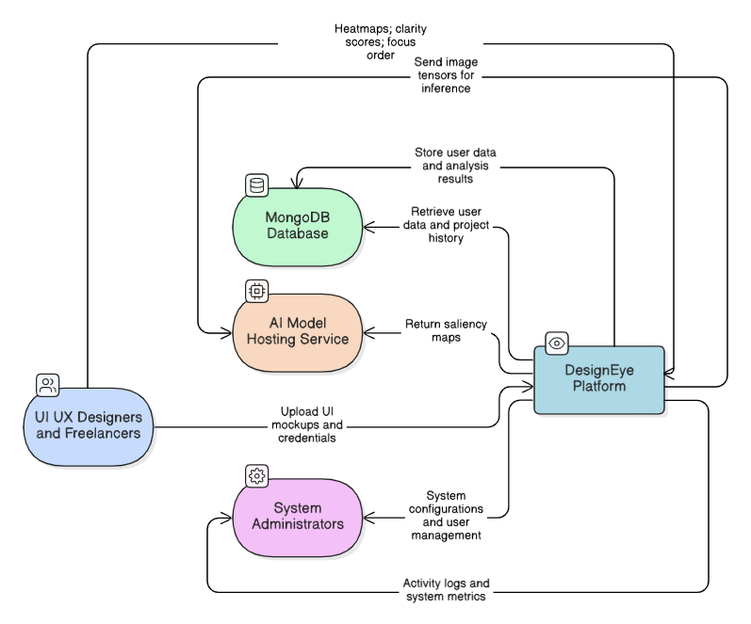

3.2.2 DFD Level 01
This DFD shows how user data flows through the system from authentication and upload to inference, analytics, and result delivery.

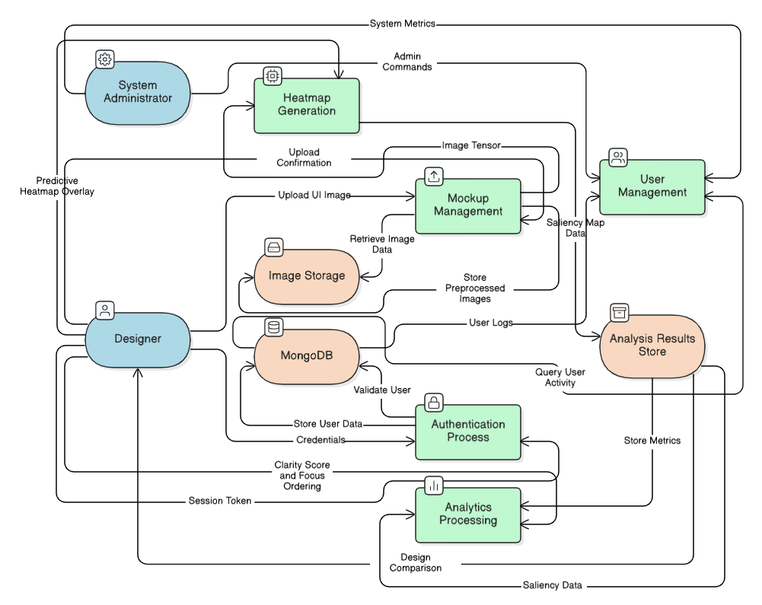

3.2.3 DFD Level 02
Decomposes Preprocessing and Inference into sub-functions: Image Normalization, Tensor Preparation, U-Net/SalGAN Forward Pass, Saliency Map Postprocessing, Clarity Score Calculation, and Focus Order Extraction. This helps trace each transformation step from raw mockup to final heatmap.

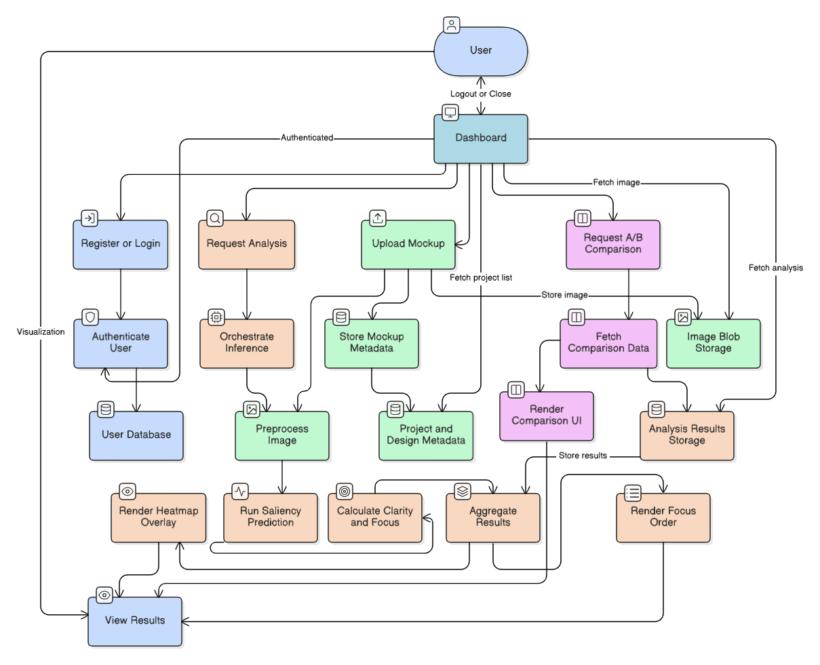

UML Diagrams

Use Case Diagram
The DesignEye use case diagram depicts all system interactions between actors (Visitor, Authenticated Designer, and System) and the platform's core functionalities. Key use cases include user registration/login, mockup upload, AI inference, heatmap visualization, Clarity Score display, Focus Order rendering, A/B comparison, and project history management. The diagram follows UML notation with <<include>> and <<extend>> relationships where applicable.

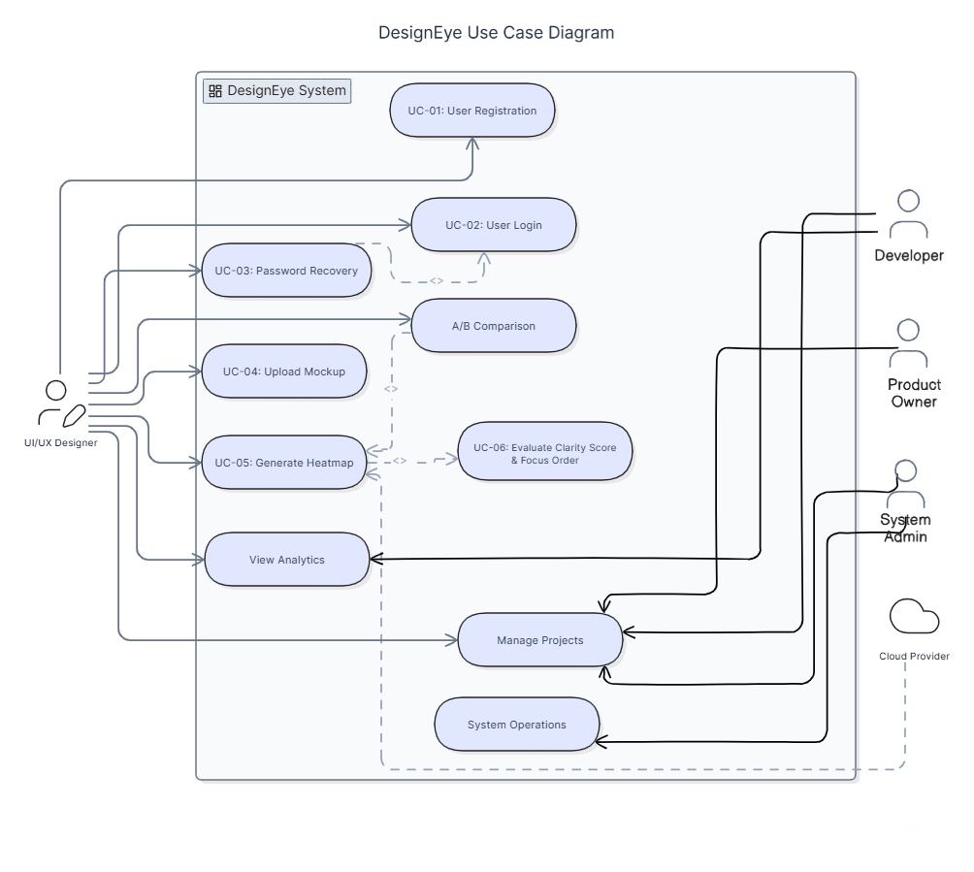

Class Diagram
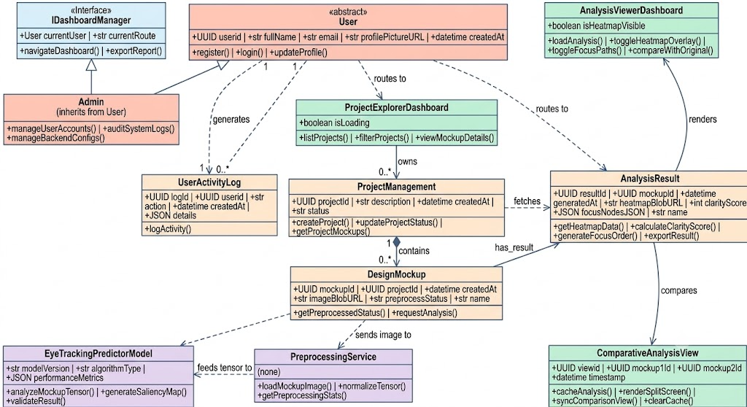
The class diagram defines the following core classes and their relationships:

Sequence Diagram
This diagram models the sequential interaction between the React.js frontend, FastAPI backend, Celery task queue, AI inference engine, and storage components during the primary heatmap generation workflow. It shows asynchronous task queuing and polling-based result retrieval.
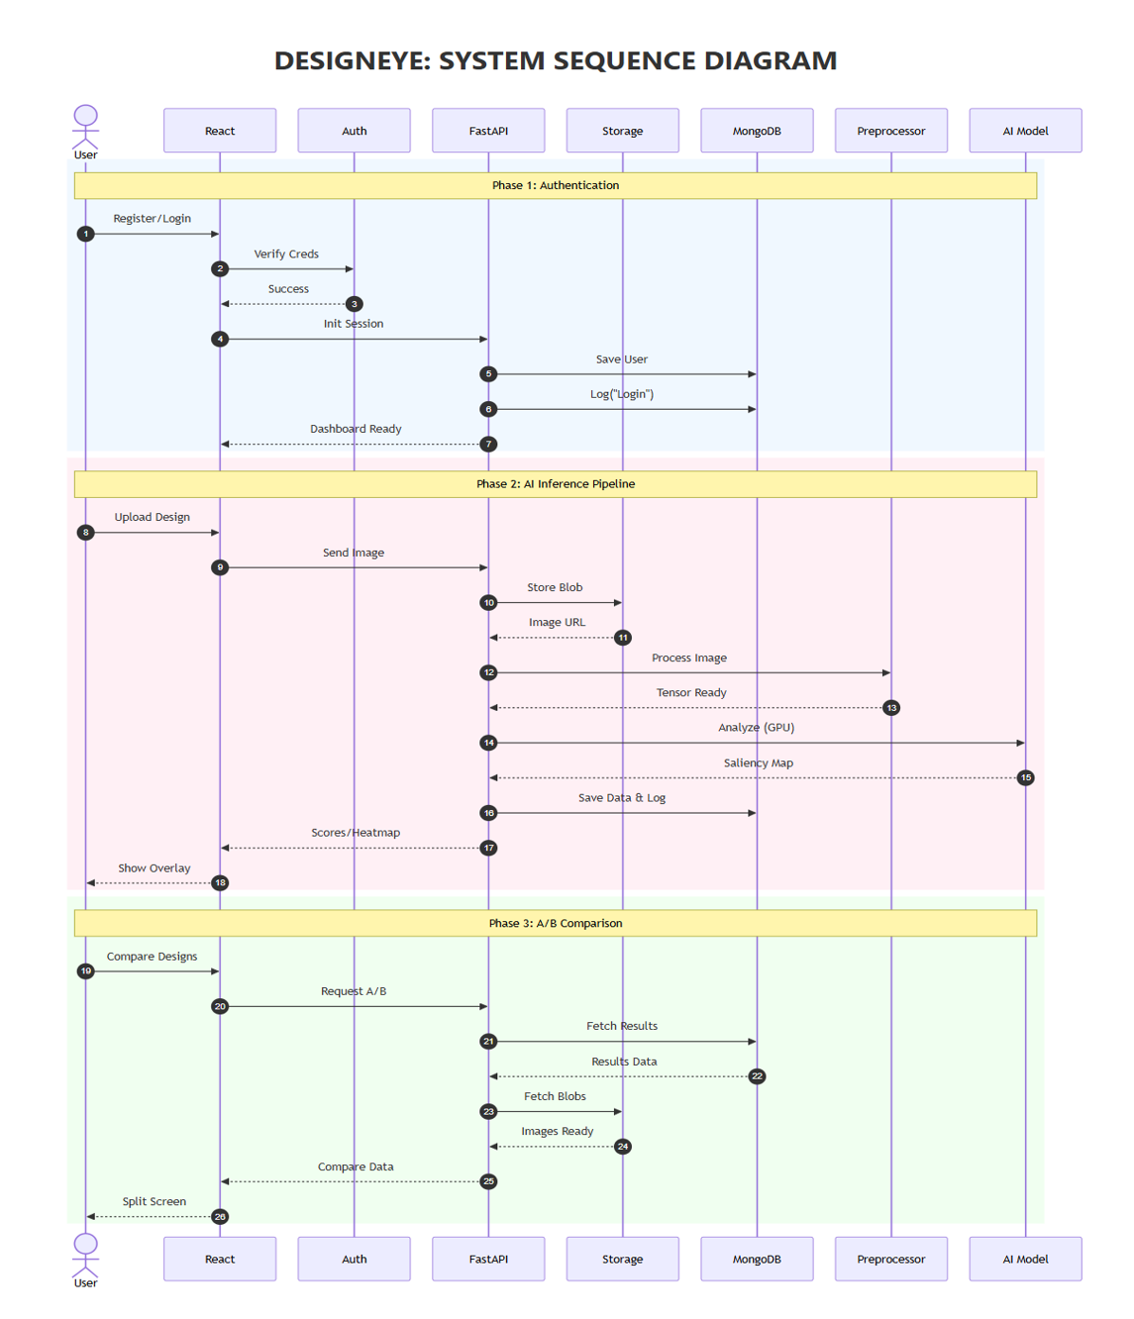

Database Design (ERD)

ER Diagram
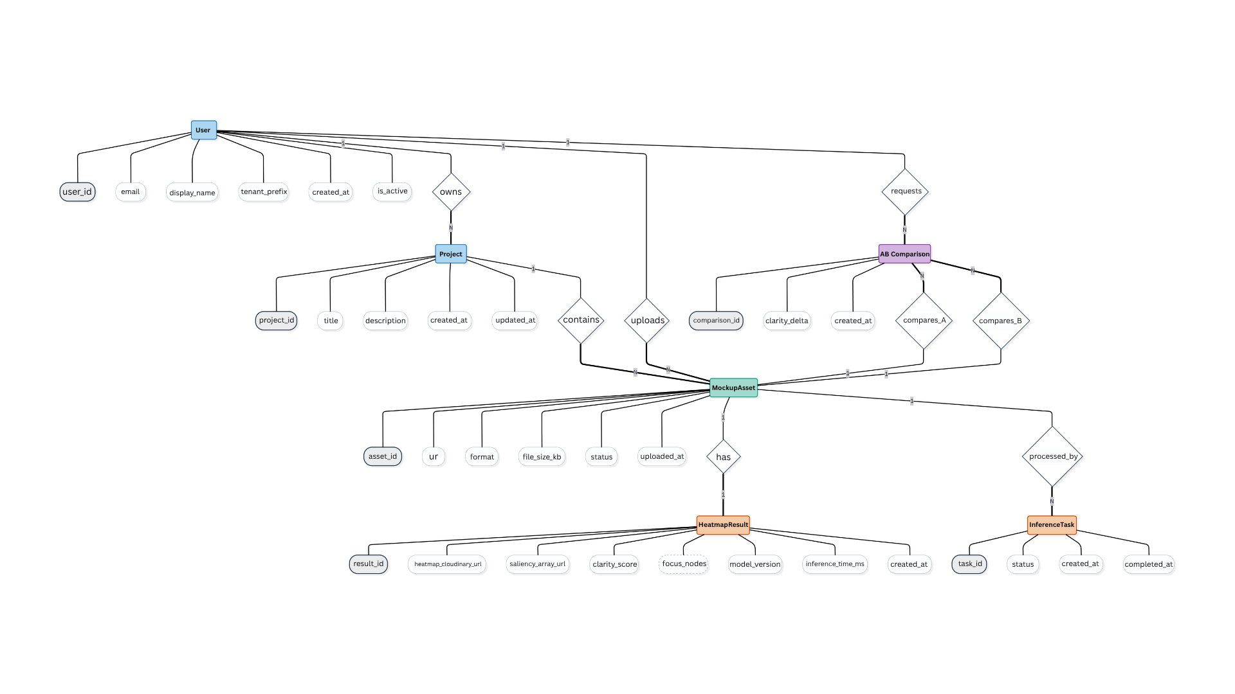
This ERD outlines data relationships between Users, Projects, MockupAssets, HeatmapResults, ABComparisons, and InferenceTasks. It ensures referential integrity and supports tenant-based asset isolation, analysis history traceability, and rerun capability across all DesignEye operations.

Schema Tables
The schema defines the structure of the MongoDB collections, including fields, data types, and constraints among entities, ensuring data integrity and supporting all system requirements.

Table 4: Users Collection

Field Name | Data Type | Constraints / Attributes | Description
user_id | String (UUID) | Primary Key, Not Null | Firebase UID - unique identifier for each user
email | String | Unique, Not Null | User's registered email address
display_name | String | Optional | User's display name
tenant_prefix | String | Not Null | Cloudinary folder prefix for asset isolation (= user_id)
created_at | DateTime | Not Null, Default: now() | Account creation timestamp
is_active | Boolean | Default: true | Account active status

Table 5: Projects Collection

Field Name | Data Type | Constraints / Attributes | Description
project_id | String (UUID) | Primary Key, Not Null | Unique project identifier
user_id | String (FK) | Foreign Key → Users, Not Null | Owner of the project
title | String | Not Null | Project name given by the designer
description | String | Optional | Project description
created_at | DateTime | Not Null, Default: now() | Project creation timestamp
updated_at | DateTime | Not Null | Last modification timestamp

Table 6: MockupAssets Collection

Field Name | Data Type | Constraints / Attributes | Description
asset_id | String (UUID) | Primary Key, Not Null | Unique asset identifier
project_id | String (FK) | Foreign Key → Projects, Not Null | Associated project
user_id | String (FK) | Foreign Key → Users, Not Null | Asset owner (tenant isolation)
_url | String | Not Null | Cloudinary URL of the stored file
format | Enum | SVG | PDF | Accepted file format
file_size_kb | Integer | Not Null | File size in kilobytes
status | Enum | pending | processing | complete | failed | Current processing status
uploaded_at | DateTime | Not Null, Default: now() | Upload timestamp

Table 7: HeatmapResults Collection

Field Name | Data Type | Constraints / Attributes | Description
result_id | String (UUID) | Primary Key, Not Null | Unique result identifier
asset_id | String (FK) | Foreign Key → MockupAssets, Unique | One-to-one with source mockup
heatmap_cloudinary_url | String | Not Null | Cloudinary URL of the generated heatmap overlay image
saliency_array_url | String | Not Null | Cloudinary URL of the raw float32 saliency array (.npy)
clarity_score | Float | Range: 0.0-100.0 | Computed Clarity Score
focus_nodes | JSON Array | Not Null | Array of {x, y, rank} focus node objects
model_version | String | Not Null | Version of the U-Net/SalGAN model used
inference_time_ms | Integer | Not Null | Inference latency in milliseconds
created_at | DateTime | Not Null, Default: now() | Result generation timestamp

Table 8: ABComparisons Collection

Field Name | Data Type | Constraints / Attributes | Description
comparison_id | String (UUID) | Primary Key, Not Null | Unique comparison identifier
user_id | String (FK) | Foreign Key → Users, Not Null | Requesting designer
asset_id_a | String (FK) | Foreign Key → MockupAssets | Design variant A
asset_id_b | String (FK) | Foreign Key → MockupAssets | Design variant B
clarity_delta | Float | Not Null | Clarity Score A minus Clarity Score B
created_at | DateTime | Not Null, Default: now() | Comparison timestamp

Table 9: InferenceTasks Collection

Field Name | Data Type | Constraints / Attributes | Description
task_id | String (UUID) | Primary Key, Not Null | Unique Celery task identifier
asset_id | String (FK) | Foreign Key → MockupAssets, Not Null | Asset being processed
status | Enum | pending | processing | complete | failed | Current task status
created_at | DateTime | Not Null, Default: now() | Task creation timestamp
completed_at | DateTime | Nullable | Task completion timestamp

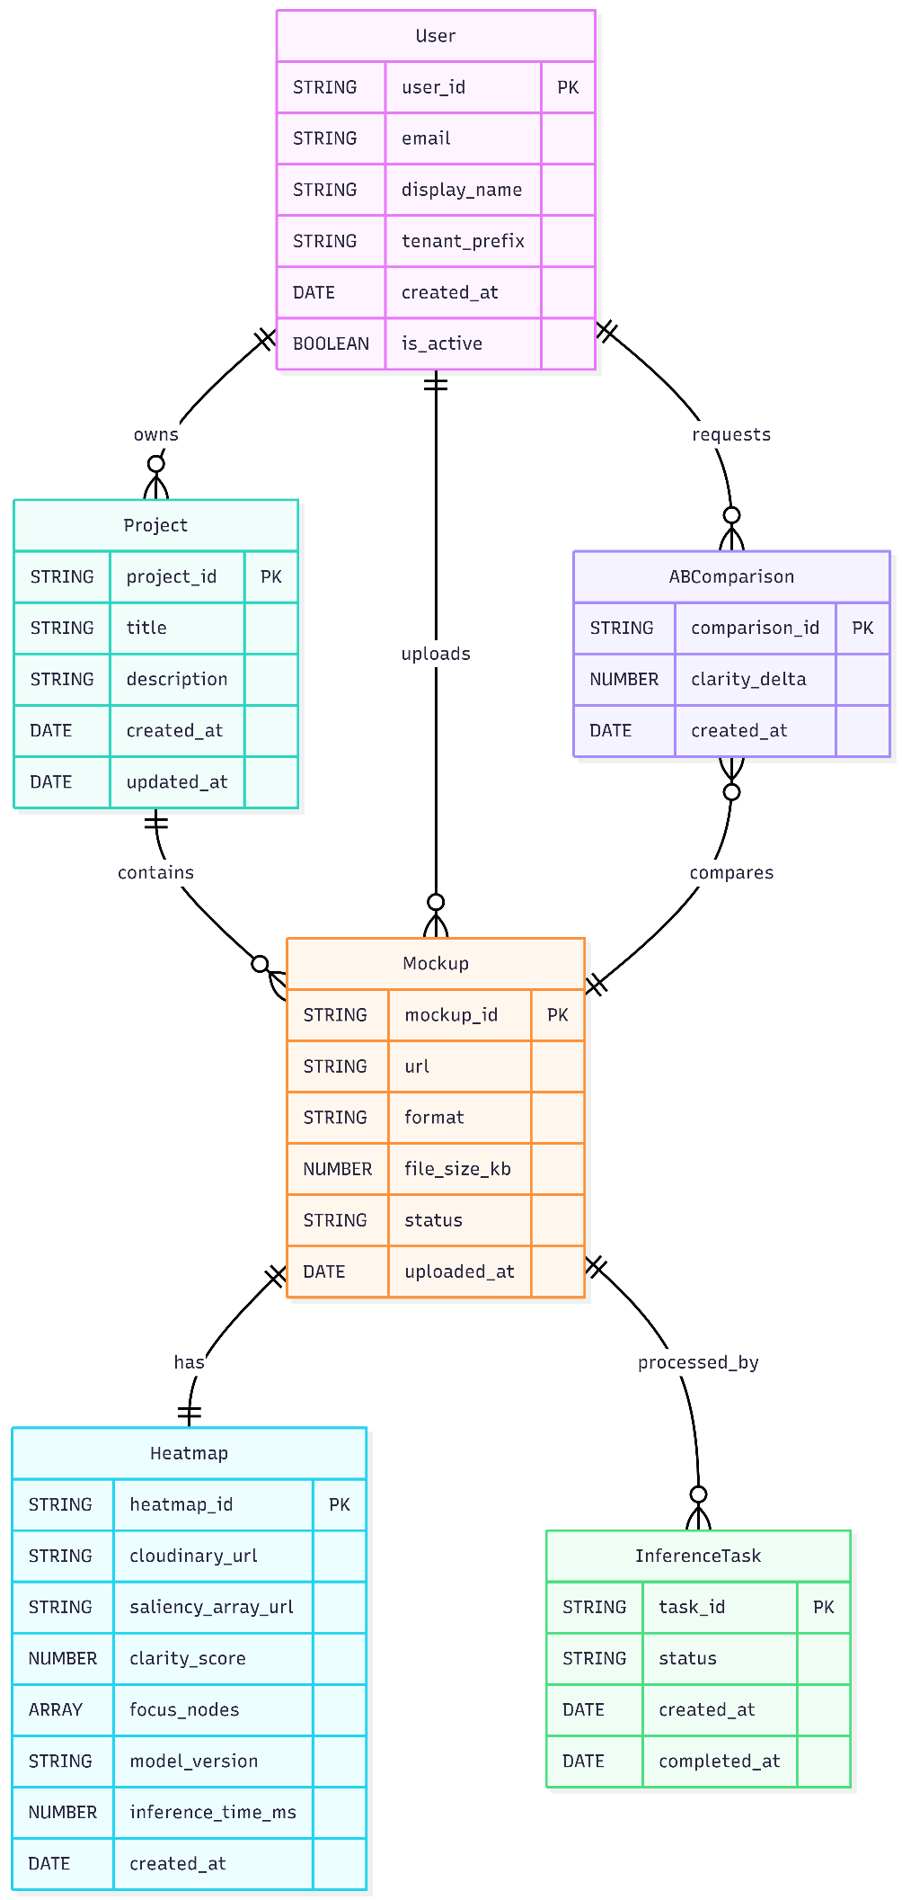
Relational Schema:

API Design

Sample Table
Endpoint | Method | Input | Output
/api/auth/register | POST | { email, password, display_name } | { user_id, token }
/api/auth/login | POST | { email, password } | { accessToken, user_id }
/api/auth/logout | POST | { } (token in header) | { message: 'Logged out' }
/api/auth/reset-password | POST | { email } | { message: 'Reset link sent' }
/api/upload | POST | multipart/form-data: { file, project_id } | { asset_id, task_id, status: 'pending' }
/api/status/{task_id} | GET | Path param: task_id | { status, result_url, clarity_score, focus_nodes }
/api/results/{asset_id} | GET | Path param: asset_id | { heatmap_url, clarity_score, focus_nodes, model_version }
/api/results/{asset_id}/rerun | POST | Path param: asset_id | { new_task_id, status: 'pending' }
/api/compare | POST | { asset_id_a, asset_id_b } | { comparison_id, heatmap_a_url, heatmap_b_url, clarity_delta }
/api/compare/{comparison_id} | GET | Path param: comparison_id | { comparison details, delta score }
/api/projects | GET | Query: page, limit | { projects[], total_count }
/api/projects | POST | { title, description } | { project_id, title, created_at }
/api/projects/{project_id} | GET | Path param: project_id | { project details, assets[] }

UI/UX Design (Prototypes)

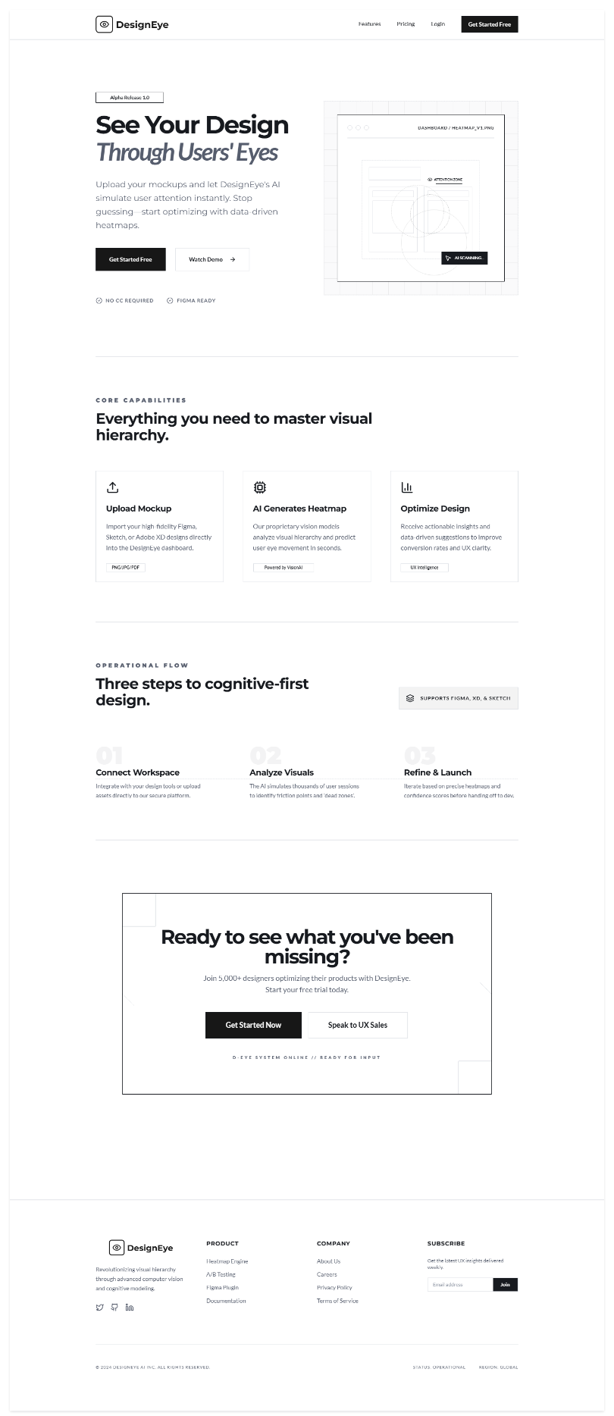
Wireframes(Low Fidelity Prototypes):
Landing Page:

Sign Up Page:
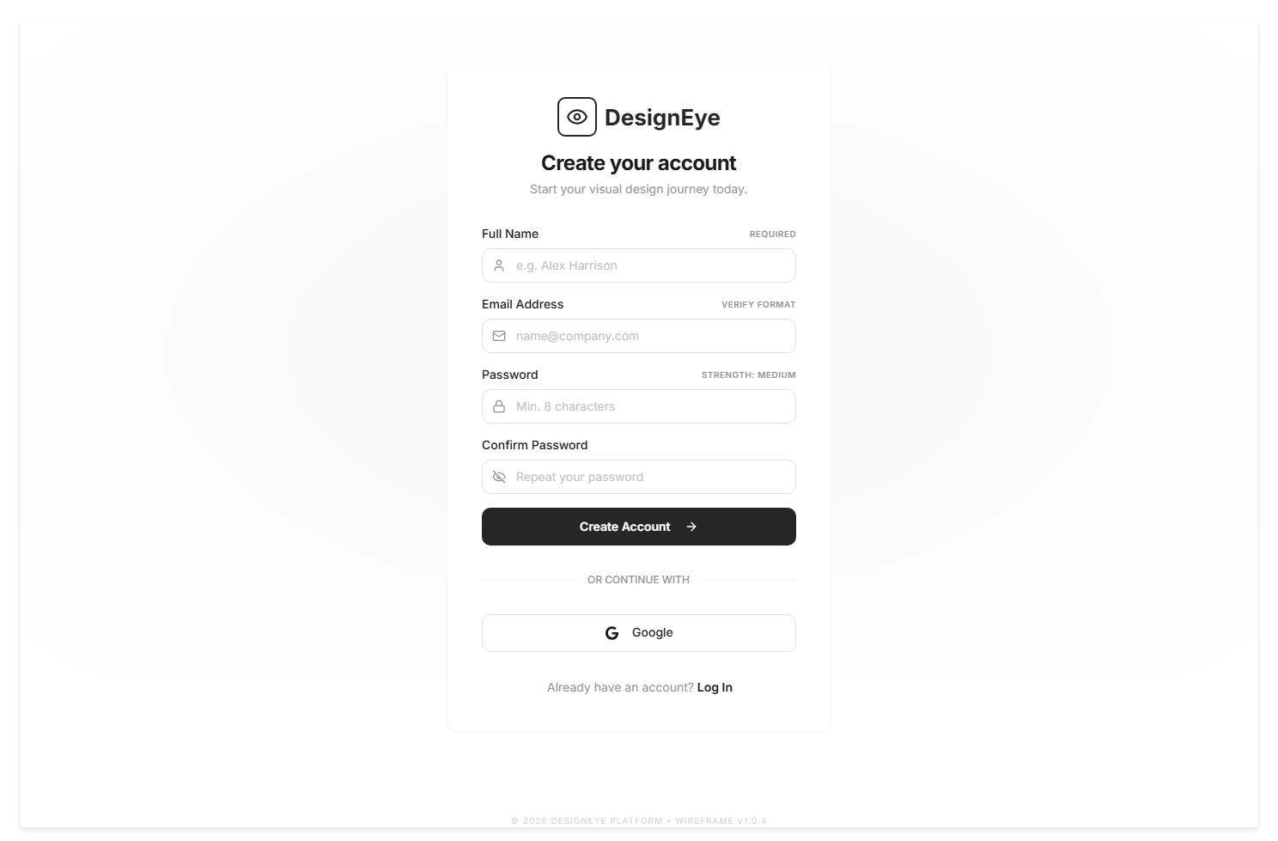

Login Page:
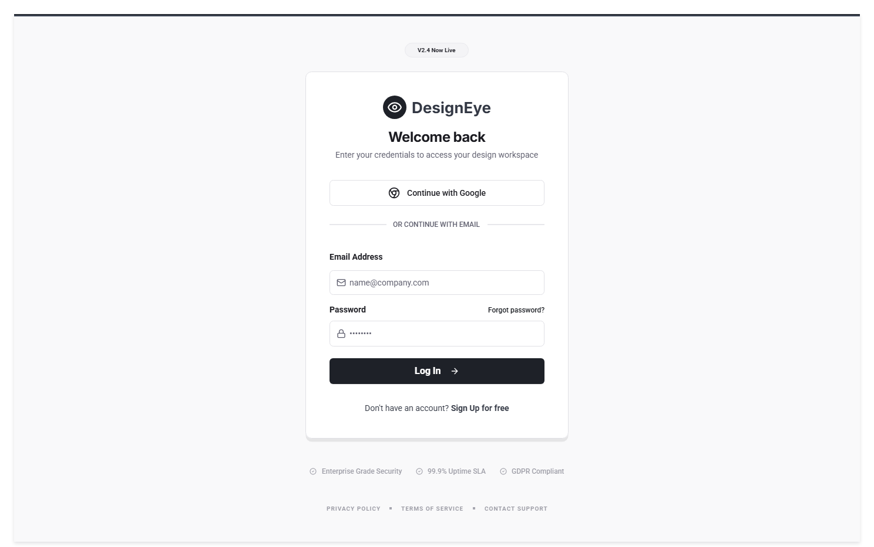

Password Reset Page:


Profile Settings Page:
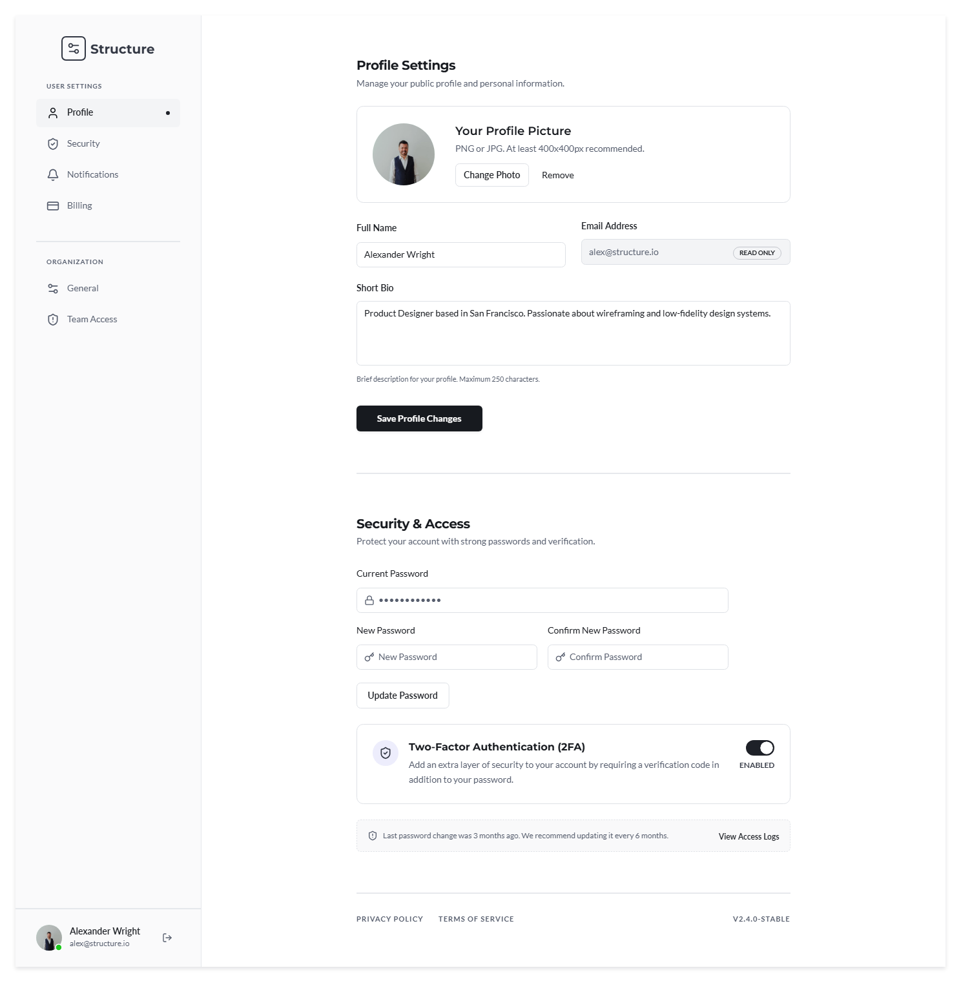

Dashboard Page:
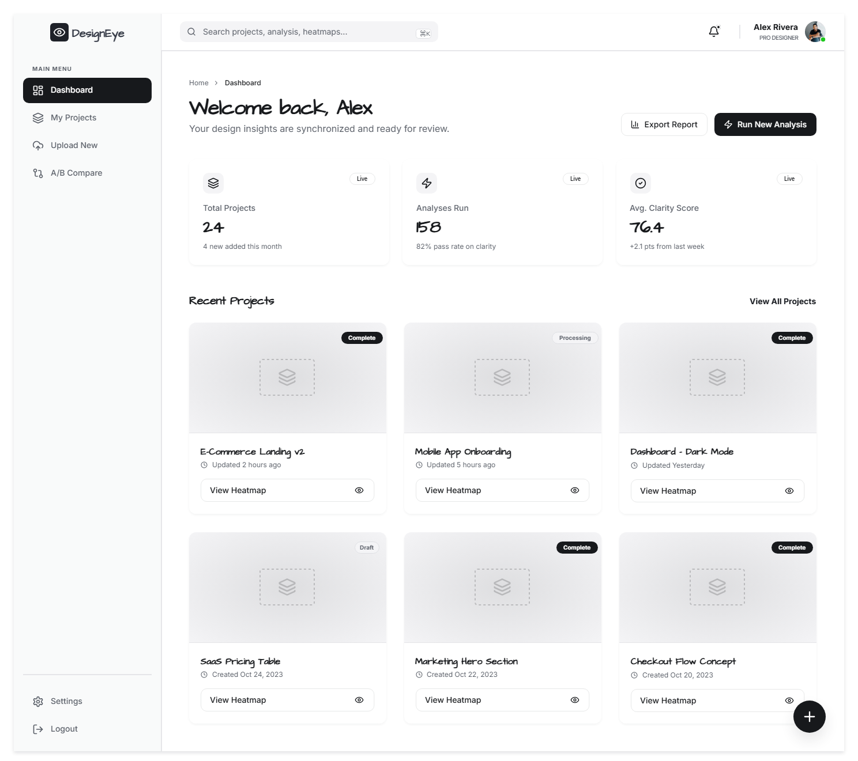

Project Management Page:

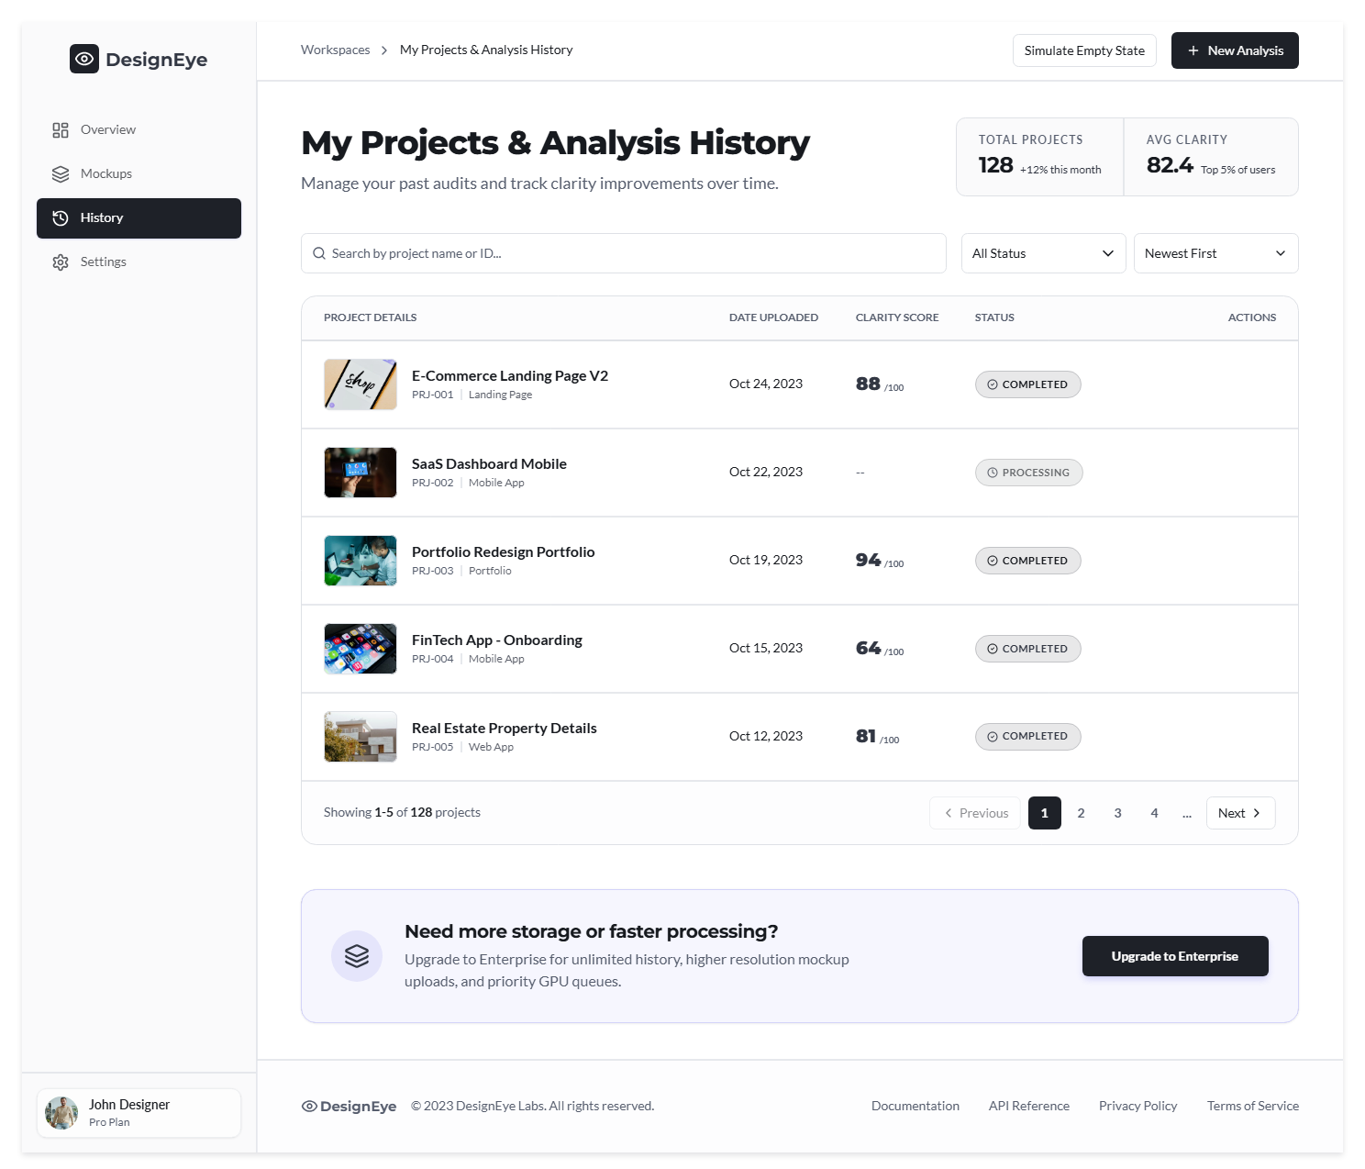

Upload UI Mockup Page:
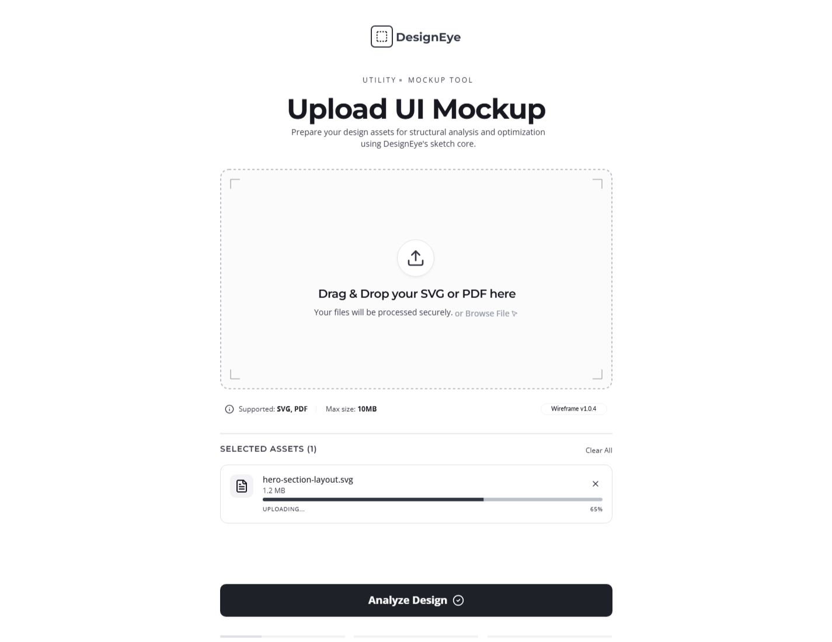

Analysis Result Page:
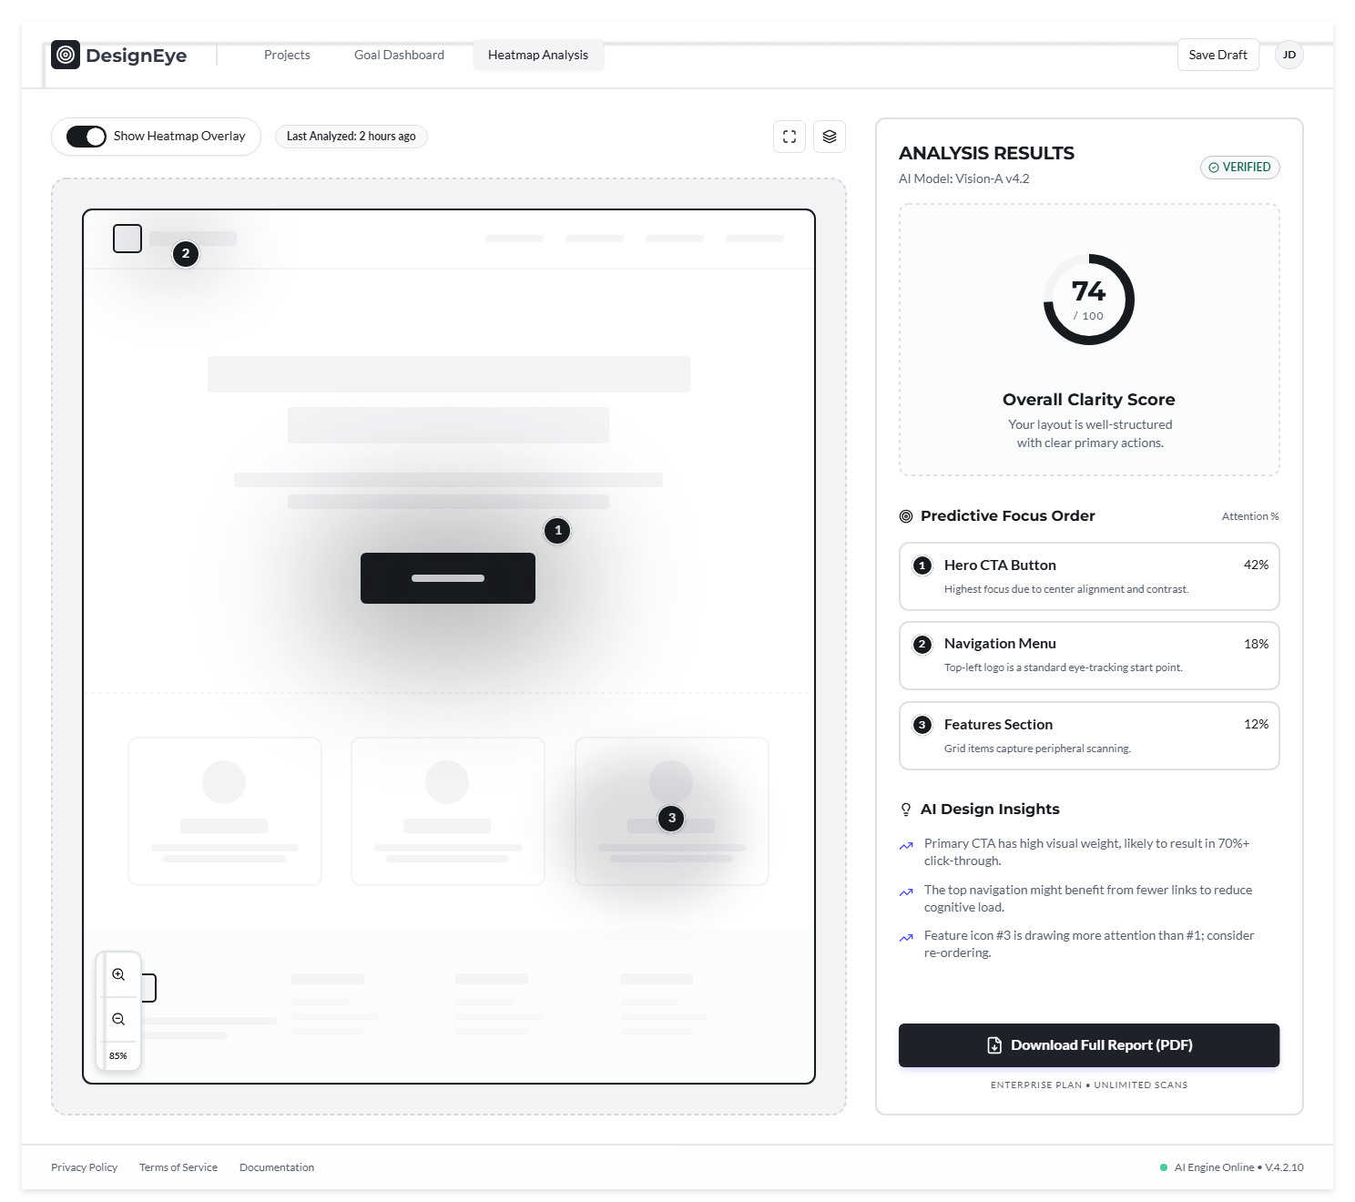

Focus Nodes and Saliency Score Page:
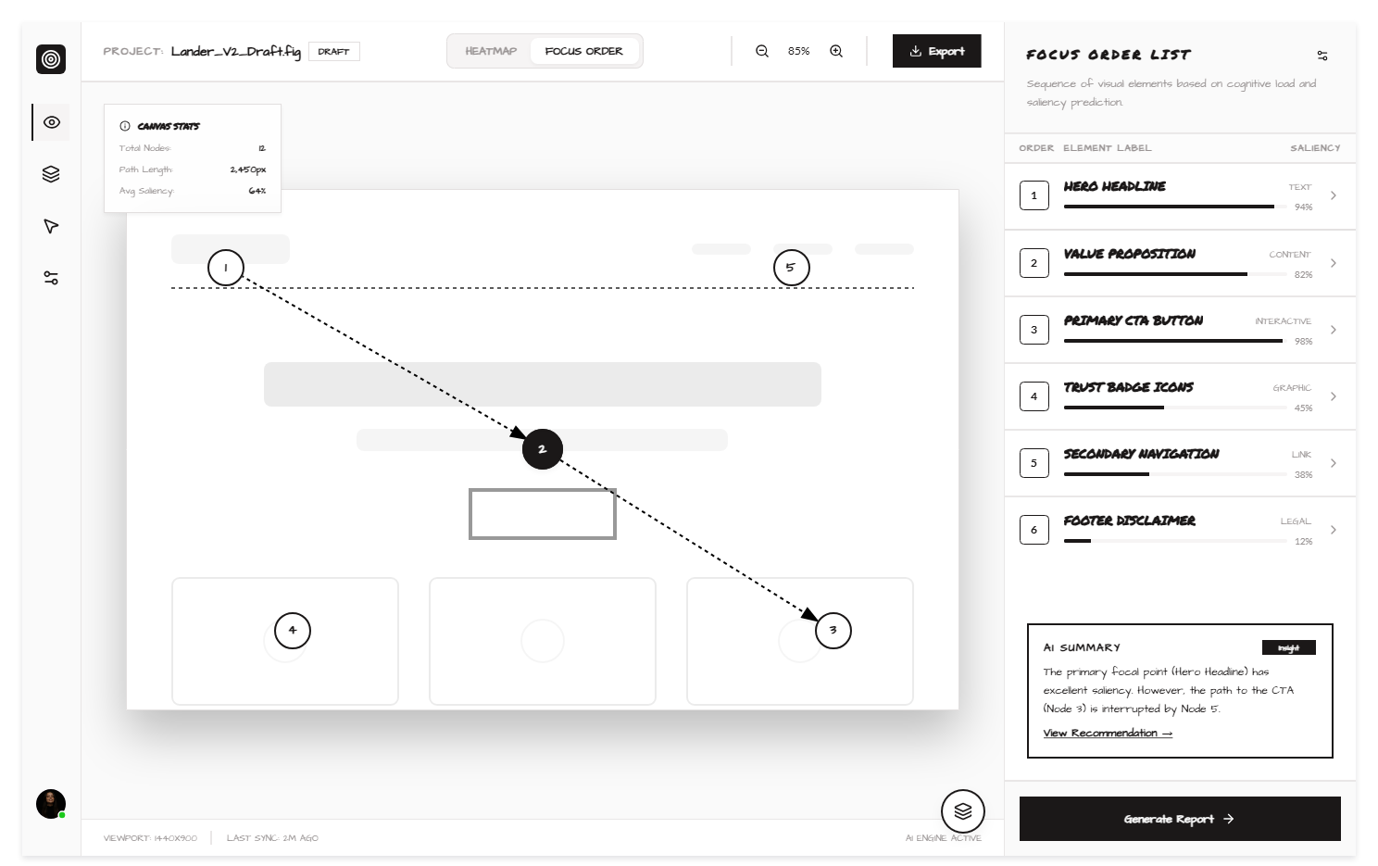

A/B Comparison Page:

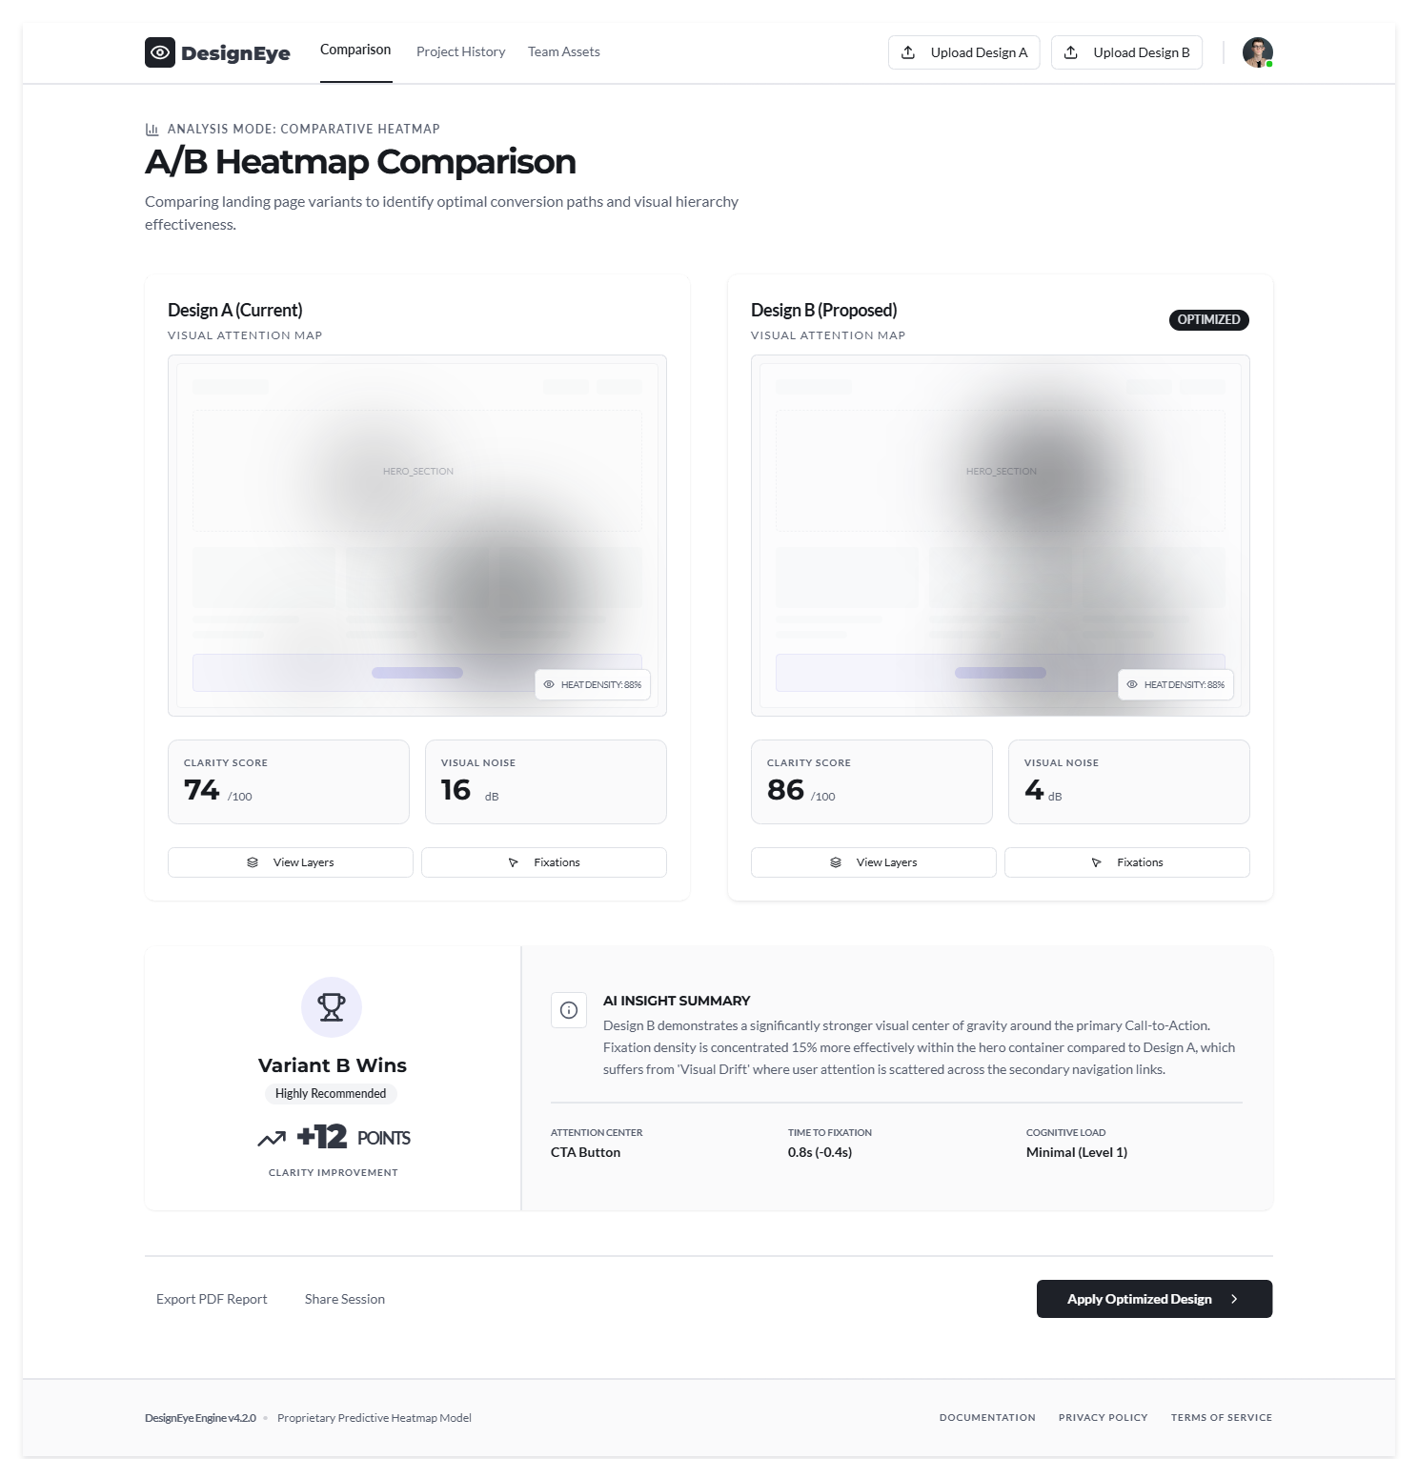

Download and Export Analysis Report Page:


2. Navigation Flow:

Flow Summary:
- User starts at Landing Page → authenticates (Login/Sign Up) → lands on Designer Dashboard.
- Core DesignEye workflow: Upload Mockup → View Heatmap → View Focus Order → Compare Designs.
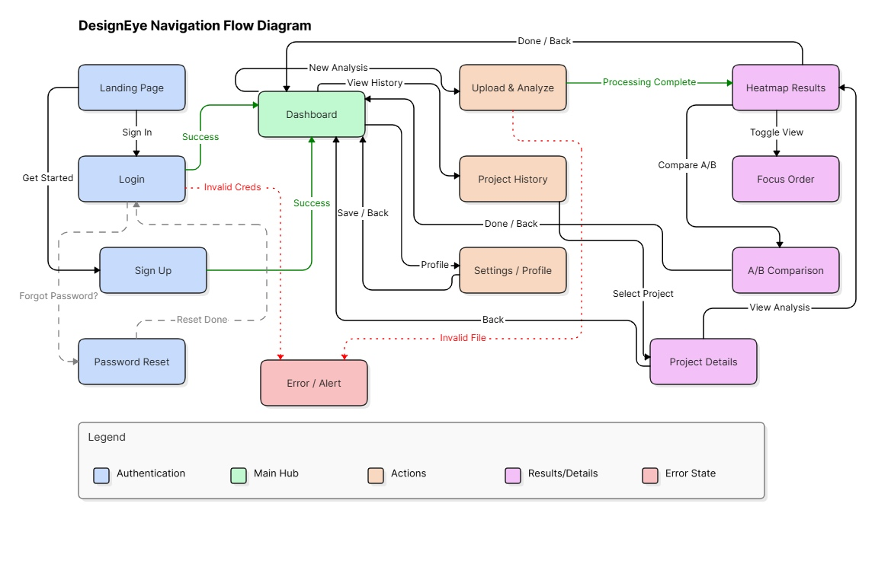
- From Dashboard: access Project History, Settings/Profile, or initiate new upload.

Screens(High Fidelity Prototypes):

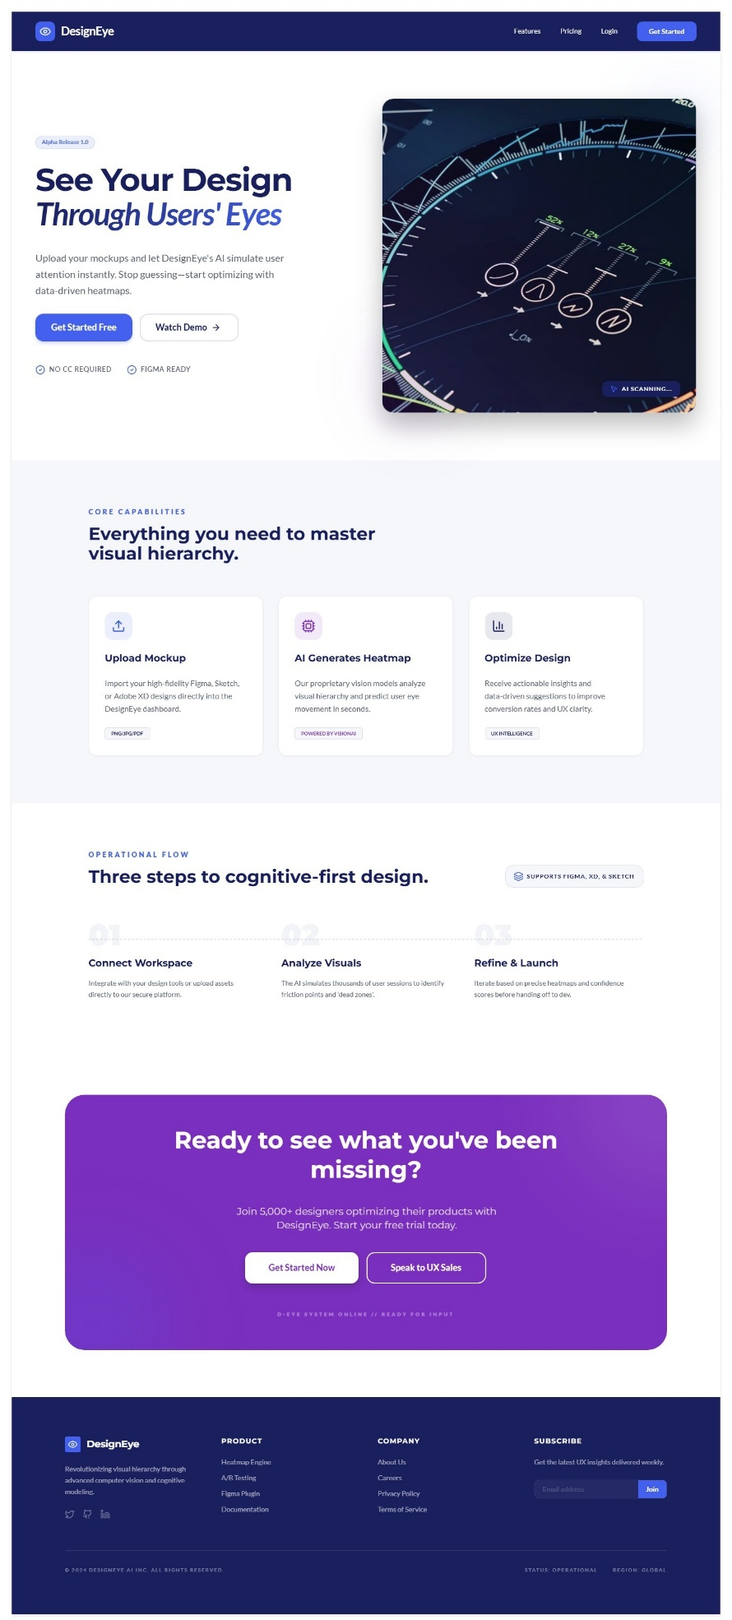
Frontend Pages:
Landing Page:

Authentication Pages:
Sign Up Page:
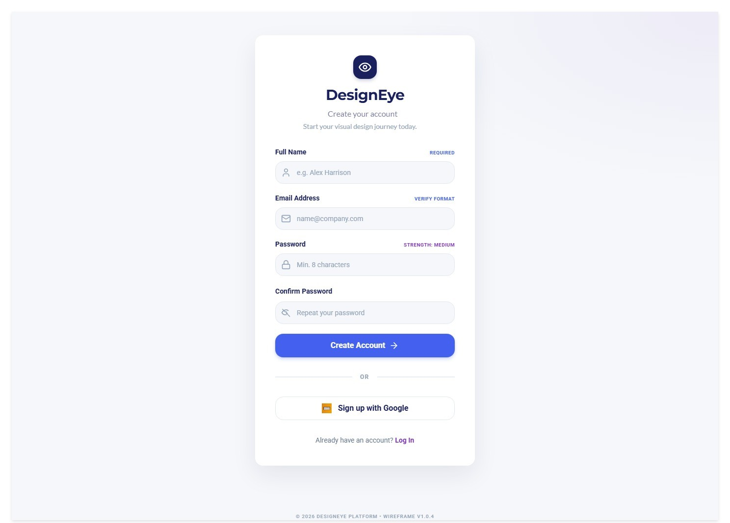

Login Page:
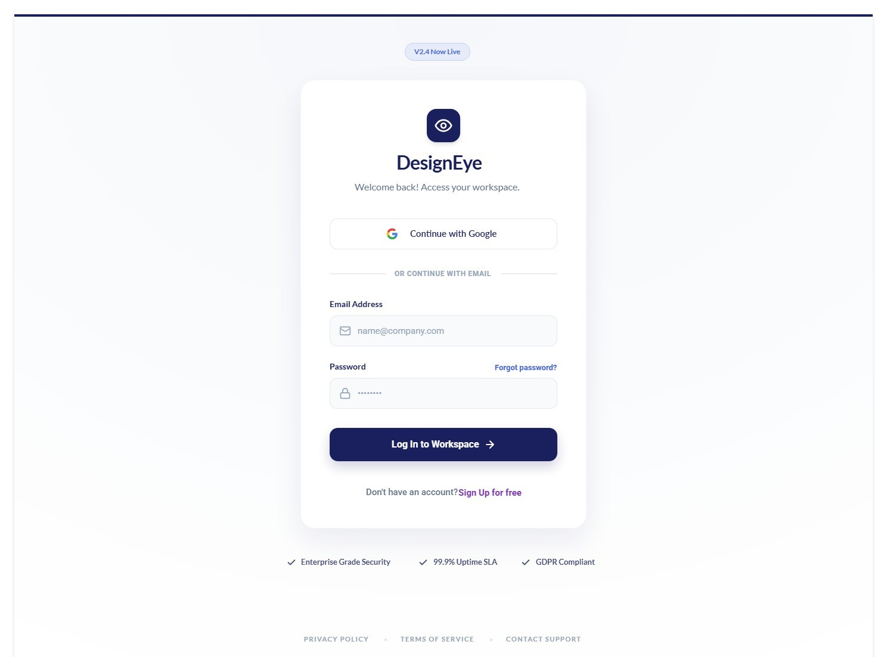

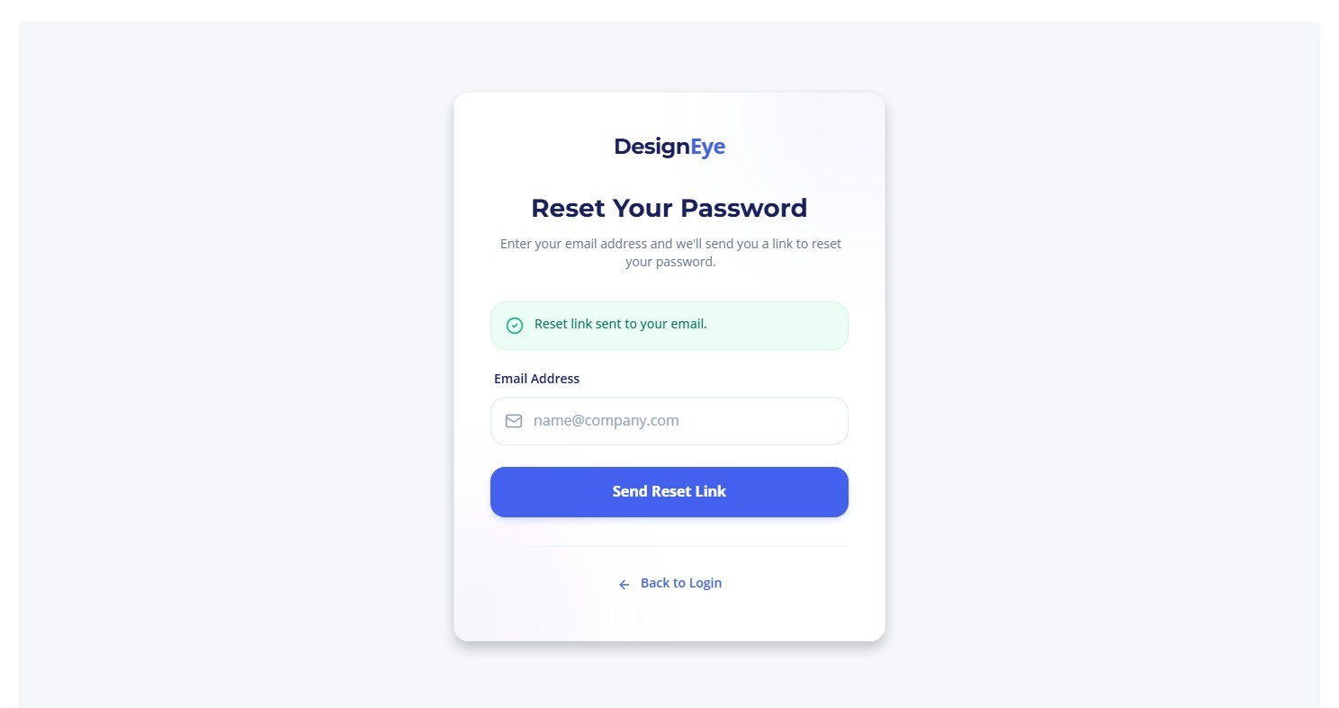
Password Reset Page:
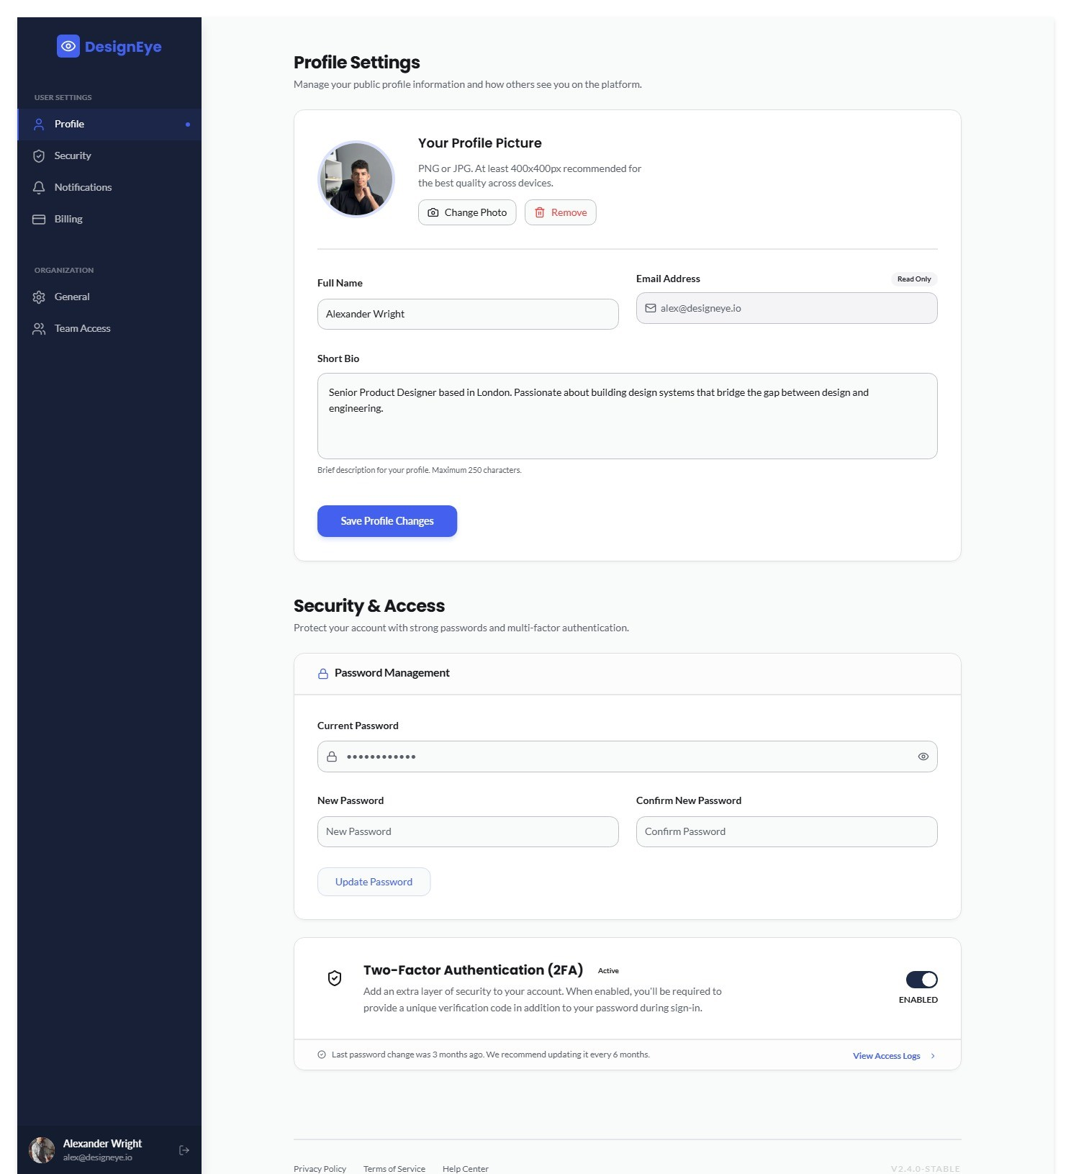
Profile Settings Page:

Backend Pages:
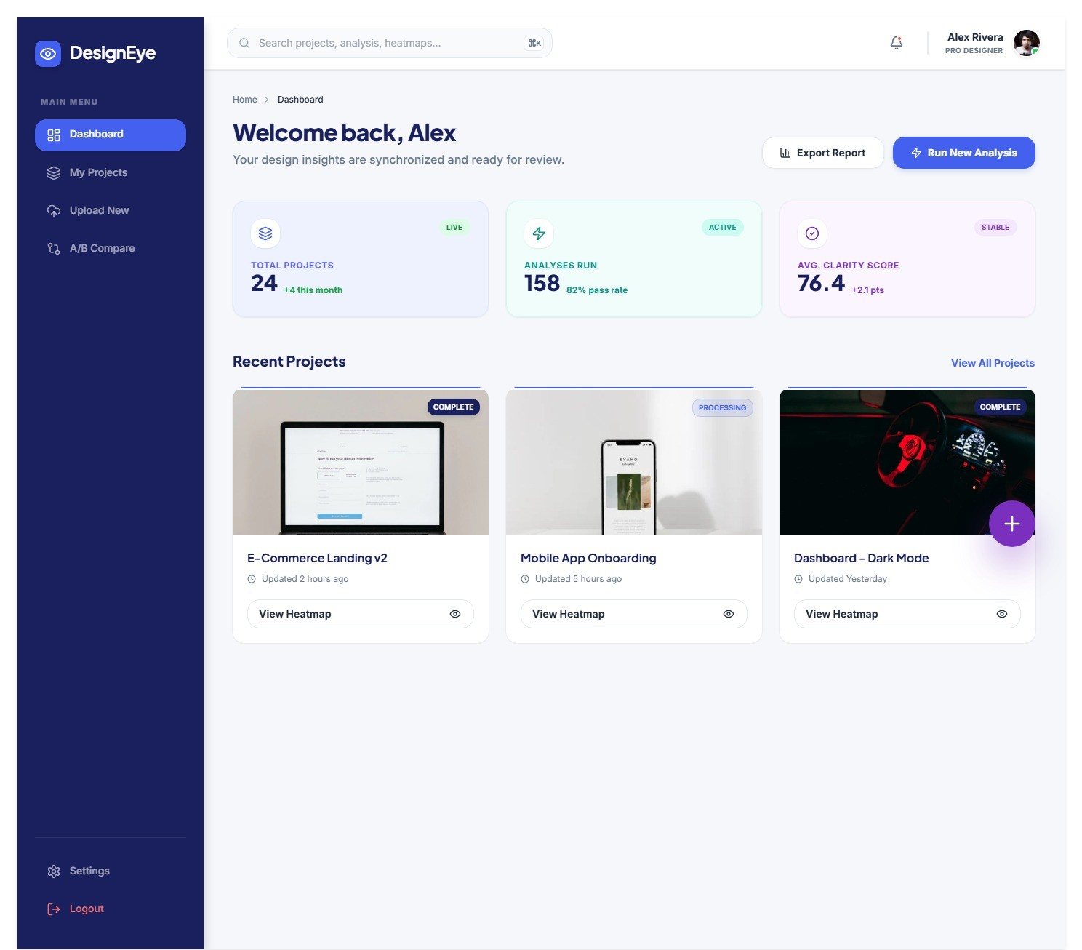
Dashboard Page:

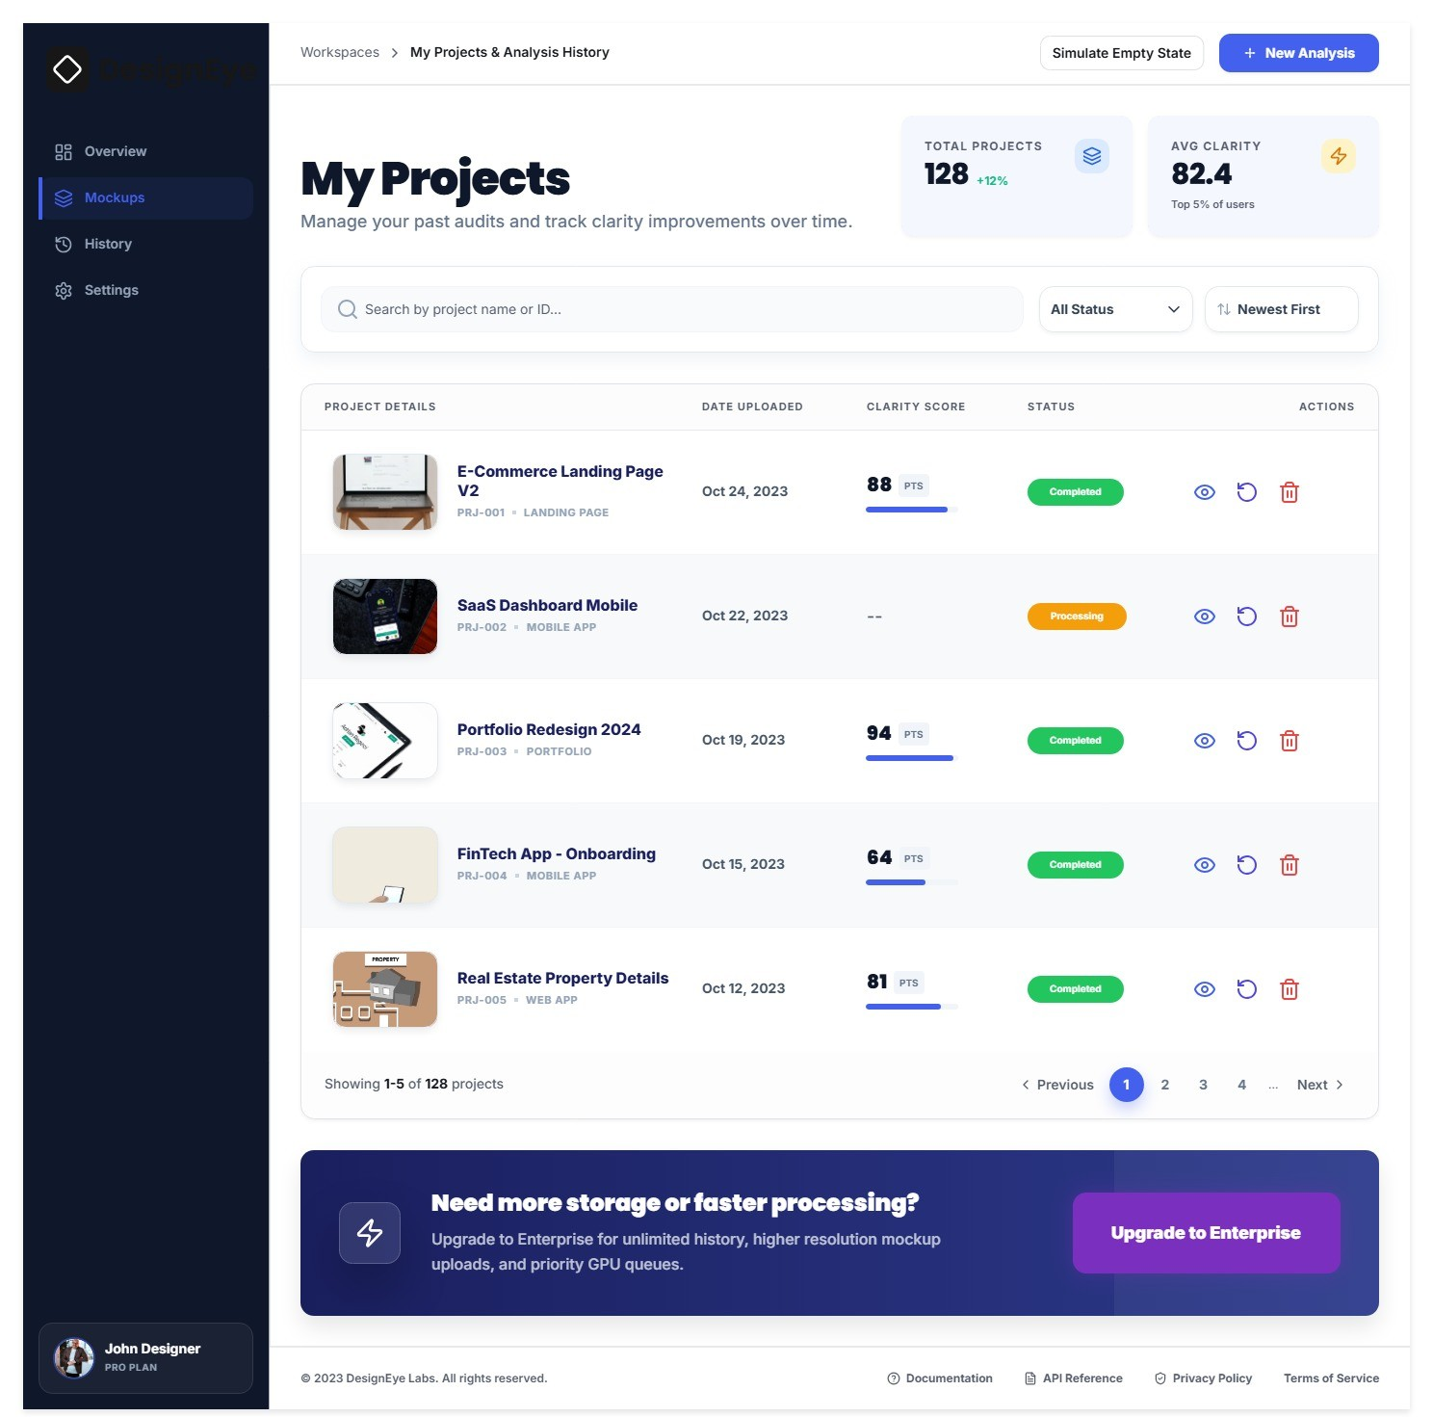
Project Management Page:

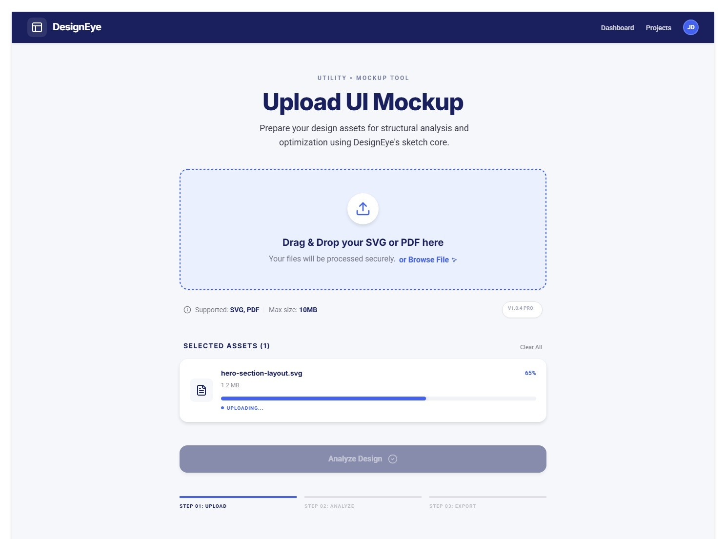
Upload UI Mockup Page:

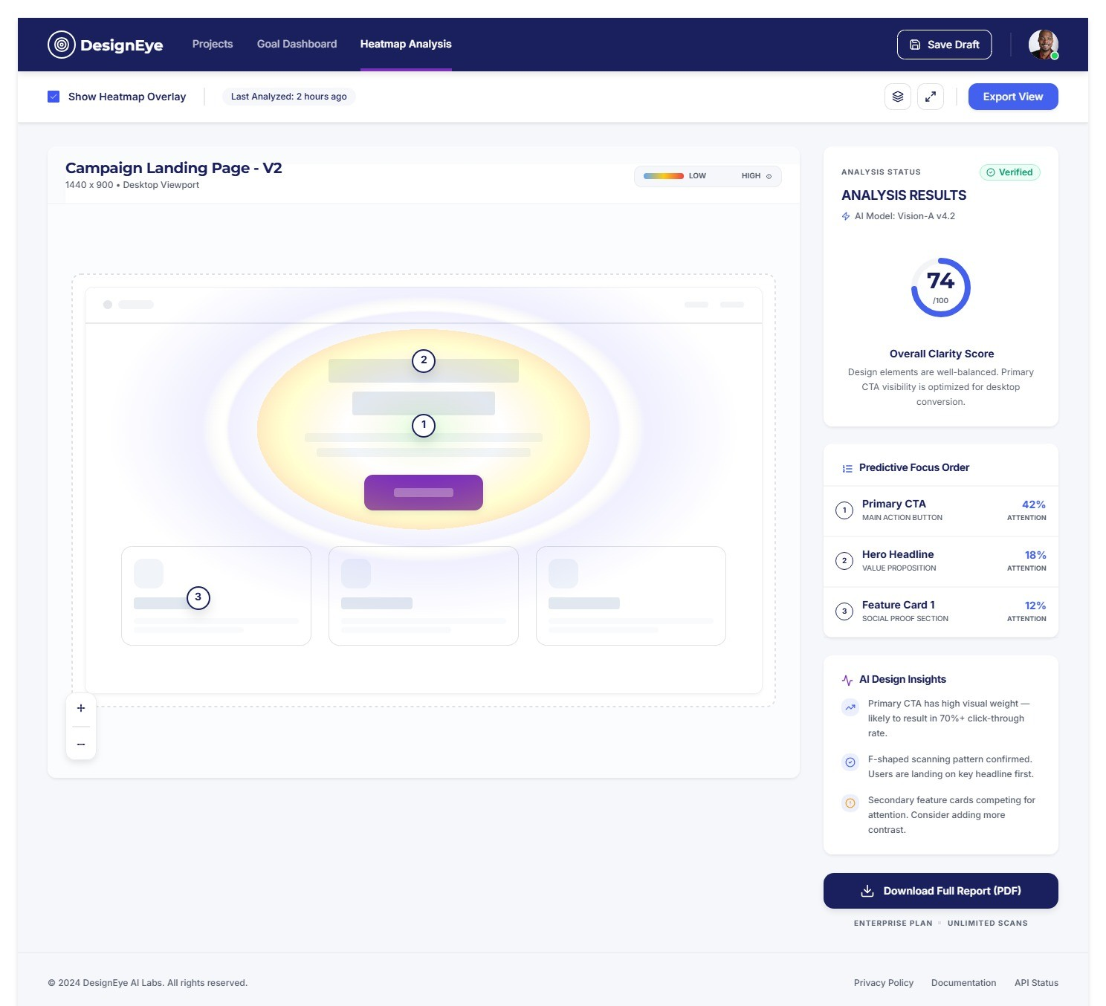
Analysis Result Page:

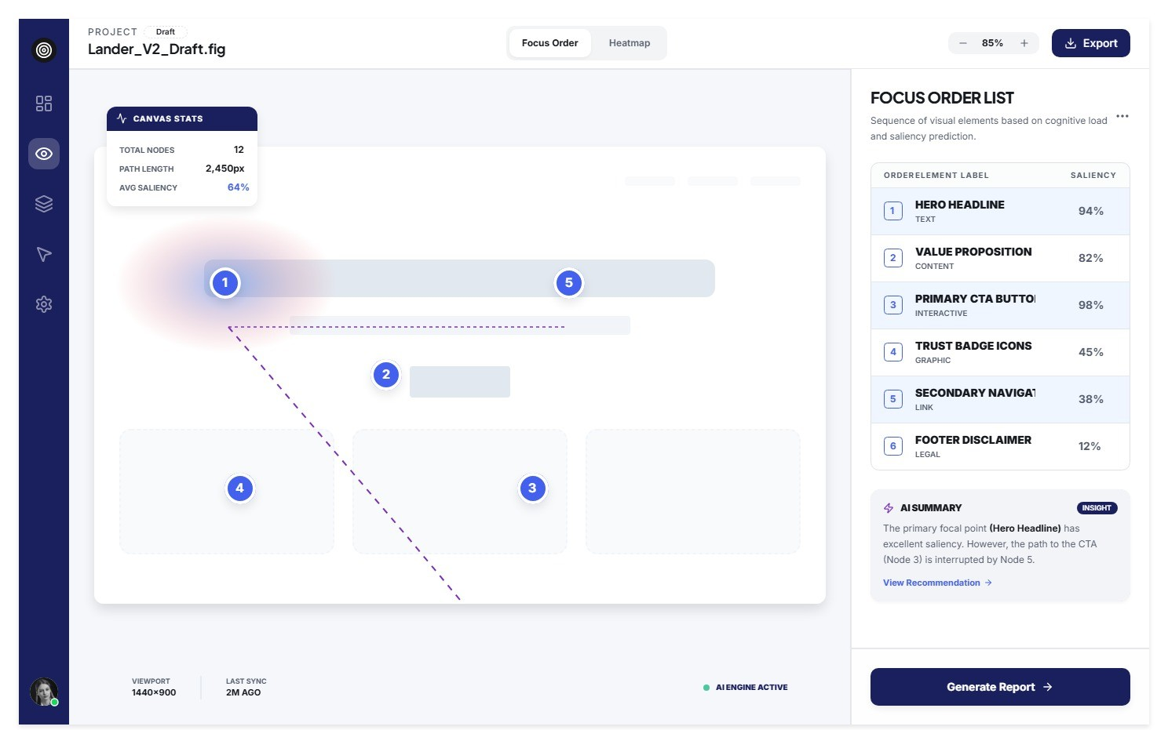
Focus Nodes and Saliency Score Page:

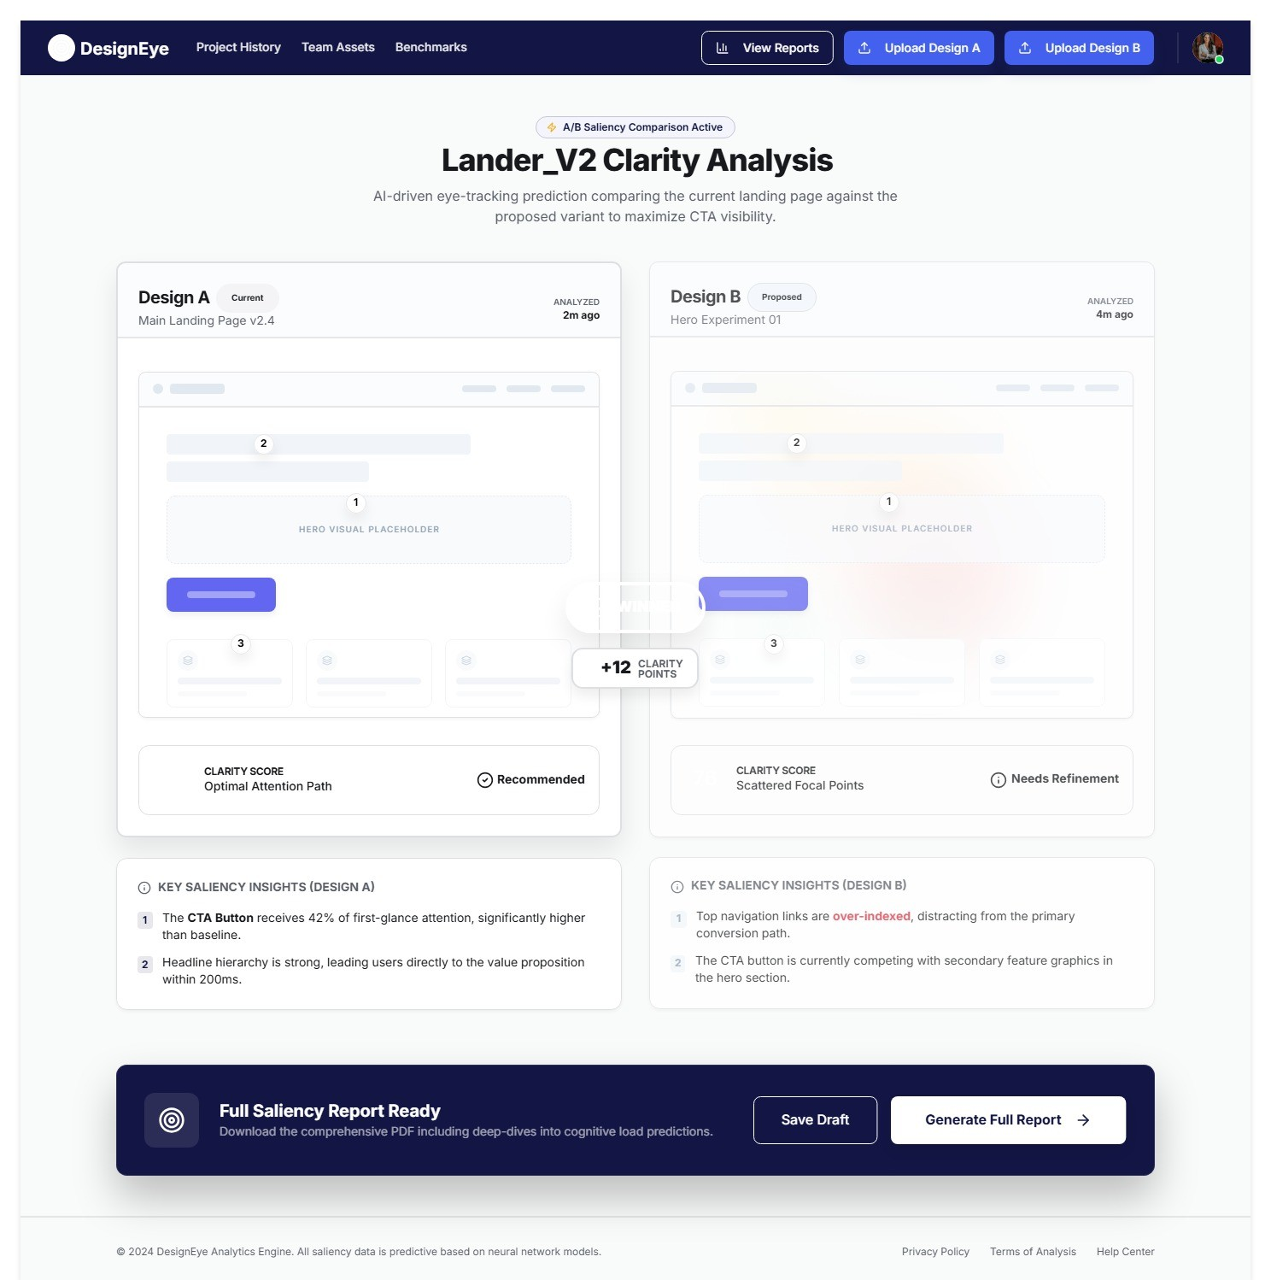
A/B Comparison Page:

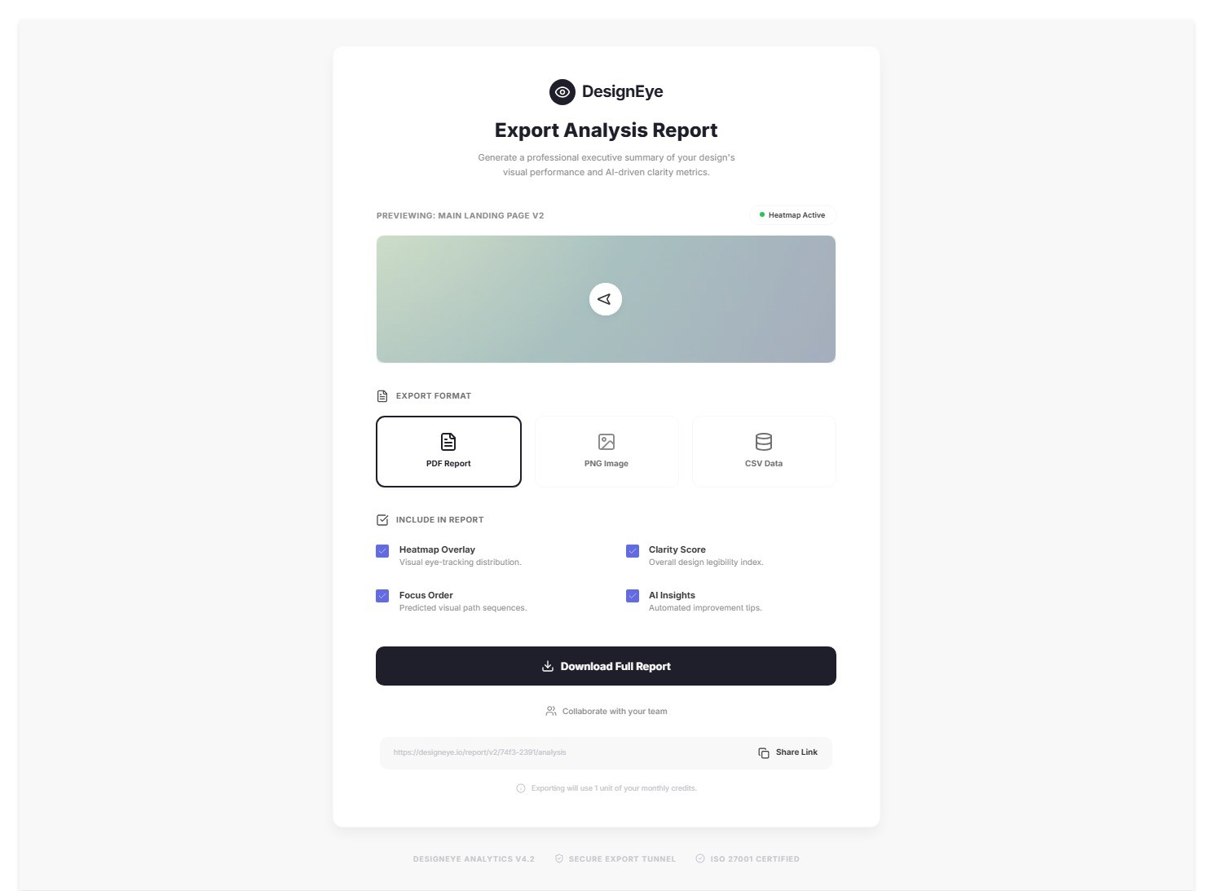
Download and Export Analysis Report Page:

Sprint-wise Design Evolution

Sample Table
Sprint | Features Designed | Improvements
Sprint 1 (May 2026) | System architecture diagram, FastAPI project scaffold, Firebase/Node Auth (JWT), Dashboard layout mock, Users + Projects MongoDB collections. | Architecture narrowed from microservices to three-tier client-server after evaluating team capacity. Subscription-based model not needed; Firebase/Node Auth chosen over custom OAuth for speed. Celery + Redis introduced to decouple GPU inference from API response thread.
Sprint 2 (May-Jun 2026) | Upload & Preprocessing UI component, FormatValidator, ImageNormalizer (Pillow), Cloudinary storage with tenant-prefix isolation, /upload and /status API endpoints. | Initial design used local disk storage - pivoted to Cloudinary after risk review (data loss risk). Normalization pipeline changed from OpenCV to Pillow for simpler dependencies.
Sprint 3 (Jun 2026) | U-Net/SalGAN model integration, Celery InferenceWorker, HeatmapPostprocessor (JET colormap), Heatmap Results View UI with opacity slider. | INT8 model quantization applied to reduce inference from ~58s to ~22s (within 30s SLA). JET colormap selected over VIRIDIS for better perceptual contrast on UI elements. Canvas-based overlay chosen over CSS for pixel-accurate heatmap rendering.
Sprint 4 (Jun-Jul 2026) | ClarityScoreCalculator (Sobel + entropy), FocusOrderExtractor (NMS), results panel UI, Focus Order View, A/B Comparison module, DeltaScoreEngine. | Initial Clarity Score formula revised to include edge density co-factor after high-entropy abstract designs received inflated scores. NMS radius changed from 10px to 20px after early testing. Sync-scroll added to A/B view after independent scrolling made comparison difficult.
Sprint 5 (Jul-Aug 2026) | A/B Comparison module, DeltaScoreEngine, Project Dashboard, HistoryPaginator, RerunService, integrated deployment pipeline. | Split-screen A/B layout revised to include sync-scroll after usability feedback. Dashboard pagination introduced after large project history caused UI lag. Rerun endpoint decoupled from upload flow to reduce API complexity.

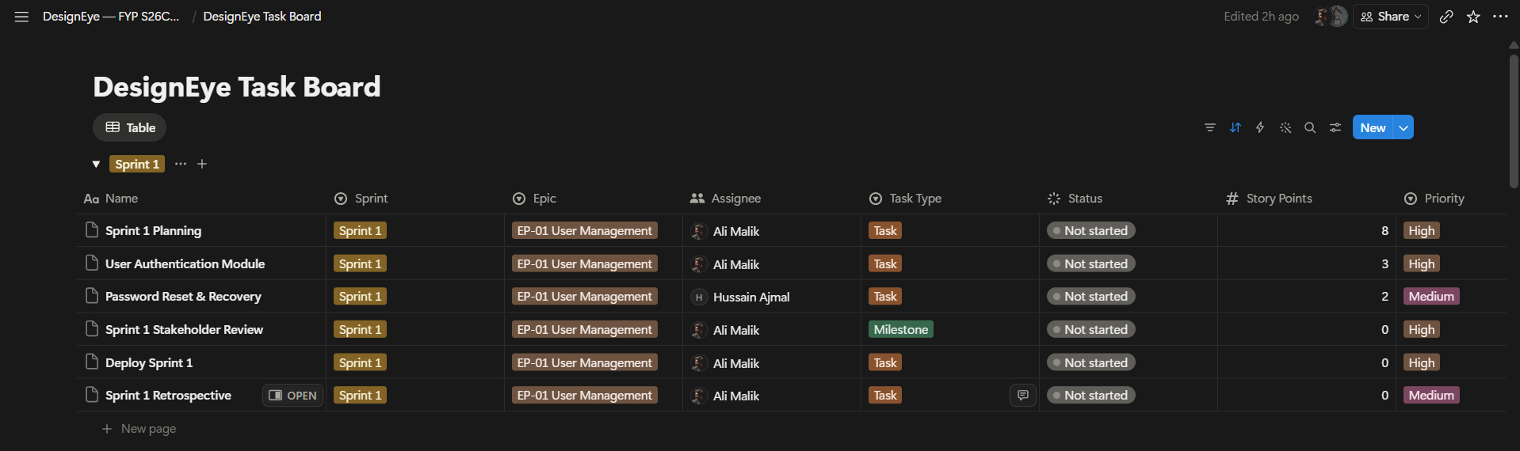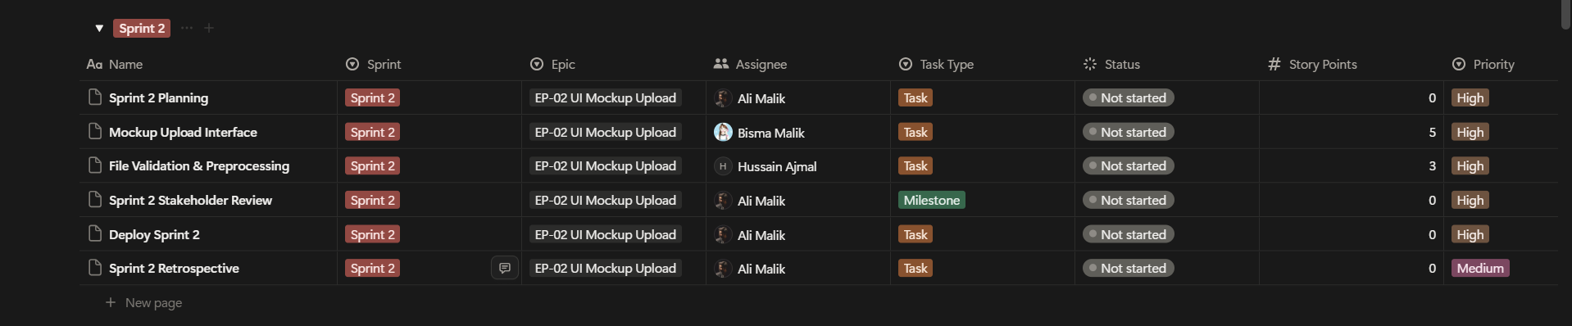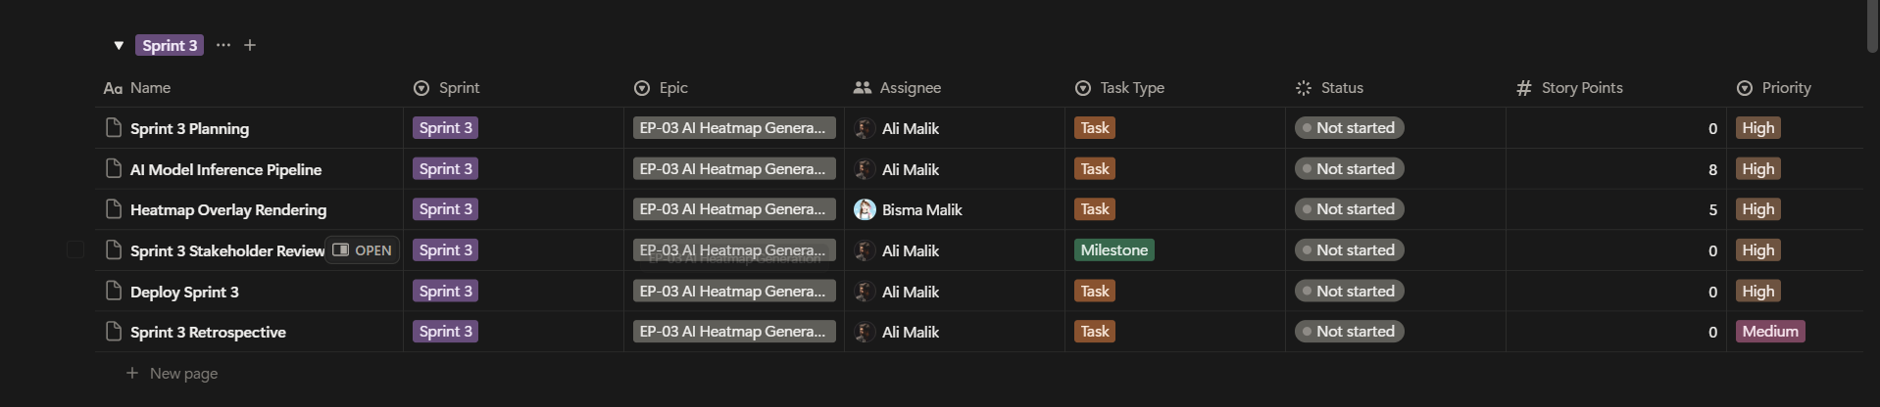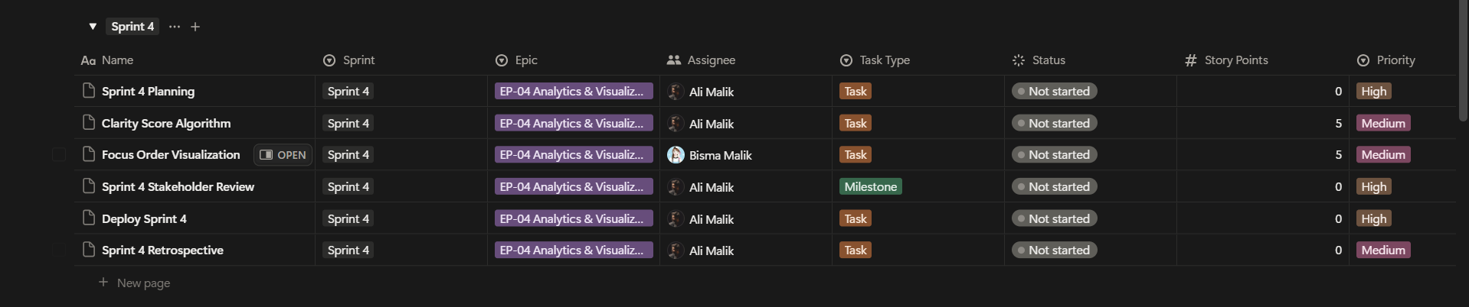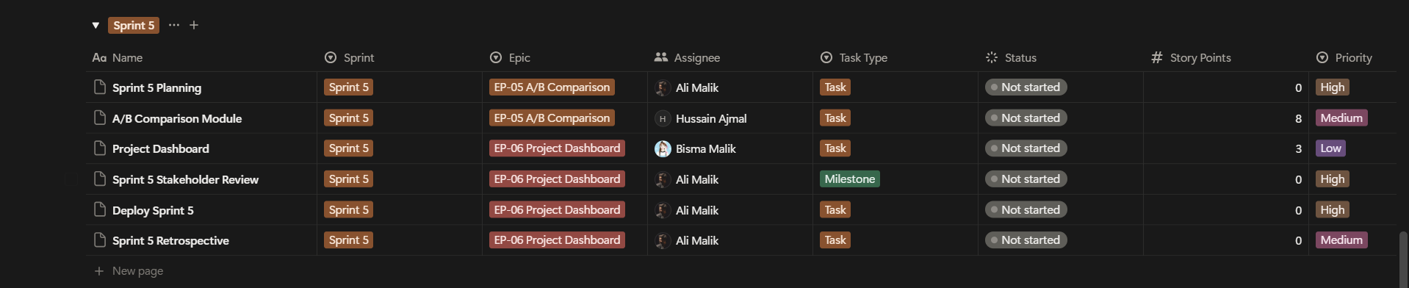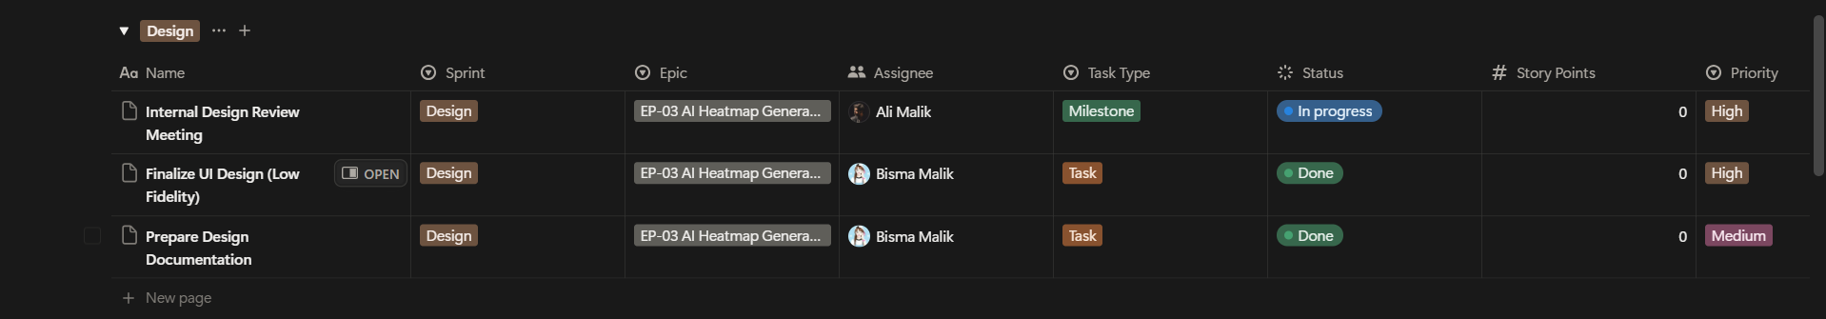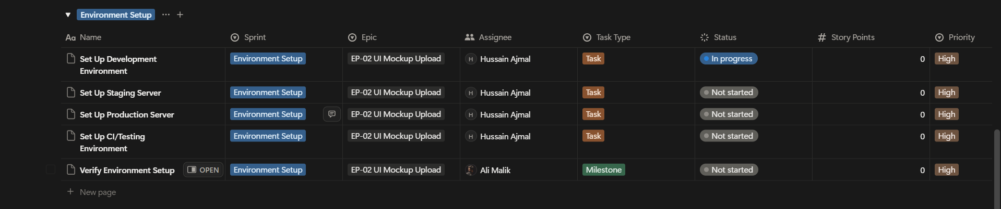
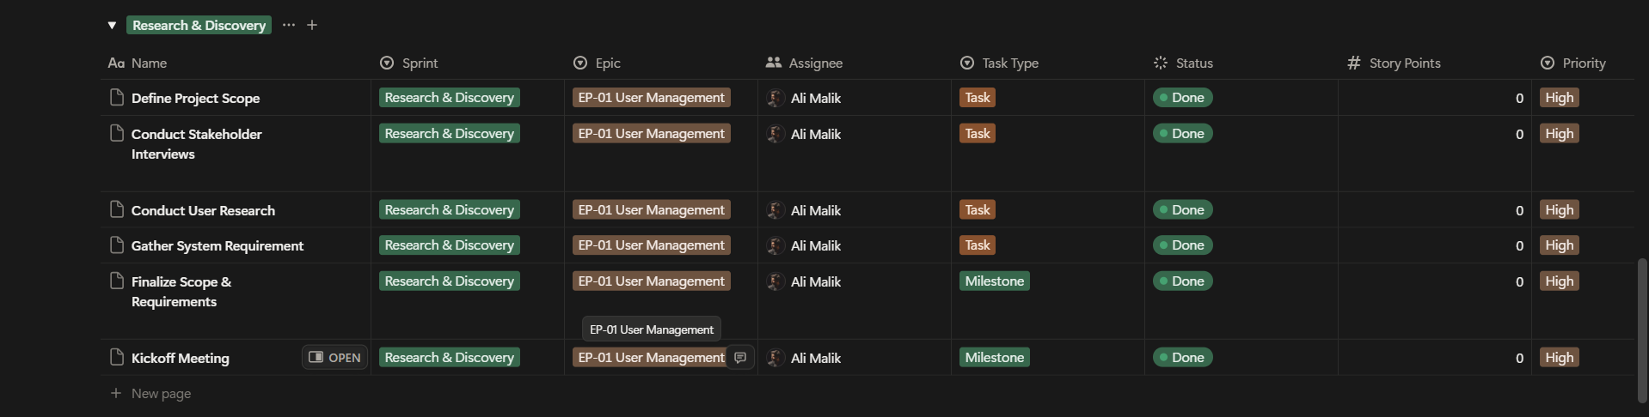

Test Design
Sample test case table
Test ID | Scenario | Expected Result
TC-01 | User registers with a valid email and password. | Account created; Firebase/Node JWT returned; user redirected to dashboard.
TC-02 | User tries to register with an already-used email. | Error: 'Email already in use.' No duplicate record created.
TC-03 | User uploads a valid SVG mockup file. | File stored in Cloudinary; metadata record created; task_id returned with status 'pending'.
TC-04 | User uploads an unsupported file type (e.g., .png). | Error 400: 'Invalid file format. Only SVG and PDF are supported.'
TC-05 | User uploads a file exceeding 10MB. | Error 400: 'File size exceeds 10MB limit.'
TC-06 | Inference task completes within 30 seconds. | Heatmap result available in MongoDB; GET /status/{task_id} returns status 'complete'.
TC-07 | Clarity Score is computed for a clean, focused design. | Clarity Score > 75 returned for design with clear visual hierarchy.
TC-08 | Clarity Score is computed for a cluttered design. | Clarity Score < 40 returned for high-entropy, edge-dense design.
TC-09 | User requests Focus Order for a processed mockup. | Top-5 ranked {x, y, rank} focus nodes returned; no duplicate coordinates.
TC-10 | User compares two design variants via A/B module. | Both heatmaps rendered in split-screen; clarity delta score displayed correctly.
TC-11 | Unauthorized request without JWT token. | Error 401 Unauthorized returned; file not stored in Cloudinary.
TC-12 | User attempts to access another user's asset. | Error 403 Forbidden returned; asset isolation enforced by tenant_prefix check.
TC-13 | User reruns analysis without re-uploading the file. | New inference task created from stored Cloudinary asset reference; results updated.
TC-14 | Session JWT expires during active session. | Error 401 returned; user prompted to log in again.

Design Quality Attributes
This section describes how the DesignEye system design addresses the non-functional requirements established in Phase 1.

1. Scalability
- Horizontal Scaling: FastAPI is deployed on stateless worker instances behind a load balancer. Celery workers can be independently scaled to handle inference queue growth without architectural changes (NFR-SC-01).
- Database Scaling: MongoDB Atlas supports automatic horizontal sharding. User data is partitioned by user_id, enabling efficient per-tenant queries as the user base grows.
- Storage Scaling: Cloudinary storage provides virtually unlimited object storage. Tenant-prefix key design ensures storage costs scale linearly with usage per user.

2. Security
- Authentication: All user sessions are managed via Firebase/Node Authentication JWT tokens. Tokens are verified on every API request by TokenVerifyMiddleware (NFR-S-01).
- Tenant Isolation: All Cloudinary assets are stored under the requesting user's tenant_prefix (user_id/). FastAPI enforces that result retrieval only returns assets where asset.user_id matches the authenticated user_id (NFR-S-02).
- Password Security: Passwords are never stored in MongoDB - Firebase/Node handles all credential management including hashing and salting.
- HTTPS: All API communication is encrypted via TLS. Cloudinary pre-signed URLs are used for temporary, time-limited asset access.

3. Maintainability
- Loose Coupling: The AI Inference Engine is decoupled from the FastAPI backend via the Celery task queue. The model can be retrained or replaced by updating the InferenceWorker without modifying the API layer (NFR-M-01).
- Code Standards: Backend follows PEP 8 (Python), with type hints and Pydantic models for all API request/response schemas. Frontend follows ESLint + Prettier with React functional component conventions.
- Documentation: FastAPI auto-generates interactive API documentation (Swagger UI) at /docs. All modules are documented with docstrings.

Deployment Considerations
1. Hosting
- Platform: Amazon Web Services (AWS).
- API Compute: AWS EC2 / ECS (Docker) - t3.medium instances for FastAPI backend with Auto Scaling Groups.
- Inference Compute: AWS EC2 g4dn.xlarge (NVIDIA T4 GPU, 16GB GPU RAM) for U-Net/SalGAN inference within 30s SLA.
- Frontend: AWS Amplify / Vercel - CDN-distributed React.js build for low-latency global delivery.
- CDN: AWS CloudFront for static frontend assets.

2. Database
- Engine: MongoDB Atlas (M10 Cluster) - managed replication, automated backups, Atlas free tier for development.
- Task Queue Broker: AWS ElastiCache (Redis) - managed Redis for Celery task queue.
- Object Storage: Cloudinary - cloud storage for mockup assets and heatmap results.

3. Version Control & CI/CD
- Repository: GitHub (private) with feature-branch workflow and PR reviews.
- Branching Strategy: GitFlow - main (production), develop (integration), feature/* (per user story), hotfix/* (urgent patches).
- CI/CD: GitHub Actions pipeline runs pytest (backend), eslint (frontend), and Docker build on every pull request. Merges to main trigger automatic deployment to AWS.
- Secrets Management: All credentials (Firebase/Node service account, AWS keys, MongoDB URI) stored in AWS Secrets Manager; never committed to Git.

Future Enhancements
Table 13: Future Enhancements
Enhancement | Description | Target Version
Multi-format Support | Extend preprocessing to accept PNG, JPEG, and Figma file exports (.fig) in addition to SVG and PDF. | v2.0
Collaborative Reviews | Allow team members to annotate heatmap results with comments for async design review. | v2.0
Mobile UI Optimization | Train a mobile-specific saliency model on a curated mobile UI dataset to improve accuracy for Android/iOS mockups. | v2.0
BI Tool Integration | Export Clarity Scores and focus order data directly to Figma and Adobe XD as native plugin integrations. | v2.0
Video Prototype Analysis | Extend inference pipeline to process screen-recording videos (MP4) frame-by-frame for dynamic UI analysis. | v3.0
Accessibility Heatmaps | Add cognitive load overlay mode highlighting high visual complexity areas for WCAG accessibility auditing. | v3.0
Custom Model Fine-tuning | Allow enterprise clients to upload proprietary eye-tracking data to fine-tune the saliency model on domain-specific UI patterns. | v3.0
Kubernetes Orchestration | Migrate from ECS to EKS for advanced auto-scaling and rolling deployments. | v1.5

Revised Project Plan
The revised Gantt chart below reflects all project phases from April to November 2026. A live, interactive progress tracker is maintained by the team.

Phase | Sprint | Duration | Planned Deliverable | Status | Completion %
Phase 1 | Sprint 1 | May 2026 (2 wks) | SRS Document, Backlog, Agile Framework | Complete | 100%
Phase 2 | Sprint 2 | June 2026 (2 wks) | Auth, Architecture, SDS Document | In Progress | 60%
Phase 3 | Sprint 3 | June-July 2026 (2 wks) | Upload Pipeline, Preprocessing | Planned | 0%
Phase 3 | Sprint 4 | July 2026 (2 wks) | AI Inference Engine + Heatmap Overlay | Planned | 0%
Phase 4 | Sprint 5 | July-Aug 2026 (2 wks) | Analytics - Clarity Score + Focus Order + A/B | Planned | 0%

References
[1] J. Pan et al., "SalGAN: Visual Saliency Prediction with Generative Adversarial Networks," in IEEE Conference on Computer Vision and Pattern Recognition Workshops (CVPRW), Honolulu, HI, 2017.
[2] O. Ronneberger, P. Fischer, and T. Brox, "U-Net: Convolutional Networks for Biomedical Image Segmentation," in Medical Image Computing and Computer-Assisted Intervention (MICCAI), 2015, pp. 234-241.
[3] M. Jiang, S. Huang, J. Duan, and Q. Zhao, "SALICON: Saliency in Context," in Proceedings of the IEEE CVPR, Boston, MA, 2015, pp. 1072-1080.
[4] L. Itti, C. Koch, and E. Niebur, "A model of saliency-based visual attention for rapid scene analysis," IEEE Transactions on Pattern Analysis and Machine Intelligence, vol. 20, no. 11, pp. 1254-1259, 1998.
[5] Tiangolo, S., "FastAPI - Modern, Fast (High-Performance) Web Framework for Building APIs with Python," 2024. [Online]. Available: https://fastapi.tiangolo.com
[6] Meta Open Source, "React - A JavaScript Library for Building User Interfaces," 2024. [Online]. Available: https://react.dev
[7] Cloudinary, "Cloudinary Documentation - Cloud Storage and Media Management," 2024. [Online]. Available: https://cloudinary.com/documentation
[8] Google Firebase, "Firebase/Node Authentication Documentation," 2024. [Online]. Available: https://firebase.google.com/docs/auth
[9] MongoDB, "MongoDB Atlas Documentation - Cloud Database Service," 2024. [Online]. Available: https://www.mongodb.com/docs/atlas
[10] Celery Project, "Celery: Distributed Task Queue Documentation," 2024. [Online]. Available: https://docs.celeryq.dev
[11] Fortune Business Insights, "User Experience (UX) Research Software Market Size, Share & Industry Analysis, 2032," 2025. [Online].

Appendix A: Glossary
Term / Acronym | Description
A/B Testing | A methodology for comparing two design variants to determine which produces better visual attention metrics.
API | Application Programming Interface - a set of rules enabling communication between software applications.
Asset ID | A UUID-based unique identifier assigned to each uploaded mockup file.
Celery | An asynchronous distributed task queue used to offload GPU-intensive model inference from the FastAPI main thread.
Clarity Score | A numerical metric (0-100) quantifying the visual cleanliness and hierarchy of a UI design.
CNN | Convolutional Neural Network - the architectural family that includes U-Net and SalGAN saliency models.
FastAPI | A modern, async Python web framework used for the DesignEye REST API backend.
Firebase/Node Auth | Google's managed authentication service for user registration, login, and session management.
Focus Order | The ranked sequence of UI elements predicted to attract visual attention, shown as numbered nodes.
Heatmap | A color-coded overlay (JET colormap) representing predicted visual attention intensity across a UI design.
INT8 Quantization | A model compression technique that reduces PyTorch model weights to 8-bit integers, lowering inference latency.
JWT | JSON Web Token - a cryptographically signed token issued by Firebase/Node upon login.
MongoDB | A document-oriented NoSQL database used to store user profiles, project records, and heatmap results.
NFR | Non-Functional Requirement - system quality attributes such as performance, security, and scalability.
Redis | An in-memory data store used as the message broker for the Celery task queue.
SaaS | Software as a Service - DesignEye's deployment model as a web-based platform.
SALICON | Saliency in Context dataset - used for training the U-Net/SalGAN saliency prediction model.
SDS | Software Design Specification - this Phase 2 document.
Saliency Map | A 2D float32 array output by the AI model representing predicted visual attention per pixel.
Scrum | An Agile framework for project management using iterative sprints with defined ceremonies and roles.
Sprint | A fixed-length (2-week) iteration in Scrum during which a potentially shippable increment is created.
Tenant Isolation | Security design pattern where each user's data is scoped to their unique user_id prefix.
U-Net | A convolutional neural network architecture adapted for pixel-wise saliency regression in DesignEye.

Appendix B: IV & V Report
(Independent verification & validation)
IV & V Resource

Name Signature

S# | Defect Description | Origin Stage | Status | Fix Time
 |  |  |  | Hours | Minutes
1
2
3
…
Table 1: List of non-trivial defects

 |  |  | University of Central Punjab  (Incorporated by Ordinance No. XXIV of 2002 promulgated by Government of the Punjab)  Faculty of Information Technology and Computer Science
 |  | Semester wise SDP Meeting Report
 |  | Group ID |  | Student Roll Number |  |  |  |  | Student Name and Signatures |  | Advisor
 |  | S26CS003 |  | L1S23BSCS0014 |  |  |  |  | Ali Malik |  | Dr. Ghulam Mustafa
 |  |  |  | L1S23BSCS0142 |  |  |  |  | Muhammad Hussain
 |  |  |  | L1S23BSCS0002 |  |  |  |  | Bisma Zahid
 | Sr. | Date |  | Status (P/A/L) |  |  |  |  | Agenda Items | Notes
 |  |  |  | Student1 | Student 2 |  | Student 3
 | 1 | 25-05-2026 |  | P | P |  | P |  | P | Initial project approval completed. Technology stack finalized.
 | 2 | 5-06-2026 |  | P | P |  | P |  | P | Authentication and AI inference modules completed successfully.
 | 3 | 10-06-2026 |  | P | P |  | P |  | P | Final review and deployment preparation completed successfully.
 | 4
 | 5
 | 6
 | 7
 | 8
 | 9
 | 10
 |  | Date: |  |  | Advisor's Signatures: |  |  |  | ________________________________

