

Medical care

System analysis project



January 12, 2022

[ faculty of computer science ]

[ Helwan university]

***System description***

*- Medical care is a clinic system that allow patient to choose the suitable doctor and appointment. It also allows the patient to edit his/her information on the system and write feedbacks that helps in improving the system.*

*- Doctor can log in to the system and write prescribe drugs form to each patient. He/she can also receive notices about the patients.*

*- The admin of the system will add patients and doctors to the system so they can manage their accounts. Admin can display special offers to the patients, also he can display the working hours of the clinic so the patients can see it on the system. The database of the system will be managed by the admin.*

***Functional requirements***

Patient’s functional requirements:

***1) Register***

System must allow patients to register in the system using their information:

* Name
* Email
* Id
* sex
* age
* Phone
* Address
* Password

***2) Log-in***

- System should allow patients to “login” using their Email & Password.

***3) Edit info***

- system should allow the patient to update his/her data.

***4) Choose specialty***

- system must show all the clinic medical specialty.

***5) Choose doctor***

- system must show all the available doctors.

***6) Book appointment***

- system must show all the available appointments.

***7) Cancel reservation***

- system must provide cancellation for the reservation.

***8) Make payment***

- system must provide suitable paying method.

***9) Receive Prescription***

- system must provide Prescription for patient to receive rescripted drugs.

***10) Send feedback***

- system must provide feedback form.

***11) Log Out***

- System must allow the patient to log out from the system and end up their session.

Doctor’s functional requirements:

***1) Log-in***

- System should allow doctors to “login” to the system and manage it using their Email & Password.

***2) Edit info***

- system should allow the user to update his/her data.

***3) Cancel reservation***

- system should provide cancelation form to cancel the appointment.

***4) Prescribe drugs***

- system should allow doctor to write prescribe drugs form.

***5) Receive notices***

- system should provide doctors with info about patients**.**

***6) Log Out***

- System must allow the doctor to log out from the system and end up their session.

Admin’s functional requirements:

***1)Register***

System must allow admins to register in the system using their information:

• Name

• Email

• id

• Password

***2) Log-in***

- System should allow admins to “login” to the system and manage it using their Email & Password.

***3) Edit info***

- system should allow the admin to update his data.

***4) Add***

- doctor

System should allow admins to add doctor to the system.

- patient

System should allow admins to add patient to the system.

***5) Delete***

- doctor

System should allow admins to delete doctor to the system.

- patient

System should allow admins to delete patient to the system

***6) Update database***

- doctor

System should allow admins to update information about doctors on the system.

- patient

System should allow admins to update information about patient on the system.

***7) Add offers***

- System should allow the admins to add special offers.

***8) Display clinic working hours***

- System should allow the administrator to display workhours.

***9) Prepare schedule***

- system should allow doctors to choose suitable working hours.

***10) Provide notices***

- Admin should provide doctors with info about patients.

***11) Display/Hide Feedback***

- The admin can choose to publish which opinions in the feedback form to be visible to all users.

***12) Log Out***

- System must allow the admins to log out from the system and end up their session.

***Non-functional requirements***

1) Performance:

- patient should have opportunity to choose language they want to use.

- The system must respond the business operation in less than 3 seconds for patient or admin.

- The system should response the operation messages to the patients after solving the complaint.

2) Security:

- The system must handle safe login and logout through session.

- The web application must be secure.

- It must be protected to avoid any data breach.

- Reveal who registered and who did not but only available for system employees not anyone else.

3) Reliability:

- Every error in the system must be handled and prompt the patient.

- Mean time of failure does not exceed 3 seconds and 20-time breakdown at a year.

- The system must be available at all patients.

4) Usability:

- The system must open to all computers and browsers.

- The system should have user-friendly interface.

- Using different languages.

- Utilize for illiterate people.

- Provide tools for handicapped.

- Web application should be eased to use.

- Allow different methods of paying.

5) Availability:

- The system must be available 24/7.

- It must work continuously at any time during the 24 hours.

***Class diagram***

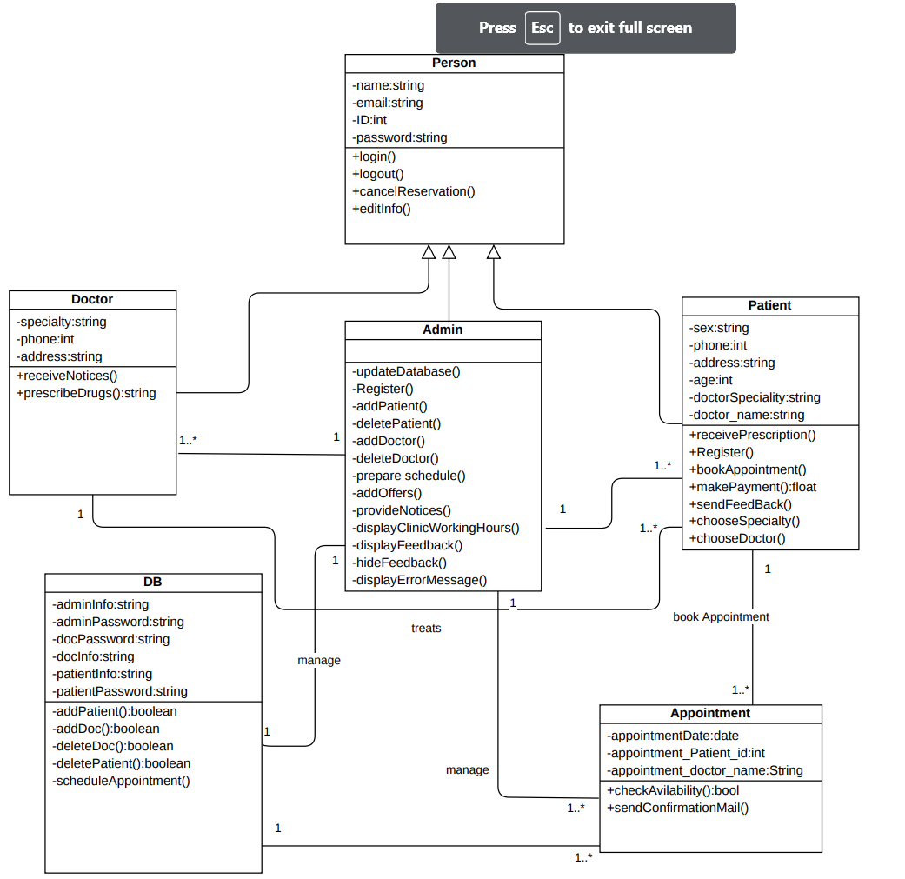

***Activity diagram***

Full system:

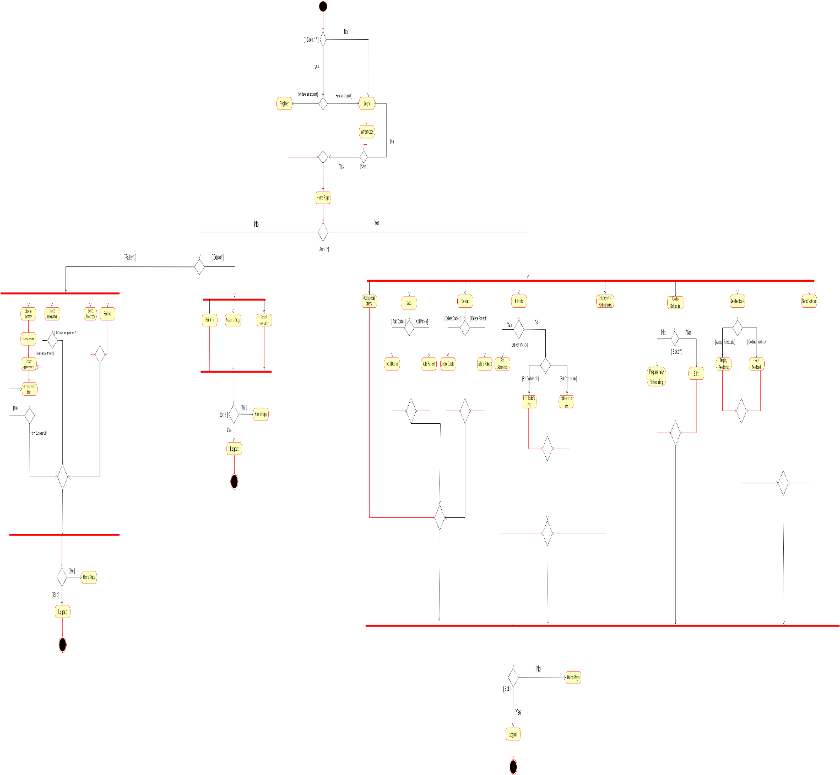

Admin:

Doctor:

Patient:

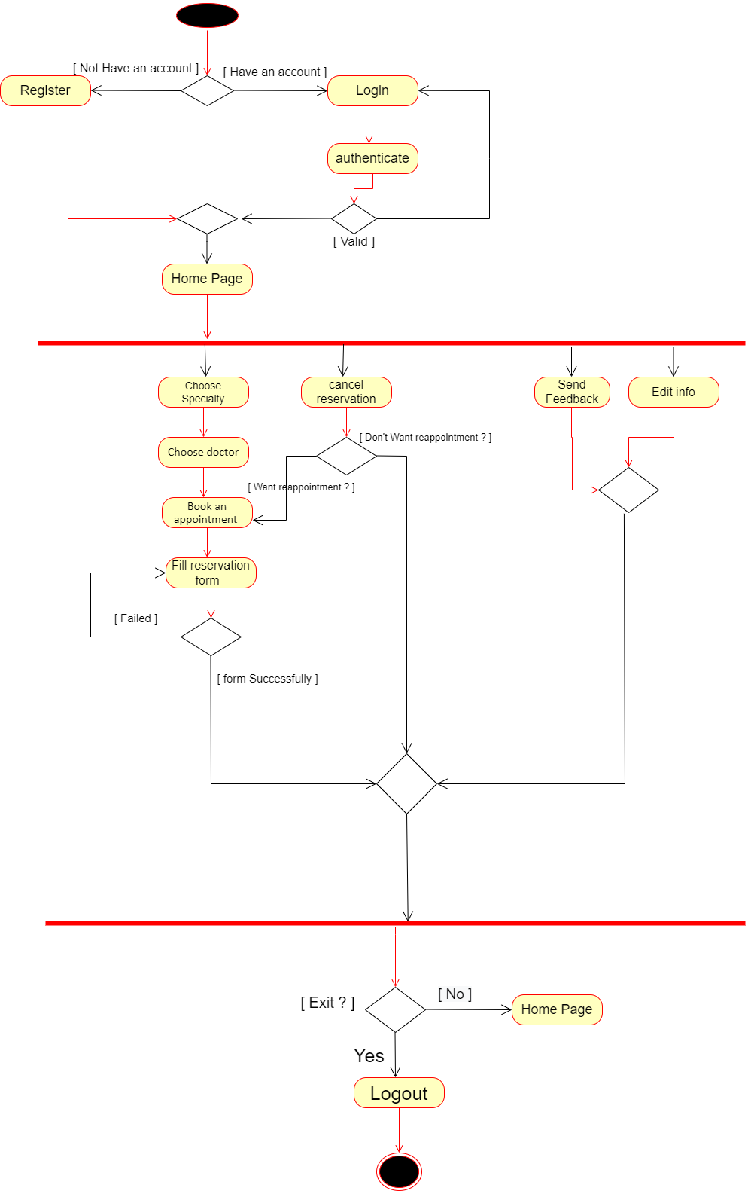

Book appointment:

Prescribe drugs:

Add doctor:

Display/Hide feedback:

***Sequence diagram***

Patient’s Sequence Diagrams:

1. login:

1. Reservation:

1. Edit information:

1. Make payment:

1. Cancel reservation:

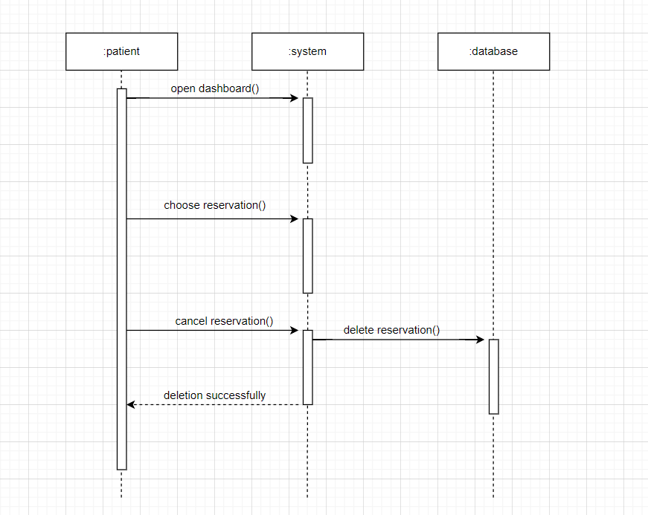

Doctor’s Sequence Diagrams:

1. Receive notices:

1. Prescribe drugs:

1. Logout:

Admin’s Sequence Diagrams:

1)Add patient:

2)Add doctor:

3)Delete doctor:

4)Add offers:

5)Display/Hide feedback:

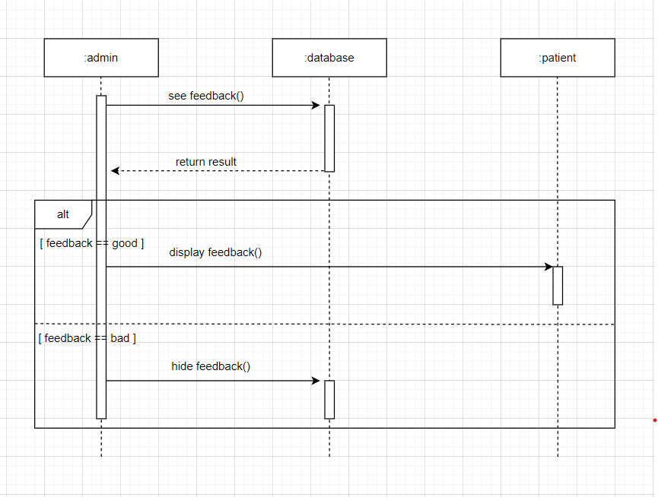

6)Display clinic working hours:

***Data flow diagram***

Context diagram:

Level 1 diagram:

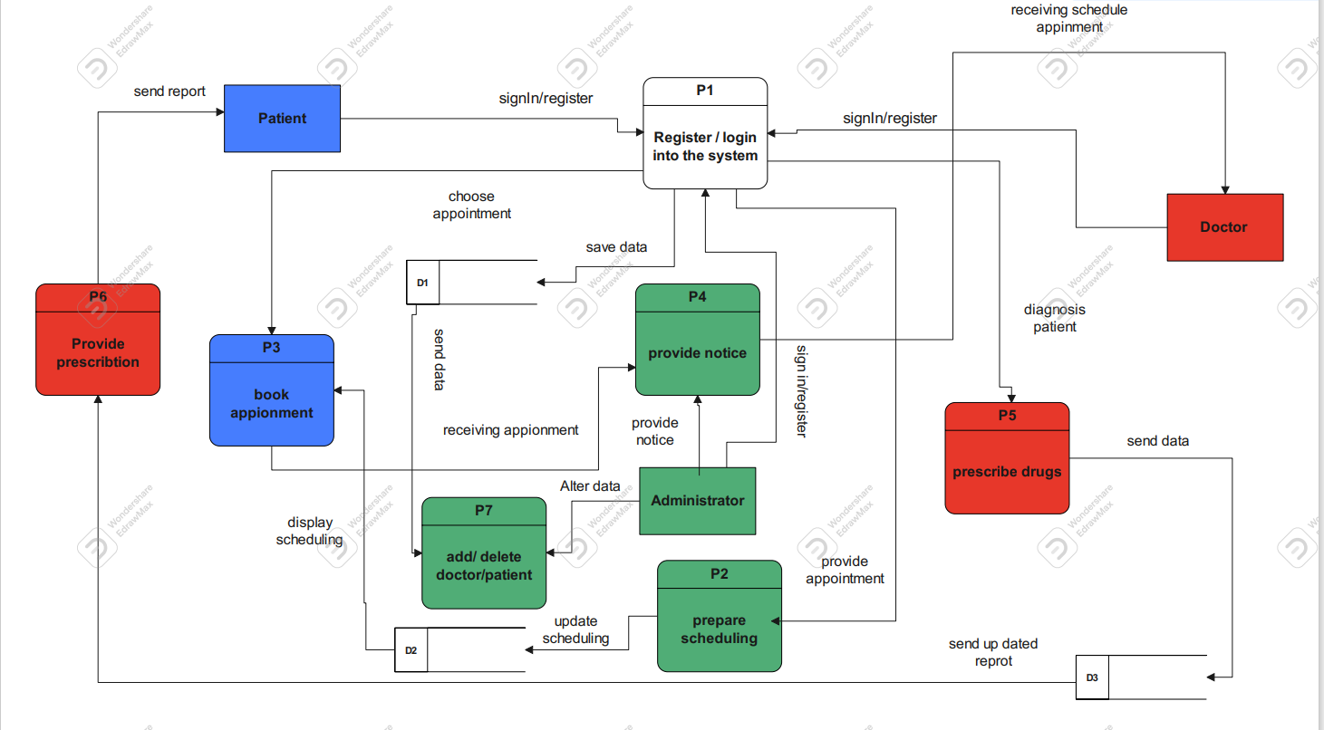

Level 2 diagram:

***Use case diagram***

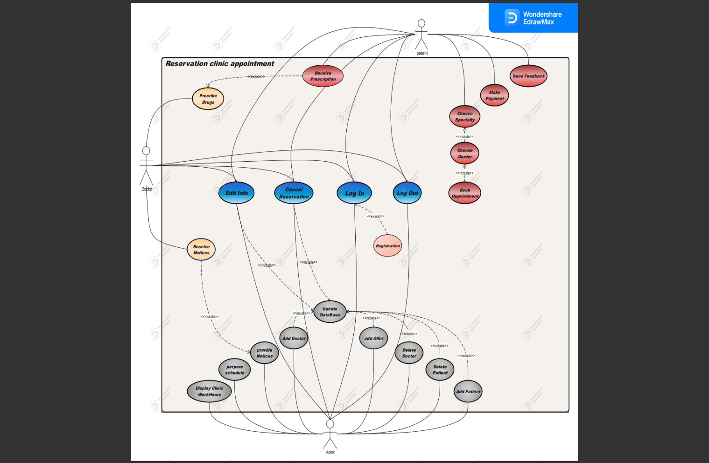

***Use case scenario***

1- Register:

|  |  |
| --- | --- |
| ***Actors*** | ***Patient*** |
| ***Description*** | ***System must allow users to register in the system using their information: Name, Email, ID, sex, Phone, Address, Password*** |
| ***Pre-conditions*** | ***User has to fill registration form with his info: Name, Email, SSN, Phone, Address, Password.*** |
| ***Post-conditions*** | ***1. Open register page. 2. Enter the users’ Name, Email, SSN, Phone, Address, Password. 3. Click on register button.*** |
| ***Main Scenario*** | ***1. Open register page. 2. Enter the users’ Name, Email, SSN, Phone, Address, Password. 3. Click on register button.*** |
| ***Alternative (Unsuccessful scenario)*** | ***if the user has entered wrong: - id: if the id was entered wrong more than 3 times the account will be closed after being prompted to renter it. - Email and password: will be prompted “invalid, please renter it “, after 2 trials account will be closed*** |

2- Login:

|  |  |
| --- | --- |
| ***Actors*** | ***Patient*** |
| ***Description*** | ***System must allow users to log in the system*** |
| ***Pre-conditions*** | ***User should enter their email &pass*** |
| ***Post-conditions*** | ***User should enter their email &pass*** |
| ***Main Scenario*** | ***1. Open sign in page. 2. Enter the users’ Email, Password. 3. Click on log in button.*** |
| ***Alternative (Unsuccessful scenario)*** | ***if the user has entered wrong: - Email and password: will be prompted “invalid, please renter it “, after 2 trials account will be closed*** |

3- Edite info (for patient):

|  |  |
| --- | --- |
| ***Actors*** | ***Patient*** |
| ***Description*** | ***System should allow the user to edit his data.*** |
| ***Pre-conditions*** | ***User should enter his data which will be edit in the system*** |
| ***Post-conditions*** | ***If the update completed Successfully: - user’s updated data will be store in the system.*** |
| ***Main Scenario*** | ***1. Open profile page of the user. 2. Enter the users’ data which will be update 3. Click on save button.*** |
| ***Alternative (Unsuccessful scenario)*** | ***if the user has entered wrong info which won’t accept the validation: - the system will be prompted “invalid, please renter a valid info*** |

4- Choose specialty:

|  |  |
| --- | --- |
| ***Actors*** | ***Patient*** |
| ***Description*** | ***System must show all the clinic medical specialty.*** |
| ***Pre-conditions*** | ***User should choose the medical specialty that he wants ex: dental care: TEETH WHITENING, CROWNS, IMPLANTS, DENTAL BRIDGES***  ***2-CARDIOLOGIST***  ***3-CHIROPRACTOR***  ***4-PEDIATRIC***  ***5-COSMETIC*** |
| ***Post-conditions*** | ***If the user chooses the specialty: - the system should redirect him to the page which he will choose the available doctors.*** |
| ***Main Scenario*** | ***1. Open clinic medical departments page. 2. the user will click on the medical department he wants 3. The system will redirect him to the available doctors of this department.*** |
| ***Alternative (Unsuccessful scenario)*** | ***none*** |

5- Choose doctor:

|  |  |
| --- | --- |
| ***Actors*** | ***Patient*** |
| ***Description*** | ***system must show all the available doctors.*** |
| ***Pre-conditions*** | ***User should choose one of the available doctors*** |
| ***Post-conditions*** | ***If the user chooses the available doctor:  - the system should redirect him to the page which he will choose the available appointment.*** |
| ***Main Scenario*** | ***1. the user will choose the doctor he wants 2. The system will redirect him to the available appointments of this doctor he had chosen.*** |
| ***Alternative (Unsuccessful scenario)*** | ***If the user chooses more than one doctor the system must alert him that he should choose one doctor to reserve with him a visit*** |

6- Book appointment:

|  |  |
| --- | --- |
| ***Actors*** | ***Patient*** |
| ***Description*** | ***system must show all the available appointment.*** |
| ***Pre-conditions*** | ***User should choose one of the available appointments of the timetable which has shown in the page*** |
| ***Post-conditions*** | ***If the user chooses the available appointment:  - the system should display the reservation form*** |
| ***Main Scenario*** | ***the user will choose the appointment he wants*** |
| ***Alternative (Unsuccessful scenario)*** | ***If the user chooses more than one appointment, the system must alert him that he should choose one appointment only to reserve a visit to that doctor*** |

7- Receive prescription:

|  |  |
| --- | --- |
| ***Actors*** | ***Patient*** |
| ***Description*** | ***system must provide Prescription for patient to receive Prescription drugs.*** |
| ***Pre-conditions*** | ***After user had chosen one of the available appointment the system will create a reservation form and display it to the user*** |
| ***Post-conditions*** | ***If the system displays the form Successfully and there’s anything wrong with-it user can reappointment*** |
| ***Main Scenario*** | ***1. Open Dashboard page of the user which it contains all the reservation appointments that the user has reserved. 2. system will display a reservation form.*** |
| ***Alternative (Unsuccessful scenario)*** | ***none*** |

8- Cancel reservation:

|  |  |
| --- | --- |
| ***Actors*** | ***Patient*** |
| ***Description*** | ***system must provide cancellation for the reservation.*** |
| ***Pre-conditions*** | ***User should had chosen appointment to cancel it*** |
| ***Post-conditions*** | ***If the user cancelled the chosen appointment:  - the system should delete the reservation form from dashboard page and from the data stored in the DB.*** |
| ***Main Scenario*** | ***1.the user will open the dashboard page***  ***2.the user will click on the cancel the appointment button*** |
| ***Alternative (Unsuccessful scenario)*** | ***If the user didn’t reserve any appointment, so the button won’t be available*** |

9- Make payment:

|  |  |
| --- | --- |
| ***Actors*** | ***Patient*** |
| ***Description*** | ***system must provide suitable paying method.*** |
| ***Pre-conditions*** | ***User should choose one of the available payment’s methods*** |
| ***Post-conditions*** | ***If the user chose one of the available payments methods:  - the system should confirm the payment process has done successfully*** |
| ***Main Scenario*** | ***1-the user will click on the dropdown button to choose the payment method of the available options***  ***2-the user should enter his card number /CVV/ his PayPal acc***  ***3- the system must pop up a message to confirm that the process has done successfully*** |
| ***Alternative (Unsuccessful scenario)*** | ***If the user chooses more than one payment method, the system must alert him that he should choose only one method*** |

10- Send feedback:

|  |  |
| --- | --- |
| ***Actors*** | ***Patient*** |
| ***Description*** | ***system must provide feedback form*** |
| ***Pre-conditions*** | ***User can write his opinion in his experiments with the system &doctors*** |
| ***Post-conditions*** | ***If the user submits a feedback form:  - the admin can choose to publish his opinion in the feedback form.*** |
| ***Main Scenario*** | ***1-the user will open the feedback form and write his opinion***  ***2-click on the submit button to save the form*** |
| ***Alternative (Unsuccessful scenario)*** | ***none*** |

11-Logout (Patient, Admin, Doctor):

|  |  |
| --- | --- |
| ***Actors*** | ***Patient, Admin, Doctor.*** |
| ***Description*** | ***- System must allow the users to log out from the system and end up their session.*** |
| ***Pre-conditions*** | ***none*** |
| ***Post-conditions*** | ***If the case completed Successfully: - The admin will log-out.*** |
| ***Main Scenario*** | ***1. Enter Log-out page. 2. Press Log-out Button*** |
| ***Alternative (Unsuccessful scenario)*** | ***none*** |

12- Login (for doctors):

|  |  |
| --- | --- |
| ***Actors*** | ***Doctor.*** |
| ***Description*** | ***System must allow doctors to log in the system and manage it with their access control*** |
| ***Pre-conditions*** | ***doctor should enter their email &pass*** |
| ***Post-conditions*** | ***If the logged in completed Successfully: - doctor can log-in to the system.*** |
| ***Main Scenario*** | ***1. Open sign in page. 2. Enter the doctors’ Email, Password. 3. Click on log in button.*** |
| ***Alternative (Unsuccessful scenario)*** | ***if the doctor has entered wrong: - Email and password: will be prompted “invalid, please renter it “, after 2 trials account will be closed*** |

13- Edite info (for doctor):

|  |  |
| --- | --- |
| ***Actors*** | ***Doctor.*** |
| ***Description*** | ***System should allow the doctor to update his data.*** |
| ***Pre-conditions*** | ***doctor should enter his data which will be update in the system*** |
| ***Post-conditions*** | ***If the update completed Successfully: - doctor’s updated data will be store in the system.*** |
| ***Main Scenario*** | ***1. Open profile page of the doctor. 2. Enter the doctors’ data which will be update 3. Click on save button.*** |
| ***Alternative (Unsuccessful scenario)*** | ***if the doctor has entered wrong info which won’t accept the validation: - the system will be prompted “invalid, please renter a valid info*** |

14- Cancel reservation (for doctor):

|  |  |
| --- | --- |
| ***Actors*** | ***Doctor.*** |
| ***Description*** | ***system should provide cancellation form to cancel the appointment.*** |
| ***Pre-conditions*** | ***doctor should have to choose an appointment to cancel it*** |
| ***Post-conditions*** | ***If the doctor cancelled the chosen appointment:  - the system should delete that appointment from available appointments page and from the data stored in the DB.*** |
| ***Main Scenario*** | ***1.the doctor will open the available appointment page***  ***2.the doctor will click on the cancel the appointment button*** |
| ***Alternative (Unsuccessful scenario)*** | ***none*** |

15- Prescribe drugs:

|  |  |
| --- | --- |
| ***Actors*** | ***Doctor.*** |
| ***Description*** | ***- system should allow doctor to write prescribe drugs form*** |
| ***Pre-conditions*** | ***doctor should upload the prescribe drugs form to patient profile*** |
| ***Post-conditions*** | ***If the prescribe drugs form uploaded Successfully to the patient account: - the prescribe drugs should be visible to that patient in the Dashboard page.*** |
| ***Main Scenario*** | ***1. doctor should enter the id and name of the patient which will be the prescribe drugs form uploaded there. 2. The doctor will choose the Prescribe Drugs form which will be uploaded 3. Click on submit button.*** |
| ***Alternative (Unsuccessful scenario)*** | ***if the doctor has entered wrong id, invalid format of the uploaded file which won’t accept the validation: - the system will be prompted “invalid, please renter a valid id, format*** |

16- Receive notices:

|  |  |
| --- | --- |
| ***Actors*** | ***Doctor.*** |
| ***Description*** | ***system should provide doctors with info about patients.*** |
| ***Pre-conditions*** | ***Admin will send to the doctor the id number of patient’s profile*** |
| ***Post-conditions*** | ***If the doctor gets the id of patient’s account:  -he can upload the prescribe drugs to its patient profile*** |
| ***Main Scenario*** | ***1.the doctor will send the admin the name of patient to get its profile id***  ***2.the doctor will save the id to upload the prescribe drugs there*** |
| ***Alternative (Unsuccessful scenario)*** | ***none*** |

17- Register (for admin):

|  |  |
| --- | --- |
| ***Actors*** | ***Admin.*** |
| ***Description*** | ***System must allow users to register in the system using their information: Name, Email, SSN, Password*** |
| ***Pre-conditions*** | ***admin has to fill registration form with his info: Name, Email, SSN, Password*** |
| ***Post-conditions*** | ***If the info that the admin has submitted was validated Successfully: - admin can access the system and interact with his authorization only*** |
| ***Main Scenario*** | ***1. Open register page. 2. Enter the admins’ Name, Email, SSN, Phone, Address, Password. 3. Click on register button.*** |
| ***Alternative (Unsuccessful scenario)*** | ***if the admin has entered wrong: - Email and password: will be prompted “invalid, please renter it “, after 2 trials account will be closed*** |

18- Login (for admin):

|  |  |
| --- | --- |
| ***Actors*** | ***Admin.*** |
| ***Description*** | ***System must allow admin to log in the system*** |
| ***Pre-conditions*** | ***admin should enter their email &pass*** |
| ***Post-conditions*** | ***If the logged in completed Successfully: - admin can log-in to the system.*** |
| ***Main Scenario*** | ***1. Open sign in page. 2. Enter the admin’s Email, Password. 3. Click on log in button.*** |
| ***Alternative (Unsuccessful scenario)*** | ***if the admin has entered wrong: - Email and password: will be prompted “invalid, please renter it “, after 2 trials account will be closed*** |

19- Add patient:

|  |  |
| --- | --- |
| ***Actors*** | ***Admin.*** |
| ***Description*** | ***System should allow admins to add users to the system*** |
| ***Pre-conditions*** | ***admin should specify the name, email, id of the user which will be added to the system (data about the user which will be store into the DB for authentication stuff)*** |
| ***Post-conditions*** | ***The profile of patients can be accessible by their own and admin should specify their access limit on the system*** |
| ***Main Scenario*** | ***Admin will create profile account to the patient by:***  ***1.add their data in the DB 2. Specify authorization for each user and doctor with the process which they can interact with system*** |
| ***Alternative (Unsuccessful scenario)*** | ***none*** |

20- Add doctor:

|  |  |
| --- | --- |
| ***Actors*** | ***Admin.*** |
| ***Description*** | ***System should allow admins to add doctors to the system*** |
| ***Pre-conditions*** | ***admin should specify the name and specialty of the doctor which will be added to the system (data about the doctor which will be store into the DB for authentication stuff)*** |
| ***Post-conditions*** | ***The profile of doctors can be accessible by their own and admin should specify their access limit on the system*** |
| ***Main Scenario*** | ***Admin will create profile account to the doctor by:***  ***1.add their data in the DB 2. Display doctors’ profiles to all users 3. Specify authorization for each doctor with the process which they can interact with system*** |
| ***Alternative (Unsuccessful scenario)*** | ***none*** |

21- Delete doctor:

|  |  |
| --- | --- |
| ***Actors*** | ***Admin.*** |
| ***Description*** | ***-System should allow admins to delete doctor from the system*** |
| ***Pre-conditions*** | ***admin should specify the name and id of the doctor profile which will be deleted from the system*** |
| ***Post-conditions*** | ***The profile of users and doctors should be deleted from the system and not accessible*** |
| ***Main Scenario*** | ***Admin will delete the doctor profile account by:***  ***delete their data from the DB*** |
| ***Alternative (Unsuccessful scenario)*** | ***none*** |

22- Delete patient:

|  |  |
| --- | --- |
| ***Actors*** | ***Admin.*** |
| ***Description*** | ***-System should allow admins to delete patients from the system*** |
| ***Pre-conditions*** | ***admin should specify the name, id of the user profile which will be deleted from the system*** |
| ***Post-conditions*** | ***The profile of patients should be deleted from the system and not accessible*** |
| ***Main Scenario*** | ***Admin will delete the patients’ profile account by:***  ***delete their data from the DB*** |
| ***Alternative (Unsuccessful scenario)*** | ***none*** |

23- Edite info (for admin):

|  |  |
| --- | --- |
| ***Actors*** | ***Admin.*** |
| ***Description*** | ***System should allow the admin to update his data.*** |
| ***Pre-conditions*** | ***admin should enter his data which will be update in the system*** |
| ***Post-conditions*** | ***If the update completed Successfully: - admin’s updated data will be store in the system.*** |
| ***Main Scenario*** | ***1. Open profile page of the admin. 2. Enter the admin’s data which will be update 3. Click on save button.*** |
| ***Alternative (Unsuccessful scenario)*** | ***if the admin has entered wrong info which won’t accept the validation: - the system will be prompted “invalid, please renter a valid info*** |

24- Update database:

|  |  |
| --- | --- |
| ***Actors*** | ***Admin.*** |
| ***Description*** | ***- doctor***  ***System should allow admins to update doctors’ info in the system***  ***- user***  ***System should allow admins to update users’ info in the system*** |
| ***Pre-conditions*** | ***admin should specify the name and specialty of the doctor which will be updated in the system (data about the doctor which will be updated in the DB)***  ***admin should specify the name, email, id of the user which will be updated in the system (data about the user which will be updated in the DB)*** |
| ***Post-conditions*** | ***The data of the user and doctor must be updated in the DB and reflected to the Front end of the system*** |
| ***Main Scenario*** | ***Admin will update profile account to the user and the doctor by:***  ***1.add the new data in the DB 2. Save the new data and delete the old one*** |
| ***Alternative (Unsuccessful scenario)*** | ***none*** |

25- Add offers:

|  |  |
| --- | --- |
| ***Actors*** | ***Admin.*** |
| ***Description*** | ***System should allow the administrator to add special offers.*** |
| ***Pre-conditions*** | ***Admin should specify the offers that will be added in the DB*** |
| ***Post-conditions*** | ***If the offers table has added Successfully: - the system should display all the offers to all users in the system*** |
| ***Main Scenario*** | ***1. Open special offer page. 2. Admin add& update the offers. 3. Click on save button.*** |
| ***Alternative (Unsuccessful scenario)*** | ***none*** |

26- Display clinic working hours:

|  |  |
| --- | --- |
| ***Actors*** | ***Admin.*** |
| ***Description*** | ***System should allow the administrator to display working hours of the clinic*** |
| ***Pre-conditions*** | ***admin has to fill a timetable which has the working hours of the clinic*** |
| ***Post-conditions*** | ***If the info that the admin has submitted was uploaded Successfully: - users can access the working hours timetable in the system*** |
| ***Main Scenario*** | ***1. Open working hours table page. 2. Enter the data into the timetable. 3. Save and upload the data in the DB.*** |
| ***Alternative (Unsuccessful scenario)*** | ***none*** |

27- Prepare schedule:

|  |  |
| --- | --- |
| ***Actors*** | ***Admin.*** |
| ***Description*** | ***system should allow administrator to show the available appointment hours for doctors*** |
| ***Pre-conditions*** | ***doctors should choose the available appointment and admin should add these appointments into the DB*** |
| ***Post-conditions*** | ***the available appointment of doctors should be visible to all users of system*** |
| ***Main Scenario*** | ***the admin will add the appointment that the doctors has specified*** |
| ***Alternative (Unsuccessful scenario)*** | ***If the doctor updates an appointment, the system must alert the users that the appointment has been changed*** |

28- Provide notices:

|  |  |
| --- | --- |
| ***Actors*** | ***Admin.*** |
| ***Description*** | ***Admin should provide doctors with info about patients.*** |
| ***Pre-conditions*** | ***Admin will send to the doctor the id number of patient’s profile*** |
| ***Post-conditions*** | ***If the doctor gets the id of patient’s account:  -he can upload the prescribe drugs to its patient profile*** |
| ***Main Scenario*** | ***1.the admin will send the profile id of patient to the doctor***  ***2.the doctor will save the id to upload the prescribe drugs there*** |
| ***Alternative (Unsuccessful scenario)*** | ***none*** |

29- Display/Hide feedback:

|  |  |
| --- | --- |
| ***Actors*** | ***Admin.*** |
| ***Description*** | ***the admin can choose to publish which opinions in the feedback form to be visible to all users.*** |
| ***Pre-conditions*** | ***User can write his opinion in his experiments with the system &doctors*** |
| ***Post-conditions*** | ***If the user submits a feedback form:  - the admin can choose to publish his opinion in the feedback form.*** |
| ***Main Scenario*** | ***The admin will display the feedback form to all users*** |
| ***Alternative (Unsuccessful scenario)*** | ***none*** |

***The end***