Methods
Machine-learning analysis of blood metals and metabolic syndrome in NHANES 2007–2018
1. Study design, data source and reporting
This cross-sectional prediction-model development study uses six consecutive two-year cycles of the National Health and Nutrition Examination Survey (NHANES), 2007–2008 through 2017–2018. NHANES applies a complex, multistage probability design to sample the civilian non-institutionalized United States population, pairing a household interview with a standardized examination and laboratory assessment [1,2]. All data are public and were downloaded from the National Center for Health Statistics (https://wwwn.cdc.gov/nchs/nhanes/). The thirteen survey modules used are listed in Table S1; all were merged on the respondent sequence number (SEQN), with the demographic file defining the sampled-person universe. Reporting follows TRIPOD+AI [3] and STROBE [4]. The Mendelian randomization component is reported separately.
2. Study population and data cleaning
Figure 1 gives the data-cleaning sequence with the number excluded at each step and the number remaining. From 59,842 pooled participants we excluded 25,072 aged under 20 years, 21,433 adults missing any measurement required to define the outcome (mainly because triglycerides and fasting glucose are restricted to the fasting subsample), and 2,193 with no blood metal assayed, leaving 11,144 adults. Selenium and manganese were not assayed in 2007–2008 or 2009–2010; those participants were retained because they contribute complete lead, cadmium and mercury data, making the resulting absence structural rather than random (Section 4). Refusal and don't-know codes were recoded to missing before analysis.
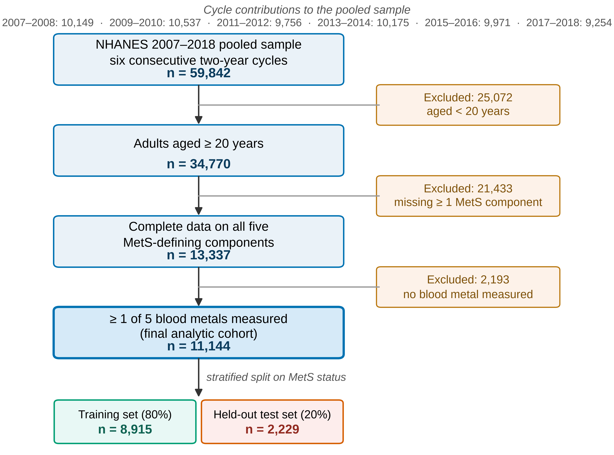
Figure 1. Data-cleaning and participant-flow diagram. Boxes on the left give the number remaining after each step; boxes on the right give the number excluded at that step and the reason. Cycle-level contributions to the pooled sample are shown above the diagram. MetS, metabolic syndrome.
3. Outcome definition
Metabolic syndrome was defined by the harmonized criteria of the joint interim statement of the International Diabetes Federation, NHLBI, American Heart Association and collaborating bodies [5], which extend the earlier AHA/NHLBI thresholds [6] by scoring a component positive when the participant is pharmacologically treated for it even if the measured value is below the cut-point. Cases met at least three of five components; definitions, thresholds and source variables are in Table S2. NHANES asks about lipid-lowering treatment only once, without separating HDL- from triglyceride-specific therapy, so that item is applied to both lipid components, consistent with the or logic of the definition. The treatment clause moved 1,201 participants from non-case to case and none in reverse, raising prevalence from 35.55% to 46.33%. The five component measurements and four medication items build the label only and were excluded from the predictor set, since a model given any of them could recover the outcome arithmetically rather than learn a risk relationship [7].
4. Predictor variables
Predictors were specified in advance from the metabolic-syndrome and metal-toxicity literature, across four domains. The blood-metal panel is lead, cadmium, total mercury, selenium and manganese: the analytes measured together in the NHANES whole-blood assay and the panel used in prior NHANES analyses of metals and metabolic syndrome [8]. Demographic and socioeconomic predictors (age, sex, race/ethnicity, education, marital status, household size, income-to-poverty ratio, examination period) are established correlates of both the outcome and metal exposure and are retained as adjustment variables. The anthropometric domain is body mass index. Lifestyle predictors cover smoking, alcohol use, self-rated diet quality, four physical-activity items and resting pulse. Table S1 gives every variable with its NHANES item code, a plain description of what that code records, its coding and the model columns it contributes; after encoding the set held 33 columns from 24 source variables.
No data-driven selection procedure (stepwise regression or the least absolute shrinkage and selection operator) was used in this phase. Selection algorithms run on a fixed dataset produce model-selection instability, biased effect estimates and confidence intervals whose nominal coverage fails, so the surviving set partly reflects a stochastic screening step rather than which variables matter [9]. Since this phase exists to rank candidate exposures for the Mendelian randomization analysis, a step that discards variables before ranking would remove the quantity of interest. Penalized selection retains a clear role there, applied to the high-dimensional genetic instrument space rather than a pre-specified 33-column epidemiological set.
Two candidates were removed prospectively. Hip circumference was excluded on training-partition grounds (correlation 0.937 with body mass index and 82.0% missing), so it adds imputation burden while splitting importance with a near-identical retained variable. Physician-diagnosed diabetes was held out as partly downstream of the glucose component and reintroduced only in sensitivity analysis. Two items needed harmonization: the alcohol gatekeeper question changed between cycles, with ALQ101 ("had at least 12 alcoholic drinks in any one year") in 2007–2016 and ALQ111 ("ever had a drink of any kind of alcohol") only in 2017–2018, so the two were combined into one ever-drank indicator, since using either alone imposes roughly 83% structural missingness from questionnaire redesign; and PAD645 (minutes walking or bicycling for transportation) is asked only of those answering yes to PAQ635 ("walk or use a bicycle for transportation"), so a blank after a no denotes zero minutes and was recoded accordingly.
5. Missing data
Missingness was concentrated in four predictors: current smoking intensity (55.3%, a skip pattern rather than non-response), selenium and manganese (43.3% each, almost entirely the two cycles lacking the assay), average daily drinks (36.6%) and income-to-poverty ratio (9.2%); all others were under 10%. Values were imputed inside the pipeline using the median for continuous and the modal category for categorical variables, fitted on training folds only. Multiple imputation is standard for etiological analysis [10] but sits awkwardly with a model that must also score a future incomplete record, and simulation work spanning development and deployment finds single imputation with missing indicators comparable for that purpose [11]. Each continuous predictor therefore carries a binary observed/imputed indicator, emitted at fixed width in every fold so the transformed matrix holds a constant 46 columns. Indicators let the model use informative missingness, which is structural here, but can bias predictions when missingness depends on the outcome [11]; they are reported separately from the substantive predictors rather than interpreted as risk factors.
6. Partitioning and prevention of information leakage
The cohort was split once into 8,915 training (80%) and 2,229 held-out test participants (20%), stratified on outcome. The test partition was opened only after development was complete and contributed to no imputation statistic, scaling parameter, resampling step, hyperparameter choice or decision threshold. With 4,130 events and 33 candidate columns the training partition provides about 125 events per candidate predictor; that benchmark was derived for regression models and does not translate directly to the effective complexity of a boosted ensemble [12], so it is a descriptive adequacy check rather than a licence for complexity, which was controlled by cross-validated tuning instead.
Every step that estimates anything from data sits inside one pipeline object, so cross-validation refits the whole sequence within each training fold (Figure S1). Fitting imputation, scaling or synthetic oversampling on the full dataset before splitting is among the most common forms of data leakage: a systematic survey identified 294 affected papers across 17 fields, and in several the corrected analysis erased the reported advantage of complex models over logistic regression [13]. Leakage through preprocessing and feature handling is specifically flagged as a recurring failure in biomedical machine learning [7]. The variable screens in Section 4 were likewise computed on training data alone.
7. Model development
Continuous predictors were median-imputed and standardized; binary, ordinal and one-hot columns were mode-imputed and left on their original scale. Standardization is required because the model set includes distance- and kernel-based learners (k-nearest neighbors, the support vector machine and the multilayer perceptron) whose objectives are not scale-invariant, so an unscaled predictor measured in hundreds (selenium, µg/L) would dominate the distance metric over one measured in units. Tree ensembles are invariant to monotone rescaling and are unaffected, so one shared preprocessing path keeps all eleven models comparable. Indicator columns are left unscaled because standardizing a 0/1 column changes nothing for trees and makes linear coefficients harder to read. Column order after transformation is deterministic and identical in every fold, which is what lets SHAP values be aligned unambiguously to predictor names.
Training-partition prevalence was 46.3%, so the classes are near-balanced and the usual case for resampling is weak. Synthetic Minority Over-sampling for Nominal and Continuous features (SMOTENC) was nonetheless applied within each training fold. SMOTENC rather than SMOTE was necessary because the predictor set mixes continuous measurements with binary and one-hot columns: SMOTE interpolates linearly between neighbors and would place fractional values on categorical columns, creating synthetic records with impossible category memberships, whereas SMOTENC interpolates only continuous features and assigns each synthetic record the majority category among its neighbors [14]. The countervailing evidence is also relevant: imbalance correction can leave risk models badly miscalibrated without improving discrimination, and shifting the decision threshold achieves the same sensitivity–specificity trade-off without that cost [15]. We therefore treated the choice as a parameter to test rather than assume, compared SMOTENC against class weighting in a prespecified sensitivity analysis (Section 9), and report calibration alongside discrimination for every model.
Eleven classifiers spanning linear, instance-based, kernel, neural and tree-ensemble families were trained: logistic regression, decision tree, random forest, gradient boosting, LightGBM, XGBoost, CatBoost, support vector machine, Gaussian naïve Bayes, multilayer perceptron and k-nearest neighbors. Hyperparameters were tuned by randomized search over the grids in Table S3 with 10-fold stratified cross-validation on the training partition, optimizing AUROC; selected configurations are reported there. Thresholds were selected by maximizing the Youden index [16] on out-of-fold training predictions, since choosing a threshold on the data used to report sensitivity and specificity inflates both; results are given at the tuned threshold and at 0.5.
8. Performance evaluation and model interpretation
Discrimination was summarized by AUROC and the area under the precision–recall curve, with accuracy, sensitivity, specificity, predictive values, F1 and Cohen's kappa at both thresholds and 1,000-resample bootstrap intervals. Because all models are scored on the same participants their AUROC estimates are correlated, so comparing independent intervals would overstate the uncertainty of a difference [17]; models were compared by paired bootstrap, applying the same resampled indices to both models in every draw. Calibration was assessed with quantile-binned curves, the Brier score, the calibration slope and the observed-to-expected ratio, because a model can rank well while misstating absolute risk: the failure that matters if a predicted probability reaches a clinician [18]. Clinical utility was assessed by decision-curve analysis against treat-all and treat-none strategies [19].
Predictor contributions were quantified two ways. SHapley Additive exPlanations were computed with the exact tree explainer [20], giving each predictor an additive contribution to each prediction on the log-odds scale, with global importance the mean absolute value. Permutation importance was the mean decrease in AUROC over ten permutations of each column, with the standard deviation retained so rank differences can be read against the noise producing them [21]. The two measure different things: how far a predictor moves individual predictions, versus how much ranking performance depends on it. A predictor substitutable by correlated predictors therefore scores high on the first and low on the second, and both are reported. SHAP runs on the 46-column transformed matrix and permutation importance on the 33 original columns, so SHAP importances are ranked among those 33 predictors to keep one denominator. Cross-model agreement was assessed by recomputing permutation importance independently in each of the four leading models.
9. Sensitivity and subgroup analyses
Four prespecified sensitivity analyses addressed the design choices most likely to affect conclusions: adding physician-diagnosed diabetes; replacing SMOTENC with class weighting; restricting the panel to blood lead alone, to quantify what the other four metals contribute; and substituting a measured-value-only outcome definition. Each used 10-fold cross-validation on the training partition with the three leading algorithms at default hyperparameters, so the difference between arms is not confounded by a second search; absolute values are consequently lower than the tuned values in Table S3 and not comparable to them. Discrimination and calibration were also recomputed within strata of sex, age tertile and race/ethnicity, with bootstrap intervals and the calibration model refitted in every resample. Subgroup analyses are descriptive; each stratum is nested within the overall sample, so subgroup intervals are not independent of the overall estimate and are not used to test against it.
10. Scope, software and availability
This is a development study with internal validation only: performance is estimated on a held-out partition of the same cohort, controlling optimism from model fitting but not from the cohort itself. No external or temporal validation was performed, though the six-cycle design would permit holding out the most recent cycle, and a single random partition under one seed leaves split-to-split variability that within-partition bootstrapping does not capture [3]. The models are a research instrument for prioritizing exposures for the Mendelian randomization phase, not a clinical screening tool, and have not been evaluated prospectively. Analyses used Python 3.11 with scikit-learn, imbalanced-learn, LightGBM, XGBoost, CatBoost and SHAP, one seed fixed throughout. Descriptive statistics used the NHANES complex-survey design with Taylor-series linearization, domain estimation and cycle-appropriate weights divided by the number of contributing cycles [1,2]; models were fitted unweighted, the target being individual-level discrimination rather than a population parameter. Data are public at https://wwwn.cdc.gov/nchs/nhanes/; code, derived metrics and model artifacts will be deposited publicly on publication. NHANES protocols were approved by the NCHS Research Ethics Review Board with written informed consent; this secondary analysis required no additional approval.
References
1. Johnson CL, Paulose-Ram R, Ogden CL, Carroll MD, Kruszon-Moran D, Dohrmann SM, et al. National Health and Nutrition Examination Survey: analytic guidelines, 1999–2010. Vital Health Stat 2. 2013;(161):1–24. PMID: 25090154.
2. Chen TC, Parker JD, Clark J, Shin HC, Rammon JR, Burt VL. National Health and Nutrition Examination Survey: estimation procedures, 2011–2014. Vital Health Stat 2. 2018;(177):1–26. PMID: 29775431.
3. Collins GS, Moons KGM, Dhiman P, Riley RD, Beam AL, Van Calster B, et al. TRIPOD+AI statement: updated guidance for reporting clinical prediction models that use regression or machine learning methods. BMJ. 2024;385:e078378. doi:10.1136/bmj-2023-078378.
4. von Elm E, Altman DG, Egger M, Pocock SJ, Gøtzsche PC, Vandenbroucke JP. The Strengthening the Reporting of Observational Studies in Epidemiology (STROBE) statement: guidelines for reporting observational studies. Lancet. 2007;370(9596):1453–7. doi:10.1016/S0140-6736(07)61602-X.
5. Alberti KGMM, Eckel RH, Grundy SM, Zimmet PZ, Cleeman JI, Donato KA, et al. Harmonizing the metabolic syndrome: a joint interim statement of the International Diabetes Federation Task Force on Epidemiology and Prevention; National Heart, Lung, and Blood Institute; American Heart Association; World Heart Federation; International Atherosclerosis Society; and International Association for the Study of Obesity. Circulation. 2009;120(16):1640–5. doi:10.1161/CIRCULATIONAHA.109.192644.
6. Grundy SM, Cleeman JI, Daniels SR, Donato KA, Eckel RH, Franklin BA, et al. Diagnosis and management of the metabolic syndrome: an American Heart Association/National Heart, Lung, and Blood Institute scientific statement. Circulation. 2005;112(17):2735–52. doi:10.1161/CIRCULATIONAHA.105.169404.
7. Bernett J, Blumenthal DB, Grimm DG, Haselbeck F, Joeres R, Kalinina OV, et al. Guiding questions to avoid data leakage in biological machine learning applications. Nat Methods. 2024;21(8):1444–53. doi:10.1038/s41592-024-02362-y.
8. Lo K, Yang JL, Chen CL, Liu L, Huang YQ, Feng YQ, et al. Associations between blood and urinary manganese with metabolic syndrome and its components: cross-sectional analysis of National Health and Nutrition Examination Survey 2011–2016. Sci Total Environ. 2021;780:146527. doi:10.1016/j.scitotenv.2021.146527.
9. Heinze G, Wallisch C, Dunkler D. Variable selection – a review and recommendations for the practicing statistician. Biom J. 2018;60(3):431–49. doi:10.1002/bimj.201700067.
10. Sterne JAC, White IR, Carlin JB, Spratt M, Royston P, Kenward MG, et al. Multiple imputation for missing data in epidemiological and clinical research: potential and pitfalls. BMJ. 2009;338:b2393. doi:10.1136/bmj.b2393.
11. Sisk R, Sperrin M, Peek N, van Smeden M, Martin GP. Imputation and missing indicators for handling missing data in the development and deployment of clinical prediction models: a simulation study. Stat Methods Med Res. 2023;32(8):1461–77. doi:10.1177/09622802231165001.
12. Riley RD, Ensor J, Snell KIE, Harrell FE, Martin GP, Reitsma JB, et al. Calculating the sample size required for developing a clinical prediction model. BMJ. 2020;368:m441. doi:10.1136/bmj.m441.
13. Kapoor S, Narayanan A. Leakage and the reproducibility crisis in machine-learning-based science. Patterns (N Y). 2023;4(9):100804. doi:10.1016/j.patter.2023.100804.
14. Chawla NV, Bowyer KW, Hall LO, Kegelmeyer WP. SMOTE: synthetic minority over-sampling technique. J Artif Intell Res. 2002;16:321–57. doi:10.1613/jair.953.
15. van den Goorbergh R, van Smeden M, Timmerman D, Van Calster B. The harm of class imbalance corrections for risk prediction models: illustration and simulation using logistic regression. J Am Med Inform Assoc. 2022;29(9):1525–34. doi:10.1093/jamia/ocac093.
16. Youden WJ. Index for rating diagnostic tests. Cancer. 1950;3(1):32–5. doi:10.1002/1097-0142(1950)3:1<32::aid-cncr2820030106>3.0.co;2-3.
17. DeLong ER, DeLong DM, Clarke-Pearson DL. Comparing the areas under two or more correlated receiver operating characteristic curves: a nonparametric approach. Biometrics. 1988;44(3):837–45. PMID: 3203132.
18. Van Calster B, McLernon DJ, van Smeden M, Wynants L, Steyerberg EW. Calibration: the Achilles heel of predictive analytics. BMC Med. 2019;17:230. doi:10.1186/s12916-019-1466-7.
19. Vickers AJ, Elkin EB. Decision curve analysis: a novel method for evaluating prediction models. Med Decis Making. 2006;26(6):565–74. doi:10.1177/0272989X06295361.
20. Lundberg SM, Erion G, Chen H, DeGrave A, Prutkin JM, Nair B, et al. From local explanations to global understanding with explainable AI for trees. Nat Mach Intell. 2020;2(1):56–67. doi:10.1038/s42256-019-0138-9.
21. Altmann A, Toloşi L, Sander O, Lengauer T. Permutation importance: a corrected feature importance measure. Bioinformatics. 2010;26(10):1340–7. doi:10.1093/bioinformatics/btq134.

