Results
Machine-learning analysis of blood metals and metabolic syndrome in NHANES 2007–2018
1. Study population
Of 59,842 participants sampled across the six NHANES cycles, 10,879 non-pregnant adults in the fasting subsample with complete outcome and metal data formed the analytic cohort (Figure 1), divided into 8,703 training and 2,176 held-out test participants. Metabolic syndrome was present in 5,079 participants, a crude prevalence of 46.69%. Of these, 1,237 reached the three-component threshold only because a drug-treatment clause scored a component positive that the measured value alone would not have; under a measured-value-only definition the prevalence would have been 35.32%.
Survey-weighted characteristics by metabolic syndrome status are given in Table 1. Participants with metabolic syndrome were on average 13.5 years older and had a body mass index 5.5 kg/m² higher. Comparing geometric means, lead (+14%) and cadmium (+7%) were higher in the metabolic syndrome group; mercury (−8%) and manganese (−2%) were lower; selenium (+1%) did not differ at p < 0.05. The percentages are the relative difference in geometric mean; all are small relative to the spread of the concentrations within each group, and none is adjusted for age, which differs sharply between the groups.
Table 1. Survey-weighted characteristics of the analytic cohort by metabolic syndrome status. Continuous variables are weighted means (standard error); blood metals are weighted geometric means (95% confidence interval); categorical variables are weighted percentages (standard error). All estimates use the fasting-subsample weight divided by six and Taylor-series linearization with the participants' own strata and primary sampling units.
Characteristic | No MetS | MetS | p
Age (years) | 41.64 (0.33) | 55.14 (0.33) | < 0.001
Body mass index (kg/m²) | 26.59 (0.13) | 32.10 (0.18) | < 0.001
Blood lead (µg/dL)† | 1.03 (1.00–1.06) | 1.17 (1.13–1.22) | < 0.001
Blood cadmium (µg/L)† | 0.32 (0.31–0.33) | 0.34 (0.33–0.35) | 0.002
Blood mercury, total (µg/L)† | 0.91 (0.86–0.96) | 0.84 (0.79–0.88) | 0.001
Blood selenium (µg/L)† | 193.07 (191.62–194.53) | 195.10 (192.64–197.59) | 0.070
Blood manganese (µg/L)† | 9.38 (9.24–9.52) | 9.16 (9.01–9.30) | 0.035
Income-to-poverty ratio | 3.02 (0.04) | 2.93 (0.05) | 0.078
Sex: Male | 48.8 (0.8) | 50.0 (1.0) | 0.391
Sex: Female | 51.2 (0.8) | 50.0 (1.0) | 0.391
Race/ethnicity: Mexican American | 8.9 (0.8) | 8.2 (0.8) | < 0.001
Race/ethnicity: Other Hispanic | 6.5 (0.6) | 5.1 (0.5) | < 0.001
Race/ethnicity: Non-Hispanic White | 64.4 (1.4) | 70.0 (1.6) | < 0.001
Race/ethnicity: Non-Hispanic Black | 11.4 (0.8) | 10.3 (0.8) | < 0.001
Race/ethnicity: Other/Multi-Racial | 8.8 (0.6) | 6.5 (0.5) | < 0.001
Education level: <9th grade | 4.5 (0.3) | 7.0 (0.5) | < 0.001
Education level: 9-11th grade | 9.6 (0.6) | 12.0 (0.7) | < 0.001
Education level: HS grad/GED | 21.1 (0.9) | 26.1 (1.0) | < 0.001
Education level: Some college/AA degree | 30.2 (1.0) | 30.9 (1.1) | < 0.001
Education level: College grad or above | 34.7 (1.4) | 23.9 (1.2) | < 0.001
Smoked ≥100 cigarettes in life: Yes | 41.5 (1.0) | 48.9 (1.0) | < 0.001
Smoked ≥100 cigarettes in life: No | 58.5 (1.0) | 51.1 (1.0) | < 0.001
MetS, metabolic syndrome. Unweighted group sizes: no MetS n = 5,800; MetS n = 5,079. †Geometric mean. Selenium and manganese were assayed only from the 2011–2012 cycle onward, so both are based on n = 3,347 without and n = 2,961 with metabolic syndrome. p-values for continuous variables are design-based t tests of the domain difference (on the log scale for the metals), with degrees of freedom equal to primary sampling units minus strata among participants measured: 94 for most rows and 62 for selenium and manganese; for categorical variables they are design-adjusted Wald F tests.
2. Model performance
All eleven models were evaluated once on the held-out test partition (Table 2, Figure 2). CatBoost achieved the highest area under the receiver operating characteristic curve at 0.853 (0.837–0.869), and Naive Bayes the lowest at 0.746 (0.725–0.765). XGBoost, Gradient Boosting and LightGBM were statistically indistinguishable from it (DeLong p = 0.524, p = 0.423 and p = 0.302; Figure S2), so these models form a tied leading group rather than a ranking. The remaining models differed from CatBoost at p ≤ 0.002. Two caveats apply: the reference was chosen as the test-set maximum, so the differences carry a winner's-curse bias, and no adjustment was made for the ten simultaneous comparisons. The margin over the simplest baseline is modest in any case: logistic regression reached 0.843, 0.010 AUROC units below CatBoost (95% CI 0.004–0.016).
Cross-validation repeated over 5 different random partitions of the training data (10 folds each; Table S9) gave CatBoost a mean AUROC of 0.842, with the individual folds spanning 0.822 to 0.863 (2.5th to 97.5th percentile). The repeated-CV ordering placed CatBoost first, followed by XGBoost, LightGBM and Gradient Boosting; the means of the leading models lay within 0.003 AUROC units of one another, smaller than the fold-to-fold standard deviation of 0.012.
Calibration slopes of the four highest-AUROC models ranged from 1.06 to 1.10 against an ideal of 1.00 (Figure S3). Calibration did not track discrimination across the wider field: Random Forest (slope 1.34, AUROC 0.846; under-dispersed), MLP (slope 0.45, AUROC 0.802; over-dispersed) and Naive Bayes (slope 0.19, AUROC 0.746; over-dispersed) departed from the ideal slope by more than 0.2. A slope below 1 means predicted probabilities that are too extreme, and above 1 too timid; either can coexist with acceptable ranking while giving an individual a wrong absolute risk. Decision-curve analysis (Figure S4) showed CatBoost above both reference strategies at every threshold from 0.02 to 0.80. At a risk threshold of 0.20 its net benefit was 0.375 against 0.334 for treating everyone, equivalent to 167 fewer unnecessary interventions per 1,000 adults for the same number of cases found. Threshold-level classification metrics, each with a bootstrap 95% confidence interval, are given in Table S4.
Table 2. Discrimination and calibration on the held-out test partition (n = 2,176), ordered by AUROC. Δ AUROC is CatBoost minus the model, with a paired-bootstrap 95% confidence interval (1,000 resamples, the same participants scored under both models); p is from DeLong's test for correlated ROC curves. Models in bold are statistically indistinguishable from CatBoost (p ≥ 0.05).
Model | AUROC (95% CI) | AUPRC | Brier | Cal. slope | Δ AUROC vs CatBoost (95% CI) | p
CatBoost | 0.853 (0.837–0.869) | 0.823 | 0.1558 | 1.06 | reference | –
XGBoost | 0.852 (0.836–0.868) | 0.818 | 0.1563 | 1.07 | 0.0010 (−0.0021 to 0.0044) | 0.524
Gradient Boosting | 0.852 (0.836–0.868) | 0.820 | 0.1567 | 1.06 | 0.0014 (−0.0022 to 0.0051) | 0.423
LightGBM | 0.851 (0.835–0.868) | 0.820 | 0.1569 | 1.10 | 0.0017 (−0.0015 to 0.0052) | 0.302
Random Forest | 0.846 (0.830–0.862) | 0.806 | 0.1616 | 1.34 | 0.0070 (0.0023 to 0.0115) | 0.002
Logistic Regression | 0.843 (0.826–0.860) | 0.792 | 0.1618 | 1.10 | 0.0101 (0.0043 to 0.0160) | < 0.001
SVM | 0.840 (0.824–0.857) | 0.800 | 0.1622 | 0.97 | 0.0128 (0.0074 to 0.0181) | < 0.001
Decision Tree | 0.831 (0.814–0.847) | 0.778 | 0.1672 | 0.92 | 0.0223 (0.0136 to 0.0307) | < 0.001
KNN | 0.807 (0.788–0.825) | 0.750 | 0.1810 | 1.09 | 0.0461 (0.0358 to 0.0568) | < 0.001
MLP | 0.802 (0.784–0.819) | 0.752 | 0.1939 | 0.45 | 0.0515 (0.0397 to 0.0630) | < 0.001
Naive Bayes | 0.746 (0.725–0.765) | 0.687 | 0.2484 | 0.19 | 0.1073 (0.0921 to 0.1242) | < 0.001
AUROC, area under the receiver operating characteristic curve; AUPRC, area under the precision–recall curve; Cal. slope, calibration slope (1.00 = perfect). Lower Brier scores indicate better probabilistic accuracy. Bootstrap 95% confidence intervals for AUPRC and Brier score are in 04_Results_Tables/model_comparison.csv.
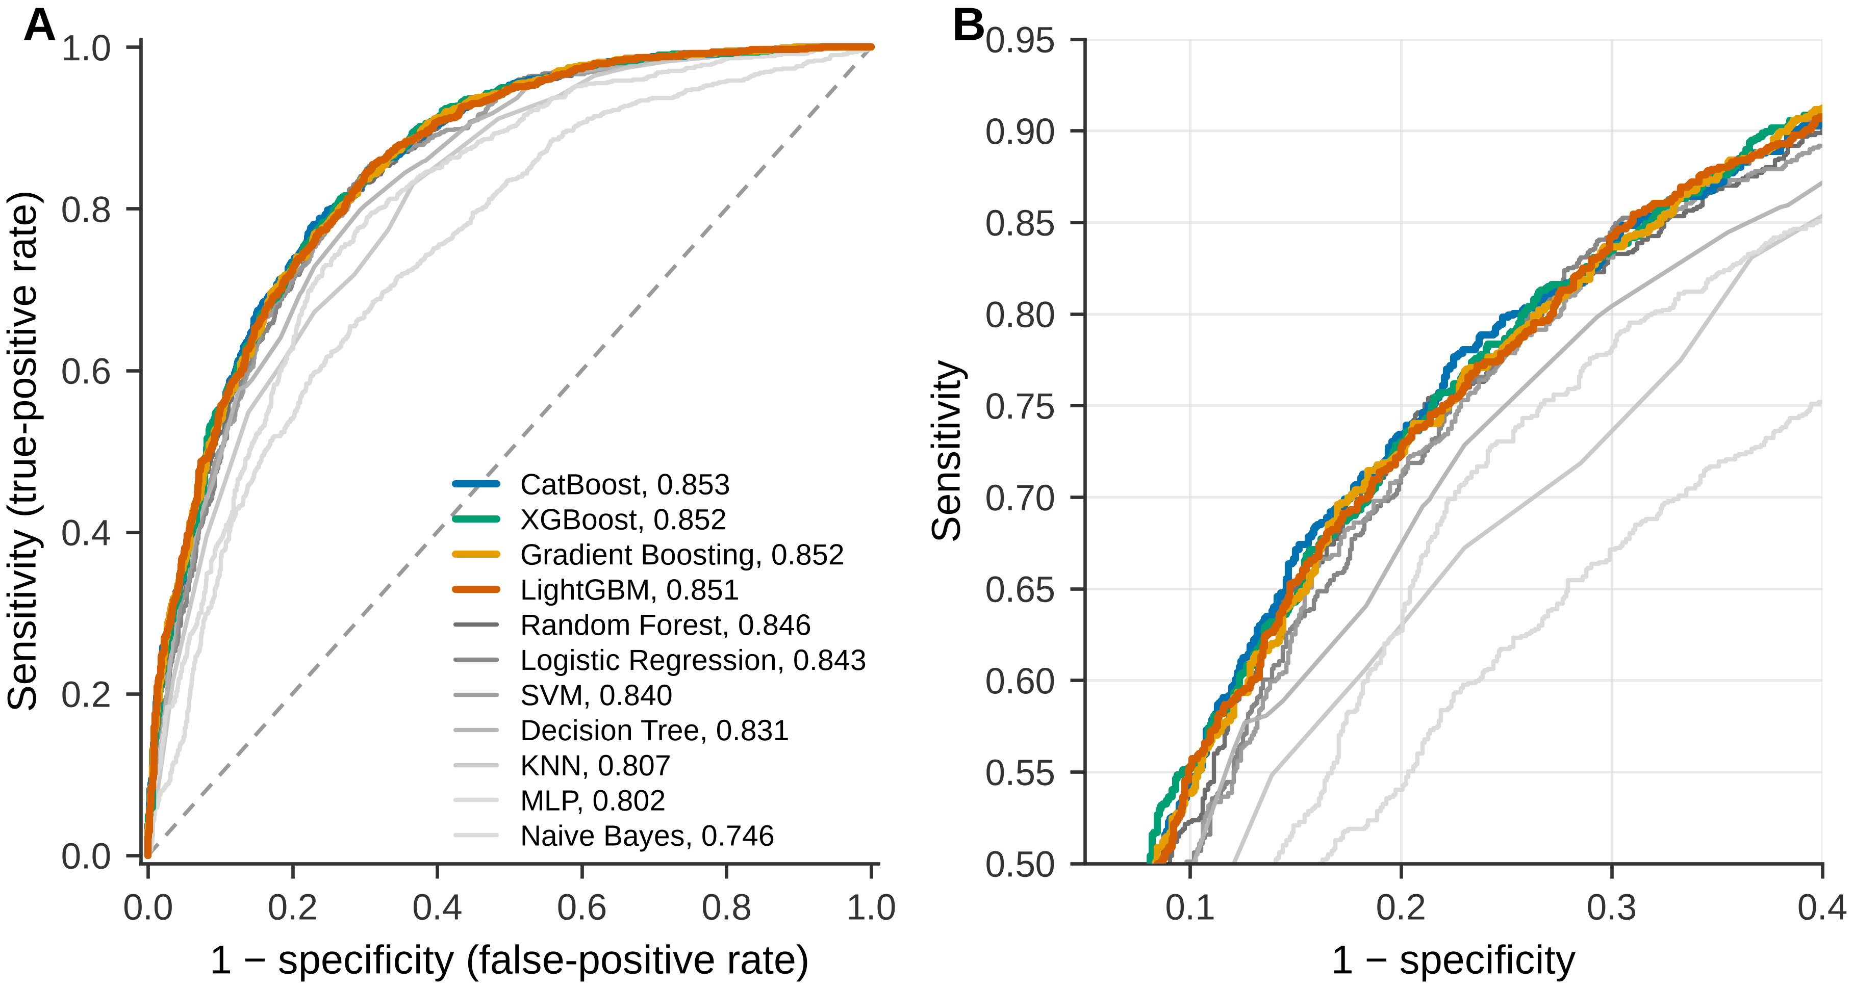
Figure 2. Receiver operating characteristic curves on the held-out test partition. (A) All eleven models, with AUROC in the legend; the four models statistically indistinguishable from the best performer are drawn in color and the remainder in grey. (B) Detail of the region of clinical interest.
3. Predictor importance
Two predictors dominated both importance analyses for CatBoost (Figures 3 and 4; full ranking in Table S5). By mean absolute SHAP value, body mass index (1.047) and age (0.938) were followed by vigorous recreational activity at 0.175, a 5.4-fold drop from second to third. By permutation importance, randomly shuffling body mass index cost 0.165 AUROC units and age 0.147, against 0.0055 for the third-ranked predictor. Everything else adjusts risk at the margin; Table S8 shows what this means for the model as a whole.
The two methods agreed only moderately below the top of the ranking (Spearman ρ = 0.67 across 32 predictors; Figure 4A). Disagreement of this kind is expected: mean absolute SHAP measures how far a predictor moves individual predictions, whereas permutation importance measures how much ranking performance degrades when that predictor is scrambled, so a predictor that correlated predictors can substitute for scores well on the first and poorly on the second. The missing-value indicator for income-to-poverty ratio also carried SHAP weight of at least 0.01; such indicators describe questionnaire structure rather than biology and are kept out of the predictor ranking.
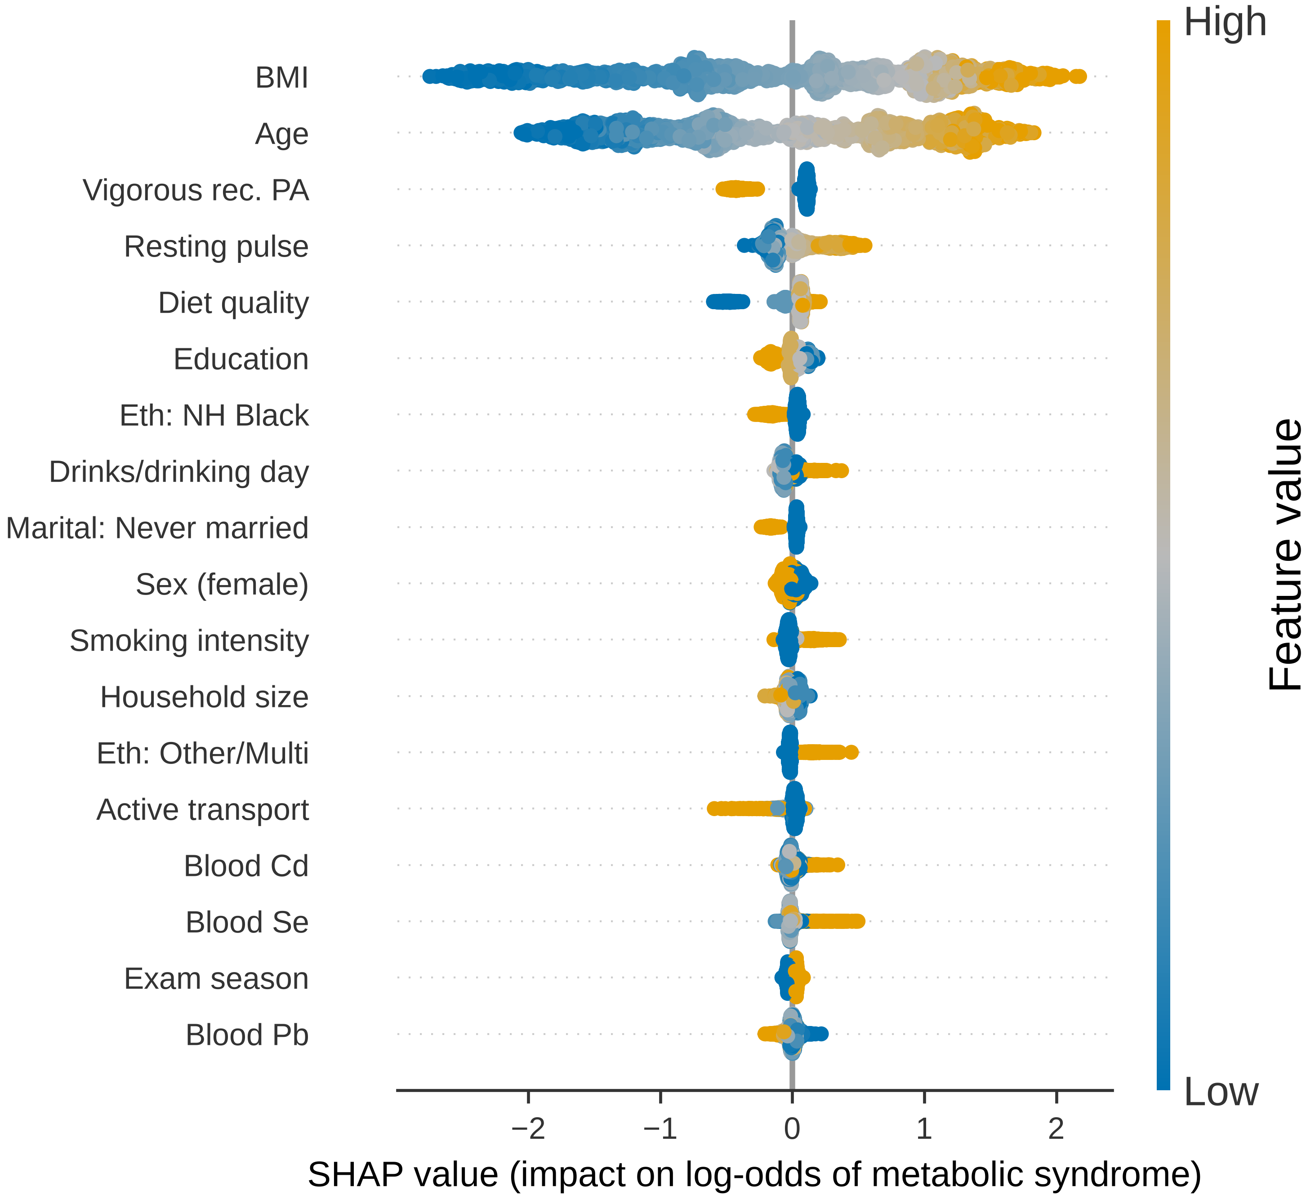
Figure 3. SHAP summary plot for the CatBoost model on the held-out test partition, showing the 18 highest-ranked features. Each point is one participant; horizontal position is that feature's contribution to that participant's predicted log-odds of metabolic syndrome, and color encodes the feature's value from low (blue) to high (orange). Abbreviations: BMI, body mass index (kg/m²); Vigorous rec. PA, vigorous recreational activity; Resting pulse, resting pulse (60 sec); Diet quality, self-rated diet quality (1=excellent...5=poor); Eth: NH Black, race/ethnicity: Non-Hispanic Black; Drinks/drinking day, avg. drinks per drinking day (past 12 mo, 0 for non-drinkers); Smoking intensity, current smoking intensity (0=none, 1=some days, 2=every day); Eth: Other/Multi, race/ethnicity: Other/Multi-Racial; Active transport, minutes walking/biking for transportation; Blood Cd, blood cadmium (µg/L); Blood Se, blood selenium (µg/L); Exam season, exam month: May-Oct (vs. Nov-Apr); Blood Pb, blood lead (µg/dL).
4. Blood metals
The five metals ranked between 11 and 23 of 32 predictors, and their order depended on the importance method. By SHAP the highest-ranked metal was cadmium (rank 15); by permutation importance it was lead (rank 11). The widest disagreement belonged to lead (18 by SHAP versus 11 by permutation), and the closest agreement to selenium (16 versus 16).
Across the four highest-AUROC models, each fitted and permuted independently (Figure 4B), permutation ranks were cadmium 13–16, lead 6–11, selenium 9–16, mercury 15–30 and manganese 17–32, from most to least stable. The permutation analysis carries its own uncertainty: across ten shuffles, only lead (0.00114 ± 0.00051) and cadmium (0.00100 ± 0.00042) had a mean importance larger than its own standard deviation, whereas for mercury, selenium and manganese the mean was smaller than the shuffle-to-shuffle variability. The defensible statement is therefore narrower than a rank list.
The shape of each metal's contribution is shown in Figure 5, as the mean SHAP value within twelve equal-count bins of the exposure: lead was falling, from 0.036 in the lowest bin to −0.070 in the highest (range −0.070 to 0.036); cadmium was U-shaped, from 0.048 in the lowest bin to 0.055 in the highest (range −0.033 to 0.055); mercury was falling, from 0.043 in the lowest bin to −0.006 in the highest (range −0.052 to 0.043); selenium was flat apart from a rise in the highest bin, from 0.017 in the lowest bin to 0.214 in the highest (range −0.024 to 0.214); manganese was irregular, from 0.019 in the lowest bin to −0.018 in the highest (range −0.018 to 0.019). These are contributions to the predicted log-odds within one fitted model, adjusted for everything else the model contains. No binned mean for any metal exceeded 0.214 in absolute value, against mean absolute contributions of 1.047 and 0.938 for the two leading predictors.
The lower predicted risk at the highest blood lead concentrations deserves emphasis rather than quiet omission, because it runs against the hypothesis that motivated the analysis. It is an associational pattern within one model, not an estimate of a causal effect. Residual confounding by smoking, which raises blood lead and cadmium and is associated with lower body mass index, is one plausible explanation, and dilution of blood metal concentrations with greater body size is another. Separating these is what the Mendelian randomization component is designed to do, and the direction observed here is a question posed to that analysis rather than an answer from this one.
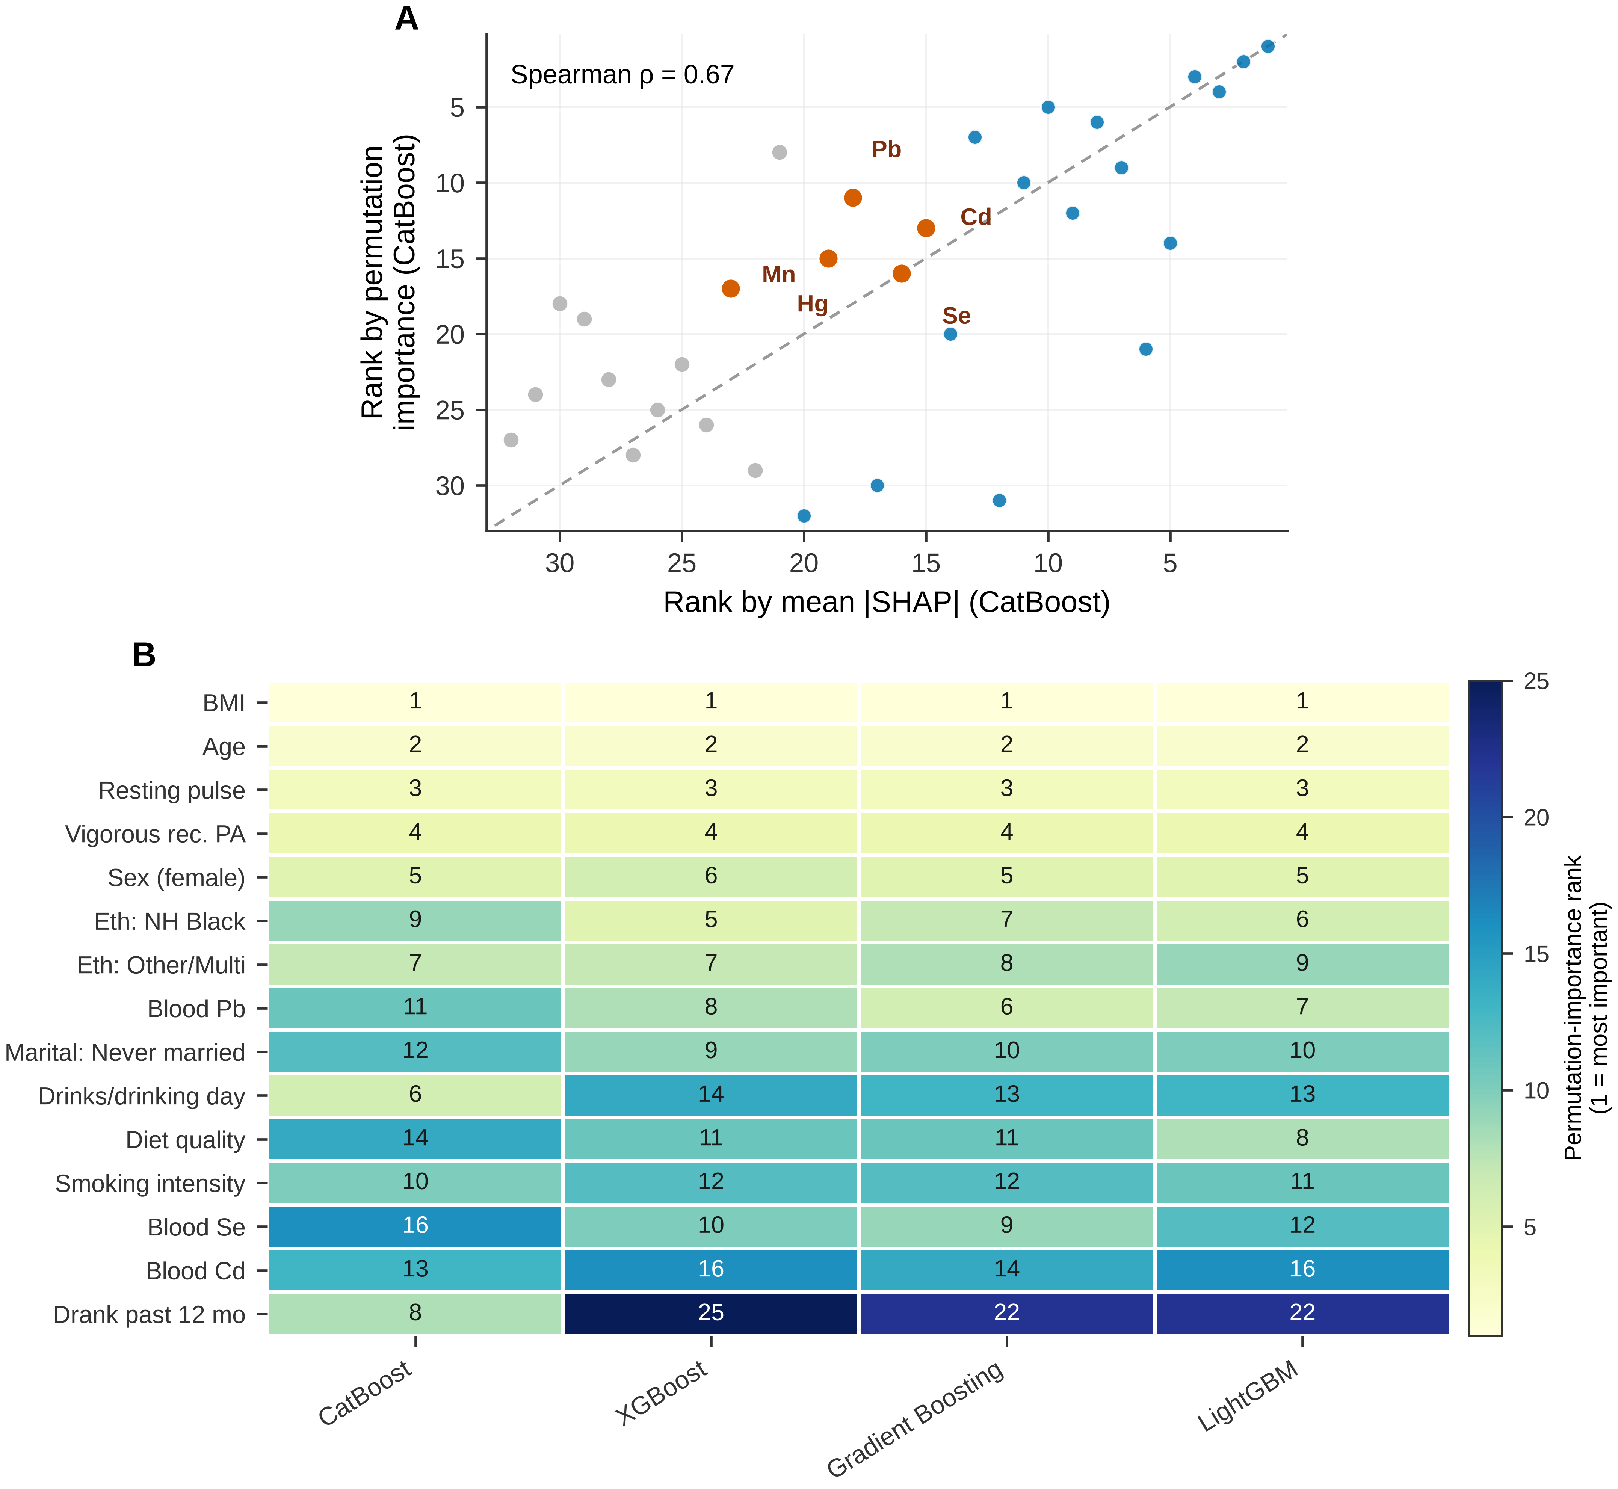
Figure 4. Agreement between importance methods and across models. (A) Rank by mean absolute SHAP value against rank by permutation importance for the CatBoost model; the five blood metals are highlighted and the diagonal denotes perfect agreement. (B) Permutation-importance rank of the fifteen highest-ranked predictors in each of the four highest-AUROC models, fitted independently. A predictor whose row is uniform is important as a property of the data; one whose row varies is important as a property of a particular fitted model. Abbreviations as in Figure 3, plus Blood Mn, blood manganese (µg/L); Blood Hg, blood mercury, total (µg/L); Drank past 12 mo, drank alcohol in past 12 months.
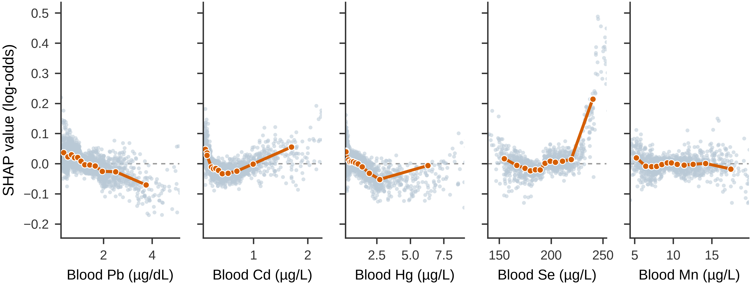
Figure 5. SHAP dependence for the five blood metals in the CatBoost model on the held-out test partition. Each grey point is one participant; the orange line joins mean SHAP values within twelve equal-count bins of the exposure, and the dashed line at zero marks no contribution to the predicted log-odds. Axes are truncated at the 1st and 98th percentiles. Selenium and manganese are based on the 1,303 test participants from cycles in which those analytes were assayed. Abbreviations as in Figure 3.
5. Incremental value, subgroups and sensitivity analyses
Table S8 tests directly what the metals add. Refitting CatBoost with its tuned settings but without the five metals changed test-set AUROC from 0.853 to 0.853, a difference of −0.0001 (95% CI −0.0028 to 0.0028; p = 0.951); keeping lead as the only metal gave 0.853, −0.0004 (95% CI −0.0031 to 0.0023; p = 0.778). Removing body mass index instead gave 0.774, −0.0796 (95% CI −0.0949 to −0.0641; p < 0.001), and a logistic regression on age and body mass index alone reached 0.835, −0.0186 (95% CI −0.0263 to −0.0113; p < 0.001). On this test set the metals' contribution to discrimination is not distinguishable from zero. Their importance ranks describe attribution within a fitted model, not predictive value that would be lost without them.
Against an overall test-set AUROC of 0.853 (0.837–0.869), subgroup AUROC ranged from 0.780 in the age band > 59 y (0.740–0.816) to 0.877 in Other/Multi-racial (0.834–0.915; Table S6, Figure S5); the interval for the age band 41–59 y and the age band > 59 y lay entirely below the overall interval. Within an age band the range of age is compressed, so the model's second most important predictor separates participants less well there; prevalence across the age bands ran from 22.9% to 70.7%. Calibration departed detectably from ideal (slope or observed-to-expected ratio interval excluding 1) in women. These are descriptive screens over 22 intervals without multiplicity adjustment.
In temporal validation (Table S10), CatBoost re-tuned and developed on the 2007–2014 cycles (n = 7,786) reached an AUROC of 0.833 (0.819–0.846) on the 2015–2018 cycles (n = 3,093), against 0.853 for the random split. Its calibration slope was 1.06 and its calibration-in-the-large −0.008, with an observed-to-expected ratio of 0.997.
Sensitivity analyses are given in Table S7 (cross-validated AUROC on the training partition, CatBoost, LightGBM and XGBoost at their tuned settings). Adding physician-diagnosed diabetes changed discrimination by 0.0095 to 0.0112 AUROC units, as expected for a variable partly downstream of the glucose component. Replacing SMOTENC with class weighting changed it by −0.0013 to −0.0003. The measured-value-only outcome changed it by −0.0374 to −0.0356, dropping the lipid-medication clause by −0.0057 to −0.0047 (training-partition prevalence 40.1% instead of 46.7%), and using only the first blood-pressure reading by −0.0002 to 0.0019. Restricting the metal panel to lead changed it by −0.0010 to 0.0002. Differences of a few thousandths sit within the fold-to-fold variability shown in Table S9.

