Supplementary Material
Machine-learning analysis of blood metals and metabolic syndrome in NHANES 2007–2018
Table S1. Predictor dictionary. Each NHANES item code is given with a plain description of what the item records, its coding in this analysis, and the number of model columns it contributes after encoding (total 32). Categorical variables with more than two levels were one-hot encoded with the stated reference category omitted.
Domain | NHANES code | What the item records | Coding | Cols
Blood metals | LBXBPB | Blood lead concentration | Continuous, µg/dL | 1
 | LBXBCD | Blood cadmium concentration | Continuous, µg/L | 1
 | LBXTHG | Blood total mercury concentration | Continuous, µg/L | 1
 | LBXBSE | Blood selenium concentration | Continuous, µg/L | 1
 | LBXBMN | Blood manganese concentration | Continuous, µg/L | 1
Demographic and socioeconomic | RIDAGEYR | Age at screening | Continuous, years | 1
 | RIAGENDR | Sex | Binary (female = 1) | 1
 | RIDRETH1 | Race/Hispanic origin | One-hot; Mexican American = reference | 4
 | DMDEDUC2 | Highest education level completed (adults) | Ordinal 1–5 (<9th grade → college graduate) | 1
 | DMDMARTL | Marital status | One-hot; married = reference, plus a column for a missing answer | 6
 | DMDHHSIZ | Total number of people in the household | Continuous, count | 1
 | INDFMPIR | Ratio of family income to the federal poverty threshold | Continuous, 0–5 | 1
 | RIDEXMON | Six-month period in which the examination took place | Binary (May–October = 1) | 1
Anthropometric | BMXBMI | Body mass index from measured height and weight | Continuous, kg/m² | 1
Lifestyle | SMQ020 | Smoked at least 100 cigarettes in life | Binary (yes = 1) | 1
 | SMQ040 | Current cigarette smoking frequency (never-smokers, who skip the item, coded not at all) | Ordinal, recoded 0 = not at all, 1 = some days, 2 = every day | 1
 | ALQ120Q / ALQ121 | Any alcohol in the past 12 months, from the past-year drinking frequency (ALQ120Q in 2007–2016, ALQ121 in 2017–2018); those who never had 12 drinks in their life or never had a drink skip it and are coded no | Binary (yes = 1) | 1
 | ALQ130 | Average number of alcoholic drinks on drinking days, past 12 months (0 for past-year non-drinkers) | Continuous, drinks/day | 1
 | DBQ700 | Self-rated overall diet quality | Ordinal 1–5 (excellent → poor) | 1
 | PAQ605 | Vigorous-intensity activity as part of work | Binary (yes = 1) | 1
 | PAQ650 | Vigorous-intensity recreational activity | Binary (yes = 1) | 1
 | PAQ665 | Moderate-intensity recreational activity | Binary (yes = 1) | 1
 | PAD645 | Minutes spent walking or bicycling for transportation on a typical day (gated on PAQ635, "walk or use a bicycle for transportation") | Continuous, minutes/day | 1
 | BPXPLS | Resting pulse, 60-second count | Continuous, beats/min | 1
Survey modules used, all merged on the respondent sequence number (SEQN): demographics (DEMO), body measures (BMX), blood pressure (BPX), triglycerides (TRIGLY), HDL cholesterol (HDL), plasma fasting glucose (GLU), blood lead–cadmium–mercury–selenium–manganese (PBCD), alcohol use (ALQ), diet behavior (DBQ), smoking (SMQ), diabetes (DIQ), physical activity (PAQ), and blood pressure and cholesterol (BPQ). Hip circumference (BMXHIP) and physician-diagnosed diabetes (DIQ010) were screened but not retained in the primary predictor set.
Table S2. Metabolic syndrome component definitions. A component is scored positive when either the measured criterion or the drug-treatment criterion is met, following the harmonized joint interim statement [5], which retains the AHA/NHLBI thresholds and treatment clauses [6]. Participants meeting at least three of five components were classified as cases.
Component | Measured criterion | NHANES variable | Drug-treatment criterion
Abdominal obesity | Waist circumference ≥ 102 cm (men) or ≥ 88 cm (women) | BMXWAIST | Not applicable
Elevated triglycerides | Triglycerides ≥ 150 mg/dL | LBXTR | BPQ100D (currently taking prescribed medicine for cholesterol)
Reduced HDL cholesterol | HDL-C < 40 mg/dL (men) or < 50 mg/dL (women) | LBDHDD | BPQ100D (currently taking prescribed medicine for cholesterol)
Elevated blood pressure | Mean systolic ≥ 130 mmHg or mean diastolic ≥ 85 mmHg | BPXSY1–4, BPXDI1–4 (mean of valid readings) | BPQ050A (currently taking prescribed medicine for hypertension)
Elevated fasting glucose | Fasting plasma glucose ≥ 100 mg/dL | LBXGLU | DIQ050 (currently taking insulin); DIQ070 (taking pills to lower blood sugar)
HDL-C, high-density lipoprotein cholesterol. NHANES carries only one cholesterol-medication item and does not name the drug, whereas the guideline's lipid treatment clause refers to drugs such as fibrates and nicotinic acid; BPQ100D is applied to both lipid components as a stated modelling choice, and a sensitivity analysis without it is given in Table S7. Blood pressure is the mean of all valid readings (a diastolic reading of 0 mmHg is treated as invalid); a first-reading-only version is also tested in Table S7. Component measurements and medication items were used solely to construct the outcome and were excluded from the predictor set.
Table S3. Hyperparameter search space, selected configuration and cross-validated discrimination for each algorithm. Every grid holds at most 12 configurations and was searched exhaustively, with 10-fold stratified cross-validation on the training partition, optimizing AUROC. These values are tuning-selection statistics and are optimistically biased; test-partition performance is reported in the main text.
Algorithm | Search space | Selected configuration | CV AUROC
CatBoost | iterations ∈ {200, 500}; learning_rate ∈ {0.01, 0.05, 0.1}; depth ∈ {4, 6} | learning_rate = 0.05, iterations = 200, depth = 6 | 0.8438
LightGBM | n_estimators ∈ {200, 500}; learning_rate ∈ {0.01, 0.05, 0.1}; num_leaves ∈ {15, 31} | num_leaves = 15, n_estimators = 500, learning_rate = 0.01 | 0.8400
XGBoost | n_estimators ∈ {200, 500}; learning_rate ∈ {0.01, 0.05, 0.1}; max_depth ∈ {3, 5} | n_estimators = 200, max_depth = 3, learning_rate = 0.05 | 0.8399
Gradient Boosting | n_estimators ∈ {100, 200}; learning_rate ∈ {0.01, 0.1}; max_depth ∈ {2, 3} | n_estimators = 100, max_depth = 3, learning_rate = 0.1 | 0.8393
SVM | C ∈ {0.1, 1, 10}; kernel ∈ {RBF, linear} | kernel = rbf, C = 1 | 0.8374
Random Forest | n_estimators ∈ {200, 500}; max_depth ∈ {None, 8, 15}; min_samples_leaf ∈ {1, 5} | n_estimators = 500, min_samples_leaf = 5, max_depth = None | 0.8371
Logistic Regression | C ∈ {0.01, 0.1, 1, 10}; penalty = L2 | penalty = l2, C = 0.01 | 0.8352
Decision Tree | max_depth ∈ {3, 5, 8, None}; min_samples_leaf ∈ {1, 5, 20} | min_samples_leaf = 20, max_depth = 5 | 0.8184
KNN | n_neighbors ∈ {5, 15, 25} | n_neighbors = 25 | 0.8018
MLP | hidden_layer_sizes ∈ {(64), (64, 32)}; alpha ∈ {0.0001, 0.001} | hidden_layer_sizes = (64), alpha = 0.001 | 0.7898
Naive Bayes | none (no hyperparameters searched) | – | 0.7438
Selections at the edge of their search range, where a wider grid might have chosen a more extreme value: CatBoost (iterations = 200); CatBoost (depth = 6); LightGBM (num_leaves = 15); LightGBM (n_estimators = 500); LightGBM (learning_rate = 0.01); XGBoost (n_estimators = 200); XGBoost (max_depth = 3); Gradient Boosting (n_estimators = 100); Gradient Boosting (max_depth = 3); Gradient Boosting (learning_rate = 0.1); Random Forest (n_estimators = 500); Random Forest (min_samples_leaf = 5); Logistic Regression (C = 0.01); Decision Tree (min_samples_leaf = 20); KNN (n_neighbors = 25); MLP (alpha = 0.001).
Table S4. Classification performance on the held-out test partition at the decision threshold selected by maximizing the Youden index on out-of-fold training predictions, and at the conventional 0.5 cut-point for comparison. All values except the threshold, F1 and κ are percentages.
Model | Thresh. | Acc. | Sens. | Spec. | PPV | NPV | F1 | κ | Acc.₀.₅ | Sens.₀.₅ | Spec.₀.₅
CatBoost | 0.511 | 77.3 | 78.3 | 76.4 | 74.4 | 80.1 | 0.763 | 0.545 | 77.2 | 79.4 | 75.3
XGBoost | 0.531 | 76.8 | 76.2 | 77.2 | 74.6 | 78.7 | 0.754 | 0.533 | 76.7 | 79.3 | 74.4
Gradient Boosting | 0.552 | 76.4 | 74.0 | 78.5 | 75.0 | 77.5 | 0.745 | 0.525 | 76.5 | 78.3 | 74.9
LightGBM | 0.532 | 76.6 | 75.0 | 78.0 | 74.9 | 78.1 | 0.750 | 0.530 | 76.4 | 77.8 | 75.1
Random Forest | 0.486 | 76.4 | 78.8 | 74.3 | 72.9 | 80.0 | 0.757 | 0.529 | 76.3 | 77.3 | 75.4
Logistic Regression | 0.446 | 76.8 | 83.3 | 71.1 | 71.6 | 82.9 | 0.770 | 0.538 | 76.5 | 76.3 | 76.6
SVM | 0.473 | 76.0 | 79.2 | 73.1 | 72.1 | 80.1 | 0.755 | 0.520 | 76.3 | 77.8 | 74.9
Decision Tree | 0.493 | 75.0 | 72.8 | 77.0 | 73.5 | 76.4 | 0.732 | 0.498 | 75.0 | 72.8 | 77.0
KNN | 0.520 | 71.7 | 77.5 | 66.7 | 67.1 | 77.2 | 0.719 | 0.438 | 71.7 | 77.5 | 66.7
MLP | 0.338 | 72.8 | 82.7 | 64.2 | 66.9 | 80.9 | 0.740 | 0.462 | 74.0 | 74.5 | 73.5
Naive Bayes | 0.220 | 67.4 | 74.3 | 61.3 | 62.7 | 73.2 | 0.680 | 0.352 | 68.5 | 64.2 | 72.3
Acc., accuracy; Sens., sensitivity; Spec., specificity; PPV, positive predictive value; NPV, negative predictive value; κ, Cohen's kappa. Subscript 0.5 denotes the conventional cut-point. Thresholds were selected without reference to the test partition. Bootstrap 95% confidence intervals for every value are given in 04_Results_Tables/model_comparison.csv.
Table S5. The fifteen highest-ranked predictors by mean absolute SHAP value, with their permutation-importance values and ranks for comparison. Both methods are applied to the CatBoost model on the held-out test partition and both rank over the same 32 predictors.
Predictor | Mean |SHAP| | SHAP rank | Permutation Δ AUROC (mean ± SD) | Perm. rank | Above noise
Body mass index (kg/m²) | 1.0474 | 1 | 0.16527 ± 0.00795 | 1 | yes
Age (years) | 0.9382 | 2 | 0.14661 ± 0.01000 | 2 | yes
Vigorous recreational activity | 0.1753 | 3 | 0.00303 ± 0.00110 | 4 | yes
Resting pulse (60 sec) | 0.1516 | 4 | 0.00548 ± 0.00167 | 3 | yes
Self-rated diet quality | 0.1016 | 5 | 0.00070 ± 0.00071 | 14 | no
Education level | 0.0773 | 6 | 0.00009 ± 0.00051 | 21 | no
Race/ethnicity: Non-Hispanic Black | 0.0629 | 7 | 0.00134 ± 0.00058 | 9 | yes
Avg. drinks per drinking day (past 12 mo, 0 for non-drinkers) | 0.0562 | 8 | 0.00178 ± 0.00119 | 6 | yes
Marital status: Never married | 0.0561 | 9 | 0.00105 ± 0.00039 | 12 | yes
Sex: Female | 0.0446 | 10 | 0.00271 ± 0.00065 | 5 | yes
Current smoking intensity | 0.0445 | 11 | 0.00120 ± 0.00063 | 10 | yes
Household size | 0.0407 | 12 | −0.00046 ± 0.00032 | 31 | no
Race/ethnicity: Other/Multi-Racial | 0.0368 | 13 | 0.00151 ± 0.00040 | 7 | yes
Minutes walking/biking for transportation | 0.0363 | 14 | 0.00009 ± 0.00059 | 20 | no
Blood cadmium (µg/L) | 0.0311 | 15 | 0.00100 ± 0.00042 | 13 | yes
Permutation Δ AUROC is the mean decrease in test-set AUROC over ten permutations of the predictor, with the standard deviation across those permutations. Above noise is a descriptive heuristic, not a hypothesis test: it flags predictors whose mean exceeds one permutation standard deviation, a roughly one-sigma bar reflecting permutation variability only and not sampling variability of the test partition. Only 11 of these fifteen clear it, so ranks below the leading few should not be read as a resolved ordering. A negative value means permuting the predictor left discrimination unchanged or marginally improved it; 5 of the 32 predictors had a negative mean and 1 exactly zero, so the lower permutation ranks are not interpretable.
Table S6. Discrimination and calibration of the CatBoost model within subgroups of the held-out test partition. Calibration is reported alongside discrimination because a model can rank participants poorly within a stratum while still stating their absolute risk correctly, and the two have different consequences in use.
Subgroup | n | Prev. (%) | AUROC (95% CI) | Cal. slope (95% CI) | O:E ratio (95% CI)
Overall | 2,176 | 46.7 | 0.853 (0.837–0.869) | 1.06 (0.97–1.16) | 0.983 (0.945–1.016)
Male | 1,031 | 48.3 | 0.858 (0.834–0.880) | 1.09 (0.97–1.25) | 1.031 (0.980–1.082)
Female | 1,145 | 45.2 | 0.851 (0.829–0.872) | 1.04 (0.94–1.18) | 0.940 (0.892–0.989)
Age 20–40 y | 760 | 22.9 | 0.855 (0.824–0.887) | 1.03 (0.87–1.24) | 0.924 (0.827–1.025)
Age 41–59 y | 717 | 48.5 | 0.795 (0.764–0.828) | 1.02 (0.88–1.21) | 0.989 (0.923–1.051)
Age > 59 y | 699 | 70.7 | 0.780 (0.740–0.816) | 1.09 (0.90–1.31) | 1.001 (0.959–1.044)
Non-Hispanic White | 908 | 49.1 | 0.850 (0.826–0.873) | 1.02 (0.90–1.15) | 0.974 (0.921–1.026)
Mexican American | 337 | 45.1 | 0.830 (0.783–0.871) | 1.02 (0.79–1.33) | 0.962 (0.861–1.052)
Non-Hispanic Black | 424 | 46.9 | 0.861 (0.828–0.895) | 1.17 (0.97–1.46) | 0.990 (0.913–1.076)
Other Hispanic | 233 | 47.2 | 0.858 (0.807–0.903) | 1.13 (0.88–1.56) | 0.966 (0.859–1.067)
Other/Multi-racial | 274 | 39.8 | 0.877 (0.834–0.915) | 1.07 (0.82–1.43) | 1.060 (0.935–1.177)
Cal. slope, calibration slope, describing dispersion of the predictions (1.00 = perfect); O:E, ratio of observed to expected outcome frequency, describing calibration in the large (1.00 = perfect). All intervals come from the same 1,000 percentile bootstrap resamples, with the calibration model refitted in each. Slope and O:E answer different questions and are not interchangeable. Age groups are tertiles of the test-partition age distribution. Subgroups are nested within the overall sample, so their intervals are not independent of the overall row and should not be used to test against it.
Table S7. Sensitivity analyses. Each entry is the mean AUROC from 10-fold stratified cross-validation on the training partition, using the three algorithms with the highest cross-validated AUROC in Table S3 at their tuned hyperparameters, holding everything except the stated change fixed. The outcome-definition arms change the label, and therefore its prevalence, as well as the difficulty of the task; prevalences quoted for these arms refer to the training partition.
Analysis | Model | Primary | Alternative | Δ AUROC
Add diagnosed diabetes | CatBoost | 0.8438 | 0.8533 | +0.0095
Add diagnosed diabetes | LightGBM | 0.8400 | 0.8504 | +0.0104
Add diagnosed diabetes | XGBoost | 0.8399 | 0.8512 | +0.0112
Class weighting instead of SMOTENC | CatBoost | 0.8438 | 0.8430 | -0.0008
Class weighting instead of SMOTENC | LightGBM | 0.8400 | 0.8387 | -0.0013
Class weighting instead of SMOTENC | XGBoost | 0.8399 | 0.8397 | -0.0003
Lead only, other four metals dropped | CatBoost | 0.8438 | 0.8428 | -0.0010
Lead only, other four metals dropped | LightGBM | 0.8400 | 0.8401 | +0.0002
Lead only, other four metals dropped | XGBoost | 0.8399 | 0.8399 | -0.0000
Measured-value-only outcome definition | CatBoost | 0.8438 | 0.8067 | -0.0371
No lipid-medication clause in the outcome | CatBoost | 0.8438 | 0.8381 | -0.0057
Outcome with first blood-pressure reading only | CatBoost | 0.8438 | 0.8436 | -0.0002
Measured-value-only outcome definition | LightGBM | 0.8400 | 0.8044 | -0.0356
No lipid-medication clause in the outcome | LightGBM | 0.8400 | 0.8353 | -0.0047
Outcome with first blood-pressure reading only | LightGBM | 0.8400 | 0.8408 | +0.0008
Measured-value-only outcome definition | XGBoost | 0.8399 | 0.8025 | -0.0374
No lipid-medication clause in the outcome | XGBoost | 0.8399 | 0.8347 | -0.0052
Outcome with first blood-pressure reading only | XGBoost | 0.8399 | 0.8418 | +0.0019
Δ AUROC is the alternative specification minus the primary, so a positive value indicates the alternative discriminated better. For the outcome-definition arms the primary specification is the harmonized definition used throughout. Gradient boosting has no class-weight option and used balanced sample weights instead.
Table S8. Incremental value of the blood metals and simple baselines. The leading algorithm (CatBoost) was refitted with its tuned hyperparameters on reduced predictor sets; every model was scored on the same 2,176 test participants and compared with the full model by DeLong's test, with a paired-bootstrap 95% CI for the difference.
Model | Columns | CV AUROC | Test AUROC (95% CI) | Δ vs full (95% CI) | p
Full model (all predictors) | 32 | 0.8438 | 0.853 (0.837–0.869) | reference | –
Without the five metals | 27 | 0.8423 | 0.853 (0.837–0.869) | −0.0001 (−0.0028 to 0.0028) | 0.951
Lead as the only metal | 28 | 0.8428 | 0.853 (0.837–0.869) | −0.0004 (−0.0031 to 0.0023) | 0.778
Without body mass index | 31 | 0.7734 | 0.774 (0.751–0.793) | −0.0796 (−0.0949 to −0.0641) | < 0.001
Age and body mass index only (logistic regression) | 2 | 0.8264 | 0.835 (0.817–0.853) | −0.0186 (−0.0263 to −0.0113) | < 0.001
CV AUROC, mean of 10-fold cross-validation on the training partition. Removing body mass index also removes its missing-value indicator. Waist circumference defines one outcome component and correlates strongly with body mass index, so part of the no-BMI loss is definitional.
Table S9. Repeated stratified cross-validation on the training partition (10 folds × 5 repeats, 50 fits per model), showing how much discrimination varies between data partitions. The hyperparameters tuned on the same training partition were reused rather than re-tuned inside each fold, so the means are mildly optimistic.
Model | Mean AUROC | SD across folds | 2.5th–97.5th percentile | Range of repeat means
CatBoost | 0.8419 | 0.0116 | 0.8219–0.8627 | 0.8397–0.8438
XGBoost | 0.8401 | 0.0112 | 0.8225–0.8613 | 0.8388–0.8418
LightGBM | 0.8397 | 0.0114 | 0.8183–0.8610 | 0.8383–0.8411
Gradient Boosting | 0.8392 | 0.0110 | 0.8195–0.8603 | 0.8382–0.8405
SVM | 0.8372 | 0.0115 | 0.8137–0.8595 | 0.8352–0.8384
Random Forest | 0.8366 | 0.0118 | 0.8162–0.8582 | 0.8351–0.8375
Logistic Regression | 0.8356 | 0.0123 | 0.8131–0.8609 | 0.8352–0.8362
Decision Tree | 0.8177 | 0.0125 | 0.7923–0.8396 | 0.8154–0.8195
KNN | 0.8014 | 0.0133 | 0.7708–0.8249 | 0.7999–0.8028
MLP | 0.7896 | 0.0164 | 0.7584–0.8203 | 0.7880–0.7924
Naive Bayes | 0.7438 | 0.0172 | 0.7165–0.7717 | 0.7429–0.7454
Table S10. Temporal validation of the CatBoost model: development on the 2007–2014 cycles with hyperparameters re-tuned by 10-fold cross-validation on those cycles only, testing on 2015–2018, compared with the primary random split.
Design | Train n | Test n | AUROC (95% CI) | Cal. slope | Cal. intercept | O:E
Random split (primary analysis) | 8,703 | 2,176 | 0.853 (0.837–0.869) | 1.06 | −0.051 | 0.983
Temporal holdout (develop 2007-2014, test 2015-2018; re-tuned) | 7,786 | 3,093 | 0.833 (0.819–0.846) | 1.06 | −0.008 | 0.997
Cal. intercept, calibration-in-the-large (slope fixed at 1; 0 = perfect).
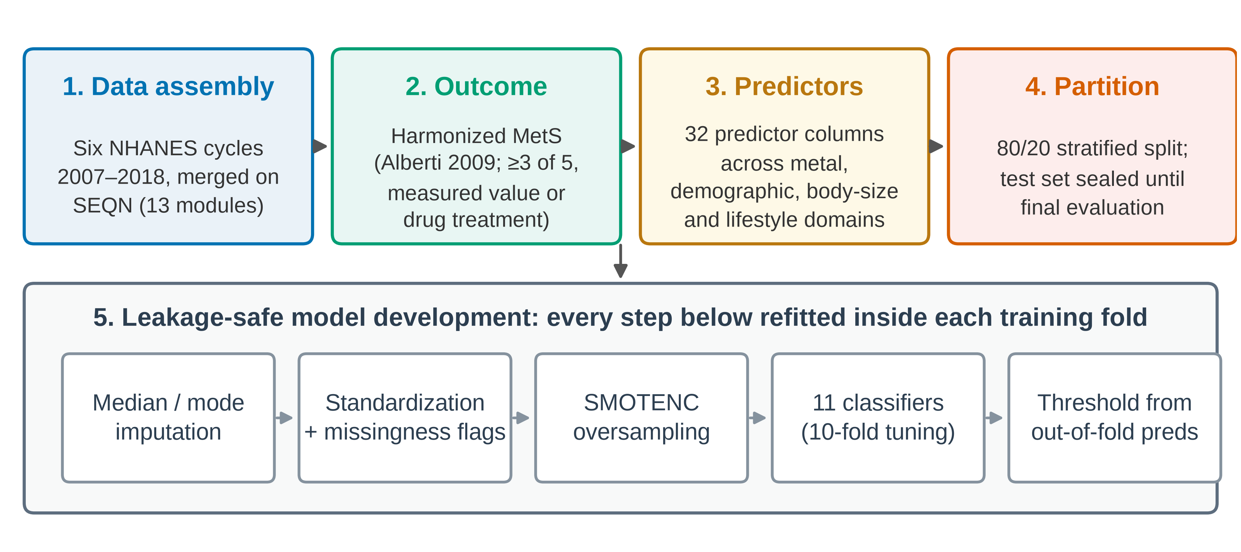
Figure S1. Analysis pipeline. Stages 1–4 are performed once on the cohort. Every step in stage 5 is refitted independently inside each training fold during cross-validation, and inside the training partition alone for the final models, so that no quantity estimated from held-out data can influence a model later scored on it.
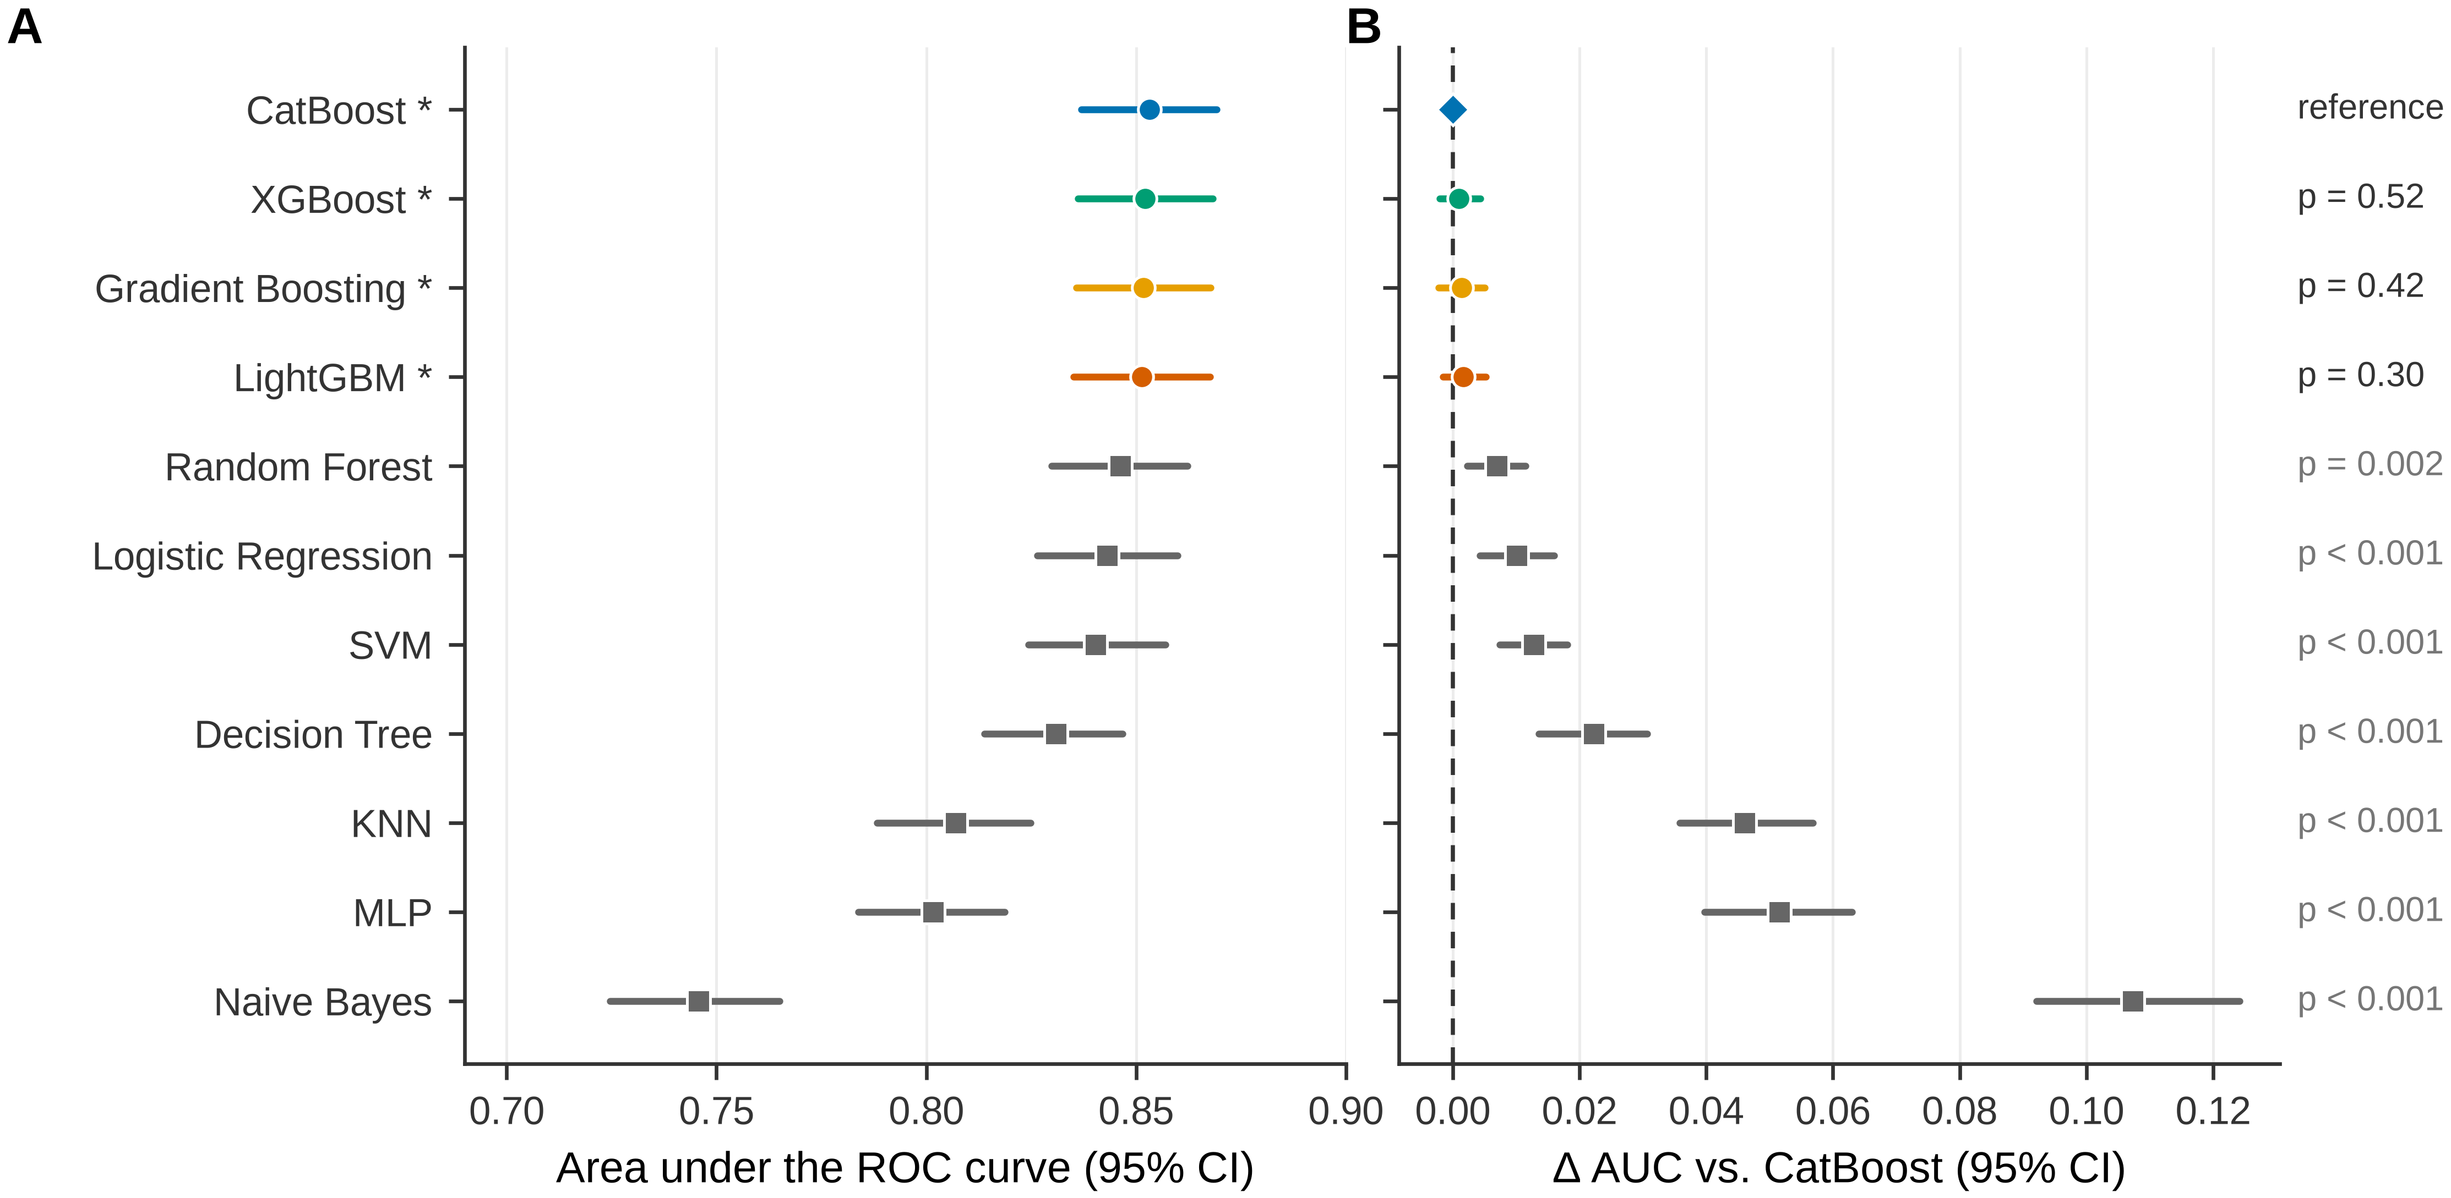
Figure S2. Model discrimination and pairwise comparison against CatBoost. (A) AUROC with bootstrap 95% confidence intervals. (B) Difference in AUROC from CatBoost, with a paired-bootstrap 95% confidence interval (the same resampled participants scored under both models) and the DeLong p-value; intervals crossing zero indicate models that cannot be distinguished from CatBoost. Using unpaired intervals from panel A for these comparisons would overstate the uncertainty, because all models are scored on the same participants.
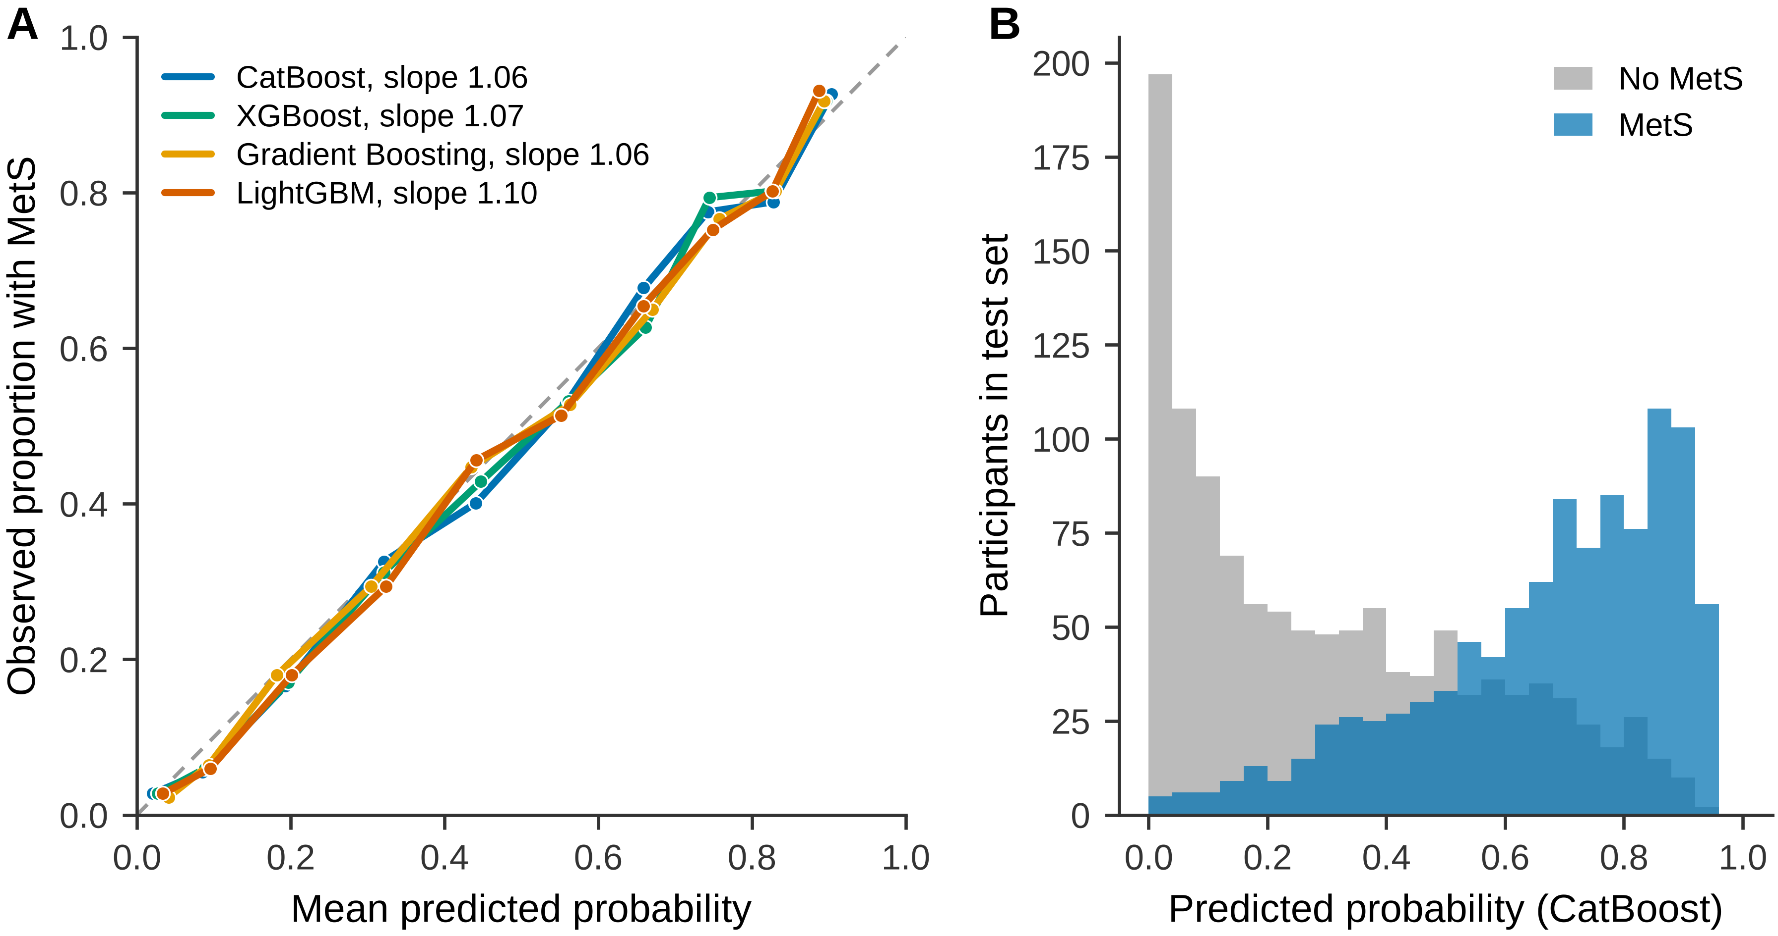
Figure S3. Calibration on the held-out test partition. (A) Calibration curves for the four leading models using ten quantile-based bins, with calibration slopes in the legend; the diagonal denotes perfect calibration. (B) Distribution of predicted probabilities from CatBoost by true outcome status.
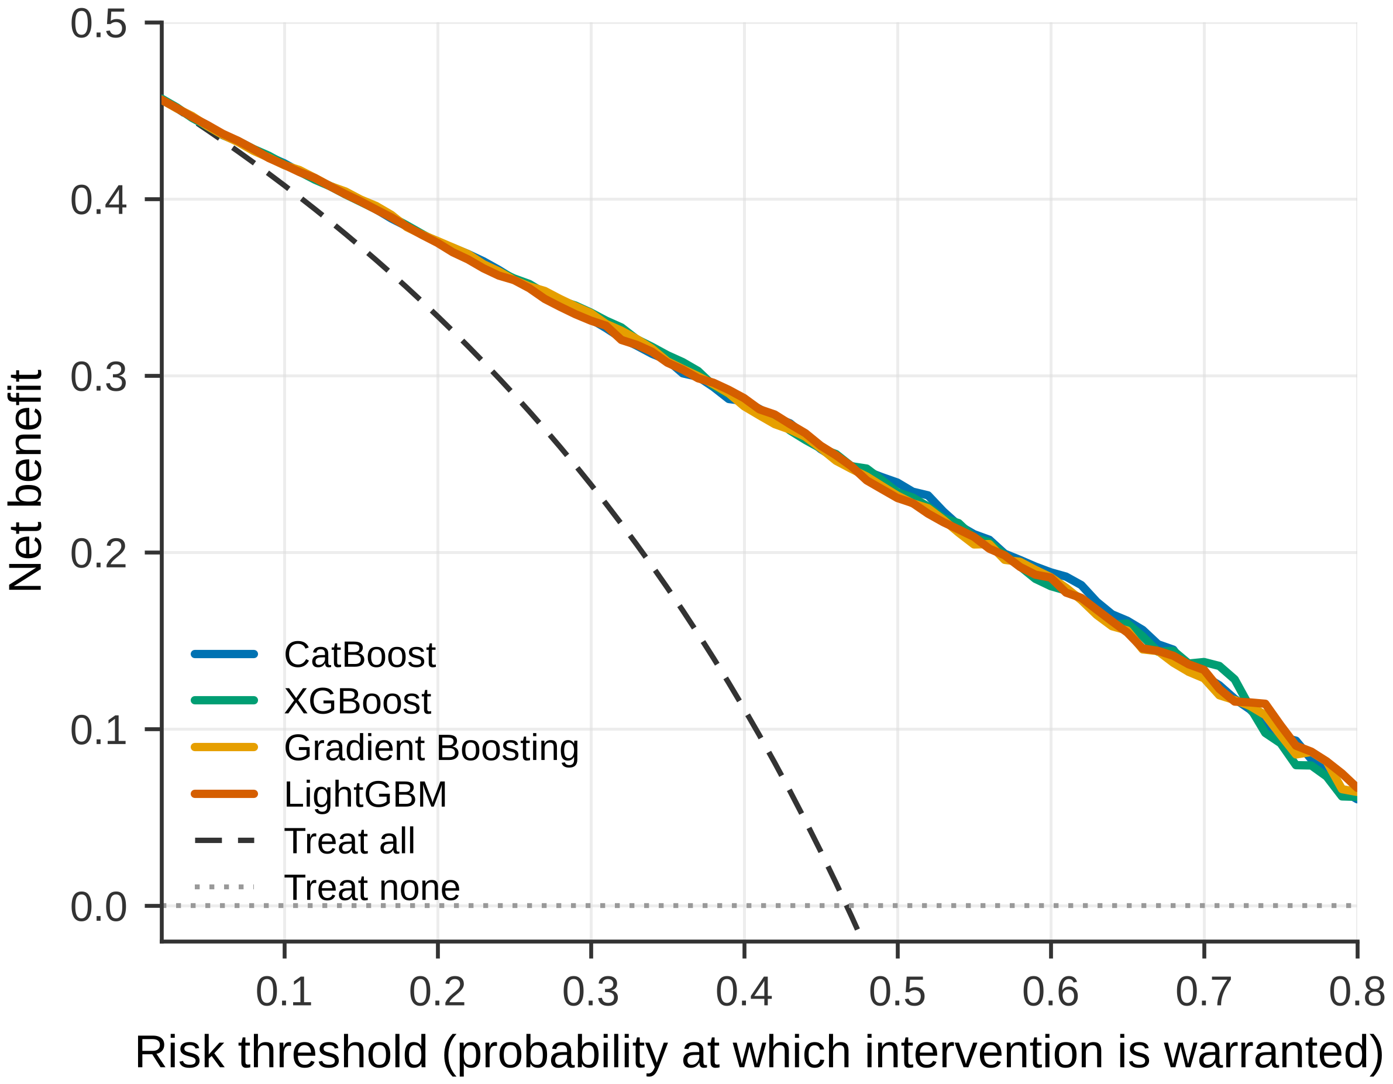
Figure S4. Decision-curve analysis on the held-out test partition. Net benefit is plotted against the risk threshold (2% to 80%) at which intervention would be considered warranted, for the four leading models and for the treat-all and treat-none reference strategies.
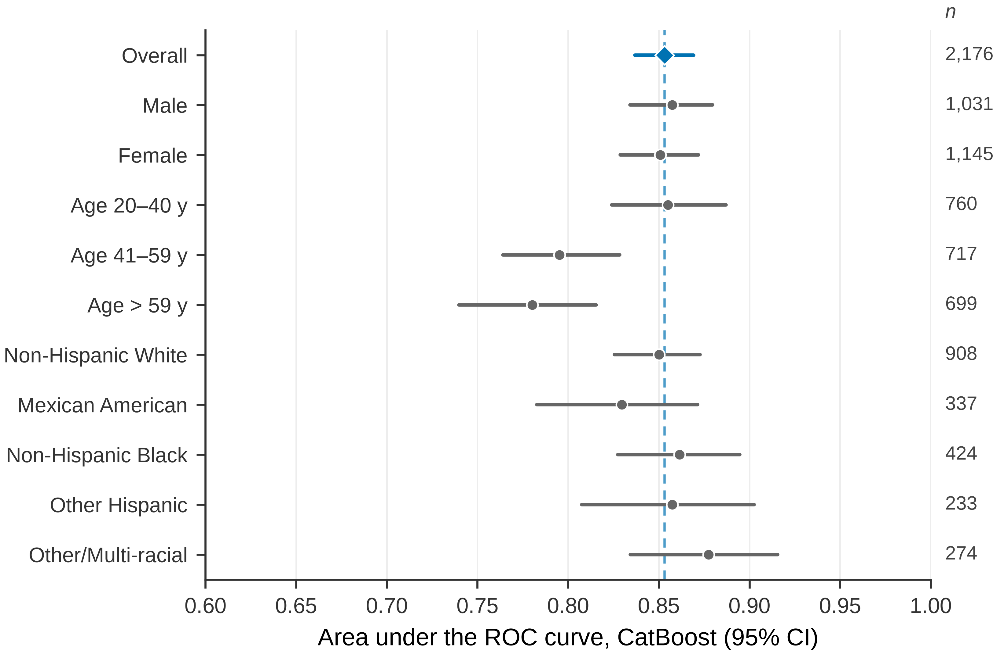
Figure S5. Discrimination of the CatBoost model within subgroups of the held-out test partition, with bootstrap 95% confidence intervals from 1,000 resamples. The dashed vertical line marks the overall test-set AUROC and subgroup sizes are given at the right. Age groups are tertiles of the test-partition age distribution. Because every subgroup is nested within the overall sample, these intervals are not independent of the overall estimate and overlap with it should not be read as a significance test. Subgroup calibration is reported in Table S6.

