Observational Study

Mendelian randomization study of remnant cholesterol in relation to non-alcoholic fatty liver disease
Alireza Soleymani Tª, Mahdi Akbarzadeh^{b}, Danial Habibi^{c,}*
Abstract
Although observational data suggest a relationship between remnant cholesterol (RC) and non-alcoholic fatty liver disease (NAFLD), there remain questions about causality. RC is the cholesterol carried by triglyceride-rich lipoproteins and their remnants, and the liver is both the source of these particles and the organ that stores their triglyceride. Mendelian randomization (MR) is a method that uses genetic variants as instruments for making causal inferences about an exposure and an outcome. For the exposure variable, we selected 52 independent genome-wide significant variants for RC from a UK Biobank GWAS of 115,082 participants. We then applied GWAS summary statistics for NAFLD from 3 datasets: Ghodsian et al (8,434 cases and 770,180 controls), Fairfield et al (4,761 cases and 373,227 controls) and FinnGen release 5 (894 cases and 217,898 controls). Genetically predicted RC showed no association with NAFLD (Ghodsian: OR = 1.045, 95% CI: 0.864–1.265, P = .650; Fairfield: OR = 0.999, 95% CI: 0.776–1.286, P = .994; FinnGen: OR = 0.848, 95% CI: 0.561–1.281, P = .433). There was substantial heterogeneity [Q_{IVW} = 204.8, P = 1.4 × 10⁻²¹; I² = 77.1%; I²_{GX} = 99.35%] but no evidence of directional pleiotropy [MR-Egger intercept = 0.0112, P = .261] in the first dataset. This finding was consistently supported across multiple analytical methods, including MR-PRESSO (OR = 1.023, 95% CI: 0.914–1.145, P = .695), and the same instruments were strongly associated with coronary artery disease as a positive control (OR = 1.579, 95% CI: 1.378–1.809). We found no strong evidence of a causal association between genetically predicted RC and NAFLD under the current study design; however, moderate effects cannot be excluded.
Abbreviations: CAD = coronary artery disease, CI = confidence interval, GWAS = genome-wide association study, IVW = inverse variance weighted, LD = linkage disequilibrium, LDL = low-density lipoprotein, MASLD = metabolic dysfunction-associated steatotic liver disease, MR = Mendelian randomization, NAFLD = non-alcoholic fatty liver disease, OR = odds ratio, RC = remnant cholesterol, SNP = single nucleotide polymorphism, STROBE-MR = Strengthening the Reporting of Observational Studies in Epidemiology Using Mendelian Randomization, TSMR = two-sample Mendelian randomization.
Keywords: Association, Mendelian randomization, Non-alcoholic fatty liver disease, Remnant cholesterol

The authors have no funding and conflicts of interest to declare.  The datasets generated during and/or analyzed during the current study are publicly available; the analysis code is available at https://github.com/AliiReezaa/remnant-cholesterol-nafld-mr.  No additional ethics approval was needed because all data in the study were previously collected, analyzed, and published.  Supplemental Digital Content is available in the online version of this article (Supplemental Digital Content 1–3). | ª Graduate School of Engineering Science and Technology, National Yunlin University of Science and Technology, Yunlin, Taiwan.  ^{b} Research Institute for Endocrine Sciences, Shahid Beheshti University of Medical Sciences, Tehran, Iran.  ^{c} Department of Biostatistics and Epidemiology, School of Public Health, Babol University of Medical Sciences, Babol, Iran.  *Correspondence: Danial Habibi, Department of Biostatistics and Epidemiology, School of Public Health, Babol University of Medical Sciences, Babol, Iran (e-mail: [to be added by the corresponding author]).

1. Introduction
Non-alcoholic fatty liver disease (NAFLD), also described as metabolic dysfunction-associated steatotic liver disease (MASLD), is the most common chronic liver condition worldwide, affecting roughly a quarter to a third of adults.^{[1,2]} It is defined by the accumulation of fat in the liver in the absence of other causes of liver disease and spans a spectrum from simple steatosis to steatohepatitis, fibrosis, and cirrhosis.^{[3,4]} Its pathogenesis is closely tied to obesity, insulin resistance, and dyslipidemia, and intrahepatic fat, more than visceral fat, tracks the metabolic complications of obesity.^{[5]} Despite this burden, the causal contribution of individual circulating lipid fractions to liver fat remains poorly defined.
Remnant cholesterol (RC) is the cholesterol content of triglyceride-rich lipoproteins, that is, very low-density lipoprotein and intermediate-density lipoprotein remnants in the fasting state, together with chylomicron remnants after a meal.^{[6,7]} Because these particles are not removed efficiently by the low-density lipoprotein (LDL) receptor, they can enter the arterial intima, and RC has emerged as a cardiovascular risk factor that is partly independent of LDL cholesterol and apolipoprotein B.^{[8]} Genetic and observational evidence together support a causal role of RC in ischemic heart disease.^{[9]} The liver is the origin of very low-density lipoprotein. Fatty acids reaching the liver from adipose tissue, de novo lipogenesis, and the diet supply both the triglyceride stored in hepatocytes and the triglyceride secreted in lipoproteins,^{[10]} so that RC and hepatic fat share a metabolic source and are plausibly linked in both directions.
In observational studies, higher RC has been repeatedly associated with prevalent and incident NAFLD, including in non-obese individuals and in analyses of cumulative exposure,^{[11–13]} and with insulin resistance among patients with metabolic dysfunction-associated fatty liver disease.^{[14]} Such associations are particularly vulnerable to confounding and reverse causation. Adiposity, insulin resistance, diet, alcohol use, and physical inactivity influence both RC and liver fat, while hepatic steatosis itself increases the secretion of triglyceride-rich lipoproteins. Conventional analyses therefore cannot show whether elevated RC contributes to fatty liver or is mainly one of its consequences.
The genetic architecture of NAFLD adds a further complication. Variants in PNPLA3, TM6SF2, GCKR, and TRIB1 influence hepatic lipid handling and are associated with liver fat,^{[15–18]} and some of these loci also change circulating lipoproteins, not always in the expected direction. The TM6SF2 variant that increases liver fat, for example, lowers circulating lipids because it impairs the secretion of triglyceride-rich particles from the liver.^{[16]} Two Mendelian randomization (MR) studies have addressed RC and fatty liver with conflicting results: a two-sample analysis of RC with several cardiometabolic outcomes found no causal association with NAFLD,^{[19]} whereas a one-sample analysis in the Taiwan Biobank reported very large positive effects, but with exposure and outcome drawn from the same cohort and a single ancestry.^{[20]} Because genetic instruments for RC are likely to include variants that act on the liver itself, an MR analysis of this exposure and outcome pair is unusually exposed to horizontal pleiotropy and requires explicit outlier handling.
MR uses genetic variants as instrumental variables to estimate the causal effect of an exposure on an outcome, and it is less prone to confounding and reverse causation because alleles are allocated at conception.^{[21,22]} We employed two-sample MR to investigate the causal impact of genetically predicted RC on NAFLD, using 3 large NAFLD GWAS datasets, a range of pleiotropy-robust estimators, explicit outlier and influence diagnostics, and a positive control outcome, and we examined which effect sizes the available data can and cannot exclude.
2. Method
2.1. Study design and data sources
This study utilized a two-sample Mendelian randomization (TSMR) design, relying on GWAS summary-level data, to explore the potential causal link between RC (as the exposure) and NAFLD (as the outcome) in individuals of European ancestry (Fig. 1). The design rests on 3 assumptions: the genetic instruments are associated with RC (relevance), they are independent of confounders of the RC and NAFLD relation (independence), and they affect NAFLD only through RC (exclusion restriction). The analysis adhered to the STROBE-MR reporting guidelines^{[23]} and followed current recommendations for MR investigations;^{[24]} it was not pre-registered.
For the exposure variable, we used summary statistics for RC from the GWAS by Richardson et al,^{[25]} measured by nuclear magnetic resonance (Nightingale Health platform) in up to 115,082 participants of European ancestry from the UK Biobank.^{[26,27]} Values were inverse rank-normalized, so effect sizes are expressed per 1-SD higher RC, and associations were estimated with BOLT-LMM.^{[28]} Data on the outcome, NAFLD, were sourced from 3 European-ancestry GWAS: the electronic health record meta-analysis by Ghodsian et al (GWAS Catalog GCST90091033), which combined eMERGE, FinnGen, the UK Biobank, and the Estonian Biobank and included 8,434 cases and 770,180 controls;^{[29]} the UK Biobank GWAS by Fairfield et al (GCST90054782), which defined cases with diagnostic codes recommended in consensus guidelines and included 4,761 cases and 373,227 controls;^{[18]} and FinnGen release 5 (finn-b-NAFLD), which included 894 cases and 217,898 controls.^{[30]} The term NAFLD is used because the source studies defined cases under that name; these cases largely overlap with MASLD under the 2023 nomenclature.^{[4]} The 3 outcome datasets are not fully independent, and the UK Biobank contributes to both the exposure and 2 of the outcome datasets (section 2.3).
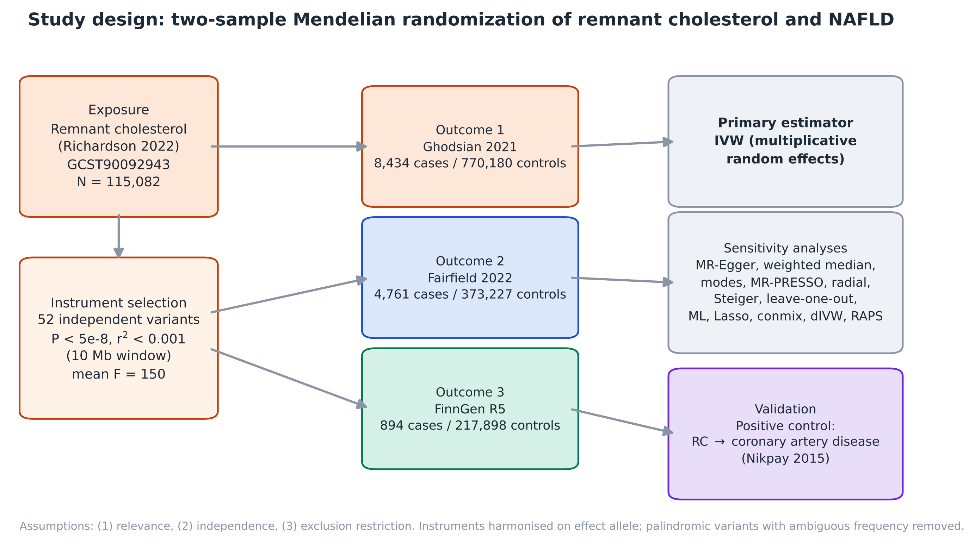
Figure 1. Two-sample Mendelian randomization study of remnant cholesterol in relation to non-alcoholic fatty liver disease. Fifty-two independent variants for remnant cholesterol were harmonized with 3 NAFLD GWAS datasets. The inverse variance weighted estimator was the primary analysis, followed by pleiotropy-robust and outlier-robust sensitivity analyses. The same instruments were tested against coronary artery disease as a positive control.
2.2. Selection of SNPs associated with remnant cholesterol
We implemented several quality control procedures to ensure the reliability of the selected SNPs. We began by applying a genome-wide significance threshold of P < 5 × 10⁻⁸, which yielded 8,873 variants after removal of duplicated identifiers. To retain only independent instruments, we performed linkage disequilibrium (LD) clumping with r² < 0.001 and a clumping window of 10,000 kb, using the European reference panel from the 1000 Genomes Project (Phase 3).^{[31]} Within each LD block, only the SNP with the lowest P value was retained, which resulted in 52 independent SNPs; the 1,280 variants absent from the reference panel could not be clumped. In cases where a target SNP was unavailable in an outcome dataset, proxy variants in high LD (r² ≥ 0.8 within 250 kb) were used, and 3 variants without a proxy (rs7534572, rs574454081, and rs532754706) were dropped from the Ghodsian and FinnGen analyses.
Instrument strength was evaluated using the F statistic (F = β²/SE²), and we verified that all SNPs had F-values above 10.^{[32]} To strengthen robustness, we conducted additional sensitivity analyses excluding SNPs with F statistics < 30 and SNPs with a minor allele frequency < 0.01. During harmonization, effects were aligned to the RC-increasing allele, and ambiguous palindromic SNPs with intermediate allele frequencies (between 0.42 and 0.58) were excluded to avoid strand alignment errors (1 SNP, rs1293261). Finally, Steiger filtering was applied to assess directionality by removing SNPs that explained more variance in the outcome than in the exposure.^{[33]} Because the APOE region is strongly pleiotropic, the analysis was also repeated after excluding it. An earlier analysis of these data used a different instrument set whose clumping settings were not recorded; we reconstructed it from its variant list and report it as a sensitivity analysis (Supplemental Digital Content 1).
2.3. Mendelian randomization analysis
For the univariable MR analysis, we primarily used the inverse variance weighted (IVW) method within a multiplicative random-effects framework.^{[34]} Given the potential for pleiotropy or the inclusion of invalid instruments to bias IVW estimates, we applied a range of additional methods to strengthen causal inference. These included MR-Egger regression,^{[35]} the weighted median estimator,^{[36]} and both simple and weighted mode-based approaches.^{[37]} To further reinforce the robustness of our results, we incorporated maximum likelihood estimation, MR-Lasso,^{[38]} the contamination mixture model,^{[39]} debiased IVW,^{[40]} and robust adjusted profile score (MR-RAPS) with Tukey and Huber loss functions,^{[41]} which relax different assumptions about the instruments.^{[42]} Effect estimates are reported as odds ratios (OR) of NAFLD per 1-SD higher genetically predicted RC with 95% confidence intervals (CI), and tests were two-sided with α = .05; no adjustment was made for multiple testing because a single relation was examined in 3 datasets.
We also carried out extensive sensitivity analyses to assess the reliability of our findings. Heterogeneity among genetic instruments was evaluated using Cochran's Q statistic and the I² index for IVW, as well as Rücker's Q test in the MR-Egger framework,^{[43]} with P values above .05 suggesting low heterogeneity, and instrument strength for MR-Egger was assessed with I²_{GX}.^{[44]} To detect horizontal pleiotropy, we used both the MR-Egger intercept and the MR-PRESSO global test,^{[45]} while potential outlier SNPs were identified using MR-PRESSO (10,000 simulations) and radial MR.^{[46]} Influential genetic variants were further examined using Cook's distance (threshold 4/n) and studentized residuals, and effect estimates were recalculated after excluding outliers. Leave-one-out analyses were performed to determine whether any single SNP disproportionately influenced the overall result, and funnel plots were inspected for asymmetry.
The minimum detectable OR with 80% power at α = .05 was calculated from the observed standard error of the IVW estimate in each dataset.^{[47,48]} Because the exposure GWAS and parts of the outcome data come from the UK Biobank, the bias from sample overlap was approximated as the overlap proportion divided by the F statistic.^{[49]} As a positive control, the same 52 instruments were tested against coronary artery disease (CAD) using the CARDIoGRAMplusC4D 1000 Genomes-based meta-analysis (60,801 cases and 123,504 controls; GWAS Catalog GCST003116),^{[50]} an association known to exist for RC;^{[9]} this analysis was added after the NAFLD analysis and was not pre-registered.
The primary analyses were conducted with custom Python code implementing the algorithms of the "TwoSampleMR" package,^{[51]} validated against R output of a previous analysis of the same data. MR-PRESSO, the extended estimators ("MendelianRandomization"^{[52]} and "mr.raps"), radial MR ("RadialMR"), and the positive control ("TwoSampleMR") were run in R 4.4.3, and figures were drawn with matplotlib. Software versions, settings, and the run history are given in Supplemental Digital Content 1.
3. Results
3.1. Main results
This analysis investigated a potential causal link between genetically predicted RC and NAFLD using Mendelian randomization. Following established criteria (genome-wide significance threshold of P < 5 × 10⁻⁸ and clumping for independence), 52 SNPs associated with RC were selected as instrumental variables, which jointly explained 6.5% of the variance in RC. The strength of these instruments was confirmed by high F statistics (all F > 10; for the 48 SNPs retained in the Ghodsian data, mean 150, range: 29.8–1598, overall F = 159). Data harmonization retained 48, 51, and 48 SNPs for the Ghodsian, Fairfield, and FinnGen datasets, respectively. The Steiger directionality test removed 3, 4, and 13 SNPs in the 3 datasets without changing the conclusion (Supplemental Digital Content 2).
The IVW analysis found no statistically significant association between RC and the risk of NAFLD in any dataset [Ghodsian: OR = 1.045, 95% CI: 0.864–1.265, P = .650; Fairfield: OR = 0.999, 95% CI: 0.776–1.286, P = .994; FinnGen: OR = 0.848, 95% CI: 0.561–1.281, P = .433; Table 1]. The weighted median, MR-Egger, and mode-based estimators were likewise nonsignificant, although point estimates differed in direction from the IVW estimate in some datasets, a pattern consistent with imprecision rather than a coherent effect. There was substantial heterogeneity among instruments [Q_{IVW} = 204.8, P = 1.4 × 10⁻²¹; Q_{Egger} = 199.2, P = 5.8 × 10⁻²¹; I² = 77.1%; I²_{GX} = 99.35% for the Ghodsian data; I² = 80.1% and 55.7% for the Fairfield and FinnGen data] but no evidence of directional pleiotropy [MR-Egger intercept = 0.0112, P = .261; 0.0211, P = .118; and −0.0013, P = .952, respectively]. The MR-PRESSO global test was significant in all 3 datasets (P < .0001), which indicates the presence of outlying variants.
Table 1. Mendelian randomization estimates of NAFLD per 1-SD higher genetically predicted remnant cholesterol.
Method | Ghodsian OR (95% CI) | P | Fairfield OR (95% CI) | P | FinnGen OR (95% CI) | P
IVW | 1.045 (0.864–1.265) | .650 | 0.999 (0.776–1.286) | .994 | 0.848 (0.561–1.281) | .433
Weighted median | 1.108 (0.954–1.287) | .178 | 1.022 (0.832–1.256) | .833 | 1.082 (0.700–1.673) | .722
MR-Egger | 0.901 (0.654–1.240) | .524 | 0.754 (0.492–1.155) | .201 | 0.863 (0.426–1.745) | .683
Simple mode | 1.006 (0.791–1.280) | .960 | 0.792 (0.565–1.110) | .182 | 0.839 (0.387–1.816) | .658
Weighted mode | 1.071 (0.936–1.226) | .321 | 0.983 (0.803–1.203) | .867 | 0.900 (0.598–1.355) | .617
IVW after MR-PRESSO outlier removal | 1.023 (0.914–1.145) | .695 | 1.009 (0.871–1.169) | .908 | 0.839 (0.624–1.127) | .250
IVW after Steiger filtering | 1.081 (0.943–1.238) | .263 | 0.996 (0.865–1.146) | .951 | 0.949 (0.706–1.275) | .727
IVW excluding the APOE region | 1.073 (0.853–1.349) | .548 | 1.014 (0.748–1.374) | .930 | 0.859 (0.539–1.369) | .523
OR = odds ratio; CI = confidence interval; IVW = inverse variance weighted (multiplicative random effects). The first 5 rows use 48, 51, and 48 SNPs; MR-PRESSO-corrected estimates (R package) use 44, 48, and 46 SNPs, and Steiger-filtered estimates use 45, 47, and 35 SNPs.
MR-PRESSO identified rs112875651 (TRIB1 region) and rs58542926 (TM6SF2) as outliers in every dataset, rs4665972 (near GCKR) in the Ghodsian and Fairfield data, and rs2326077 in the Ghodsian data, and radial MR flagged 8, 7, and 3 SNPs, a superset of these. The TM6SF2 variant was the only one with a strong effect opposite in direction to the others (Fig. 2 and Supplemental Digital Content 2). Following the removal of the outliers, the IVW analysis remained null [Ghodsian: OR = 1.023, 95% CI: 0.914–1.145, P = .695; Fairfield: OR = 1.009, 95% CI: 0.871–1.169, P = .908; FinnGen: OR = 0.839, 95% CI: 0.624–1.127, P = .250], with much narrower intervals in the first two. No leave-one-out estimate reached P < .05 (OR ranges 0.991–1.121, 0.932–1.123, and 0.735–0.966), excluding SNPs with F statistics < 30 did not materially alter the effect estimates, and the 11 additional estimators gave odds ratios between 1.02 and 1.06 in the Ghodsian data, 0.99 and 1.02 in the Fairfield data, and 0.84 and 1.06 in the FinnGen data, all compatible with the null (Fig. 3). With the reconstructed earlier instrument set, the FinnGen estimate moved to OR = 0.752 (95% CI: 0.562–1.006, P = .055), which remained nonsignificant (Supplemental Digital Content 1).
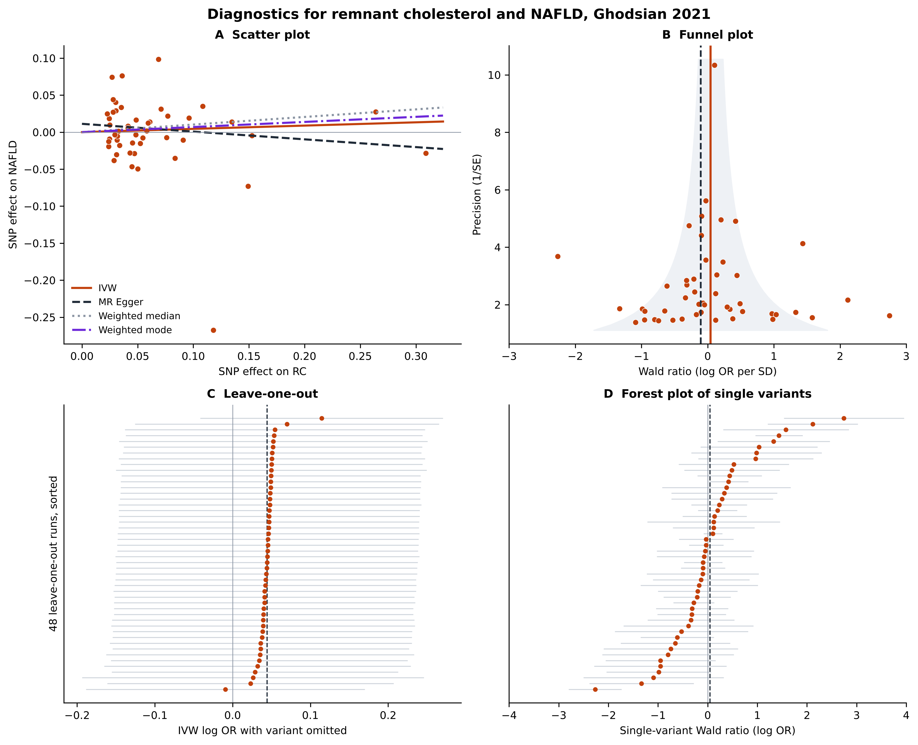
Figure 2. Assesses the potential influence of individual genetic variants (SNPs) in the Ghodsian dataset. Panel A: scatter plot of SNP effects on remnant cholesterol and on NAFLD with the IVW, MR-Egger, weighted median, and weighted mode fits; the near-zero slopes indicate no association. Panel B: funnel plot of single-SNP Wald ratios, in which the scatter outside the funnel reflects heterogeneity driven by a few hepatic loci. Panel C: leave-one-out analysis, showing that no single SNP changes the estimate materially. Panel D: forest plot of the single-SNP Wald ratios. Corresponding figures for the Fairfield and FinnGen datasets are in Supplemental Digital Content 2.
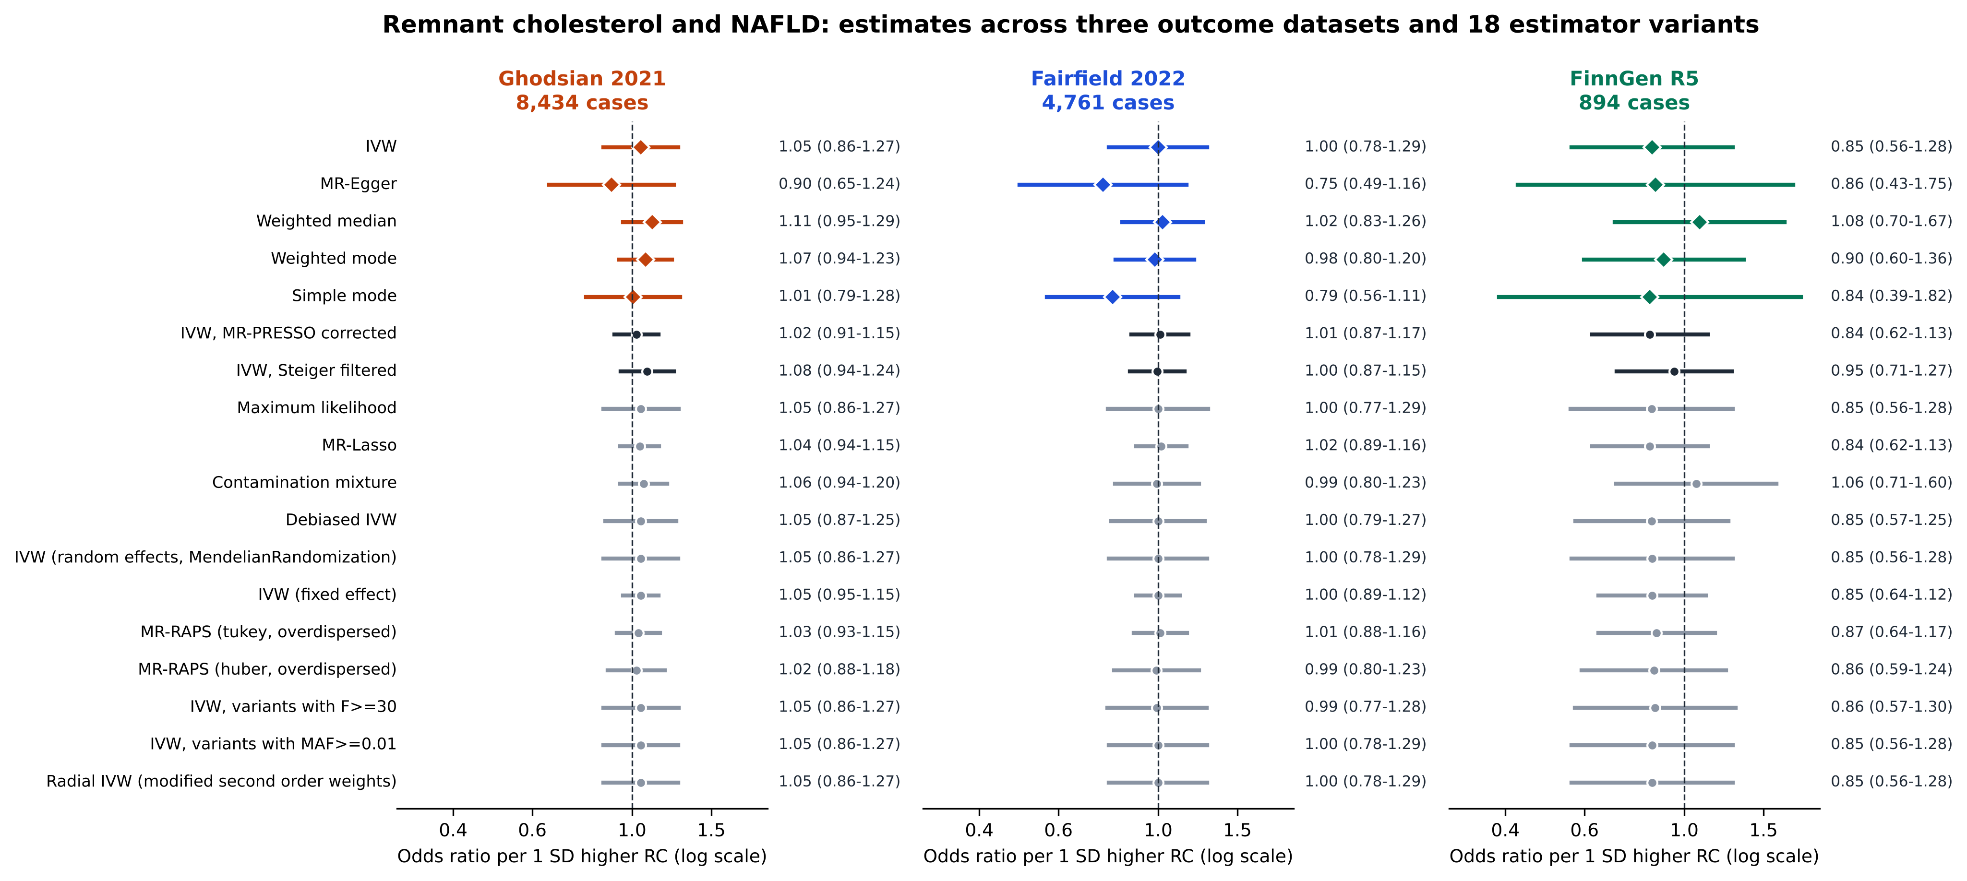
Figure 3. Forest plot of the association between genetically predicted remnant cholesterol and NAFLD in 3 outcome datasets. Diamonds are the 5 primary estimators using all SNPs, black circles are IVW sensitivity analyses (MR-PRESSO-corrected and Steiger-filtered), and gray circles are the extended estimators. Bars are 95% confidence intervals on a log scale and the dashed line marks no association. Odds ratios are rounded to 2 decimals in the figure.
With 80% power at α = .05, the minimum detectable OR per 1-SD was 1.31 in the Ghodsian data, 1.43 in the Fairfield data, and 1.80 in the FinnGen data (Figure S3, Supplemental Digital Content 2), and, with an overall F statistic of 159, the bias from complete sample overlap would be at most about 0.6% of the confounded association. In contrast to NAFLD, the same instruments were strongly associated with coronary artery disease in the positive control analysis [IVW OR = 1.579, 95% CI: 1.378–1.809, P = 5.2 × 10⁻¹¹; weighted median OR = 1.475; MR-Egger OR = 1.871; outlier-corrected OR = 1.492], with 49 of the 52 SNPs available (Fig. 4 and Tables S7 and S16, Supplemental Digital Content 2).
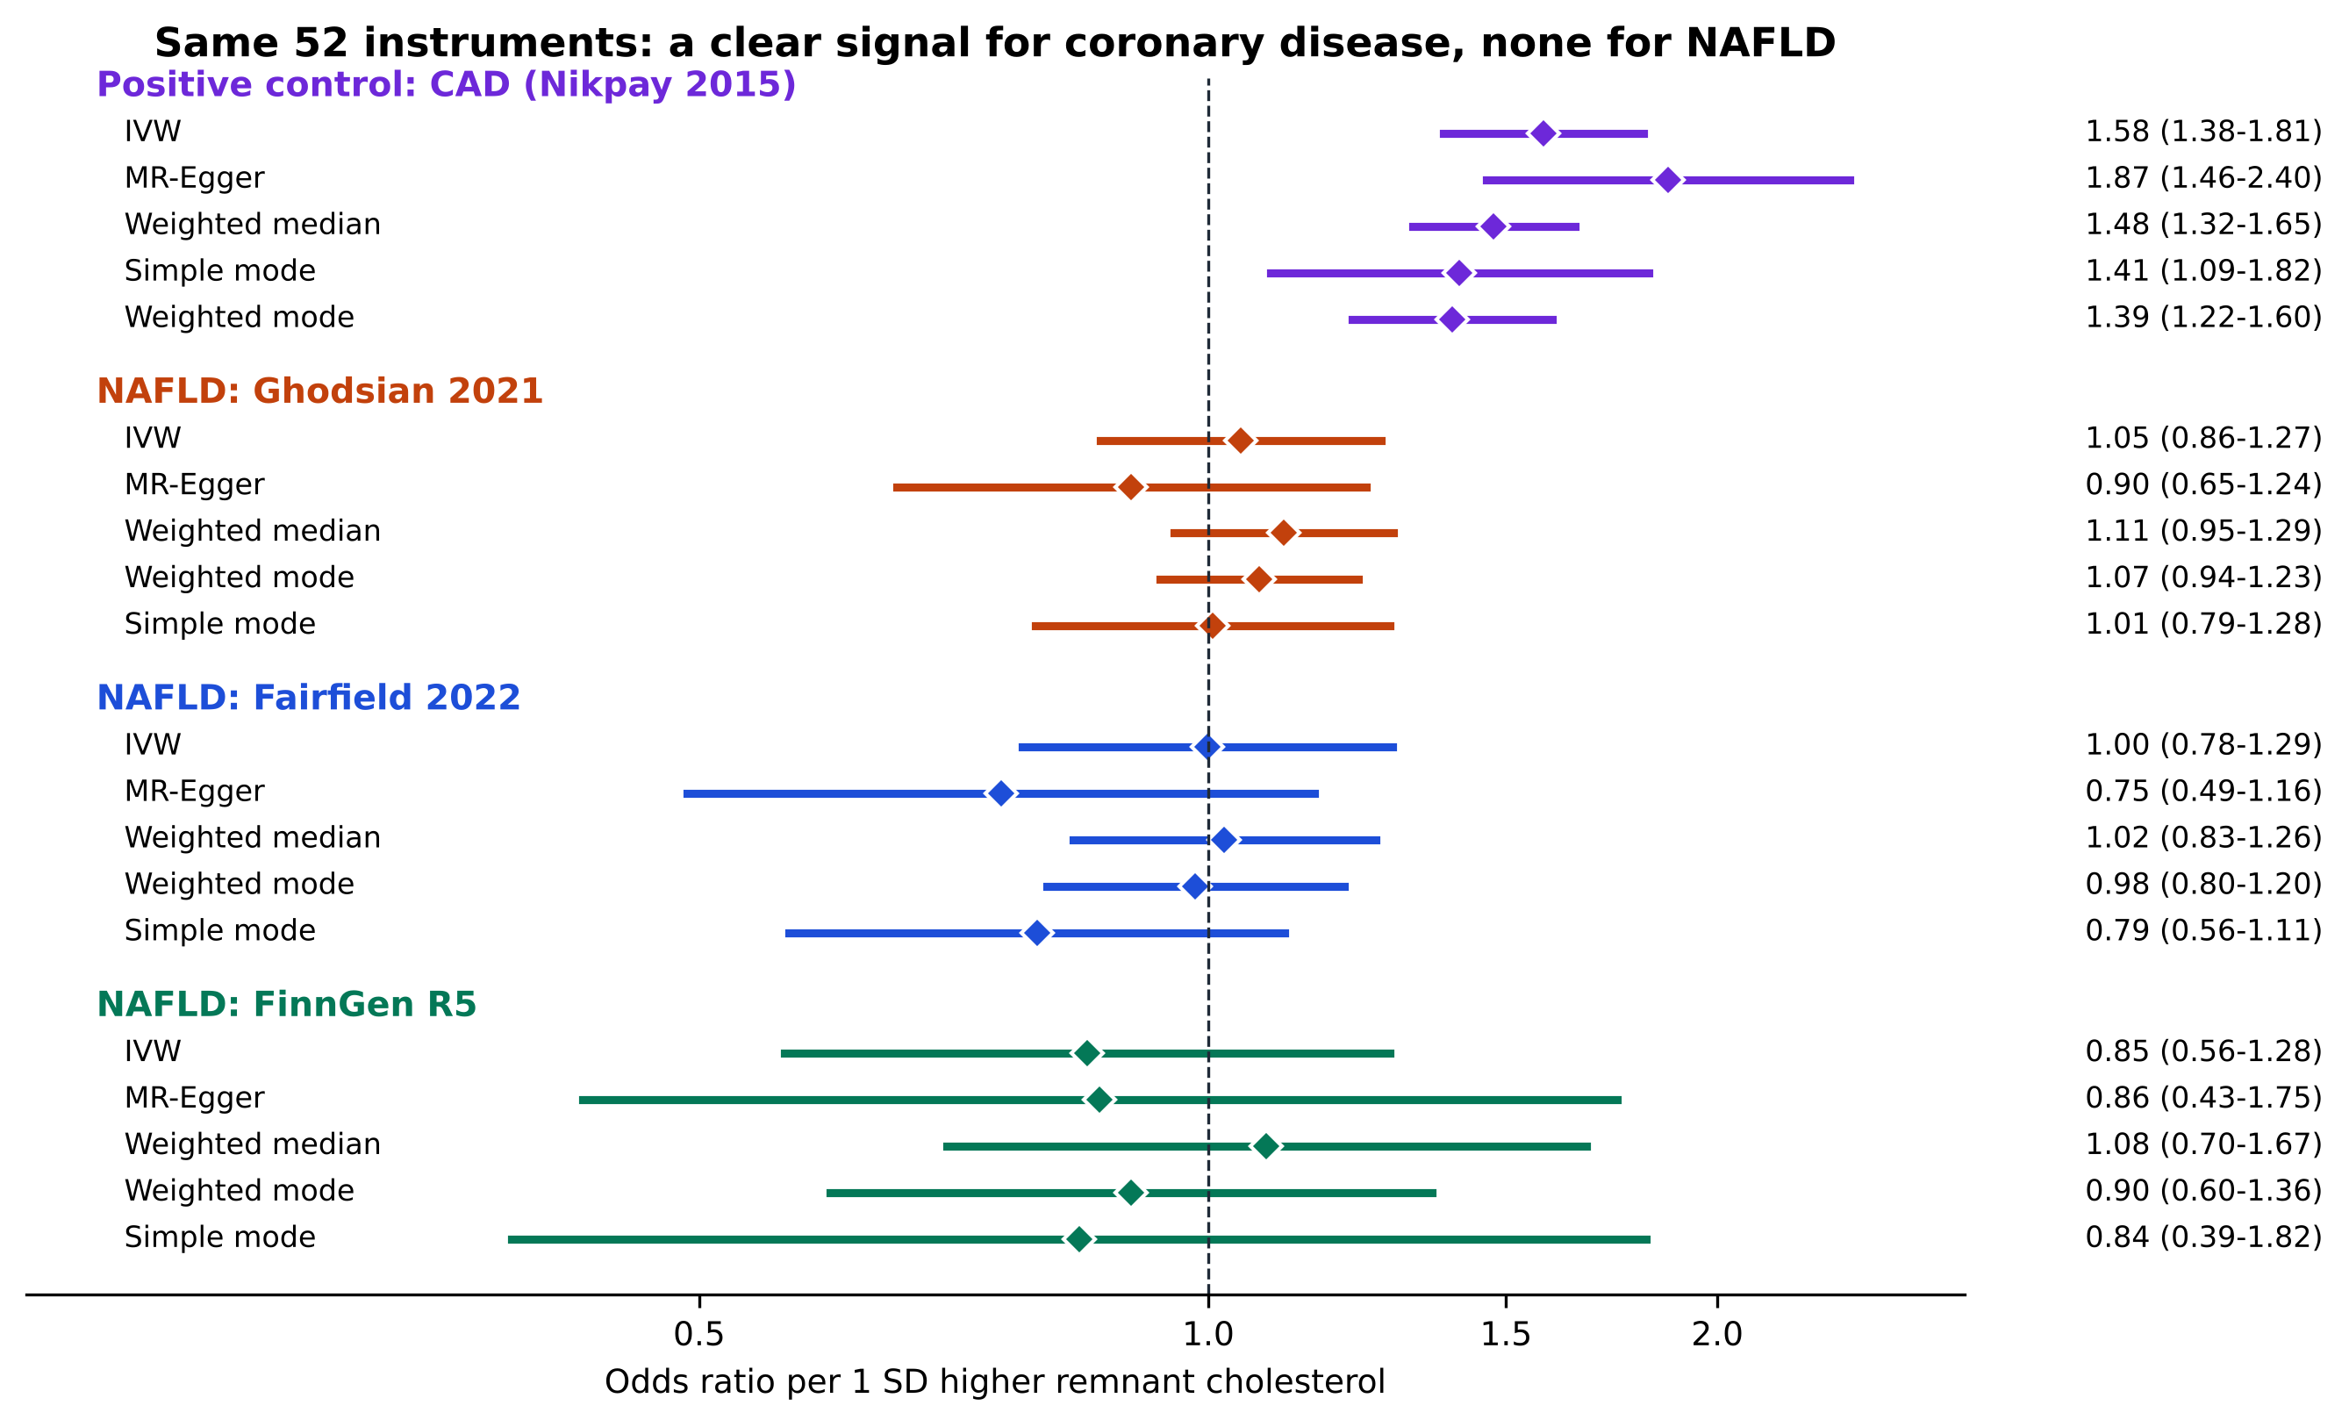
Figure 4. The same 52 instruments show a clear association with coronary artery disease and none with NAFLD. Odds ratios per 1-SD higher genetically predicted remnant cholesterol for the positive control (coronary artery disease, purple) and for NAFLD in the 3 datasets, from the IVW, MR-Egger, weighted median, and mode-based estimators.
4. Discussion
The relationship between circulating triglyceride-rich lipoproteins and liver fat is biologically plausible but, to date, unsettled. In this study of up to 14,089 NAFLD cases and more than 1.3 million controls from 3 overlapping datasets, we found no strong evidence of a causal effect of genetically predicted RC on NAFLD; however, given the limited precision of the smallest dataset, moderate effects cannot be excluded. The IVW odds ratios were close to the null in all 3 datasets, with 95% confidence intervals that excluded odds ratios above approximately 1.3 per SD in the Ghodsian and Fairfield data, and none of the sensitivity analyses produced a significant result.
Several explanations may account for the null finding, including a true absence of effect, residual horizontal pleiotropy at hepatic loci, limited statistical power, misclassification of cases, and the restricted ancestry of the study populations; these limitations are discussed below. Our result agrees with the earlier two-sample MR by Guan et al, which found no causal association of RC with NAFLD using essentially the same exposure data.^{[19]} The present study adds 3 outcome datasets rather than one, systematic reporting of outliers, heterogeneity, and influence, a battery of additional estimators, a positive control, and an explicit power assessment; because the exposure instruments are shared, however, it is not an independent confirmation of the earlier exposure analysis. Our result disagrees with the one-sample MR in the Taiwan Biobank, which reported odds ratios above 6 per mmol/L.^{[20]} Exposure and outcome in that study came from the same cohort, which biases one-sample MR toward the confounded observational association, the instruments were derived in a different ancestry, and its own sensitivity tests showed significant heterogeneity. Our findings also contrast with the consistent positive observational associations between RC and NAFLD.^{[11–13]} A null MR result alongside positive observational results is compatible with confounding by adiposity and insulin resistance, or with reverse causation in which hepatic fat increases the secretion of triglyceride-rich lipoproteins,^{[10]} although we did not test the reverse direction.
The heterogeneity we observed was driven by a small number of variants, several at loci with a known hepatic role. The TM6SF2 variant (rs58542926) is the clearest example: its RC-raising allele is associated with a lower risk of NAFLD in our data, which fits the biology of the locus, since TM6SF2 influences the secretion of triglyceride-rich lipoproteins from the liver, so that reduced function retains fat in hepatocytes while lowering circulating lipoproteins.^{[16]} Variants in the TRIB1 and GCKR regions pointed in the opposite direction and have been linked to liver fat.^{[17,18]} Variants that act in the liver may influence NAFLD through routes other than circulating RC, which would violate the exclusion restriction, and opposing directions of such variants may cancel in the IVW estimate. For this reason we examined the effect of removing them, and the MR-PRESSO-corrected, Steiger-filtered, MR-Lasso, contamination mixture, and MR-RAPS estimators, which down-weight or exclude such variants, were all null. The very high I²_{GX} (above 99%) indicates that regression dilution is not a concern for MR-Egger, but the intercept test has limited power when heterogeneity is this large,^{[53]} so directional pleiotropy cannot be excluded on the intercept alone.
This study has several limitations that could explain our null findings regarding the effect of RC on NAFLD. First, the statistical power to detect modest causal effects was limited: the minimum detectable OR with 80% power was 1.31, 1.43, and 1.80, so the null MR findings should be interpreted as no strong evidence of a large effect rather than definitive evidence of no causal effect. The FinnGen estimate, based on 894 cases, is the least informative, and it moved to OR = 0.752 (P = .055) when our earlier instrument set was used, which we interpret as the imprecision of a small dataset combined with a different set of variants, not as evidence of protection. Second, the 3 NAFLD datasets partly overlap (the UK Biobank contributes to 2 and FinnGen to 2), so they are not independent replications, and sample overlap with the exposure GWAS could bias estimates toward the observational association, although this bias is small given the strength of the instruments. Third, NAFLD cases were identified from health records or diagnostic codes, which favor diagnosed and more severe cases, and non-differential misclassification would be expected to bias estimates toward the null; imaging-based liver fat or histology would be more precise, and we could not examine fibrosis or steatohepatitis.
Fourth, RC is genetically correlated with triglycerides and other apolipoprotein B-containing lipoproteins, and we did not perform multivariable MR,^{[54,55]} so our results address the total effect of genetically predicted RC and cannot separate it from that of correlated lipid traits. Fifth, MR estimates the effect of lifelong differences in RC under a linear model, and it cannot exclude nonlinear effects or effects of short-term interventions. Sixth, all datasets are of European ancestry, so the results may not generalize to other populations. Seventh, the positive control supports instrument relevance but cannot exclude pleiotropic pathways specific to liver fat; it was added after the main analysis, and the CAD data are of mixed ancestry. Finally, the analyses were not pre-registered and used custom Python code, although the key MR-PRESSO and positive control results were confirmed with R packages.
Using genetic instruments for RC, we found no strong evidence of a causal association with NAFLD. The data make large effects unlikely in the two larger datasets, but small to moderate effects cannot be excluded, and these findings should therefore be considered inconclusive for such effects rather than definitive evidence of no effect. They do not support lowering RC specifically to prevent fatty liver, and they do not alter the case for treating RC for cardiovascular prevention, for which the same instruments show a clear effect. Future work should use larger imaging-based or histology-based liver fat GWAS, multivariable and drug-target MR to separate RC from triglycerides and apolipoprotein B, bidirectional analyses to test whether liver fat raises RC, and nonlinear MR in individual-level data.
Acknowledgments
We want to acknowledge the participants and investigators of the UK Biobank, FinnGen, eMERGE, the Estonian Biobank, and CARDIoGRAMplusC4D who made summary data available.
Author contributions
Conceptualization: Alireza Soleymani T., Danial Habibi. Data curation: Alireza Soleymani T. Formal analysis: Alireza Soleymani T. Methodology: Alireza Soleymani T., Mahdi Akbarzadeh, Danial Habibi. Software: Alireza Soleymani T. Supervision: Mahdi Akbarzadeh, Danial Habibi. Visualization: Alireza Soleymani T. Writing – original draft: Alireza Soleymani T. Writing – review & editing: Mahdi Akbarzadeh, Danial Habibi.
References
[1] Younossi ZM, Koenig AB, Abdelatif D, et al. Global epidemiology of nonalcoholic fatty liver disease: meta-analytic assessment of prevalence, incidence, and outcomes. Hepatology. 2016;64:73–84.
[2] Younossi ZM, Golabi P, Paik JM, et al. The global epidemiology of nonalcoholic fatty liver disease (NAFLD) and nonalcoholic steatohepatitis (NASH): a systematic review. Hepatology. 2023;77:1335–1347.
[3] Chalasani N, Younossi Z, Lavine JE, et al. The diagnosis and management of nonalcoholic fatty liver disease: Practice guidance from the American Association for the Study of Liver Diseases. Hepatology. 2018;67:328–357.
[4] Rinella ME, Lazarus JV, Ratziu V, et al. A multisociety Delphi consensus statement on new fatty liver disease nomenclature. Hepatology. 2023;78:1966–1986.
[5] Fabbrini E, Sullivan S, Klein S. Obesity and nonalcoholic fatty liver disease: biochemical, metabolic, and clinical implications. Hepatology. 2010;51:679–689.
[6] Nordestgaard BG, Varbo A. Triglycerides and cardiovascular disease. Lancet. 2014;384:626–635.
[7] Nordestgaard BG. Triglyceride-rich lipoproteins and atherosclerotic cardiovascular disease. Circ Res. 2016;118:547–563.
[8] Quispe R, Martin SS, Michos ED, et al. Remnant cholesterol predicts cardiovascular disease beyond LDL and ApoB: a primary prevention study. Eur Heart J. 2021;42:4324–4332.
[9] Varbo A, Benn M, Tybjærg-Hansen A, et al. Remnant cholesterol as a causal risk factor for ischemic heart disease. J Am Coll Cardiol. 2013;61:427–436.
[10] Donnelly KL, Smith CI, Schwarzenberg SJ, et al. Sources of fatty acids stored in liver and secreted via lipoproteins in patients with nonalcoholic fatty liver disease. J Clin Invest. 2005;115:1343–1351.
[11] Zou Y, Lan J, Zhong Y, et al. Association of remnant cholesterol with nonalcoholic fatty liver disease: a general population-based study. Lipids Health Dis. 2021;20:139.
[12] Miao Y, Tao H. Association between remnant lipoprotein cholesterol levels and risk of non-alcoholic fatty liver disease in non-obese populations: a Chinese longitudinal prospective cohort study. BMJ Open. 2023;13:e069440.
[13] Liu L, Wang C, Hu Z, et al. Not only baseline but cumulative exposure of remnant cholesterol predicts the development of nonalcoholic fatty liver disease: a cohort study. Environ Health Prev Med. 2024;29:5.
[14] Wang S, Zhang Q, Qin B. Association between remnant cholesterol and insulin resistance levels in patients with metabolic-associated fatty liver disease. Sci Rep. 2024;14:4596.
[15] Romeo S, Kozlitina J, Xing C, et al. Genetic variation in PNPLA3 confers susceptibility to nonalcoholic fatty liver disease. Nat Genet. 2008;40:1461–1465.
[16] Kozlitina J, Smagris E, Stender S, et al. Exome-wide association study identifies a TM6SF2 variant that confers susceptibility to nonalcoholic fatty liver disease. Nat Genet. 2014;46:352–356.
[17] Speliotes EK, Yerges-Armstrong LM, Wu J, et al. Genome-wide association analysis identifies variants associated with nonalcoholic fatty liver disease that have distinct effects on metabolic traits. PLoS Genet. 2011;7:e1001324.
[18] Fairfield CJ, Drake TM, Pius R, et al. Genome-wide association study of NAFLD using electronic health records. Hepatol Commun. 2022;6:297–308.
[19] Guan B, Wang A, Xu H. Causal associations of remnant cholesterol with cardiometabolic diseases and risk factors: a Mendelian randomization analysis. Cardiovasc Diabetol. 2023;22:207.
[20] Ko YS, Hsu LA, Wu S, et al. Causal associations between remnant cholesterol levels and atherosclerosis-related cardiometabolic risk factors: A bidirectional Mendelian randomization analysis. Genes. 2025;16:157.
[21] Davey Smith G, Ebrahim S. ‘Mendelian randomization’: can genetic epidemiology contribute to understanding environmental determinants of disease?. Int J Epidemiol. 2003;32:1–22.
[22] Sanderson E, Glymour MM, Holmes MV, et al. Mendelian randomization. Nat Rev Methods Primers. 2022;2:6.
[23] Skrivankova VW, Richmond RC, Woolf BAR, et al. Strengthening the reporting of observational studies in epidemiology using Mendelian randomization: the STROBE-MR statement. JAMA. 2021;326:1614–1621.
[24] Burgess S, Davey Smith G, Davies NM, et al. Guidelines for performing Mendelian randomization investigations. Wellcome Open Res. 2020;4:186.
[25] Richardson TG, Leyden GM, Wang Q, et al. Characterising metabolomic signatures of lipid-modifying therapies through drug target Mendelian randomisation. PLoS Biol. 2022;20:e3001547.
[26] Sudlow C, Gallacher J, Allen N, et al. UK Biobank: an open access resource for identifying the causes of a wide range of complex diseases of middle and old age. PLoS Med. 2015;12:e1001779.
[27] Soininen P, Kangas AJ, Würtz P, et al. Quantitative serum nuclear magnetic resonance metabolomics in cardiovascular epidemiology and genetics. Circ Cardiovasc Genet. 2015;8:192–206.
[28] Loh PR, Tucker G, Bulik-Sullivan BK, et al. Efficient Bayesian mixed-model analysis increases association power in large cohorts. Nat Genet. 2015;47:284–290.
[29] Ghodsian N, Abner E, Emdin CA, et al. Electronic health record-based genome-wide meta-analysis provides insights on the genetic architecture of non-alcoholic fatty liver disease. Cell Rep Med. 2021;2:100437.
[30] Kurki MI, Karjalainen J, Palta P, et al. FinnGen provides genetic insights from a well-phenotyped isolated population. Nature. 2023;613:508–518.
[31] Auton A, Brooks LD, Durbin RM, et al.; 1000 Genomes Project Consortium. A global reference for human genetic variation. Nature. 2015;526:68–74.
[32] Burgess S, Thompson SG. Avoiding bias from weak instruments in Mendelian randomization studies. Int J Epidemiol. 2011;40:755–764.
[33] Hemani G, Tilling K, Davey Smith G. Orienting the causal relationship between imprecisely measured traits using GWAS summary data. PLoS Genet. 2017;13:e1007081.
[34] Burgess S, Butterworth A, Thompson SG. Mendelian randomization analysis with multiple genetic variants using summarized data. Genet Epidemiol. 2013;37:658–665.
[35] Bowden J, Davey Smith G, Burgess S. Mendelian randomization with invalid instruments: effect estimation and bias detection through Egger regression. Int J Epidemiol. 2015;44:512–525.
[36] Bowden J, Davey Smith G, Haycock PC, et al. Consistent estimation in Mendelian randomization with some invalid instruments using a weighted median estimator. Genet Epidemiol. 2016;40:304–314.
[37] Hartwig FP, Davey Smith G, Bowden J. Robust inference in summary data Mendelian randomization via the zero modal pleiotropy assumption. Int J Epidemiol. 2017;46:1985–1998.
[38] Rees JMB, Wood AM, Dudbridge F, et al. Robust methods in Mendelian randomization via penalization of heterogeneous causal estimates. PLoS One. 2019;14:e0222362.
[39] Burgess S, Foley CN, Allara E, et al. A robust and efficient method for Mendelian randomization with hundreds of genetic variants. Nat Commun. 2020;11:376.
[40] Ye T, Shao J, Kang H. Debiased inverse-variance weighted estimator in two-sample summary-data Mendelian randomization. Ann Stat. 2021;49:2079–2100.
[41] Zhao Q, Wang J, Hemani G, et al. Statistical inference in two-sample summary-data Mendelian randomization using robust adjusted profile score. Ann Stat. 2020;48:1742–1769.
[42] Slob EAW, Burgess S. A comparison of robust Mendelian randomization methods using summary data. Genet Epidemiol. 2020;44:313–329.
[43] Bowden J, Del Greco M F, Minelli C, et al. A framework for the investigation of pleiotropy in two-sample summary data Mendelian randomization. Stat Med. 2017;36:1783–1802.
[44] Bowden J, Del Greco M F, Minelli C, et al. Assessing the suitability of summary data for two-sample Mendelian randomization analyses using MR-Egger regression: the role of the I2 statistic. Int J Epidemiol. 2016;45:1961–1974.
[45] Verbanck M, Chen CY, Neale B, et al. Detection of widespread horizontal pleiotropy in causal relationships inferred from Mendelian randomization between complex traits and diseases. Nat Genet. 2018;50:693–698.
[46] Bowden J, Spiller W, Del Greco M F, et al. Improving the visualization, interpretation and analysis of two-sample summary data Mendelian randomization via the Radial plot and Radial regression. Int J Epidemiol. 2018;47:1264–1278.
[47] Brion MJA, Shakhbazov K, Visscher PM. Calculating statistical power in Mendelian randomization studies. Int J Epidemiol. 2013;42:1497–1501.
[48] Burgess S. Sample size and power calculations in Mendelian randomization with a single instrumental variable and a binary outcome. Int J Epidemiol. 2014;43:922–929.
[49] Burgess S, Davies NM, Thompson SG. Bias due to participant overlap in two-sample Mendelian randomization. Genet Epidemiol. 2016;40:597–608.
[50] Nikpay M, Goel A, Won HH, et al.; CARDIoGRAMplusC4D Consortium. A comprehensive 1000 Genomes-based genome-wide association meta-analysis of coronary artery disease. Nat Genet. 2015;47:1121–1130.
[51] Hemani G, Zheng J, Elsworth B, et al. The MR-Base platform supports systematic causal inference across the human phenome. eLife. 2018;7:e34408.
[52] Yavorska OO, Burgess S. MendelianRandomization: an R package for performing Mendelian randomization analyses using summarized data. Int J Epidemiol. 2017;46:1734–1739.
[53] Burgess S, Thompson SG. Interpreting findings from Mendelian randomization using the MR-Egger method. Eur J Epidemiol. 2017;32:377–389.
[54] Burgess S, Thompson SG. Multivariable Mendelian randomization: the use of pleiotropic genetic variants to estimate causal effects. Am J Epidemiol. 2015;181:251–260.
[55] Sanderson E, Davey Smith G, Windmeijer F, et al. An examination of multivariable Mendelian randomization in the single-sample and two-sample summary data settings. Int J Epidemiol. 2019;48:713–727.

