Supplemental Digital Content

Mendelian randomization study of remnant cholesterol in relation to non-alcoholic fatty liver disease
Alireza Soleymani T, Mahdi Akbarzadeh, Danial Habibi
This document accompanies the main manuscript. Supplemental Digital Content 1 contains the supplementary methods (data provenance, instrument selection flow, formulas, harmonisation, estimator settings, validation, run history and software) and the STROBE-MR checklist. Supplemental Digital Content 2 contains supplementary tables S1 to S16, the supplementary results and supplementary figures S1 to S9. The complete tables, including all variant-level data, are in the Excel workbook Supplementary_Tables.xlsx (Supplemental Digital Content 3), and all code, console logs and intermediate files are in the public repository https://github.com/AliiReezaa/remnant-cholesterol-nafld-mr.
Table of contents. Overview.
Item | Content
SDC 1, Part A | Supplementary methods 1 to 15: data provenance, instrument selection flow, formulas, harmonisation, MR-PRESSO and extended estimator settings, validation, run history, software, diagnostics, extended estimators, concordance, power and overlap, positive control
SDC 1, Part B | STROBE-MR checklist with location in the main manuscript
SDC 2, Tables | S1 instruments; S2 harmonised variant data; S3 all MR estimates; S4 heterogeneity and pleiotropy; S5 leave-one-out; S6 proxies; S7 positive control (Python and R); S8 extended estimators; S9 heterogeneity (I², Egger, NOME); S10 influence diagnostics; S11 radial outliers; S12 cross-dataset concordance; S13 dataset and instrument characteristics; S14 diagnostics summary; S15 sensitivity analyses; S16 positive control summary
SDC 2, Supplementary results | Instrument characteristics and concordance; heterogeneity, pleiotropy and outliers; sensitivity analyses; extended estimators; power and overlap; positive control
SDC 2, Figures | S1 instrument architecture and concordance; S2 variant-level scatter plots; S3 power and precision; S4 and S5 diagnostics for Fairfield and FinnGen; S6 strength, heterogeneity and influence; S7 radial MR; S8 positive-control diagnostics; S9 graphical abstract
SDC 3 | Supplementary_Tables.xlsx (all supplementary tables, sheets S1 to S12)

Supplemental Digital Content 1
Part A. Supplementary methods
1. Data sources and provenance. All data are public summary statistics. Table SM1 lists each source, accession and the details recorded when the data were extracted. The CAD file was downloaded on 15 October 2026 from the GWAS Catalog FTP in its genome build 37 harmonised form (239,499,711 bytes, 9,455,778 variants) and its MD5 checksum (0d296695219d8f4867bee625ac031ff0) matched the checksum published by EMBL-EBI. Case and control counts for the CAD meta-analysis (60,801 and 123,504) were taken from the study README on the GRASP site and not from the paper text, which could not be retrieved, and should be checked against the paper before submission.
Table SM1. Data sources used in the study.
Role | Source | Accession / identifier | Sample | Notes
Exposure: remnant cholesterol | Richardson et al, PLoS Biol 2022 (UK Biobank NMR, Nightingale) | GCST90092943 (OpenGWAS) | 115,082, European ancestry | Inverse rank-normalised, SD units; BOLT-LMM
Outcome 1: NAFLD | Ghodsian et al, Cell Rep Med 2021 | GCST90091033 | 8,434 cases / 770,180 controls | eMERGE, FinnGen freeze 4, UK Biobank, Estonian Biobank; EHR-defined
Outcome 2: NAFLD | Fairfield et al, Hepatol Commun 2022 | GCST90054782 | 4,761 cases / 373,227 controls | UK Biobank; consensus diagnostic codes
Outcome 3: NAFLD | FinnGen release 5 | finn-b-NAFLD (OpenGWAS) | 894 cases / 217,898 controls | FinnGen
Positive control: CAD | Nikpay et al, Nat Genet 2015 (CARDIoGRAMplusC4D 1000G) | GCST003116 | 60,801 cases / 123,504 controls | Mixed ancestry, mainly European; build 37 harmonised file
LD reference | 1000 Genomes Phase 3 European panel | – | 503 individuals | Clumping (r² < 0.001, 10,000 kb) and proxies (r² ≥ 0.8, 250 kb)

2. Instrument selection flow. 8,873 variants with P < 5 × 10⁻⁸ for remnant cholesterol (after removal of duplicated identifiers) → 7,593 present in the 1000 Genomes European panel (1,280 absent and not clumpable) → 52 independent variants after clumping (r² < 0.001, 10,000 kb, ranked by P). In the outcome datasets: Ghodsian, 3 variants missing without proxy and 6 variants replaced by proxies (Table S6), 1 palindromic variant removed, 48 used; Fairfield, 0 missing, 1 palindromic variant removed, 51 used; FinnGen, 3 missing without proxy, 3 proxies, 1 palindromic variant removed, 48 used. Positive control: 46 found by rsID, 2 by position, 2 by proxy, 2 absent, 1 palindromic removed, 49 used.
3. Formulas. Per-variant F statistic: F = (β/SE)². Variance explained by a variant, R² = 2p(1−p)β² with β in SD units; the overall F statistic was F = R²(N − k − 1) / ((1 − R²)k), with R² the summed variance explained, k the number of variants and N the exposure sample size (159.2 for 48 variants, R² = 6.23%, N = 115,082). Wald ratio: β_{Y}/β_{X} with standard error SE_{Y}/|β_{X}|. IVW estimate: a regression of β_{Y} on β_{X} weighted by 1/SE_{Y}² with the intercept fixed at zero and multiplicative random-effects standard errors (residual standard error floored at one). Steiger test: for each variant the variance explained in the exposure was compared with that in the outcome; the latter was approximated on the latent logistic scale as 2p(1−p)β² / (2p(1−p)β² + π²/3) without a prevalence assumption. Minimum detectable effect with 80% power: |log OR| = (z_{0.975} + z_{0.80}) × SE_{IVW}, i.e. 2.80 × SE_{IVW}. Bias from complete sample overlap relative to the confounded association: approximately 1/F_{overall}.
4. Harmonisation. Effects were aligned to the RC-increasing allele. Proxies were selected as the variant with the highest r² ≥ 0.8 within 250 kb in the 1000 Genomes European panel and alleles were aligned by LD phase. Palindromic variants with effect allele frequency between 0.42 and 0.58 were excluded; other palindromic variants were aligned by allele frequency. No allele mismatches were found.
5. MR-PRESSO and extended estimator settings. MR-PRESSO was run with the MRPRESSO R package with 10,000 simulations, outlier and distortion tests, a significance threshold of 0.05 for outlier detection and seed 2026; the raw and outlier-corrected estimates, the global test and the outlier list are in the repository (results/mrpresso_results.csv). Extended estimators were run with the MendelianRandomization package (maximum likelihood, MR-Lasso, contamination mixture, debiased IVW, IVW fixed and random effects) with default settings, with mr.raps (Tukey and Huber losses with overdispersion) and with RadialMR (IVW radial, modified second-order weights; outliers flagged at the Bonferroni-adjusted 5% level of the individual Q statistic). The random seed was 2026. Influence diagnostics used Cook’s distance (threshold 4/n) and studentized residuals from the weighted regression of β_{Y} on β_{X} through the origin.
6. Validation of the Python implementation. Before use, the Python code was compared with R output of a previous analysis of these data: IVW and MR-Egger estimates and standard errors, the Egger intercept, Cochran’s Q and the MR-PRESSO global statistic (RSSobs 186.53 in both) and outlier-corrected estimate were reproduced. For the positive control, the Python and R (TwoSampleMR) analyses gave identical IVW and MR-Egger estimates and the same weighted median to the third decimal; the weighted mode point estimate (1.408 in Python, 1.393 in R) and the bootstrap standard errors of the simple mode differ slightly, and the reason for the difference in the weighted mode was not investigated further (Table S7).
7. Run history. Table SM2 lists every analysis run, including runs that were superseded, so that the reported results can be traced.
Table SM2. Run history of the analyses.
Run | Analysis | Software | Outcome / note
1 | Primary NAFLD analysis, 52-variant set, three datasets | Python (custom TwoSampleMR-equivalent code) | Results reported in main text
2 | MR-PRESSO confirmation | R MRPRESSO 1.0, 10,000 simulations, seed 2026 | Same outliers as Python; FinnGen corrected P .250 (R) vs .24 (Python); R values reported
3 | Sensitivity sets: APOE region excluded; earlier 48-variant set | Python | Reported in Table 1 and Table S15
4 | Positive control (CAD), Python | Python | Reported (Table S7)
5 | Positive control, R run 1 (first run) | R 4.4.3, TwoSampleMR 0.6.22 | Superseded: logging only; kept in repository
6 | Positive control, R run 2 (logged, unseeded) | R 4.4.3 | Superseded: bootstrap standard errors for mode estimators varied between runs; kept in repository
7 | Positive control, R run 3 (final, seed 2026) | R 4.4.3 | Reported in the main text and Table S16
8 | Extended estimators, influence, radial, I² (three datasets) | R 4.4.3; MendelianRandomization 0.10.0, mr.raps 0.2, RadialMR 1.2.1 | Reported in the main text and Tables S8–S11
9 | Manuscript figures and concordance statistics | Python 3 (matplotlib, scipy) | Script code/s13_manuscript_figures.py

8. Software. Python 3 (numpy, pandas, scipy, matplotlib); R 4.4.3 (2025-02-28) with TwoSampleMR 0.6.22, MRPRESSO 1.0, MendelianRandomization 0.10.0, mr.raps 0.2 and RadialMR 1.2.1. The study was not pre-registered.
9. Earlier instrument set. An earlier analysis of these data by our group used a different instrument set whose clumping settings were not recorded; we reconstructed it from its variant list (48 variants listed, 41 to 48 available per dataset after harmonisation; five were in the APOE region) and report it as a sensitivity analysis.
10. Heterogeneity, pleiotropy, outlier and influence diagnostics. Heterogeneity among instruments was assessed with Cochran's Q statistic and the I² index for IVW and with Rücker's Q for the MR-Egger framework,^{[1]} with P values above .05 suggesting low heterogeneity. The regression dilution of MR-Egger was assessed with I²_{GX}, where values close to 100% indicate that the no-measurement-error (NOME) assumption is reasonable.^{[2]} Directional pleiotropy was assessed with the MR-Egger intercept and the MR-PRESSO global test.^{[3]} Outlying variants were identified with MR-PRESSO (outlier test, 10,000 simulations) and radial MR,^{[4]} and influential variants with Cook's distance (threshold 4/n) and studentized residuals of the IVW regression; estimates were recalculated after removing MR-PRESSO outliers. Leave-one-out analyses determined whether any single variant drove the overall estimate, and funnel plots were inspected for asymmetry. The Steiger filter and the exclusion of the APOE region described above were treated as further sensitivity analyses. Variance explained in the outcome was approximated on the latent logistic scale without a prevalence assumption, which differs slightly from the TwoSampleMR implementation.
11. Extended estimators. To test the consistency of the findings under a wider set of assumptions, we additionally applied maximum likelihood estimation, MR-Lasso,^{[5]} the contamination mixture model,^{[6]} the debiased IVW estimator,^{[7]} and robust adjusted profile score (MR-RAPS) with Tukey and Huber loss functions and overdispersion,^{[8]} as well as fixed-effect IVW, radial IVW, and IVW restricted to variants with F ≥ 30 or MAF ≥ 0.01, and re-estimated the random-effects IVW with the MendelianRandomization package as a software cross-check. These estimators relax, respectively, the assumptions of a balanced pleiotropy distribution, plurality validity, weak-instrument bias and measurement error in the exposure associations.^{[9]} Together with the five methods above, they give 16 estimator variants per dataset, some of which (for example the software cross-check and the MAF restriction, which removed no variants) are re-estimations rather than independent methods.
12. Cross-dataset concordance. To examine whether the three outcome datasets agree at the level of single variants, we calculated the Wald ratio (outcome effect divided by exposure effect) and its z score for each variant and compared them across datasets by Spearman rank correlation and by the proportion of variants with the same sign. Because the datasets share participants, concordance is expected to be higher than for independent replications and is reported descriptively.
13. Statistical power and sample overlap. We calculated the minimum detectable OR with 80% power at α = .05 from the observed standard error of the IVW estimate in each dataset, and drew power curves across a range of true effects.^{[10,11]} Because the exposure GWAS and parts of the outcome data come from the UK Biobank, we considered the bias arising from sample overlap, which for a two-sample design is approximately the overlap proportion divided by the F statistic.^{[12]} We assumed complete overlap for the Fairfield dataset, which gives an upper bound, and note that the same applies in part to the Ghodsian data. Because variants were selected and estimated in the same exposure sample, the F statistic is also subject to winner's curse.^{[13]}
14. Positive control analysis. To check that the instruments capture a known causal effect, we repeated the analysis with coronary artery disease (CAD) as the outcome, because RC is an established cause of ischaemic heart disease.^{[14,15]} We used the 1000 Genomes-based CARDIoGRAMplusC4D meta-analysis (GWAS Catalog GCST003116; 60,801 cases and 123,504 controls; mainly European, South Asian and East Asian ancestry),^{[16,17]} downloaded in its genome build 37 harmonised form and verified against the published MD5 checksum. The same 52 instruments were used. Instruments missing by rsID were replaced by a variant at the same chromosomal position with the same allele pair (two variants) or by the best proxy with r² ≥ 0.8 in the European 1000 Genomes panel (two variants), and two variants without a usable proxy were dropped; one palindromic variant was removed. The analysis was run in Python with the same code as the NAFLD analysis and independently in R with the TwoSampleMR package, in which harmonisation and the five estimators were produced by the package and MR-PRESSO was run with the MRPRESSO package (10,000 simulations, seed 2026). The R analysis was run three times; the first two runs differed from the final run only in logging and in the random seed used for bootstrap standard errors, and all runs are provided. This analysis was added after the NAFLD analysis and was not pre-registered.
15. Software and validation. The NAFLD analyses were conducted with custom Python code implementing the TwoSampleMR and MR-PRESSO algorithms,^{[3,18]} validated against R output of a previous analysis of the same data (it reproduced the IVW and MR-Egger estimates and standard errors, the Egger intercept, Cochran's Q, the MR-PRESSO global statistic and the outlier-corrected estimate). MR-PRESSO was re-run with the official R package, which identified the same outliers and gave the same corrected estimates as the Python implementation except for a negligible difference in the FinnGen P value (.250 in R against .24 in Python); the values reported here are the R results. Extended estimators were run in R 4.4.3 with the MendelianRandomization (version 0.10.0),^{[19]} mr.raps (version 0.2) and RadialMR (version 1.2.1) packages. Figures were drawn with matplotlib. All code, console logs and intermediate files are available in the public repository listed at the start of this document.
Part B. STROBE-MR checklist
Table SM3. STROBE-MR checklist (item wording paraphrased).
Item | Recommendation | Location
1 | Identify MR as the design in the title or abstract | Title; Abstract
2 | Background and rationale, including causal plausibility and why MR is suitable | 1. Introduction
3 | Specific objectives and causal hypotheses | 1. Introduction (final paragraph)
4a | Setting, design, underlying population, dates | 2.1; Fig. 1; Table S13
4b | Participants, eligibility, sample size, power calculations | 2.1; 2.3; Table S13
4c | Measurement, quality control and selection of genetic variants | 2.2
4d | Methods and diagnostic criteria for exposure and outcomes | 2.1 (NMR remnant cholesterol; NAFLD case definitions of the source GWAS)
4e | Ethics approval and consent | Information block; Acknowledgments (public summary data; no new approval)
5 | State the three IV assumptions | 2.1
6a–c | Quantitative variables, genetic variants and weights, estimator and covariates | 2.1–2.3
6d | Handling of missing data | 2.2 (proxies, dropped variants)
6e | Multiple testing | 2.3 (no adjustment; one relation in three datasets)
7 | Methods to assess the IV assumptions | 2.2 (F, Steiger); 2.3; Part A (10, 14)
8 | Sensitivity and additional analyses | 2.2; 2.3; Part A (9–14)
9a | Software, packages, versions, settings | 2.3 (last paragraph); Part A (8, 15)
9b | Pre-registration | 2.1 (not pre-registered); 4. Discussion
10a | Numbers at each study stage and reasons for exclusion | 2.2; 3.1; Fig. 1; Part A (2)
10b | Summary statistics for exposure and outcomes | 2.1; Table S13
10c | Heterogeneity across meta-analysed studies | Not applicable (summary statistics used as published)
10d | Similarity of variant–exposure associations across samples; overlapping individuals | Overlap: 2.1, 2.3, 3.1, 4. Similarity of exposure associations across samples was not tested separately (all samples European ancestry); stated as a limitation
11a | Variant–exposure and variant–outcome associations | Fig. 2; Figs. S1, S2; Tables S1, S2
11b | MR estimates with uncertainty on an interpretable scale | 3.1; Table 1; Fig. 3
11c | Absolute risk translation | Not done (null result)
11d | Plots (forest, scatter) | Figs. 2, 3; Figs. S2, S4, S5
12a, b | Assessment of assumptions; I², Q | 3.1; Tables S4, S9, S14
13a, b | Robustness to assumption violations; other sensitivity analyses | 3.1; Table 1; Tables S8, S15
13c | Assessment of causal direction (bidirectional MR) | Not done; Steiger filter used; stated as a limitation
13d | Comparison with non-MR estimates | 4. Discussion (published observational studies)
13e | Additional plots (leave-one-out) | Fig. 2C; Figs. S4, S5
14 | Key results with reference to objectives | 4. Discussion (first paragraph)
15 | Limitations: IV assumptions, bias, imprecision | 4. Discussion (limitations paragraphs)
16a–c | Cautious interpretation, mechanisms, clinical relevance | 4. Discussion (first, third and last paragraphs)
17 | Generalizability | 4. Discussion (sixth limitation)
18 | Funding | Information block
19 | Data and code sharing | Information block (GitHub repository)
20 | Conflicts of interest | Information block

Supplemental Digital Content 2
Supplementary tables
Table S1. The 52 remnant cholesterol instruments.
SNP | Chr | Position (build 37) | EA/OA | EAF | β (SD) | SE | P | F | R² (%) | Used*
rs72654473 | 19 | 45,414,399 | C/A | 0.892 | 0.264 | 0.007 | < 1e-300 | 1598 | 1.37 | GFN
rs12151108 | 19 | 11,197,261 | G/A | 0.880 | 0.153 | 0.006 | 7.0e-130 | 588 | 0.51 | GFN
rs157580 | 19 | 45,395,266 | G/A | 0.395 | −0.084 | 0.004 | 5.1e-89 | 400 | 0.35 | GFN
rs11591147 | 1 | 55,505,647 | G/T | 0.983 | 0.309 | 0.016 | 5.6e-87 | 391 | 0.34 | GFN
rs12740374 | 1 | 109,817,590 | G/T | 0.779 | 0.096 | 0.005 | 1.4e-84 | 380 | 0.33 | GFN
rs693 | 2 | 21,232,195 | G/A | 0.479 | −0.077 | 0.004 | 1.6e-78 | 352 | 0.30 | GFN
rs261290 | 15 | 58,678,720 | T/C | 0.345 | 0.076 | 0.004 | 4.1e-69 | 309 | 0.27 | GFN
rs112875651 | 8 | 126,506,694 | G/A | 0.608 | 0.069 | 0.004 | 1.7e-58 | 260 | 0.23 | GFN
rs58542926 | 19 | 19,379,549 | C/T | 0.926 | 0.118 | 0.008 | 1.2e-51 | 229 | 0.20 | GFN
rs247616 | 16 | 56,989,590 | C/T | 0.675 | 0.061 | 0.004 | 7.4e-44 | 193 | 0.17 | GFN
rs12916 | 5 | 74,656,539 | T/C | 0.600 | −0.058 | 0.004 | 8.7e-44 | 193 | 0.17 | GFN
rs7534572 | 1 | 62,999,675 | C/G | 0.353 | −0.056 | 0.004 | 9.4e-39 | 170 | 0.15 | –F–
rs633695 | 15 | 58,725,839 | A/G | 0.708 | −0.055 | 0.005 | 1.4e-33 | 146 | 0.13 | GFN
rs964184 | 11 | 116,648,917 | G/C | 0.133 | 0.071 | 0.006 | 6.6e-32 | 138 | 0.12 | GFN
rs115478735 | 9 | 136,149,711 | A/T | 0.817 | −0.059 | 0.005 | 3.8e-29 | 126 | 0.11 | GFN
rs77542162 | 17 | 67,081,278 | A/G | 0.977 | −0.149 | 0.014 | 2.8e-27 | 117 | 0.10 | GFN
rs4299376 | 2 | 44,072,576 | G/T | 0.324 | 0.047 | 0.004 | 7.1e-27 | 115 | 0.10 | GFN
rs102275 | 11 | 61,557,803 | T/C | 0.650 | 0.045 | 0.004 | 3.9e-26 | 112 | 0.10 | GFN
rs4704834 | 5 | 156,443,066 | A/G | 0.356 | −0.041 | 0.004 | 5.1e-22 | 93 | 0.08 | GFN
rs574454081 | 19 | 45,305,530 | G/A | 0.801 | −0.062 | 0.007 | 3.2e-21 | 89 | 0.08 | –F–
rs72848251 | 6 | 32,601,288 | G/A | 0.805 | −0.048 | 0.005 | 7.5e-20 | 83 | 0.07 | GFN
rs1883711 | 20 | 39,179,822 | G/C | 0.969 | −0.109 | 0.012 | 2.1e-19 | 81 | 0.07 | GFN
rs4665972 | 2 | 27,598,097 | T/C | 0.395 | 0.036 | 0.004 | 1.6e-17 | 73 | 0.06 | GFN
rs3777411 | 6 | 160,476,945 | C/T | 0.849 | 0.048 | 0.006 | 3.2e-17 | 71 | 0.06 | GFN
rs11206517 | 1 | 55,526,428 | T/G | 0.967 | −0.091 | 0.011 | 2.5e-15 | 63 | 0.05 | GFN
rs2738447 | 19 | 11,227,480 | A/C | 0.407 | −0.033 | 0.004 | 3.6e-15 | 62 | 0.05 | GFN
rs34042070 | 16 | 72,101,525 | C/G | 0.813 | −0.041 | 0.005 | 6.2e-15 | 61 | 0.05 | GFN
rs926053 | 19 | 44,952,075 | G/C | 0.889 | 0.050 | 0.007 | 1.4e-14 | 59 | 0.05 | GFN
rs77960347 | 18 | 47,109,955 | A/G | 0.987 | −0.135 | 0.018 | 5.7e-14 | 56 | 0.05 | GFN
rs56325564 | 17 | 45,766,771 | G/A | 0.517 | −0.030 | 0.004 | 2.1e-13 | 54 | 0.05 | GFN
rs472495 | 1 | 55,521,313 | G/T | 0.351 | −0.031 | 0.004 | 2.5e-13 | 54 | 0.05 | GFN
rs12804228 | 11 | 126,260,684 | A/G | 0.915 | −0.052 | 0.007 | 1.9e-12 | 50 | 0.04 | GFN
rs72631343 | 17 | 67,191,270 | C/G | 0.871 | 0.043 | 0.006 | 2.2e-12 | 49 | 0.04 | GFN
rs553427 | 1 | 234,852,760 | C/T | 0.483 | −0.029 | 0.004 | 2.6e-12 | 49 | 0.04 | GFN
rs11854242 | 15 | 58,571,910 | C/T | 0.725 | 0.032 | 0.005 | 6.2e-12 | 47 | 0.04 | GFN
rs1169292 | 12 | 121,426,478 | C/T | 0.690 | −0.030 | 0.004 | 7.6e-12 | 47 | 0.04 | GFN
rs838146 | 19 | 49,248,052 | C/T | 0.500 | 0.028 | 0.004 | 1.3e-11 | 46 | 0.04 | GFN
rs6601299 | 8 | 9,184,691 | T/C | 0.101 | −0.045 | 0.007 | 4.5e-11 | 43 | 0.04 | GFN
rs10260606 | 7 | 44,584,551 | G/C | 0.817 | −0.034 | 0.005 | 1.8e-10 | 41 | 0.04 | GFN
rs2326077 | 8 | 59,385,919 | C/T | 0.337 | 0.027 | 0.004 | 4.7e-10 | 39 | 0.03 | GFN
rs2737245 | 8 | 116,658,583 | G/T | 0.721 | 0.028 | 0.005 | 1.1e-09 | 37 | 0.03 | GFN
rs653178 | 12 | 112,007,756 | C/T | 0.484 | −0.025 | 0.004 | 1.6e-09 | 36 | 0.03 | GFN
rs72843670 | 6 | 29,812,895 | T/C | 0.862 | −0.035 | 0.006 | 2.6e-09 | 35 | 0.03 | GFN
rs532754706 | 6 | 161,329,915 | A/G | 0.977 | 0.096 | 0.016 | 3.3e-09 | 35 | 0.03 | –F–
rs9616847 | 22 | 50,868,669 | A/T | 0.612 | −0.025 | 0.004 | 3.3e-09 | 35 | 0.03 | GFN
rs4939883 | 18 | 47,167,214 | T/C | 0.181 | −0.031 | 0.005 | 5.9e-09 | 34 | 0.03 | GFN
rs1500188 | 5 | 122,827,953 | A/G | 0.550 | 0.024 | 0.004 | 6.0e-09 | 34 | 0.03 | GFN
rs35633876 | 2 | 20,363,074 | G/T | 0.518 | 0.024 | 0.004 | 6.9e-09 | 34 | 0.03 | GFN
rs1293261 | 1 | 25,713,234 | no/no | – | – | – | 8.4e-09 | – | – | –––
rs6602911 | 13 | 114,547,372 | C/T | 0.640 | −0.025 | 0.004 | 9.0e-09 | 33 | 0.03 | GFN
rs72694391 | 14 | 24,874,026 | T/C | 0.518 | −0.023 | 0.004 | 3.6e-08 | 30 | 0.03 | GFN
rs12620918 | 2 | 63,268,355 | T/C | 0.826 | −0.030 | 0.005 | 4.8e-08 | 30 | 0.03 | GFN
*G = Ghodsian, F = Fairfield, N = FinnGen; – = not used (missing without proxy or palindromic). EA = effect (RC-raising) allele; OA = other allele; EAF = effect allele frequency. Variant-level outcome data are in Supplementary_Tables.xlsx (S2).
S2. Harmonised variant-level data (exposure and outcome effect, standard error, P value, Wald ratio, Steiger direction) for the three NAFLD datasets and the positive control are in Supplementary_Tables.xlsx (sheets S2 and S7) and in the repository folder analysis/primary_clumped52.
Table S3. All MR estimates for the primary 52-variant set (Python), by analysis set and method.
Dataset | Analysis set | Method | SNPs | OR | 95% CI | P
Ghodsian | all SNPs | IVW | 48 | 1.045 | 0.864–1.265 | .650
Ghodsian | all SNPs | MR-Egger | 48 | 0.901 | 0.654–1.240 | .524
Ghodsian | all SNPs | Weighted median | 48 | 1.108 | 0.954–1.287 | .178
Ghodsian | all SNPs | Simple mode | 48 | 1.006 | 0.791–1.280 | .960
Ghodsian | all SNPs | Weighted mode | 48 | 1.071 | 0.936–1.226 | .321
Ghodsian | Steiger-filtered | IVW | 45 | 1.081 | 0.943–1.238 | .263
Ghodsian | Steiger-filtered | MR-Egger | 45 | 1.066 | 0.847–1.342 | .589
Ghodsian | Steiger-filtered | Weighted median | 45 | 1.108 | 0.958–1.282 | .166
Ghodsian | Steiger-filtered | Simple mode | 45 | 1.013 | 0.794–1.292 | .918
Ghodsian | Steiger-filtered | Weighted mode | 45 | 1.073 | 0.928–1.242 | .346
Ghodsian | MR-PRESSO outliers removed | IVW | 44 | 1.023 | 0.914–1.145 | .693
Ghodsian | MR-PRESSO outliers removed | MR-Egger | 44 | 1.020 | 0.845–1.232 | .835
Ghodsian | MR-PRESSO outliers removed | Weighted median | 44 | 1.108 | 0.959–1.280 | .165
Ghodsian | MR-PRESSO outliers removed | Simple mode | 44 | 1.013 | 0.785–1.308 | .922
Ghodsian | MR-PRESSO outliers removed | Weighted mode | 44 | 1.073 | 0.931–1.237 | .335
Fairfield | all SNPs | IVW | 51 | 0.999 | 0.776–1.286 | .994
Fairfield | all SNPs | MR-Egger | 51 | 0.754 | 0.492–1.155 | .201
Fairfield | all SNPs | Weighted median | 51 | 1.022 | 0.832–1.256 | .833
Fairfield | all SNPs | Simple mode | 51 | 0.792 | 0.565–1.110 | .182
Fairfield | all SNPs | Weighted mode | 51 | 0.983 | 0.803–1.203 | .867
Fairfield | Steiger-filtered | IVW | 47 | 0.996 | 0.865–1.146 | .951
Fairfield | Steiger-filtered | MR-Egger | 47 | 0.923 | 0.727–1.172 | .513
Fairfield | Steiger-filtered | Weighted median | 47 | 1.021 | 0.844–1.236 | .828
Fairfield | Steiger-filtered | Simple mode | 47 | 0.767 | 0.528–1.116 | .172
Fairfield | Steiger-filtered | Weighted mode | 47 | 1.002 | 0.819–1.225 | .986
Fairfield | MR-PRESSO outliers removed | IVW | 48 | 1.009 | 0.871–1.169 | .907
Fairfield | MR-PRESSO outliers removed | MR-Egger | 48 | 0.897 | 0.700–1.150 | .395
Fairfield | MR-PRESSO outliers removed | Weighted median | 48 | 1.022 | 0.847–1.233 | .823
Fairfield | MR-PRESSO outliers removed | Simple mode | 48 | 0.780 | 0.536–1.135 | .201
Fairfield | MR-PRESSO outliers removed | Weighted mode | 48 | 0.989 | 0.804–1.217 | .921
FinnGen | all SNPs | IVW | 48 | 0.848 | 0.561–1.281 | .433
FinnGen | all SNPs | MR-Egger | 48 | 0.863 | 0.426–1.745 | .683
FinnGen | all SNPs | Weighted median | 48 | 1.082 | 0.700–1.673 | .722
FinnGen | all SNPs | Simple mode | 48 | 0.839 | 0.387–1.816 | .658
FinnGen | all SNPs | Weighted mode | 48 | 0.900 | 0.598–1.355 | .617
FinnGen | Steiger-filtered | IVW | 35 | 0.949 | 0.706–1.275 | .727
FinnGen | Steiger-filtered | MR-Egger | 35 | 0.918 | 0.562–1.502 | .737
FinnGen | Steiger-filtered | Weighted median | 35 | 1.134 | 0.704–1.827 | .605
FinnGen | Steiger-filtered | Simple mode | 35 | 0.894 | 0.423–1.889 | .771
FinnGen | Steiger-filtered | Weighted mode | 35 | 1.017 | 0.613–1.688 | .948
FinnGen | MR-PRESSO outliers removed | IVW | 46 | 0.839 | 0.624–1.127 | .244
FinnGen | MR-PRESSO outliers removed | MR-Egger | 46 | 0.952 | 0.580–1.564 | .848
FinnGen | MR-PRESSO outliers removed | Weighted median | 46 | 1.039 | 0.682–1.582 | .858
FinnGen | MR-PRESSO outliers removed | Simple mode | 46 | 0.843 | 0.428–1.661 | .623
FinnGen | MR-PRESSO outliers removed | Weighted mode | 46 | 0.909 | 0.572–1.444 | .688
The MR-PRESSO-corrected IVW estimates reported in the main text (R package) are in Table 1. Estimates for the APOE-excluded and earlier 48-variant sets are in Supplementary_Tables.xlsx and the repository.
Table S4. Heterogeneity, pleiotropy and Steiger filtering.
Dataset | SNPs | Q IVW | P | Q Egger | P | Egger intercept (SE) | P | Steiger-filtered IVW OR | Removed
Ghodsian | 48 | 204.8 | 1.4e-21 | 199.2 | 5.8e-21 | 0.0112 (0.0099) | .261 | 1.081 | 3
Fairfield | 51 | 251.4 | 1.2e-28 | 239.0 | 8.1e-27 | 0.0211 (0.0133) | .118 | 0.996 | 4
FinnGen | 48 | 106.2 | 1.8e-06 | 106.2 | 1.2e-06 | −0.0013 (0.0215) | .952 | 0.949 | 13

Table S5. Leave-one-out summary for the IVW estimate.
Dataset | Runs | OR range | Smallest P | Three most influential omitted variants (OR when omitted)
Ghodsian | 48 | 0.991–1.121 | 0.150 | rs58542926 (1.121), rs112875651 (0.991), rs157580 (1.073)
Fairfield | 51 | 0.932–1.123 | 0.261 | rs58542926 (1.123), rs112875651 (0.932), rs72654473 (0.958)
FinnGen | 48 | 0.735–0.966 | 0.102 | rs112875651 (0.735), rs58542926 (0.966), rs72654473 (0.792)
Every single-omission estimate is in Supplementary_Tables.xlsx (S5).
Table S6. Proxy variants used in the NAFLD outcome datasets.
Outcome | Target variant | Proxy | r² | Distance (bp)
Ghodsian | rs247616 | rs247617 | 1.000 | 1,126
Ghodsian | rs115478735 | rs635634 | 0.981 | 5,289
Ghodsian | rs72848251 | rs35062987 | 0.801 | 10,553
Ghodsian | rs56325564 | rs3809868 | 0.922 | 16,175
Ghodsian | rs12804228 | rs35823964 | 0.931 | 3,288
Ghodsian | rs838146 | rs838147 | 1.000 | 1,186
FinnGen | rs247616 | rs247617 | 1.000 | 1,126
FinnGen | rs72848251 | rs17205170 | 0.862 | 1,195
FinnGen | rs12804228 | rs35823964 | 0.931 | 3,288
Three variants (rs7534572, rs574454081, rs532754706) had no proxy and were dropped from the Ghodsian and FinnGen analyses.
Table S7. Positive control (CAD): Python and R estimates side by side (49 variants).
Method | Python OR (95% CI) | P | R OR (95% CI) | P
MR Egger | 1.871 (1.461–2.395) | 9.4e-06 | 1.871 (1.461–2.395) | 9.4e-06
Weighted median | 1.475 (1.321–1.648) | 5.9e-12 | 1.475 (1.321–1.648) | 5.6e-12
Inverse variance weighted | 1.579 (1.378–1.809) | 5.2e-11 | 1.579 (1.378–1.809) | 5.2e-11
Simple mode | 1.408 (1.072–1.849) | 1.7e-02 | 1.408 (1.088–1.821) | 1.2e-02
Weighted mode | 1.408 (1.241–1.597) | 2.8e-06 | 1.393 (1.216–1.597) | 1.7e-05
Cochran’s Q 276.9 (48 df), P = 6.2e-34; Egger intercept −0.0115 (SE 0.0072), P = 0.116. MR-PRESSO (R): global P < .0001; 6 outliers (rs115478735, rs12151108, rs12740374, rs1500188, rs3777411, rs653178); corrected OR 1.492 (1.348–1.651); distortion test P = .175. Python: 5 outliers, corrected OR 1.540. Steiger removed rs653178 (IVW OR 1.602). Leave-one-out IVW OR 1.51–1.62, all P < 10⁻⁸. Substitutions for missing instruments: rs115478735 → rs507666 (r² 0.988); rs838146 → rs838147 (r² 1.0); rs72848251 → rs115129597 (same position); rs72843670 → rs115366102 (same position); rs574454081 and rs532754706 dropped. R run 1 and run 2 are kept in the repository.
Table S8. Extended estimators for all datasets.
Dataset | Estimator | SNPs | OR | 95% CI | P | Note
Ghodsian | Maximum likelihood | 48 | 1.047 | 0.862–1.270 | .645
Ghodsian | MR-Lasso | 48 | 1.040 | 0.942–1.149 | .438 | valid instruments: 40
Ghodsian | Contamination mixture | 48 | 1.062 | 0.942–1.197 | – | CI 0.932-1.185; valid 33
Ghodsian | Debiased IVW | 48 | 1.046 | 0.873–1.253 | .629
Ghodsian | IVW (random effects, MendelianRandomization) | 48 | 1.045 | 0.864–1.265 | .650
Ghodsian | IVW (fixed effect) | 48 | 1.045 | 0.954–1.145 | .343
Ghodsian | MR-RAPS (tukey, overdispersed) | 48 | 1.033 | 0.925–1.153 | .565
Ghodsian | MR-RAPS (huber, overdispersed) | 48 | 1.022 | 0.883–1.183 | .772
Ghodsian | IVW, variants with F>=30 | 47 | 1.046 | 0.862–1.269 | .648
Ghodsian | IVW, variants with MAF>=0.01 | 48 | 1.045 | 0.864–1.265 | .650
Ghodsian | Radial IVW (modified second order weights) | 48 | 1.045 | 0.864–1.265 | .650 | outliers: rs157580;rs112875651;rs58542926;rs4665972;rs56325564;rs553427;rs2326077;rs2737245
Fairfield | Maximum likelihood | 51 | 0.999 | 0.773–1.292 | .994
Fairfield | MR-Lasso | 51 | 1.016 | 0.893–1.156 | .809 | valid instruments: 45
Fairfield | Contamination mixture | 51 | 0.994 | 0.802–1.232 | – | CI 0.766-1.178; valid 41
Fairfield | Debiased IVW | 51 | 0.999 | 0.786–1.270 | .994
Fairfield | IVW (random effects, MendelianRandomization) | 51 | 0.999 | 0.776–1.286 | .994
Fairfield | IVW (fixed effect) | 51 | 0.999 | 0.893–1.118 | .987
Fairfield | MR-RAPS (tukey, overdispersed) | 51 | 1.010 | 0.882–1.158 | .883
Fairfield | MR-RAPS (huber, overdispersed) | 51 | 0.991 | 0.798–1.232 | .938
Fairfield | IVW, variants with F>=30 | 50 | 0.993 | 0.770–1.280 | .958
Fairfield | IVW, variants with MAF>=0.01 | 51 | 0.999 | 0.776–1.286 | .994
Fairfield | Radial IVW (modified second order weights) | 51 | 0.999 | 0.776–1.286 | .994 | outliers: rs157580;rs112875651;rs58542926;rs1883711;rs4665972;rs1169292;rs2326077
FinnGen | Maximum likelihood | 48 | 0.846 | 0.559–1.282 | .431
FinnGen | MR-Lasso | 48 | 0.839 | 0.624–1.127 | .244 | valid instruments: 46
FinnGen | Contamination mixture | 48 | 1.063 | 0.705–1.601 | – | CI 0.698-1.585; valid 38
FinnGen | Debiased IVW | 48 | 0.847 | 0.572–1.253 | .406
FinnGen | IVW (random effects, MendelianRandomization) | 48 | 0.848 | 0.561–1.281 | .433
FinnGen | IVW (fixed effect) | 48 | 0.848 | 0.644–1.116 | .238
FinnGen | MR-RAPS (tukey, overdispersed) | 48 | 0.868 | 0.644–1.170 | .353
FinnGen | MR-RAPS (huber, overdispersed) | 48 | 0.856 | 0.591–1.239 | .410
FinnGen | IVW, variants with F>=30 | 47 | 0.861 | 0.570–1.301 | .478
FinnGen | IVW, variants with MAF>=0.01 | 48 | 0.848 | 0.561–1.281 | .433
FinnGen | Radial IVW (modified second order weights) | 48 | 0.848 | 0.561–1.281 | .433 | outliers: rs112875651;rs58542926;rs6601299
The contamination mixture model does not provide a P value; its interval is a likelihood-based confidence interval. MR-Lasso and the contamination mixture model also report the number of variants judged valid.
Table S9. Heterogeneity, I² and no-measurement-error (NOME) statistics.
Dataset | SNPs | Q IVW | I² (%) | Q Egger | I²_{GX} (%) | Egger intercept (SE) | P | φ
Ghodsian | 48 | 204.8 | 77.1 | 199.2 | 99.35 | 0.0112 (0.0099) | .255 | 4.36
Fairfield | 51 | 251.4 | 80.1 | 239.0 | 99.33 | 0.0211 (0.0133) | .112 | 5.03
FinnGen | 48 | 106.2 | 55.7 | 106.2 | 99.35 | −0.0013 (0.0215) | .952 | 2.26
φ = multiplicative random-effects residual standard error (values above 1 indicate overdispersion). These values come from the R run (MendelianRandomization package), which tests the Egger intercept against a normal distribution; Tables S4 and S14 give the t-distribution P values from the primary analysis (.261, .118 and .952). The conclusion is the same.
Table S10. Variants exceeding the Cook’s distance threshold (4/n).
Dataset | SNP | Cook’s distance | Studentized residual | Leverage | Threshold
Fairfield | rs58542926 | 0.820 | −5.71 | 0.039 | 0.078
Fairfield | rs112875651 | 0.288 | 3.11 | 0.034 | 0.078
Fairfield | rs72654473 | 0.107 | 0.65 | 0.202 | 0.078
Fairfield | rs157580 | 0.089 | 1.28 | 0.052 | 0.078
Fairfield | rs4665972 | 0.081 | 3.11 | 0.010 | 0.078
FinnGen | rs112875651 | 0.460 | 3.89 | 0.038 | 0.083
FinnGen | rs58542926 | 0.386 | −4.54 | 0.026 | 0.083
FinnGen | rs72654473 | 0.103 | 0.72 | 0.163 | 0.083
Ghodsian | rs58542926 | 0.521 | −5.14 | 0.030 | 0.083
Ghodsian | rs112875651 | 0.302 | 3.04 | 0.037 | 0.083
Full diagnostics for all variants are in Supplementary_Tables.xlsx.
Table S11. Radial MR outliers.
Dataset | Outliers | Variants
Ghodsian | 8 | rs157580, rs112875651, rs58542926, rs4665972, rs56325564, rs553427, rs2326077, rs2737245
Fairfield | 7 | rs157580, rs112875651, rs58542926, rs1883711, rs4665972, rs1169292, rs2326077
FinnGen | 3 | rs112875651, rs58542926, rs6601299

Table S12. Cross-dataset concordance of single-variant Wald ratios.
Pair | Variants | Spearman ρ | P | Same sign (%)
Ghodsian 2021 vs Fairfield 2022 | 48 | 0.678 | 1.2 × 10⁻⁷ | 66.7
Ghodsian 2021 vs FinnGen R5 | 48 | 0.487 | 4.5 × 10⁻⁴ | 62.5
Fairfield 2022 vs FinnGen R5 | 48 | 0.328 | .023 | 62.5
Datasets share participants, so concordance is expected to exceed that of independent replications.
Table S13. Characteristics of the exposure, outcome and positive-control datasets and of the instruments after harmonisation.
Dataset | Design / source | Cases | Controls | Variants used | R² (%) | Mean F (min) | MDE, OR*
Exposure: RC | UK Biobank NMR GWAS (Richardson 2022); N = 115,082 | – | – | 52 | 6.2 | 150 (29.8) | –
Ghodsian 2021 | EHR meta-analysis of 4 cohorts; GCST90091033 | 8,434 | 770,180 | 48 | 6.2 | 150 (29.8) | 1.31
Fairfield 2022 | UK Biobank; GCST90054782 | 4,761 | 373,227 | 51 | 6.5 | 147 (29.8) | 1.43
FinnGen R5 | FinnGen; finn-b-NAFLD | 894 | 217,898 | 48 | 6.2 | 150 (29.8) | 1.80
Positive control: CAD | CARDIoGRAMplusC4D 1000G (Nikpay 2015); GCST003116 | 60,801 | 123,504 | 49 | 6.4 | 150 (29.8) | 1.22
*Minimum detectable odds ratio per 1-SD higher genetically predicted RC with 80% power at α = .05, from the observed standard error of the IVW estimate. EHR = electronic health record; CAD = coronary artery disease; MDE = minimum detectable effect.
Supplementary results. The text below gives the analyses that are summarized in section 3.1 of the main manuscript. Table S13 gives the characteristics of the datasets and instruments.
Instrument characteristics and cross-dataset concordance
The 52 independent variants jointly explained 6.5% of the variance in RC (6.2% for the 48 variants retained in the Ghodsian and FinnGen data); the mean F statistic in the Ghodsian data was 150 (range: 29.8–1598) and the overall F statistic was 159; every variant had F > 10 and the weakest was 29.8 (Figure S6A). Instrument strength by variant and the single-variant Wald-ratio z scores in the three datasets are shown in Figure S1. Single-variant Wald ratios were positively correlated across datasets (Spearman ρ = 0.678 between Ghodsian and Fairfield, P = 1.2 × 10⁻⁷; 0.487 between Ghodsian and FinnGen, P = 4.5 × 10⁻⁴; 0.328 between Fairfield and FinnGen, P = .023), and 67%, 62% and 62% of variants had the same sign. Because the datasets share participants and because a few large-effect hepatic variants dominate the pattern, this concordance reflects shared heterogeneity more than independent replication of a causal effect.
Heterogeneity, pleiotropy and outliers
Heterogeneity among instruments was substantial in all three datasets (Table S14): Cochran's Q was 204.8 (47 degrees of freedom; P = 1.4 × 10⁻²¹) in the Ghodsian data, 251.4 (50; P = 1.2 × 10⁻²⁸) in Fairfield and 106.2 (47; P = 1.8 × 10⁻⁶) in FinnGen, corresponding to I² values of 77.1%, 80.1% and 55.7%. The I²_{GX} values were about 99.3% in each dataset, so regression dilution of MR-Egger was minimal. There was no evidence of directional pleiotropy (MR-Egger intercepts 0.0112, 0.0211 and −0.0013; P = .261, .118 and .952), although with this much heterogeneity the test has limited power. The MR-PRESSO global test was significant in all three datasets (P < .0001, the smallest value that 10,000 simulations can resolve). MR-PRESSO identified rs112875651 (TRIB1 region) and rs58542926 (TM6SF2) as outliers in every dataset, rs4665972 (near GCKR) in the Ghodsian and Fairfield data, and rs2326077 in the Ghodsian data, and radial MR flagged 8, 7 and 3 variants, a superset of these (Figure 2 of the main text and Figures S2, S6 and S7). The TM6SF2 variant was the only one with a strong effect in the direction opposite to the rest (Wald ratio about −2.3 log odds of NAFLD per SD in the Ghodsian data), consistent with the known biology of this locus. Cook's distance exceeded the 4/n threshold for 2, 5 and 3 variants in the three datasets, and the two most influential variants in every dataset were rs58542926 and rs112875651 (Figure S6C).
Table S14. Heterogeneity, pleiotropy, outlier and influence diagnostics.
Dataset | SNPs | Q_{IVW} (P) | I² (%) | I²_{GX} (%) | Egger intercept (P) | MR-PRESSO outliers | Radial outliers | Cook > 4/n
Ghodsian | 48 | 204.8 (1.4 × 10⁻²¹) | 77.1 | 99.3 | 0.0112 (.261) | rs112875651, rs58542926, rs4665972, rs2326077 | 8 | 2
Fairfield | 51 | 251.4 (1.2 × 10⁻²⁸) | 80.1 | 99.3 | 0.0211 (.118) | rs112875651, rs58542926, rs4665972 | 7 | 5
FinnGen | 48 | 106.2 (1.8 × 10⁻⁶) | 55.7 | 99.3 | −0.0013 (.952) | rs112875651, rs58542926 | 3 | 3
The MR-PRESSO global test had P < .0001 in all three datasets. Q_{IVW} = Cochran’s Q for the IVW estimate; I² = proportion of variability due to heterogeneity; I²_{GX} = instrument-strength measure for MR-Egger; PRESSO = pleiotropy residual sum and outlier test (R package).
Sensitivity analyses
The estimates were stable across the planned sensitivity analyses (Table S15). After removal of MR-PRESSO outliers, the IVW estimate remained null in the Ghodsian (OR = 1.023, 95% CI: 0.914–1.145, P = .695; 44 variants), Fairfield (OR = 1.009, 95% CI: 0.871–1.169, P = .908; 48 variants) and FinnGen data (OR = 0.839, 95% CI: 0.624–1.127, P = .250; 46 variants), with much narrower intervals in the first two. The Steiger filter removed 3, 4 and 13 variants in the three datasets without changing the conclusion; the 13 removed in FinnGen probably reflect the small number of cases (894), for which variance explained in the outcome is estimated with little precision, so this result should be read with caution. No leave-one-out estimate reached P < .05 (OR ranges 0.991–1.121, 0.932–1.123 and 0.735–0.966; Figure 2C of the main text and Figures S4 and S5). Excluding the APOE region, restricting to variants with F ≥ 30 and excluding variants with MAF < 0.01 (which removed none) did not materially alter the effect estimates or their precision. The reconstructed earlier instrument set gave IVW odds ratios of 0.984 (95% CI: 0.869–1.114, P = .798; 41 variants), 0.990 (95% CI: 0.851–1.152, P = .898; 48 variants) and 0.752 (95% CI: 0.562–1.006, P = .055; 43 variants), with much less heterogeneity (Cochran's Q P = .005, .002 and .480). None of the three estimates is significant. We report this analysis in full because the change of instrument set affects the heterogeneity and, in FinnGen, the point estimate, which falls in the protective direction.
Table S15. Inverse variance weighted estimates in sensitivity analyses.
Analysis | Ghodsian: OR (95% CI), P | Fairfield: OR (95% CI), P | FinnGen: OR (95% CI), P
All variants | 1.045 (0.864–1.265), .650 [48] | 0.999 (0.776–1.286), .994 [51] | 0.848 (0.561–1.281), .433 [48]
MR-PRESSO outliers removed | 1.023 (0.914–1.145), .695 [44] | 1.009 (0.871–1.169), .908 [48] | 0.839 (0.624–1.127), .250 [46]
Steiger-filtered | 1.081 (0.943–1.238), .263 [45] | 0.996 (0.865–1.146), .951 [47] | 0.949 (0.706–1.275), .727 [35]
APOE region excluded | 1.073 (0.853–1.349), .548 [45] | 1.014 (0.748–1.374), .930 [47] | 0.859 (0.539–1.369), .523 [45]
F ≥ 30 only | 1.046 (0.862–1.269), .648 [47] | 0.993 (0.770–1.280), .958 [50] | 0.861 (0.570–1.301), .478 [47]
Earlier 48-variant set | 0.984 (0.869–1.114), .798 [41] | 0.990 (0.851–1.152), .898 [48] | 0.752 (0.562–1.006), .055 [43]
MR-PRESSO-corrected estimates are from the R package. Square brackets give the number of variants. The earlier 48-variant set is described in Supplementary method 9.
Extended robust estimators
Eleven further estimators, which relax different assumptions about the instruments, gave results that were uniformly compatible with the null (Table S8 and Figure 3 of the main text). In the Ghodsian data the odds ratios ranged from 1.022 to 1.062, in the Fairfield data from 0.991 to 1.016 and in FinnGen from 0.839 to 1.063. MR-Lasso retained 40, 45 and 46 variants as valid and the contamination mixture model classified 33, 41 and 38 variants as valid, and both gave estimates close to the IVW result; MR-RAPS with robust loss functions and the debiased IVW estimator, which down-weight outliers and correct for weak-instrument bias, did the same. The fixed-effect IVW intervals were narrower than the random-effects intervals because they ignore the heterogeneity, and they are reported for completeness only.
Statistical power and sample overlap
With 80% power at α = .05, the minimum detectable OR per 1-SD was 1.31 in the Ghodsian data, 1.43 in Fairfield and 1.80 in FinnGen (or 0.76, 0.70 and 0.55 for a protective effect; Figure S3). The confidence intervals therefore exclude a large harmful effect in the two larger datasets (upper limits 1.27 and 1.29) but cannot exclude a small to moderate one, and the FinnGen result is compatible with a wide range of effects. With an overall F statistic of about 159, bias from complete sample overlap would be at most about 0.6% of the confounded association, although this figure is optimistic because of winner's curse. These power calculations are post hoc, assume valid instruments and refer to a lifelong difference of 1 SD in RC.
Positive control: coronary artery disease
Forty-nine of the 52 instruments were available for CAD (46 found directly by rsID, two by position and two by proxy; two were absent without a proxy and one ambiguous palindromic variant was removed). They explained 6.4% of the variance in RC (mean F = 150). In contrast to the NAFLD results, genetically predicted RC was strongly associated with CAD (IVW OR = 1.579, 95% CI: 1.378–1.809, P = 5.2 × 10⁻¹¹; Table S16 and Figure 4 of the main text). The weighted median (1.475), MR-Egger (1.871) and mode-based estimates (1.408 and 1.393) pointed in the same direction. Heterogeneity was large (Q = 276.9, 48 degrees of freedom, P = 6.2 × 10⁻³⁴), but the MR-Egger intercept gave no evidence of directional pleiotropy (−0.0115, P = .116). The association remained after removal of MR-PRESSO outliers (R: six outliers, OR = 1.492; Python: five outliers, OR = 1.540), after the Steiger filter (OR = 1.602; one variant removed) and in the leave-one-out analysis (ORs 1.51–1.62, all P < 10⁻⁸). The Python and R analyses gave identical IVW, MR-Egger and weighted median estimates and differed slightly only for the weighted mode and the number of MR-PRESSO outliers, as in the NAFLD analysis. The instruments therefore reproduce the known association of RC with coronary disease, which supports their relevance and their ability to detect an effect on a clinical outcome in these data, although it does not exclude pleiotropy specific to liver fat.
Table S16. Positive control: Mendelian randomization estimates of coronary artery disease per 1-SD higher genetically predicted remnant cholesterol.
Method | SNPs | OR | 95% CI | P
IVW | 49 | 1.579 | 1.378–1.809 | 5.2 × 10⁻¹¹
MR-Egger | 49 | 1.871 | 1.461–2.395 | 9.4 × 10⁻⁶
Weighted median | 49 | 1.475 | 1.321–1.648 | 5.6 × 10⁻¹²
Simple mode | 49 | 1.408 | 1.088–1.821 | .012
Weighted mode | 49 | 1.393 | 1.216–1.597 | 1.7 × 10⁻⁵
IVW after MR-PRESSO outlier removal (R) | 43 | 1.492 | 1.348–1.651 | 1.4 × 10⁻⁹
R (TwoSampleMR 0.6.22 and MRPRESSO); Nikpay et al 2015. The Python analysis gave identical IVW, MR-Egger and weighted median estimates (Table S7).
Supplementary figures
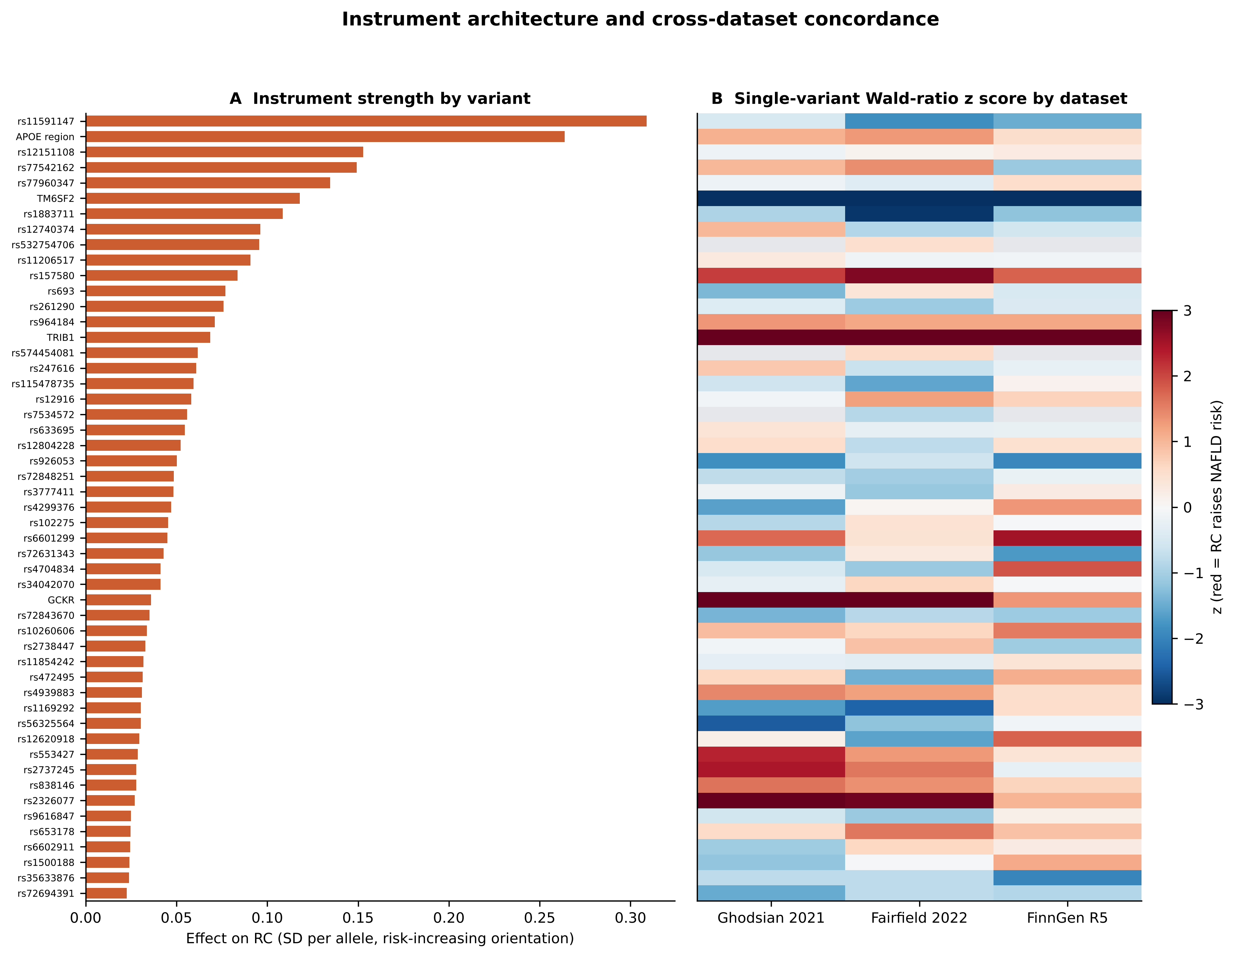
Figure S1. Instrument architecture and concordance across the three NAFLD datasets. Panel A: effect of each of the 52 variants on remnant cholesterol (SD per allele, RC-increasing orientation). Panel B: z score of the single-variant Wald ratio in each dataset; red indicates that the RC-raising allele is associated with higher NAFLD risk and grey cells indicate variants that were not available. The scale saturates at |z| = 3.
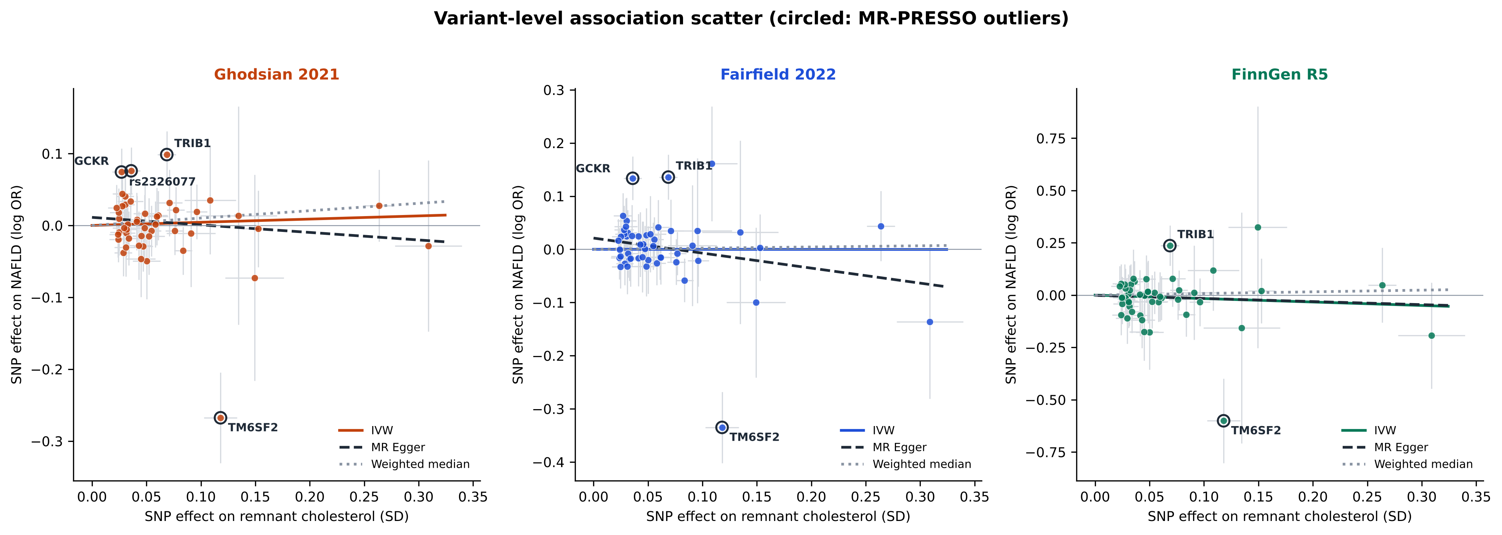
Figure S2. Variant-level associations with remnant cholesterol and NAFLD in the three datasets. Alleles are aligned to the RC-raising allele. Grey bars are 95% confidence intervals, the solid line is the IVW estimate, the dashed line is the MR-Egger fit and the dotted line is the weighted median. Circled points are MR-PRESSO outliers; the TM6SF2 variant lies far below the regression line in all three datasets.
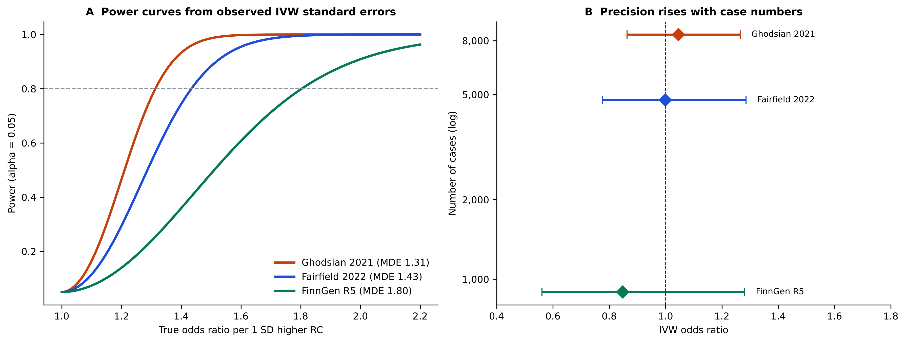
Figure S3. Statistical power and precision of the three outcome datasets. Panel A: power to detect a given true odds ratio per 1-SD higher remnant cholesterol, computed from the observed IVW standard errors; the dashed line marks 80% power. Panel B: IVW odds ratios with 95% confidence intervals against the number of cases (log scale).
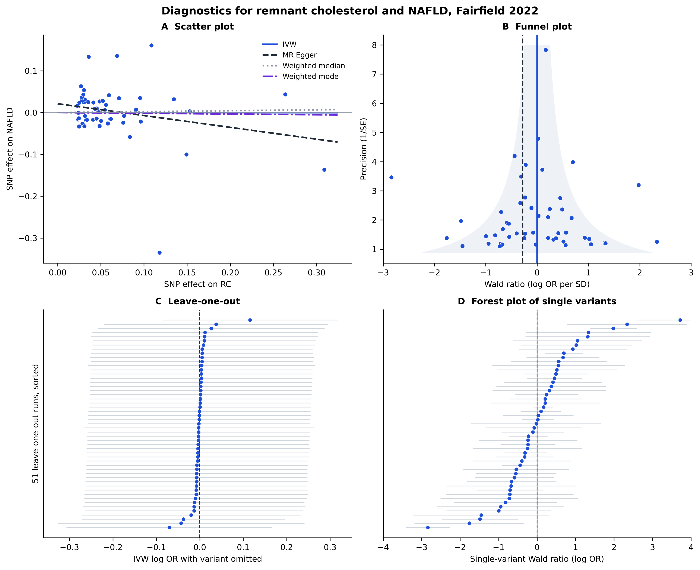
Figure S4. Diagnostics for remnant cholesterol and NAFLD in the Fairfield (UK Biobank) dataset. Panel A: scatter plot with IVW, MR-Egger, weighted median and weighted mode fits; panel B: funnel plot; panel C: leave-one-out; panel D: single-variant forest plot.
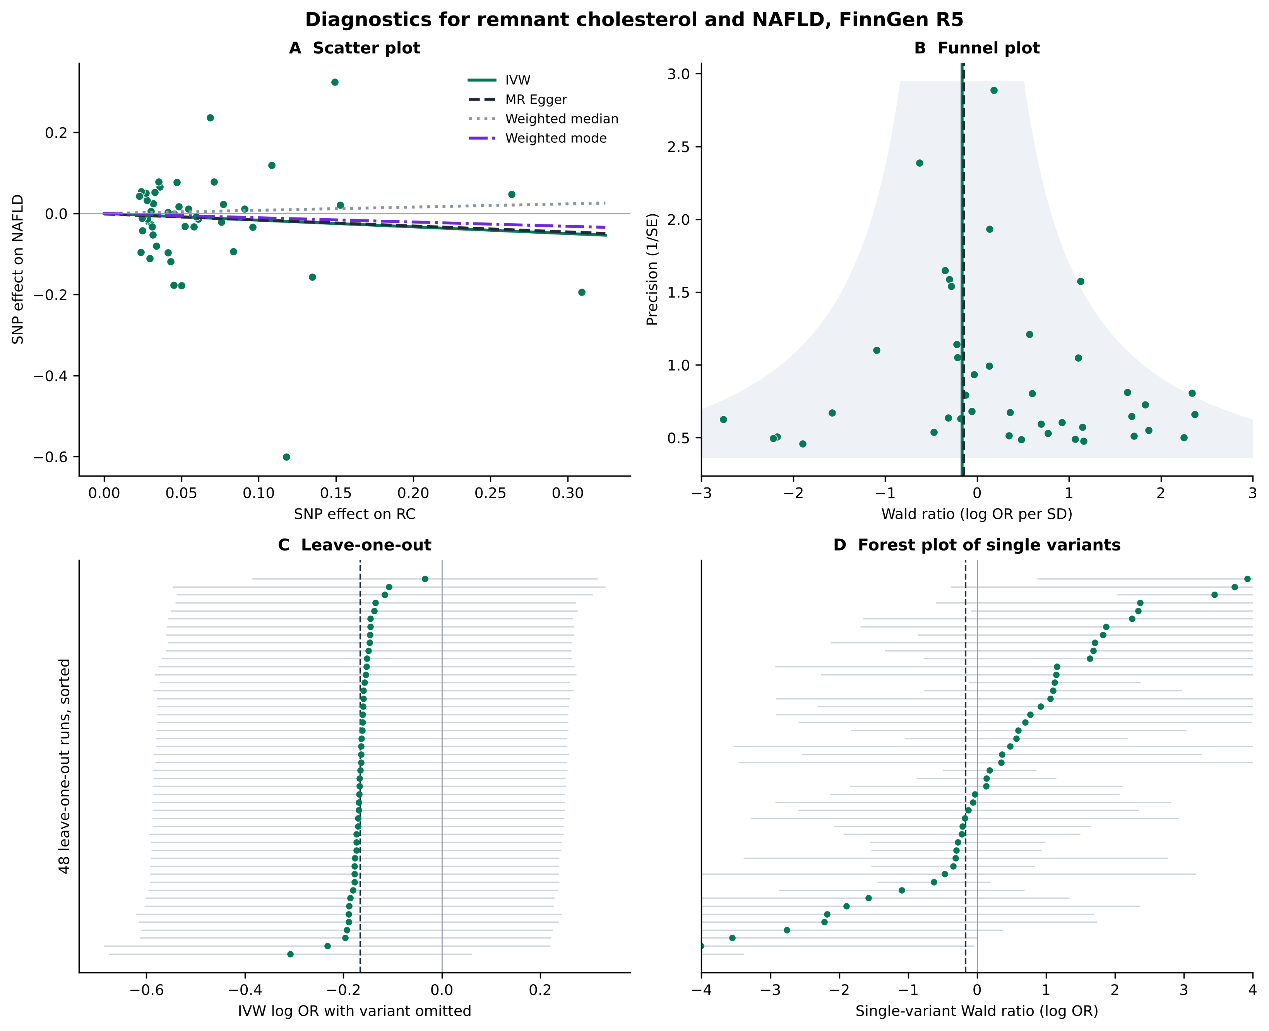
Figure S5. Diagnostics for remnant cholesterol and NAFLD in the FinnGen release 5 dataset. Panels as in Figure S4. The wide intervals reflect the small number of cases (894).
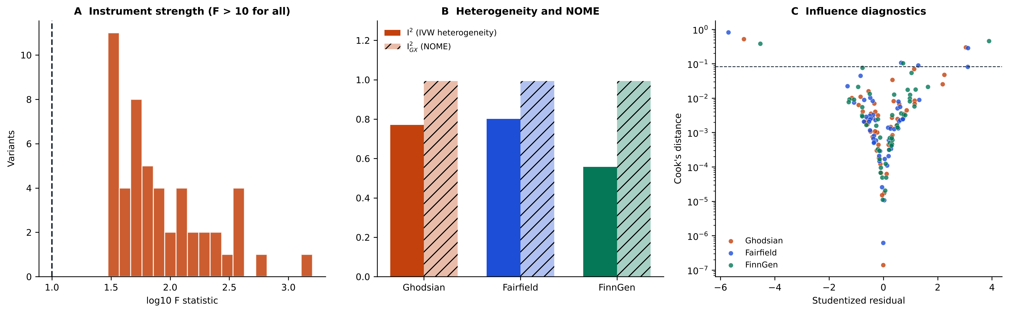
Figure S6. Instrument strength, heterogeneity and influence. Panel A: distribution of per-variant F statistics (dashed line: F = 10). Panel B: I² of the IVW estimate and I²_{GX} of the MR-Egger framework in each dataset. Panel C: studentized residuals against Cook’s distance (dashed line: 4/n); the points above the line are rs58542926 (TM6SF2) and rs112875651 (TRIB1) in all datasets.
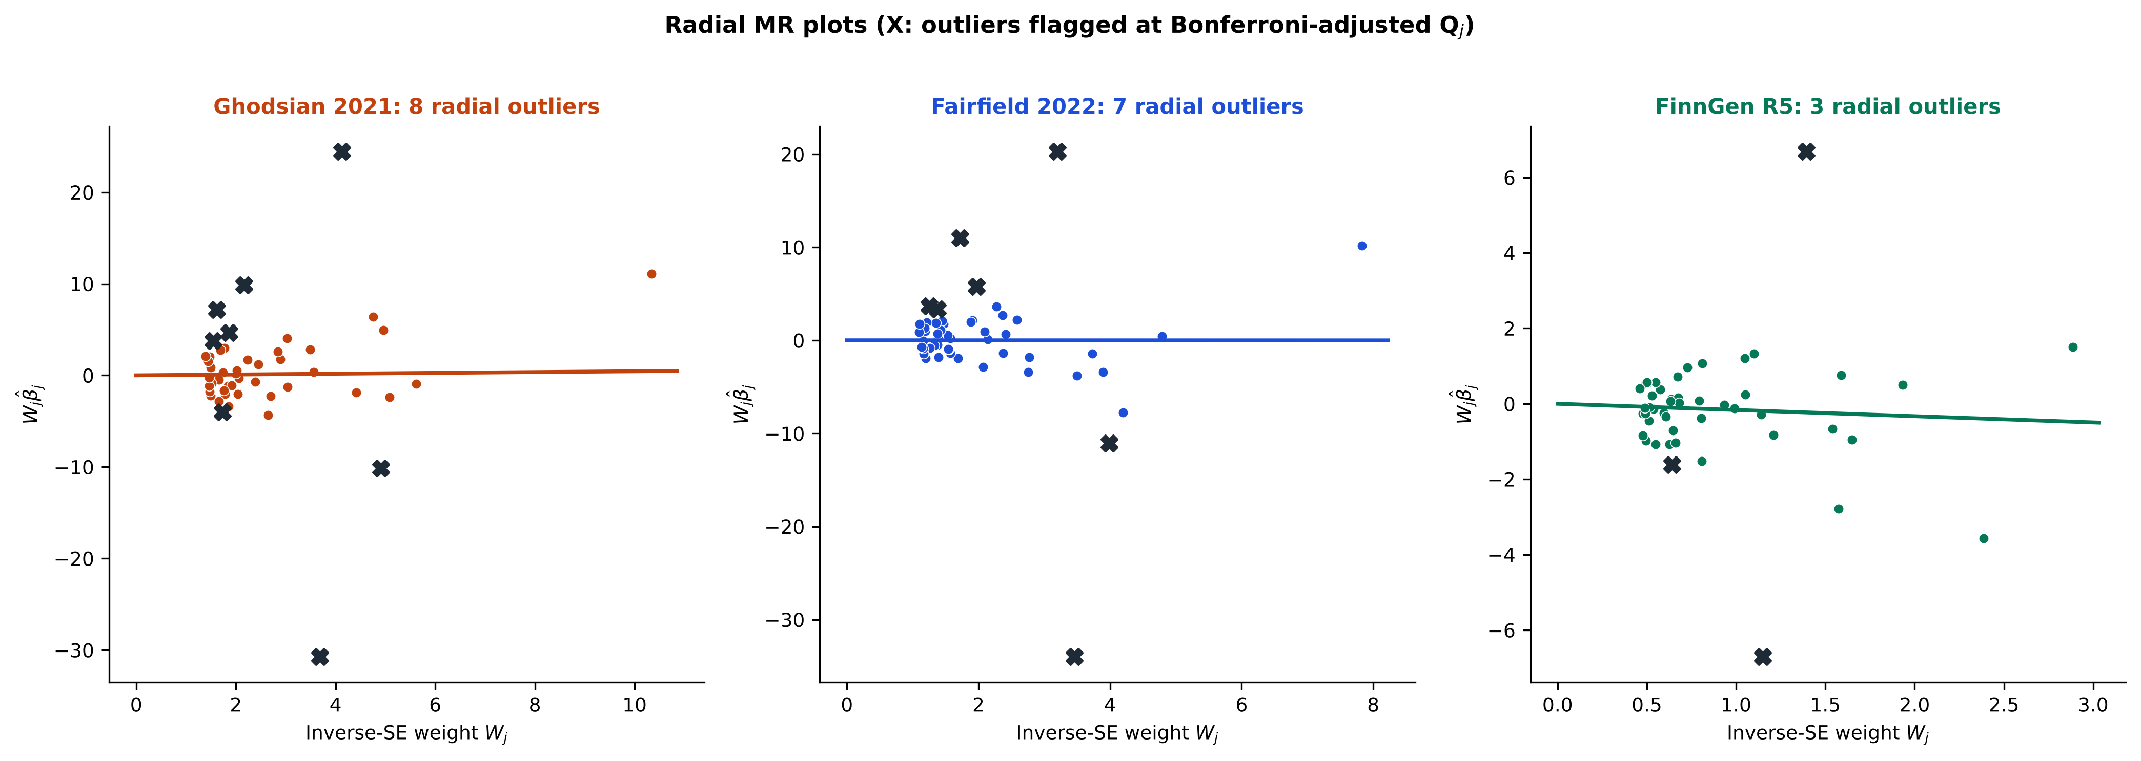
Figure S7. Radial MR plots. Each point is a variant plotted by inverse-standard-error weight and weighted ratio estimate; the line is the radial IVW estimate and crosses mark variants flagged as outliers.
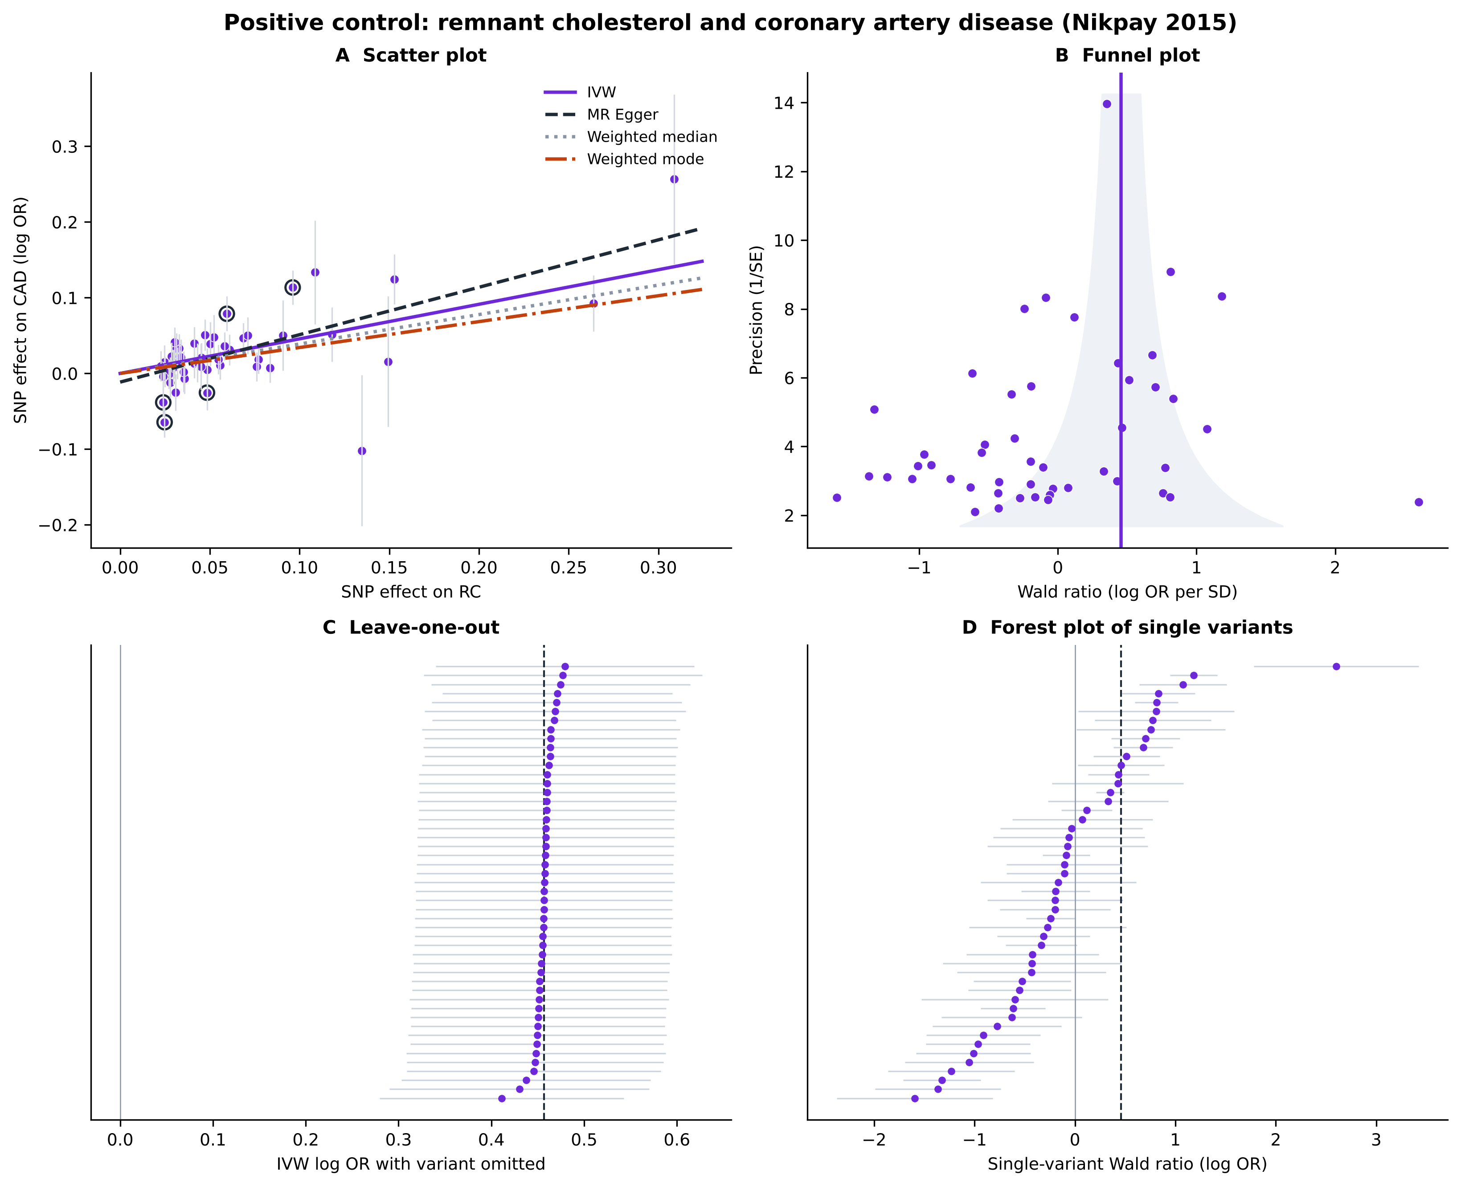
Figure S8. Diagnostics for the positive control (remnant cholesterol and coronary artery disease). Panel A: scatter plot (circled points are MR-PRESSO outliers in the Python analysis); panel B: funnel plot; panel C: leave-one-out analysis, in which no single omission removes the association; panel D: single-variant forest plot.
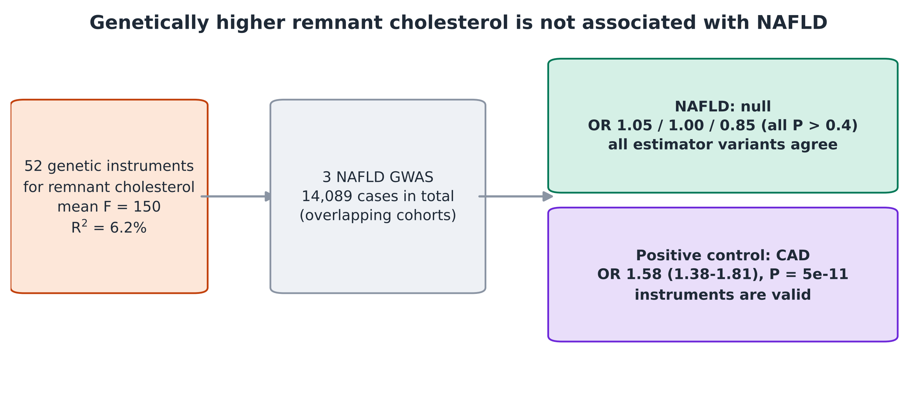
Figure S9. Graphical abstract. Fifty-two genetic instruments for remnant cholesterol were tested against three NAFLD datasets (null) and against coronary artery disease as a positive control (strong association).
References (Supplemental Digital Content)
[1] Bowden J, Del Greco M F, Minelli C, et al. A framework for the investigation of pleiotropy in two-sample summary data Mendelian randomization. Stat Med. 2017;36:1783–1802.
[2] Bowden J, Del Greco M F, Minelli C, et al. Assessing the suitability of summary data for two-sample Mendelian randomization analyses using MR-Egger regression: the role of the I2 statistic. Int J Epidemiol. 2016;45:1961–1974.
[3] Verbanck M, Chen CY, Neale B, et al. Detection of widespread horizontal pleiotropy in causal relationships inferred from Mendelian randomization between complex traits and diseases. Nat Genet. 2018;50:693–698.
[4] Bowden J, Spiller W, Del Greco M F, et al. Improving the visualization, interpretation and analysis of two-sample summary data Mendelian randomization via the Radial plot and Radial regression. Int J Epidemiol. 2018;47:1264–1278.
[5] Rees JMB, Wood AM, Dudbridge F, et al. Robust methods in Mendelian randomization via penalization of heterogeneous causal estimates. PLoS One. 2019;14:e0222362.
[6] Burgess S, Foley CN, Allara E, et al. A robust and efficient method for Mendelian randomization with hundreds of genetic variants. Nat Commun. 2020;11:376.
[7] Ye T, Shao J, Kang H. Debiased inverse-variance weighted estimator in two-sample summary-data Mendelian randomization. Ann Stat. 2021;49:2079–2100.
[8] Zhao Q, Wang J, Hemani G, et al. Statistical inference in two-sample summary-data Mendelian randomization using robust adjusted profile score. Ann Stat. 2020;48:1742–1769.
[9] Slob EAW, Burgess S. A comparison of robust Mendelian randomization methods using summary data. Genet Epidemiol. 2020;44:313–329.
[10] Brion MJA, Shakhbazov K, Visscher PM. Calculating statistical power in Mendelian randomization studies. Int J Epidemiol. 2013;42:1497–1501.
[11] Burgess S. Sample size and power calculations in Mendelian randomization with a single instrumental variable and a binary outcome. Int J Epidemiol. 2014;43:922–929.
[12] Burgess S, Davies NM, Thompson SG. Bias due to participant overlap in two-sample Mendelian randomization. Genet Epidemiol. 2016;40:597–608.
[13] Mounier N, Kutalik Z. Bias correction for inverse variance weighting Mendelian randomization. Genet Epidemiol. 2023;47:314–331.
[14] Varbo A, Benn M, Tybjærg-Hansen A, et al. Remnant cholesterol as a causal risk factor for ischemic heart disease. J Am Coll Cardiol. 2013;61:427–436.
[15] Nordestgaard BG. Triglyceride-rich lipoproteins and atherosclerotic cardiovascular disease. Circ Res. 2016;118:547–563.
[16] Nikpay M, Goel A, Won HH, et al.; CARDIoGRAMplusC4D Consortium. A comprehensive 1000 Genomes-based genome-wide association meta-analysis of coronary artery disease. Nat Genet. 2015;47:1121–1130.
[17] Sollis E, Mosaku A, Abid A, et al. The NHGRI-EBI GWAS catalog: knowledgebase and deposition resource. Nucleic Acids Res. 2023;51:D977–D985.
[18] Hemani G, Zheng J, Elsworth B, et al. The MR-Base platform supports systematic causal inference across the human phenome. eLife. 2018;7:e34408.
[19] Yavorska OO, Burgess S. MendelianRandomization: an R package for performing Mendelian randomization analyses using summarized data. Int J Epidemiol. 2017;46:1734–1739.

