Observational Study

Mendelian randomization study of remnant cholesterol in relation to non-alcoholic fatty liver disease
Alireza Soleymani Tª, Mahdi Akbarzadeh^{b}, Danial Habibi^{c,}*
Abstract
Observational studies link higher remnant cholesterol (RC) to non-alcoholic fatty liver disease (NAFLD), yet it remains unclear whether the association is causal, and the two earlier Mendelian randomization (MR) studies reached opposite conclusions. RC is the cholesterol carried by triglyceride-rich lipoprotein remnants, and the liver both secretes these particles and stores the fatty acids from which they are built, so confounding and reverse causation are plausible explanations for the observational findings. MR uses genetic variants as instruments to make causal inferences about an exposure and an outcome. For the exposure, we used 52 independent genome-wide significant variants for RC from a nuclear magnetic resonance GWAS of 115,082 UK Biobank participants (mean F = 150; variance explained = 6.2%). We then applied summary statistics from three European-ancestry NAFLD GWAS: an electronic-health-record meta-analysis (8,434 cases and 770,180 controls), the UK Biobank (4,761 cases and 373,227 controls) and FinnGen release 5 (894 cases and 217,898 controls). Genetically predicted RC was not associated with NAFLD in any dataset (inverse variance weighted odds ratio per 1-SD increase = 1.045, 95% CI: 0.864–1.265, P = .650; 0.999, 95% CI: 0.776–1.286, P = .994; and 0.848, 95% CI: 0.561–1.281, P = .433). Heterogeneity was substantial and was driven by a few variants at hepatic lipid loci (TM6SF2, TRIB1, GCKR) [Q_{IVW} = 204.8, P = 1.4 × 10⁻²¹; I² = 77.1%; I²_{GX} = 99.3% in the first dataset], whereas there was no evidence of directional pleiotropy [MR-Egger intercept = 0.0112, P = .261]. The null result persisted after outlier removal (MR-PRESSO-corrected OR = 1.023, 95% CI: 0.914–1.145, P = .695), Steiger filtering, exclusion of the APOE region, leave-one-out analysis and 11 additional estimator variants, including MR-Lasso, the contamination mixture model, debiased IVW and MR-RAPS. As a positive control, the same instruments were strongly associated with coronary artery disease (OR = 1.579, 95% CI: 1.378–1.809, P = 5.2 × 10⁻¹¹). The minimum detectable odds ratios with 80% power were 1.31, 1.43 and 1.80. We found no evidence that genetically predicted remnant cholesterol causes NAFLD under the current study design; large effects are unlikely in the two larger datasets, but small to moderate effects cannot be excluded.
Abbreviations: ApoB = apolipoprotein B, CAD = coronary artery disease, CI = confidence interval, GWAS = genome-wide association study, IVW = inverse variance weighted, LD = linkage disequilibrium, MAF = minor allele frequency, MASLD = metabolic dysfunction-associated steatotic liver disease, MR = Mendelian randomization, NAFLD = non-alcoholic fatty liver disease, NMR = nuclear magnetic resonance, OR = odds ratio, RC = remnant cholesterol, SNP = single nucleotide polymorphism, STROBE-MR = Strengthening the Reporting of Observational Studies in Epidemiology Using Mendelian Randomization, TSMR = two-sample Mendelian randomization.
Keywords: Association, Mendelian randomization, Non-alcoholic fatty liver disease, Remnant cholesterol, Triglyceride-rich lipoproteins

The authors have no funding and conflicts of interest to declare.  The datasets generated during and/or analyzed during the current study are publicly available (see Data availability).  No additional ethics approval was needed because all data in the study were previously collected, analyzed, and published.  Supplemental Digital Content is available in the online version of this article (Supplemental Digital Content 1–3). | ª Graduate School of Engineering Science and Technology, National Yunlin University of Science and Technology, Yunlin, Taiwan.  ^{b} Research Institute for Endocrine Sciences, Shahid Beheshti University of Medical Sciences, Tehran, Iran.  ^{c} Department of Biostatistics and Epidemiology, School of Public Health, Babol University of Medical Sciences, Babol, Iran.  *Correspondence: Danial Habibi, Department of Biostatistics and Epidemiology, School of Public Health, Babol University of Medical Sciences, Babol, Iran (e-mail: [to be added by the corresponding author]).

1. Introduction
Non-alcoholic fatty liver disease (NAFLD), now also described as metabolic dysfunction-associated steatotic liver disease (MASLD), is the most common chronic liver condition worldwide, affecting roughly a quarter to a third of adults.^{[1–3]} It encompasses a spectrum from simple steatosis to steatohepatitis, fibrosis and cirrhosis, and it is defined by hepatic fat accumulation in the absence of other causes of liver disease.^{[4–6]} Its pathogenesis is closely tied to obesity, insulin resistance and dyslipidaemia, and intrahepatic fat, more than visceral fat, tracks the metabolic complications of obesity.^{[7,8]} Despite this burden, the causal contribution of individual circulating lipid fractions to liver fat remains poorly defined.
Remnant cholesterol (RC) is the cholesterol content of triglyceride-rich lipoproteins, that is, very low-density lipoprotein (VLDL) and intermediate-density lipoprotein remnants in the fasting state, together with chylomicron remnants after a meal.^{[9,10]} Because these particles are not removed efficiently by the LDL receptor, they can enter the arterial intima, and RC has emerged as a cardiovascular risk factor that is partly independent of LDL cholesterol and apolipoprotein B.^{[11,12]} Genetic and observational evidence together support a causal role of RC in ischaemic heart disease.^{[13,14]} The liver is the origin of VLDL. Fatty acids reaching the liver from adipose tissue, de novo lipogenesis and the diet supply both the triglyceride stored in hepatocytes and the triglyceride secreted in VLDL,^{[15]} so RC and hepatic fat share a metabolic source and are plausibly linked in both directions.
In observational studies, higher RC has been repeatedly associated with prevalent and incident NAFLD, including in non-obese people and in analyses of cumulative exposure,^{[16–18]} and with insulin resistance among patients with metabolic dysfunction-associated fatty liver disease.^{[19]} Such associations are vulnerable to confounding and reverse causation. Adiposity, insulin resistance, diet, alcohol use and physical inactivity influence both RC and liver fat, while hepatic steatosis itself increases the secretion of triglyceride-rich lipoproteins. Conventional analyses can therefore not show whether elevated RC contributes to fatty liver or is mainly one of its consequences.
The genetic architecture of NAFLD adds a further complication. Variants in PNPLA3, TM6SF2, GCKR and TRIB1 influence hepatic lipid handling and are associated with liver fat.^{[20–23]} Some of these loci also change circulating lipoproteins, and not always in the direction one would expect. The TM6SF2 variant that increases liver fat, for example, lowers circulating lipids because it impairs the secretion of triglyceride-rich particles from the liver.^{[21]} Genetic instruments for RC are therefore likely to include variants that act on the liver itself, which makes a Mendelian randomization (MR) analysis of this particular exposure and outcome pair unusually exposed to horizontal pleiotropy and calls for explicit outlier handling.
MR uses genetic variants as instrumental variables to estimate the causal effect of an exposure on an outcome, and it is less prone to confounding and reverse causation because alleles are allocated at conception.^{[24–27]} Two MR studies have addressed RC and fatty liver with conflicting results. A two-sample MR of RC with many cardiometabolic outcomes found no causal association with NAFLD.^{[28]} A one-sample MR in the Taiwan Biobank reported very large positive effects on NAFLD and related definitions, but exposure and outcome came from the same cohort and a single ancestry.^{[29]} Because MR findings need robust support and transparent reporting,^{[30,31]} we investigated the causal effect of genetically predicted RC on NAFLD using three large NAFLD GWAS, a battery of pleiotropy-robust estimators, explicit outlier and influence diagnostics, a positive control analysis, and a formal assessment of statistical power and sample overlap. Our aim was to determine whether RC is causally related to NAFLD and to state which effect sizes the available data can and cannot exclude.
2. Method
2.1. Study design and data sources
This study used a two-sample Mendelian randomization (TSMR) design based on GWAS summary-level data to explore the potential causal link between RC (as the exposure) and NAFLD (as the outcome) in individuals of European ancestry (Fig. 1). The analysis relies on three core assumptions: the genetic instruments are associated with RC (relevance), they are independent of confounders of the RC–NAFLD relation (independence), and they affect NAFLD only through RC (exclusion restriction). The study adhered to the STROBE-MR reporting guideline^{[31,32]} (checklist in Supplemental Digital Content 1) and followed current guidance for MR investigations.^{[33]} The analysis was not pre-registered.
For the exposure variable, we used summary statistics for RC from the GWAS of 249 NMR metabolic traits by Richardson et al,^{[34]} measured on the Nightingale Health platform in up to 115,082 participants of European ancestry from the UK Biobank.^{[35–38]} RC corresponds to the non-HDL, non-LDL cholesterol fraction quantified by the platform. Values were inverse rank-normalised, so effect sizes are expressed per 1-SD higher RC, and associations were estimated with BOLT-LMM adjusted for age, sex, fasting time and genotyping array.^{[39]} Data on the outcome, NAFLD, were taken from three European-ancestry GWAS (Table 1): the electronic-health-record meta-analysis by Ghodsian et al (GWAS Catalog GCST90091033), which combined eMERGE, FinnGen (data freeze 4), UK Biobank and Estonian Biobank and included 8,434 cases and 770,180 controls;^{[40]} the UK Biobank GWAS by Fairfield et al (GCST90054782), which defined NAFLD from diagnostic codes recommended in consensus guidelines and included 4,761 cases and 373,227 controls;^{[23]} and FinnGen release 5 (OpenGWAS record finn-b-NAFLD), which included 894 cases and 217,898 controls.^{[41,42]} We use the term NAFLD because the source studies defined cases under that name; the cases largely overlap with MASLD under the 2023 nomenclature,^{[6]} although the datasets did not apply its criteria. The three outcome datasets are not fully independent: the UK Biobank contributes to both the Ghodsian and Fairfield analyses, and FinnGen participants contribute to both the Ghodsian meta-analysis and FinnGen release 5. The exposure and two outcome datasets also draw on the UK Biobank, a point we address in the sample-overlap analysis (section 2.7).
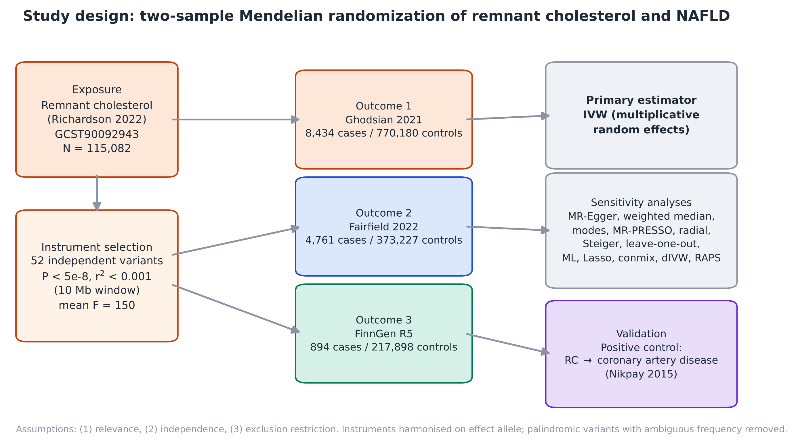
Figure 1. Two-sample Mendelian randomization study of remnant cholesterol in relation to non-alcoholic fatty liver disease. Fifty-two independent variants for remnant cholesterol were harmonised with three NAFLD GWAS. The inverse variance weighted estimator was the primary analysis, followed by pleiotropy-robust and outlier-robust sensitivity analyses. The same instruments were tested against coronary artery disease as a positive control.
Table 1. Characteristics of the exposure, outcome and positive-control datasets and of the instruments after harmonisation.
Dataset | Design / source | Cases | Controls | Variants used | R² (%) | Mean F (min) | MDE, OR*
Exposure: RC | UK Biobank NMR GWAS (Richardson 2022); N = 115,082 | – | – | 52 | 6.2 | 150 (29.8) | –
Ghodsian 2021 | EHR meta-analysis of 4 cohorts; GCST90091033 | 8,434 | 770,180 | 48 | 6.2 | 150 (29.8) | 1.31
Fairfield 2022 | UK Biobank; GCST90054782 | 4,761 | 373,227 | 51 | 6.5 | 147 (29.8) | 1.43
FinnGen R5 | FinnGen; finn-b-NAFLD | 894 | 217,898 | 48 | 6.2 | 150 (29.8) | 1.80
Positive control: CAD | CARDIoGRAMplusC4D 1000G (Nikpay 2015); GCST003116 | 60,801 | 123,504 | 49 | 6.4 | 150 (29.8) | 1.22
*Minimum detectable odds ratio per 1-SD higher genetically predicted RC with 80% power at α = .05, from the observed standard error of the IVW estimate. EHR = electronic health record; CAD = coronary artery disease; MDE = minimum detectable effect.
2.2. Selection of SNPs associated with remnant cholesterol
We implemented a series of quality-control steps to ensure the reliability of the selected instruments. We began with a genome-wide significance threshold of P < 5 × 10⁻⁸, which gave 8,873 variants after removal of duplicated identifiers. To retain only independent instruments, we performed LD clumping with r² < 0.001 within a 10,000 kb window, ranking variants by P value, using the 1000 Genomes Phase 3 European reference panel (503 individuals).^{[43]} Variants absent from the reference panel (1,280 of 8,873) could not be clumped and were excluded; this is a limitation of the clumping step. This procedure yielded 52 independent variants (Supplemental Digital Content 2, Table S1). Where a target variant was unavailable in an outcome dataset, we searched for proxy variants (r² ≥ 0.8 within 250 kb in the same reference panel) and aligned proxy alleles to the target by LD phase; proxies were used for 6 variants in the Ghodsian data and 3 in FinnGen, and 3 variants without a proxy (rs7534572, rs574454081 and rs532754706) were dropped from both.
Instrument strength was evaluated with the F statistic, F = (β/SE)², and with the variance explained (R²); we checked that every variant had F > 10,^{[44]} and additionally repeated the analysis restricted to variants with F ≥ 30. Variants with a minor allele frequency (MAF) < 0.01 were excluded in a further sensitivity analysis. During harmonisation, effects were aligned to the RC-increasing allele and ambiguous palindromic variants with intermediate allele frequency (0.42–0.58) were excluded to avoid strand-alignment errors (one variant, rs1293261, in every dataset). The final analyses used 48 variants (Ghodsian), 51 (Fairfield) and 48 (FinnGen). Finally, Steiger filtering was applied to assess directionality, which removes variants that explain more variance in the outcome than in the exposure.^{[45]} Because the APOE region (chromosome 19, 44.4–46.5 Mb) is strongly pleiotropic, we also repeated the analysis after excluding it. An earlier analysis of these data by our group used a different instrument set whose clumping settings were not recorded; we reconstructed it from its variant list (48 variants, including five in the APOE region) and report it as a sensitivity analysis.
2.3. Mendelian randomization analysis
For the univariable MR analysis, we primarily used the IVW method within a multiplicative random-effects framework.^{[46]} Given that pleiotropy or invalid instruments can bias IVW estimates, we applied additional methods that make different assumptions about the instruments: MR-Egger regression,^{[47]} the weighted median estimator,^{[48]} and the simple and weighted mode-based estimators.^{[49]} Effect estimates are reported as odds ratios (OR) of NAFLD per 1-SD higher genetically predicted RC with 95% confidence intervals (CI). Tests were two-sided with α = .05, and we did not adjust for multiple testing because a single exposure–outcome relation was examined in three datasets.
2.4. Heterogeneity, pleiotropy, outlier and influence diagnostics
Heterogeneity among instruments was assessed with Cochran's Q statistic and the I² index for IVW and with Rücker's Q for the MR-Egger framework,^{[50]} with P values above .05 suggesting low heterogeneity. The regression dilution of MR-Egger was assessed with I²_{GX}, where values close to 100% indicate that the no-measurement-error (NOME) assumption is reasonable.^{[51]} Directional pleiotropy was assessed with the MR-Egger intercept and the MR-PRESSO global test.^{[52]} Outlying variants were identified with MR-PRESSO (outlier test, 10,000 simulations) and radial MR,^{[53]} and influential variants with Cook's distance (threshold 4/n) and studentized residuals of the IVW regression; estimates were recalculated after removing MR-PRESSO outliers. Leave-one-out analyses determined whether any single variant drove the overall estimate, and funnel plots were inspected for asymmetry. The Steiger filter and the exclusion of the APOE region described above were treated as further sensitivity analyses. Variance explained in the outcome was approximated on the latent logistic scale without a prevalence assumption, which differs slightly from the TwoSampleMR implementation.
2.5. Extended estimators
To test the consistency of the findings under a wider set of assumptions, we additionally applied maximum likelihood estimation, MR-Lasso,^{[54]} the contamination mixture model,^{[55]} the debiased IVW estimator,^{[56]} and robust adjusted profile score (MR-RAPS) with Tukey and Huber loss functions and overdispersion,^{[57]} as well as fixed-effect IVW, radial IVW, and IVW restricted to variants with F ≥ 30 or MAF ≥ 0.01, and re-estimated the random-effects IVW with the MendelianRandomization package as a software cross-check. These estimators relax, respectively, the assumptions of a balanced pleiotropy distribution, plurality validity, weak-instrument bias and measurement error in the exposure associations.^{[58]} Together with the five methods above, they give 16 estimator variants per dataset, some of which (for example the software cross-check and the MAF restriction, which removed no variants) are re-estimations rather than independent methods.
2.6. Cross-dataset concordance
To examine whether the three outcome datasets agree at the level of single variants, we calculated the Wald ratio (outcome effect divided by exposure effect) and its z score for each variant and compared them across datasets by Spearman rank correlation and by the proportion of variants with the same sign. Because the datasets share participants, concordance is expected to be higher than for independent replications and is reported descriptively.
2.7. Statistical power and sample overlap
We calculated the minimum detectable OR with 80% power at α = .05 from the observed standard error of the IVW estimate in each dataset, and drew power curves across a range of true effects.^{[59,60]} Because the exposure GWAS and parts of the outcome data come from the UK Biobank, we considered the bias arising from sample overlap, which for a two-sample design is approximately the overlap proportion divided by the F statistic.^{[61]} We assumed complete overlap for the Fairfield dataset, which gives an upper bound, and note that the same applies in part to the Ghodsian data. Because variants were selected and estimated in the same exposure sample, the F statistic is also subject to winner's curse.^{[62]}
2.8. Positive control analysis
To check that the instruments capture a known causal effect, we repeated the analysis with coronary artery disease (CAD) as the outcome, because RC is an established cause of ischaemic heart disease.^{[10,13]} We used the 1000 Genomes-based CARDIoGRAMplusC4D meta-analysis (GWAS Catalog GCST003116; 60,801 cases and 123,504 controls; mainly European, South Asian and East Asian ancestry),^{[63,64]} downloaded in its genome build 37 harmonised form and verified against the published MD5 checksum. The same 52 instruments were used. Instruments missing by rsID were replaced by a variant at the same chromosomal position with the same allele pair (two variants) or by the best proxy with r² ≥ 0.8 in the European 1000 Genomes panel (two variants), and two variants without a usable proxy were dropped; one palindromic variant was removed. The analysis was run in Python with the same code as the NAFLD analysis and independently in R with the TwoSampleMR package, in which harmonisation and the five estimators were produced by the package and MR-PRESSO was run with the MRPRESSO package (10,000 simulations, seed 2026). The R analysis was run three times; the first two runs differed from the final run only in logging and in the random seed used for bootstrap standard errors, and all runs are provided. This analysis was added after the NAFLD analysis and was not pre-registered.
2.9. Software and validation
The NAFLD analyses were conducted with custom Python code implementing the TwoSampleMR and MR-PRESSO algorithms,^{[52,65]} validated against R output of a previous analysis of the same data (it reproduced the IVW and MR-Egger estimates and standard errors, the Egger intercept, Cochran's Q, the MR-PRESSO global statistic and the outlier-corrected estimate). MR-PRESSO was re-run with the official R package, which identified the same outliers and gave the same corrected estimates as the Python implementation except for a negligible difference in the FinnGen P value (.250 in R against .24 in Python); the values reported here are the R results. Extended estimators were run in R 4.4.3 with the MendelianRandomization (version 0.10.0),^{[66]} mr.raps (version 0.2) and RadialMR (version 1.2.1) packages. Figures were drawn with matplotlib. All code, console logs and intermediate files are available in the public repository listed under Code availability.
3. Results
3.1. Main results
This analysis investigated a potential causal link between genetically predicted RC and NAFLD using Mendelian randomization. Following established criteria (genome-wide significance of P < 5 × 10⁻⁸ and clumping for independence), 52 SNPs associated with RC were selected as instrumental variables. After harmonisation, 48, 51 and 48 SNPs were retained for the Ghodsian, Fairfield and FinnGen datasets, respectively. The IVW analysis found no statistically significant association between RC and the risk of NAFLD in any dataset (Ghodsian: OR = 1.045, 95% CI: 0.864–1.265, P = .650; Fairfield: OR = 0.999, 95% CI: 0.776–1.286, P = .994; FinnGen: OR = 0.848, 95% CI: 0.561–1.281, P = .433; Table 2 and Fig. 2). The weighted median, MR-Egger and mode-based estimators were likewise non-significant, although their point estimates differed in direction from the IVW estimate in some datasets (for example, MR-Egger OR = 0.901 and 0.754 in the Ghodsian and Fairfield data), a pattern consistent with imprecise estimates rather than a coherent effect.
Table 2. Mendelian randomization estimates of NAFLD per 1-SD higher genetically predicted remnant cholesterol, using all available variants.
Dataset | Method | SNPs | OR | 95% CI | P
Ghodsian | IVW | 48 | 1.045 | 0.864–1.265 | .650
 | Weighted median | 48 | 1.108 | 0.954–1.287 | .178
 | MR-Egger | 48 | 0.901 | 0.654–1.240 | .524
 | Simple mode | 48 | 1.006 | 0.791–1.280 | .960
 | Weighted mode | 48 | 1.071 | 0.936–1.226 | .321
Fairfield | IVW | 51 | 0.999 | 0.776–1.286 | .994
 | Weighted median | 51 | 1.022 | 0.832–1.256 | .833
 | MR-Egger | 51 | 0.754 | 0.492–1.155 | .201
 | Simple mode | 51 | 0.792 | 0.565–1.110 | .182
 | Weighted mode | 51 | 0.983 | 0.803–1.203 | .867
FinnGen | IVW | 48 | 0.848 | 0.561–1.281 | .433
 | Weighted median | 48 | 1.082 | 0.700–1.673 | .722
 | MR-Egger | 48 | 0.863 | 0.426–1.745 | .683
 | Simple mode | 48 | 0.839 | 0.387–1.816 | .658
 | Weighted mode | 48 | 0.900 | 0.598–1.355 | .617
OR = odds ratio; CI = confidence interval; IVW = inverse variance weighted (multiplicative random effects).
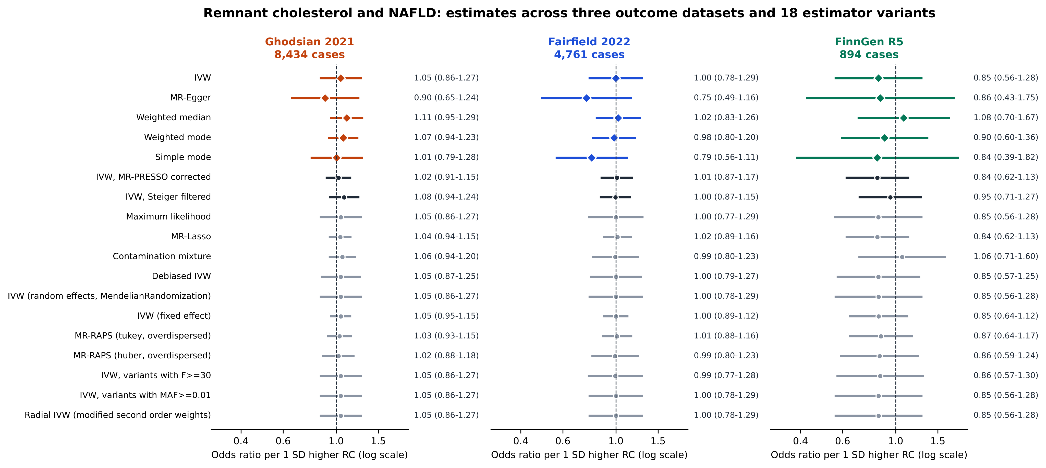
Figure 2. Estimates of the association between genetically predicted remnant cholesterol and NAFLD in three outcome datasets. Diamonds are the primary five estimators using all variants, black circles are IVW sensitivity analyses (MR-PRESSO-corrected and Steiger-filtered) and grey circles are the extended estimators. Bars are 95% confidence intervals on a log scale, and the dashed line marks no association. Odds ratios are rounded to two decimals in the figure and given to three in the tables.
3.2. Instrument characteristics and cross-dataset concordance
The 52 independent variants jointly explained 6.2% of the variance in RC, with a mean F statistic of 150 (range: 29.8–1598) and an overall F statistic of 159; every variant had F > 10 and the weakest was 29.8 (Fig. S4A). Instrument strength by variant and the single-variant Wald-ratio z scores in the three datasets are shown in Fig. 3. Single-variant Wald ratios were positively correlated across datasets (Spearman ρ = 0.678 between Ghodsian and Fairfield, P = 1.2 × 10⁻⁷; 0.487 between Ghodsian and FinnGen, P = 4.5 × 10⁻⁴; 0.328 between Fairfield and FinnGen, P = .023), and 67%, 62% and 62% of variants had the same sign. Because the datasets share participants and because a few large-effect hepatic variants dominate the pattern, this concordance reflects shared heterogeneity more than independent replication of a causal effect.
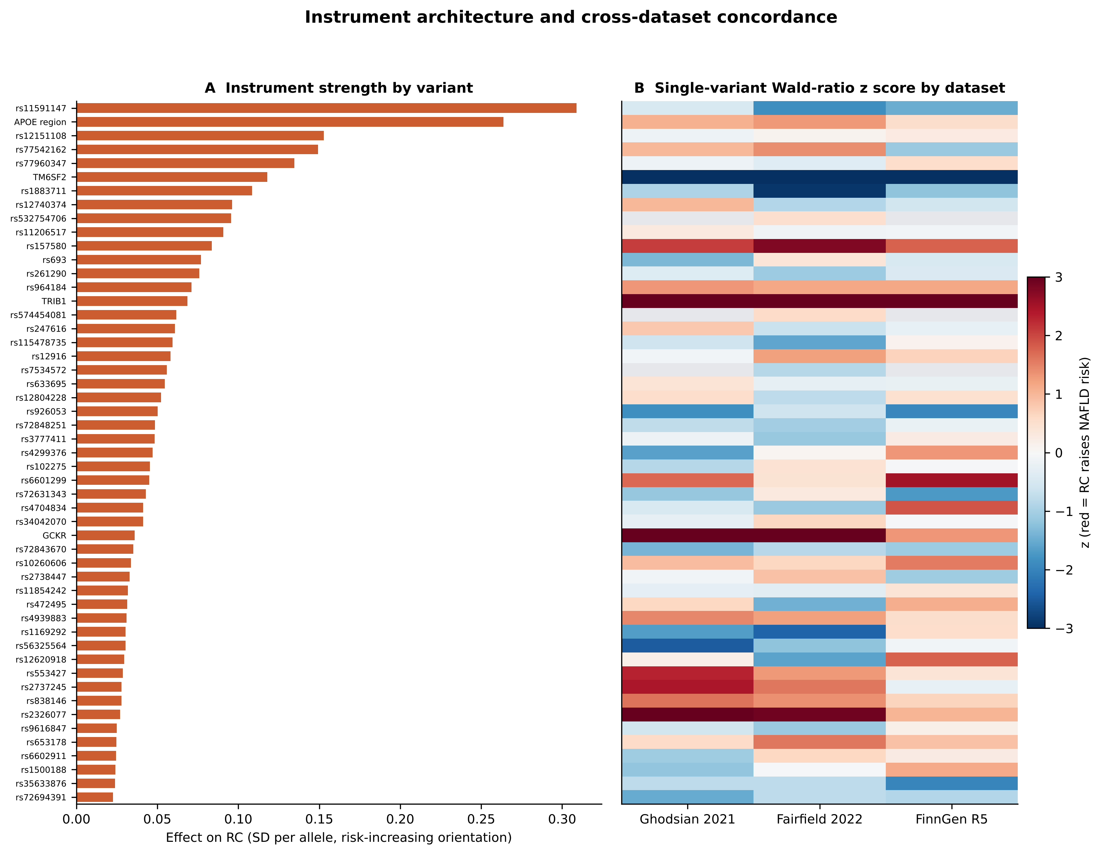
Figure 3. Instrument architecture and concordance across the three NAFLD datasets. Panel A: effect of each of the 52 variants on remnant cholesterol (SD per allele, RC-increasing orientation). Panel B: z score of the single-variant Wald ratio in each dataset; red indicates that the RC-raising allele is associated with higher NAFLD risk and grey cells indicate variants that were not available. The scale saturates at |z| = 3.
3.3. Heterogeneity, pleiotropy and outliers
Heterogeneity among instruments was substantial in all three datasets (Table 3): Cochran's Q was 204.8 (47 degrees of freedom; P = 1.4 × 10⁻²¹) in the Ghodsian data, 251.4 (50; P = 1.2 × 10⁻²⁸) in Fairfield and 106.2 (47; P = 1.8 × 10⁻⁶) in FinnGen, corresponding to I² values of 77.1%, 80.1% and 55.7%. The I²_{GX} values were about 99.3% in each dataset, so regression dilution of MR-Egger was minimal. There was no evidence of directional pleiotropy (MR-Egger intercepts 0.0112, 0.0211 and -0.0013; P = .261, .118 and .952), although with this much heterogeneity the test has limited power. The MR-PRESSO global test was significant in all three datasets (P < .0001, the smallest value that 10,000 simulations can resolve). MR-PRESSO identified rs112875651 (TRIB1 region) and rs58542926 (TM6SF2) as outliers in every dataset, rs4665972 (near GCKR) in the Ghodsian and Fairfield data, and rs2326077 in the Ghodsian data, and radial MR flagged 8, 7 and 3 variants, a superset of these (Fig. 4, Fig. 5 and Fig. S5). The TM6SF2 variant was the only one with a strong effect in the direction opposite to the rest (Wald ratio about −2.3 log odds of NAFLD per SD in the Ghodsian data), consistent with the known biology of this locus. Cook's distance exceeded the 4/n threshold for 2, 5 and 3 variants in the three datasets, and the two most influential variants in every dataset were rs58542926 and rs112875651 (Fig. S4C).
Table 3. Heterogeneity, pleiotropy, outlier and influence diagnostics.
Dataset | SNPs | Q_{IVW} (P) | I² (%) | I²_{GX} (%) | Egger intercept (P) | MR-PRESSO outliers | Radial outliers | Cook > 4/n
Ghodsian | 48 | 204.8 (1.4 × 10⁻²¹) | 77.1 | 99.3 | 0.0112 (.261) | rs112875651, rs58542926, rs4665972, rs2326077 | 8 | 2
Fairfield | 51 | 251.4 (1.2 × 10⁻²⁸) | 80.1 | 99.3 | 0.0211 (.118) | rs112875651, rs58542926, rs4665972 | 7 | 5
FinnGen | 48 | 106.2 (1.8 × 10⁻⁶) | 55.7 | 99.3 | -0.0013 (.952) | rs112875651, rs58542926 | 3 | 3
The MR-PRESSO global test had P < .0001 in all three datasets. Q_{IVW} = Cochran’s Q for the IVW estimate; I² = proportion of variability due to heterogeneity; I²_{GX} = instrument-strength measure for MR-Egger; PRESSO = pleiotropy residual sum and outlier test (R package).
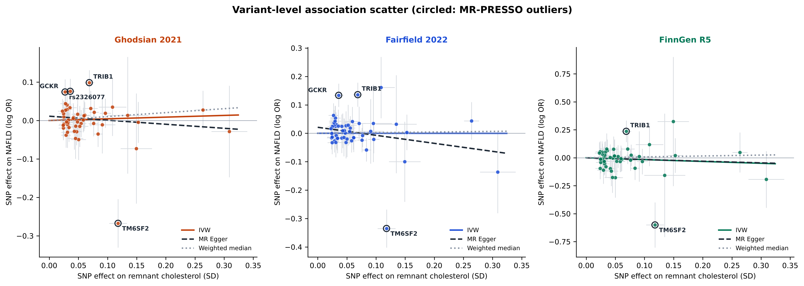
Figure 4. Variant-level associations with remnant cholesterol and NAFLD in the three datasets. Alleles are aligned to the RC-raising allele. Grey bars are 95% confidence intervals, the solid line is the IVW estimate, the dashed line is the MR-Egger fit and the dotted line is the weighted median. Circled points are MR-PRESSO outliers; the TM6SF2 variant lies far below the regression line in all three datasets.
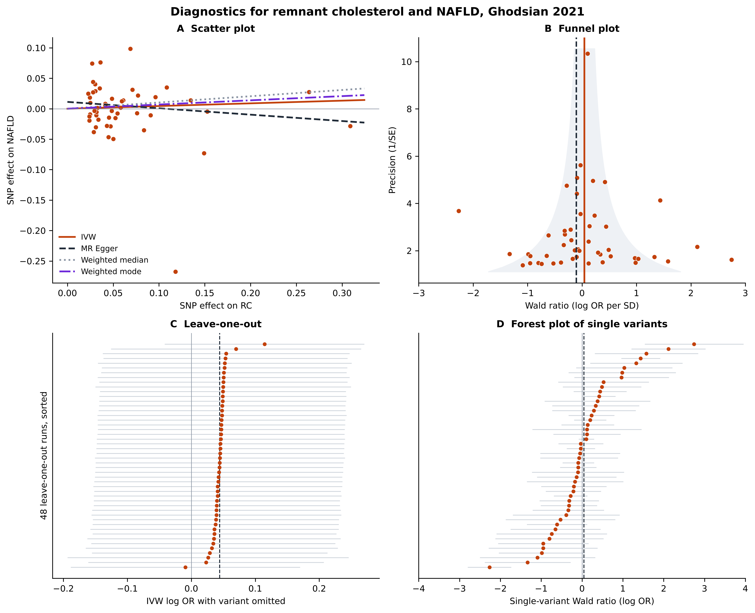
Figure 5. Diagnostics for the causal effect of remnant cholesterol on NAFLD in the Ghodsian meta-analysis. Panel A: scatter plot of variant effects on remnant cholesterol and on NAFLD with the IVW, MR-Egger, weighted median and weighted mode fits; the near-zero slopes of all methods indicate no association. Panel B: funnel plot of single-variant Wald ratios against precision; the asymmetric scatter outside the funnel reflects the heterogeneity driven by a few hepatic loci. Panel C: leave-one-out analysis, showing that no single variant changes the estimate materially. Panel D: forest plot of the single-variant Wald ratios. The equivalent figures for the Fairfield and FinnGen datasets are in Supplemental Digital Content 2 (Figs. S2 and S3).
3.4. Sensitivity analyses
The estimates were stable across the planned sensitivity analyses (Table 4). After removal of MR-PRESSO outliers, the IVW estimate remained null in the Ghodsian (OR = 1.023, 95% CI: 0.914–1.145, P = .695; 44 variants), Fairfield (OR = 1.009, 95% CI: 0.871–1.169, P = .908; 48 variants) and FinnGen data (OR = 0.839, 95% CI: 0.624–1.127, P = .250; 46 variants), with much narrower intervals in the first two. The Steiger filter removed 3, 4 and 13 variants in the three datasets without changing the conclusion; the 13 removed in FinnGen probably reflect the small number of cases (894), for which variance explained in the outcome is estimated with little precision, so this result should be read with caution. No leave-one-out estimate reached P < .05 (OR ranges 0.991–1.121, 0.932–1.123 and 0.735–0.966; Fig. 5C and Figs. S2–S3). Excluding the APOE region, restricting to variants with F ≥ 30 and excluding variants with MAF < 0.01 (which removed none) did not materially alter the effect estimates or their precision. The reconstructed earlier instrument set gave IVW odds ratios of 0.984 (95% CI: 0.869–1.114, P = .798; 41 variants), 0.990 (95% CI: 0.851–1.152, P = .898; 48 variants) and 0.752 (95% CI: 0.562–1.006, P = .055; 43 variants), with much less heterogeneity (Cochran's Q P = .005, .002 and .480). None of the three estimates is significant. We report this analysis in full because the change of instrument set affects the heterogeneity and, in FinnGen, the point estimate, which falls in the protective direction.
Table 4. Inverse variance weighted estimates in sensitivity analyses.
Analysis | Ghodsian: OR (95% CI), P | Fairfield: OR (95% CI), P | FinnGen: OR (95% CI), P
All variants | 1.045 (0.864–1.265), .650 [48] | 0.999 (0.776–1.286), .994 [51] | 0.848 (0.561–1.281), .433 [48]
MR-PRESSO outliers removed | 1.023 (0.914–1.145), .695 [44] | 1.009 (0.871–1.169), .908 [48] | 0.839 (0.624–1.127), .250 [46]
Steiger-filtered | 1.081 (0.943–1.238), .263 [45] | 0.996 (0.865–1.146), .951 [47] | 0.949 (0.706–1.275), .727 [35]
APOE region excluded | 1.073 (0.853–1.349), .548 [45] | 1.014 (0.748–1.374), .930 [47] | 0.859 (0.539–1.369), .523 [45]
F ≥ 30 only | 1.046 (0.862–1.269), .648 [47] | 0.993 (0.770–1.280), .958 [50] | 0.861 (0.570–1.301), .478 [47]
Earlier 48-variant set | 0.984 (0.869–1.114), .798 [41] | 0.990 (0.851–1.152), .898 [48] | 0.752 (0.562–1.006), .055 [43]
MR-PRESSO-corrected estimates are from the R package. Square brackets give the number of variants. The earlier 48-variant set is described in section 2.2.
3.5. Extended robust estimators
Eleven further estimators, which relax different assumptions about the instruments, gave results that were uniformly compatible with the null (Table 5 and Fig. 2). In the Ghodsian data the odds ratios ranged from 1.022 to 1.062, in the Fairfield data from 0.991 to 1.016 and in FinnGen from 0.839 to 1.063. MR-Lasso retained 40, 45 and 46 variants as valid and the contamination mixture model classified 33, 41 and 38 variants as valid, and both gave estimates close to the IVW result; MR-RAPS with robust loss functions and the debiased IVW estimator, which down-weight outliers and correct for weak-instrument bias, did the same. The fixed-effect IVW intervals were narrower than the random-effects intervals because they ignore the heterogeneity, and they are reported for completeness only.
Table 5. Odds ratio of NAFLD per 1-SD higher genetically predicted remnant cholesterol from extended estimators.
Estimator | Ghodsian: OR (95% CI) | Fairfield: OR (95% CI) | FinnGen: OR (95% CI)
Maximum likelihood | 1.047 (0.862–1.270) | 0.999 (0.773–1.292) | 0.846 (0.559–1.282)
MR-Lasso | 1.040 (0.942–1.149) | 1.016 (0.893–1.156) | 0.839 (0.624–1.127)
Contamination mixture | 1.062 (0.942–1.197) | 0.994 (0.802–1.232) | 1.063 (0.705–1.601)
Debiased IVW | 1.046 (0.873–1.253) | 0.999 (0.786–1.270) | 0.847 (0.572–1.253)
MR-RAPS, Tukey | 1.033 (0.925–1.153) | 1.010 (0.882–1.158) | 0.868 (0.644–1.170)
MR-RAPS, Huber | 1.022 (0.883–1.183) | 0.991 (0.798–1.232) | 0.856 (0.591–1.239)
IVW, fixed effect | 1.045 (0.954–1.145) | 0.999 (0.893–1.118) | 0.848 (0.644–1.116)
Radial IVW | 1.045 (0.864–1.265) | 0.999 (0.776–1.286) | 0.848 (0.561–1.281)
MR-RAPS = robust adjusted profile score; all analyses use the primary 52-variant set after harmonisation (48, 51 and 48 variants). IVW with F ≥ 30 and with MAF ≥ 0.01 are in Table 4 and Supplemental Digital Content 2.
3.6. Statistical power and sample overlap
With 80% power at α = .05, the minimum detectable OR per 1-SD was 1.31 in the Ghodsian data, 1.43 in Fairfield and 1.80 in FinnGen (or 0.76, 0.70 and 0.55 for a protective effect; Fig. 6). The confidence intervals therefore exclude a large harmful effect in the two larger datasets (upper limits 1.27 and 1.29) but cannot exclude a small to moderate one, and the FinnGen result is compatible with a wide range of effects. With an overall F statistic of about 159, bias from complete sample overlap would be at most about 0.6% of the confounded association, although this figure is optimistic because of winner's curse. These power calculations are post hoc, assume valid instruments and refer to a lifelong difference of 1 SD in RC.
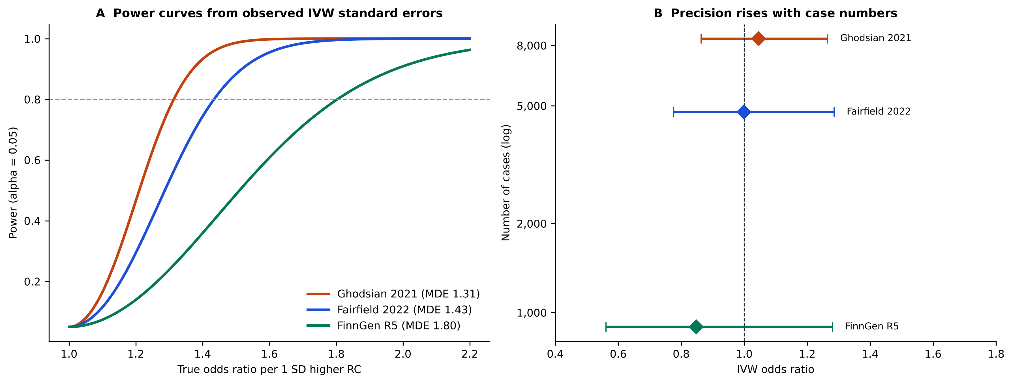
Figure 6. Statistical power and precision of the three outcome datasets. Panel A: power to detect a given true odds ratio per 1-SD higher remnant cholesterol, computed from the observed IVW standard errors; the dashed line marks 80% power. Panel B: IVW odds ratios with 95% confidence intervals against the number of cases (log scale), showing how precision rises with case numbers.
3.7. Positive control: coronary artery disease
Forty-nine of the 52 instruments were available for CAD (46 found directly by rsID, two by position and two by proxy; two were absent without a proxy and one ambiguous palindromic variant was removed). They explained 6.4% of the variance in RC (mean F = 150). In contrast to the NAFLD results, genetically predicted RC was strongly associated with CAD (IVW OR = 1.579, 95% CI: 1.378–1.809, P = 5.2 × 10⁻¹¹; Table 6 and Fig. 7). The weighted median (1.475), MR-Egger (1.871) and mode-based estimates (1.408 and 1.393) pointed in the same direction. Heterogeneity was large (Q = 276.9, 48 degrees of freedom, P = 6.2 × 10⁻³⁴), but the MR-Egger intercept gave no evidence of directional pleiotropy (-0.0115, P = .116). The association remained after removal of MR-PRESSO outliers (R: six outliers, OR = 1.492; Python: five outliers, OR = 1.540), after the Steiger filter (OR = 1.602; one variant removed) and in the leave-one-out analysis (ORs 1.51–1.62, all P < 10⁻⁸). The Python and R analyses gave identical IVW, MR-Egger and weighted median estimates and differed slightly only for the weighted mode and the number of MR-PRESSO outliers, as in the NAFLD analysis. The instruments therefore reproduce the known association of RC with coronary disease, which supports their relevance and their ability to detect an effect on a clinical outcome in these data, although it does not exclude pleiotropy specific to liver fat.
Table 6. Positive control: Mendelian randomization estimates of coronary artery disease per 1-SD higher genetically predicted remnant cholesterol.
Method | SNPs | OR | 95% CI | P
IVW | 49 | 1.579 | 1.378–1.809 | 5.2 × 10⁻¹¹
MR-Egger | 49 | 1.871 | 1.461–2.395 | 9.4 × 10⁻⁶
Weighted median | 49 | 1.475 | 1.321–1.648 | 5.6 × 10⁻¹²
Simple mode | 49 | 1.408 | 1.088–1.821 | .012
Weighted mode | 49 | 1.393 | 1.216–1.597 | 1.7 × 10⁻⁵
IVW after MR-PRESSO outlier removal (R) | 43 | 1.492 | 1.348–1.651 | 1.4 × 10⁻⁹
R (TwoSampleMR 0.6.22 and MRPRESSO); Nikpay et al 2015. The Python analysis gave identical IVW, MR-Egger and weighted median estimates (Supplemental Digital Content 2, Table S7).
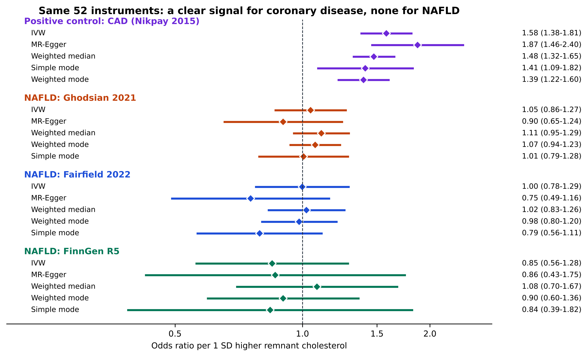
Figure 7. The same 52 instruments give a clear signal for coronary artery disease and none for NAFLD. Odds ratios per 1-SD higher genetically predicted remnant cholesterol for the positive control (coronary artery disease, purple) and for NAFLD in the three datasets. The IVW, MR-Egger, weighted median and mode-based estimates are shown for each outcome.
4. Discussion
In this two-sample MR study of up to 14,089 NAFLD cases and about 1.4 million participants (with some overlap between datasets), we found no evidence that genetically predicted RC causally affects NAFLD. The IVW estimates were close to the null in all three datasets (OR per 1-SD 0.85–1.05), the pleiotropy-robust and outlier-robust estimators were also non-significant, and no analysis gave a significant result after removing outlying variants, applying a Steiger filter, excluding the APOE region or dropping each variant in turn. In the two larger datasets the confidence intervals exclude odds ratios above about 1.3 per SD, and the minimum detectable effect was 1.31 and 1.43. The same instruments showed the expected strong association with coronary artery disease (IVW OR = 1.58), so the null result is not explained by weak or invalid instruments in general.
Our result agrees with the earlier two-sample MR by Guan et al, which found no causal association of RC with NAFLD using essentially the same exposure data (about 115,000 UK Biobank participants).^{[28]} The present study adds three NAFLD outcome datasets rather than one, a systematic report of outliers, heterogeneity and influence, a battery of additional estimators, a positive control and an explicit power assessment, but because the exposure instruments are shared it is not an independent confirmation of them. Our result disagrees with the one-sample MR in the Taiwan Biobank, which reported odds ratios above 6 per mmol/L.^{[29]} Several features of that study could explain the difference: exposure and outcome came from the same cohort, which biases one-sample MR towards the confounded observational association; the instruments were derived in a different ancestry; and its own sensitivity tests showed significant heterogeneity. Our findings also contrast with the consistent positive observational associations between RC and NAFLD.^{[16–18]} A null MR result alongside positive observational results is compatible with confounding by adiposity and insulin resistance, or with reverse causation in which hepatic fat increases the secretion of triglyceride-rich lipoproteins;^{[15]} we did not test the reverse direction, so this remains a hypothesis.
The heterogeneity we observed was driven by a small number of variants, several at loci with a known hepatic role. The TM6SF2 variant (rs58542926) is the clearest example. Its RC-raising allele is associated with a lower risk of NAFLD in our data, which fits the biology of the locus: TM6SF2 influences the secretion of triglyceride-rich lipoproteins from the liver, so reduced function retains fat in hepatocytes while lowering circulating lipoproteins.^{[21]} Variants in the TRIB1 and GCKR regions pointed in the opposite direction and have been linked to liver fat.^{[22,23]} Variants that act in the liver may influence NAFLD through routes other than circulating RC, which would violate the exclusion restriction, and the opposing directions of such variants could cancel in the IVW estimate. This is why we examined the effect of removing them: the MR-PRESSO-corrected, Steiger-filtered, MR-Lasso, contamination mixture and RAPS estimators, which down-weight or exclude such variants, were all null. The very high I²_{GX} (above 99%) means that regression dilution is not a concern for MR-Egger, but the intercept test is underpowered when heterogeneity is this large,^{[67]} so directional pleiotropy cannot be excluded on the intercept alone. The tight entanglement of the genetic architecture of circulating lipoproteins and liver fat also means that a clean MR test of this exposure–outcome pair is difficult.
Several features of the analysis strengthen the interpretation. The instruments were strong (mean F = 150), three NAFLD datasets with different case definitions and populations were analysed, 16 estimator variants with different assumptions were applied, and the code was validated against R output and reproduced it, including the MR-PRESSO statistic. The positive control with CAD, run in both Python and R, supports instrument validity, and sample overlap and power are reported rather than assumed. One further result deserves emphasis: when the instrument set of our earlier analysis was used, the FinnGen estimate moved to OR = 0.752 (95% CI: 0.562–1.006, P = .055), which is close to but not below conventional significance in the protective direction. We interpret this as the imprecision of a small outcome dataset (894 cases) combined with a different set of variants, not as evidence of protection, and we report it because it shows how sensitive the FinnGen estimate is to instrument selection.
This study has several limitations. First, the three NAFLD datasets partly overlap (the UK Biobank contributes to two and FinnGen to two), so they are not independent replications. Second, NAFLD cases were identified from health records or diagnostic codes, which misclassify disease and favour diagnosed, more severe cases; non-differential misclassification would be expected to bias estimates towards the null, and imaging-based liver fat or histology would be more precise, so we could not examine fibrosis or steatohepatitis. Third, the FinnGen dataset has only 894 cases, so its estimate is imprecise. Fourth, RC is genetically correlated with triglycerides and apolipoprotein B-containing lipoproteins; we did not run multivariable MR,^{[68,69]} so we cannot separate an effect of RC from that of correlated lipid traits, and our results address the total effect of genetically predicted RC only. Fifth, the exposure and part of the outcome data come from the UK Biobank; although the bias from overlap is small given the strength of the instruments, it cannot be excluded. Sixth, MR estimates the effect of lifelong differences in RC under a linear model, and cannot exclude non-linear effects or effects of short-term interventions. Seventh, all datasets are of European ancestry, so the results may not generalise to other populations. Eighth, the positive control supports instrument relevance but cannot exclude pleiotropic pathways specific to liver fat; it was added after the main analysis, the CAD data are of mixed ancestry and 49 of 52 instruments were available. Finally, the analyses were not pre-registered and used custom Python code, although the key MR-PRESSO and positive-control results were confirmed with R packages.
In practice, these findings suggest that genetically predicted RC is unlikely to be a strong causal driver of NAFLD, and they do not support lowering RC specifically to prevent fatty liver. They do not alter the case for treating RC for cardiovascular prevention, for which the same instruments show a clear effect. Future work should use larger imaging-based or histology-based liver fat GWAS, multivariable and drug-target MR to separate RC from triglycerides and apolipoprotein B, bidirectional analyses to test whether liver fat raises RC, and non-linear MR in individual-level data.
5. Conclusion
Using three large NAFLD datasets, we found no evidence that higher genetically predicted remnant cholesterol causes NAFLD. The data exclude large effects in the two largest datasets but cannot exclude small or moderate ones, and the results should be considered inconclusive for small effects rather than definitive evidence of no effect.
Acknowledgments
We acknowledge the participants and investigators of the UK Biobank, FinnGen, eMERGE, the Estonian Biobank and CARDIoGRAMplusC4D, and the authors of the Richardson, Ghodsian, Fairfield and Nikpay GWAS, who made summary data publicly available.
Author contributions
Conceptualization: Danial Habibi, Alireza Soleymani T. Data curation: Alireza Soleymani T. Formal analysis: Alireza Soleymani T. Methodology: Alireza Soleymani T., Mahdi Akbarzadeh, Danial Habibi. Software: Alireza Soleymani T. Supervision: Danial Habibi, Mahdi Akbarzadeh. Visualization: Alireza Soleymani T. Writing – original draft: Alireza Soleymani T. Writing – review & editing: Mahdi Akbarzadeh, Danial Habibi. [Contributions to be confirmed by each author.]
Data and code availability
All data analysed are public: RC summary statistics (Richardson et al, OpenGWAS), NAFLD summary statistics (GWAS Catalog GCST90091033 and GCST90054782; FinnGen release 5, OpenGWAS finn-b-NAFLD) and CAD summary statistics (GWAS Catalog GCST003116). Variant-level harmonised data and all estimates are provided in the Supplemental Digital Content. The analysis code, console logs and intermediate files are deposited at https://github.com/AliiReezaa/remnant-cholesterol-nafld-mr (MIT licence).
Supplemental Digital Content
Supplemental Digital Content 1: STROBE-MR checklist and supplementary methods.
Supplemental Digital Content 2: Supplementary tables S1–S12 and supplementary figures S1–S6 (instrument list, harmonised data, all estimates, heterogeneity, leave-one-out, proxies, positive control, extended estimators, influence and radial diagnostics, concordance and software; diagnostics for the Fairfield and FinnGen datasets; radial plots; strength, heterogeneity and influence diagnostics; positive-control diagnostics; graphical abstract).
Supplemental Digital Content 3: Excel workbook with all supplementary tables (Supplementary_Tables.xlsx).
References
[1] Younossi ZM, Koenig AB, Abdelatif D, et al. Global epidemiology of nonalcoholic fatty liver disease—meta-analytic assessment of prevalence, incidence, and outcomes. Hepatology. 2016;64:73–84.
[2] Younossi ZM, Golabi P, Paik JM, et al. The global epidemiology of nonalcoholic fatty liver disease (NAFLD) and nonalcoholic steatohepatitis (NASH): a systematic review. Hepatology. 2023;77:1335–1347.
[3] Riazi K, Azhari H, Charette JH, et al. The prevalence and incidence of NAFLD worldwide: a systematic review and meta-analysis. Lancet Gastroenterol Hepatol. 2022;7:851–861.
[4] Chalasani N, Younossi Z, Lavine JE, et al. The diagnosis and management of nonalcoholic fatty liver disease: Practice guidance from the American Association for the Study of Liver Diseases. Hepatology. 2018;67:328–357.
[5] Eslam M, Newsome PN, Sarin SK, et al. A new definition for metabolic dysfunction-associated fatty liver disease: An international expert consensus statement. J Hepatol. 2020;73:202–209.
[6] Rinella ME, Lazarus JV, Ratziu V, et al. A multisociety Delphi consensus statement on new fatty liver disease nomenclature. Hepatology. 2023;78:1966–1986.
[7] Fabbrini E, Sullivan S, Klein S. Obesity and nonalcoholic fatty liver disease: biochemical, metabolic, and clinical implications. Hepatology. 2010;51:679–689.
[8] Fabbrini E, Magkos F, Mohammed BS, et al. Intrahepatic fat, not visceral fat, is linked with metabolic complications of obesity. Proc Natl Acad Sci U S A. 2009;106:15430–15435.
[9] Nordestgaard BG, Varbo A. Triglycerides and cardiovascular disease. Lancet. 2014;384:626–635.
[10] Nordestgaard BG. Triglyceride-rich lipoproteins and atherosclerotic cardiovascular disease. Circ Res. 2016;118:547–563.
[11] Quispe R, Martin SS, Michos ED, et al. Remnant cholesterol predicts cardiovascular disease beyond LDL and ApoB: a primary prevention study. Eur Heart J. 2021;42:4324–4332.
[12] Duran EK, Aday AW, Cook NR, et al. Triglyceride-rich lipoprotein cholesterol, small dense LDL cholesterol, and incident cardiovascular disease. J Am Coll Cardiol. 2020;75:2122–2135.
[13] Varbo A, Benn M, Tybjærg-Hansen A, et al. Remnant cholesterol as a causal risk factor for ischemic heart disease. J Am Coll Cardiol. 2013;61:427–436.
[14] Richardson TG, Sanderson E, Palmer TM, et al. Evaluating the relationship between circulating lipoprotein lipids and apolipoproteins with risk of coronary heart disease: A multivariable Mendelian randomisation analysis. PLoS Med. 2020;17:e1003062.
[15] Donnelly KL, Smith CI, Schwarzenberg SJ, et al. Sources of fatty acids stored in liver and secreted via lipoproteins in patients with nonalcoholic fatty liver disease. J Clin Invest. 2005;115:1343–1351.
[16] Zou Y, Lan J, Zhong Y, et al. Association of remnant cholesterol with nonalcoholic fatty liver disease: a general population-based study. Lipids Health Dis. 2021;20:139.
[17] Miao Y, Tao H. Association between remnant lipoprotein cholesterol levels and risk of non-alcoholic fatty liver disease in non-obese populations: a Chinese longitudinal prospective cohort study. BMJ Open. 2023;13:e069440.
[18] Liu L, Wang C, Hu Z, et al. Not only baseline but cumulative exposure of remnant cholesterol predicts the development of nonalcoholic fatty liver disease: a cohort study. Environ Health Prev Med. 2024;29:5.
[19] Wang S, Zhang Q, Qin B. Association between remnant cholesterol and insulin resistance levels in patients with metabolic-associated fatty liver disease. Sci Rep. 2024;14:4596.
[20] Romeo S, Kozlitina J, Xing C, et al. Genetic variation in PNPLA3 confers susceptibility to nonalcoholic fatty liver disease. Nat Genet. 2008;40:1461–1465.
[21] Kozlitina J, Smagris E, Stender S, et al. Exome-wide association study identifies a TM6SF2 variant that confers susceptibility to nonalcoholic fatty liver disease. Nat Genet. 2014;46:352–356.
[22] Speliotes EK, Yerges-Armstrong LM, Wu J, et al. Genome-wide association analysis identifies variants associated with nonalcoholic fatty liver disease that have distinct effects on metabolic traits. PLoS Genet. 2011;7:e1001324.
[23] Fairfield CJ, Drake TM, Pius R, et al. Genome-wide association study of NAFLD using electronic health records. Hepatol Commun. 2022;6:297–308.
[24] Davey Smith G, Ebrahim S. ‘Mendelian randomization’: can genetic epidemiology contribute to understanding environmental determinants of disease?. Int J Epidemiol. 2003;32:1–22.
[25] Davey Smith G, Hemani G. Mendelian randomization: genetic anchors for causal inference in epidemiological studies. Hum Mol Genet. 2014;23:R89–R98.
[26] Lawlor DA, Harbord RM, Sterne JAC, et al. Mendelian randomization: Using genes as instruments for making causal inferences in epidemiology. Stat Med. 2008;27:1133–1163.
[27] Sanderson E, Glymour MM, Holmes MV, et al. Mendelian randomization. Nat Rev Methods Primers. 2022;2:6.
[28] Guan B, Wang A, Xu H. Causal associations of remnant cholesterol with cardiometabolic diseases and risk factors: a Mendelian randomization analysis. Cardiovasc Diabetol. 2023;22:207.
[29] Ko YS, Hsu LA, Wu S, et al. Causal associations between remnant cholesterol levels and atherosclerosis-related cardiometabolic risk factors: A bidirectional Mendelian randomization analysis. Genes. 2025;16:157.
[30] Burgess S, Woolf B, Mason AM, et al. Addressing the credibility crisis in Mendelian randomization. BMC Med. 2024;22:374.
[31] Skrivankova VW, Richmond RC, Woolf BAR, et al. Strengthening the reporting of observational studies in epidemiology using Mendelian randomization: the STROBE-MR statement. JAMA. 2021;326:1614–1621.
[32] Skrivankova VW, Richmond RC, Woolf BAR, et al. Strengthening the reporting of observational studies in epidemiology using Mendelian randomisation (STROBE-MR): explanation and elaboration. BMJ. 2021;375:n2233.
[33] Burgess S, Davey Smith G, Davies NM, et al. Guidelines for performing Mendelian randomization investigations. Wellcome Open Res. 2020;4:186.
[34] Richardson TG, Leyden GM, Wang Q, et al. Characterising metabolomic signatures of lipid-modifying therapies through drug target Mendelian randomisation. PLoS Biol. 2022;20:e3001547.
[35] Sudlow C, Gallacher J, Allen N, et al. UK Biobank: an open access resource for identifying the causes of a wide range of complex diseases of middle and old age. PLoS Med. 2015;12:e1001779.
[36] Bycroft C, Freeman C, Petkova D, et al. The UK Biobank resource with deep phenotyping and genomic data. Nature. 2018;562:203–209.
[37] Soininen P, Kangas AJ, Würtz P, et al. Quantitative serum nuclear magnetic resonance metabolomics in cardiovascular epidemiology and genetics. Circ Cardiovasc Genet. 2015;8:192–206.
[38] Würtz P, Kangas AJ, Soininen P, et al. Quantitative serum nuclear magnetic resonance metabolomics in large-scale epidemiology: A primer on -omic technologies. Am J Epidemiol. 2017;186:1084–1096.
[39] Loh PR, Tucker G, Bulik-Sullivan BK, et al. Efficient Bayesian mixed-model analysis increases association power in large cohorts. Nat Genet. 2015;47:284–290.
[40] Ghodsian N, Abner E, Emdin CA, et al. Electronic health record-based genome-wide meta-analysis provides insights on the genetic architecture of non-alcoholic fatty liver disease. Cell Rep Med. 2021;2:100437.
[41] Kurki MI, Karjalainen J, Palta P, et al. FinnGen provides genetic insights from a well-phenotyped isolated population. Nature. 2023;613:508–518.
[42] Elsworth B, Lyon M, Alexander T, et al. The MRC IEU OpenGWAS data infrastructure. bioRxiv (preprint). 2020. doi:10.1101/2020.08.10.244293
[43] Auton A, Brooks LD, Durbin RM, et al.; 1000 Genomes Project Consortium. A global reference for human genetic variation. Nature. 2015;526:68–74.
[44] Burgess S, Thompson SG. Avoiding bias from weak instruments in Mendelian randomization studies. Int J Epidemiol. 2011;40:755–764.
[45] Hemani G, Tilling K, Davey Smith G. Orienting the causal relationship between imprecisely measured traits using GWAS summary data. PLoS Genet. 2017;13:e1007081.
[46] Burgess S, Butterworth A, Thompson SG. Mendelian randomization analysis with multiple genetic variants using summarized data. Genet Epidemiol. 2013;37:658–665.
[47] Bowden J, Davey Smith G, Burgess S. Mendelian randomization with invalid instruments: effect estimation and bias detection through Egger regression. Int J Epidemiol. 2015;44:512–525.
[48] Bowden J, Davey Smith G, Haycock PC, et al. Consistent estimation in Mendelian randomization with some invalid instruments using a weighted median estimator. Genet Epidemiol. 2016;40:304–314.
[49] Hartwig FP, Davey Smith G, Bowden J. Robust inference in summary data Mendelian randomization via the zero modal pleiotropy assumption. Int J Epidemiol. 2017;46:1985–1998.
[50] Bowden J, Del Greco M F, Minelli C, et al. A framework for the investigation of pleiotropy in two-sample summary data Mendelian randomization. Stat Med. 2017;36:1783–1802.
[51] Bowden J, Del Greco M F, Minelli C, et al. Assessing the suitability of summary data for two-sample Mendelian randomization analyses using MR-Egger regression: the role of the I2 statistic. Int J Epidemiol. 2016;45:1961–1974.
[52] Verbanck M, Chen CY, Neale B, et al. Detection of widespread horizontal pleiotropy in causal relationships inferred from Mendelian randomization between complex traits and diseases. Nat Genet. 2018;50:693–698.
[53] Bowden J, Spiller W, Del Greco M F, et al. Improving the visualization, interpretation and analysis of two-sample summary data Mendelian randomization via the Radial plot and Radial regression. Int J Epidemiol. 2018;47:1264–1278.
[54] Rees JMB, Wood AM, Dudbridge F, et al. Robust methods in Mendelian randomization via penalization of heterogeneous causal estimates. PLoS One. 2019;14:e0222362.
[55] Burgess S, Foley CN, Allara E, et al. A robust and efficient method for Mendelian randomization with hundreds of genetic variants. Nat Commun. 2020;11:376.
[56] Ye T, Shao J, Kang H. Debiased inverse-variance weighted estimator in two-sample summary-data Mendelian randomization. Ann Stat. 2021;49:2079–2100.
[57] Zhao Q, Wang J, Hemani G, et al. Statistical inference in two-sample summary-data Mendelian randomization using robust adjusted profile score. Ann Stat. 2020;48:1742–1769.
[58] Slob EAW, Burgess S. A comparison of robust Mendelian randomization methods using summary data. Genet Epidemiol. 2020;44:313–329.
[59] Brion MJA, Shakhbazov K, Visscher PM. Calculating statistical power in Mendelian randomization studies. Int J Epidemiol. 2013;42:1497–1501.
[60] Burgess S. Sample size and power calculations in Mendelian randomization with a single instrumental variable and a binary outcome. Int J Epidemiol. 2014;43:922–929.
[61] Burgess S, Davies NM, Thompson SG. Bias due to participant overlap in two-sample Mendelian randomization. Genet Epidemiol. 2016;40:597–608.
[62] Mounier N, Kutalik Z. Bias correction for inverse variance weighting Mendelian randomization. Genet Epidemiol. 2023;47:314–331.
[63] Nikpay M, Goel A, Won HH, et al.; CARDIoGRAMplusC4D Consortium. A comprehensive 1000 Genomes-based genome-wide association meta-analysis of coronary artery disease. Nat Genet. 2015;47:1121–1130.
[64] Sollis E, Mosaku A, Abid A, et al. The NHGRI-EBI GWAS catalog: knowledgebase and deposition resource. Nucleic Acids Res. 2023;51:D977–D985.
[65] Hemani G, Zheng J, Elsworth B, et al. The MR-Base platform supports systematic causal inference across the human phenome. eLife. 2018;7:e34408.
[66] Yavorska OO, Burgess S. MendelianRandomization: an R package for performing Mendelian randomization analyses using summarized data. Int J Epidemiol. 2017;46:1734–1739.
[67] Burgess S, Thompson SG. Interpreting findings from Mendelian randomization using the MR-Egger method. Eur J Epidemiol. 2017;32:377–389.
[68] Burgess S, Thompson SG. Multivariable Mendelian randomization: the use of pleiotropic genetic variants to estimate causal effects. Am J Epidemiol. 2015;181:251–260.
[69] Sanderson E, Davey Smith G, Windmeijer F, et al. An examination of multivariable Mendelian randomization in the single-sample and two-sample summary data settings. Int J Epidemiol. 2019;48:713–727.

