Supplemental Digital Content

Mendelian randomization study of remnant cholesterol in relation to non-alcoholic fatty liver disease
Alireza Soleymani T, Mahdi Akbarzadeh, Danial Habibi
This document accompanies the main manuscript. It contains Supplemental Digital Content 1 (supplementary methods, run history and the STROBE-MR checklist) and Supplemental Digital Content 2 (supplementary tables S1–S12 and supplementary figures S1–S6). The complete tables, including all variant-level data, are in the Excel workbook Supplementary_Tables.xlsx (Supplemental Digital Content 3), and all code, console logs and intermediate files are in the public repository https://github.com/AliiReezaa/remnant-cholesterol-nafld-mr.
Table of contents. Overview.
Item | Content
SDC 1, Part A | Supplementary methods 1–8: data provenance, instrument selection flow, formulas, harmonisation, MR-PRESSO and extended estimator settings, validation, run history, software
SDC 1, Part B | STROBE-MR checklist with location in the manuscript
SDC 2, Tables | S1 instruments; S2 harmonised variant data; S3 all MR estimates; S4 heterogeneity and pleiotropy; S5 leave-one-out; S6 proxies; S7 positive control; S8 extended estimators; S9 heterogeneity (I², Egger, NOME); S10 influence diagnostics; S11 radial outliers; S12 cross-dataset concordance
SDC 2, Figures | S1 graphical abstract; S2–S3 diagnostics for Fairfield and FinnGen; S4 instrument strength, heterogeneity and influence; S5 radial MR; S6 positive-control diagnostics
SDC 3 | Supplementary_Tables.xlsx

Supplemental Digital Content 1
Part A. Supplementary methods
1. Data sources and provenance. All data are public summary statistics. Table SM1 lists each source, accession and the details recorded when the data were extracted. The CAD file was downloaded on 15 October 2026 from the GWAS Catalog FTP in its genome build 37 harmonised form (239,499,711 bytes, 9,455,778 variants) and its MD5 checksum (0d296695219d8f4867bee625ac031ff0) matched the checksum published by EMBL-EBI. Case and control counts for the CAD meta-analysis (60,801 and 123,504) were taken from the study README on the GRASP site and not from the paper text, which could not be retrieved, and should be checked against the paper before submission.
Table SM1. Data sources used in the study.
Role | Source | Accession / identifier | Sample | Notes
Exposure: remnant cholesterol | Richardson et al, PLoS Biol 2022 (UK Biobank NMR, Nightingale) | GCST90092943 (OpenGWAS) | 115,082, European ancestry | Inverse rank-normalised, SD units; BOLT-LMM
Outcome 1: NAFLD | Ghodsian et al, Cell Rep Med 2021 | GCST90091033 | 8,434 cases / 770,180 controls | eMERGE, FinnGen freeze 4, UK Biobank, Estonian Biobank; EHR-defined
Outcome 2: NAFLD | Fairfield et al, Hepatol Commun 2022 | GCST90054782 | 4,761 cases / 373,227 controls | UK Biobank; consensus diagnostic codes
Outcome 3: NAFLD | FinnGen release 5 | finn-b-NAFLD (OpenGWAS) | 894 cases / 217,898 controls | FinnGen
Positive control: CAD | Nikpay et al, Nat Genet 2015 (CARDIoGRAMplusC4D 1000G) | GCST003116 | 60,801 cases / 123,504 controls | Mixed ancestry, mainly European; build 37 harmonised file
LD reference | 1000 Genomes Phase 3 European panel | – | 503 individuals | Clumping (r² < 0.001, 10,000 kb) and proxies (r² ≥ 0.8, 250 kb)

2. Instrument selection flow. 8,873 variants with P < 5 × 10⁻⁸ for remnant cholesterol (after removal of duplicated identifiers) → 7,593 present in the 1000 Genomes European panel (1,280 absent and not clumpable) → 52 independent variants after clumping (r² < 0.001, 10,000 kb, ranked by P). In the outcome datasets: Ghodsian, 3 variants missing without proxy and 6 variants replaced by proxies (Table S6), 1 palindromic variant removed, 48 used; Fairfield, 0 missing, 1 palindromic variant removed, 51 used; FinnGen, 3 missing without proxy, 3 proxies, 1 palindromic variant removed, 48 used. Positive control: 46 found by rsID, 2 by position, 2 by proxy, 2 absent, 1 palindromic removed, 49 used.
3. Formulas. Per-variant F statistic: F = (β/SE)². Variance explained by a variant, R² = 2p(1−p)β² with β in SD units; the overall F statistic was F = R²(N − k − 1) / ((1 − R²)k), with R² the summed variance explained, k the number of variants and N the exposure sample size (159.2 for 48 variants, R² = 6.23%, N = 115,082). Wald ratio: β_{Y}/β_{X} with standard error SE_{Y}/|β_{X}|. IVW estimate: a regression of β_{Y} on β_{X} weighted by 1/SE_{Y}² with the intercept fixed at zero and multiplicative random-effects standard errors (residual standard error floored at one). Steiger test: for each variant the variance explained in the exposure was compared with that in the outcome; the latter was approximated on the latent logistic scale as 2p(1−p)β² / (2p(1−p)β² + π²/3) without a prevalence assumption. Minimum detectable effect with 80% power: |log OR| = (z_{0.975} + z_{0.80}) × SE_{IVW}, i.e. 2.80 × SE_{IVW}. Bias from complete sample overlap relative to the confounded association: approximately 1/F_{overall}.
4. Harmonisation. Effects were aligned to the RC-increasing allele. Proxies were selected as the variant with the highest r² ≥ 0.8 within 250 kb in the 1000 Genomes European panel and alleles were aligned by LD phase. Palindromic variants with effect allele frequency between 0.42 and 0.58 were excluded; other palindromic variants were aligned by allele frequency. No allele mismatches were found.
5. MR-PRESSO and extended estimator settings. MR-PRESSO was run with the MRPRESSO R package with 10,000 simulations, outlier and distortion tests, a significance threshold of 0.05 for outlier detection and seed 2026; the raw and outlier-corrected estimates, the global test and the outlier list are in the repository (results/mrpresso_results.csv). Extended estimators were run with the MendelianRandomization package (maximum likelihood, MR-Lasso, contamination mixture, debiased IVW, IVW fixed and random effects) with default settings, with mr.raps (Tukey and Huber losses with overdispersion) and with RadialMR (IVW radial, modified second-order weights; outliers flagged at the Bonferroni-adjusted 5% level of the individual Q statistic). The random seed was 2026. Influence diagnostics used Cook’s distance (threshold 4/n) and studentized residuals from the weighted regression of β_{Y} on β_{X} through the origin.
6. Validation of the Python implementation. Before use, the Python code was compared with R output of a previous analysis of these data: IVW and MR-Egger estimates and standard errors, the Egger intercept, Cochran’s Q and the MR-PRESSO global statistic (RSSobs 186.53 in both) and outlier-corrected estimate were reproduced. For the positive control, the Python and R (TwoSampleMR) analyses gave identical IVW and MR-Egger estimates and the same weighted median to the third decimal; the weighted mode point estimate (1.408 in Python, 1.393 in R) and the bootstrap standard errors of the simple mode differ slightly, and the reason for the difference in the weighted mode was not investigated further (Table S7).
7. Run history. Table SM2 lists every analysis run, including runs that were superseded, so that the reported results can be traced.
Table SM2. Run history of the analyses.
Run | Analysis | Software | Outcome / note
1 | Primary NAFLD analysis, 52-variant set, three datasets | Python (custom TwoSampleMR-equivalent code) | Results reported in main text
2 | MR-PRESSO confirmation | R MRPRESSO 1.0, 10,000 simulations, seed 2026 | Same outliers as Python; FinnGen corrected P .250 (R) vs .24 (Python); R values reported
3 | Sensitivity sets: APOE region excluded; earlier 48-variant set | Python | Reported in Table 4
4 | Positive control (CAD), Python | Python | Reported (Table S7)
5 | Positive control, R run 1 (first run) | R 4.4.3, TwoSampleMR 0.6.22 | Superseded: logging only; kept in repository
6 | Positive control, R run 2 (logged, unseeded) | R 4.4.3 | Superseded: bootstrap standard errors for mode estimators varied between runs; kept in repository
7 | Positive control, R run 3 (final, seed 2026) | R 4.4.3 | Reported in Table 6
8 | Extended estimators, influence, radial, I² (three datasets) | R 4.4.3; MendelianRandomization 0.10.0, mr.raps 0.2, RadialMR 1.2.1 | Reported in Table 5 and Tables S8–S11
9 | Manuscript figures and concordance statistics | Python 3 (matplotlib, scipy) | Script code/s13_manuscript_figures.py

8. Software. Python 3 (numpy, pandas, scipy, matplotlib); R 4.4.3 (2025-02-28) with TwoSampleMR 0.6.22, MRPRESSO 1.0, MendelianRandomization 0.10.0, mr.raps 0.2 and RadialMR 1.2.1. The study was not pre-registered.
Part B. STROBE-MR checklist
Table SM3. STROBE-MR checklist (item wording paraphrased).
Item | Recommendation | Location
1 | Identify MR as the design in the title or abstract | Title; Abstract
2 | Background and rationale, including causal plausibility and why MR is suitable | 1. Introduction
3 | Specific objectives and causal hypotheses | 1. Introduction (final paragraph)
4a | Setting, design, underlying population, dates | 2.1; Table 1
4b | Participants, eligibility, sample size, power calculations | 2.1; 2.7; Table 1
4c | Measurement, quality control and selection of genetic variants | 2.2
4d | Methods and diagnostic criteria for exposure and outcomes | 2.1 (NMR remnant cholesterol; NAFLD case definitions of the source GWAS)
4e | Ethics approval and consent | Information block; Acknowledgments (public summary data; no new approval)
5 | State the three IV assumptions | 2.1
6a–c | Quantitative variables, genetic variants and weights, estimator and covariates | 2.1–2.3
6d | Handling of missing data | 2.2 (proxies, dropped variants)
6e | Multiple testing | 2.3 (no adjustment; one relation in three datasets)
7 | Methods to assess the IV assumptions | 2.2 (F, Steiger); 2.4; 2.8
8 | Sensitivity and additional analyses | 2.3–2.8
9a | Software, packages, versions, settings | 2.9; SDC 1 Part A (8)
9b | Pre-registration | 2.1 (not pre-registered)
10a | Numbers at each study stage and reasons for exclusion | 2.2; Fig. 1; SDC 1 Part A (2)
10b | Summary statistics for exposure and outcomes | Table 1
10c | Heterogeneity across meta-analysed studies | Not applicable (summary statistics used as published)
10d | Similarity of variant–exposure associations across samples; overlapping individuals | Overlap: 2.7, 3.6. Similarity of exposure associations across samples was not tested separately (all samples European ancestry); stated as a limitation
11a | Variant–exposure and variant–outcome associations | Fig. 3, 4; Tables S1, S2
11b | MR estimates with uncertainty on an interpretable scale | 3.1; Table 2; Fig. 2
11c | Absolute risk translation | Not done (null result)
11d | Plots (forest, scatter) | Fig. 2, 4, 5; Figs. S2, S3
12a, b | Assessment of assumptions; I², Q | 3.3; Table 3; Tables S4, S9
13a, b | Robustness to assumption violations; other sensitivity analyses | 3.4, 3.5; Tables 4, 5
13c | Assessment of causal direction (bidirectional MR) | Not done; Steiger filter used; stated as a limitation
13d | Comparison with non-MR estimates | 4. Discussion (published observational studies)
13e | Additional plots (leave-one-out) | Fig. 5C; Figs. S2, S3
14 | Key results with reference to objectives | 4. Discussion (first paragraph)
15 | Limitations: IV assumptions, bias, imprecision | 4. Discussion (limitations paragraph)
16a–c | Cautious interpretation, mechanisms, clinical relevance | 4. Discussion; 5. Conclusion
17 | Generalizability | 4. Discussion (seventh limitation)
18 | Funding | Information block
19 | Data and code sharing | Data and code availability
20 | Conflicts of interest | Information block

Supplemental Digital Content 2
Supplementary tables
Table S1. The 52 remnant cholesterol instruments.
SNP | Chr | Position (build 37) | EA/OA | EAF | β (SD) | SE | P | F | R² (%) | Used*
rs72654473 | 19 | 45,414,399 | C/A | 0.892 | 0.264 | 0.007 | < 1e-300 | 1598 | 1.37 | GFN
rs12151108 | 19 | 11,197,261 | G/A | 0.880 | 0.153 | 0.006 | 7.0e-130 | 588 | 0.51 | GFN
rs157580 | 19 | 45,395,266 | G/A | 0.395 | -0.084 | 0.004 | 5.1e-89 | 400 | 0.35 | GFN
rs11591147 | 1 | 55,505,647 | G/T | 0.983 | 0.309 | 0.016 | 5.6e-87 | 391 | 0.34 | GFN
rs12740374 | 1 | 109,817,590 | G/T | 0.779 | 0.096 | 0.005 | 1.4e-84 | 380 | 0.33 | GFN
rs693 | 2 | 21,232,195 | G/A | 0.479 | -0.077 | 0.004 | 1.6e-78 | 352 | 0.30 | GFN
rs261290 | 15 | 58,678,720 | T/C | 0.345 | 0.076 | 0.004 | 4.1e-69 | 309 | 0.27 | GFN
rs112875651 | 8 | 126,506,694 | G/A | 0.608 | 0.069 | 0.004 | 1.7e-58 | 260 | 0.23 | GFN
rs58542926 | 19 | 19,379,549 | C/T | 0.926 | 0.118 | 0.008 | 1.2e-51 | 229 | 0.20 | GFN
rs247616 | 16 | 56,989,590 | C/T | 0.675 | 0.061 | 0.004 | 7.4e-44 | 193 | 0.17 | GFN
rs12916 | 5 | 74,656,539 | T/C | 0.600 | -0.058 | 0.004 | 8.7e-44 | 193 | 0.17 | GFN
rs7534572 | 1 | 62,999,675 | C/G | 0.353 | -0.056 | 0.004 | 9.4e-39 | 170 | 0.15 | –F–
rs633695 | 15 | 58,725,839 | A/G | 0.708 | -0.055 | 0.005 | 1.4e-33 | 146 | 0.13 | GFN
rs964184 | 11 | 116,648,917 | G/C | 0.133 | 0.071 | 0.006 | 6.6e-32 | 138 | 0.12 | GFN
rs115478735 | 9 | 136,149,711 | A/T | 0.817 | -0.059 | 0.005 | 3.8e-29 | 126 | 0.11 | GFN
rs77542162 | 17 | 67,081,278 | A/G | 0.977 | -0.149 | 0.014 | 2.8e-27 | 117 | 0.10 | GFN
rs4299376 | 2 | 44,072,576 | G/T | 0.324 | 0.047 | 0.004 | 7.1e-27 | 115 | 0.10 | GFN
rs102275 | 11 | 61,557,803 | T/C | 0.650 | 0.045 | 0.004 | 3.9e-26 | 112 | 0.10 | GFN
rs4704834 | 5 | 156,443,066 | A/G | 0.356 | -0.041 | 0.004 | 5.1e-22 | 93 | 0.08 | GFN
rs574454081 | 19 | 45,305,530 | G/A | 0.801 | -0.062 | 0.007 | 3.2e-21 | 89 | 0.08 | –F–
rs72848251 | 6 | 32,601,288 | G/A | 0.805 | -0.048 | 0.005 | 7.5e-20 | 83 | 0.07 | GFN
rs1883711 | 20 | 39,179,822 | G/C | 0.969 | -0.109 | 0.012 | 2.1e-19 | 81 | 0.07 | GFN
rs4665972 | 2 | 27,598,097 | T/C | 0.395 | 0.036 | 0.004 | 1.6e-17 | 73 | 0.06 | GFN
rs3777411 | 6 | 160,476,945 | C/T | 0.849 | 0.048 | 0.006 | 3.2e-17 | 71 | 0.06 | GFN
rs11206517 | 1 | 55,526,428 | T/G | 0.967 | -0.091 | 0.011 | 2.5e-15 | 63 | 0.05 | GFN
rs2738447 | 19 | 11,227,480 | A/C | 0.407 | -0.033 | 0.004 | 3.6e-15 | 62 | 0.05 | GFN
rs34042070 | 16 | 72,101,525 | C/G | 0.813 | -0.041 | 0.005 | 6.2e-15 | 61 | 0.05 | GFN
rs926053 | 19 | 44,952,075 | G/C | 0.889 | 0.050 | 0.007 | 1.4e-14 | 59 | 0.05 | GFN
rs77960347 | 18 | 47,109,955 | A/G | 0.987 | -0.135 | 0.018 | 5.7e-14 | 56 | 0.05 | GFN
rs56325564 | 17 | 45,766,771 | G/A | 0.517 | -0.030 | 0.004 | 2.1e-13 | 54 | 0.05 | GFN
rs472495 | 1 | 55,521,313 | G/T | 0.351 | -0.031 | 0.004 | 2.5e-13 | 54 | 0.05 | GFN
rs12804228 | 11 | 126,260,684 | A/G | 0.915 | -0.052 | 0.007 | 1.9e-12 | 50 | 0.04 | GFN
rs72631343 | 17 | 67,191,270 | C/G | 0.871 | 0.043 | 0.006 | 2.2e-12 | 49 | 0.04 | GFN
rs553427 | 1 | 234,852,760 | C/T | 0.483 | -0.029 | 0.004 | 2.6e-12 | 49 | 0.04 | GFN
rs11854242 | 15 | 58,571,910 | C/T | 0.725 | 0.032 | 0.005 | 6.2e-12 | 47 | 0.04 | GFN
rs1169292 | 12 | 121,426,478 | C/T | 0.690 | -0.030 | 0.004 | 7.6e-12 | 47 | 0.04 | GFN
rs838146 | 19 | 49,248,052 | C/T | 0.500 | 0.028 | 0.004 | 1.3e-11 | 46 | 0.04 | GFN
rs6601299 | 8 | 9,184,691 | T/C | 0.101 | -0.045 | 0.007 | 4.5e-11 | 43 | 0.04 | GFN
rs10260606 | 7 | 44,584,551 | G/C | 0.817 | -0.034 | 0.005 | 1.8e-10 | 41 | 0.04 | GFN
rs2326077 | 8 | 59,385,919 | C/T | 0.337 | 0.027 | 0.004 | 4.7e-10 | 39 | 0.03 | GFN
rs2737245 | 8 | 116,658,583 | G/T | 0.721 | 0.028 | 0.005 | 1.1e-09 | 37 | 0.03 | GFN
rs653178 | 12 | 112,007,756 | C/T | 0.484 | -0.025 | 0.004 | 1.6e-09 | 36 | 0.03 | GFN
rs72843670 | 6 | 29,812,895 | T/C | 0.862 | -0.035 | 0.006 | 2.6e-09 | 35 | 0.03 | GFN
rs532754706 | 6 | 161,329,915 | A/G | 0.977 | 0.096 | 0.016 | 3.3e-09 | 35 | 0.03 | –F–
rs9616847 | 22 | 50,868,669 | A/T | 0.612 | -0.025 | 0.004 | 3.3e-09 | 35 | 0.03 | GFN
rs4939883 | 18 | 47,167,214 | T/C | 0.181 | -0.031 | 0.005 | 5.9e-09 | 34 | 0.03 | GFN
rs1500188 | 5 | 122,827,953 | A/G | 0.550 | 0.024 | 0.004 | 6.0e-09 | 34 | 0.03 | GFN
rs35633876 | 2 | 20,363,074 | G/T | 0.518 | 0.024 | 0.004 | 6.9e-09 | 34 | 0.03 | GFN
rs1293261 | 1 | 25,713,234 | no/no | – | – | – | 8.4e-09 | – | – | –––
rs6602911 | 13 | 114,547,372 | C/T | 0.640 | -0.025 | 0.004 | 9.0e-09 | 33 | 0.03 | GFN
rs72694391 | 14 | 24,874,026 | T/C | 0.518 | -0.023 | 0.004 | 3.6e-08 | 30 | 0.03 | GFN
rs12620918 | 2 | 63,268,355 | T/C | 0.826 | -0.030 | 0.005 | 4.8e-08 | 30 | 0.03 | GFN
*G = Ghodsian, F = Fairfield, N = FinnGen; – = not used (missing without proxy or palindromic). EA = effect (RC-raising) allele; OA = other allele; EAF = effect allele frequency. Variant-level outcome data are in Supplementary_Tables.xlsx (S2).
S2. Harmonised variant-level data (exposure and outcome effect, standard error, P value, Wald ratio, Steiger direction) for the three NAFLD datasets and the positive control are in Supplementary_Tables.xlsx (sheets S2 and S7) and in the repository folder analysis/primary_clumped52.
Table S3. All MR estimates for the primary 52-variant set (Python), by analysis set and method.
Dataset | Analysis set | Method | SNPs | OR | 95% CI | P
Ghodsian | all SNPs | IVW | 48 | 1.045 | 0.864–1.265 | .650
Ghodsian | all SNPs | MR-Egger | 48 | 0.901 | 0.654–1.240 | .524
Ghodsian | all SNPs | Weighted median | 48 | 1.108 | 0.954–1.287 | .178
Ghodsian | all SNPs | Simple mode | 48 | 1.006 | 0.791–1.280 | .960
Ghodsian | all SNPs | Weighted mode | 48 | 1.071 | 0.936–1.226 | .321
Ghodsian | Steiger-filtered | IVW | 45 | 1.081 | 0.943–1.238 | .263
Ghodsian | Steiger-filtered | MR-Egger | 45 | 1.066 | 0.847–1.342 | .589
Ghodsian | Steiger-filtered | Weighted median | 45 | 1.108 | 0.958–1.282 | .166
Ghodsian | Steiger-filtered | Simple mode | 45 | 1.013 | 0.794–1.292 | .918
Ghodsian | Steiger-filtered | Weighted mode | 45 | 1.073 | 0.928–1.242 | .346
Ghodsian | MR-PRESSO outliers removed | IVW | 44 | 1.023 | 0.914–1.145 | .693
Ghodsian | MR-PRESSO outliers removed | MR-Egger | 44 | 1.020 | 0.845–1.232 | .835
Ghodsian | MR-PRESSO outliers removed | Weighted median | 44 | 1.108 | 0.959–1.280 | .165
Ghodsian | MR-PRESSO outliers removed | Simple mode | 44 | 1.013 | 0.785–1.308 | .922
Ghodsian | MR-PRESSO outliers removed | Weighted mode | 44 | 1.073 | 0.931–1.237 | .335
Fairfield | all SNPs | IVW | 51 | 0.999 | 0.776–1.286 | .994
Fairfield | all SNPs | MR-Egger | 51 | 0.754 | 0.492–1.155 | .201
Fairfield | all SNPs | Weighted median | 51 | 1.022 | 0.832–1.256 | .833
Fairfield | all SNPs | Simple mode | 51 | 0.792 | 0.565–1.110 | .182
Fairfield | all SNPs | Weighted mode | 51 | 0.983 | 0.803–1.203 | .867
Fairfield | Steiger-filtered | IVW | 47 | 0.996 | 0.865–1.146 | .951
Fairfield | Steiger-filtered | MR-Egger | 47 | 0.923 | 0.727–1.172 | .513
Fairfield | Steiger-filtered | Weighted median | 47 | 1.021 | 0.844–1.236 | .828
Fairfield | Steiger-filtered | Simple mode | 47 | 0.767 | 0.528–1.116 | .172
Fairfield | Steiger-filtered | Weighted mode | 47 | 1.002 | 0.819–1.225 | .986
Fairfield | MR-PRESSO outliers removed | IVW | 48 | 1.009 | 0.871–1.169 | .907
Fairfield | MR-PRESSO outliers removed | MR-Egger | 48 | 0.897 | 0.700–1.150 | .395
Fairfield | MR-PRESSO outliers removed | Weighted median | 48 | 1.022 | 0.847–1.233 | .823
Fairfield | MR-PRESSO outliers removed | Simple mode | 48 | 0.780 | 0.536–1.135 | .201
Fairfield | MR-PRESSO outliers removed | Weighted mode | 48 | 0.989 | 0.804–1.217 | .921
FinnGen | all SNPs | IVW | 48 | 0.848 | 0.561–1.281 | .433
FinnGen | all SNPs | MR-Egger | 48 | 0.863 | 0.426–1.745 | .683
FinnGen | all SNPs | Weighted median | 48 | 1.082 | 0.700–1.673 | .722
FinnGen | all SNPs | Simple mode | 48 | 0.839 | 0.387–1.816 | .658
FinnGen | all SNPs | Weighted mode | 48 | 0.900 | 0.598–1.355 | .617
FinnGen | Steiger-filtered | IVW | 35 | 0.949 | 0.706–1.275 | .727
FinnGen | Steiger-filtered | MR-Egger | 35 | 0.918 | 0.562–1.502 | .737
FinnGen | Steiger-filtered | Weighted median | 35 | 1.134 | 0.704–1.827 | .605
FinnGen | Steiger-filtered | Simple mode | 35 | 0.894 | 0.423–1.889 | .771
FinnGen | Steiger-filtered | Weighted mode | 35 | 1.017 | 0.613–1.688 | .948
FinnGen | MR-PRESSO outliers removed | IVW | 46 | 0.839 | 0.624–1.127 | .244
FinnGen | MR-PRESSO outliers removed | MR-Egger | 46 | 0.952 | 0.580–1.564 | .848
FinnGen | MR-PRESSO outliers removed | Weighted median | 46 | 1.039 | 0.682–1.582 | .858
FinnGen | MR-PRESSO outliers removed | Simple mode | 46 | 0.843 | 0.428–1.661 | .623
FinnGen | MR-PRESSO outliers removed | Weighted mode | 46 | 0.909 | 0.572–1.444 | .688
The MR-PRESSO-corrected IVW estimates reported in the main text (R package) are in Table 4. Estimates for the APOE-excluded and earlier 48-variant sets are in Supplementary_Tables.xlsx and the repository.
Table S4. Heterogeneity, pleiotropy and Steiger filtering.
Dataset | SNPs | Q IVW | P | Q Egger | P | Egger intercept (SE) | P | Steiger-filtered IVW OR | Removed
Ghodsian | 48 | 204.8 | 1.4e-21 | 199.2 | 5.8e-21 | 0.0112 (0.0099) | .261 | 1.081 | 3
Fairfield | 51 | 251.4 | 1.2e-28 | 239.0 | 8.1e-27 | 0.0211 (0.0133) | .118 | 0.996 | 4
FinnGen | 48 | 106.2 | 1.8e-06 | 106.2 | 1.2e-06 | -0.0013 (0.0215) | .952 | 0.949 | 13

Table S5. Leave-one-out summary for the IVW estimate.
Dataset | Runs | OR range | Smallest P | Three most influential omitted variants (OR when omitted)
Ghodsian | 48 | 0.991–1.121 | 0.150 | rs58542926 (1.121), rs112875651 (0.991), rs157580 (1.073)
Fairfield | 51 | 0.932–1.123 | 0.261 | rs58542926 (1.123), rs112875651 (0.932), rs72654473 (0.958)
FinnGen | 48 | 0.735–0.966 | 0.102 | rs112875651 (0.735), rs58542926 (0.966), rs72654473 (0.792)
Every single-omission estimate is in Supplementary_Tables.xlsx (S5).
Table S6. Proxy variants used in the NAFLD outcome datasets.
Outcome | Target variant | Proxy | r² | Distance (bp)
Ghodsian | rs247616 | rs247617 | 1.000 | 1,126
Ghodsian | rs115478735 | rs635634 | 0.981 | 5,289
Ghodsian | rs72848251 | rs35062987 | 0.801 | 10,553
Ghodsian | rs56325564 | rs3809868 | 0.922 | 16,175
Ghodsian | rs12804228 | rs35823964 | 0.931 | 3,288
Ghodsian | rs838146 | rs838147 | 1.000 | 1,186
FinnGen | rs247616 | rs247617 | 1.000 | 1,126
FinnGen | rs72848251 | rs17205170 | 0.862 | 1,195
FinnGen | rs12804228 | rs35823964 | 0.931 | 3,288
Three variants (rs7534572, rs574454081, rs532754706) had no proxy and were dropped from the Ghodsian and FinnGen analyses.
Table S7. Positive control (CAD): Python and R estimates side by side (49 variants).
Method | Python OR (95% CI) | P | R OR (95% CI) | P
MR Egger | 1.871 (1.461–2.395) | 9.4e-06 | 1.871 (1.461–2.395) | 9.4e-06
Weighted median | 1.475 (1.321–1.648) | 5.9e-12 | 1.475 (1.321–1.648) | 5.6e-12
Inverse variance weighted | 1.579 (1.378–1.809) | 5.2e-11 | 1.579 (1.378–1.809) | 5.2e-11
Simple mode | 1.408 (1.072–1.849) | 1.7e-02 | 1.408 (1.088–1.821) | 1.2e-02
Weighted mode | 1.408 (1.241–1.597) | 2.8e-06 | 1.393 (1.216–1.597) | 1.7e-05
Cochran’s Q 276.9 (48 df), P = 6.2e-34; Egger intercept -0.0115 (SE 0.0072), P = 0.116. MR-PRESSO (R): global P < .0001; 6 outliers (rs115478735, rs12151108, rs12740374, rs1500188, rs3777411, rs653178); corrected OR 1.492 (1.348–1.651); distortion test P = .175. Python: 5 outliers, corrected OR 1.540. Steiger removed rs653178 (IVW OR 1.602). Leave-one-out IVW OR 1.51–1.62, all P < 10⁻⁸. Substitutions for missing instruments: rs115478735 → rs507666 (r² 0.988); rs838146 → rs838147 (r² 1.0); rs72848251 → rs115129597 (same position); rs72843670 → rs115366102 (same position); rs574454081 and rs532754706 dropped. R run 1 and run 2 are kept in the repository.
Table S8. Extended estimators for all datasets.
Dataset | Estimator | SNPs | OR | 95% CI | P | Note
Ghodsian | Maximum likelihood | 48 | 1.047 | 0.862–1.270 | .645
Ghodsian | MR-Lasso | 48 | 1.040 | 0.942–1.149 | .438 | valid instruments: 40
Ghodsian | Contamination mixture | 48 | 1.062 | 0.942–1.197 | – | CI 0.932-1.185; valid 33
Ghodsian | Debiased IVW | 48 | 1.046 | 0.873–1.253 | .629
Ghodsian | IVW (random effects, MendelianRandomization) | 48 | 1.045 | 0.864–1.265 | .650
Ghodsian | IVW (fixed effect) | 48 | 1.045 | 0.954–1.145 | .343
Ghodsian | MR-RAPS (tukey, overdispersed) | 48 | 1.033 | 0.925–1.153 | .565
Ghodsian | MR-RAPS (huber, overdispersed) | 48 | 1.022 | 0.883–1.183 | .772
Ghodsian | IVW, variants with F>=30 | 47 | 1.046 | 0.862–1.269 | .648
Ghodsian | IVW, variants with MAF>=0.01 | 48 | 1.045 | 0.864–1.265 | .650
Ghodsian | Radial IVW (modified second order weights) | 48 | 1.045 | 0.864–1.265 | .650 | outliers: rs157580;rs112875651;rs58542926;rs4665972;rs56325564;rs553427;rs2326077;rs2737245
Fairfield | Maximum likelihood | 51 | 0.999 | 0.773–1.292 | .994
Fairfield | MR-Lasso | 51 | 1.016 | 0.893–1.156 | .809 | valid instruments: 45
Fairfield | Contamination mixture | 51 | 0.994 | 0.802–1.232 | – | CI 0.766-1.178; valid 41
Fairfield | Debiased IVW | 51 | 0.999 | 0.786–1.270 | .994
Fairfield | IVW (random effects, MendelianRandomization) | 51 | 0.999 | 0.776–1.286 | .994
Fairfield | IVW (fixed effect) | 51 | 0.999 | 0.893–1.118 | .987
Fairfield | MR-RAPS (tukey, overdispersed) | 51 | 1.010 | 0.882–1.158 | .883
Fairfield | MR-RAPS (huber, overdispersed) | 51 | 0.991 | 0.798–1.232 | .938
Fairfield | IVW, variants with F>=30 | 50 | 0.993 | 0.770–1.280 | .958
Fairfield | IVW, variants with MAF>=0.01 | 51 | 0.999 | 0.776–1.286 | .994
Fairfield | Radial IVW (modified second order weights) | 51 | 0.999 | 0.776–1.286 | .994 | outliers: rs157580;rs112875651;rs58542926;rs1883711;rs4665972;rs1169292;rs2326077
FinnGen | Maximum likelihood | 48 | 0.846 | 0.559–1.282 | .431
FinnGen | MR-Lasso | 48 | 0.839 | 0.624–1.127 | .244 | valid instruments: 46
FinnGen | Contamination mixture | 48 | 1.063 | 0.705–1.601 | – | CI 0.698-1.585; valid 38
FinnGen | Debiased IVW | 48 | 0.847 | 0.572–1.253 | .406
FinnGen | IVW (random effects, MendelianRandomization) | 48 | 0.848 | 0.561–1.281 | .433
FinnGen | IVW (fixed effect) | 48 | 0.848 | 0.644–1.116 | .238
FinnGen | MR-RAPS (tukey, overdispersed) | 48 | 0.868 | 0.644–1.170 | .353
FinnGen | MR-RAPS (huber, overdispersed) | 48 | 0.856 | 0.591–1.239 | .410
FinnGen | IVW, variants with F>=30 | 47 | 0.861 | 0.570–1.301 | .478
FinnGen | IVW, variants with MAF>=0.01 | 48 | 0.848 | 0.561–1.281 | .433
FinnGen | Radial IVW (modified second order weights) | 48 | 0.848 | 0.561–1.281 | .433 | outliers: rs112875651;rs58542926;rs6601299
The contamination mixture model does not provide a P value; its interval is a likelihood-based confidence interval. MR-Lasso and the contamination mixture model also report the number of variants judged valid.
Table S9. Heterogeneity, I² and no-measurement-error (NOME) statistics.
Dataset | SNPs | Q IVW | I² (%) | Q Egger | I²_{GX} (%) | Egger intercept (SE) | P | φ
Ghodsian | 48 | 204.8 | 77.1 | 199.2 | 99.35 | 0.0112 (0.0099) | .255 | 4.36
Fairfield | 51 | 251.4 | 80.1 | 239.0 | 99.33 | 0.0211 (0.0133) | .112 | 5.03
FinnGen | 48 | 106.2 | 55.7 | 106.2 | 99.35 | -0.0013 (0.0215) | .952 | 2.26
φ = multiplicative random-effects residual standard error (values above 1 indicate overdispersion). These values come from the R run (MendelianRandomization package), which tests the Egger intercept against a normal distribution; Table 3 gives the t-distribution P values from the primary analysis (.261, .118 and .952). The conclusion is the same.
Table S10. Variants exceeding the Cook’s distance threshold (4/n).
Dataset | SNP | Cook’s distance | Studentized residual | Leverage | Threshold
Fairfield | rs58542926 | 0.820 | -5.71 | 0.039 | 0.078
Fairfield | rs112875651 | 0.288 | 3.11 | 0.034 | 0.078
Fairfield | rs72654473 | 0.107 | 0.65 | 0.202 | 0.078
Fairfield | rs157580 | 0.089 | 1.28 | 0.052 | 0.078
Fairfield | rs4665972 | 0.081 | 3.11 | 0.010 | 0.078
FinnGen | rs112875651 | 0.460 | 3.89 | 0.038 | 0.083
FinnGen | rs58542926 | 0.386 | -4.54 | 0.026 | 0.083
FinnGen | rs72654473 | 0.103 | 0.72 | 0.163 | 0.083
Ghodsian | rs58542926 | 0.521 | -5.14 | 0.030 | 0.083
Ghodsian | rs112875651 | 0.302 | 3.04 | 0.037 | 0.083
Full diagnostics for all variants are in Supplementary_Tables.xlsx.
Table S11. Radial MR outliers.
Dataset | Outliers | Variants
Ghodsian | 8 | rs157580, rs112875651, rs58542926, rs4665972, rs56325564, rs553427, rs2326077, rs2737245
Fairfield | 7 | rs157580, rs112875651, rs58542926, rs1883711, rs4665972, rs1169292, rs2326077
FinnGen | 3 | rs112875651, rs58542926, rs6601299

Table S12. Cross-dataset concordance of single-variant Wald ratios.
Pair | Variants | Spearman ρ | P | Same sign (%)
Ghodsian 2021 vs Fairfield 2022 | 48 | 0.678 | 1.2 × 10⁻⁷ | 66.7
Ghodsian 2021 vs FinnGen R5 | 48 | 0.487 | 4.5 × 10⁻⁴ | 62.5
Fairfield 2022 vs FinnGen R5 | 48 | 0.328 | .023 | 62.5
Datasets share participants, so concordance is expected to exceed that of independent replications.
Supplementary figures
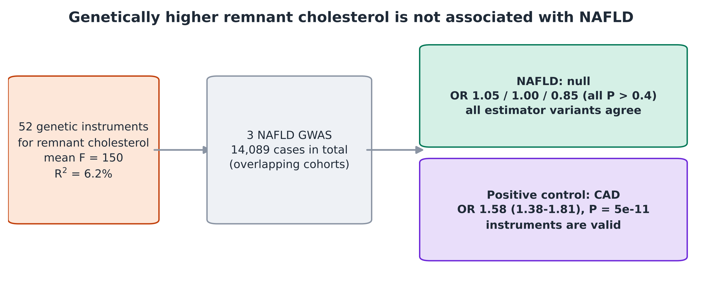
Figure S1. Graphical abstract. Fifty-two genetic instruments for remnant cholesterol were tested against three NAFLD datasets (null) and against coronary artery disease as a positive control (strong association).
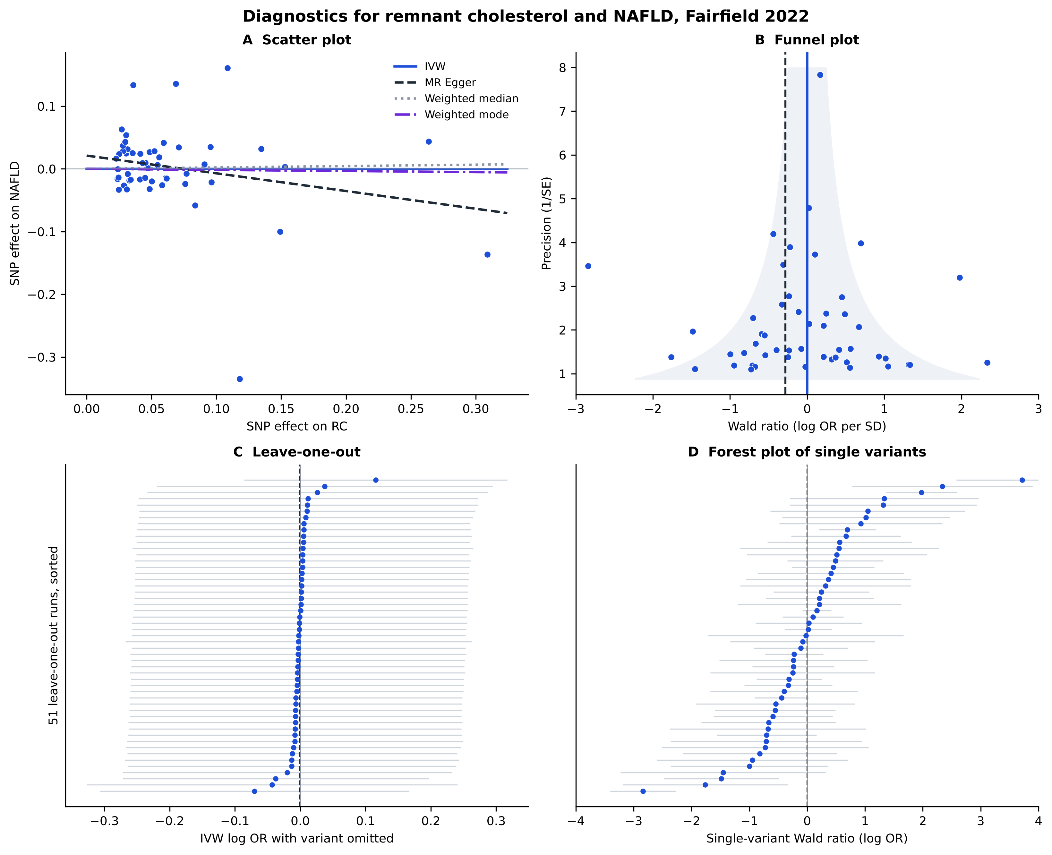
Figure S2. Diagnostics for remnant cholesterol and NAFLD in the Fairfield (UK Biobank) dataset. Panel A: scatter plot with IVW, MR-Egger, weighted median and weighted mode fits; panel B: funnel plot; panel C: leave-one-out; panel D: single-variant forest plot.
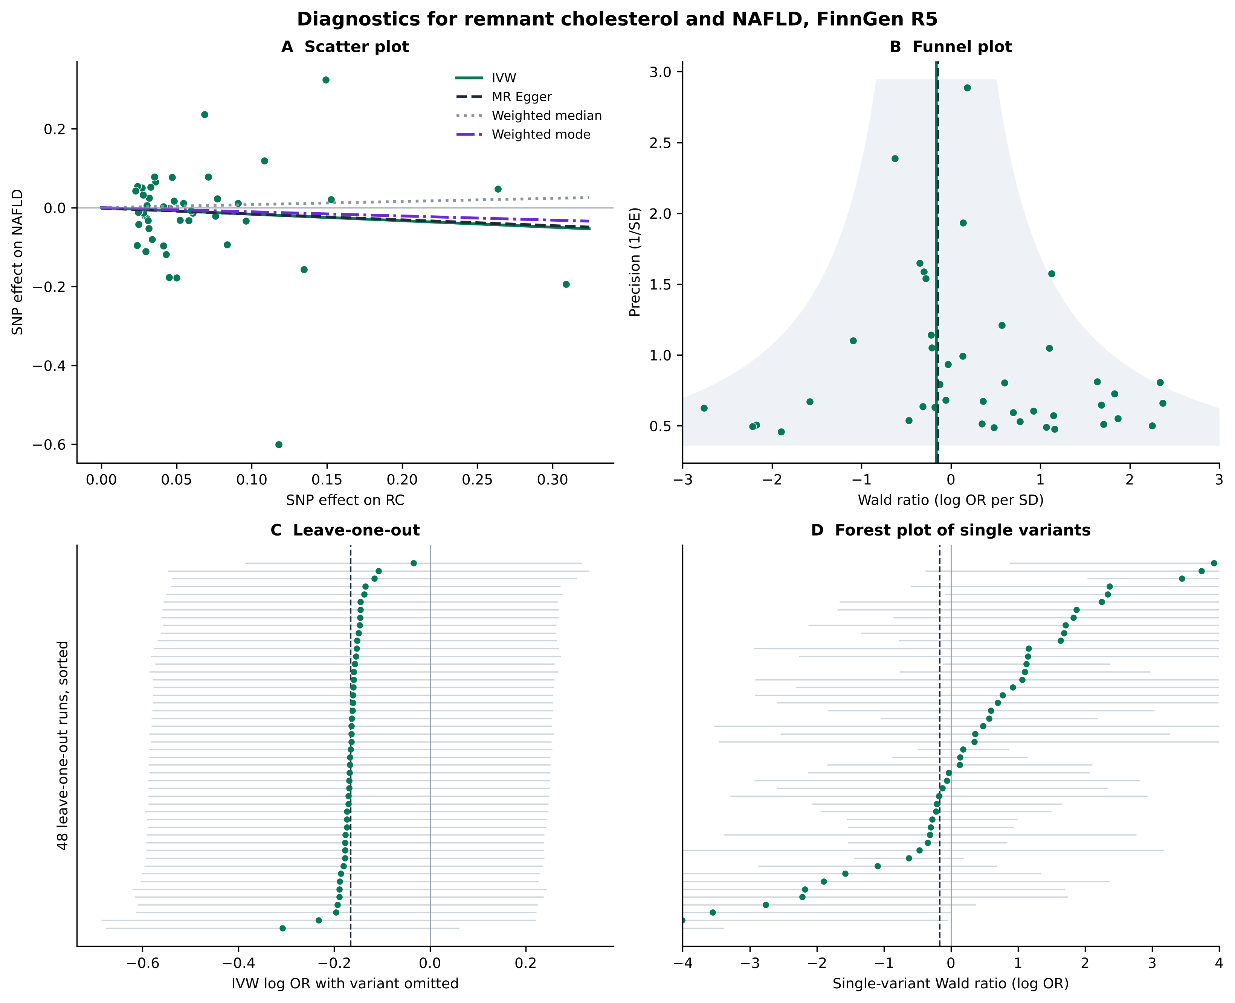
Figure S3. Diagnostics for remnant cholesterol and NAFLD in the FinnGen release 5 dataset. Panels as in Fig. S2. The wide intervals reflect the small number of cases (894).
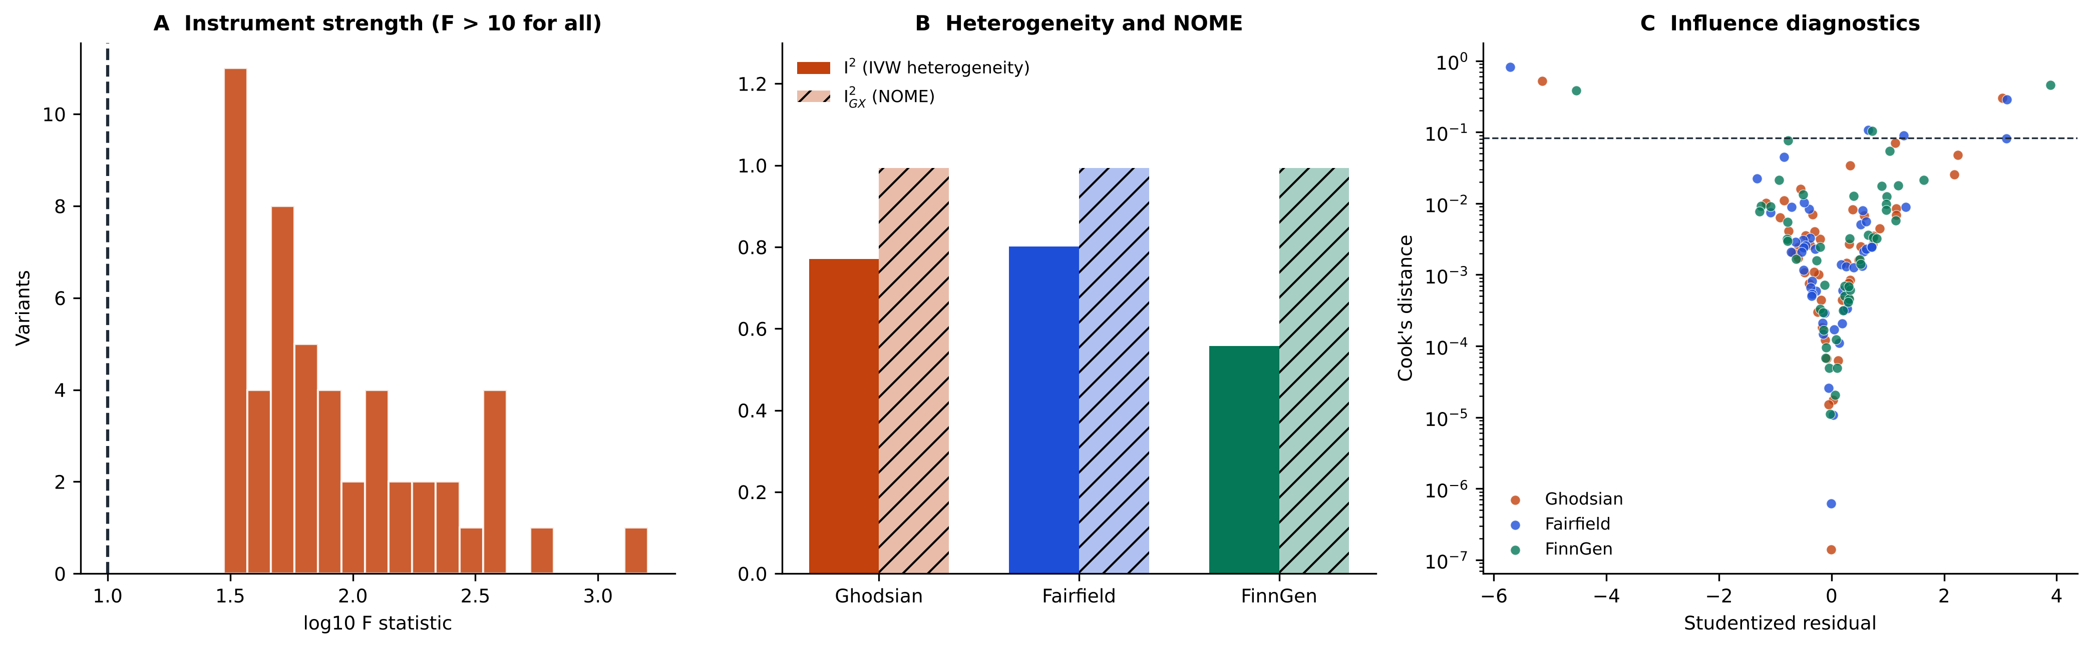
Figure S4. Instrument strength, heterogeneity and influence. Panel A: distribution of per-variant F statistics (dashed line: F = 10). Panel B: I² of the IVW estimate and I²_{GX} of the MR-Egger framework in each dataset. Panel C: studentized residuals against Cook’s distance (dashed line: 4/n); the points above the line are rs58542926 (TM6SF2) and rs112875651 (TRIB1) in all datasets.
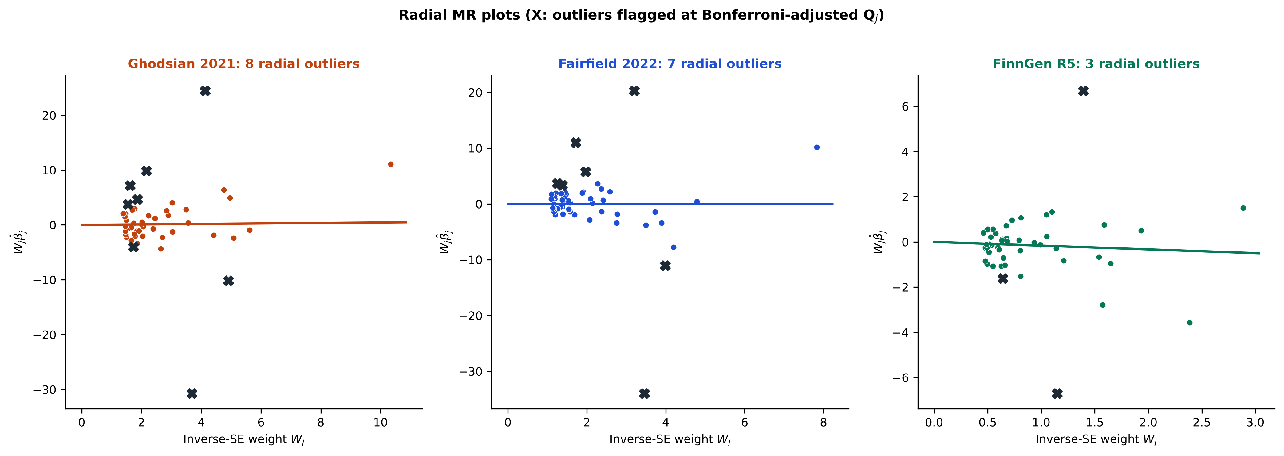
Figure S5. Radial MR plots. Each point is a variant plotted by inverse-standard-error weight and weighted ratio estimate; the line is the radial IVW estimate and crosses mark variants flagged as outliers.
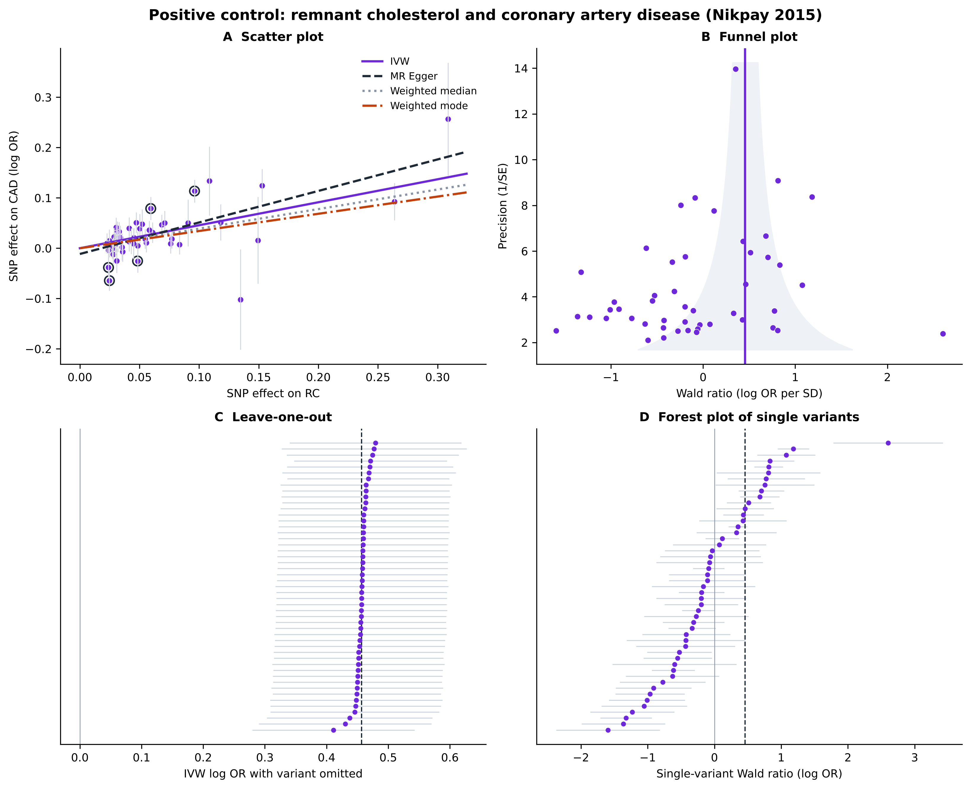
Figure S6. Diagnostics for the positive control (remnant cholesterol and coronary artery disease). Panel A: scatter plot (circled points are MR-PRESSO outliers in the Python analysis); panel B: funnel plot; panel C: leave-one-out analysis, in which no single omission removes the association; panel D: single-variant forest plot.

