ICS344
Project
Hassan Alhassan
202263680

1. Introduction
This report documents the discovery, exploitation, and remediation of security vulnerabilities within the Damn Vulnerable Serverless Application (DVSA) on AWS. Each lesson follows a rigorous 10-part structure to ensure systematic security analysis and verification.
2. Lesson #6: Denial of Service (DoS)
Part 1) Goal and Vulnerability Summary
The goal of this lesson is to demonstrate a Denial of Service (DoS) attack against the billing path. By saturating the /payment endpoint with concurrent requests, an attacker can consume the account's Lambda concurrency limit, making the service unavailable for legitimate checkouts. The main affected component is API Gateway.
Part 2) Why This Works / Root Cause
AWS Lambda functions in an account share a "Regional Concurrency Limit". If the DVSA-ORDER-BILLING function is triggered hundreds of times simultaneously, it "starves" the pool of available executions. Any other user trying to use the app will get a 502, 500, 429 error because there are no resources left to run the code.
Part 3) Environment and Setup
- URL/Endpoint: POST /Stage/payment
- Base URL: https://7XXXXXXXXXXXXXXX.execute-api.us-east-1.amazonaws.com
- Tools: Python script using the threading library and a valid JWT Authorization header.
The URL:
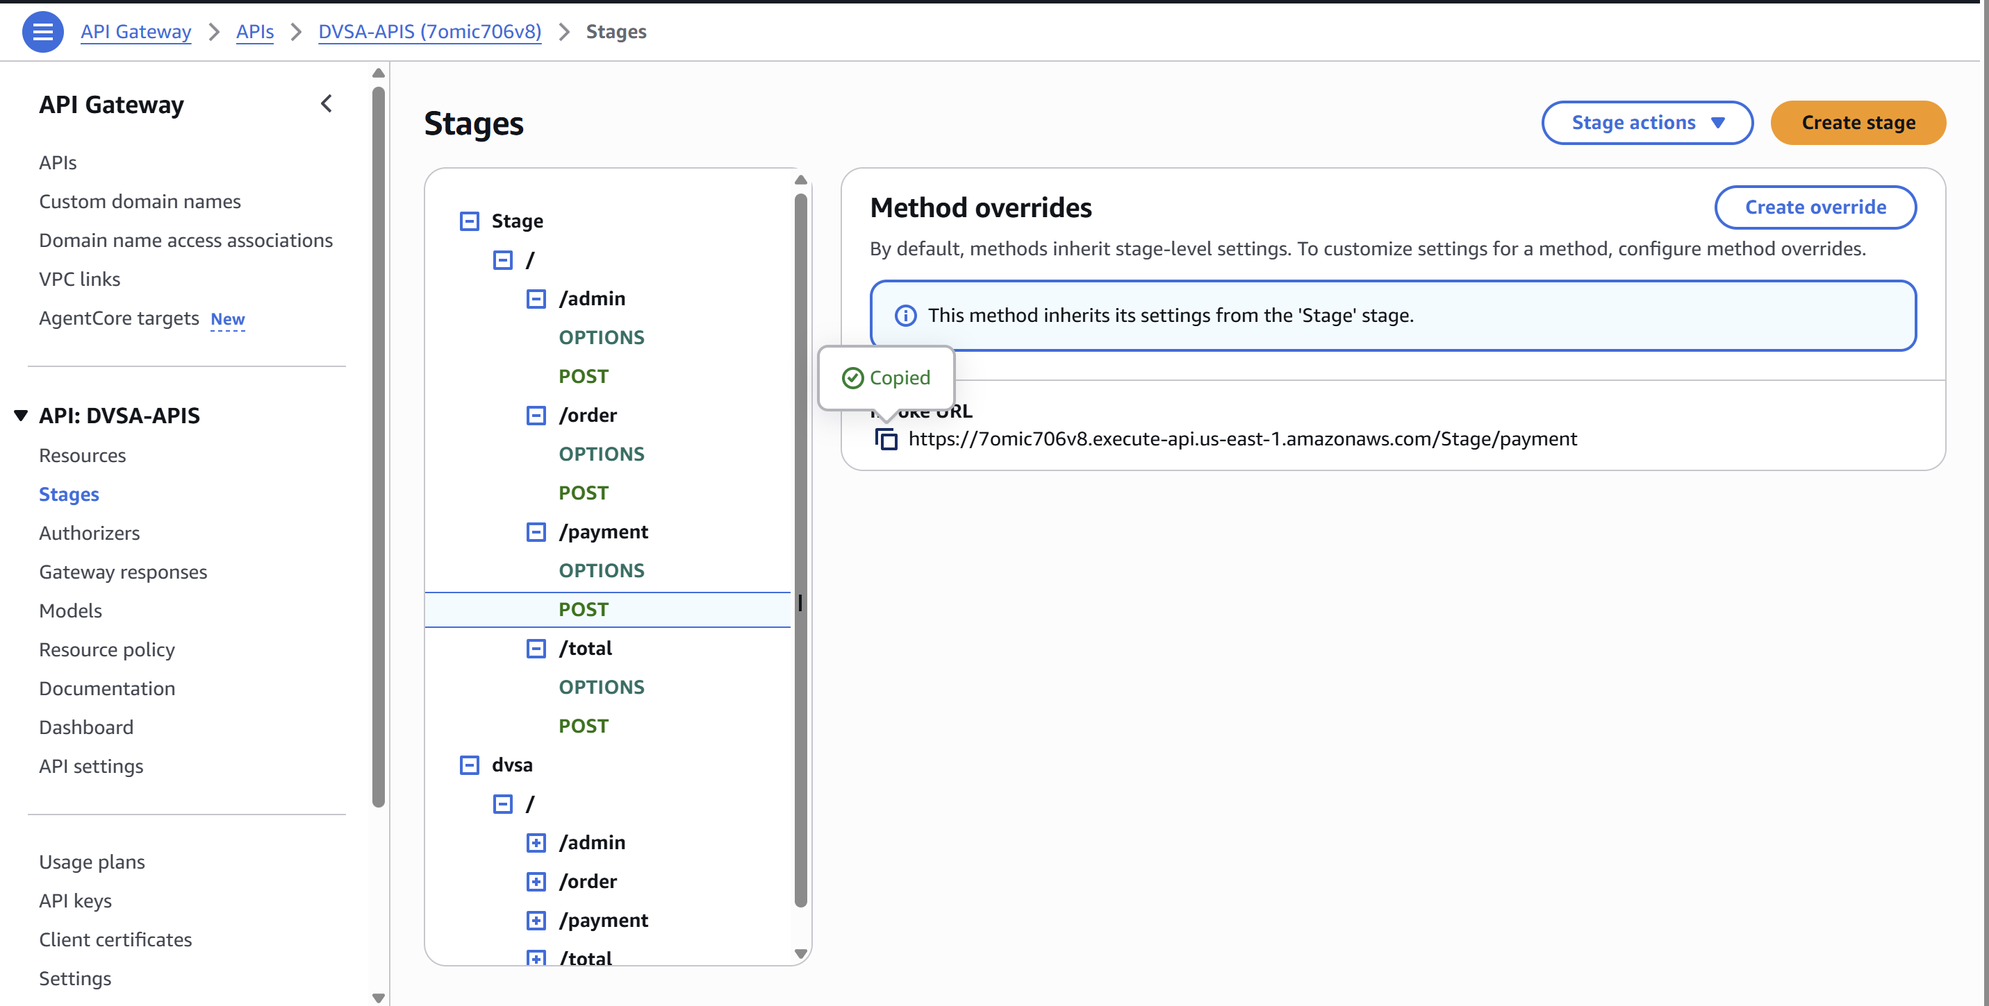
JWT:
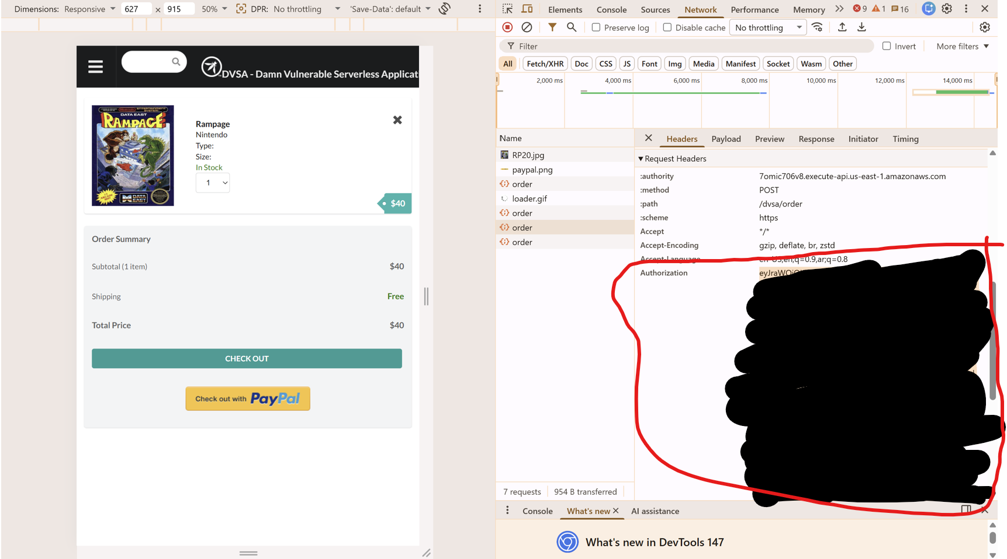

Part 4) Reproduction Steps
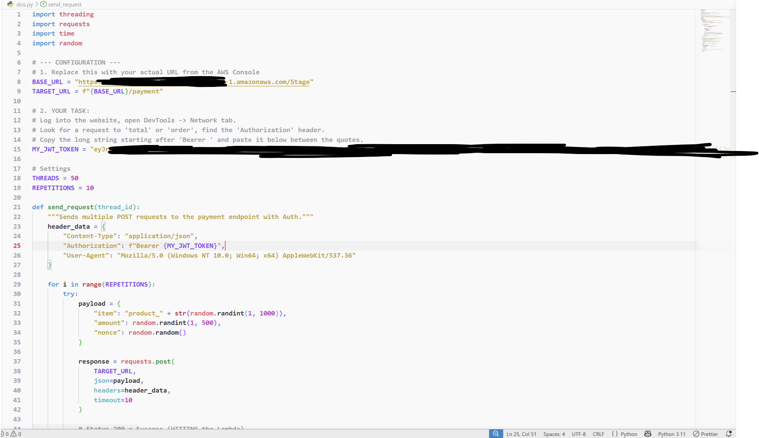
- Log into the application and extract the JWT token from the Browser DevTools.
- Configure the dos_attack.py script with the target URL and the JWT.
- Run the script to initiate 100+ parallel requests.
- While the script is running, attempt to access the /order or /total page in a separate browser tab.

Running script:
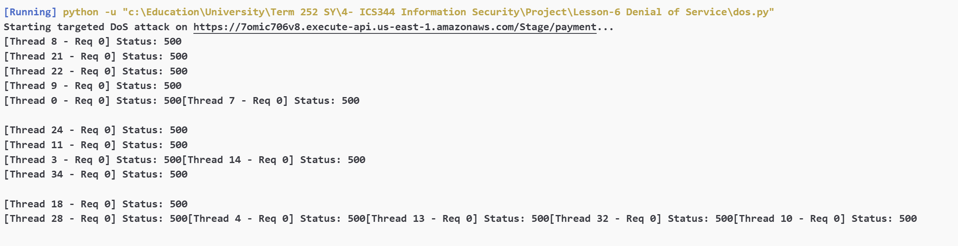

Part 5) Evidence and Proof
- Attacker Side: The script logged repeated requests. Which makes the system slow.
- User Experience: The legitimate browser request to /order hung indefinitely since the server is experiencing many requests.
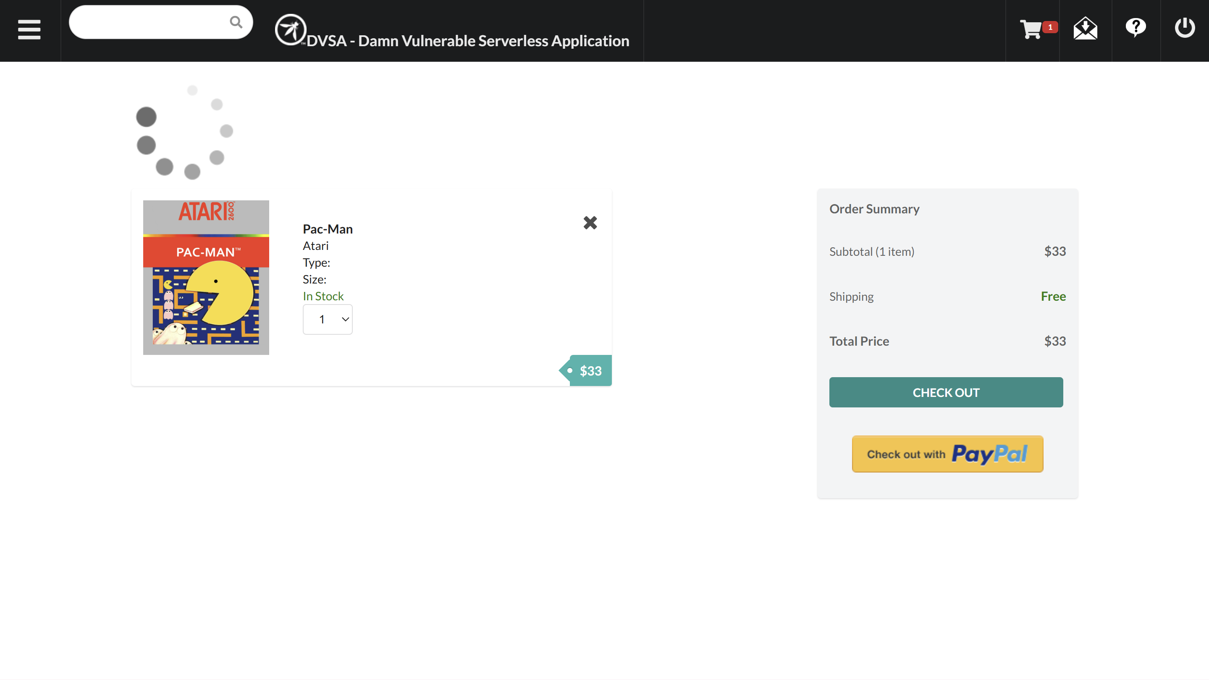
Part 6) Fix Strategy / Probable Mitigation
The root cause of the vulnerability is the absence of request control, allowing an attacker to send an excessive number of concurrent requests that overwhelm the Lambda backend. This leads to resource exhaustion and backend failures (500/502), affecting legitimate users.
Implementing API Gateway throttling and usage plans introduces rate limiting at the entry point of the system, ensuring that only a controlled number of requests are forwarded to the backend. Excess requests are rejected early with HTTP 429 responses, preventing overload of Lambda resources.
This mitigation addresses the root cause by enforcing fair usage, protecting limited backend capacity, and shifting failure handling from the backend to the gateway layer, thereby maintaining system stability and preventing service degradation for legitimate users.

Part 7) Code / Config Changes
- Go to API Gateway
- Choose stages from left side
- Click edit
- Enable Throttling
- Set rate to 10 and burst to 5

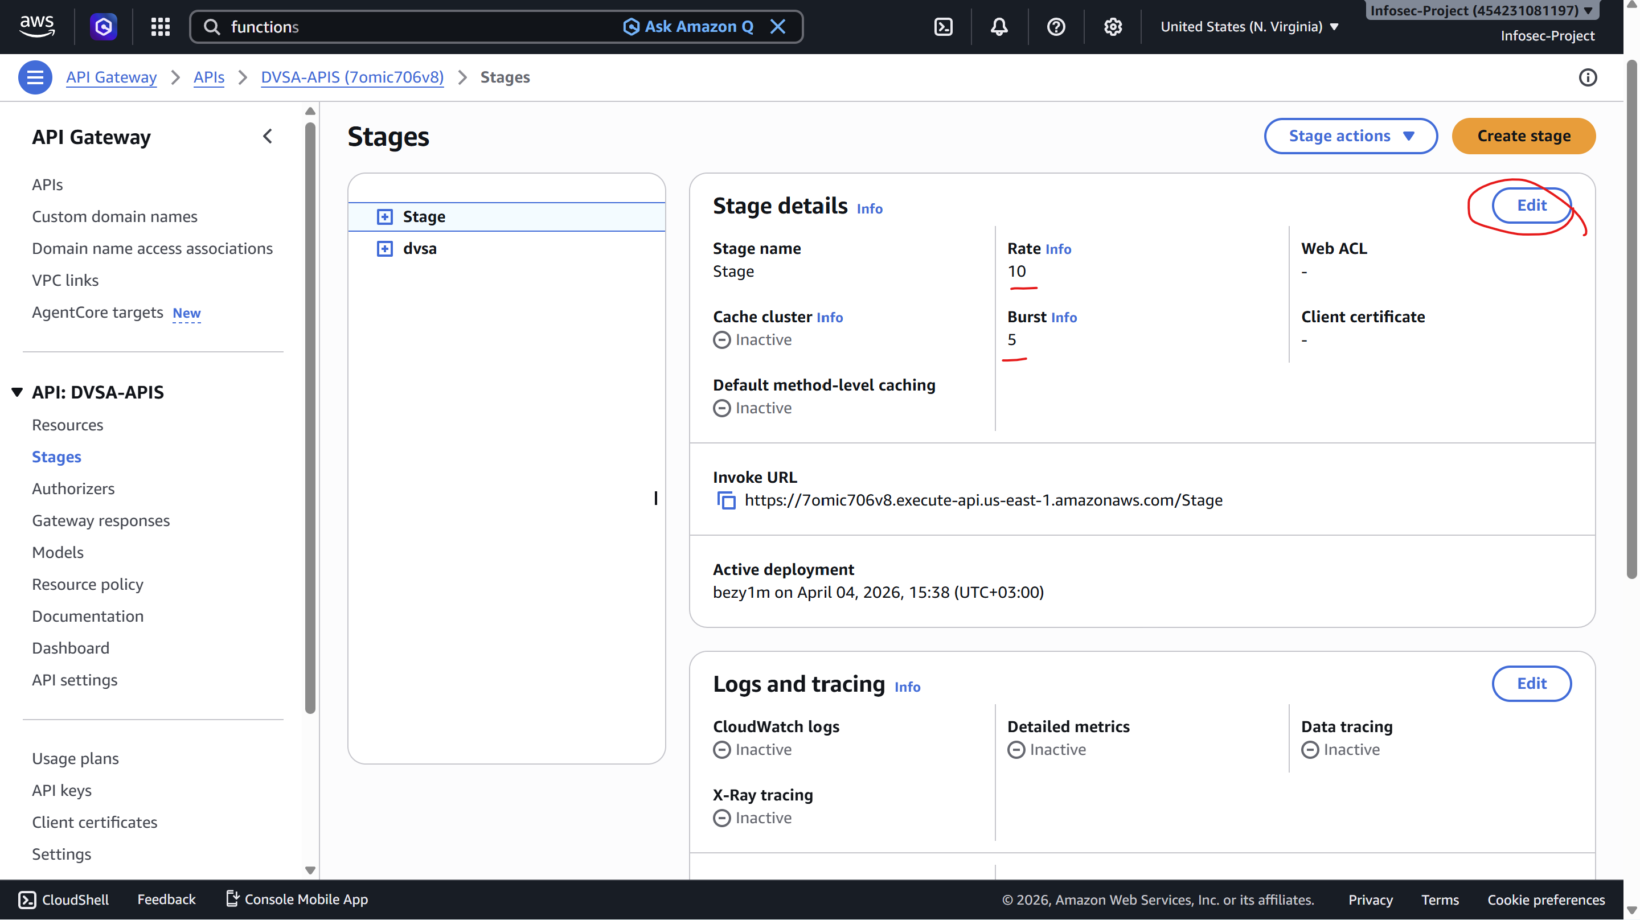
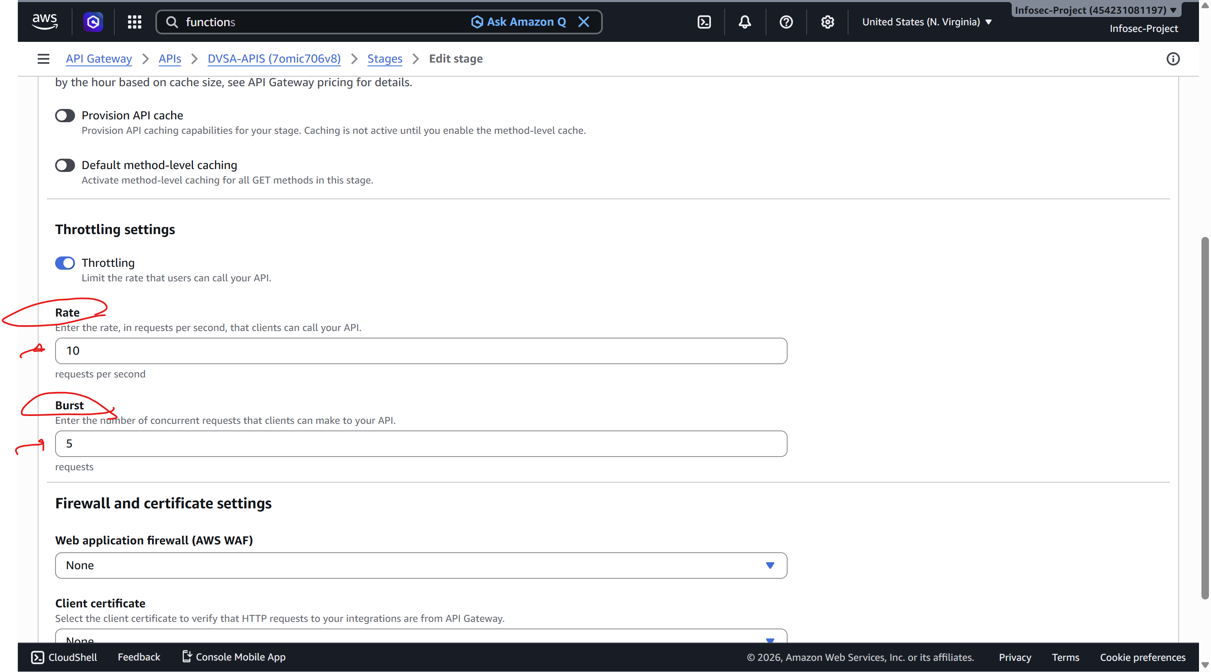
Part 8) Verification After Fix
After enable the throttling and setting rate to 10 and burst to 5, attacker no longer could overwhelm the lambda function that slows down the payment process for the users. Now, the users could continue their payment process normally even during the attack.

Previously, we were stuck here:
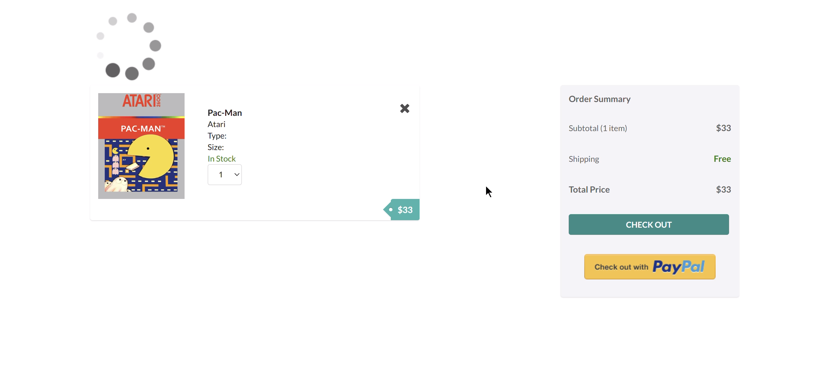
Now, we could continue in the payment process:
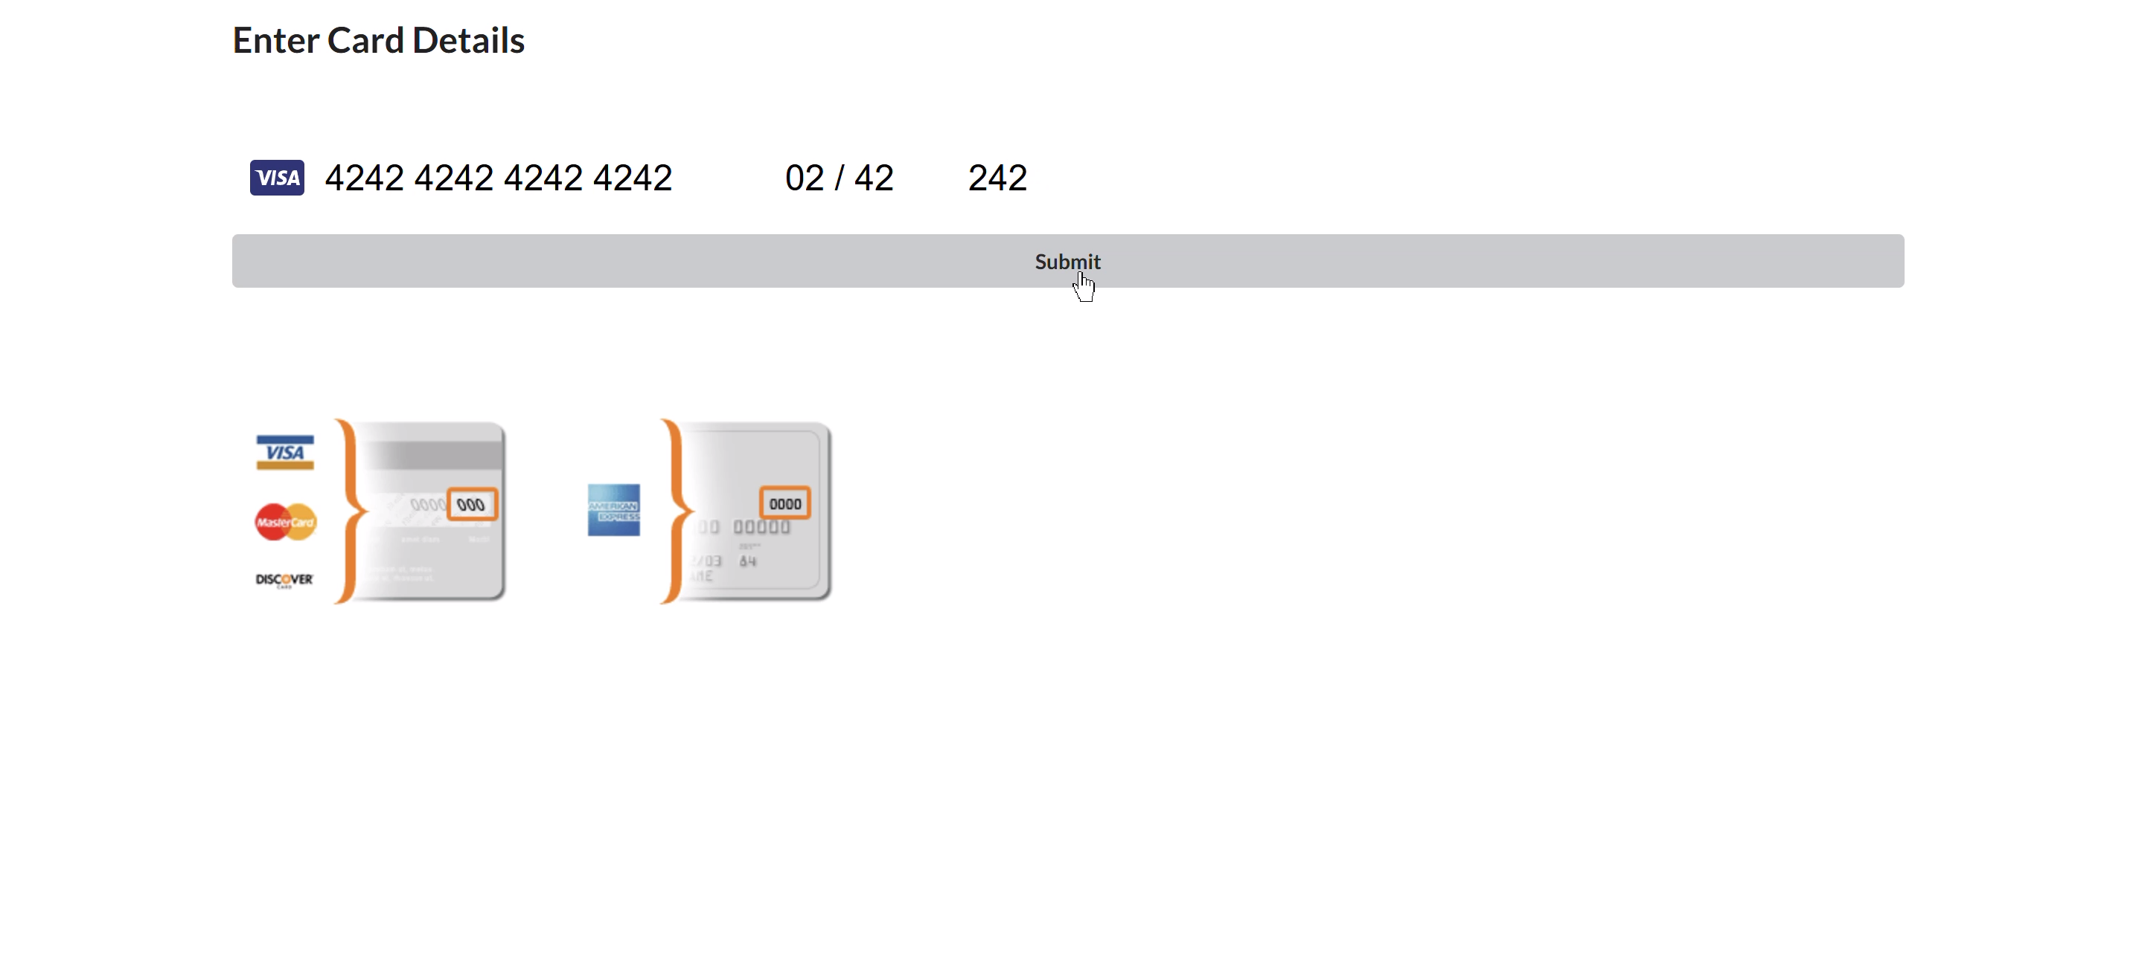
Successful payment:
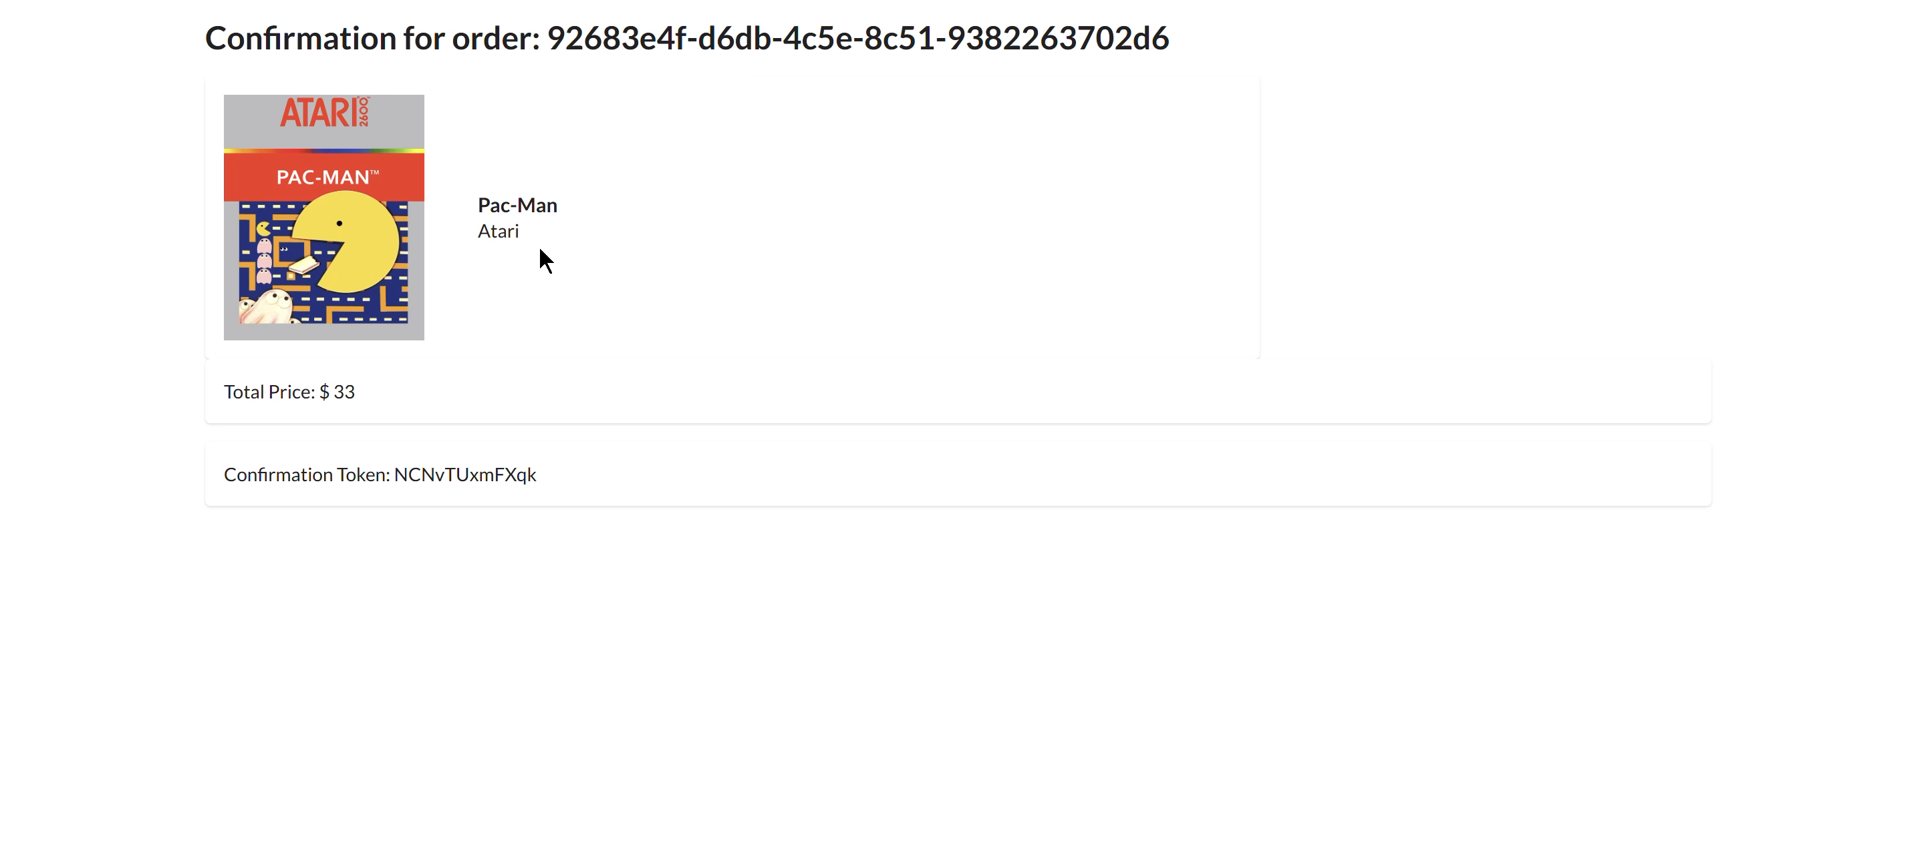
Part 9) Structured Operation and Security Analysis
1. Intended Logic and Security Rule(s)
The /payment endpoint is invoked by an authenticated user completing a checkout. The main actor is the DVSA frontend client, authenticated via a valid JWT. The request hits API Gateway (POST /Stage/payment), which forwards it to the DVSA-ORDER-BILLING Lambda. The expected flow is: one user submits one payment request → API Gateway validates the JWT → Lambda processes the order → a success response is returned. No rate control mechanism was configured, so the implicit assumption was that users would issue requests at a natural, human pace.
Security Rules:
- The payment endpoint must not allow a single actor to monopolise the shared Lambda concurrency pool.
- Excess or abusive request volume must be rejected at the API layer before reaching the backend.
2. Evidence Sources and Behavior Trace
Artifacts used: Python threading script (terminal output) and browser DevTools (JWT extraction, slow page load).
Condition | Observed Behavior
Normal | Authenticated user POSTs to /payment → Lambda executes within ~1–5s → 200 OK returned → checkout completes.
Exploit | 100 concurrent threads flood /payment → Lambda concurrency pool exhausted → legitimate user's checkout request returns 500/502 or hangs indefinitely.
Post-fix | 100 concurrent threads flood /payment → API Gateway throttle rejects flood with 429 → legitimate user's checkout completes normally with 200 OK.
3. Deviation Analysis and Classification
The exploit violates the rule that no single actor should monopolise shared backend capacity. By firing 100+ parallel requests, the attacker saturates that pool, leaving zero capacity for legitimate users. The evidence is direct: the browser tab for a normal checkout hangs indefinitely while the script is running, and when script is not running, user could proceed. This is not a code bug — the application logic is correct. The vulnerability exists purely because no request ceiling was enforced at the entry point.
Deviation Class: Intentional misuse / security-relevant abuse — the attacker deliberately exploits the absence of rate limiting to cause availability failure.
4. Explainable Fix and Post-Fix Validation
Wrong assumption: That authenticated users will only send payment requests at a natural pace, making rate limiting unnecessary.
Where the fix belongs: API Gateway — Stage-level throttling on the endpoints of the stage.
Exact change: Rate set to 10 requests/second, Burst set to 5. Excess requests receive 429 Too Many Requests immediately, never reaching Lambda.
Post-fix confirmation: Re-running the 100-thread script produces a flood of 429 responses in the terminal. Simultaneously, a legitimate browser checkout completes successfully — confirming that the throttle selectively blocks the flood without disrupting normal usage.

Table-1:
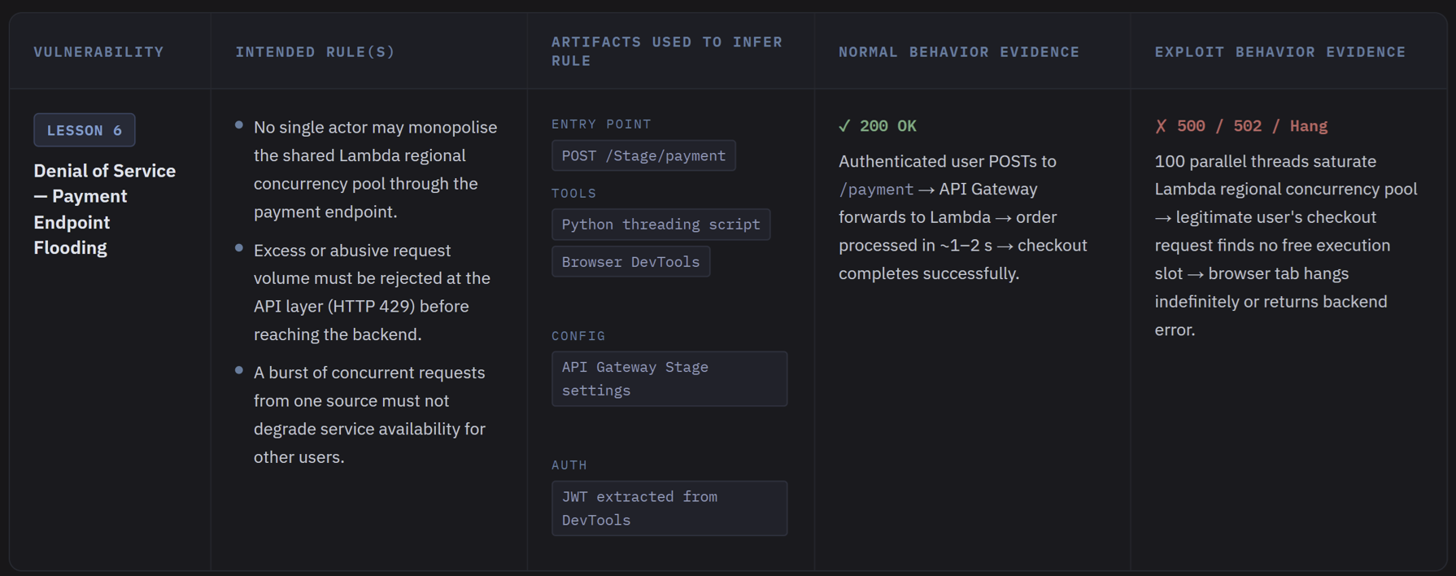

Table-2:
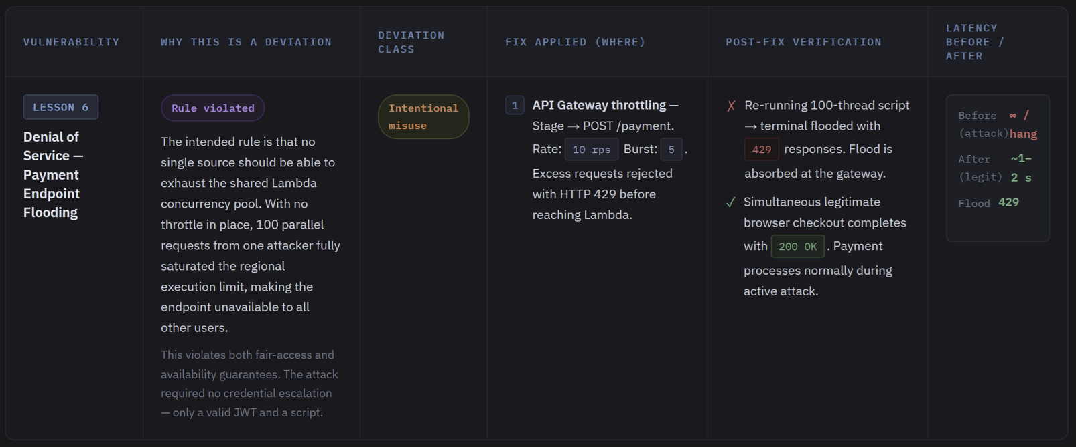

Part 10) Explainable Fix and Post-Fix Validation
The core flawed assumption here was that authentication is sufficient protection — if a user has a valid JWT, their request volume must be reasonable. In a serverless environment this assumption is especially dangerous because Lambda has no built-in per-caller fairness. One authenticated attacker is indistinguishable from one thousand concurrent legitimate users at the backend level; the concurrency pool does not care who holds the token.
The wider lesson is that availability is a security property, not just an operational concern. In serverless architectures, compute is elastic but concurrency is bounded, and the boundary is shared across all functions in the account. A single unthrottled endpoint can therefore act as an account-wide denial-of-service vector, not just a local one.
The general principle is enforce limits at the earliest possible layer. Rate limiting belongs at the API Gateway, not inside the Lambda function, because by the time Lambda is invoked the damage is already done. Throttles, burst caps, and per-user quotas must be designed in from the start — they cannot be retrofitted cheaply once the system is under attack.

