ICS344
Project
Lesson-8 Logic Vulnerabilities
Hassan Alhassan

Lesson #8: Logic Vulnerabilities (Race Condition)
Part 1) Goal and Vulnerability Summary
The goal is to exploit a Race Condition in the order-processing workflow. By sending a billing request and an order-update request almost simultaneously, the attacker aims to pay the price for one item but receive five. The main affected components are the AWS Lambda (the processing logic) and Amazon DynamoDB (the state storage). The main weakness lies in the lack of atomic state management
Part 2) Why This Works / Root Cause
The root cause is a lack of Atomic Operations and State Locking. The application reads the price at the start of the "Billing" function but doesn't verify that the order hasn't changed before writing the "Paid" status to the database. There is a "window of opportunity" between the price calculation and the final database update where the order content can be swapped.
Part 3) Environment and Setup
- Endpoints: POST /payment (Billing) and Post /order (Update).
- Target: An open order with 1 item.
- Tool: Python threading script to achieve near-simultaneous execution.
- Services: AWS Lambda & DynamoDB.
Part 4) Reproduction Steps
- Press F12 to see traffic.
- Add 1 item to your cart.
- Click checkout after choosing the desired quantity.
- Enter shipping information then submit.
- Open the Python script race_exploit.py.
- Set the orderId, the base_url and your JWT_TOKEN.
- Run the script. It will trigger the payment for 1 item and immediately try to update the quantity to 5.
- Check the DynamoDB DVSA-ORDERS-DB table.

Adding the item to the cart:
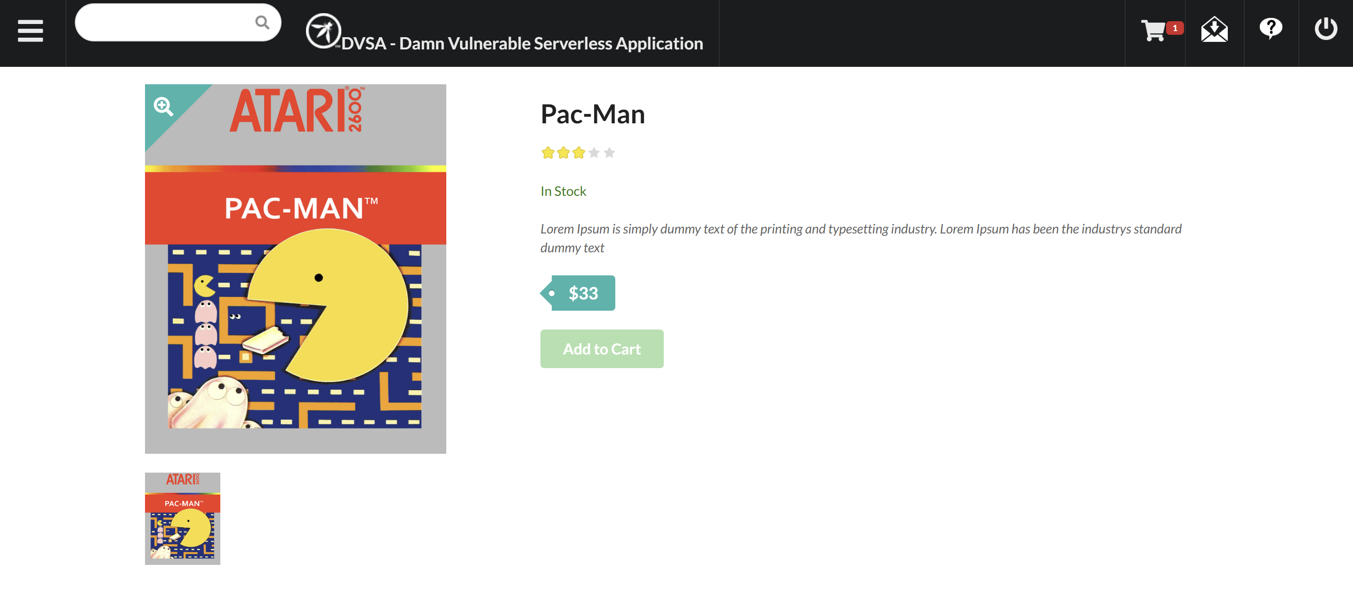
Checking out the item:
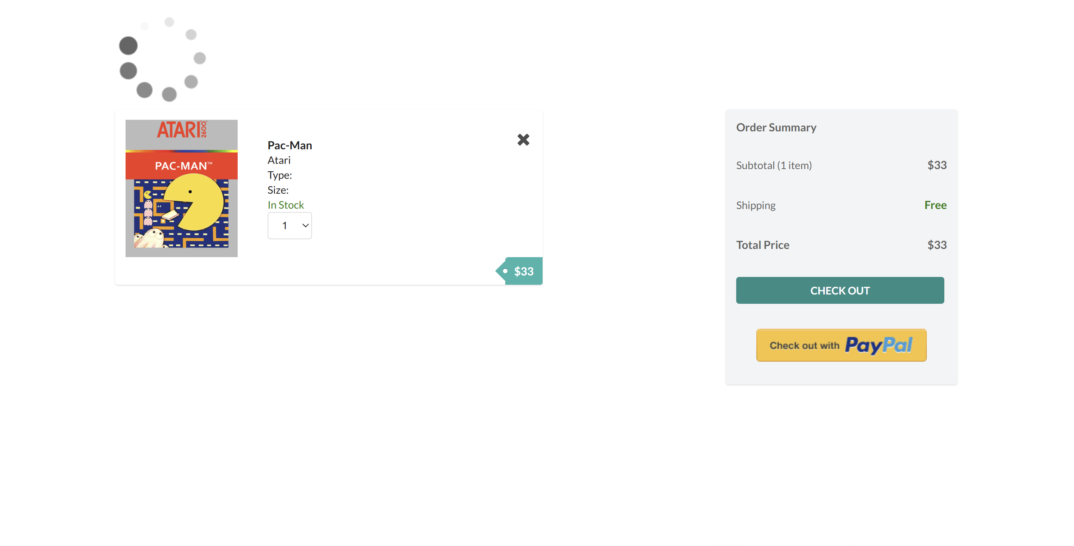
Submitting shipping details:
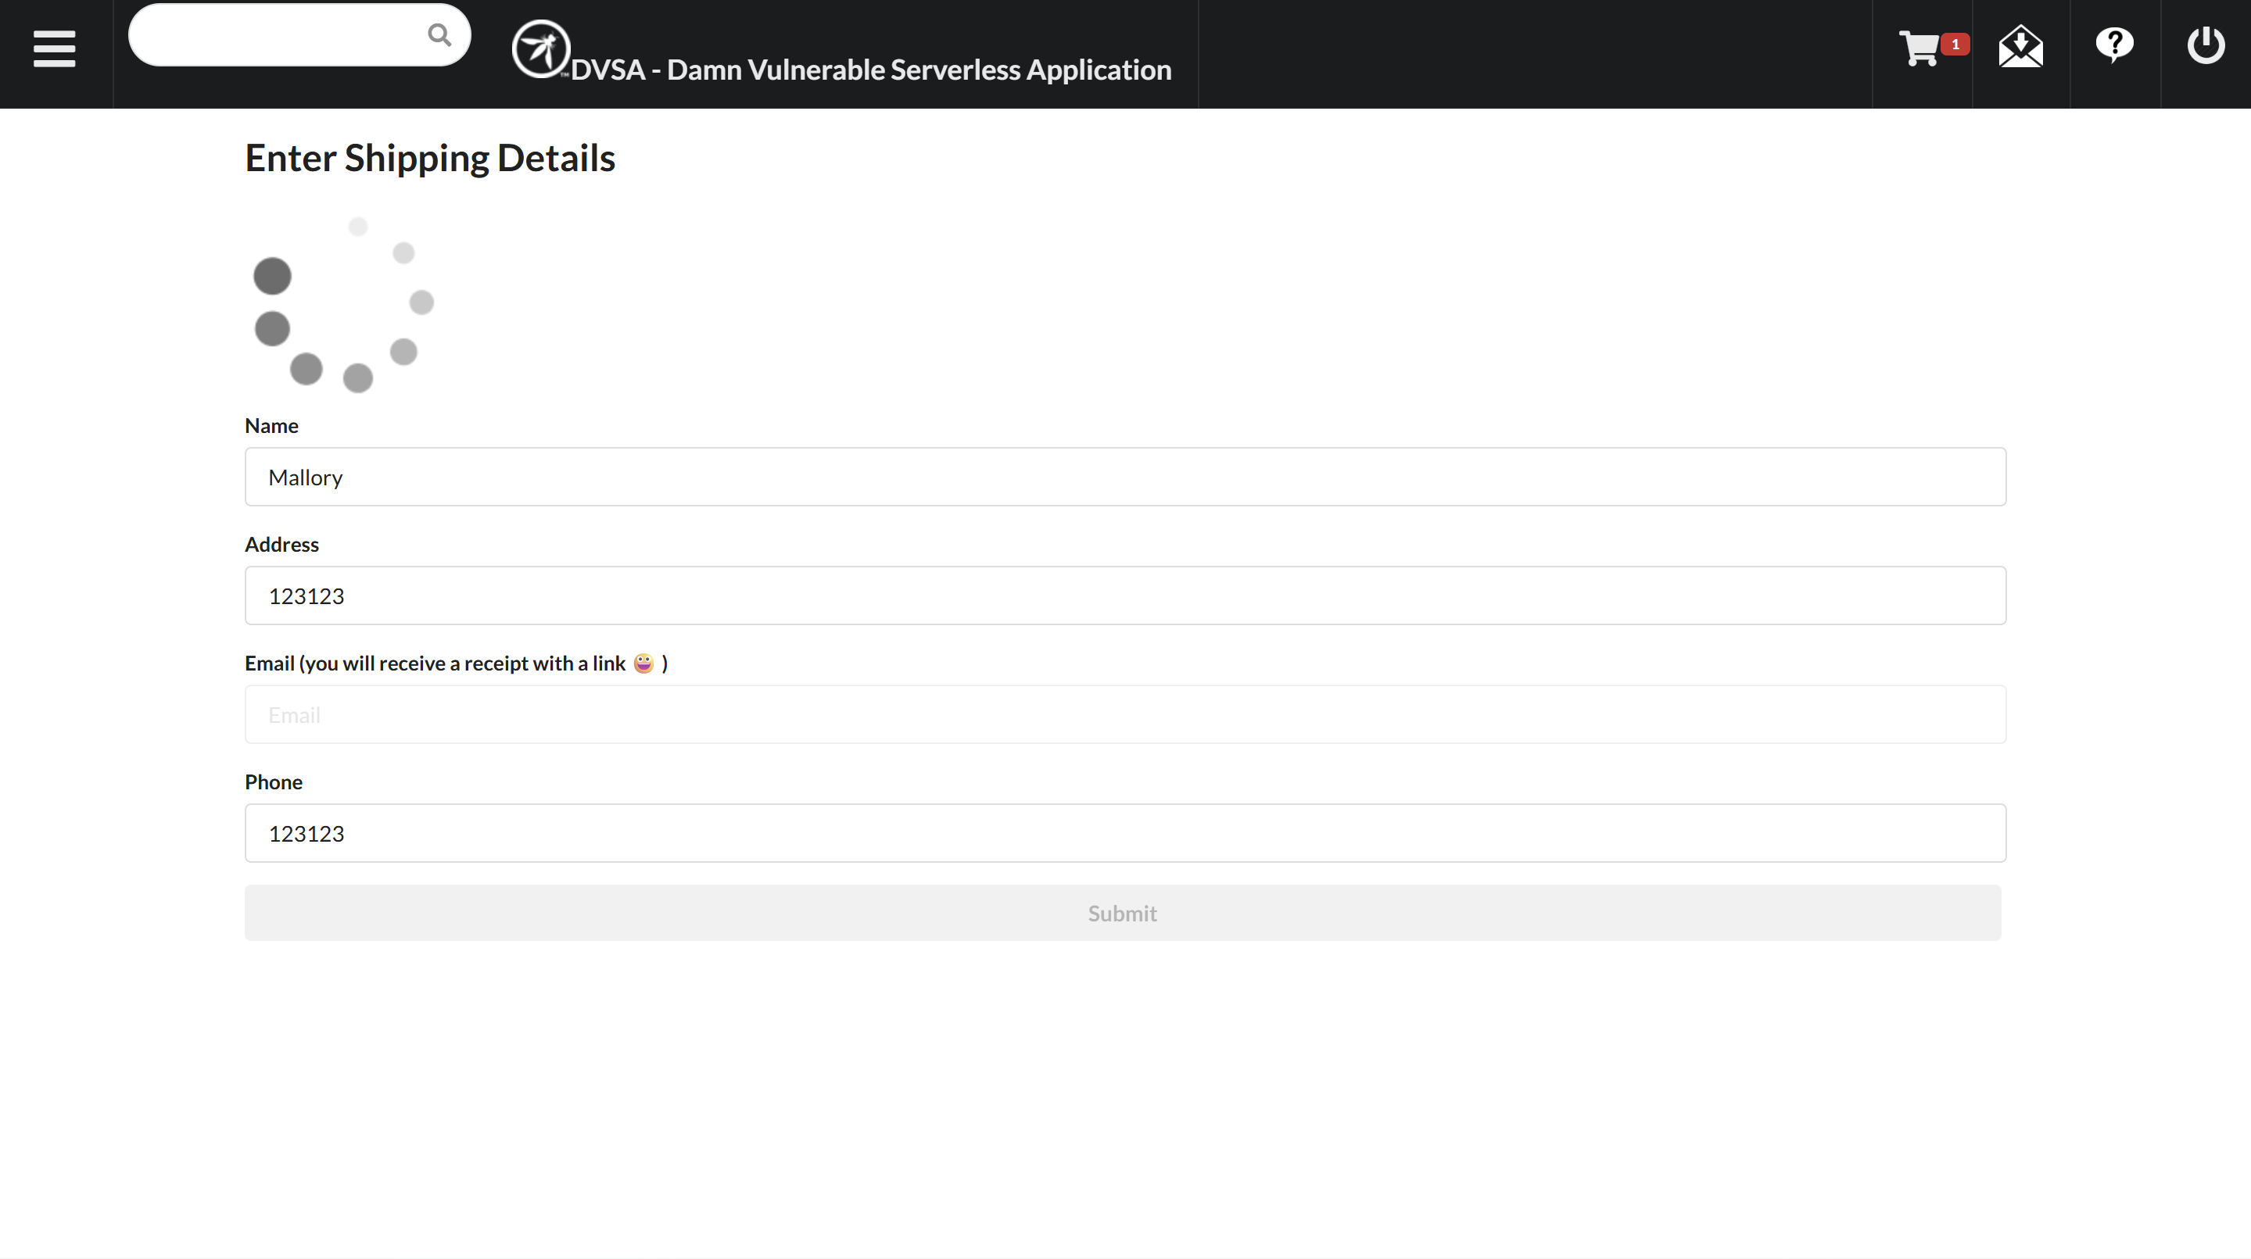
Card details page:
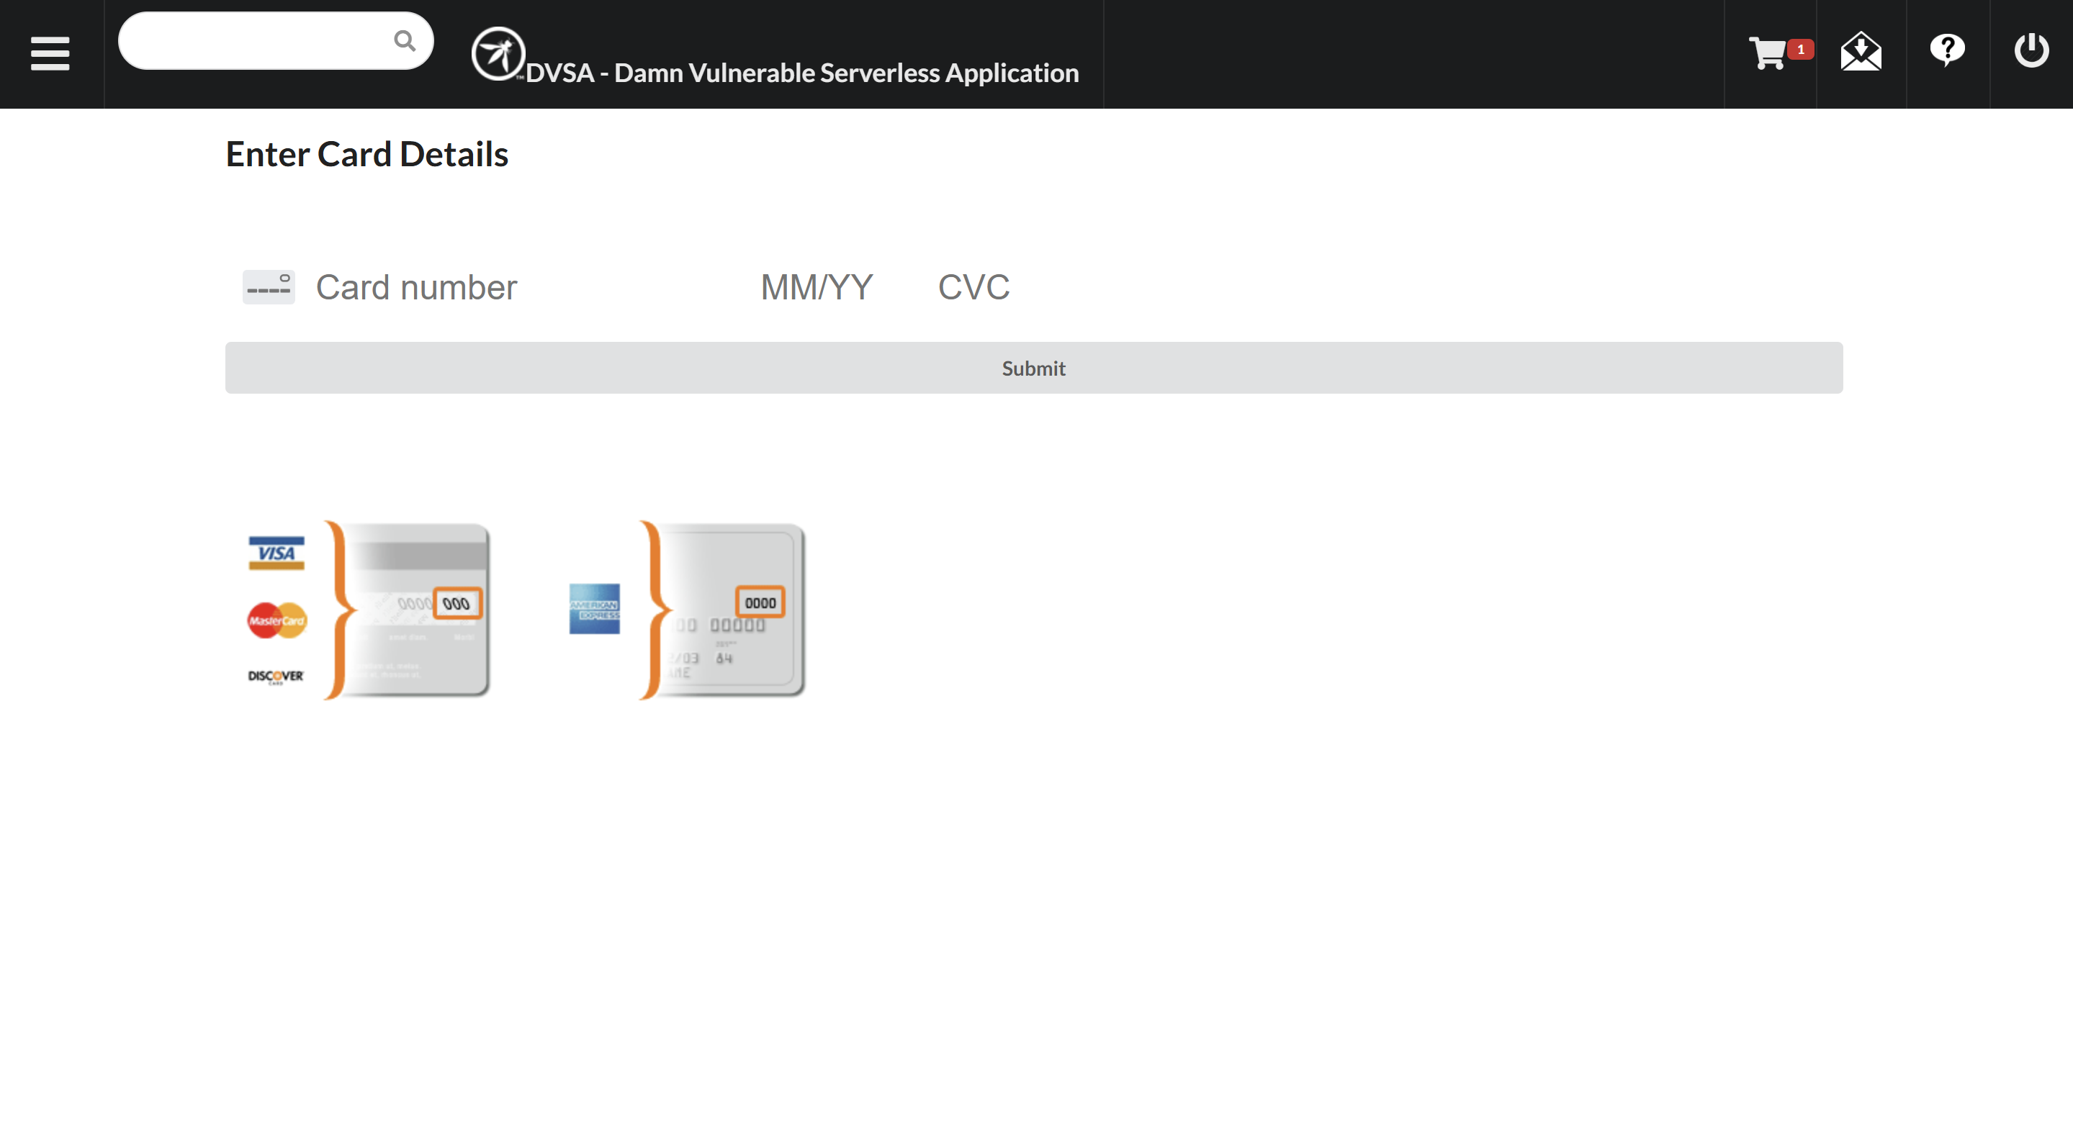

Order_id:
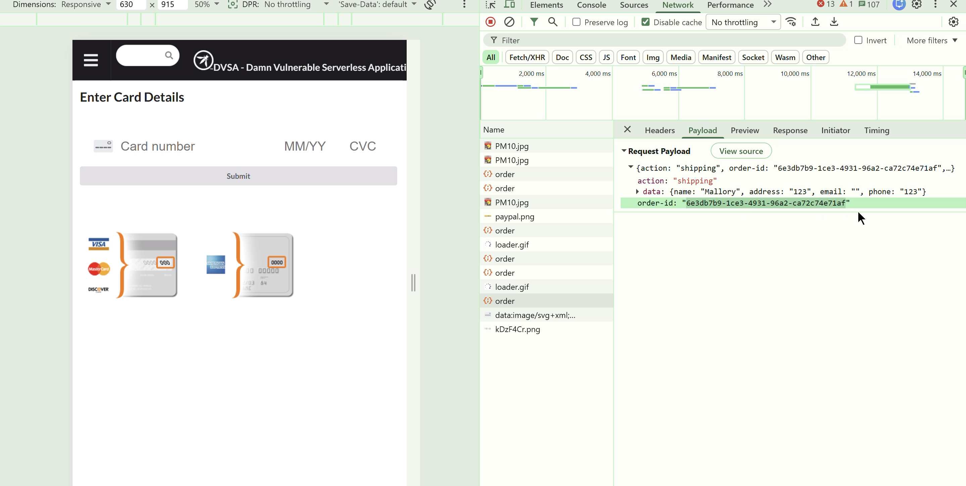

Part 5) Evidence and Proof
- Successful Exploitation: DynamoDB Shows that we have ordered 5 items at the price of only one which his 33$.

Successful run of the script:
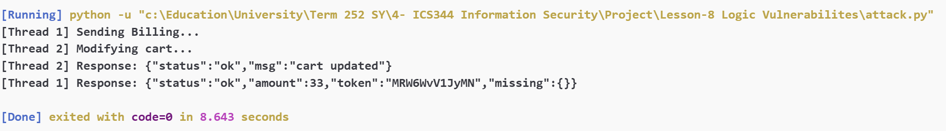

Ordered 5 items:

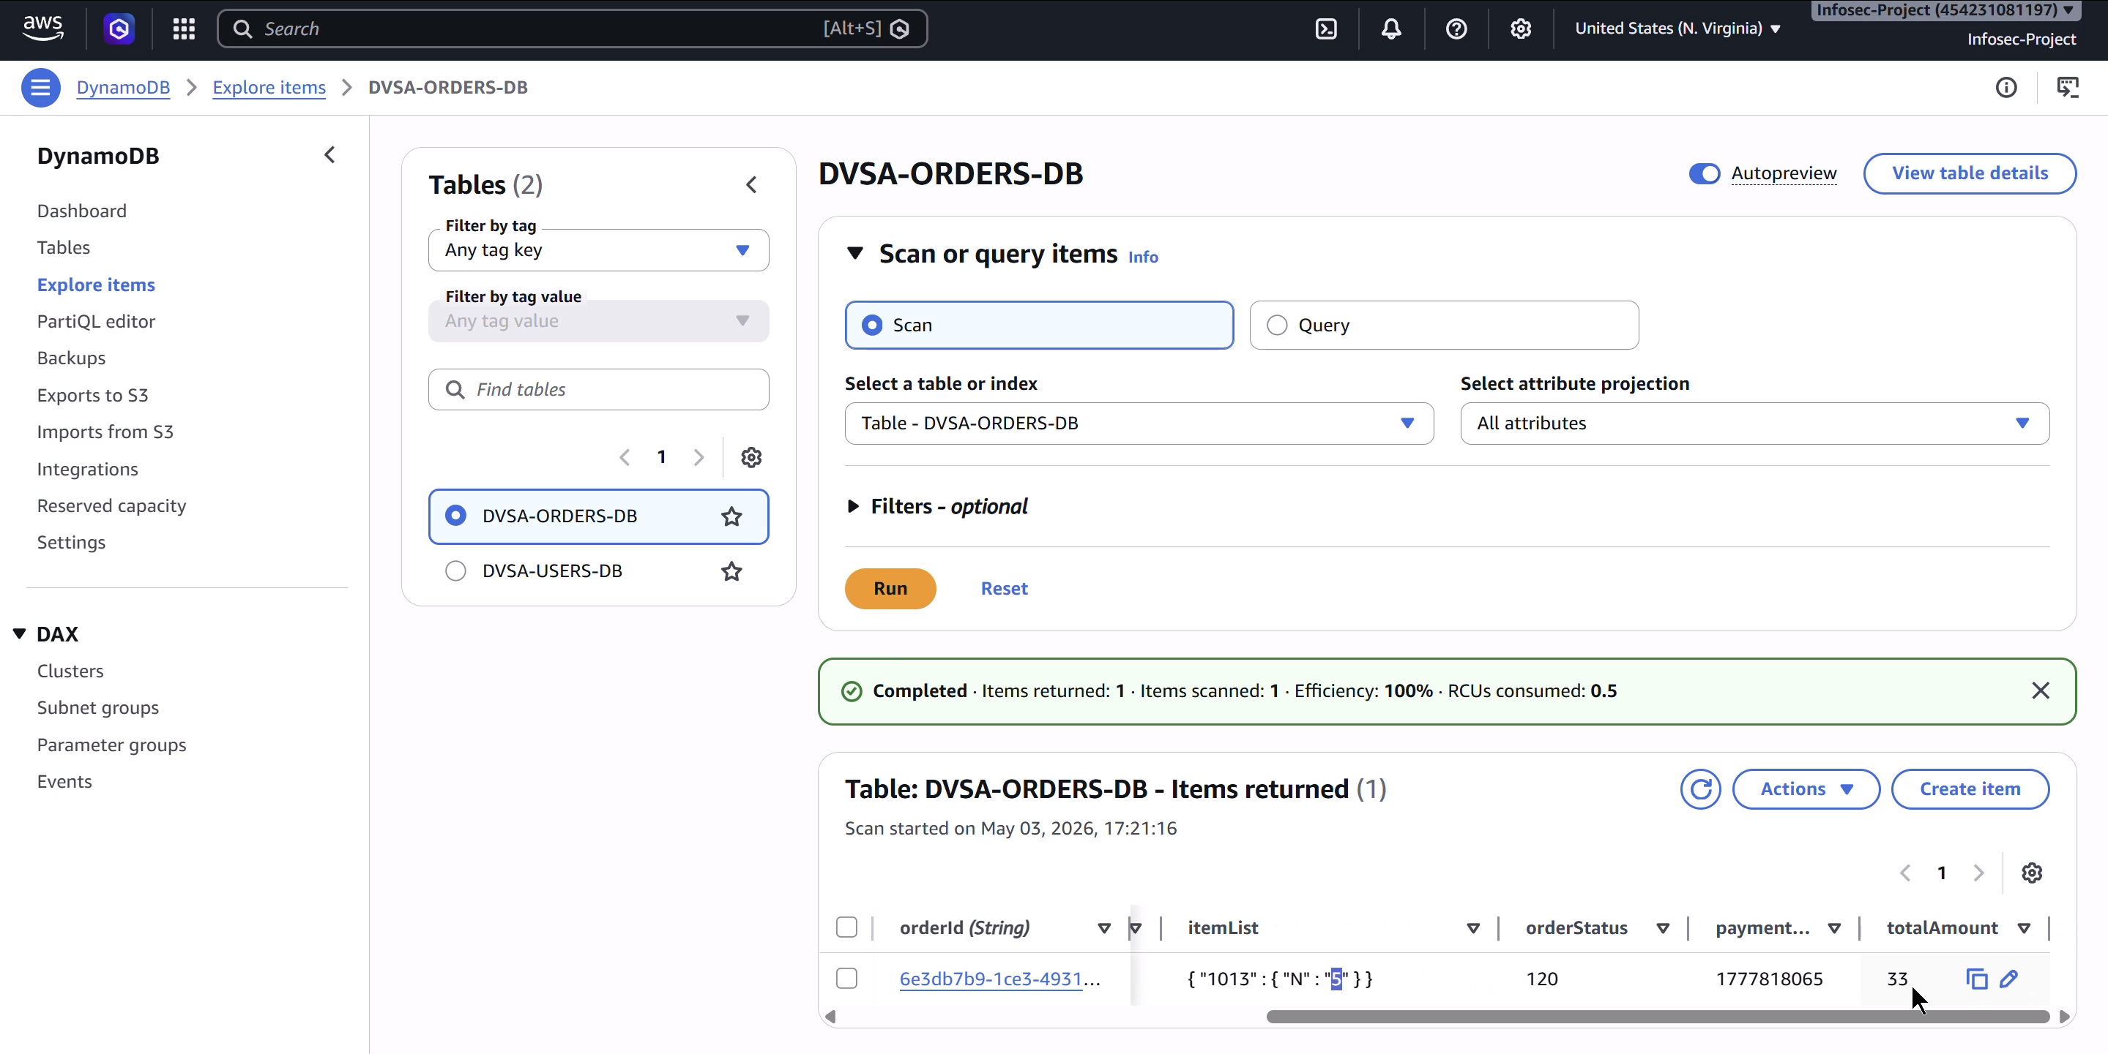

Part 6) Fix Strategy / Probable Mitigation
The fix belongs in the backend AWS Lambda functions that handle order billing and order updates, specifically DVSA-ORDER-BILLING and DVSA-ORDER-UPDATE. The main security improvement is to add atomic state locking in DynamoDB so that once payment starts, the order cannot be modified anymore.
The mitigation works by introducing a temporary locked state for the order. Before the billing process calculates the total or sends payment details, the billing Lambda changes the order status from 100 open to 105 billing in progress. This change is done using a DynamoDB conditional update, which means the lock only succeeds if the order is still open.
The update Lambda was also changed so that cart updates are allowed only when the order status is exactly 100. If the order is locked, paid, or already being processed, the update request is rejected.
This addresses the root cause because the vulnerability happened due to a race condition between payment and cart modification. Previously, the attacker could modify the item quantity while billing was already running. With the new logic, once billing starts, the order becomes locked and the update Lambda is no longer allowed to change the item list.

Part 7) Code / Config Changes
The fix was applied to two AWS Lambda functions:
- DVSA-ORDER-BILLING
- DVSA-ORDER-UPDATE
The main change was adding DynamoDB conditional updates to enforce order state transitions safely.
Change 1: Billing Lambda lock added
In the DVSA-ORDER-BILLING Lambda function, I added an atomic lock at the start of the function.
Before the fix, the billing function retrieved the order and continued processing as long as the status was less than 120:
response = table.get_item(
Key={
"orderId": orderId,
"userId": userId
},
AttributesToGet=['orderId', 'orderStatus', 'itemList']
)
status = int(json.dumps(response["Item"]['orderStatus'], cls=DecimalEncoder))
if status < 120:

This was unsafe because the order could still be updated while the billing function was calculating the price and processing payment.
After the fix, the billing Lambda first locks the order using a DynamoDB conditional update:
try:
table.update_item(
Key={
"orderId": orderId,
"userId": userId
},
UpdateExpression="SET orderStatus = :locked",
ConditionExpression="orderStatus = :open",
ExpressionAttributeValues={
":locked": 105,
":open": 100
}
)
except ClientError as e:
return {
"status": "err",
"msg": "Order is already being processed or locked"
}
This means the billing process can only start if the order is still open. Once billing starts, the order status becomes 105, which represents billing in progress.
Change 2: Billing final update protected
In the DVSA-ORDER-BILLING Lambda function, I also protected the final payment update.
Before the fix, the payment result was written without confirming that the order was still in the expected state:
response = table.update_item(
Key=key,
UpdateExpression=update_expression,
ExpressionAttributeValues=expression_attributes
)
After the fix, the final update only succeeds if the order is still locked:
table.update_item(
Key=key,
UpdateExpression=update_expression,
ConditionExpression="orderStatus = :locked",
ExpressionAttributeValues={
**expression_attributes,
":locked": 105
}
)
This prevents unexpected state changes from being accepted during the payment workflow.
Change 3: Update Lambda now only allows open orders to change
In the DVSA-ORDER-UPDATE Lambda function, the original logic checked whether the order status was greater than 110:
if response["Item"]["orderStatus"] > 110:
res = {"status": "err", "msg": "order already paid"}
return res
This was incorrect because the new locked status is 105, and 105 > 110 is false. Therefore, the attacker could still update the order while billing was in progress.
After the fix, I removed the separate read/check logic and replaced it with one atomic DynamoDB update:
try:
response = table.update_item(
Key={
"orderId": orderId,
"userId": userId
},
UpdateExpression="SET itemList = :itemList",
ConditionExpression="orderStatus = :open",
ExpressionAttributeValues={
":itemList": itemList,
":open": 100
},
ReturnValues="UPDATED_NEW"
)
return {
"status": "ok",
"msg": "cart updated"
}
except ClientError as e:
if e.response["Error"]["Code"] == "ConditionalCheckFailedException":
return {
"status": "err",
"msg": "order is locked, paid, or not editable"
}
return {
"status": "err",
"msg": "could not update cart"
}
Now, the update Lambda only allows the cart to be modified when orderStatus is exactly 100. If the billing Lambda has already changed the status to 105, the update request fails.
Summary of Security Logic Added
The following order state was added:
105: billing in progress / locked
The new secure workflow is:
Open order: orderStatus = 100
Billing starts: orderStatus changes from 100 to 105
Cart update is now blocked
Payment succeeds: orderStatus changes from 105 to 120
The main permission or logic restriction added is:
ConditionExpression="orderStatus = :open"
in the update Lambda, and:
ConditionExpression="orderStatus = :locked"
in the billing Lambda final payment update.
This ensures that cart modifications are only possible before payment starts, not during or after billing.

Part 8) Verification After Fix
Now, even if the attacker tries to update the quantity to 5, his request would be rejected since the code now is modified to lock updating the order as soon as payment process is started.

The post fix result in the DynamoDB it shows that it is exactly one item and that the attacker failed to modify the order:
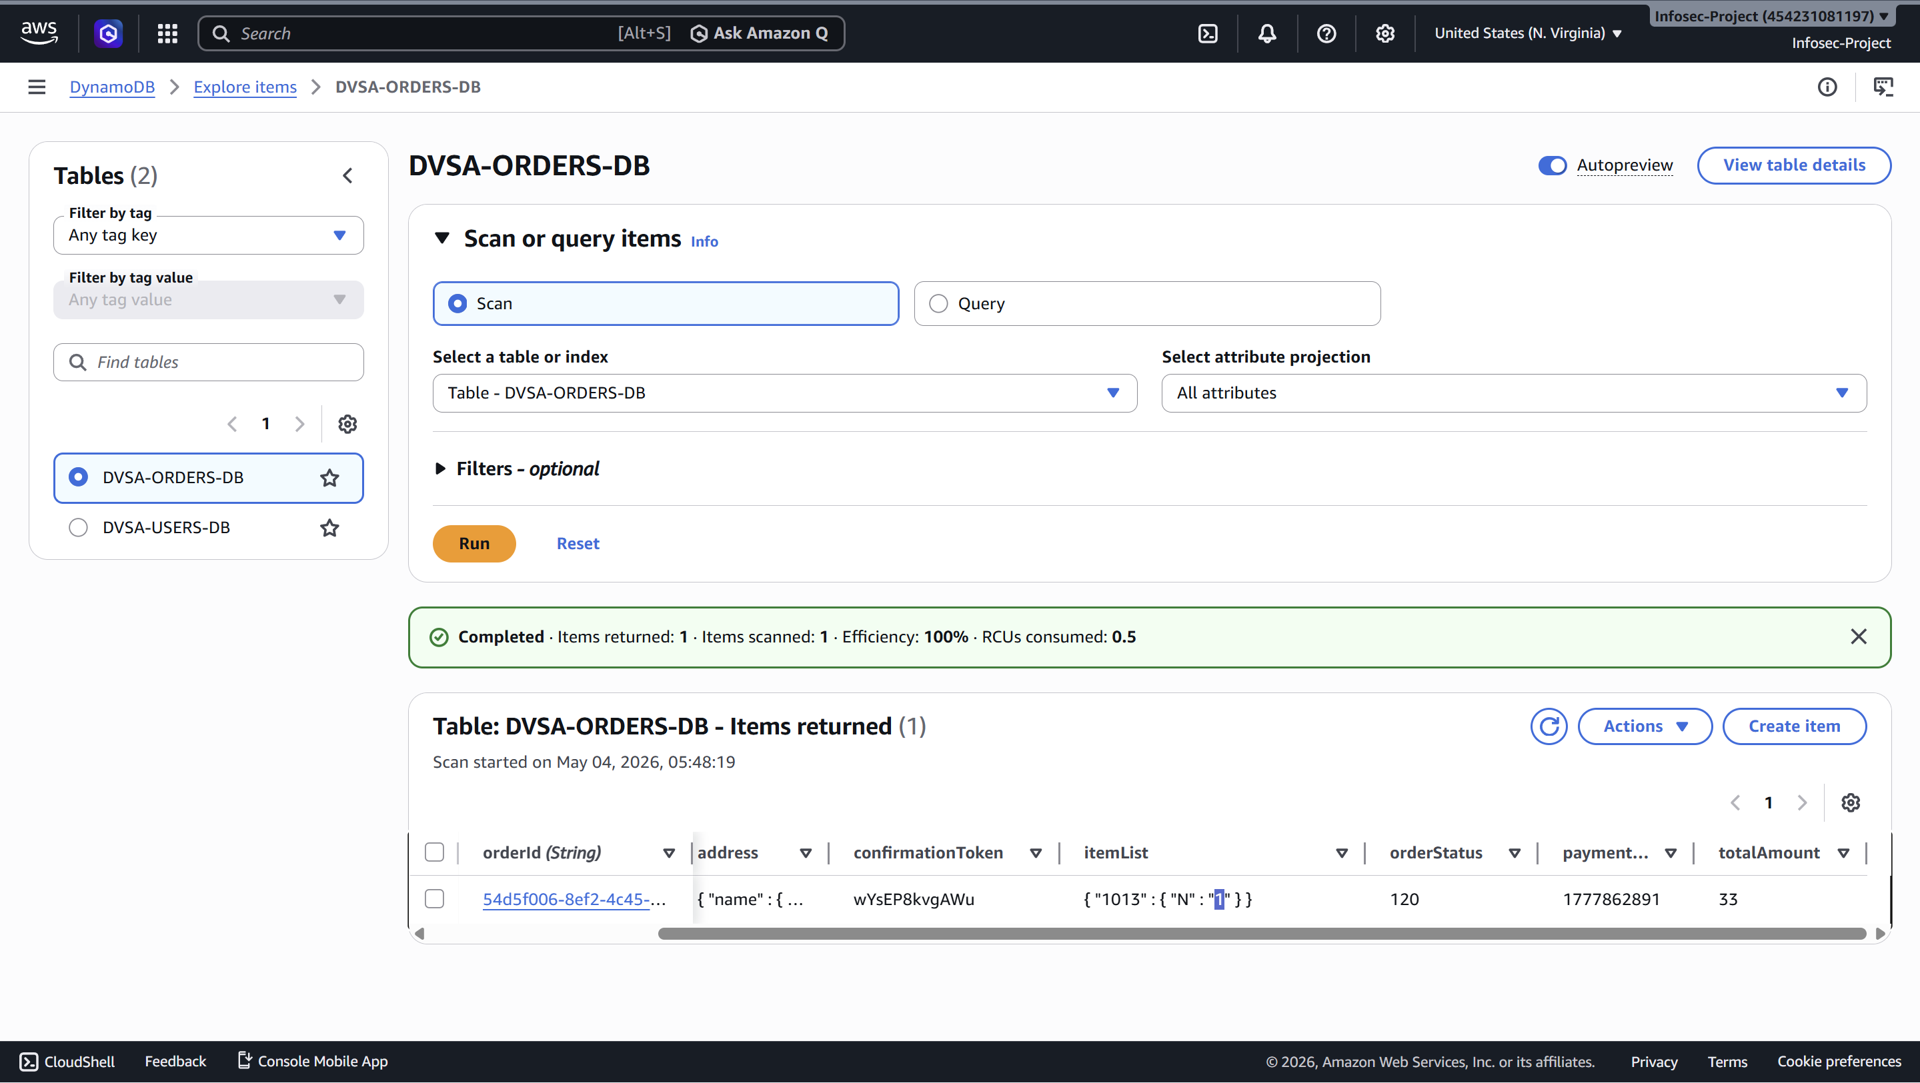
In the attacker’s terminal, it shows that the order is locked and cannot be edited:
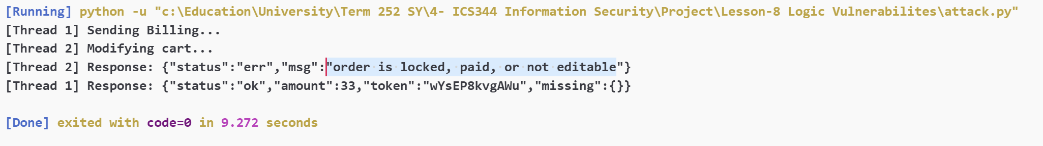

Part 9) Structured Operation and Security Analysis
1. Intended Logic and Security Rule(s)
The order-processing workflow involves two separate Lambda functions: DVSA-ORDER-BILLING handles payment, and DVSA-ORDER-UPDATE handles cart modifications. The intended design assumes these operations are sequential — a user modifies their cart, then submits payment. Once payment is submitted, the cart is considered frozen. The main actor is an authenticated user (JWT-verified). Both endpoints are reached via POST /dvsa/order, with the action field routing to the correct Lambda. DynamoDB (DVSA-ORDERS-DB) is the single source of truth for order state.
Security Rules:
- An order's itemList must be immutable from the moment billing is initiated to the moment the Paid status is committed.
- DVSA-ORDER-UPDATE must reject any modification request if the order is not in status 100 (Open).
- Status transitions must be atomic — no two operations may concurrently claim ownership of the same order.

2. Evidence Sources and Behavior Trace
Artifacts used: attack.py terminal output , DynamoDB table records (quantity/totalAmount mismatch), Lambda source code for both functions (DVSA-ORDER-BILLING and DVSA-ORDER-UPDATE), Browser DevTools (JWT extraction, orderId capture).
Condition | Observed Behavior
Normal | User adds 1 item → checks out → submit shipping details → submits payment → DynamoDB records orderStatus: 120, quantity: 1, totalAmount: $33. Sequential, no concurrency.
Exploit | Script fires billing and update simultaneously. DVSA-ORDER-UPDATE checks orderStatus > 110 — since 105 < 110, it passes the check and overwrites itemList to qty 5. Billing Lambda had already read qty 1 and calculated $33. DynamoDB ends up with quantity: 5, totalAmount: $33. Attacker receives 5 items for the price of 1.
Post-fix | Same script fired → Billing locks order to 105 atomically → Update Lambda's ConditionExpression="orderStatus = :open" fails because status is now 105 → Update returns "order is locked, paid, or not editable" → DynamoDB records quantity: 1, totalAmount: $33. Consistent across all runs.

3. Deviation Analysis and Classification
Two rules were violated simultaneously. First, the itemList was modified after billing started — violating the immutability rule. Second, DVSA-ORDER-UPDATE used a flawed guard (orderStatus > 110) that explicitly allowed modifications at status 105, which is billing-in-progress. The evidence is the DynamoDB records showing quantity: 5 with totalAmount: $33 — a price/quantity mismatch that is only possible if the cart was updated after price calculation began. The flaw required no privilege escalation — a valid JWT and a 20ms thread delay were sufficient to exploit it consistently.
Deviation Class: Intentional misuse / security-relevant abuse — the attacker deliberately engineers a concurrent state collision across two Lambda functions to obtain goods without paying for them.

4. Explainable Fix and Post-Fix Validation
Wrong assumption in billing Lambda: That locking the order in the billing function alone is sufficient, without ensuring the update function respects the lock.
Wrong assumption in update Lambda: That orderStatus > 110 correctly blocks all post-checkout modifications — it missed status 105 entirely since 105 < 110.
Where the fix belongs: Both Lambda functions.
Exact changes:
In DVSA-ORDER-BILLING: atomic ConditionExpression="orderStatus = :open" locks order from 100→105 before any price calculation. Final write protected with ConditionExpression="orderStatus = :locked".
In DVSA-ORDER-UPDATE: replaced the flawed get_item + conditional check with a single atomic update_item using ConditionExpression="orderStatus = :open" (:open = 100). The read-then-write gap is eliminated entirely.
Post-fix confirmation: Every run of race_exploit.py now returns "order is locked, paid, or not editable" for Thread 2. DynamoDB consistently shows quantity: 1, totalAmount: $33. Normal single-item checkout completes correctly — the lock is acquired and released cleanly with no impact on legitimate users.

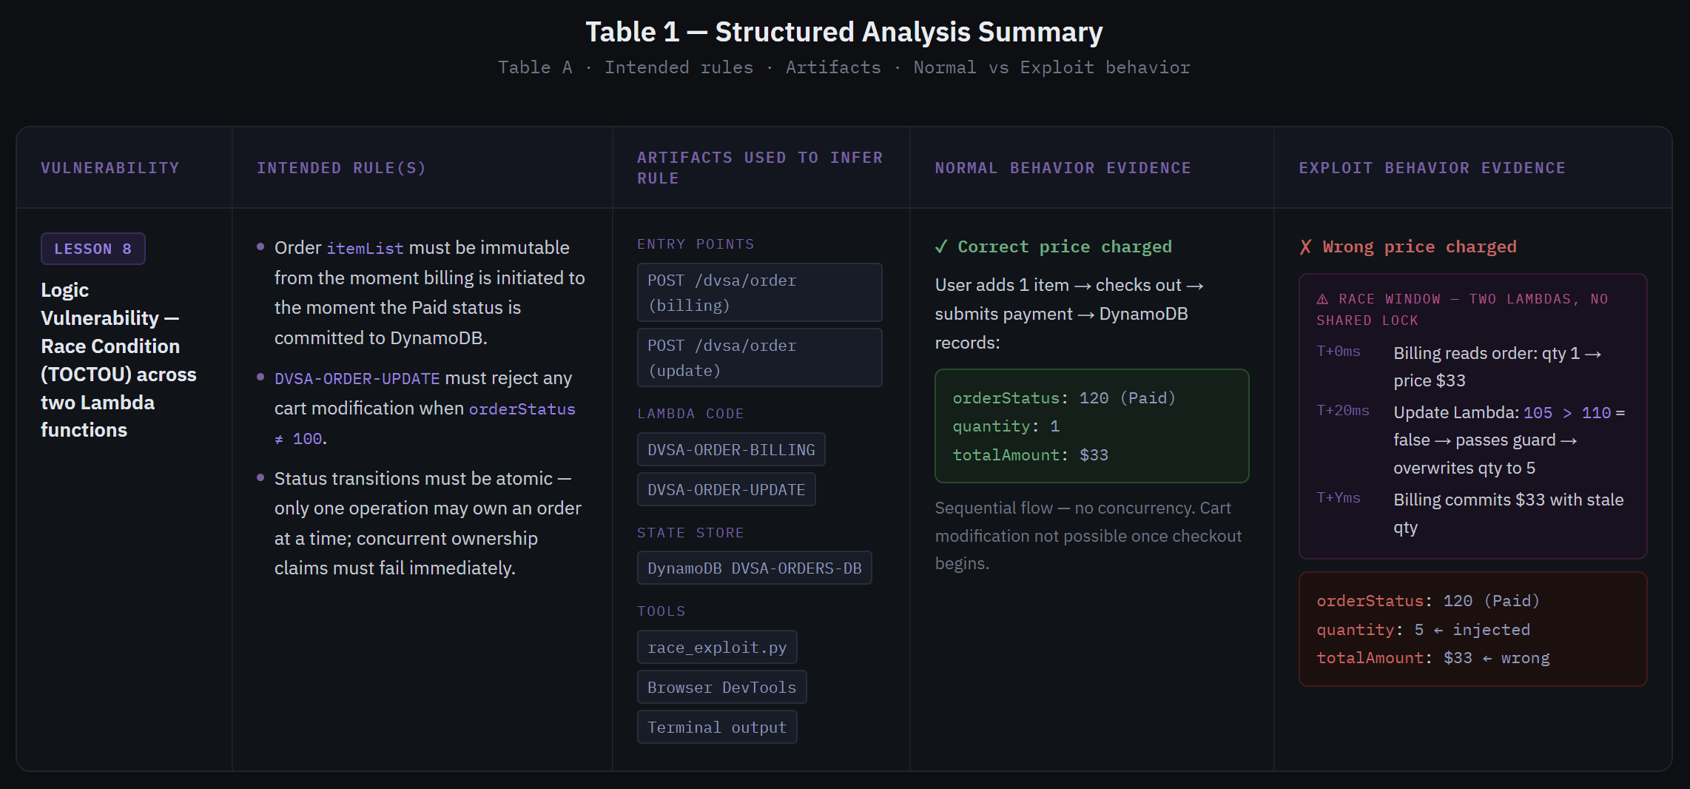
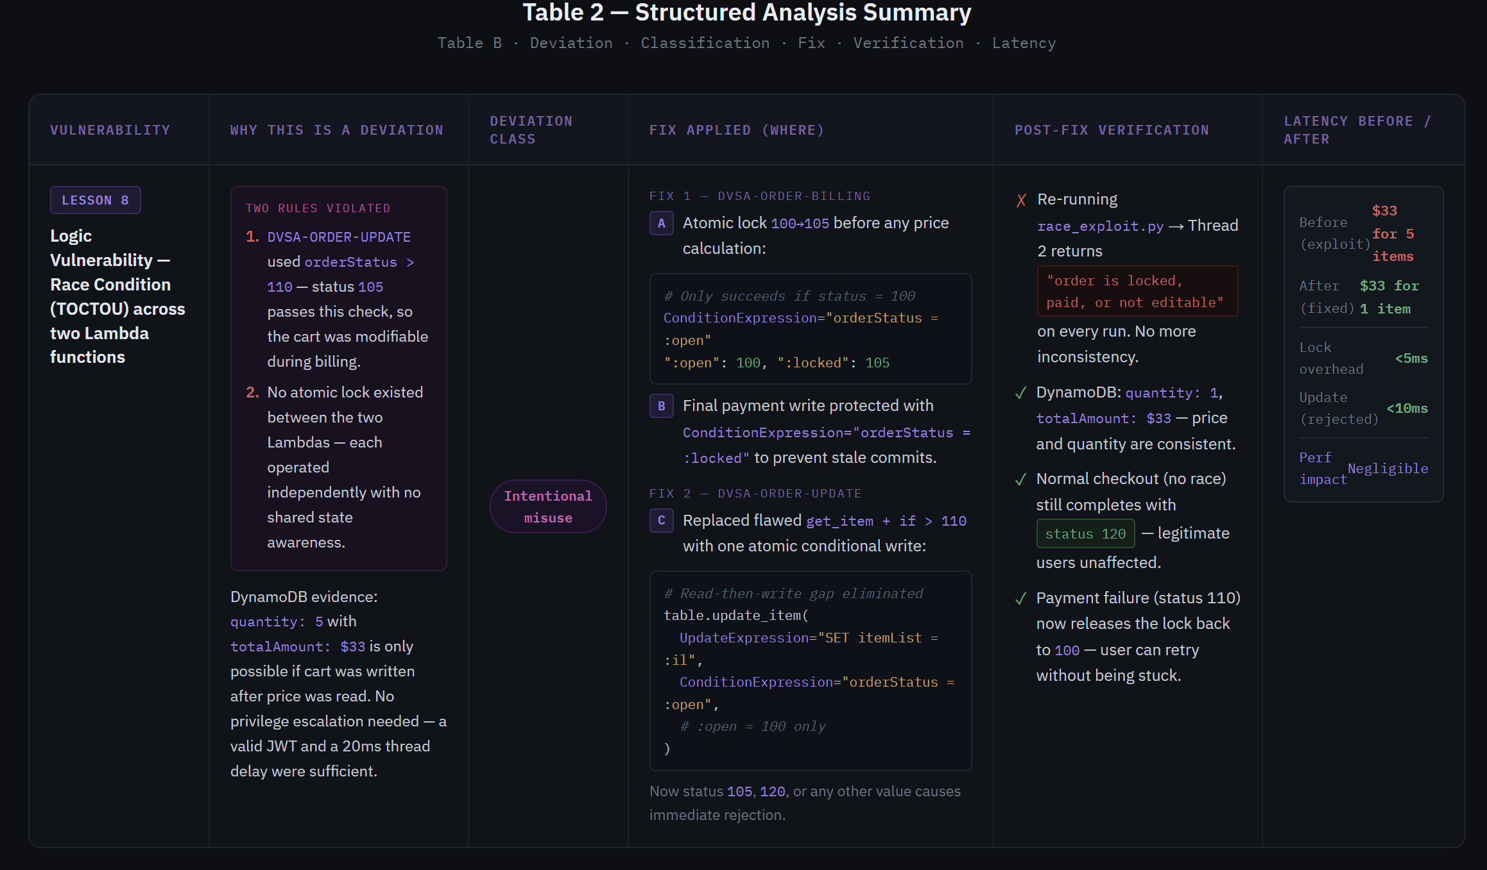

Part 10) Takeaway / Lessons Learned
The core flawed assumption was that two independent Lambda functions could safely share ownership of the same order without any coordination mechanism. The billing Lambda was fixed in isolation, but the update Lambda had its own separate guard (orderStatus > 110) that was never updated to recognize the new locked state. This is a classic partial fix problem — patching one side of a race condition without auditing all other entry points that touch the same resource.
In a serverless environment this problem is structurally worse than in monolithic systems. Each Lambda invocation is a fully isolated process with no shared memory, no thread locks, and no awareness of concurrent siblings. The only shared state is DynamoDB itself — which means DynamoDB's ConditionExpression is the only correct locking primitive available. Any solution that relies on application-level checks (read status, then decide) will always have a race window.
The general principle is make the database the gatekeeper, not the application. A ConditionExpression is atomic at the storage layer — it checks and writes in a single operation with no exploitable gap. Every state transition in a financial workflow should be expressed this way, and every Lambda that can touch the same record must respect the same set of valid states. Fixing one function without auditing all others that share the same data is not a fix — it is a false sense of security.

