3.11) (Miles per Gallon)

Drivers are concerned with the mileage obtained by their automobiles. One driver has kept track of several tankfuls of gasoline by recording miles driven and gallons used for each tankful. Develop a sentinel-controlled-repetition script that prompts the user to input the miles driven and gallons used for each tankful. The script should calculate and display the miles per gallon obtained for each tankful. After processing all input information, the script should calculate and display the combined miles per gallon obtained for all tankfuls (that is, total miles driven divided by total gallons used).

Enter the gallons used (-1 to end): 12.8

Enter the miles driven: 287

The miles/gallon for this tank was 22.421875

Enter the gallons used (-1 to end): 10.3

Enter the miles driven: 200

The miles/gallon for this tank was 19.417475

Enter the gallons used (-1 to end): 5

Enter the miles driven: 120

The miles/gallon for this tank was 24.000000

Enter the gallons used (-1 to end): -1

The overall average miles/gallon was 21.601423

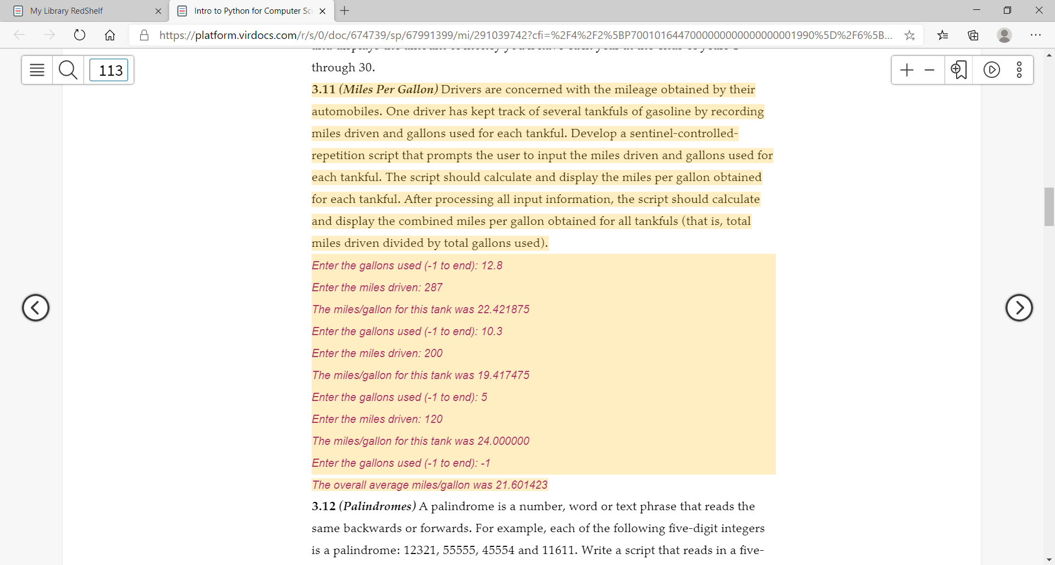

3.17) (Nested Loops)

Write a script that displays the following triangle patterns separately, one below the other. Separate each pattern from the next by one blank line. Use for loops to generate the patterns. Display all asterisks (\*) with a single statement of the form

Print(‘\*’, end=’ ’) *I’m not sure if there is a space between the quotes for end=’ ‘.*

Which causes the asterisks to display side by side. [Hint: for the last two patterns, begin each line with zero or more space characters.]

(a)01234567(b)01234567(c)01234567(d)01234567

\*,,,,,,,,,;\*\*\*\*\*\*\*\*\*\*;\*\*\*\*\*\*\*\*\*\*;,,,,,,,,,\*;

\*\*,,,,,,,,;\*\*\*\*\*\*\*\*\*,;,\*\*\*\*\*\*\*\*\*;,,,,,,,,\*\*;

\*\*\*,,,,,,,;\*\*\*\*\*\*\*\*,,;,,\*\*\*\*\*\*\*\*;,,,,,,,\*\*\*;

\*\*\*\*,,,,,,;\*\*\*\*\*\*\*,,,;,,,\*\*\*\*\*\*\*;,,,,,,\*\*\*\*;

\*\*\*\*\*,,,,,;\*\*\*\*\*\*,,,,;,,,,\*\*\*\*\*\*;,,,,,\*\*\*\*\*;

\*\*\*\*\*\*,,,,;\*\*\*\*\*,,,,,;,,,,,\*\*\*\*\*;,,,,\*\*\*\*\*\*;

\*\*\*\*\*\*\*,,,;\*\*\*\*,,,,,,;,,,,,,\*\*\*\*;,,,\*\*\*\*\*\*\*;

\*\*\*\*\*\*\*\*,,;\*\*\*,,,,,,,;,,,,,,,\*\*\*;,,\*\*\*\*\*\*\*\*;

\*\*\*\*\*\*\*\*\*,;\*\*,,,,,,,,;,,,,,,,,\*\*;,\*\*\*\*\*\*\*\*\*;

\*\*\*\*\*\*\*\*\*\*;\*,,,,,,,,,;,,,,,,,,,\*;\*\*\*\*\*\*\*\*\*\*;

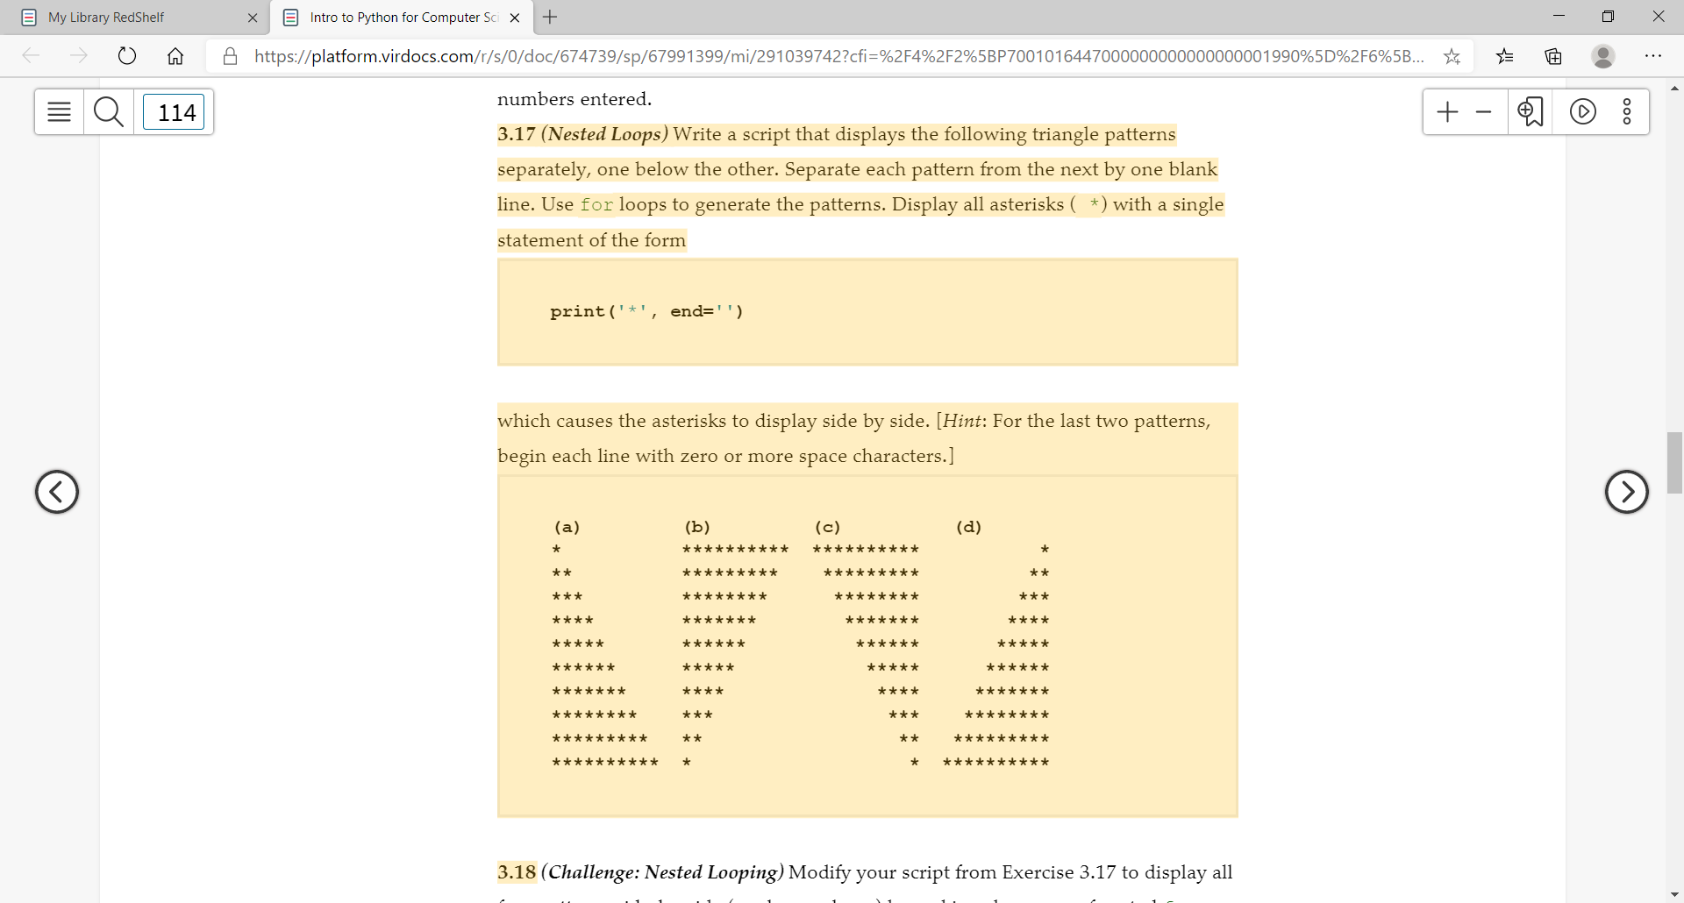

3.21 (Calculate Change Using Fewest Number of Coins)

Write a script that inputs a purchase price of a dollar or less for an item. Assume the purchaser pays with dollar bill. Determine the amount of change the cashier should give back to the purchaser. Display the change using the fewest number of pennies, nickels, dimes, and quarters. For example, if the purchaser is due 73 cents in change, the script would output:

Your change is:

2 quarters

2 dimes

3 pennies

