Report assignment 2 DAA
Zhambayev Alikhan
- Complexity Table
Структура / Операция | Best Case | Average Case | Worst Case | Space (Aux) | Почему
DynamicArray
add(x) | Θ(1) | Θ(1) | O(n) | O(n) | Копирование в конец дает 1, но если заполненный идет копирование х2
add(index, x) | Ω(1) | Θ(n) | O(n) | O(n) | Если добавляем сдвигаем все другие повезет если вставка в конец ни че сдвигать не надо будет
remove(index) | Ω(1) | Θ(n) | O(n) | O(n) | Опять сдвиг
get(index) | Θ(1) | Θ(1) | Θ(1) | O(1) | Просто получаем
contains(x) | Ω(1) | Θ(n) | O(n) | O(1) | Тут также если повезет попадем с первого раза нет так весь массив смотреть надо будет
MyLinkedList
add(x) | Θ(1) | Θ(1) | Θ(1) | O(n) | Используем Tail поэтому быстро
add(index, x) | Ω(1) | Θ(n) | O(n) | O(n) | Бегаем по ссылкам поэтому n
remove(index) | Ω(1) | Θ(n) | O(n) | O(n) | аналогично
get(index) | Ω(1) | Θ(n) | O(n) | O(1) | аналогично
contains(x) | Ω(1) | Θ(n) | O(n) | O(1) | аналогично
MinHeap
insert(x) | Ω(1) | Θ(log n) | O(log n) | O(n) | Добавляем в конец если повезет уже как надо добавим если нет то в дереве ветка будет менятся
peekMin() | Θ(1) | Θ(1) | Θ(1) | O(1) | Тут понятно minheap первый будет всегда минимальным
extractMin() | Ω(1) | Θ(log n) | O(log n) | O(1) | По дереву замена.
- Loop Invariant Proofs

1. Operation: contains(x) in DynamicArray.
Invariant: Before the -th iteration of the loop, the element x is not present in the subarray array[0 ... i-1].
Initialization: Before the very first iteration (), the subarray we have checked is array[0 ... -1]. Since this subarray is completely empty, the statement "element x is not in this subarray" is trivially true.
Maintenance: Assume the invariant is true before iteration (meaning x is not in the checked part). During the iteration, we check the current element array[i]. If array[i] != x, we move to the next iteration (). Now, we are 100% sure that x is also not in array[0 ... i], so the invariant remains true for the next step.
Termination: The loop stops for two reasons: either we find array[i] == x (and return true), or we reach the end of the array ().
Conclusion: If the loop finishes by reaching without returning true, our invariant guarantees that x is not present in the entire array[0 ... n-1]. This proves that the search method works correctly and returns false only when the element is truly missing.

2. Operation: bubbleDown(index) in MinHeap (used in extractMin()).
Invariant: Before each iteration, the subtrees rooted at the children of the current index are valid min-heaps. The only possible violation of the heap property is right between the current array[index] and its direct children.
Initialization: When we call extractMin(), we replace the root (index 0) with the last element of the array. Because the tree was a perfect min-heap before this, the left and right subtrees of the root are still perfectly valid min-heaps. The only place the rule might be broken is at the top (the new root).
Maintenance: Inside the loop, we find the smallest child. If this child is smaller than the parent, we swap them. This swap fixes the rule for the current index. The potential violation doesn't disappear; it simply moves down to the position of the swapped child (which becomes our new index for the next iteration).
Termination: The loop naturally stops when the current node has no more children (it reaches the bottom), or when the parent array[index] is already smaller than or equal to both of its children.
Conclusion: When the loop terminates, it means there are absolutely no more local violations. Since the rest of the subtrees were already valid, the entire array is now a correctly structured min-heap again.
3) 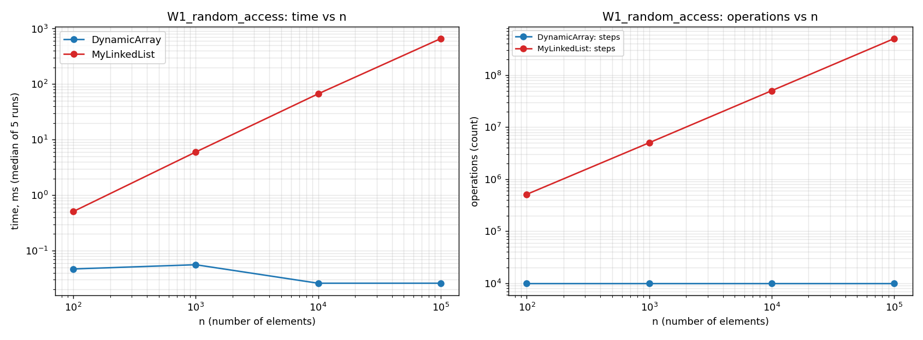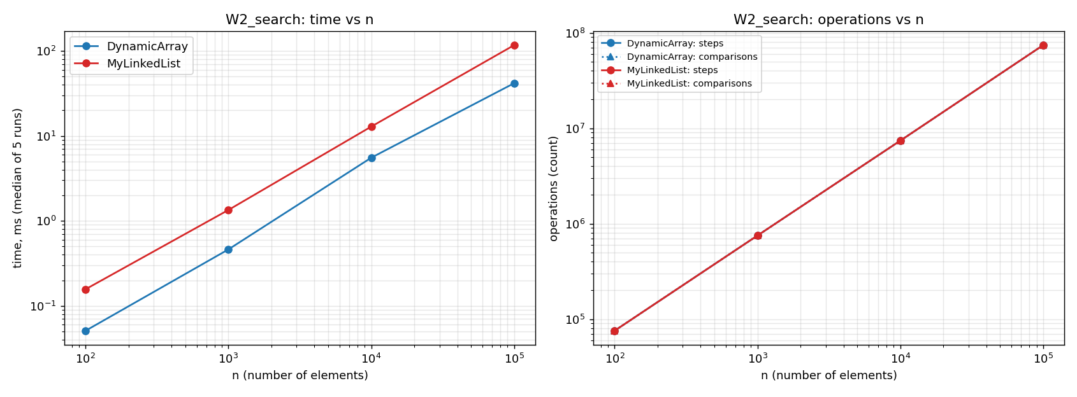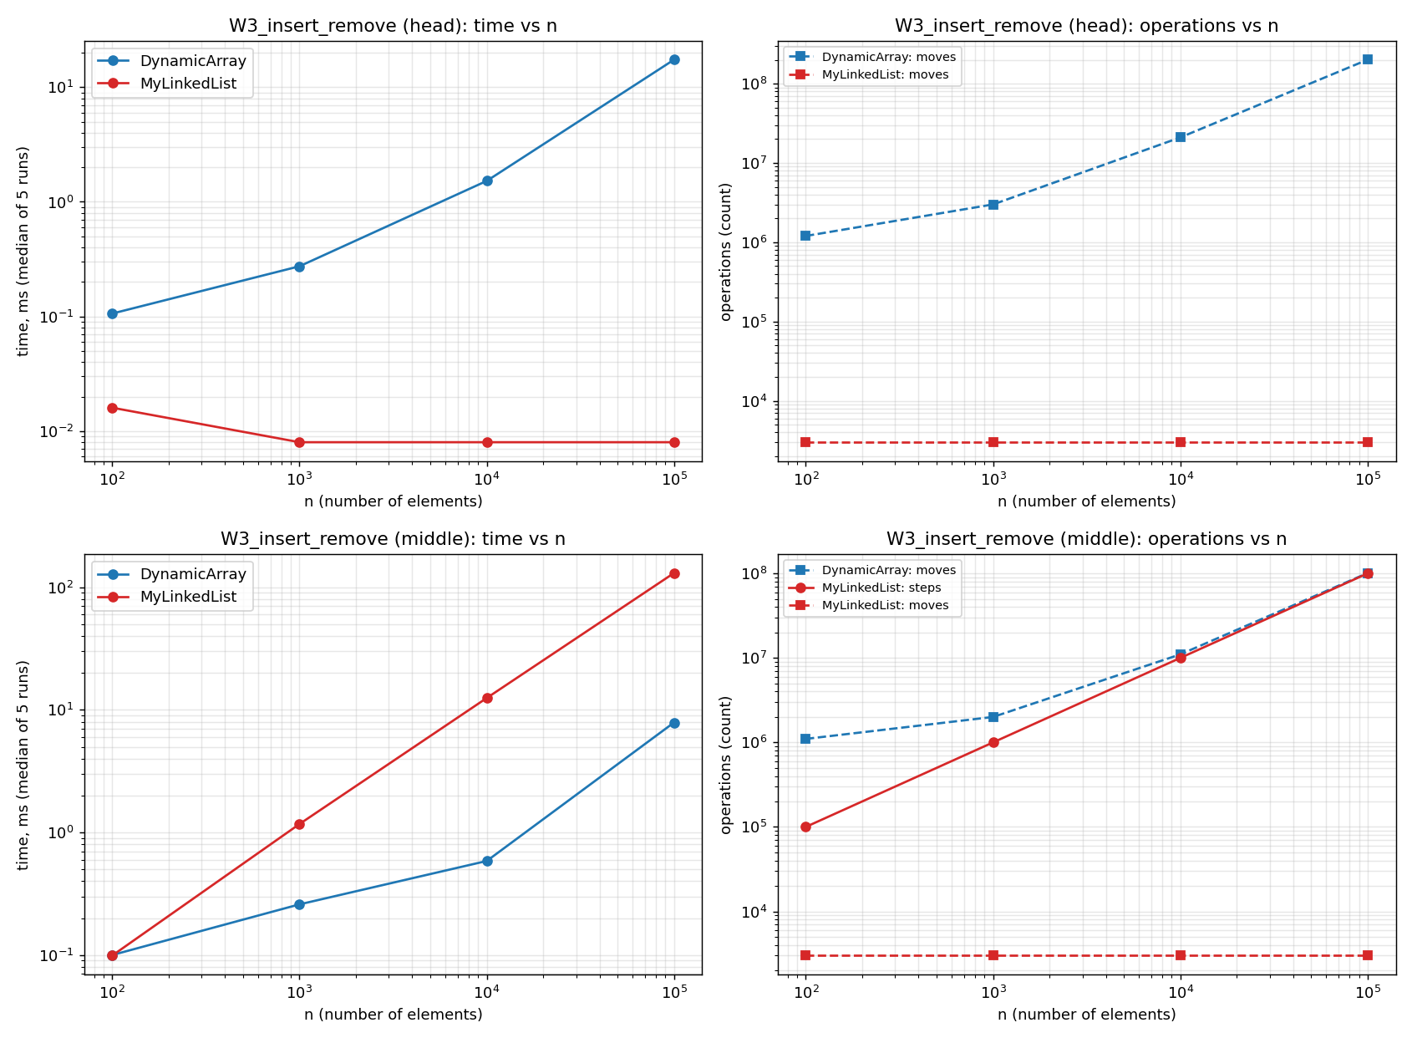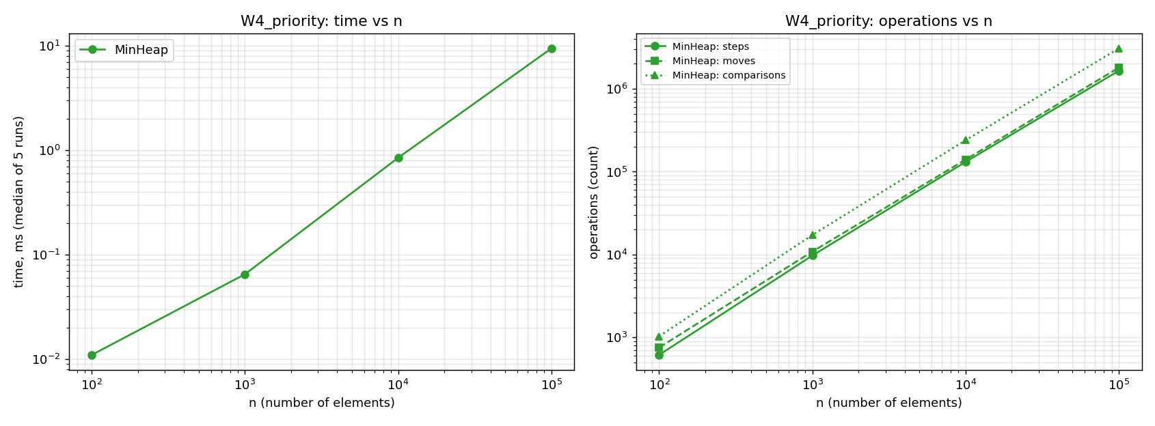
4) Why DynamicArray is faster for get(i) and even for simple iteration:
DynamicArray is significantly faster for random access and simple iterations because its elements are stored in a contiguous block of memory. When the CPU accesses a specific array index, it automatically loads adjacent elements into its CPU cache lines. This mechanism takes full advantage of high spatial locality. As a result, subsequent iterations and get(i) operations execute almost instantly from the fast cache rather than fetching data from the slower main RAM. Why the list can be slower even when both structures perform the same number of steps:
Even when both structures perform the exact same algorithmic number of steps (such as in the W2 Search workload), MyLinkedList remains much slower due to its fragmented memory layout. The list nodes are scattered randomly across the heap, forcing the CPU to constantly follow references, a problem known as pointer chasing. This access pattern causes frequent CPU cache misses, making the processor stall while waiting for data. Additionally, each node carries extra memory overhead for object headers and pointers, meaning the creation of many scattered objects puts a heavy burden on the garbage collector. When MyLinkedList or MinHeap is the better choice:
MyLinkedList becomes the optimal choice primarily when the workload involves frequent insertions and deletions strictly at the boundaries of the collection (like the head operations in W3), because it performs these in true O(1) time without shifting large blocks of memory. Conversely, MinHeap is the absolute best choice for priority queues and scheduling systems (like W4). It provides guaranteed log n time for both insertions and extractions by efficiently combining tree logic with the cache locality of a backing array.

Bonus Task B
Floyd's algorithm allows us to build a min-heap from an unsorted array in-place in O(n )time. Instead of inserting elements one by one—which takes O(n log n) in the worst case—it works bottom-up. The algorithm starts at the last parent node and calls bubbleDown() for every node up to the root. Because half of the nodes are leaves and require no work, and the remaining nodes only move down a few levels, the total work mathematically sums to O(n)
The benchmark results clearly confirm this efficiency. On descending data (the worst-case scenario for standard inserts), buildHeap performs exceptionally well. For n = 100.000 it makes 7.3 times fewer comparisons and runs 8.7 times faster than sequential insertions. On random data, the performance gap is smaller because random elements naturally settle near the bottom, making standard inserts cheaper on average. However, Floyd's algorithm remains superior because it guarantees true O(n )time for any input, whereas standard inserts degrade to O(n log n)when facing adversarial data.

