SULEYMAN DEMIREL UNIVERSITY

**ENGINEERING FACULTY**

**CSS 305 - Database Management Systems 2**

# Project documentation

# SDataU

**Checked by: Assem Talasbek**

**Made by: Alikhan Abdigani**

**Batyrbek Kaiypbai**

**Olzhas Myktybekov**

### 

### Kaskelen, 2022

**Structure:**

* Abstract
* Introduction
* Aim and objectives of research
* Background Review
* Methods and Materials
* Data and Results
* Discussion
* Conclusion
* References
* ***Abstract***

Our project is about helping students on their way to graduate from university. And the main purpose of our project is to give students statistics about certain courses and teachers so that they know which courses to enroll in advance. We will also add in some other useful functions.

* ***Introduction***

Why do students drop out of university?

Before applying, an applicant should learn about the main reasons why students drop out of school and refuse a diploma of higher education. There are multiple factors, and each course has its own reason. The Ministry of Education is puzzling over why every fifth student leaves the walls of the university without a diploma. And the reason lie on the surface.

Underachievement

In the first or second year, a student can simply be expelled from an educational institution for poor progress. The problem is that yesterday's schoolboy finds himself in an unusual environment where no one is running after him. As a result, he relaxes and becomes lagging behind. Young people who came to study from a small town to a metropolis are generally beginning to feel the taste of freedom.

Awareness

After the student has successfully completed the first two courses, he begins to realize that he is not doing what he would like to do. His choice of courses may have been wrong. Sometimes the choice is made not by the student himself, but by friends. In general, realizing that he is studying at the wrong faculty, a student can leave the university.

We know that at the beginning of the semester, our SDU students have problems choosing subjects and teachers. Most students do not know what subject they like.

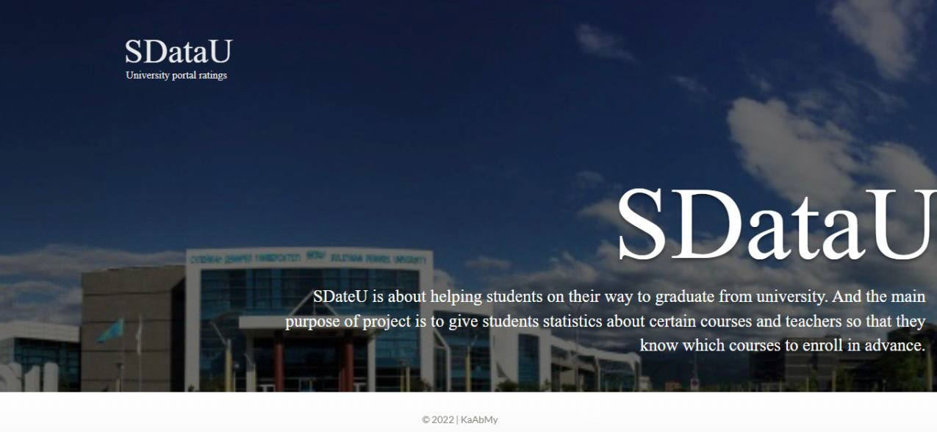

* ***Aim and objectives of research***

***Aim:*** To develop a system that can help students at the stage of choosing subjects of bachelor's degree in Kazakhstan.

***Objectives:***

• Find the most popular teacher in the semester section (You must go through the semester and year number and subject code, and also display the teacher's practice and lecture). For example, teachers of lectures on programming technology: Instructor1, Instructor2. Practice Teachers: Teacher1, Teacher2, Teacher3.

• Calculate the student's GPA for the semester and total

• Teacher rating for the semester (list)

• Subject rankings per semester (list)

• Calculate the total number of retakes for all time and withdraw the profit.

* ***Background review***

Nowadays, every student asks the question: what courses to choose, what teacher to choose. But before that, there is a big question: in what direction of the speciality will he be able to work after successfully graduating from the university and graduating from the speciality. The real problem is that 60 percent of graduates do not work in the speciality in which they graduated. We are confident that this product will reduce the percentage to about 35 percent as it is going to naturally help students choose what they actually want and need instead of relying on cool and attractive names of courses and randomness.

* ***Methods and Materials***

We used pre-collected data from SDU website.We used information about specialities(Course codes), courses, teachers(teacher IDs) and students(student IDs) and etc.

For adding DB and Pl/Sql we used PHP/HTML to display data on the website.

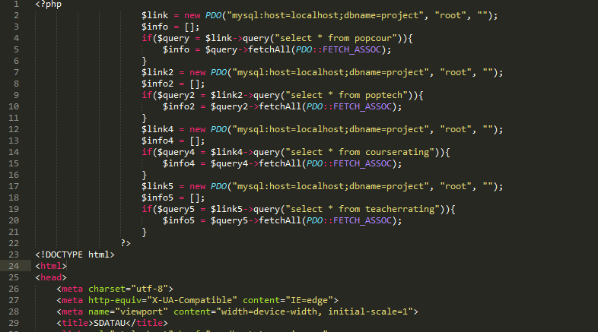

PHP example code of connecting to data

***Data and Results***

**Table description.**

Here are all the data that were included in the tables.

**Table: Course_schedule**

DERS_KOD – course code (code of subject)

YEAR – year when subject was conducted

TERM – 1 – Fall, 2-Spring

DERS_S_ID –

SECTION –

MIN(START_TIME) – time of subject on week by schedule

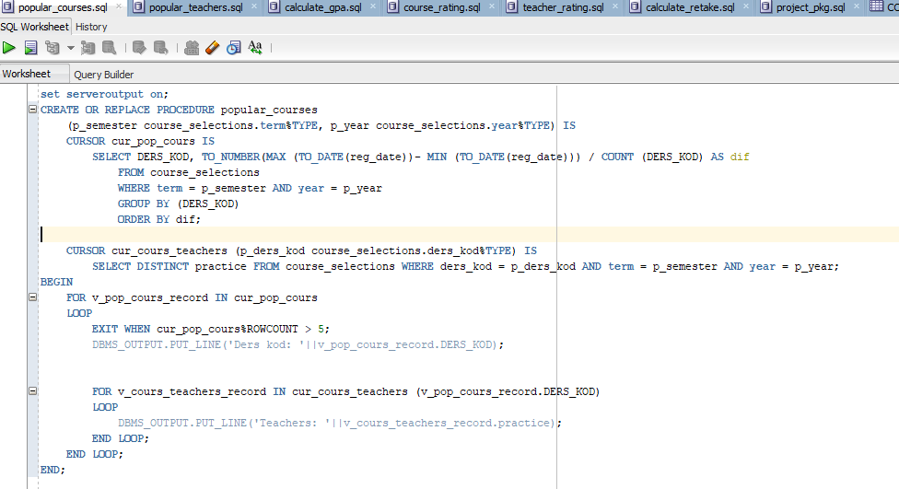

**Table: Course_sections**

DERS_SOBE_ID –

DERS_KOD – course code (code of subject)

YEAR – year when subject was conducted

TERM – 1 – Fall, 2-Spring

SECTION –

TYPE – N,L – lection P- practice

EMP_ID – id teacher, instructor

MESSAGE – comment

WEEK_NUM – how many weeks

HOUR_NUM – how many hours for semester

PACKET_DERS – skip

ATTEND_TYPE – skip

PAID_SECTION – skip

EMP_ID_ENT – id teacher, instructor who can inter marks

LAST_MODIFIED – last marks modified time

Credits – number of credits

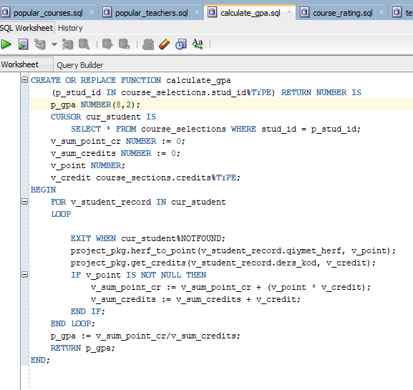

**Table: Course_selections**

STUD_ID – id student

DERS_KOD – course code (code of subject)

YEAR – year

TERM - 1 – Fall, 2-Spring

SECTION – section

LAB_SOBE_ID - skip

QIYMET_YUZ – total mark of the course

QIYMET_HERF - total mark of the course

GRADING_TYPE – PNP –pass / no pass, N - standart

ATTENDED – skip

PRACTICE – practice teacher

REG_DATE – registration time

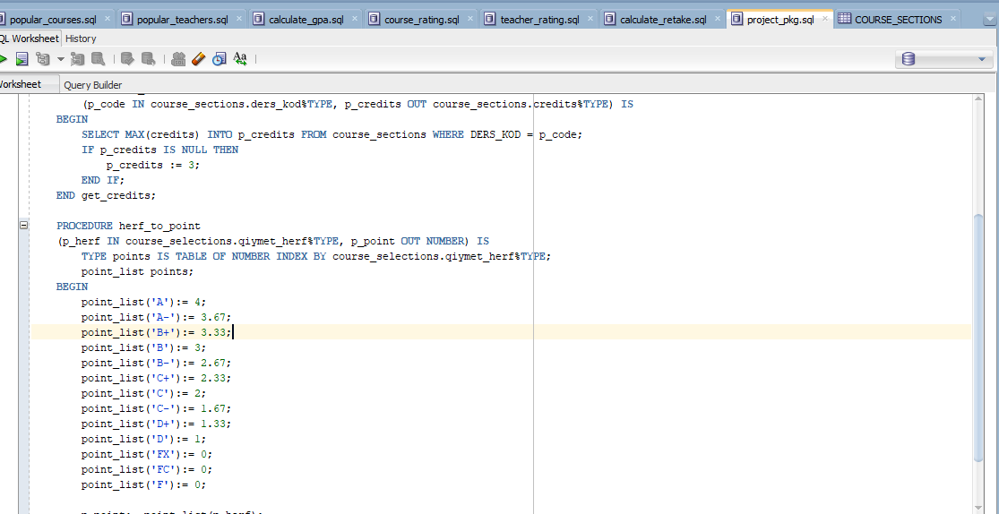

We did not get to use all the data, as most of them did not target our agenda.

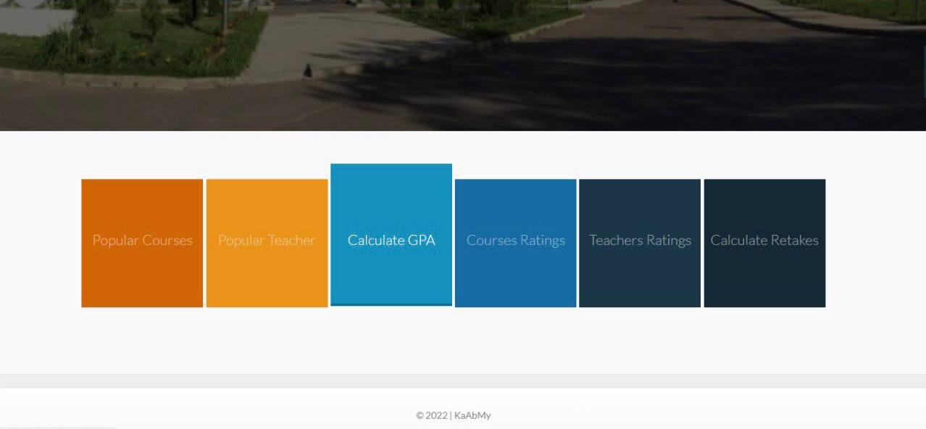

* ***Discussion***

This study showed a large number of differences in occupations for each individual specialty. Within the framework of these data, we could look at the ratio of universities between specialties and professions. Such data is collected to analyze the experience of each institution.

* ***Conclusion***

In conclusion, it should be said that the project involves the emergence of problems with the choice of subjects, and we expect that our five kopecks can be used for practical purposes or in several directions. This will help build a forecasting system and build a flexible system for building a statistics system. In the process of writing this project, our attitude changed a lot after this study. We realized the impact of the choice of subjects and made a general overview of the university. In conclusion, we believe that our approach and application will be useful and favorable.

* ***References***

[Extracting information from the database to the site](https://www.youtube.com/watch?v=z3m8quiQCFU&t=831s)

[Profile List – Suleyman Demirel University (sdu.edu.kz)](https://sdu.edu.kz/profile-list/?staff-az=*)

[We took a lot of data from teacher Aisultan](https://github.com/AlikhanAbdigani/project_db/tree/main/tables)

<https://dknews.kz/ru/dk-life/161964-pochemu-kazahstancy-brosayut-uchebu-v-universitetah>

[Our video](https://youtu.be/TnDBMor-OIg)