Frontend Assignment 1 – Report

Name: Кенжебек Алихан

Group: SE - 2408, 2

Steps

Step 1. HTML Boilerplate

Created a new file index.html and added the HTML boilerplate including <!DOCTYPE html>, <html>, <head>, <title>, and <body>.

Step 2. Headings and Paragraph

Added headings with my name and group. Wrote a short text about myself.

Step 3. Lists

Created an ordered list with my hobbies and an unordered list with my favorite websites.

Step 4. Image and Links

Inserted my photo using the <img> tag. Added two links to my favorite websites (Google and YouTube).

Step 5. Button

Added a simple button with the text 'Click Me'.

Step 6. Table

Created a table with three columns: Subject, Day, and Time. Filled in my weekly schedule.

Step 7. Emojis

Added a paragraph with three emojis showing my mood today 😀👌🔥.

Step 8. Form

Created a form with fields for Name, Email, and Favorite Color. Added a submit button.

Step 9. Code Comments

Inserted comments in the HTML code to make it more readable and structured. This improves code quality.  
  
  
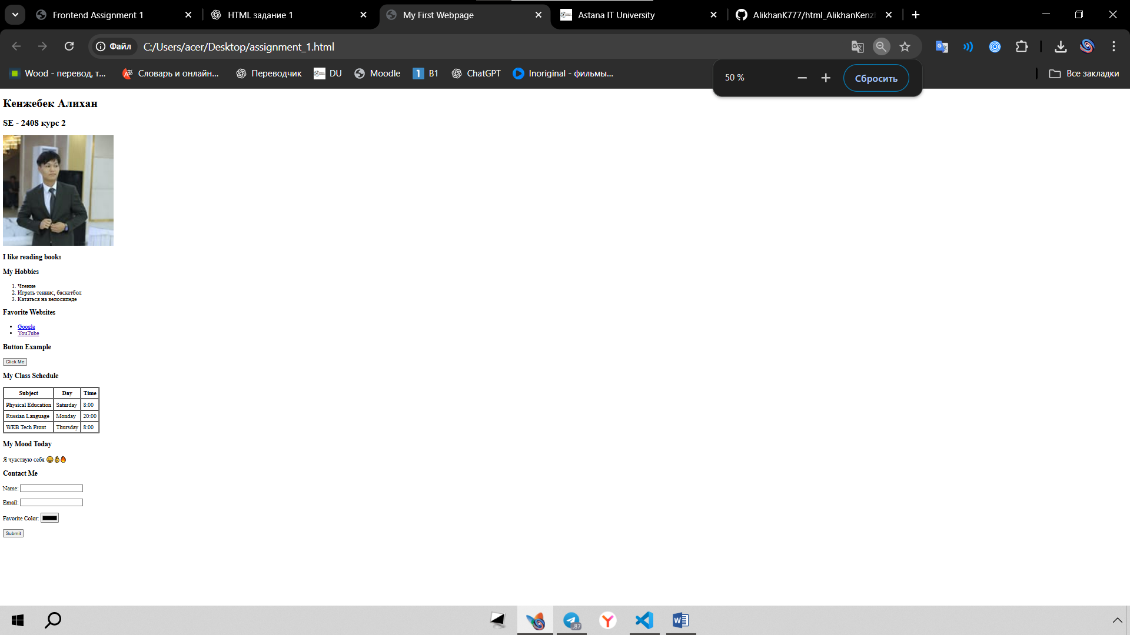  
  
  
  
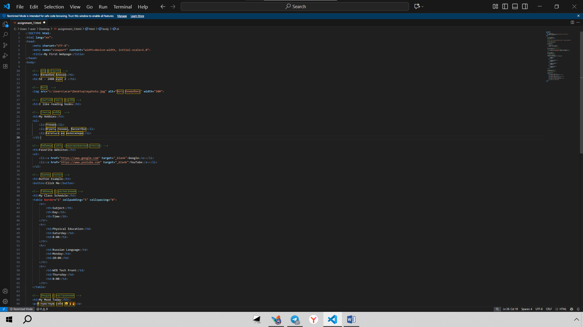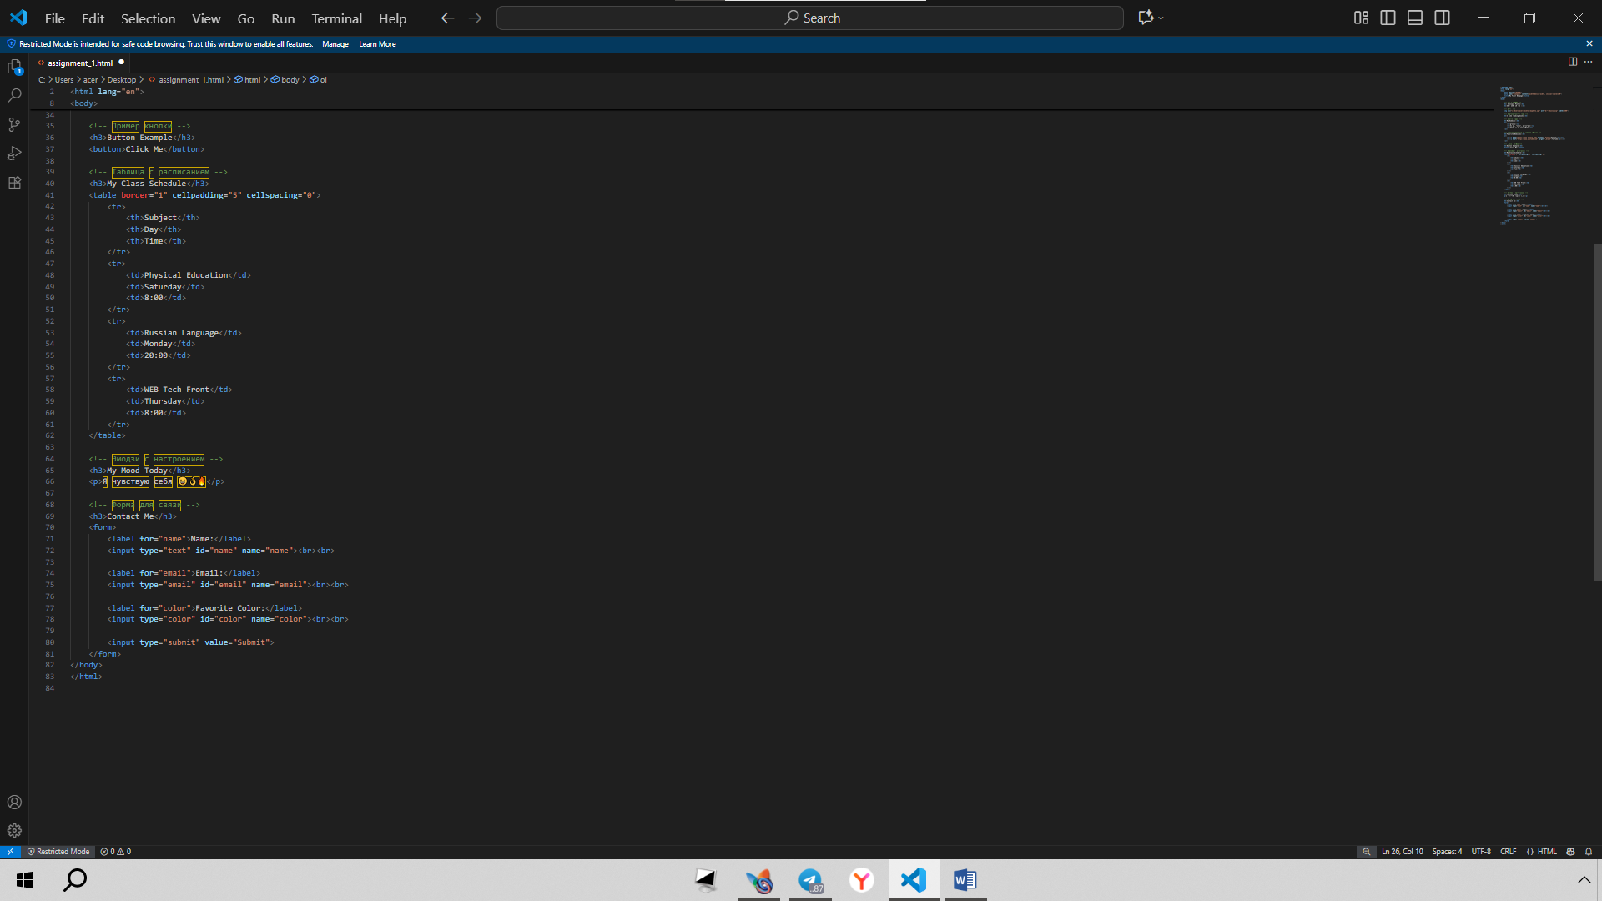

Conclusion

The assignment helped me learn and practice HTML basics. I now understand how to structure a webpage and use different elements like text, lists, images, tables, emojis, and forms.  
  
  
Github   
  
 https://github.com/AlikhanK777/html_AlikhanKenzhebek.git