**Report**

**Student**: Kenzhebek Alikhan

Group: SE-2408

Objective:

This assignment aimet to get the initial skills of working with Oracle VirtualBox Virtual

Environment. Learn how to launch and log in to UNIX/Linux.

Other Popular Virtual Environments: QUEMI, VMWare ESX, Microsoft Hyper-V, XEN.

Understand the difference among Windows, MacOS, Linux

Steps:

1. Install VM and Ubuntu Linux

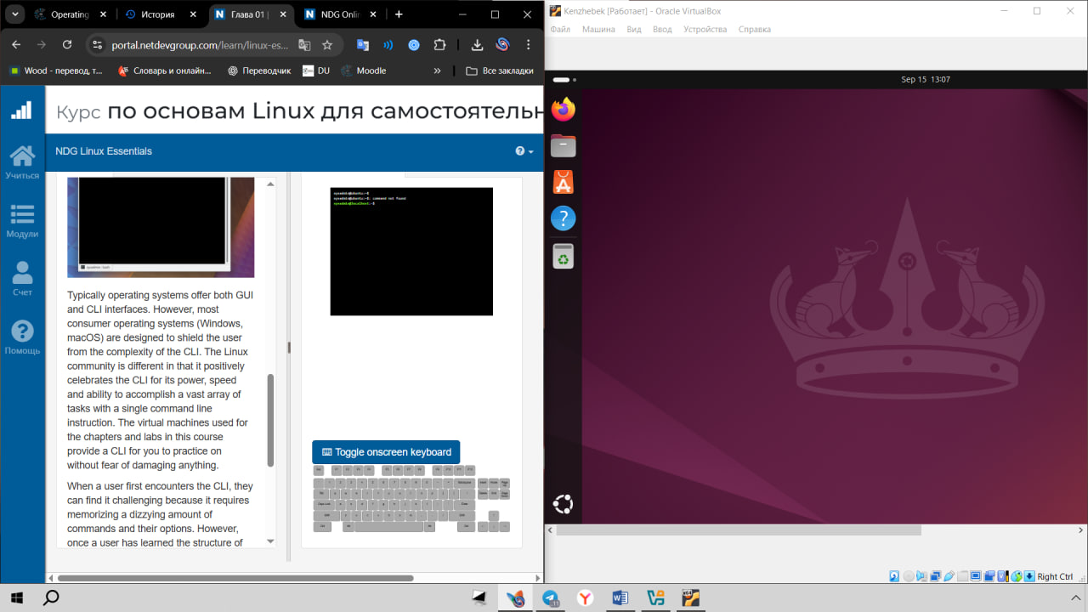

2. Pass a course exams + lab

2.1 Chapter 2 exam

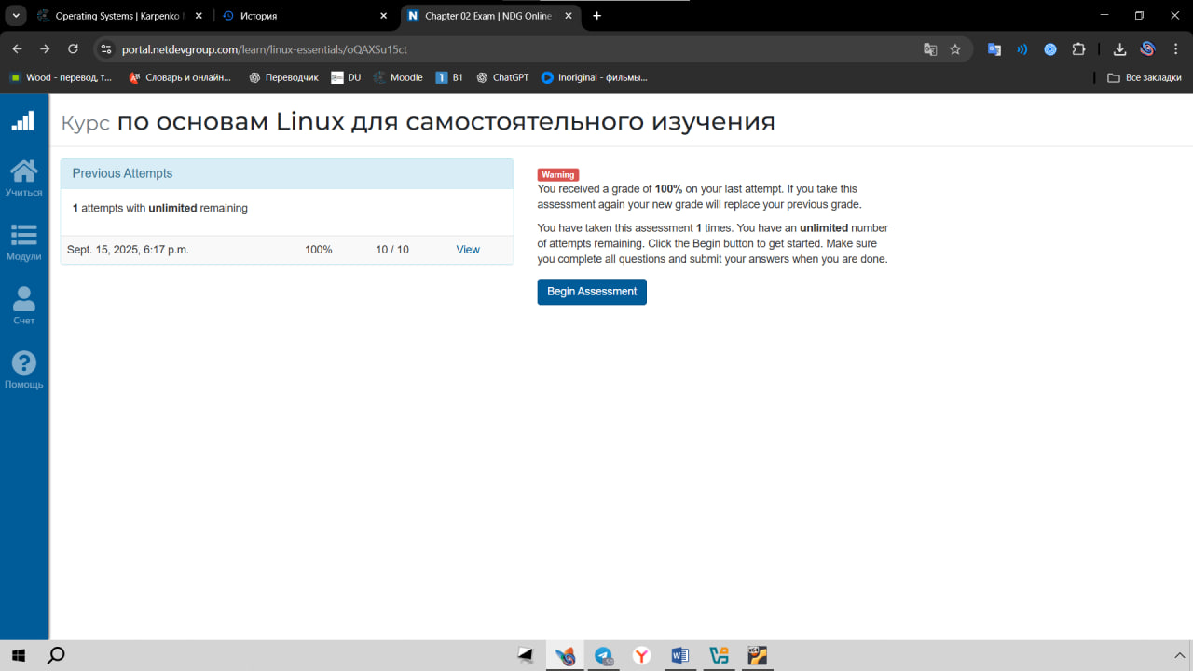

2.2 Chapter 3 exam

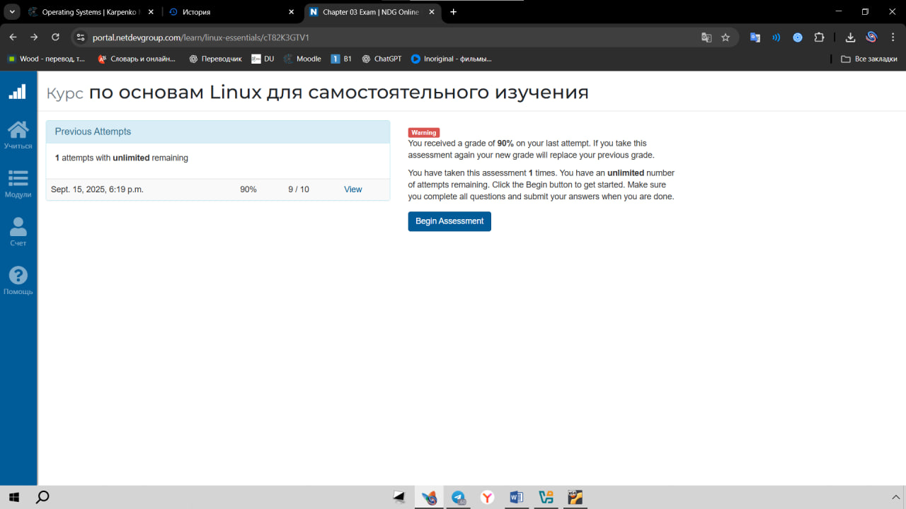

2.3 Chapter 4 exam

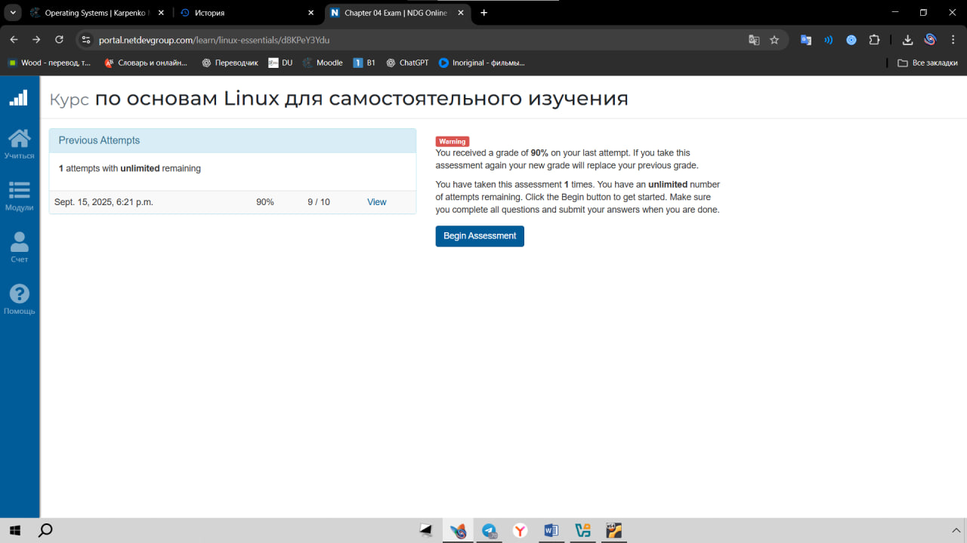

2.4 Chapter 5 exam

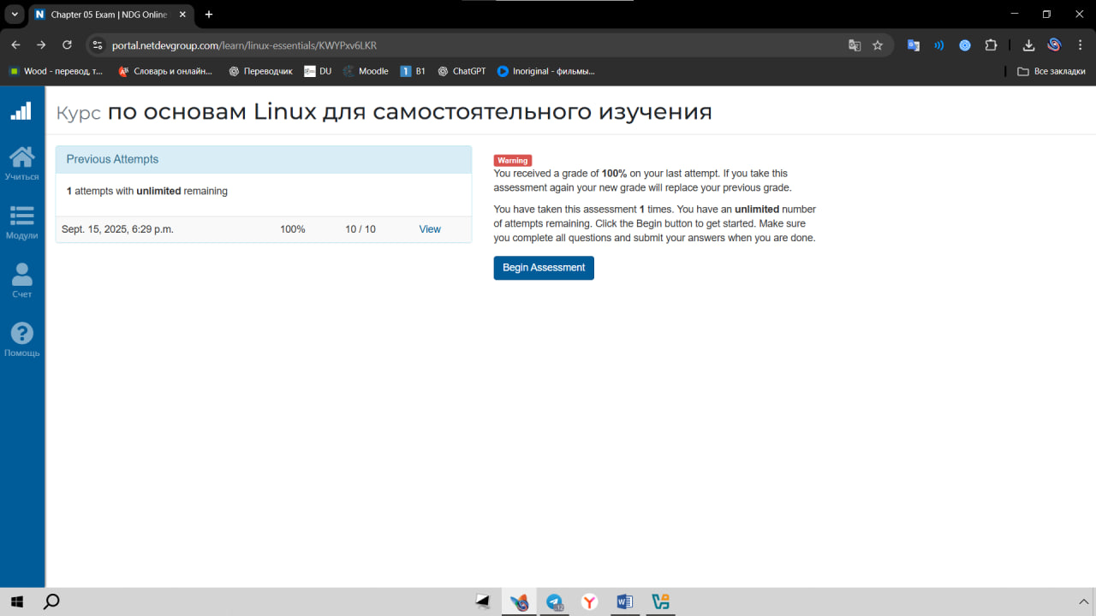

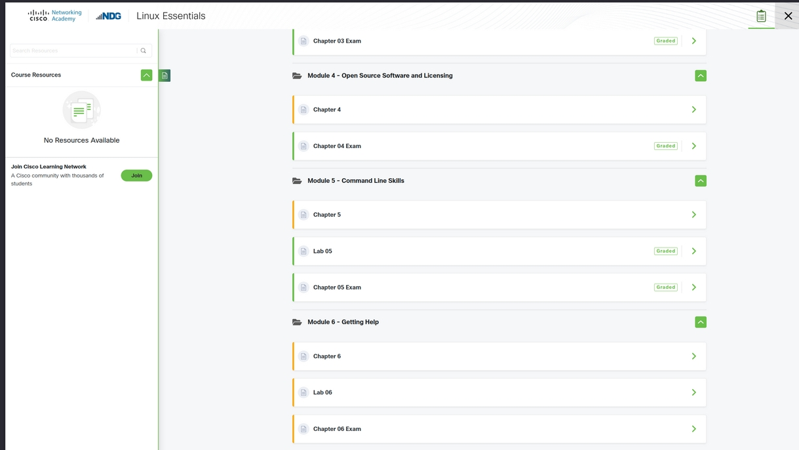2.5 LAB 5:

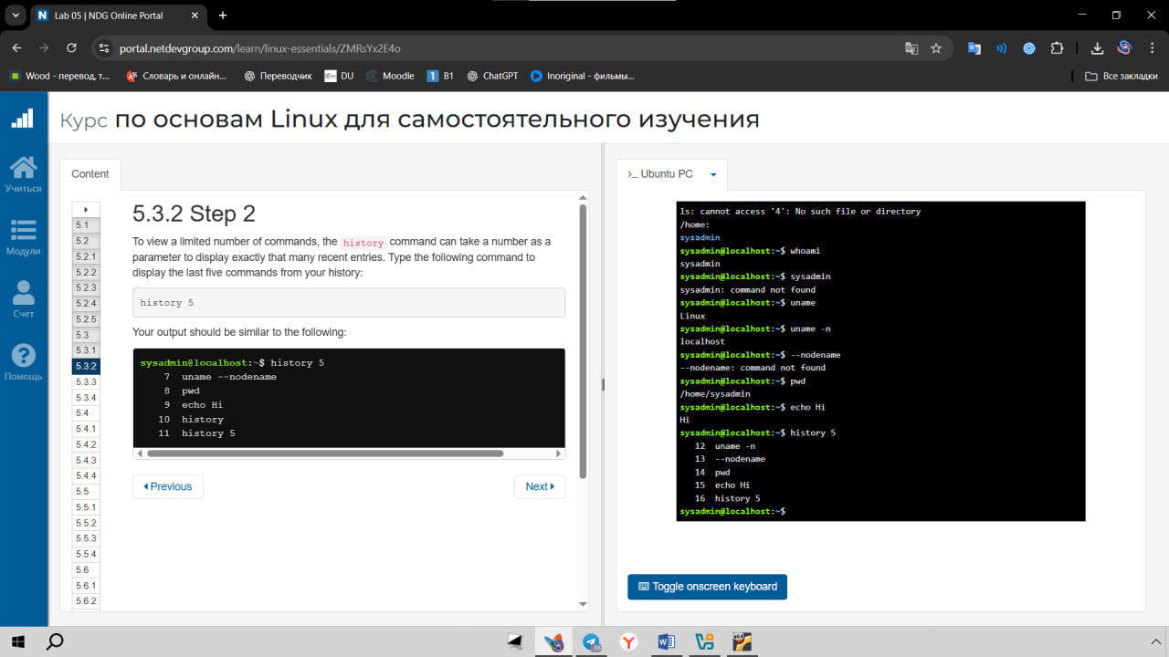

Although I had some general knowledge about computers, Linux was completely new to me. I believed this assignment would be a significant challenge. However, through the step-by-step process, I discovered that it was a very structured and accessible introduction. I gained my first practical experience with the command line and a basic understanding of how Linux operates. This assignment provided a solid and rewarding foundation for me to start learning something entirely new.