# TailorMe

##### Final Year Project Session 2021-2025

**A 4th Year Student**

A project submitted in partial fulfilment of the COMSATS University Degree

of

BS in Computer Science



Department of Computer Science COMSATS University Islamabad, Lahore Campus

#### Project Detail

|  |  |  |  |  |  |
| --- | --- | --- | --- | --- | --- |
| Type (Nature of project) | | | [✓] **Development** [ ] **Research** & **Development** | | |
| Area of specialization | | | Machine Learning & App Development | | |
| **Project Group Members** | | | | | |
| Sr.# | Reg. # | Student Name | | Email ID | *Signature |
| (i) | FA21- BCS-006 | Muhammad Ali | | MuhammadAli.16k@gma il.com |  |
| (ii) | FA21- BCS-066 | Muhammad Yaqoob | | [yaqoobk960960@gmail.c](mailto:yaqoobk960960@gmail.c) om |  |

*The candidates confirm that the work submitted is their own and appropriate credit has been given where reference has been made to work of others

##### Plagiarism Free Certificate

This is to certify that, I am Muhammad Ali S/D/o Nauman Rashid, group leader of FYP under registration no CUI/FA21-BCS-006/LHR at Computer Science Department, COMSATS Institute of Information Technology, Lahore. I declare that my FYP report is checked by my supervisor and the similarity index is 9% that is less than 20%, an acceptable limit by HEC. Report is attached herewith as Appendix A.

Date: 26/06/2025 Name of Group Leader: Muhammad Ali Signature: 

Name of Supervisor: Dr. Tariq Umer Co-Supervisor (if any):

|  |  |
| --- | --- |
| Designation: Signature: | Designation: Signature: |
| HoD: Signature: |  |

### Abstract

Clothing measurements, particularly for tailored garments, often require precise and efficient methods, which is usually done through manual measurements, and this requires being physically present at the shopping venue and the availability of measuring tools such as a measuring tape.

Hence, we have proposed TailorMe, a body measurement application, that aims to address this issue by computer vision with machine learning, for which a ResNet is used. The application processes user-uploaded images to measure body dimensions such as arm length, shoulders, neck, waist, chest and hip. Using the predicted measurements it generates a general size recommendation. We have also accommodated South Asian clothing (Shalwar Qameez) and the user can get a size prediction for it.

We hope to offer a practical solution to simplify the tailoring process and reduce the number of returns that happen during online shopping because of mismatched sizes.

In addition, the application offers a dedicated registration and dashboard system for tailors. Once registered, tailors can manage customer records, place and track orders, and view order statistics, enabling them to streamline their workflow and digitize their manual registers.

### Acknowledgement

We would like to acknowledge our supervisor, Dr. Tariq Umer, for his invaluable guidance, support, and encouragement throughout the course of our Final Year Project. His expertise and insightful feedback were instrumental in helping us shape our ideas and complete this project successfully.

We would also like to thank our institute, COMSATS University Islamabad, Lahore Campus, for providing us with the resources, academic foundation, and supportive environment that made the successful completion of this project possible.

Lastly, we would like to express our sincere gratitude to all the individuals who generously allowed us to take their pictures for the creation of our dataset. Their cooperation was crucial to the development and success of our project.

Content

Project Detail 2

Plagiarism Free Certificate 2

Abstract 3

Acknowledgement 4

1. Introduction 14
   1. Objectives 14
   2. Problem statement 14
   3. Assumptions & constraints 15
      1. Assumptions 15
      2. Constraints 15
   4. Project scope 15
      1. What to Consider 15
      2. What to not Consider 15
2. Requirement Analysis 16
   1. Literature review / Existing system study 16
   2. Stakeholders list (Actors) 16
   3. Requirements elicitation 17
      1. Functional requirements 17
      2. Non-functional requirements 18
   4. Requirements traceability matrix 19
   5. Use case descriptions 22
      1. UC01 - User Registration 22
      2. UC02 - User Login 22
      3. UC03 - Reset Password 23
      4. UC04 – Tailor Dashboard 23
      5. UC05 – Image Upload and Measurement Prediction 24
      6. UC06 – Image Capturing Using Phone Camera and Measurement Prediction

……………………………………………………………………………………………24

* + 1. UC07 – Clothing Size Recommendation 25
  1. Use case design 26
     1. User Sign-up and Login 26
     2. Profile Management 27
     3. Image Uploading and Measurement 28
     4. Image Capturing 29
  2. Software development life cycle model 30

1. System Design 31
   1. Work breakdown structure (WBS) 31
   2. Activity diagram 32
      1. AD01 – Sign Up 32
      2. AD02 – Login 33
      3. AD03 – Uploading an Existing Photo 34
      4. AD04 – Taking a Photo for Measurement 35
      5. AD05 – Tailor Dashboard 36
      6. AD06 – Database management 37
   3. Sequence diagram 38
      1. SD01 – Sign Up 38
      2. SD02 – Login 38
      3. SD03 – Taking a Photo for Measurement 39
      4. SD04 – Uploading Photo for Measurement 39
   4. Software Architecture 40
   5. Class diagram 41
   6. Database diagram 41
   7. Network diagram (Gantt chart) 42
      1. Network diagram 42
      2. Gantt Chart 42
   8. Collaboration diagram 43
      1. CD01 - Login 43
      2. CD02 - Reset Password 43
      3. CD03 - Upload Picture for Measurement 44
      4. CD04 - Take Picture for Measurement 44
      5. CD05 - Tailor Dashboard 45
2. System Testing 46
   1. Test cases 46
      1. Login 46
      2. Update Profile 46
      3. Reset Password 47
      4. User Interface 47
      5. Tailor Dashboard Management 48
      6. Image Upload 49
      7. Image Capture 49
      8. Measurement Extraction 50
      9. Manual Measurement Adjustment 50
      10. Clothing Size Recommendation 51
      11. Database Management 52
   2. Unit 53
   3. Integration 53
   4. Acceptance testing 53
3. Application Front-End 54
   1. Tailor Screens 54
      1. Tailor Home Screen 54
      2. Tailor Measurement Screen 55
      3. Measurements Result Screen 56
      4. Customer Records Screen 57
      5. Customer Details Screen 58
      6. Orders Screen 60
      7. Order Details Screen 61
      8. Statistics Screen 62
   2. Normal User Screens 63
      1. User Home Screen 63
      2. User Measurement Screen 64
      3. User Profile Screen 65
4. Conclusion 66
   1. Problems faced 66
      1. Dataset Collection: 66
      2. Server Hosting Limitation 66
      3. Model Integration Challenges 66
   2. Lessons Learned 66
      1. Importance of Modular Design 66
      2. Iterative testing is crucial 66
      3. User feedback improves UI/UX 67
      4. Effective Time management 67
   3. Project summary 67
   4. Future work 67
      1. Additional Features 67
      2. Platform Expansion 68
      3. Scalability 68
5. References 69

### List of Tables

Table 1. FR01 - User Management 17

Table 2. FR02 – Tailor Dashboard Features 17

Table 3. FR03 - User Interface 17

Table 4. FR04 - Image Upload 18

Table 5. FR05 - Capturing Image Using Phone Camera 18

Table 6. FR06 - Measurement Prediction 18

Table 7. FR07 - Measurement Adjustments 18

Table 8. FR08 - Clothing Recommendation 18

Table 9. FR09 - Backend Database 18

Table 10. NFR01 - System Performance 18

Table 11. NFR02 - Scalability 19

Table 12. NFR03 - Reliability 19

Table 13. NFR04 – Usability 19

Table 14. NFR05 - Security 19

Table 15. NFR06 - Legal and Ethical 19

Table 16. Requirements traceability matrix 22

Table 17. UC01 - User Registration 22

Table 18. UC02 - User Login 23

Table 19. UC03 - Reset Password 23

Table 20. UC04 - Tailor Dashboard 24

Table 21. UC05 - Image Upload and Measurement Prediction 24

Table 22. UC06 - Image Capturing Using Phone Camera and Measurement Prediction 25

Table 23. UC07 - Clothing Size Recommendation 25

Table 24. Test Case - Login 46

Table 25. Test Case - Update Profile 47

Table 26. Test Case - Reset Password 47

Table 27. Test Case - User Interface 48

Table 28. Test Case - Tailor Dashboard Management 48

Table 29. Test Case - Image Upload 49

Table 30. Test Case - Image Capture 50

Table 31. Test Case - Measurement Extraction 50

Table 32. Test Case - Manual Measurement Adjustment 51

Table 33. Test Case - Clothing Size Recommendation 52

Table 34. Test Case - Database Management 52

### List of Figures

Figure 1. User Sign-up and Login 26

Figure 2. Profile Management 27

Figure 3. Image Uploading and Measurement 28

Figure 4. Image Capturing 29

Figure 5. Software Development Life Cycle 30

Figure 6. Work Breakdown Structure 31

Figure 7. AD01 - Sign Up 32

Figure 8. AD02 - Login 33

Figure 9. AD03 - Uploading an Existing Photo 34

Figure 10. AD04 - Taking a Photo for Measurement 35

Figure 11. AD05 - Tailor Dashboard 36

Figure 12. AD06 - Database Management 37

Figure 13. SD01 - Sign Up 38

Figure 14. SD02 - Login 38

Figure 15. SD03 - Taking a Photo for Measurement 39

Figure 16. SD04 - Uploading Photo for Measurement 39

Figure 17. Software Architecture 40

Figure 18. Class Diagram 41

Figure 19. Database Diagram 41

Figure 20. Network Diagram 42

Figure 21. Gantt Chart 42

Figure 22. CD01 – Login 43

Figure 23. CD02 - Reset Password 43

Figure 24. CD03 - Upload Picture for Measurement 44

Figure 25. CD04 - Take Picture for Measurement 44

Figure 26. CD05 - Tailor Dashboard 45

Figure 27. Tailor Home Screen 54

Figure 28. Tailor Measurement Screen 55

Figure 29. Measurements Result Screen 1 56

Figure 30. Measurements Result Screen 2 56

Figure 31. Customer Records Screen 57

Figure 32. Customer Details Screen 1 58

Figure 33. Customer Details Screen 2 59

Figure 34. Order Screen 60

Figure 35. Order Details Screen 61

Figure 36. Statistics Screen 62

Figure 37. User Home Screen 63

Figure 38. User Measurement Screen 64

Figure 39. User Profile Screen 65

1. **Introduction**

Clothing measurements are a crucial aspect of tailoring and garment shopping, yet many individuals struggle with obtaining precise and consistent body measurements. This is particularly challenging when tailoring traditional or custom-made clothing, where accurate measurements are essential for a proper fit. To address this issue, we propose TailorMe, a body measurement application that utilizes Computer Vision using Deep Learning (ResNet) for Multi-Output Regression to provide users with accurate measurements that are used for tailoring such as neck size, waist, shoulder length, arm length, chest and hip size. The app also provides tailors the functionality to manage customer records, place and track orders, and view order statistics, enabling them to streamline their workflow and digitize their manual registers.

This app aims to change how people measure their body dimensions by introducing a simple and user-friendly platform that leverages technology. Allowing them to take measurements from the privacy of their home. Using a smartphone camera, users can take or upload photos, which are processed to extract key measurements, based on which the application recommends clothing size.

The machine learning model, built with Python and powered by libraries like Tensorflow, Keras for building and training the ResNet model using deep learning. Numpy and Pandas for handling numerical computations and preprocessing the dataset. OpenCV for image preprocessing. The frontend, designed in React Native with Expo framework, provides users with an intuitive interface to interact with the App.

This introduction provides a foundation for this project, outlining its objectives and scope while highlighting its potential to simplify tailoring and garment shopping experiences for users worldwide.

###### Objectives

* Provide reliable body measurements using machine learning
* Offer sizing recommendations for desi clothing (Shalwar Qameez).
* Create a user-friendly application for taking and uploading images for measurements.
* Reduce dependency on manual measurement methods.
* Digitize manual tailor records and orders.

###### Problem statement

Accurate body measurements are essential for tailored clothing and garment shopping, yet traditional manual methods are prone to errors and inconsistencies. This often results in ill- fitting garments and a time-consuming tailoring process. Additionally, there is no accessible tool for users to measure their bodies accurately using their smartphones. The

absence of such a tool limits the ability to quickly obtain precise measurements for various clothing types, especially for desi attire where standard size charts may not suffice. This highlights the need for an innovative solution to simplify the measurement process and ensure accuracy in clothing fit.

###### Assumptions & constraints

* + 1. **Assumptions**
* Smartphones with cameras are widely available for app users.
* Users are willing to grant camera and gallery access for measurement purposes.
* Measurement results will comply with standard size recommendations.
* Privacy and security of user images and data will be maintained.
* Users will follow on-screen guidelines for taking proper measurement photos.
  + 1. **Constraints**
* Image quality directly affects measurement accuracy.
* Limited time and resources for model training, development, and testing.
* Network latency or lack of internet may delay API-based measurement results.
* Predicted measurements may not be wholly accurate and will have margin of error.
* Almost no available dataset with required measurement labels for training. Hence clothing size recommendation is limited to Shalwar Qameez.
* Dataset was collected manually across campus and hostels.
* Data imbalance (e.g., underrepresentation of certain body types) may affect model generalization.

###### Project scope

* + 1. **What to Consider**
* Development of a computer vision machine learning model for measurement prediction using Python.
* React Native with the Expo Framework is used to build a seamless user interface.
* Integration of security measures for image data storage and processing.
  + 1. **What to not Consider**
* Advanced AI features like predictive sizing beyond measurements.
* Integration with third-party clothing brands for virtual try-ons.
* Detailed customization options for niche clothing types.
* Extensions beyond core functionality like body posture analysis.

### Requirement Analysis

We identify the requirements here and give a brief description of them in a conclusive way.

###### Literature review / Existing system study

Various research and development efforts have been made in body measurement extraction. Previous work includes techniques in computer vision, such as contour detection and key-point estimation using libraries like **OpenPose** 1.

During our research we came across apps like **MirrorSize** 2, which uses AI for body measurements. **3DLOOK** 3**,** an app that captures over 80 points of measurement using just two photos taken by the user. **Bodymapp** 4**,** a 3D body scanning app that allows users to measure and track their body composition and circumference measurements using an iPhone X or above.

We also came across the following Studies and research papers:

1. A Review of Body Measurement Using 3D Scanning 5: [https://www.researchgate.net/publication/351207865_A_Review_of_Body_Measure](https://www.researchgate.net/publication/351207865_A_Review_of_Body_Measurement_Using_3D_Scanning) [ment_Using_3D_Scanning](https://www.researchgate.net/publication/351207865_A_Review_of_Body_Measurement_Using_3D_Scanning)
2. This study focused on estimating upper body dimensions using a single RGB camera, such as those found on smartphones. The process involved several steps, including image calibration and feature extraction, to accurately derive body measurements 6: [https://www.semanticscholar.org/paper/Measuring-the-Human-Body-from-a-Single-](https://www.semanticscholar.org/paper/Measuring-the-Human-Body-from-a-Single-Camera%2C-with-Montazerian-LEYMARIE/ae8c70ec2e5fe71f7692f51a9f7527f173d46f41?utm_source=direct_link) [Camera%2C-with-Montazerian-](https://www.semanticscholar.org/paper/Measuring-the-Human-Body-from-a-Single-Camera%2C-with-Montazerian-LEYMARIE/ae8c70ec2e5fe71f7692f51a9f7527f173d46f41?utm_source=direct_link) [LEYMARIE/ae8c70ec2e5fe71f7692f51a9f7527f173d46f41?utm_source=direct_link](https://www.semanticscholar.org/paper/Measuring-the-Human-Body-from-a-Single-Camera%2C-with-Montazerian-LEYMARIE/ae8c70ec2e5fe71f7692f51a9f7527f173d46f41?utm_source=direct_link)
3. Designing a Contactless, AI System to Measure the Human Body using a Single Camera for the Clothing and Fashion Industry – University of London 7: [https://www.researchgate.net/publication/373343443_Designing_a_Contactless_AI_S](https://www.researchgate.net/publication/373343443_Designing_a_Contactless_AI_System_to_Measure_the_Human_Body_using_a_Single_Camera_for_the_Clothing_and_Fashion_Industry) [ystem_to_Measure_the_Human_Body_using_a_Single_Camera_for_the_Clothing_a](https://www.researchgate.net/publication/373343443_Designing_a_Contactless_AI_System_to_Measure_the_Human_Body_using_a_Single_Camera_for_the_Clothing_and_Fashion_Industry) [nd_Fashion_Industry](https://www.researchgate.net/publication/373343443_Designing_a_Contactless_AI_System_to_Measure_the_Human_Body_using_a_Single_Camera_for_the_Clothing_and_Fashion_Industry)
4. Automatic Extraction of 3D Body Measurements from 2D Images: This paper proposes an automated system that extracts body measurements from 2D images, facilitating better garment fitting for small businesses. The system was tested on images of young females, comparing the results with manual measurements to validate its accuracy 8~ [https://www.semanticscholar.org/paper/Automatic-Extraction-of-3-d-Body-](https://www.semanticscholar.org/paper/Automatic-Extraction-of-3-d-Body-Measurements-from-Sehgal-Gupta/d49108ddfdeb2ddf973589bb078000274ee7fb01) [Measurements-from-Sehgal-Gupta/d49108ddfdeb2ddf973589bb078000274ee7fb01](https://www.semanticscholar.org/paper/Automatic-Extraction-of-3-d-Body-Measurements-from-Sehgal-Gupta/d49108ddfdeb2ddf973589bb078000274ee7fb01)

###### Stakeholders list (Actors)

* Users: Individuals seeking body measurements or size recommendations.
* Tailors: Seeking to streamline their workflow from taking measurements to record keeping.
* Developers: Building and maintaining the application.

###### Requirements elicitation

* + 1. Functional requirements

##### FR01 – User Management

*Table 1. FR01 - User Management*

|  |  |
| --- | --- |
| FR01 - 01 | **User Registration:** User should be able to create their profile on the application and select relevant role: Normal User or Tailor. |
| FR01 - 02 | **User Login:** User should be to login using their credentials. (Username/Email and Password). |
| FR01 - 03 | **Profile Management:** Users should be able to update and manage their profile information. |

##### FR02 – Tailor Dashboard Features

*Table 2. FR02 - Tailor Dashboard Features*

|  |  |
| --- | --- |
| FR02 – 01 | **Register as Tailor:** Tailors can register and create a profile. |
| FR02 – 02 | **Save and Manage Customer Records:** Tailors can save customer contact info, measurements and order history. |
| FR02 - 03 | **Add and Update Orders:** Tailors can create new orders, update status (e.g. In-Progress, Completed), and assign delivery dates. |
| FR02 - 04 | **View Order and Customer Statistics:** Tailors can view analytics like Total orders, customers, completed orders, pending work and total revenue. |

##### FR03 - User Interface

*Table 3. FR03 - User Interface*

|  |  |
| --- | --- |
| FR03 – 01 | The User interface should be an intuitive interface for easy navigation. |

##### FR04 - Image Upload

*Table 4. FR04 - Image Upload*

|  |  |
| --- | --- |
| FR04 - 01 | The user or tailor should be allowed to upload images for measurement. |

##### FR05 – Capturing Image using Phone Camera

*Table 5. FR05 - Capturing Image Using Phone Camera*

|  |  |
| --- | --- |
| FR05 - 01 | The Users phone camera must be calibrated properly to take correct images for measurement extraction. They must follow the instructions on screen. |
| FR05 - 02 | The User shall be able to capture image through the apps camera interface. |

##### FR06 - Measurement Prediction

*Table 6. FR06 - Measurement Prediction*

|  |  |
| --- | --- |
| FR06 - 01 | Ensuring the measurements have minimum error. |

##### FR07 - Measurement Adjustments

*Table 7. FR07 - Measurement Adjustment*

|  |  |
| --- | --- |
| FR07 - 01 | Enable users to manually edit measurements if needed. |

##### FR08 - Clothing Size Recommendations

*Table 8. FR08 - Clothing Recommendation*

|  |  |
| --- | --- |
| FR08 - 01 | **Size Recommendation:** Suggests general size recommendation based on extracted measurements and size recommendations for Shalwar Qameez. |

##### FR09 - Backend Database

*Table 9. FR09 - Backend Database*

|  |  |
| --- | --- |
| FR09 - 01 | **Data Storage:** The system will Store user data, measurements, and preferences securely. |

* + 1. **Non-functional requirements**

##### NFR01 - System Performance

*Table 10. NFR01 - System Performance*

|  |  |
| --- | --- |
| NFR01 - 01 | Ensure that the app responds to the user within reasonable time. |

##### NFR02 - Scalability

*Table 11. NFR02 - Scalability*

|  |  |
| --- | --- |
| NFR02 – 01 | The app will be designed so that it can be scaled horizontally, to handle increasing user loads |
| NFR02 – 02 | In terms of system architecture, we must make sure the app can accommodate future work. |

##### NFR03 - Reliability

*Table 12. NFR03 - Reliability*

|  |  |
| --- | --- |
| NFR03 - 01 | The app should be highly available in terms of reliability. It should have minimal downtime and system failures. |

##### NFR04 – Usability

*Table 13. NFR04 - Usability*

|  |  |
| --- | --- |
| NFR04 - 01 | The app should have an intuitive interface that requires minimal learning for new users. |

##### NFR05 – Security

*Table 14. NFR05 - Security*

|  |  |
| --- | --- |
| NFR05 – 01 | The app that we will develop should implement robust security measures to protect user data that the user will provide us, including encryption of sensitive information of our user, secure authentication mechanisms, and protection against common security threats |

##### NFR06 - Legal and Ethical

*Table 15. NFR06 - Legal and Ethical*

|  |  |
| --- | --- |
| NFR06 - 01 | Adhere to intellectual property rights and avoid unauthorized use of third- party assets. |

###### Requirements traceability matrix

This table shows the functional requirements traceability matrix of our project gives the reference of use case description, activity diagram, sequence diagrams and test cases for all the functional requirements.

*Table 16. Requirements traceability matrix*

|  |  |  |  |  |  |  |
| --- | --- | --- | --- | --- | --- | --- |
| **Functional Requirement Number** | **Functional Requirement Description** | **Use Case Description Number** | **Activity Diagram Number** | **Sequence Diagram Number** | **Collaborati on**  **Diagram Number** | **Test Case Number** |
| **FR01** | User management encompasses all functionalities related to creating and maintaining  user accounts. Users should be able to register, log in, and manage their profile. Users should be able to access and review their past  measurement history and recommendations. | U01 U02 U03 | AD01 AD02 | SD01 SD02 | CD01 CD02 | TC01 TC02 TC03 TC04 |
| **FR02** | Tailor Dashboard functionalities | UC04 | AD05 | - | CD05 | TC07 |
| **FR03** | The user interface should be designed to ensure an  intuitive and seamless experience. | - | - | - | - | TC05 TC06 |
| **FR04** | The image upload functionality provides users the option to upload an image from their phone gallery for measurement Prediction. | UC05 | AD03 | SD0 4 | CD03 | TC08 |
| **FR05** | This functionality allows users to capture images directly through the app using their phone camera. The | UC06 | AD04 | SD0  3 | CD04 | TC09 |

|  |  |  |  |  |  |  |
| --- | --- | --- | --- | --- | --- | --- |
|  | camera must be calibrated first, and app should provide an interface that guides the user to take suitable photos for measurement extraction. |  |  |  |  |  |
| **FR06** | Measurement extraction focuses on accurately analyses the user’s uploaded or captured photos to derive key body measurements. The system must ensure minimal error during this process. | UC05 UC06 | AD03 AD04 | SD03 SD04 | CD03 CD04 | TC10 |
| **FR07** | This functionality allows users to edit adjust their extracted measurements. | - | - | - | - | TC11 |
| **FR08** | The clothing recommendation algorithm provides users with a general size recommendation and a size recommendation for shalwar qameez. | UC07 | AD03 AD04 | SD 03 SD 04 | CD03 CD04 | TC12 |
| **FR09** | The backend database is  responsible for securely storing user data,  measurements, and preferences. It ensures privacy of user information. | - | AD06 | - | - | TC13 |

###### Use case descriptions

* + 1. **UC01 - User Registration**

*Table 17. UC01 - User Registration*

|  |  |
| --- | --- |
| **Use Case Name:** | User Registration |
| **Actors:** | User |
| **Description:** | User enters their credentials in the registration screen. They will input their chosen Username, Email and Password. They must also chose their role: Normal User or Tailor. |
| **Pre-Condition:** | * The app must be operational * The user shall not have another account with the same email |
| **Post-Condition:** | * The app confirms the new account was created |
| **Normal Flow of Event** | * User Opens the app. * Clicks on sign-up button. * Enters credentials. * The system validates the user’s information. * A new accounted is created. * User is shown home screen relevant to chosen role. |

* + 1. **UC02 - User Login**

*Table 18. UC02 - User Login*

|  |  |
| --- | --- |
| **Use Case Name:** | User Login |
| **Actors:** | User |
| **Description:** | User |
| **Pre-Condition:** | * App must be operational   User must have an account as a normal user or tailor. |
| **Post-Condition:** | User is logged in. |
| **Normal Flow of Event** | * User opens the app. * Enters their credentials on the login screen. * The system validates the user.   User is now logged into the app with their account. |

* + 1. **UC03 - Reset Password**

*Table 19. UC03 - Reset Password*

|  |  |
| --- | --- |
| **Use Case Name:** | Reset Password |
| **Actors:** | User |
| **Description:** | User resets their password |
| **Pre-Condition:** | * App must be operational |
| **Post-Condition:** | * User has a new password, which they can use to login. |
| **Normal Flow of Event** | * The user opens the app. * User navigates to profile screen and then to settings. * User enters new password in the change password field. * User can login with the new password. |

* + 1. **UC04 – Tailor Dashboard**

*Table 20. UC04 - Tailor Dashboard*

|  |  |
| --- | --- |
| **Use Case Name:** | Tailor Dashboard |
| **Actors:** | User with Tailor role. |
| **Description:** | Tailor registers their profile and gains access to features for managing customer records, adding orders, and viewing order statistics. |
| **Pre-Condition:** | * App must be operational. * User must be logged in with tailor account. |
| **Post-Condition:** | * Tailor gains access to a personalized dashboard. * Tailor data (customers, orders, stats) is stored in the database. |
| **Normal Flow of Event** | * User logs in their account with the tailor role. * User gains access to tailor dashboard. |

* + 1. **UC05 – Image Upload and Measurement Prediction**

*Table 21. UC05 - Image Upload and Measurement Prediction*

|  |  |
| --- | --- |
| **Use Case Name:** | Image Upload & Measurement Prediction |
| **Actors:** | User |
| **Description:** | User shall be able to upload an image from their phone gallery for measurement extraction. |
| **Pre-Condition:** | * App must be operational. * User must be logged in. |
| **Post-Condition:** | * Measurements are predicted by the model and shown to the user. |
| **Normal Flow of Event** | * User logs in their account. * User navigates to “Take Measurement” screen. * User clicks/taps on the image upload button. * User selects an image from gallery. * Measurements are predicted by the model and shown on   screen. |

* + 1. **UC06 – Image Capturing Using Phone Camera and Measurement Prediction**

*Table 22. UC06 - Image Capturing Using Phone Camera and Measurement Prediction*

|  |  |
| --- | --- |
| **Use Case Name:** | Image Capturing Using Phone Camera & Measurement Prediction. |
| **Actors:** | User |
| **Description:** | User shall be able to capture an image from their phone. |
| **Pre-Condition:** | * App must be operational. * User must be logged in. |
| **Post-Condition:** | * Measurements are predicted by the model and shown to the user. |
| **Normal Flow of Event** | * User logs in their account or uses guest mode. * User clicks/taps on the image capture button. * User takes an image. * App validates the image. * Measurements are predicted by the model and shown on screen. |

* + 1. **UC07 – Clothing Size Recommendation**

*Table 23. UC07 - Clothing Size Recommendation*

|  |  |
| --- | --- |
| **Use Case Name:** | Clothing Size Recommendation |
| **Actors:** | User |
| **Description:** | User can get clothing size recommendation on   1. Shalwar Qameez. 2. General Size recommendation. |
| **Pre-Condition:** | * App must be operational. * User must be logged in. |
| **Post-Condition:** | * Clothing Size Recommendations are shown to the user. |
| **Normal Flow of Event** | * User logs in their account. * User captures or uploads an image for measurement extraction. * Clothing Size recommendation are shown on screen. |

###### Use case design

* + 1. **User Sign-up and Login**

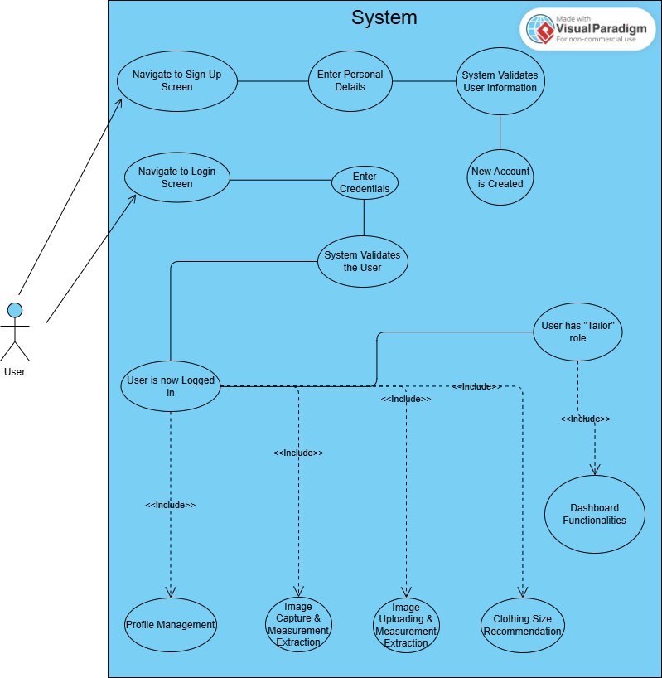

*Figure 1. User Sign-up and Login*

* + 1. **Profile Management**

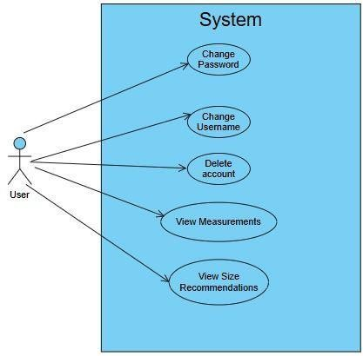

*Figure 2. Profile Management*

* + 1. **Image Uploading and Measurement**

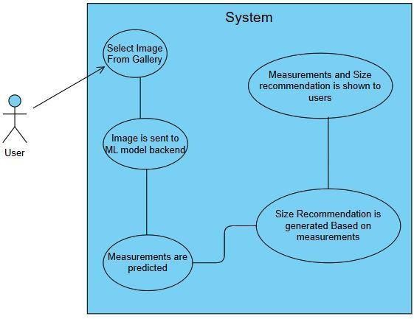

*Figure 3. Image Uploading and Measurement*

* + 1. **Image Capturing**

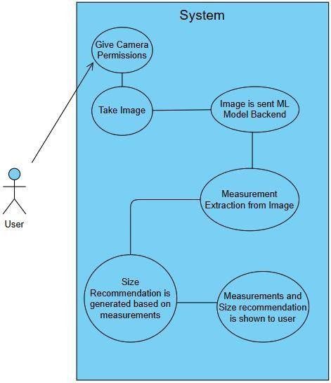

*Figure 4. Image Capturing*

###### Software development life cycle model

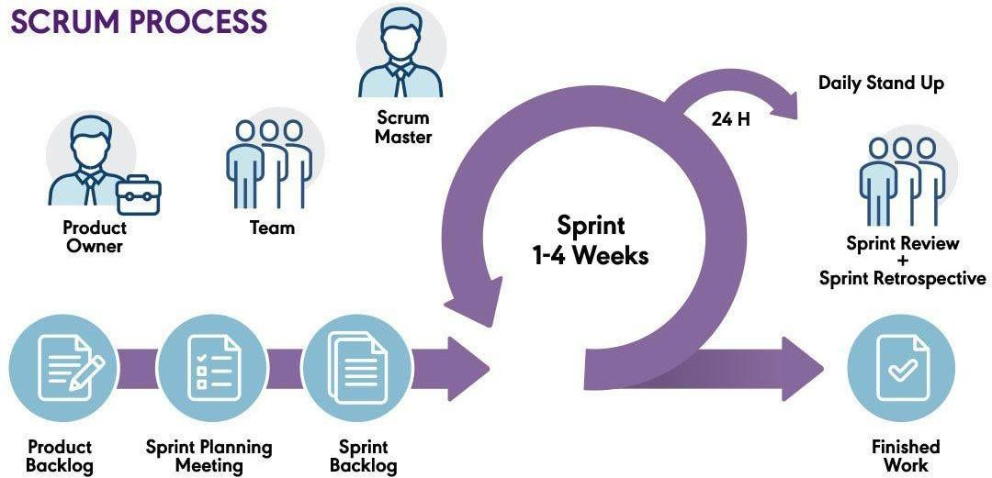

*Figure 5. Software Development Life Cycle*

Agile methodologies, specifically in our case the Scrum, are particularly well-suited for our project. Scrum enables our development team to work concurrently, ensuring efficient progress across various aspects of the Application. Furthermore, testing is integrated seamlessly into the development process, ensuring that quality assurance is an ongoing endeavor rather than a final step.

Scrum's adaptability is paramount for our project, as image processing and back-end algorithms may change frequently. By prioritizing tasks based on their importance for each iteration, Scrum allows us to deliver valuable increments of the project consistently, thereby enhancing accuracy of the app and a smooth UI.

Regular team meetings are a cornerstone of our Agile approach. These meetings provide opportunities to clarify requirements, test development up to that point, and ensure that the app aligns with initial project goals and objectives.

### System Design

###### Work breakdown structure (WBS)

The Work Breakdown Structure (WBS) divides the project into manageable tasks and sub-tasks, ensuring a clear understanding of each phase of development. It provides a hierarchical view of the project components, helping to organize, schedule, and track progress efficiently.

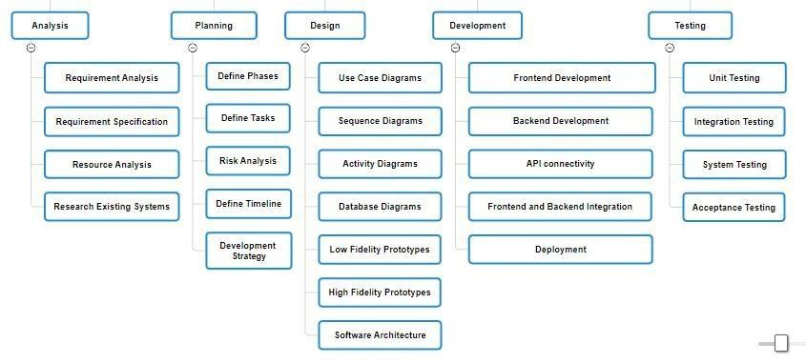

*Figure 6. Work Breakdown Structure*

###### Activity diagram

* + 1. **AD01 – Sign Up**

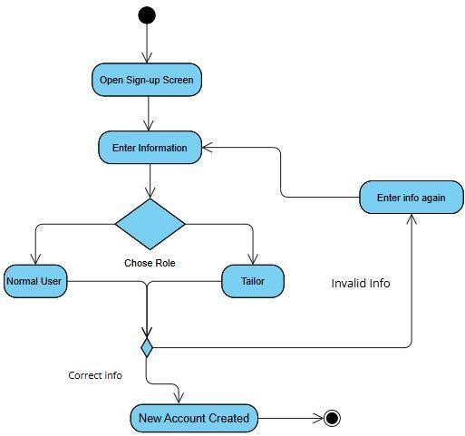

*Figure 7. AD01 - Sign Up*

* + 1. **AD02 – Login**

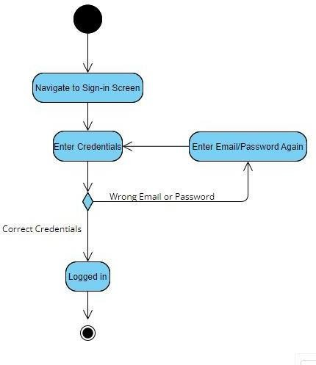

*Figure 8. AD02 - Login*

* + 1. **AD03 – Uploading an Existing Photo**

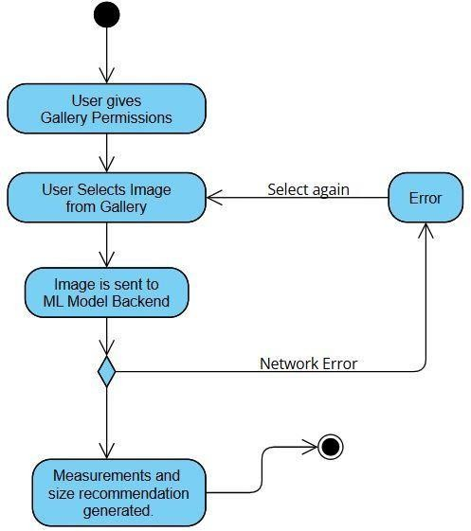

*Figure 9. AD03 - Uploading an Existing Photo*

* + 1. **AD04 – Taking a Photo for Measurement**

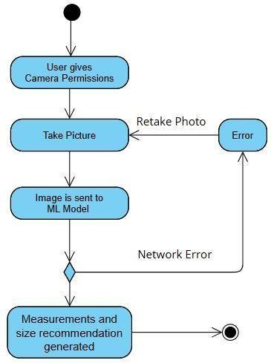

*Figure 10. AD04 - Taking a Photo for Measurement*

* + 1. **AD05 – Tailor Dashboard**

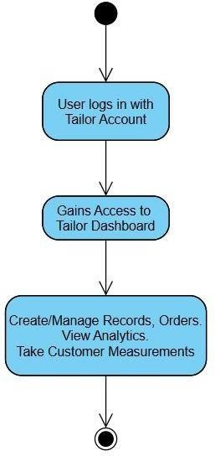

*Figure 11. AD05 - Tailor Dashboard*

* + 1. **AD06 – Database management**

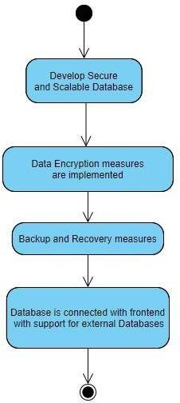

*Figure 12. AD06 - Database Management*

###### Sequence diagram

* + 1. **SD01 – Sign Up**

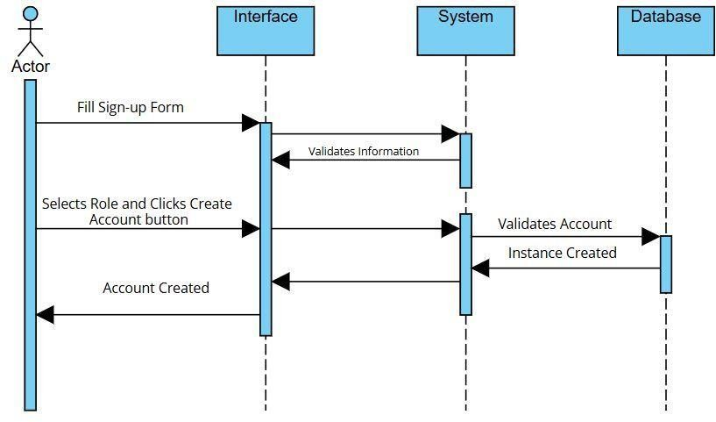

*Figure 13. SD01 - Sign Up*

* + 1. **SD02 – Login**

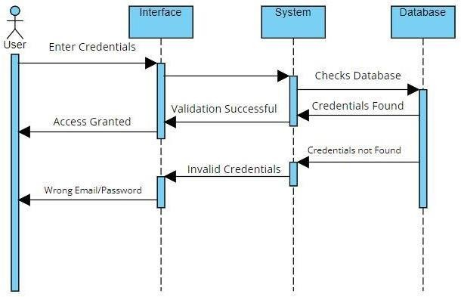

*Figure 14. SD02 - Login*

* + 1. **SD03 – Taking a Photo for Measurement**

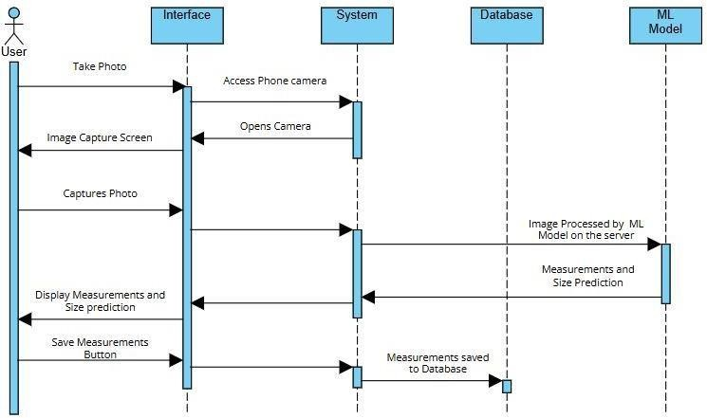

*Figure 15. SD03 - Taking a Photo for Measurement*

* + 1. **SD04 – Uploading Photo for Measurement**

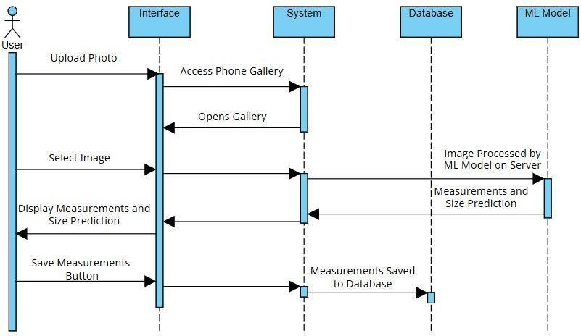

*Figure 16. SD04 - Uploading Photo for Measurement*

###### Software Architecture

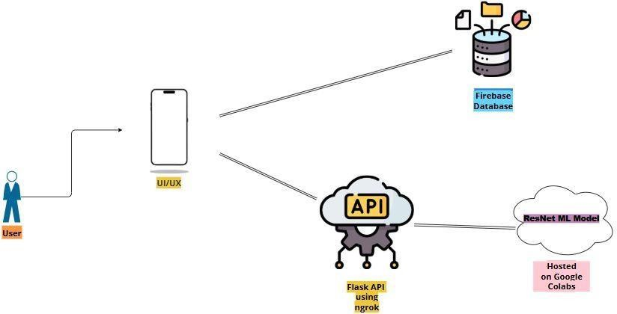

*Figure 17. Software Architecture*

Client-Side UI/UX is made through **React-Native** with **Expo Framework**. Which has been chosen for its cross-platform compatibility with both IOS and Android.

The **ResNet Model** is hosted on **Google Colabs** and accessed via a **Flask API** with **ngrok** used to exposed local server to the internet**.** This API handles the core functionalities of predicting body measurements and providing size recommendation.

**Firebase Authentication** is used for user like sign-up and login.This application database is managed using **Firebase Firestore** which stores user information, measurements, records and orders.

For production deployment, the ResNet model and API can be migrated to a **cloud platform** such as **AWS**, **Google Cloud**, or **Railway**. **Docker** can be used to containerize the backend. However, deploying in a production environment typically involves **paid server resources**.

###### Class diagram

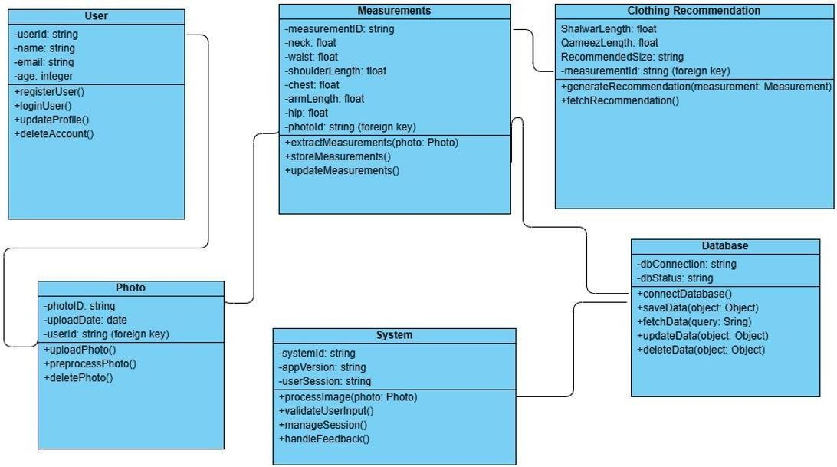

*Figure 18. Class Diagram*

###### Database diagram

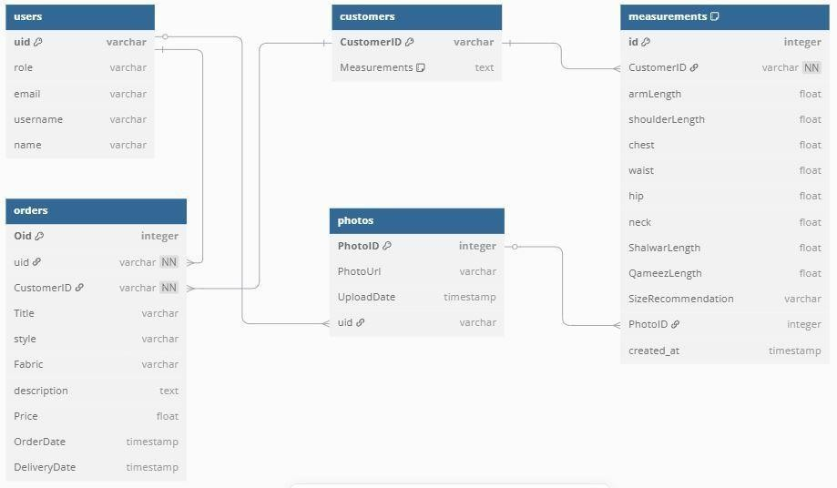

*Figure 19. Database Diagram*

###### Network diagram (Gantt chart)

* + 1. **Network diagram**

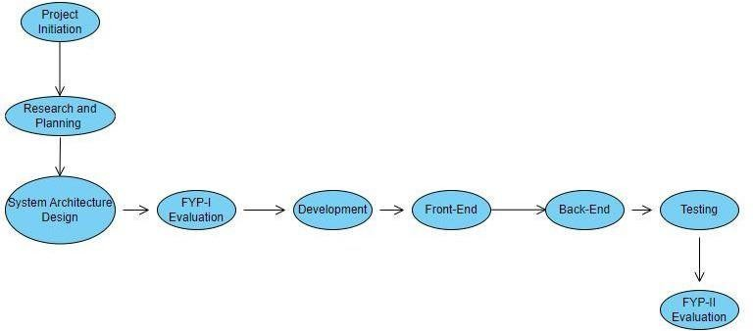

*Figure 20. Network Diagram*

* + 1. **Gantt Chart**

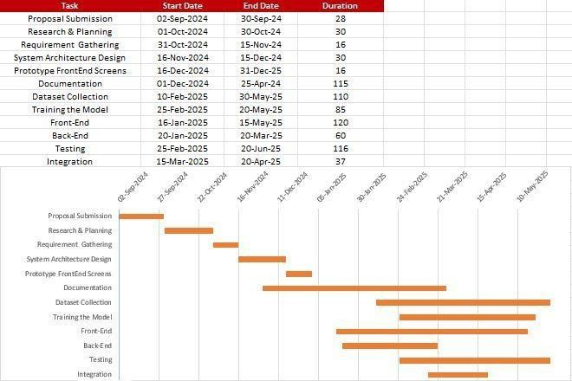

*Figure 21. Gantt Chart*

###### Collaboration diagram

* + 1. **CD01 - Login**

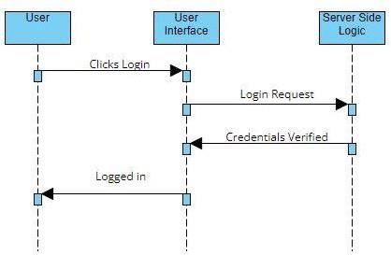

*Figure 22. CD01 – Login*

* + 1. **CD02 - Reset Password**

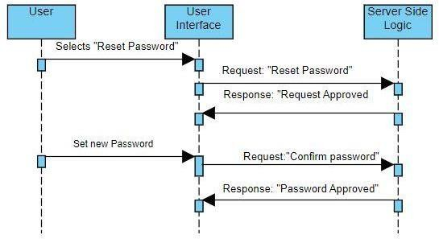

*Figure 23. CD02 - Reset Password*

* + 1. **CD03 - Upload Picture for Measurement**

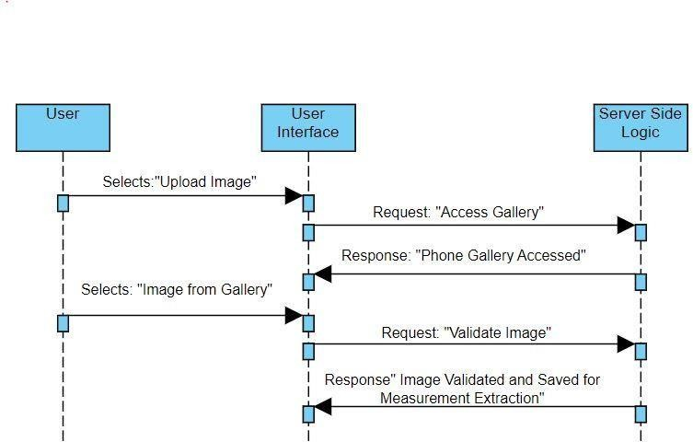

*Figure 24. CD03 - Upload Picture for Measurement*

* + 1. **CD04 - Take Picture for Measurement**

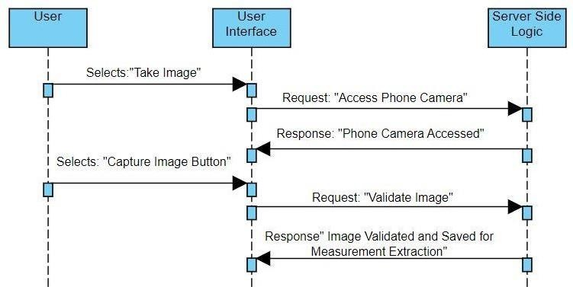

*Figure 25. CD04 - Take Picture for Measurement*

* + 1. **CD05 - Tailor Dashboard**

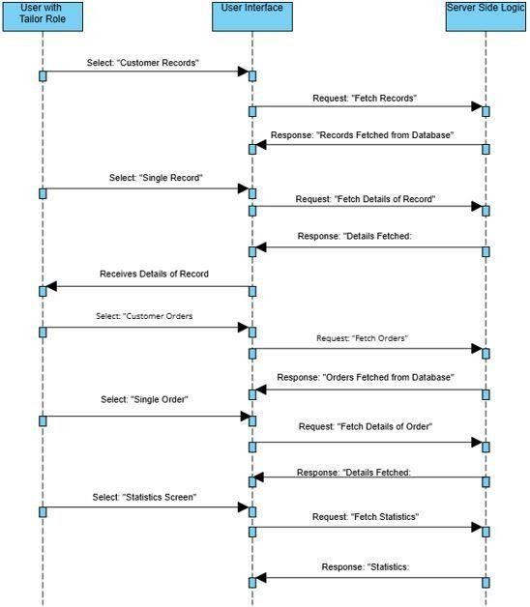

*Figure 26. CD05 - Tailor Dashboard*

### System Testing

###### Test cases

* + 1. **Login**

*Table 24. Test Case - Login*

|  |  |  |  |  |  |  |
| --- | --- | --- | --- | --- | --- | --- |
| **Test Case ID** | **Name** | **Description** | **Test Steps** | **Expected Result** | **Actual Result** | **Pass/Fail** |
| TC01 | Valid Credentials | Verify that the User/Admin can login in valid Credentials. | 1. User navigates to login screen. 2. Enters correct   email and password.   1. Taps login button. | The User is successfully logged in. | The User was successfully logged in. | Pass |
| TC02 | Invalid Credentials | Ensure User cannot log  in with  Invalid Credentials. | 1. User navigates to the login page. 2. Enters incorrect email or   password.   1. Taps on the login button. | The app  displays an error message, and the login fails. | Error message display. Login Failed. | Pass |

* + 1. **Update Profile**

*Table 25. Test Case – Update Profile*

|  |  |  |  |  |  |  |
| --- | --- | --- | --- | --- | --- | --- |
| **Test Case ID** | **Name** | **Description** | **Test Steps** | **Expected Result** | **Actual Result** | **Pass/Fail** |

|  |  |  |  |  |  |  |
| --- | --- | --- | --- | --- | --- | --- |
| TC03 | Update User Details | Verify that the user can update user details like username, name etc. | 1. User taps on user profile icon. 2. User updates details like username, name, etc | The user  successfully changed details | User details updated successfully. | Pass |

* + 1. **Reset Password**

*Table 26. Test Case - Reset Password*

|  |  |  |  |  |  |  |
| --- | --- | --- | --- | --- | --- | --- |
| **Test Case ID** | **Name** | **Description** | **Test Steps** | **Expected Result** | **Actual Result** | **Pass/Fail** |
| TC04 | Reset Password | Verify that the user can reset their password. | 1. User taps on user profile icon. 2. User taps on reset password button. 3. User sets a new password | The user  successfully  sets a new password. | Password Result successful. | Pass |

* + 1. **User Interface**

*Table 27. Test Case – User Interface*

|  |  |  |  |  |  |  |
| --- | --- | --- | --- | --- | --- | --- |
| **Test Case ID** | **Name** | **Description** | **Test Steps** | **Expected Result** | **Actual Result** | **Pass/Fail** |
| TC05 | Intuitive and  User- Friendly Interface | Verify that the user interface is user- friendly and easy to use | 1. Users access the interface. 2. Navigates easily through different modules and functionalities. | User interface is intuitive and user-friendly.  Navigation and interaction are easy. | Interface was user- friendly and easy  to use.  Users navigate modules  without confusion. | Pass |

|  |  |  |  |  |  |  |
| --- | --- | --- | --- | --- | --- | --- |
| TC06 | Responsive Interface | Verify that the interface is responsive to user interaction. | 1. Users access the interface 2. User finds the interface is responsive. | User interface is responsive and provides consistent user experience. | Interface was responsive and provided consistent  user experience. | Pass |

* + 1. **Tailor Dashboard Management**

*Table 28. Test Case - Tailor Dashboard Management*

|  |  |  |  |  |  |  |
| --- | --- | --- | --- | --- | --- | --- |
| **Test Case ID** | **Name** | **Description** | **Test Steps** | **Expected Result** | **Actual Result** | **Pass/Fail** |
| TC07 | Tailor Dashboard Management | Verify that the users with tailor role can create/view customer records, orders and business analytics. | 1. Users log into their account which has tailor role. 2. Navigate to customer record screen, order screen, statistics screen. 3. User is shown relevant information and can perform relevant functions. | User can easily create/view customer records, orders and statistics. | User was successfully able to  perform all functionalities associated with tailor dashboard. | Pass |

* + 1. **Image Upload**

*Table 29. Test Case - Image Upload*

|  |  |  |  |  |  |  |
| --- | --- | --- | --- | --- | --- | --- |
| **Test Case ID** | **Name** | **Description** | **Test Steps** | **Expected Result** | **Actual Result** | **Pass/Fail** |
| TC08 | Image Upload | Verify that the app allows the user to upload images from their gallery | 1. User log into their account. 2. Navigates to upload from gallery screen 3. User uploads image from gallery for measurement extraction. | User can upload image from  gallery for measurement extraction. | User was able to upload images from gallery. | Pass |

* + 1. **Image Capture**

*Table 30. Test Case - Image Capture*

|  |  |  |  |  |  |  |
| --- | --- | --- | --- | --- | --- | --- |
| **Test Case ID** | **Name** | **Description** | **Test Steps** | **Expected Result** | **Actual Result** | **Pass/Fail** |
| TC09 | Image Capture | Verify that the app allows the user to capture images from their phone camera for measurement extraction. | 1. User log into their account. 2. Navigates to capture image screen 3. User captures an image using   phone camera. | User is able to successfully capture an image via phone camera. | User was able to capture images via phone camera. | Pass |

* + 1. **Measurement Extraction**

*Table 31. Test Case - Measurement Extraction*

|  |  |  |  |  |  |  |
| --- | --- | --- | --- | --- | --- | --- |
| **Test Case ID** | **Name** | **Description** | **Test Steps** | **Expected Result** | **Actual Result** | **Pass/ Fail** |
| TC10 | Measurem ent Extraction | Verify that the app successfully extractions measurements from user  uploaded/captured images with minimal error. | 1. User log into their account. 2. Navigates to upload from gallery screen or image capture screen. 3. User uploads/captur es an image for measurement extraction. | The app successfully extractions accurate measurements with minimal error. | Measurements were successfully predicted by the ResNet Model. The lowest total error on all measurements: Arm, Shoulder, Chest, Waist, Hip, Neck was **4.03 inches.**  Highest individual error was 1.31 inches on arm length, while lowest was  0.32 inches on waist. | Pass |

* + 1. **Manual Measurement Adjustment**

*Table 32. Test Case - Manual Measurement Adjustment*

|  |  |  |  |  |  |  |
| --- | --- | --- | --- | --- | --- | --- |
| **Test Case ID** | **Name** | **Description** | **Test Steps** | **Expected Result** | **Actual Result** | **Pass/Fail** |

|  |  |  |  |  |  |  |
| --- | --- | --- | --- | --- | --- | --- |
| TC11 | Manual Measurement Adjustment | Verify that the app allows the user manually adjust measurements after they are extracted | 1. User log into their account. 2. If they have tailor role can edit customer measurements manually or if they have normal user role they can edit their measurements from profile. | User is  successfully able to adjust measurements after they are extracted. | User was successfully able to edit measurements. | Pass |

* + 1. **Clothing Size Recommendation**

*Table 33. Test Case - Clothing Size Recommendation*

|  |  |  |  |  |  |  |
| --- | --- | --- | --- | --- | --- | --- |
| **Test Case ID** | **Name** | **Description** | **Test Steps** | **Expected Result** | **Actual Result** | **Pass/ Fail** |
| TC12 | Clothing Size Recommenda tion | Verify that the app gives users correct clothing size recommendati on based on measurements. | 1. User log into their account. 2. Navigates to upload from gallery screen or image capture screen. 3. User uploads/captur es an image for measurement extraction. | The app successfully generates correct clothing size recommendati ons. | App successfully generates size recommendation based on the predicted measurements. | Pass |

|  |  |  |  |  |  |  |
| --- | --- | --- | --- | --- | --- | --- |
|  |  |  | 4. App generates appropriate general size recommendati on and sizes for shalwar qameez. |  |  |  |

* + 1. **Database Management**

*Table 34. Test Case - Database Management*

|  |  |  |  |  |  |  |
| --- | --- | --- | --- | --- | --- | --- |
| **Test Case ID** | **Name** | **Description** | **Test Steps** | **Expected Result** | **Actual Result** | **Pass/ Fail** |
| TC13 | Store and retrieve user data | Verify that the database can store and retrieve user data efficiently. | 1. Register a new user, upload/capture images, extract measurements, get size recommendatio ns 2. Check database to ensure all of these are stored securely in the database 3. View past user records to check if database can efficiently   retrieve data. | Data is stored and retrieved efficiently and reliably. | User data was successfully stored and retrieved. | Pass |

###### Unit

To verify and ensure that each component of the app works and operates as intended, unit testing was performed. Individual components such as database, measurement extraction, and size recommendation were tested successfully.

###### Integration

Integration testing was performed to ensure that the modules function as intended when integrated with each other. Components such as image capture/upload worked successfully when integrated with the model API. Moreover, we tested interactions between components like frontend and backend, application and the database.

###### Acceptance testing

In acceptance testing we tested to see if the app fulfils the project requirements. We tested whether users could get correct measurements and clothing size recommendations with minimal error. During this testing phase it was ensured that the flow of events: upload/capture image, extract measurements and receive clothing size recommendation, happened without issues or errors. Users had a seamless UI experience and navigation between different modules and functionalities was intuitive and easy.

### Application Front-End

This section contains screenshots of various screens in the android application.

###### Tailor Screens

Following are the main screens for users with tailor role

* + 1. **Tailor Home Screen**

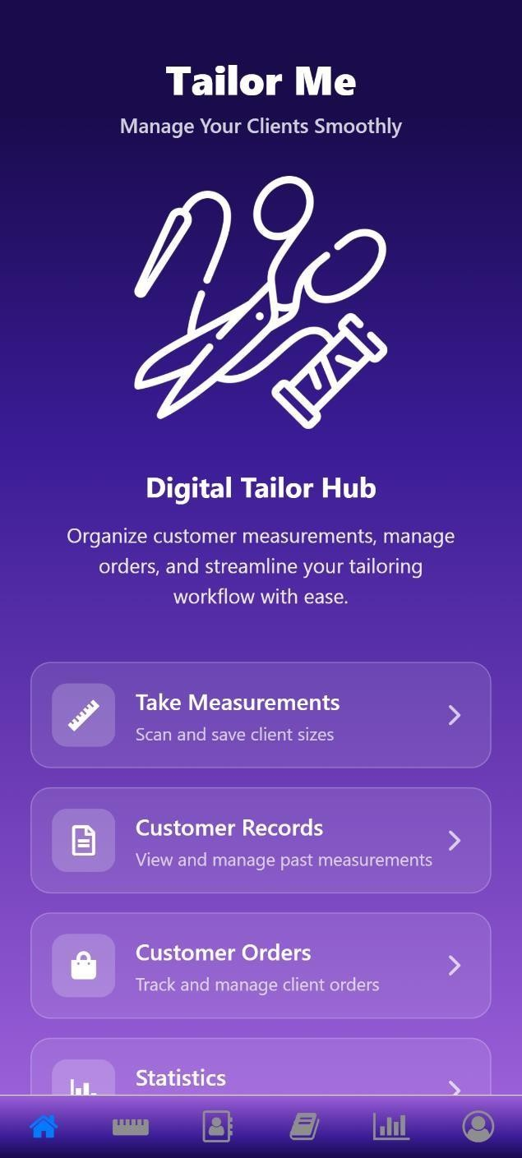

*Figure 27. Tailor Home Screen*

* + 1. **Tailor Measurement Screen**

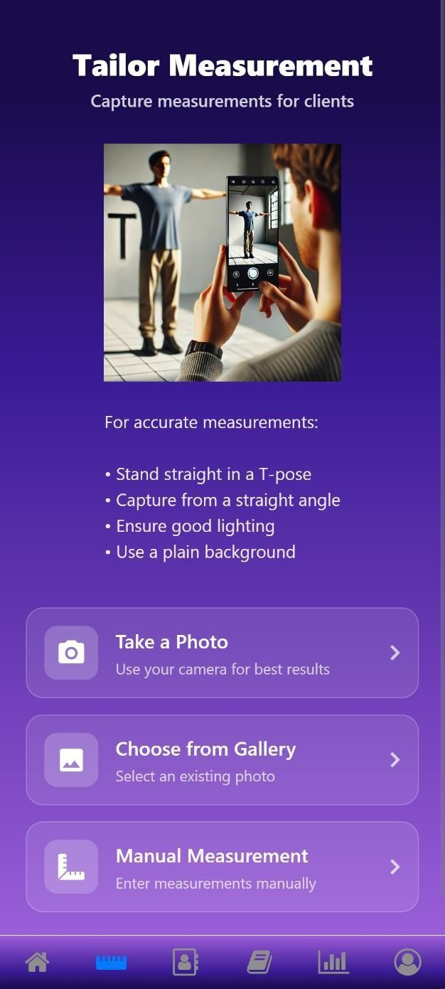

*Figure 28. Tailor Measurement Screen*

* + 1. **Measurements Result Screen**

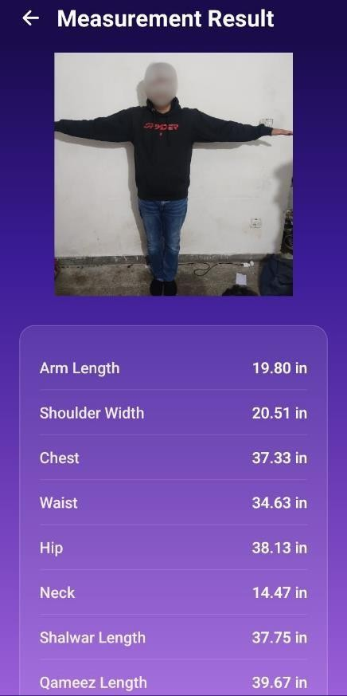

*Figure 29. Measurements Result Screen 1*

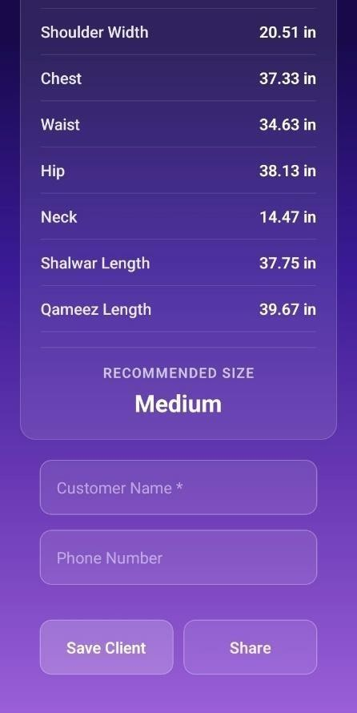

*Figure 30. Measurements Result Screen 2*

* + 1. **Customer Records Screen**

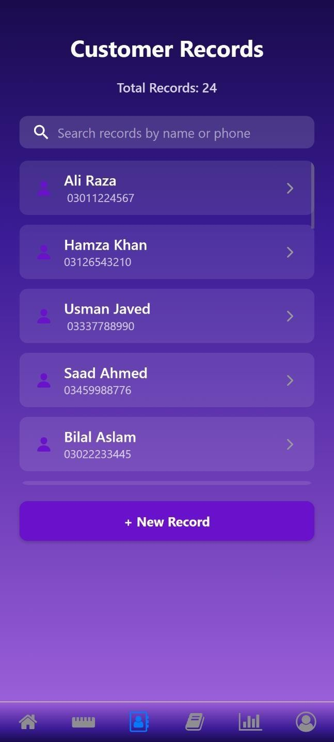

*Figure 31. Customer Records Screen*

* + 1. **Customer Details Screen**

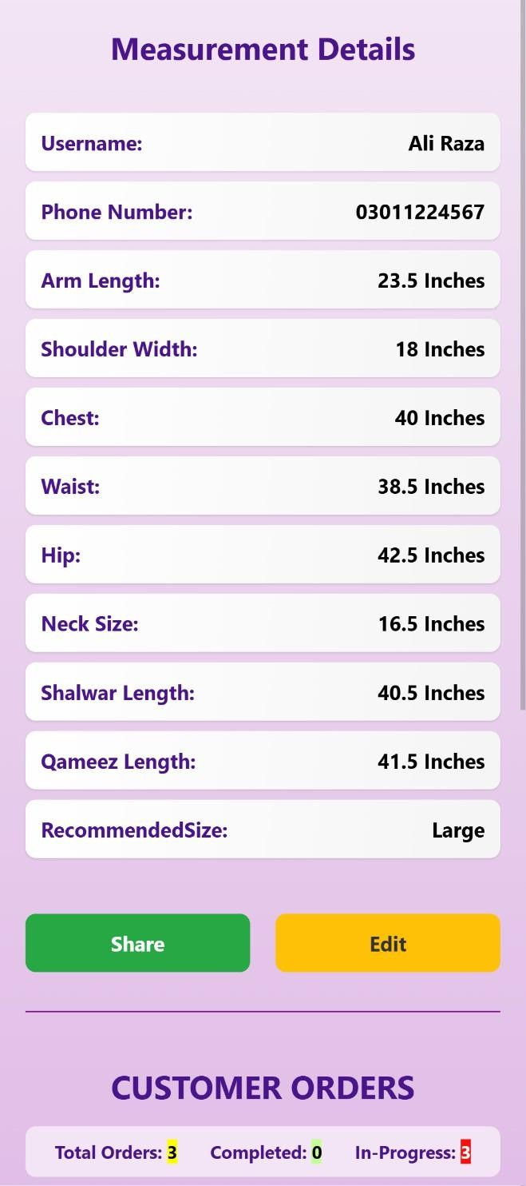

*Figure 32. Customer Details Screen 1*

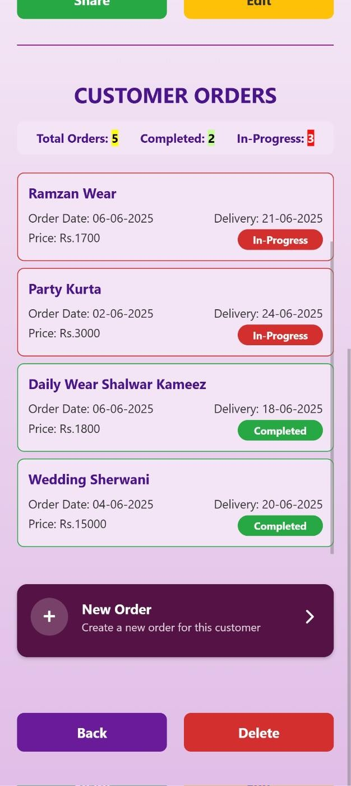

*Figure 33. Customer Details Screen 2*

* + 1. **Orders Screen**

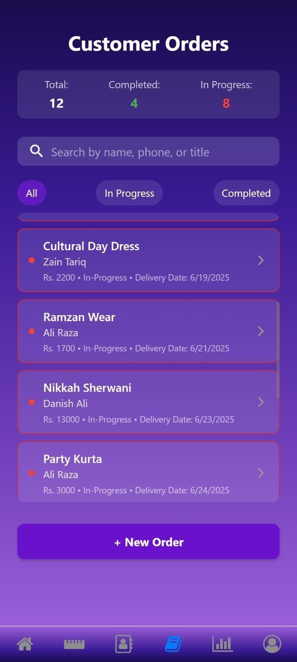

*Figure 34. Order Screen*

* + 1. **Order Details Screen**

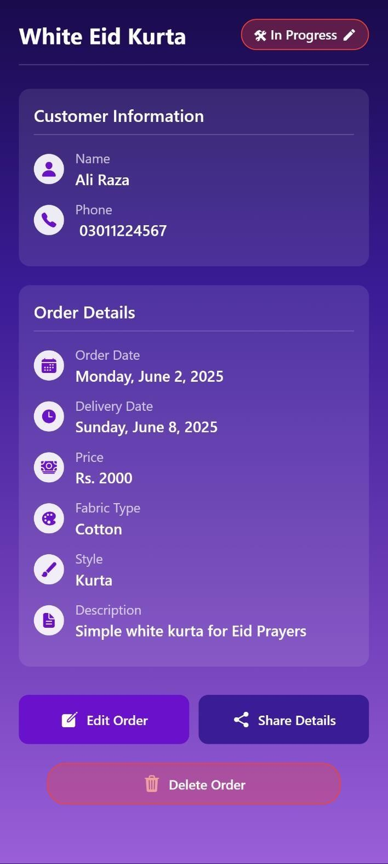

*Figure 35. Order Details Screen*

* + 1. **Statistics Screen**

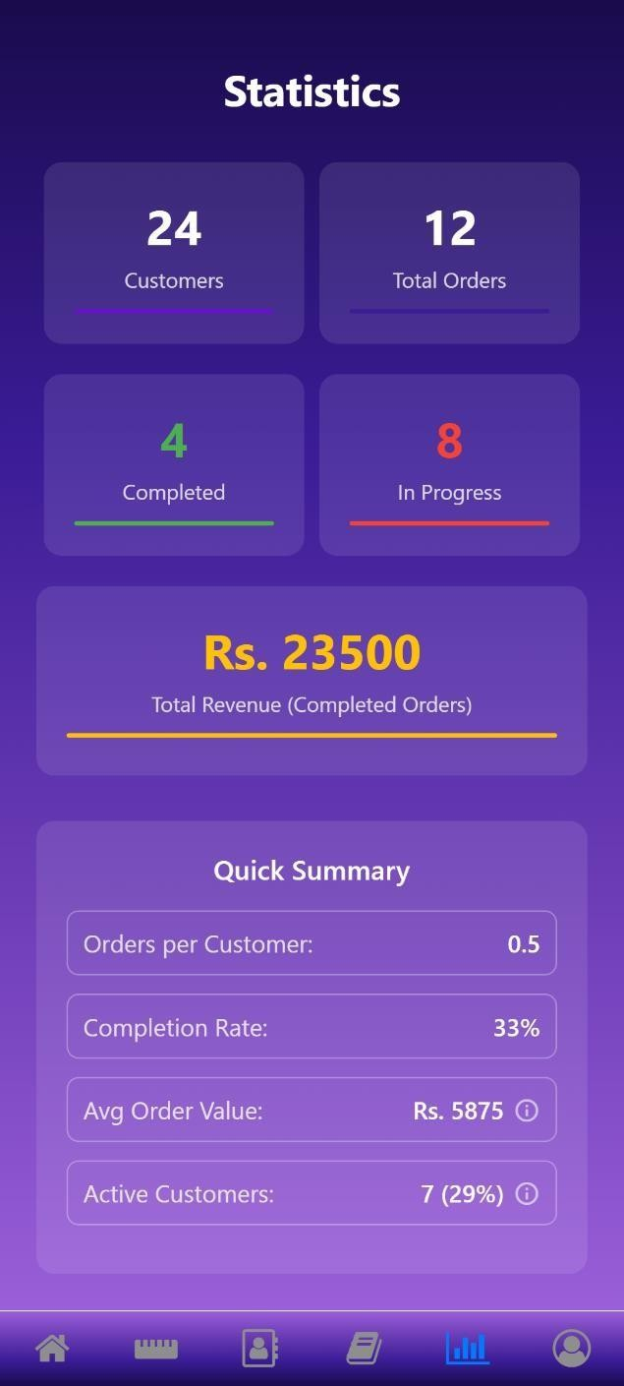

*Figure 36. Statistics Screen*

###### Normal User Screens

Following are the main screens for users with normal user role

* + 1. **User Home Screen**

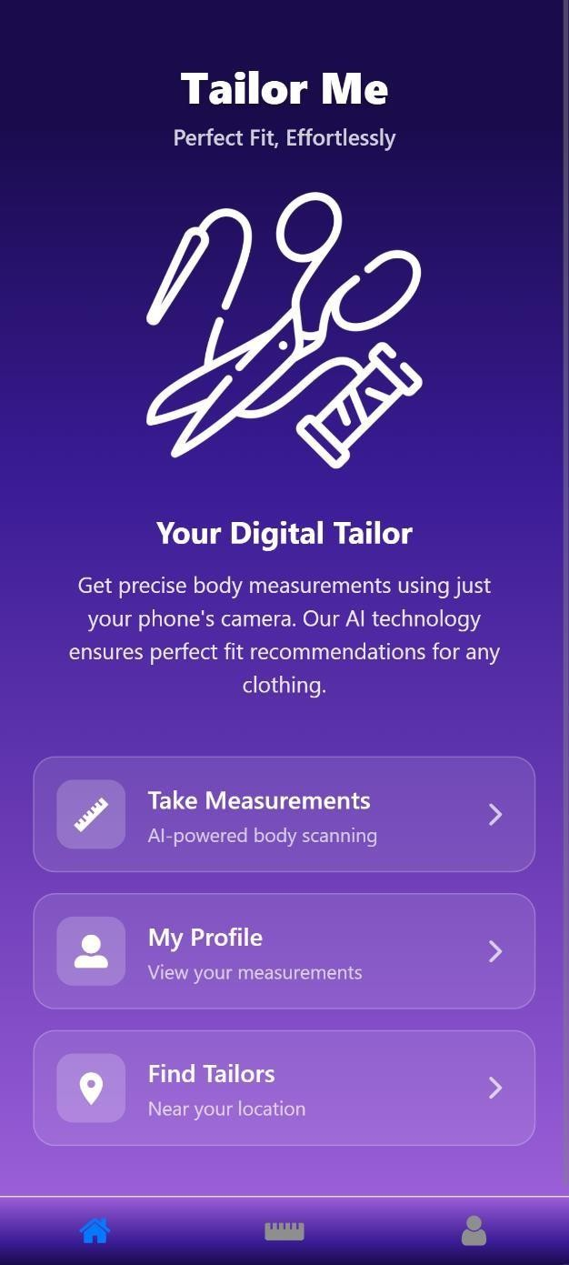

*Figure 37. User Home Screen*

* + 1. **User Measurement Screen**

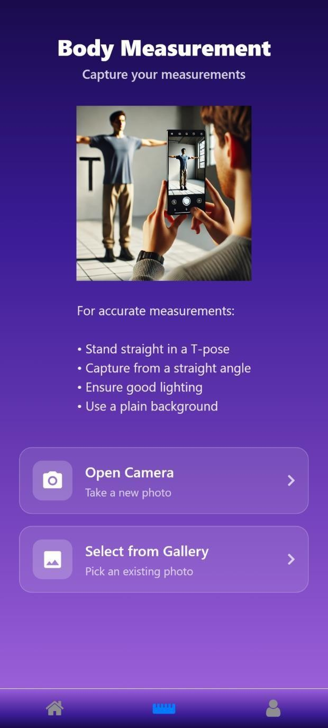

*Figure 38. User Measurement Screen*

* + 1. **User Profile Screen**

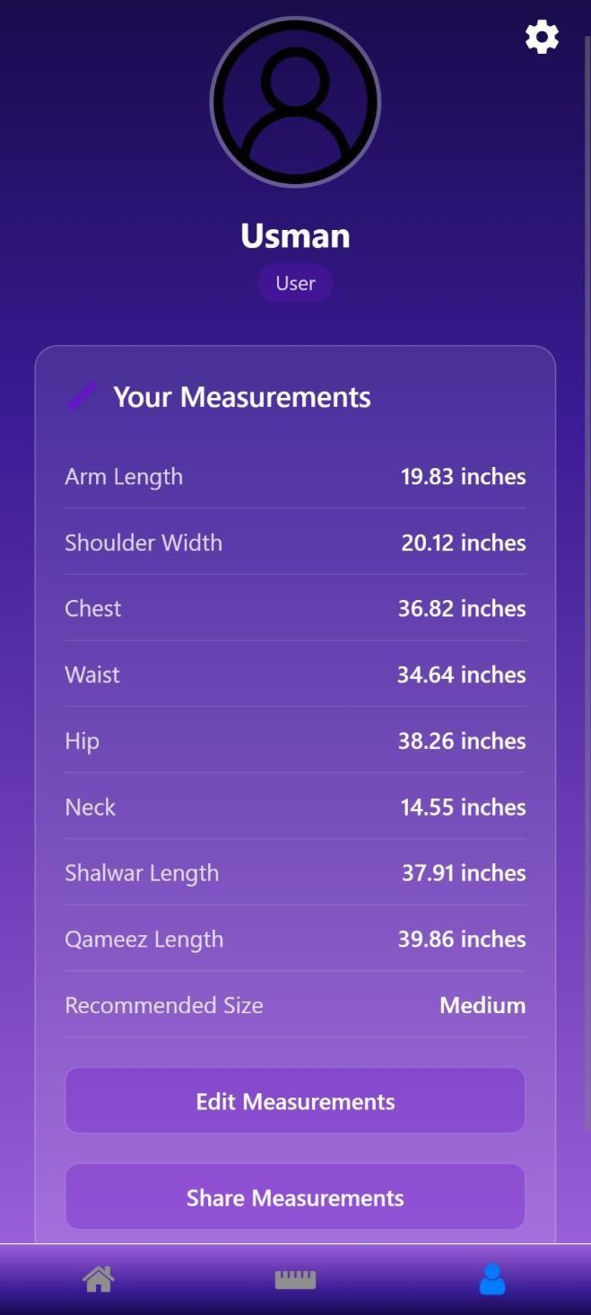

*Figure 39. User Profile Screen*

### Conclusion

This section highlights the challenges encountered during development, and discusses the lessons learned. It also outlines potential future work and enhancements to improve the application.

###### Problems faced

We faced problems in the following areas of development:

* + 1. **Dataset Collection:**

A major challenge was the unavailability of an online dataset containing human body images labelled with precise clothing measurements (e.g., chest, waist, Qameez length). Moreover, we specifically needed images of **South Asian (Desi) individuals** to reflect local clothing styles and body proportions. Additionally, most datasets didn't match the requirements in terms of pose, angle, or clothing type (shalwar qameez).

* + 1. **Server Hosting Limitation:**

As students finding a free and reliable server for hosting the Flask API and ResNet model was a major challenge. Most cloud platforms such as AWS, Google Cloud, and Railway require payment for persistent deployment, especially for compute-intensive tasks like image processing**.** Free tiers or trial versions often come with strict limitations like verifying with a credit/debit card first and involve limited compute and uptime hours

* + 1. **Model Integration Challenges:**
* **Library Compatibility:** The model was built using libraries (e.g., OpenCV, TensorFlow) that are not directly supported in React Native or Expo. This created compatibility issues when trying to run or interface with the model natively on the device.
* **Inference Speed & Resource Use:** Running the model on a server required sending images from the app to the server and waiting for a response, introducing latency and performance issues, especially on slower networks.

###### Lessons Learned

Following are the lessons we learned during development:

* + 1. **Importance of Modular Design**

Breaking the project down into smaller manageable components in the beginning is key to better development, debugging and testing.

* + 1. **Iterative testing is crucial**

Iterative testing must be done during development to identify issues early on the development phase. Particularly with image processing and data storage.

* + 1. **User feedback improves UI/UX**

Incorporating user feedback about the UI during development enhances the app’s usability and smooth.

* + 1. **Effective Time management**

Time management is essential to development. We must prioritize tasks, use scheduling and employ regiment of work.

###### Project summary

The TailorMe project aims to revolutionize the tailoring and clothing shopping experience by providing an accurate body measurement application. It uses deep learning and rule-based algorithms to predict body measurements, such as neck, waist, shoulders, chest, hip, and arm length, along with size recommendations directly from user-uploaded or captured photos. The application also offers clothing size recommendations based on these measurements for Shalwar Qameez

Key features include measurement extraction, size recommendation, tailor dashboard, and a smooth user interface for capturing and uploading images. The project integrates backend database management for securely storing user data, measurement history, customer records, orders and statistics.

###### Future work

Following is the future work that we aim to do on the application:

* + 1. **Additional Features**

1. **Posture detection:** Posture analysis to further improve measurement accuracy.
2. **Clothing Types:** Expand to more south Asian and western clothing for size recommendation.
3. **Integration with online Clothing Stores:** Collaborating with online retailers to redirect users to their website after a size prediction on a particular type of clothing. This expansion would require collecting additional annotated datasets across various body types and clothing styles,
4. **Social media features:** By integrating social features such as liking, commenting, following, and posting, the app can evolve into a community-driven platform. Users can showcase their stitched outfits, share styling ideas, or post their tailoring experiences. Tailors can create portfolio-like profiles and receive feedback or appreciation and accept direct orders from within the platform. This transforms the app from a utilitarian tool into a vibrant niche social network focused on tailoring, fashion, and craftsmanship.
5. **Fashion News and Forum modules:** Including a dynamic news feed that showcases the latest trends, seasonal styles, sustainable fashion practices, and tailoring innovations can enhance user engagement. A forum section would allow users to discuss design ideas, seek help, and

share knowledge on stitching techniques, fabric recommendations, and fashion trends. This makes the platform not just interactive, but educational and community-focused.

1. **Image Generation:** Generating clothing images from predicted measurements. This may involve virtual try on functionality.
   * 1. **Platform Expansion**

* **Web Version**: While the React Native app can run in a browser, a dedicated web-based version using a web-specific framework would offer better optimization and performance.
* **iOS Version**: React Native supports cross-platform development, enabling the same codebase to run on iOS. However, due to lack of access to an iPhone, proper testing was not possible, and an IPA (iOS installation file) was not generated.
  + 1. **Scalability**

Leverage cloud services for scalability, fast processing and responsiveness.

### References

1. ***Z. Cao, G. Hidalgo, T. Simon, S.-E. Wei, and Y. Sheikh,*** "OpenPose: Realtime Multi-Person 2D Pose Estimation Using Part Affinity Fields," *IEEE Transactions on Pattern Analysis and Machine Intelligence, vol. 43, no. 2, pp. 172-186, 2018. [Online]. Available:* [*https://arxiv.org/pdf/1812.08008.pdf*](https://arxiv.org/pdf/1812.08008.pdf)*.*
2. ***Mirrorsize****. "Ultimate Body-Measuring App for Perfectly Fitting Clothes." [Online]. Available:* [*https://www.mirrorsize.com/blogs/ultimate-body-measuring-app-for-perfectly-fitting-*](https://www.mirrorsize.com/blogs/ultimate-body-measuring-app-for-perfectly-fitting-clothes)[*clothes.*](https://www.mirrorsize.com/blogs/ultimate-body-measuring-app-for-perfectly-fitting-clothes)
3. ***3DLOOK****.* "3DLOOK" *[Online]. Available:* [*https://3dlook.ai/content-hub/3dlook-is-a-*](https://3dlook.ai/content-hub/3dlook-is-a-member-of-the-mobile-body-scanning-standards-developed-by-ieee/)[*member-of-the-mobile-body-scanning-standards-developed-by-ieee/.*](https://3dlook.ai/content-hub/3dlook-is-a-member-of-the-mobile-body-scanning-standards-developed-by-ieee/)
4. ***Bodymapp.*** *"3D Body Scanning App | Health and Fitness Tracker." [Online]. Available:* [*https://bodymapp.co.*](https://bodymapp.co/)
5. ***Kristijan Bartol, David Bojanić, Tomislav Petković, Tomislav Pribanic,*** *"A Review of Body Measurement Using 3D Scanning," ResearchGate, 2022. [Online].*

Available: [https://www.researchgate.net/publication/351207865_A_Review_of_Body_Measurem](https://www.researchgate.net/publication/351207865_A_Review_of_Body_Measurement_Using_3D_Scanning) [ent_Using_3D_Scanning.](https://www.researchgate.net/publication/351207865_A_Review_of_Body_Measurement_Using_3D_Scanning)

1. ***M. Montazerian and L. LEYMARIE,*** *"Measuring the Human Body from a Single Camera," Semantic Scholar, 2022. [Online].*

*Available:* [*https://www.semanticscholar.org/paper/Measuring-the-Human-Body-from-a-Single-*](https://www.semanticscholar.org/paper/Measuring-the-Human-Body-from-a-Single-Camera%2C-with-Montazerian-LEYMARIE/ae8c70ec2e5fe71f7692f51a9f7527f173d46f41?utm_source=direct_link)[*Camera%2C-with-Montazerian-*](https://www.semanticscholar.org/paper/Measuring-the-Human-Body-from-a-Single-Camera%2C-with-Montazerian-LEYMARIE/ae8c70ec2e5fe71f7692f51a9f7527f173d46f41?utm_source=direct_link)[*LEYMARIE/ae8c70ec2e5fe71f7692f51a9f7527f173d46f41?utm_source=direct_link.*](https://www.semanticscholar.org/paper/Measuring-the-Human-Body-from-a-Single-Camera%2C-with-Montazerian-LEYMARIE/ae8c70ec2e5fe71f7692f51a9f7527f173d46f41?utm_source=direct_link)

1. ***University of London,*** *"Designing a Contactless AI System to Measure the Human Body using a Single Camera for the Clothing and Fashion Industry," ResearchGate, 2023. [Online]. Available:* [*https://www.researchgate.net/publication/373343443_Designing_a_Contactless_AI_S*](https://www.researchgate.net/publication/373343443_Designing_a_Contactless_AI_System_to_Measure_the_Human_Body_using_a_Single_Camera_for_the_Clothing_and_Fashion_Industry)[*ystem_to_Measure_the_Human_Body_using_a_Single_Camera_for_the_Clothing_and_Fashion*](https://www.researchgate.net/publication/373343443_Designing_a_Contactless_AI_System_to_Measure_the_Human_Body_using_a_Single_Camera_for_the_Clothing_and_Fashion_Industry)

[*_Industry*](https://www.researchgate.net/publication/373343443_Designing_a_Contactless_AI_System_to_Measure_the_Human_Body_using_a_Single_Camera_for_the_Clothing_and_Fashion_Industry)

1. ***A. Sehgal and A. Gupta,*** *"Automatic Extraction of 3D Body Measurements from 2D Images," Semantic Scholar, 2022.*

Appendix A

taliorfypreport final

ORIGINALITY REPORT

9%

SIMILARITY INDEX

6%

INTERNET SOURCES

2%

PUBLICATIONS

8%

STUDENT PAPERS

PRIMARY SOURCES

Submitted to Higher Education Commission

1

2

Pakistan %

Student Paper

softwaretestingfield.blogspot.com

2

Internet Source

repository.cuilahore.edu.pk

3

Internet Source

research.gold.ac.uk

4

Internet Source

Submitted to American University of Beirut

5

Student Paper

Submitted to Institute of Research & Postgraduate Studies, Universiti Kuala Lumpur

6

Student Paper

Submitted to University of Hertfordshire

7

Student Paper

Submitted to Universiti Teknologi Malaysia

8

Student Paper

Submitted to Commonwealth College of Excellence

9

Student Paper

Submitted to University of Wales Institute, Cardiff

10

Student Paper

Submitted to Goldsmiths' College

11

Student Paper

Qingguang Chen, Liang Song, Xinghao Zhang, Guohao Zhang, Hang Lu, Jiajin Liu, Yingying

12

2%

2%

1%

<1%

<1%

<1%

<1%

<1%

<1%

<1%

<1%

Pan, Wenhan Luo. "Accurate 3D anthropometric measurement using compact multi-view imaging", Measurement, 2025

Publication

Sivaraj Selvaraj. "Chapter 4 Authentication and Authorization", Springer Science and Business Media LLC, 2024

13

Publication

[www.nimbleappgenie.com](http://www.nimbleappgenie.com/)

14

Internet Source

[www.slideshare.net](http://www.slideshare.net/)

15

Internet Source

16 Anjali Sharma, Diksha Khangarot, Kiran, Anand Sharma, Aishna Birla. "K-ADAA:

Intelligent Vision System for Designing of Personalized Apparel", Procedia Computer Science, 2025

Publication

<1%

<1%

<1%

<1%

Exclude quotes Off Exclude bibliography Off

Exclude matches Off

Page 1 of 59 - Cover Page Submission ID trn:oid:::1:3273813755

# Ali Hassan1

## taliorfypreport final

 Quick Submit  Quick Submit

 COMSATS University Islamabad, Lahore Campus

Document Details

Submission ID trn:oid:::1:3273813755

57 Pages

5,390 Words

31,212 Characters

Submission Date

Jun 11, 2025, 12:01 PM GMT+5

Download Date

Jun 26, 2025, 10:43 AM GMT+5

File Name FA24CS16_TailorMe.docx

File Size

3.4 MB

Page 2 of 59 - AI Writing Overview Submission ID trn:oid:::1:3273813755

## *% detected as AI

Caution: Review required.

It is essential to understand the limitations of AI detection before making decisions about a student’s work. We encourage you to learn more about Turnitin’s AI detection capabilities before using the tool.

AI detection includes the possibility of false positives. Although some text in this submission is likely AI generated, scores below the 20% threshold are not surfaced because they have a higher likelihood of false positives.

Disclaimer

Our AI writing assessment is designed to help educators identify text that might be prepared by a generative AI tool. Our AI writing assessment may not always be accurate (it may misidentify writing that is likely AI generated as AI generated and AI paraphrased or likely AI generated and AI paraphrased writing as only AI generated) so it should not be used as the sole basis for adverse actions against a student. It takes further scrutiny and human judgment in conjunction with an organization's application of its specific academic policies to determine whether any academic misconduct has occurred.

Frequently Asked Questions

How should I interpret Turnitin's AI writing percentage and false positives?

The percentage shown in the AI writing report is the amount of qualifying text within the submission that Turnitin’s AI writing detection model determines was either likely AI-generated text from a large-language model or likely AI-generated text that was likely revised using an AI-paraphrase tool or word spinner.

False positives (incorrectly flagging human-written text as AI-generated) are a possibility in AI models.

AI detection scores under 20%, which we do not surface in new reports, have a higher likelihood of false positives. To reduce the likelihood of misinterpretation, no score or highlights are attributed and are indicated with an asterisk in the report (*%).

The AI writing percentage should not be the sole basis to determine whether misconduct has occurred. The reviewer/instructor should use the percentage as a means to start a formative conversation with their student and/or use it to examine the submitted assignment in accordance with their school's policies.

What does 'qualifying text' mean?

Our model only processes qualifying text in the form of long-form writing. Long-form writing means individual sentences contained in paragraphs that make up a longer piece of written work, such as an essay, a dissertation, or an article, etc. Qualifying text that has been determined to be likely AI-generated will be highlighted in cyan in the submission, and likely AI-generated and then likely AI-paraphrased will be highlighted purple.

Non-qualifying text, such as bullet points, annotated bibliographies, etc., will not be processed and can create disparity between the submission highlights and the percentage shown.