**1. Part one: QA challenge**

In my framework,

**Features:**

I define the tests and tests steps and test data at the **feature files** which are under the resources folder.

**Step Definitions:**

I write test scripts under *step_definitions* folder with using java programming language.

I have Hooks class under *step_definitions* folder to create Before methods which are coming from Junit Annotations.

**Runners:**

I have a *CukesRunner* class under *runners* folder to trigger my test suite. Alternatively, I can run my test suite through maven terminal like

***mvn verify*** command

**Note that:** If you want to generate a test report, you need to run test suite through Maven command line. **( mvn verify ).**

You can reach the **test** **report** under the target folder

*target/cucumber-html-reports/overview-features.html*

**Utilities:**

There is **a Configuration.properties** file to keep credentials like **apiUrl** under the project folder.

To retrieve those credentials, I have a **ConfigReader.class** under the utilities folder. With the help of that class, I can easily reach the information I need.

I add and manage my dependencies with using POM.xml file which provided by **Maven**

**2. Part two: Questions**

**Question 1**: Explain why you chose to use those particular tools/frameworks in the technical challenge?

**Answer 1:**

**The Tools I used:**

I used the tools below to create a Cucumber BDD framework. And the tools

* **Java programming language:** to write test scripts
* **Cucumber BDD framework :** to define explicitly the tests and test steps in feature file with using Gherkin language. With the help of that cucumber feature, even non-technical people can understand the features under tests and tests steps easily.

Cucumber provides us reusable code and test steps to automate different scenarios.

And cucumber provides a detailed report to analyse test result clearly

* **Rest Assured Library: I used** to test the API endpoints with the help of Rest Assured library.

We can test all features of an **Restfull APIs** with using **RestAssured Library.**

I can specity the parameters with using pathParameter or queryParamerter methods.

I make authentication and send all HTTP request to the end point with using related Rest assured methods. And

We can validate;

* Status Code,
* body format
* Headers
* Data
* Schema and so on

* **Json Schema Validator:** I use that dependency to validate JSON Schemas where I need
* **Cucumber Junit:** I used Junit to combine Features files and java codes with the help of @CucumberOptions and @RunWith which are coming from Junit
* **Cucumber Java:** I use Cucumber dependency to create a test framework
* **Maven:** to manage my dependencies and plug-ins
* **Maven surefire plugin:** To run test suites through **Maven**
* **Maven Cucumber Reporting Plugin:** to generate a detailed test report after run the test suite through maven

**Question 2:** Describe the reason for the scope of your solution. Why did you test what you did, and why didn’t you test other things?

I test the **endpoints** that provided by the documentation.

I send **GET** and POST, PUT, DELETE, PATCH requests to the web services and checked

* **Status code**: at the API testing First thing first I need to check if the status code is like as expected. When I send a GET request with valid way, Status code need to be 200 but with invalid credentials the status code should **not** be 200.
* **Response** payload: I made verification for response payload in different ways;
  + checked if the data I received as expected.
  + Verified if the woeid ID of <cityName> is retrieved correctly
  + Verified if the response payload members are correct
  + Verified if the response payload belongs to correct city
  + Verified if the response body is a JsonBody (assumed is supposed to be)
* **Response headers;** 
  + Verified if the response has the headers looked for. (assumed is supposed to have a few headers base on the response I saw with the help of Postman)
* **Content Type**: I send a get request with expecting specific Content Type (XML) and I checked if the response content type is as expected
* **Response payload schema:** 
  + I verified if the location search payload matches with the schema expected
* **Authentication:** I sent to the endpoints **POST, PUT, PATCH, DELETE** requests which are required Authentication and checked the status codes are as expected

However, I did not test all the data, and I was not able to. Because of lack of the expected data, I was not able to test /api/location/(woeid)/(date)/ endpoint. Because I did not know what it needs to response exactly except a general introduction. When I accept the response is in correct structure, I was not able to verify it and I was not able to verify if the data belongs to correct location.

Additionally, I did not test entire Headers. Because there is no information about the headers we expect.

**Question 3:** What questions would you ask your Product Owner / what information would you need to know, to be able to test the whole MetaWeather API service comprehensively?

Answer 3:

I would ask especially what we expect from those Web services like;

* What data we expect especially from /api/location/(woeid)/(date)/?
* What type of status code do we expect especially for invalid inputs and requests?
* What type of Content type should the end points provide?
* What type of Content type are the end point able to accept?
* What are the credentials and authentication type for POST, PUT, PATCH and DELETE methods to test endpoints with those request types?
* Where can I get the data to verify payload data are correct? (any data base or something else?).
* And of course, to do exploratory testing, most important thing is experience and knowing each corner of the application. So, I ask from my PO some recommendation and advise to test those web services.

**Question 4:** After completing the technical challenge, what would you do differently if you were asked to do the same challenge again?

Answer 4: it is a good question.

BUGS:

**1.** When I send POST, PUT, PATCH, DELETE request to endpoint (/api/location/(woeid)/(date)/ )with using Postman, I got the regular response with ***status code is 200.***  *But what the weird is when I do it with automation, It works properly and returns the request code* ***405.***

***Here is some screenshots.***

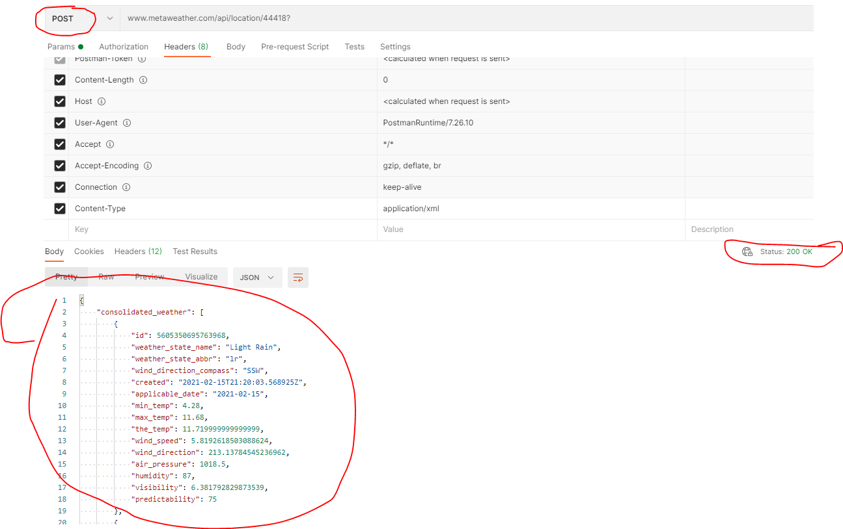

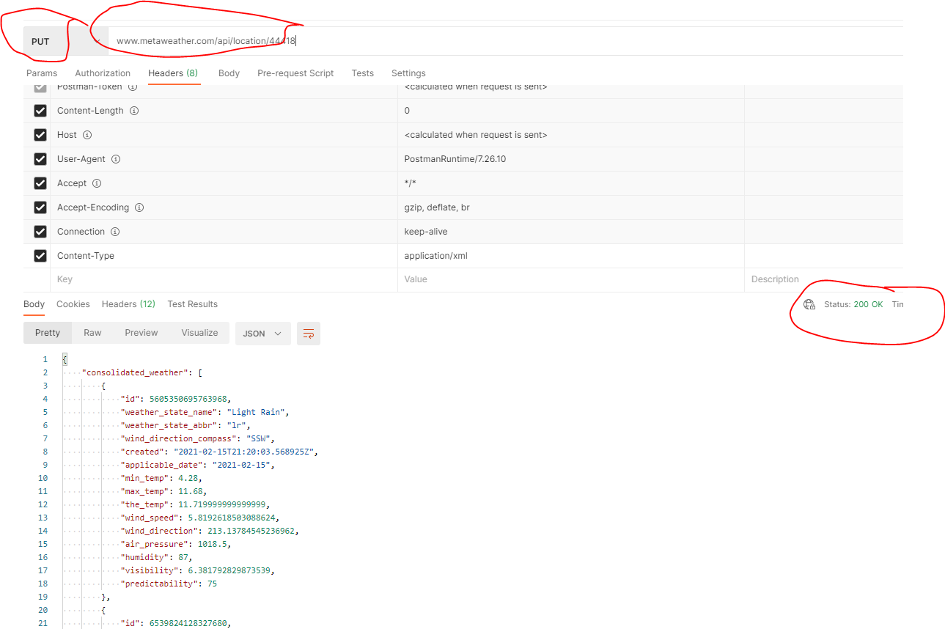

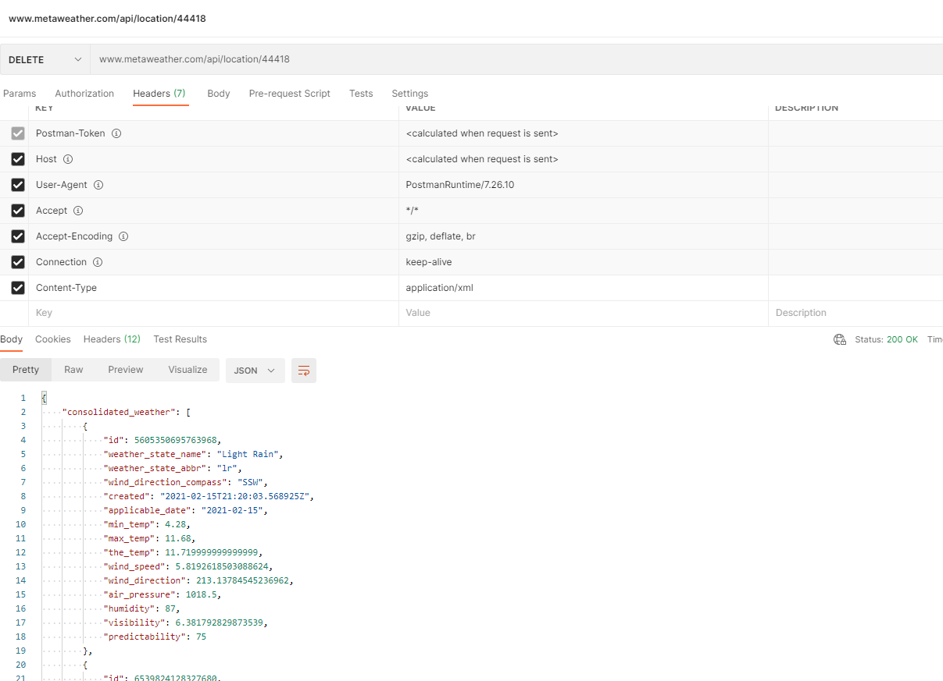

**2.** When I send a get request to web services with I want to retrieve a response with Content type is different than Json like XML, OR **HTML**, but they return only **application JSON**.

